Graphical Abstract
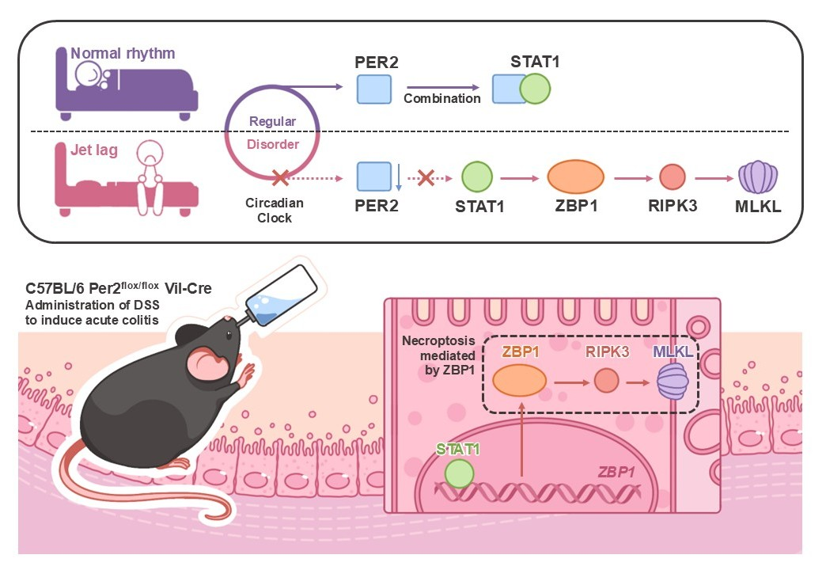
Disruption of circadian rhythm (e.g., via jet lag) suppresses intestinal PER2 expression, impairing its interaction with STAT1. This disinhibition leads to STAT1-mediated transcriptional upregulation of ZBP1, thereby activating the necroptosis pathway via RIPK3 and MLKL in colonic epithelial cells. In a DSS-induced colitis model, epithelial-specific deletion of Per2 (Villin-Cre; Per2^flox/flox) exacerbates mucosal injury through enhanced necroptosis. These findings identify PER2 as a circadian gatekeeper of epithelial homeostasis and highlight the STAT1–ZBP1 axis as a potential therapeutic target in ulcerative colitis with circadian disruption.

