Supplementary Information:
Biodegradable Platforms for Next-Generation Electronics: Sustainable Gold Nanowire Fabrication using Pulse-Atomic Force nanolithography on Chitosan Films
P. Pellegrino ^{1†*}, L. Vincenti^{1,2†}, I. Farella¹, V. De Matteis³, M. Cascione², A. Bianco³, F. Quaranta¹ and R. Rinaldi^{1,2}
¹ Institute for Microelectronics and Microsystems (IMM), CNR, Via Monteroni, 73100 Lecce, Italy
² Department of Mathematics and Physics “E. De Giorgi”, University of Salento, Via Monteroni, 73100 Lecce, Italy
³ Department of Experimental Medicine, University of Salento, Via Monteroni, 73100 Lecce, Italy

† These authors equally contributed to this work
*Correspondence to: paolo.pellegrino@cnr.it

Section 3.2 “CP-AFL of nanogrooves on M-Ch films”
The Table 1S reports the normal forces measured at each Setpoint value by AFM force–spectroscopy calibration. The Force estimations were performed by acquiring Force–Distance curves in contact mode on a silicon wafer using an NSG30 probe, for Setpoint values ranging from 0.5 nA to 21 nA. For each Setpoint, ten curves were analyzed to calculate the average normal force and standard deviation, based on the cantilever spring constant and the slope of the contact region. To this aim, a proper script was developed in Python.

 | SetPoint  (nA) | 0.5 | 1 | 1.5 | 2 | 2.5 | 3 | 3.5 | 4 | 4.5 | 5
 | Force (nN) | 0.23 | 0.44 | 0.64 | 0.85 | 1.05 | 1.24 | 1.43 | 1.63 | 1.83 | 2.03
 | Err. (nN) | 0.03 | 0.02 | 0.03 | 0.03 | 0.04 | 0.05 | 0.05 | 0.06 | 0.06 | 0.07
 | SetPoint  (nA) | 5.5 | 6 | 6.5 | 7 | 7.5 | 8 | 8.5 | 9 | 9.5 | 10
 | Force (nN) | 2.21 | 2.41 | 2.60 | 2.80 | 3.00 | 3.20 | 3.39 | 3.59 | 3.79 | 3.99
 | Err. (nN) | 0.08 | 0.08 | 0.09 | 0.10 | 0.10 | 0.11 | 0.12 | 0.12 | 0.13 | 0.14
 | SetPoint  (nA) | 10.5 | 11 | 11.5 | 12 | 12.5 | 13 | 13.5 | 14 | 14.5 | 15
 | Force (nN) | 4.19 | 4.39 | 4.58 | 4.79 | 4.99 | 5.20 | 5.41 | 5.60 | 5.81 | 6.02
 | Err. (nN) | 0.15 | 0.15 | 0.16 | 0.17 | 0.17 | 0.18 | 0.19 | 0.19 | 0.20 | 0.21
SetPoint  (nA) |  | 15.5 | 16 | 16.5 | 17 | 17.5 | 18 | 18.5 | 19 | 19.5 | 20
Force (nN) |  | 6.24 | 6.44 | 6.66 | 6.88 | 7.10 | 7.25 | 7.48 | 7.71 | 7.94 | 8.17
Err. (nN) |  | 0.22 | 0.22 | 0.23 | 0.24 | 0.26 | 0.25 | 0.26 | 0.27 | 0.28 | 0.28
 | SetPoint  (nA) | 20.5 | 21
 | Force (nN) | 8.35 | 8.60
 | Err. (nN) | 0.29 | 0.30

Table S1. Normal force values estimated by force spectroscopy. Estimation of Normal Force action on the AFM probe at a specific Setpoint value through force–spectroscopy measurements. The average normal force (± SD) was determined for each Setpoint (0.5–21 nA) by analyzing 10 Force–Distance curves, acquired with an NSG30 probe in contact mode on a silicon wafer.
Section 3.2 “CP-AFL of nanogrooves on M-Ch films”
The Fig. S1 reports the linear correlation between AFM Setpoint (0.5–21 nA) and the measured normal force, obtained from Force–Distance curve analysis by using the NSG30 probes. The fitted linear regression (R² = 0.99977), measured by Origin Software, demonstrates the high accuracy and reproducibility of the force calibration, ensuring precise control of the maximum normal force applied during CP-AFL nanolithography and consistent nanogroove depth across fabrication processes.
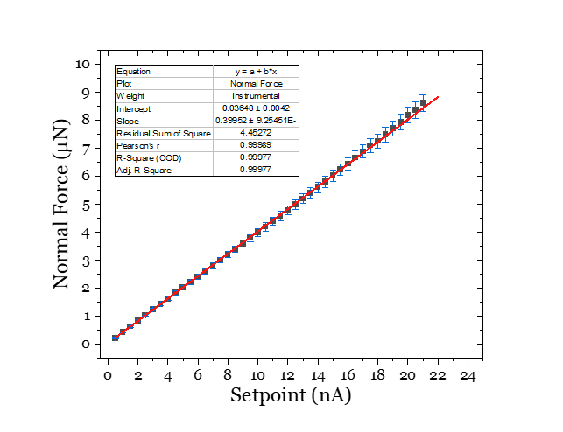

Figure S1: Fitting of the Normal force values as a function of the Setpoints. Estimation of the force applied for the patterning of nanogrooves on Ch-M layers, corresponding to the Setpoint values from 0.5 nA to 21 nA. The data were reported as mean value ± standard deviation (n=10).

Section 3.2 “CP-AFL of nanogrooves on M-Ch films”
Estimated fitting parameters of the sigmoidal logistic function (Eq. 3) used to model the dependence of nanogroove depth on the applied normal force during CP-AFL nanolithography. The analysis was performed for chitosan films with concentrations of 0.7%, 0.8%, and 0.9% (w/v), each showing a characteristic nonlinear force–depth response. The reported parameters reflect the steepness and saturation behavior of the nanostructure formation process and provide quantitative insight into the mechanical response of chitosan films under nanoscale indentation.

 | Ch-M 0.7% | Ch-M 0.8% | Ch-M 0.9%
a | (54.1 ± 0.5) nm | (56.1 ± 0.1) nm | (78.4 ± 0.4) nm
k | (0.53 ± 0.02) nA⁻¹ | (0.61 ± 0.01) nA⁻¹ | (0.86 ± 0.05) nA⁻¹
x_{c} | (10.1 ± 0.2) nA | (9.99 ± 0.05) nA | (7.11 ± 0.10) nA
R-squared (COD) | 0.9978 | 0.9997 | 0.9960

Table S2: fitting parameters of sigmoidal logistic function. The fitting parameters of the curves describing the variation of the nanogrooves depth as a function of the applied normal force during the CP-AFL were estimated by using the Eq. 3. The parameters are reported for the nanostructures patterned on Ch-M 0.7%, 0.8%, and 0.9%, respectively.

Section 3.2 “CP-AFL of nanogrooves on M-Ch films”
Nanogroove depth as a function of Setpoint used for CP-AFL patterning on chitosan films. The results show that increasing Setpoint leads to greater groove depth, with the inflection point shifting to lower values as chitosan concentration increases. This trend, along with a steeper curve slope, indicates that higher concentrations reach the maximum depth more quickly.
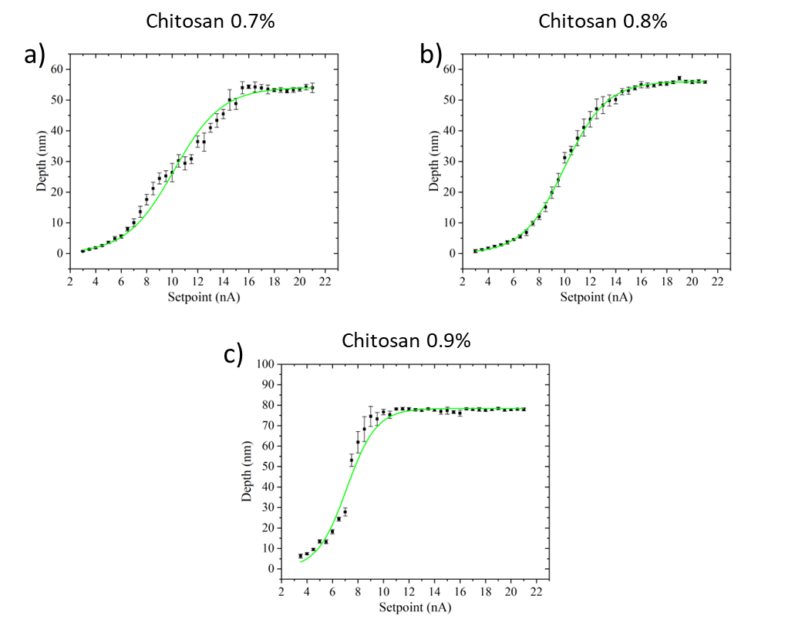
Figure S2: Graphs reporting the sigmoidal fit of the nanogrooves depth. Fitting of the depth values of nanogrooves patterned on CP-AFL on Ch-M with concentrations of 0.7%, 0.8%, and 0.9% w/v.
The fitting was performed by using a sigmoidal logistic model (green curves) in OriginLab. The analysis shows a progressive increase in nanogroove depth with applied normal force, accompanied by a shift of the inflection point from (10.1 ± 0.2) nA at 0.7% to (7.11 ± 0.10) nA at 0.9%. Concurrently, the steepness parameter k increases (from 0.53 ± 0.02 to 0.86 ± 0.05 nA⁻¹), reflecting a more rapid attainment of the plateau depth at higher chitosan concentrations. These trends are linked to variations in the viscoelastic behavior and film thickness, with thinner coatings showing stronger mechanical influence from the underlying substrate, thereby affecting groove morphology.

