Online Supplementary Material (OSM)
Assessing the impact of the Bristol’s outdoor advertisement restrictions policy on exposure to advertisements and consumption of unhealthy commodities.

Authors:
Buckland G¹, Toumpakari Z², Sillero-Rejon C³, Jago R^{1,3}, Cummins S⁴, Nobles J⁵, Harding S^{1,3}, Horwood J^{1,3,}, Nairn A⁶, Hollingworth W¹, Blake S², de Vocht F^{1,3}
Affiliations:
¹Population Health Sciences, Bristol Medical School, University of Bristol, Bristol
²School for Policy Studies, University of Bristol, UK
³NIHR Applied Research Collaboration West (NIHR ARC West), Bristol, UK
⁴Population Health Innovation Lab, Department of Public Health, Environments & Society, London School of Hygiene & Tropical Medicine, London, UK
⁵Obesity Institute, School of Health, City Campus, Leeds Beckett University, Leeds, UK
⁶Bristol Hub for Gambling Harms Research, University of Bristol, Bristol, UK

OSM Table 1 (T1): STROBE Statement
 | Item No. | Recommendation | Section/Paragraph Number | Relevant text from manuscript
Title and abstract | 1 | (a) Indicate the study’s design with a commonly used term in the title or the abstract | Abstract
Title and abstract | 1 | (b) Provide in the abstract an informative and balanced summary of what was done and what was found | Abstract
Introduction
Background/rationale | 2 | Explain the scientific background and rationale for the investigation being reported | Introduction/P4-P5
Objectives | 3 | State specific objectives, including any prespecified hypotheses | Introduction/P5
Methods
Study design | 4 | Present key elements of study design early in the paper | Methods/Study design/P5
Setting | 5 | Describe the setting, locations, and relevant dates, including periods of recruitment, exposure, follow-up, and data collection | Methods/Study design/P5-P6
Participants | 6 | (a) Cohort study—Give the eligibility criteria, and the sources and methods of selection of participants. Describe methods of follow-up  Case-control study—Give the eligibility criteria, and the sources and methods of case ascertainment and control selection. Give the rationale for the choice of cases and controls  Cross-sectional study—Give the eligibility criteria, and the sources and methods of selection of participants | Methods/Study design/P5
Participants | 6 | (b) Cohort study—For matched studies, give matching criteria and number of exposed and unexposed  Case-control study—For matched studies, give matching criteria and the number of controls per case
Variables | 7 | Clearly define all outcomes, exposures, predictors, potential confounders, and effect modifiers. Give diagnostic criteria, if applicable | Methods/P5-P6
Data sources/ measurement | 8* | For each variable of interest, give sources of data and details of methods of assessment (measurement). Describe comparability of assessment methods if there is more than one group | Methods/P5-P6
Bias | 9 | Describe any efforts to address potential sources of bias | Methods/Sensitivity Analyses/P6
Study size | 10 | Explain how the study size was arrived at | Methods/P7/Fig1

Quantitative variables | 11 | Explain how quantitative variables were handled in the analyses. If applicable, describe which groupings were chosen and why | Methods/ P5-P6
Statistical methods | 12 | (a) Describe all statistical methods, including those used to control for confounding | Methods/P6
Statistical methods | 12 | (b) Describe any methods used to examine subgroups and interactions | Methods/P6
Statistical methods | 12 | © Explain how missing data were addressed | Methods/P6
Statistical methods | 12 | (d) Cohort study—If applicable, explain how loss to follow-up was addressed  Case-control study—If applicable, explain how matching of cases and controls was addressed  Cross-sectional study—If applicable, describe analytical methods taking account of sampling strategy | Methods/P5-P6
Statistical methods | 12 | © Describe any sensitivity analyses | Methods/P6
Results
Participants | 13* | (a) Report numbers of individuals at each stage of study—eg numbers potentially eligible, examined for eligibility, confirmed eligible, included in the study, completing follow-up, and analysed | Results/P6/Figure 1
Participants | 13* | (b) Give reasons for non-participation at each stage | N/A
Participants | 13* | © Consider use of a flow diagram | Fig 1
Descriptive data | 14* | (a) Give characteristics of study participants (eg demographic, clinical, social) and information on exposures and potential confounders | Results/P5
Descriptive data | 14* | (b) Indicate number of participants with missing data for each variable of interest | Results/P7 /Table 1
Descriptive data | 14* | © Cohort study—Summarise follow-up time (eg, average and total amount)
Outcome data | 15* | Cohort study—Report numbers of outcome events or summary measures over time | Results/P7/Tables 2 and supplementary material
Outcome data | 15* | Case-control study—Report numbers in each exposure category, or summary measures of exposure
Outcome data | 15* | Cross-sectional study—Report numbers of outcome events or summary measures
Main results | 16 | (a) Give unadjusted estimates and, if applicable, confounder-adjusted estimates and their precision (eg, 95% confidence interval). Make clear which confounders were adjusted for and why they were included | Results/P7/ Table 2 & 3 and supplementary material
Main results | 16 | (b) Report category boundaries when continuous variables were categorized
Main results | 16 | © If relevant, consider translating estimates of relative risk into absolute risk for a meaningful time period

Other analyses | 17 | Report other analyses done—eg analyses of subgroups and interactions, and sensitivity analyses | Results/P7-8/Table 4 Figure 2 & 3/Supplementary material
Discussion
Key results | 18 | Summarise key results with reference to study objectives | Discussion/P8-P9
Limitations | 19 | Discuss limitations of the study, taking into account sources of potential bias or imprecision. Discuss both direction and magnitude of any potential bias | Discussion/P9-P10
Interpretation | 20 | Give a cautious overall interpretation of results considering objectives, limitations, multiplicity of analyses, results from similar studies, and other relevant evidence | Discussion/P10
Generalisability | 21 | Discuss the generalisability (external validity) of the study results | Discussion/P10
Other information
Funding | 22 | Give the source of funding and the role of the funders for the present study and, if applicable, for the original study on which the present article is based | Funding Statement P11

*Give information separately for cases and controls in case-control studies and, if applicable, for exposed and unexposed groups in cohort and cross-sectional studies.

Note: An Explanation and Elaboration article discusses each checklist item and gives methodological background and published examples of transparent reporting. The STROBE checklist is best used in conjunction with this article (freely available on the Web sites of PLoS Medicine at http://www.plosmedicine.org/, Annals of Internal Medicine at http://www.annals.org/, and Epidemiology at http://www.epidem.com/). Information on the STROBE Initiative is available at www.strobe-statement.org.

OSM Table 2 (T2): Self-reported exposure to outdoor advertisements by respondents in Bristol, before and after the advertising restrictions policy.
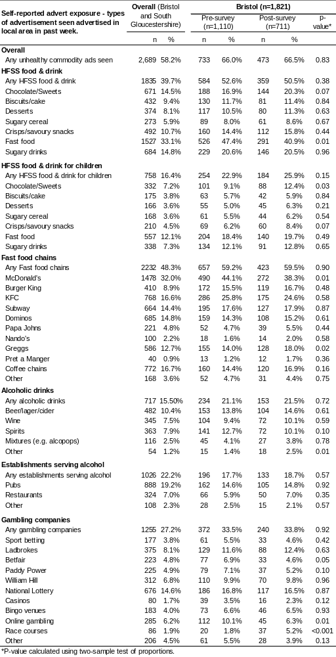
OSM Table 3 (T3): Self-reported exposure to outdoor advertisements by respondents in South Gloucestershire, before and after the advertising restrictions policy.
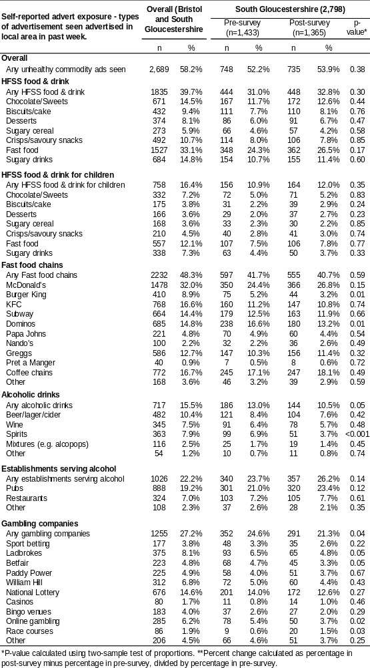
OSM Table 4 (T4): Self-reported consumption/use of unhealthy commodities by respondents in Bristol, before and after the advertising restrictions policy.
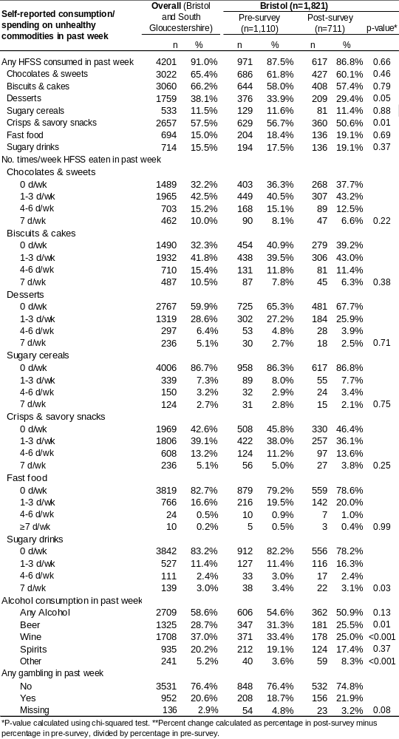

OSM Table 5 (T5): Self-reported consumption/use of unhealthy commodities by respondents in South Gloucestershire, before and after the advertising restrictions policy.
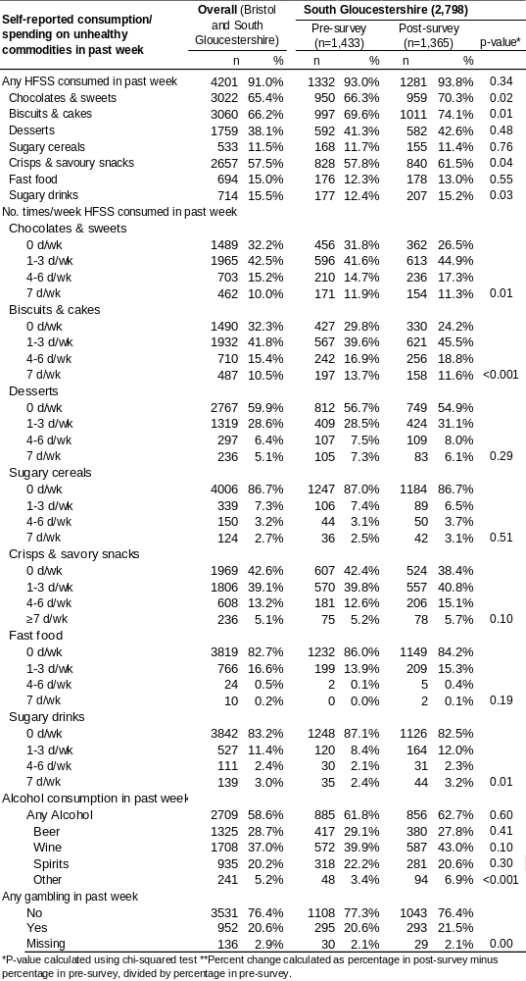

OSM Table 6 (T6): Location of where adverts of unhealthy commodities were seen by respondents in Bristol and South Gloucestershire, before and after the advertising restrictions policy.
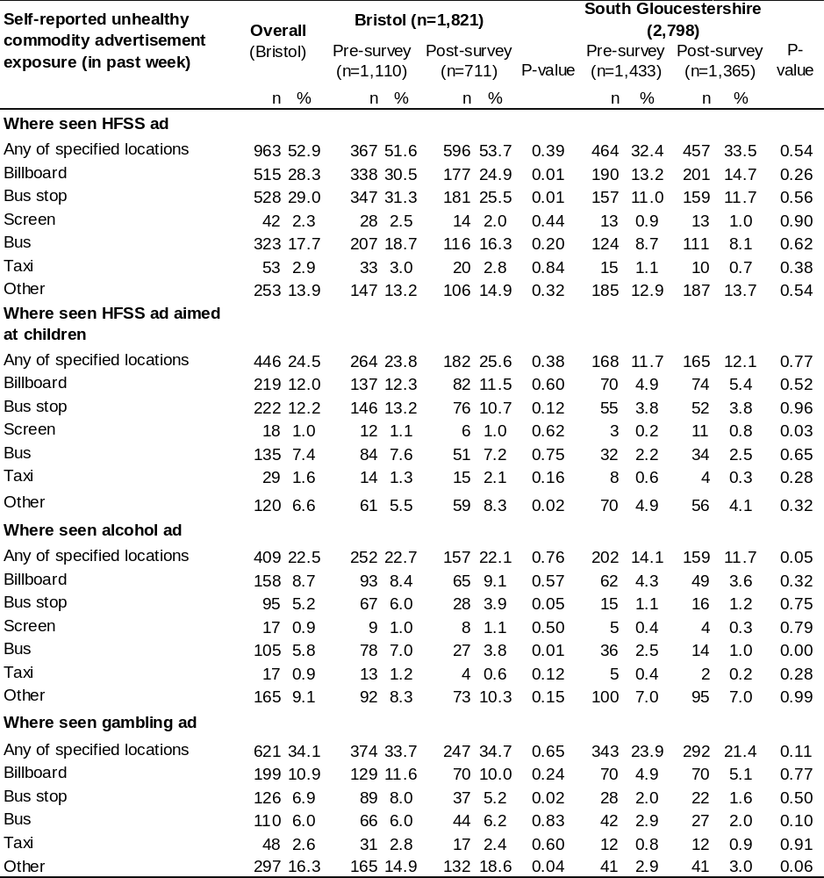

OSM Table 7 (T7): Changes in exposure to adverts of HFSS products following the Bristol advertisement restrictions policy, comparing Bristol post-policy to the comparator areas (Bristol pre- and South Gloucestershire pre- and post-policy).
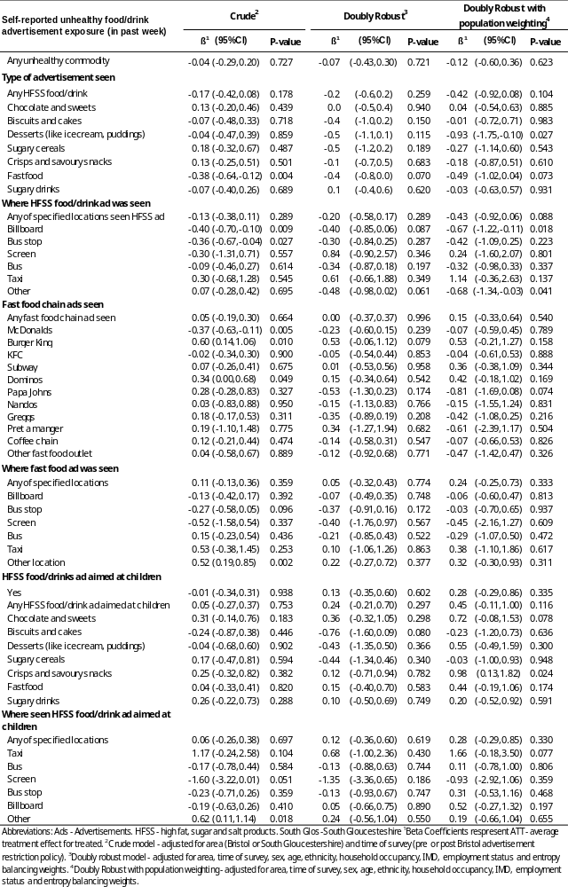
OSM Table 8 (T8): Changes in exposure to adverts of alcohol and gambling following the Bristol advertisement restrictions policy, comparing Bristol post-policy to the comparator areas (Bristol pre- and South Gloucestershire pre- and post-policy).
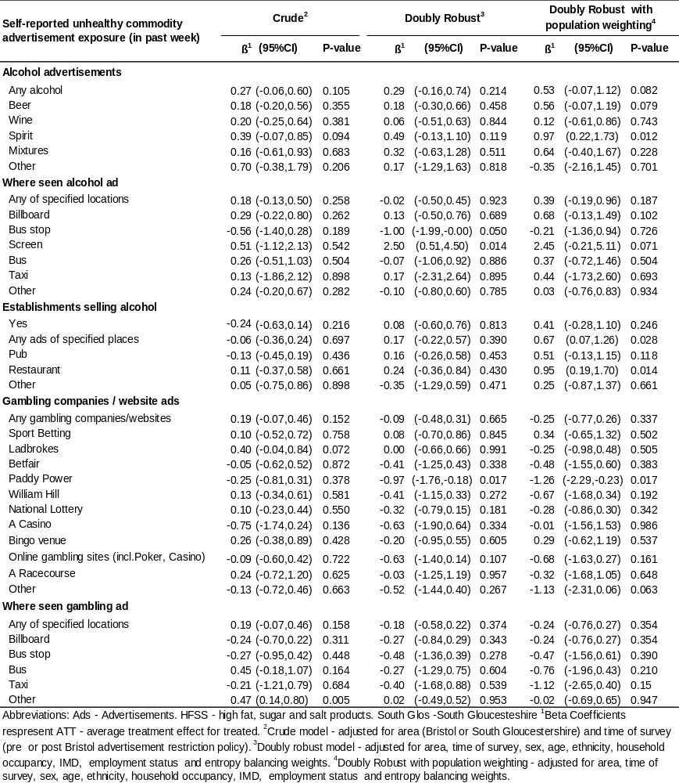
OSM Table 9 (T9): Changes in consumption of HFSS products, alcohol and gambling following the Bristol advertisement restrictions policy, comparing Bristol post-policy to the comparator areas (Bristol pre- and South Gloucestershire pre- and post-policy).
