Supplementary Table S1. ICD-10 codes
Supplementary Table S2. ARIMA model diagnostics and metrics for forecasts 1-3
Supplementary Table S3. Annual tuberculosis case counts and incidence rates per 1,000,000
Supplementary Table S4. Annual deaths stratified by gender, race, 10-year age groups, region, and urbanisation status
Supplementary Table S5. Annual age-adjusted mortality rate per 1,000,000 (95% confidence interval) stratified by gender and race
Supplementary Table S6. Crude mortality rate per 1,000,000 (95% confidence interval) stratified by ten-year age groups
Supplementary Table S7. Age-adjusted mortality rates per 1,000,000 stratified by states
Supplementary Table S8. Annual age-adjusted mortality rate per 1,000,000 (95% confidence interval) stratified by regions and urbanisation status
Supplementary Table S9. Annual number of deaths and age-adjusted mortality rate per 1,000,000 (95% confidence interval) stratified by ICD-10 subcodes of tuberculosis
Supplementary Table S10. Number of deaths and percentage of total deaths stratified by place of death
Supplementary Table S11. AAMR forecasts with 95% confidence intervals using the ARIMA model in forecasts 1-3
Supplementary Figure S1. Age-adjusted mortality rates per million stratified by urbanisation status
Supplementary Figure S2. Age-adjusted mortality rates per million, stratified by ICD-10 codes for tuberculosis
Supplementary Figure S3. Forecast 2: Projected tuberculosis mortality for 2024-2035 using ARIMA modeling trained on the full historical dataset (1999-2023)
Supplementary Figure S4. Forecast 3: Projected tuberculosis mortality for 2024-2035 using ARIMA modeling trained on the most recent 15 years of data (2009-2023)

Supplementary Table S1. ICD-10 codes
ICD-10 code | Description
A16 | Respiratory tuberculosis, not confirmed bacteriologically or histologically
A17 | Tuberculosis of nervous system
A18 | Tuberculosis of other organs
A19 | Miliary tuberculosis

Supplementary Table S2. ARIMA model diagnostics and metrics for forecasts 1-3
Model diagnostics and metrics | Forecast 1 | Forecast 2 | Forecast 3
ADF test (p-value) | 0.8845 | 0.8154 | 0.9628
Differencing applied | Yes (d = 1) | Yes (d = 2) | Yes (d = 1)
Selected ARIMA model (p,d,q) | (0,1,0) with drift | (0,2,2) | (0,1,0)
BIC | 6.08 | 55.89 | 21.31
Training RMSE | 0.2521 | 0.5960 | 0.4553
Training MAE | 0.1875 | 0.4829 | 0.3672
Training MAPE (%) | 2.84 | 5.60 | 5.29
ACF1 of residuals | 0.0512 | 0.1576 | -0.2083
Ljung-Box p-value | 0.8787 | 0.7163 | 0.3761
Rolling cross-validation RMSE | 1.0412 | 4.4715 | 1.3517

Supplementary Table S3. Annual tuberculosis case counts and incidence rates per 1,000,000
Year | Case Counts | Incidence rates per million
1999 | 17,531 | 64.3
2000 | 16,377 | 60.1
2001 | 15,989 | 56.8
2002 | 15,075 | 53.6
2003 | 14,874 | 51.7
2004 | 14,517 | 50.9
2005 | 14,097 | 48.0
2006 | 13,779 | 46.5
2007 | 13,299 | 44.4
2008 | 12,904 | 42.8
2009 | 11,545 | 38.0
2010 | 11,182 | 36.4
2011 | 10,528 | 34.1
2012 | 9,945 | 31.9
2013 | 9,582 | 30.5
2014 | 9,421 | 29.5
2015 | 9,557 | 29.7
2016 | 9,272 | 28.7
2017 | 9,105 | 28.0
2018 | 9,025 | 27.6
2019 | 8,916 | 27.2
2020 | 7,174 | 21.8
2021 | 7,882 | 23.9
2022 | 8,331 | 25.0

Supplementary Table S4. Annual deaths stratified by gender, race, 10-year age groups, region, and urbanisation status
Year | Overall | Genders |  | Races |  |  |  |  | Age Groups |  |  |  |  | Regions |  |  |  | Urbanisation Status
Year | Overall | Females | Males | AI/AN* | Blacks | Whites | A/PI** | Hispanics | 45-54 | 55-64 | 65-74 | 75-84 | ≥85 | Northeast | Midwest | South | West | Large  Metropolitan | Medium/Small  Metropolitan | Nonmetropolitan
1999 | 1,657 | 623 | 1,034 | 26 | 394 | 885 | 156 | 178 | 203 | 251 | 369 | 497 | 337 | 281 | 310 | 664 | 402 | 921 | 463 | 273
2000 | 1,390 | 548 | 842 | 29 | 343 | 730 | 140 | 131 | 183 | 190 | 297 | 476 | 244 | 240 | 271 | 567 | 312 | 748 | 404 | 238
2001 | 1,350 | 539 | 811 | 24 | 314 | 734 | 129 | 141 | 156 | 217 | 299 | 434 | 244 | 211 | 226 | 585 | 328 | 748 | 373 | 229
2002 | 1,291 | 516 | 775 | 36 | 306 | 680 | 132 | 132 | 157 | 197 | 292 | 410 | 235 | 210 | 208 | 529 | 344 | 694 | 343 | 254
2003 | 1,244 | 481 | 763 | 26 | 273 | 676 | 136 | 126 | 185 | 199 | 234 | 416 | 210 | 208 | 237 | 478 | 321 | 690 | 365 | 189
2004 | 1,102 | 436 | 666 | 29 | 257 | 561 | 110 | 138 | 144 | 169 | 248 | 320 | 221 | 167 | 173 | 465 | 297 | 622 | 318 | 162
2005 | 1,121 | 444 | 677 | 23 | 249 | 556 | 158 | 131 | 161 | 180 | 228 | 333 | 219 | 153 | 194 | 443 | 331 | 646 | 320 | 155
2006 | 1,105 | 411 | 694 | 26 | 249 | 524 | 149 | 153 | 167 | 183 | 215 | 332 | 208 | 161 | 176 | 418 | 350 | 629 | 313 | 163
2007 | 939 | 355 | 584 | 21 | 200 | 468 | 128 | 118 | 137 | 154 | 185 | 295 | 168 | 125 | 168 | 371 | 275 | 498 | 281 | 160
2008 | 1,016 | 385 | 631 | 28 | 214 | 478 | 155 | 137 | 141 | 172 | 211 | 277 | 215 | 157 | 158 | 394 | 307 | 558 | 308 | 150
2009 | 915 | 354 | 561 | 18 | 178 | 450 | 141 | 124 | 115 | 166 | 176 | 284 | 174 | 165 | 144 | 356 | 250 | 519 | 277 | 119
2010 | 932 | 343 | 589 | 27 | 174 | 447 | 147 | 133 | 114 | 198 | 196 | 231 | 193 | 145 | 154 | 354 | 279 | 496 | 282 | 154
2011 | 922 | 373 | 549 | 27 | 174 | 427 | 159 | 132 | 107 | 201 | 181 | 254 | 179 | 142 | 144 | 341 | 295 | 529 | 267 | 126
2012 | 895 | 336 | 559 | 22 | 140 | 448 | 140 | 137 | 118 | 186 | 178 | 231 | 182 | 133 | 146 | 349 | 267 | 497 | 259 | 139
2013 | 901 | 307 | 594 | 23 | 150 | 470 | 147 | 108 | 91 | 183 | 206 | 216 | 205 | 118 | 144 | 339 | 300 | 501 | 270 | 130
2014 | 847 | 282 | 565 | 21 | 159 | 405 | 148 | 107 | 87 | 187 | 177 | 212 | 184 | 134 | 161 | 297 | 255 | 494 | 221 | 132
2015 | 824 | 276 | 548 | 17 | 121 | 389 | 174 | 116 | 102 | 161 | 191 | 192 | 178 | 146 | 125 | 301 | 252 | 478 | 231 | 115
2016 | 883 | 301 | 582 | 24 | 179 | 389 | 165 | 125 | 92 | 207 | 204 | 202 | 178 | 139 | 137 | 332 | 275 | 528 | 238 | 117
2017 | 893 | 324 | 569 | 13 | 135 | 408 | 184 | 150 | 77 | 186 | 231 | 220 | 179 | 150 | 154 | 315 | 274 | 529 | 244 | 120
2018 | 927 | 323 | 604 | 18 | 160 | 417 | 167 | 153 | 89 | 187 | 221 | 248 | 182 | 138 | 164 | 344 | 281 | 504 | 277 | 146
2019 | 907 | 323 | 584 | 10 | 142 | 416 | 212 | 120 | 65 | 182 | 248 | 232 | 180 | 146 | 134 | 358 | 269 | 533 | 259 | 115
2020 | 1,052 | 384 | 668 | 21 | 174 | 465 | 200 | 176 | 100 | 231 | 288 | 248 | 185 | 171 | 170 | 396 | 315 | 575 | 317 | 160
2021 | 1,088 | 393 | 695 | 15 | 179 | 498 | 231 | 158 | 112 | 229 | 323 | 257 | 167 | 145 | 201 | 434 | 308 | 619 | 319 | 150
2022 | 1,010 | 372 | 638 | 20 | 173 | 445 | 226 | 141 | 90 | 241 | 284 | 243 | 152 | 179 | 165 | 362 | 304 | 560 | 310 | 140
2023 | 1,130 | 431 | 699 | 22 | 168 | 511 | 263 | 158 | 102 | 215 | 303 | 326 | 184 | 184 | 195 | 401 | 350 | 628 | 334 | 168
Total | 26,341 | 9,860 | 16,481 | 566 | 5,205 | 12,877 | 4,097 | 3,423 | 3,095 | 4,872 | 5,985 | 7,386 | 5,003 | 4,148 | 4,459 | 10,193 | 7,541 | 14,744 | 7,593 | 4,004
*AI/AN: American Indians or Alaska Natives
**A/PI: Asians or Pacific Islanders

Supplementary Table S5. Annual age-adjusted mortality rate per 1,000,000 (95% confidence interval) stratified by gender and race
Year | Overall | Genders |  | Races
Year | Overall | Females | Males | AI/AN* | Blacks | Whites | A/PI** | Hispanics
1999 | 17.4  (16.6 - 18.3) | 10.9  (10.1 - 11.8) | 26.8  (25.1 - 28.4) | 67.9  (43.1 - 101.9) | 47.8  (43.0 - 52.6) | 11.1  (10.4 - 11.8) | 76.1  (63.6 - 88.7) | 37.4  (31.7 - 43.2)
2000 | 14.4  (13.7 - 15.2) | 9.5  (8.7 - 10.3) | 21.1  (19.7 - 22.6) | 65.7  (42.9 - 96.3) | 40.8  (36.4 - 45.2) | 9.1  (8.4 - 9.7) | 63.3  (52.5 - 74.2) | 26.0  (21.3 - 30.6)
2001 | 13.7  (13.0 - 14.5) | 9.2  (8.4 - 10.0) | 19.9  (18.5 - 21.3) | 53.9  (33.3 - 82.3) | 36.3  (32.2 - 40.4) | 9.0  (8.3 - 9.6) | 54.0  (44.4 - 63.7) | 26.7  (22.1 - 31.3)
2002 | 12.9  (12.2 - 13.6) | 8.8  (8.0 - 9.5) | 18.7  (17.3 - 20.0) | 76.8  (52.5 - 108.4) | 34.5  (30.5 - 38.4) | 8.2  (7.6 - 8.8) | 50.5  (41.5 - 59.5) | 22.8  (18.8 - 26.9)
2003 | 12.2  (11.5 - 12.8) | 8.1  (7.4 - 8.8) | 17.8  (16.5 - 19.1) | 56.6  (35.9 - 84.9) | 29.7  (26.1 - 33.3) | 8.1  (7.4 - 8.7) | 47.6  (39.3 - 55.9) | 20.8  (17.0 - 24.7)
2004 | 10.7  (10.0 - 11.3) | 7.2  (6.5 - 7.9) | 15.4  (14.2 - 16.6) | 59.7  (39.0 - 87.4) | 27.7  (24.2 - 31.2) | 6.6  (6.1 - 7.2) | 36.2  (29.2 - 43.2) | 22.3  (18.4 - 26.2)
2005 | 10.6  (10.0 - 11.2) | 7.2  (6.5 - 7.8) | 15.1  (14.0 - 16.3) | 44.9  (27.4 - 69.3) | 26.2  (22.9 - 29.5) | 6.4  (5.9 - 7.0) | 51.0  (42.8 - 59.2) | 19.7  (16.1 - 23.3)
2006 | 10.2  (9.6 - 10.8) | 6.6  (5.9 - 7.2) | 15.0  (13.8 - 16.1) | 46.7  (29.3 - 70.7) | 24.6  (21.5 - 27.8) | 6.0  (5.5 - 6.5) | 46.3  (38.7 - 54.0) | 21.1  (17.6 - 24.6)
2007 | 8.5  (8.0 - 9.1) | 5.7  (5.1 - 6.3) | 12.4  (11.3 - 13.4) | 42.6  (25.7 - 66.5) | 20.0  (17.1 - 22.8) | 5.3  (4.8 - 5.8) | 34.6  (28.4 - 40.8) | 15.9  (12.9 - 18.9)
2008 | 9.0  (8.5 - 9.6) | 5.9  (5.3 - 6.5) | 13.1  (12.0 - 14.1) | 55.3  (35.8 - 81.6) | 20.3  (17.5 - 23.1) | 5.3  (4.8 - 5.7) | 43.8  (36.7 - 50.8) | 17.1  (14.1 - 20.1)
2009 | 8.0  (7.5 - 8.5) | 5.4  (4.8 - 6.0) | 11.3  (10.4 - 12.3) | - | 16.5  (14.0 - 19.0) | 4.9  (4.5 - 5.4) | 36.3  (30.1 - 42.4) | 14.2  (11.5 - 16.8)
2010 | 7.9  (7.4 - 8.4) | 5.2  (4.6 - 5.7) | 11.5  (10.6 - 12.5) | 48.1  (30.8 - 71.6) | 15.2  (12.8 - 17.5) | 4.8  (4.3 - 5.2) | 35.0  (29.1 - 40.8) | 15.4  (12.7 - 18.2)
2011 | 7.7  (7.2 - 8.2) | 5.4  (4.9 - 6.0) | 10.4  (9.5 - 11.3) | 41.2  (26.4 - 61.3) | 15.1  (12.8 - 17.4) | 4.5  (4.1 - 5.0) | 35.4  (29.8 - 41.1) | 14.4  (11.8 - 16.9)
2012 | 7.3  (6.8 - 7.7) | 4.9  (4.3 - 5.4) | 10.4  (9.5 - 11.2) | 36.3  (22.2 - 56.1) | 11.8  (9.8 - 13.8) | 4.7  (4.2 - 5.1) | 29.2  (24.2 - 34.2) | 13.8  (11.4 - 16.3)
2013 | 7.1  (6.7 - 7.6) | 4.2  (3.8 - 4.7) | 10.7  (9.9 - 11.6) | 36.3  (22.5 - 55.5) | 12.6  (10.5 - 14.7) | 4.7  (4.3 - 5.2) | 29.5  (24.7 - 34.4) | 10.8  (8.7 - 12.9)
2014 | 6.5  (6.1 - 7.0) | 3.8  (3.4 - 4.3) | 10.0  (9.2 - 10.9) | 26.0  (15.7 - 40.7) | 12.5  (10.5 - 14.5) | 4.1  (3.7 - 4.5) | 27.5  (23.0 - 32.0) | 10.2  (8.2 - 12.2)
2015 | 6.2  (5.8 - 6.7) | 3.7  (3.2 - 4.1) | 9.4  (8.6 - 10.3) | - | 9.2  (7.5 - 10.9) | 3.8  (3.4 - 4.2) | 29.9  (25.4 - 34.5) | 10.1  (8.2 - 12.0)
2016 | 6.5  (6.1 - 7.0) | 4.0  (3.6 - 4.5) | 9.7  (8.9 - 10.5) | 29.9  (18.8 - 45.3) | 13.0  (11.1 - 15.0) | 3.7  (3.4 - 4.1) | 27.0  (22.8 - 31.2) | 10.9  (8.9 - 12.9)
2017 | 6.4  (6.0 - 6.9) | 4.2  (3.7 - 4.6) | 9.2  (8.5 - 10.0) | - | 9.4  (7.7 - 11.0) | 3.9  (3.5 - 4.3) | 28.9  (24.6 - 33.1) | 11.9  (10.0 - 13.9)
2018 | 6.6  (6.2 - 7.0) | 4.1  (3.7 - 4.6) | 9.8  (9.0 - 10.6) | - | 11.3  (9.5 - 13.1) | 4.0  (3.6 - 4.4) | 26.3  (22.3 - 30.4) | 11.2  (9.3 - 13.0)
2019 | 6.3  (5.9 - 6.7) | 4.0  (3.6 - 4.4) | 9.1  (8.3 - 9.8) | - | 9.8  (8.1 - 11.4) | 3.9  (3.5 - 4.3) | 30.9  (26.6 - 35.1) | 8.5  (6.9 - 10.1)
2020 | 7.2  (6.7 - 7.6) | 4.7  (4.3 - 5.2) | 10.2  (9.4 - 11.0) | 23.7  (14.5 - 36.6) | 11.6  (9.8 - 13.3) | 4.3  (3.9 - 4.7) | 28.1  (24.1 - 32.0) | 12.2  (10.3 - 14.0)
2021 | 7.5  (7.1 - 8.0) | 5.0  (4.5 - 5.5) | 10.6  (9.8 - 11.4) | - | 11.6  (9.9 - 13.4) | 4.7  (4.3 - 5.2) | 31.9  (27.8 - 36.1) | 10.3  (8.6 - 11.9)
2022 | 6.7  (6.3 - 7.1) | 4.5  (4.1 - 5.0) | 9.4  (8.6 - 10.1) | 22.1  (13.3 - 34.6) | 11.4  (9.6 - 13.1) | 4.1  (3.7 - 4.5) | 28.7  (24.9 - 32.5) | 8.8  (7.3 - 10.3)
Year | Overall | Genders |  | Races
Year | Overall | Females | Males | AI/AN* | Blacks | Whites | A/PI** | Hispanics
2023 | 7.5  (7.0 - 7.9) | 5.2  (4.7 - 5.7) | 10.3  (9.6 - 11.1) | 23.7  (14.7 - 36.2) | 10.7  (9.1 - 12.4) | 4.6  (4.2 - 5.1) | 32.6  (28.7 - 36.6) | 9.8  (8.2 - 11.3)
*AI/AN: American Indians or Alaska Natives
**A/PI: Asians or Pacific Islanders
CDC suppresses the counts of fewer than 10 in CDC WONDER data to protect confidentiality, and death rates are marked unreliable for a count less than 20. Our data did have suppressed or unreliable data for subgroups with lower counts. This limitation has been indicated in the manuscript with “-” in the tables and dotted lines in figures.

Supplementary Table S6. Crude mortality rate per 1,000,000 (95% confidence interval) stratified by ten-year age groups
Year | 45-54 | 55-64 | 65-74 | 75-84 | ≥85
1999 | 5.5  (4.8 - 6.3) | 10.6  (9.3 - 11.9) | 20.0  (18.0 - 22.1) | 40.7  (37.1 - 44.2) | 81.1  (72.5 - 89.8)
2000 | 4.9  (4.2 - 5.6) | 7.8  (6.7 - 8.9) | 16.1  (14.3 - 18.0) | 38.5  (35.0 - 42.0) | 57.6  (50.3 - 64.8)
2001 | 4.0  (3.3 - 4.6) | 8.6  (7.5 - 9.8) | 16.3  (14.4 - 18.1) | 34.5  (31.2 - 37.7) | 56.6  (49.5 - 63.7)
2002 | 3.9  (3.3 - 4.5) | 7.4  (6.3 - 8.4) | 15.9  (14.1 - 17.7) | 32.1  (29.0 - 35.2) | 53.8  (46.9 - 60.7)
2003 | 4.5  (3.9 - 5.2) | 7.1  (6.1 - 8.1) | 12.6  (11.0 - 14.3) | 32.3  (29.2 - 35.4) | 47.0  (40.7 - 53.4)
2004 | 3.5  (2.9 - 4.0) | 5.8  (4.9 - 6.6) | 13.3  (11.6 - 14.9) | 24.6  (21.9 - 27.3) | 48.6  (42.2 - 55.0)
2005 | 3.8  (3.2 - 4.4) | 5.9  (5.0 - 6.7) | 12.1  (10.5 - 13.6) | 25.5  (22.7 - 28.2) | 46.7  (40.5 - 52.8)
2006 | 3.9  (3.3 - 4.4) | 5.7  (4.9 - 6.6) | 11.2  (9.7 - 12.7) | 25.4  (22.6 - 28.1) | 42.7  (36.9 - 48.6)
2007 | 3.1  (2.6 - 3.6) | 4.6  (3.9 - 5.4) | 9.4  (8.0 - 10.7) | 22.5  (20.0 - 25.1) | 33.3  (28.3 - 38.4)
2008 | 3.2  (2.6 - 3.7) | 5.0  (4.3 - 5.8) | 10.3  (8.9 - 11.7) | 21.2  (18.7 - 23.7) | 41.4  (35.8 - 46.9)
2009 | 2.6  (2.1 - 3.0) | 4.7  (4.0 - 5.4) | 8.3  (7.1 - 9.5) | 21.8  (19.3 - 24.3) | 32.4  (27.6 - 37.2)
2010 | 2.5  (2.1 - 3.0) | 5.4  (4.7 - 6.2) | 9.0  (7.8 - 10.3) | 17.7  (15.4 - 20.0) | 35.1  (30.2 - 40.1)
2011 | 2.4  (1.9 - 2.8) | 5.3  (4.6 - 6.0) | 8.1  (6.9 - 9.2) | 19.3  (16.9 - 21.6) | 31.2  (26.6 - 35.8)
2012 | 2.7  (2.2 - 3.1) | 4.8  (4.1 - 5.5) | 7.4  (6.3 - 8.5) | 17.4  (15.2 - 19.6) | 30.9  (26.4 - 35.4)
2013 | 2.1  (1.7 - 2.6) | 4.7  (4.0 - 5.3) | 8.2  (7.1 - 9.3) | 16.1  (13.9 - 18.2) | 33.9  (29.3 - 38.6)
2014 | 2.0  (1.6 - 2.5) | 4.7  (4.0 - 5.3) | 6.7  (5.7 - 7.7) | 15.5  (13.4 - 17.6) | 29.9  (25.5 - 34.2)
2015 | 2.4  (1.9 - 2.8) | 3.9  (3.3 - 4.5) | 6.9  (5.9 - 7.9) | 13.8  (11.8 - 15.7) | 28.3  (24.2 - 32.5)
2016 | 2.2  (1.7 - 2.6) | 5.0  (4.3 - 5.7) | 7.1  (6.1 - 8.1) | 14.2  (12.2 - 16.1) | 27.9  (23.8 - 32.0)
2017 | 1.8  (1.4 - 2.3) | 4.4  (3.8 - 5.1) | 7.8  (6.8 - 8.8) | 15.0  (13.0 - 16.9) | 27.7  (23.6 - 31.7)
2018 | 2.1  (1.7 - 2.6) | 4.4  (3.8 - 5.1) | 7.2  (6.3 - 8.2) | 16.1  (14.1 - 18.1) | 27.8  (23.8 - 31.8)
2019 | 1.6  (1.2 - 2.0) | 4.3  (3.7 - 4.9) | 7.9  (6.9 - 8.9) | 14.5  (12.7 - 16.4) | 27.3  (23.3 - 31.2)
2020 | 2.5  (2.0 - 3.0) | 5.4  (4.7 - 6.2) | 8.8  (7.8 - 9.9) | 15.1  (13.2 - 17.0) | 27.8  (23.8 - 31.8)
2021 | 2.8  (2.2 - 3.3) | 5.4  (4.7 - 6.0) | 9.6  (8.5 - 10.6) | 15.9  (13.9 - 17.8) | 27.9  (23.7 - 32.2)
2022 | 2.2  (1.8 - 2.7) | 5.7  (5.0 - 6.4) | 8.4  (7.4 - 9.4) | 13.9  (12.1 - 15.6) | 23.4  (19.7 - 27.2)
Year | 45-54 | 55-64 | 65-74 | 75-84 | ≥85
2023 | 2.5  (2.0 - 3.0) | 5.1  (4.5 - 5.8) | 8.7  (7.8 - 9.7) | 17.7  (15.8 - 19.7) | 29.7  (25.4 - 34.0)

Supplementary Table S7. Age-adjusted mortality rates per 1,000,000 stratified by states
Rank | State | Abbreviation | AAMR
1 | Alaska | AK | 31.1
2 | Hawaii | HI | 15.3
3 | California | CA | 14.8
4 | Mississippi | MS | 12.7
5 | Texas | TX | 12.5
6 | New Mexico | NM | 12.2
7 | Oklahoma | OK | 11.3
8 | Louisiana | LA | 10.8
9 | Tennessee | TN | 9.9
10 | Arkansas | AR | 9.5
11 | Alabama | AL | 9.2
12 | South Carolina | SC | 9.2
13 | Washington | WA | 9.1
14 | Kentucky | KY | 8.7
15 | Georgia | GA | 8.5
16 | Arizona | AZ | 8.4
17 | Maryland | MD | 8.3
18 | North Carolina | NC | 8.3
19 | New York | NY | 8.1
20 | New Jersey | NJ | 7.8
21 | Indiana | IN | 7.8
22 | Oregon | OR | 7.4
23 | Virginia | VA | 7.3
24 | Illinois | IL | 7.0
25 | Ohio | OH | 6.9
26 | Nevada | NV | 6.8
27 | Colorado | CO | 6.7
28 | Michigan | MI | 6.7
29 | Florida | FL | 6.6
30 | Nebraska | NE | 6.4
31 | Rhode Island | RI | 6.3
32 | Missouri | MO | 6.3
33 | Connecticut | CT | 6.2
34 | Massachusetts | MA | 6.2
Rank | State | Abbreviation | AAMR
35 | Minnesota | MN | 6.2
36 | Pennsylvania | PA | 6.2
37 | Wisconsin | WI | 6.1
38 | West Virginia | WV | 5.5
39 | Idaho | ID | 5.0
40 | Kansas | KS | 5.0
41 | Iowa | IA | 4.6
42 | Utah | UT | 4.1
43 | Delaware | DE | -
44 | District of Columbia | DC | -
45 | Maine | ME | -
46 | Montana | MT | -
47 | New Hampshire | NH | -
48 | North Dakota | ND | -
49 | South Dakota | SD | -
50 | Vermont | VT | -
51 | Wyoming | WY | -
“–” indicates that the age-adjusted mortality rates (AAMRs) for these states could not be calculated due to data limitations.
CDC suppresses the counts of fewer than 10 in CDC WONDER data to protect confidentiality, and death rates are marked unreliable for a count less than 20. Our data did have suppressed or unreliable data for subgroups with lower counts. This limitation has been indicated in the manuscript with “-” in the tables and dotted lines in figures.

Supplementary Table S8. Annual age-adjusted mortality rate per 1,000,000 (95% confidence interval) stratified by regions and urbanisation status
Year | Regions |  |  |  | Urbanisation Status
Year | Northeast | Midwest | South | West | Large  Metropolitan | Medium/Small  Metropolitan | Nonmetropolitan
1999 | 14.1  (12.4 - 15.7) | 13.7  (12.1 - 15.2) | 19.8  (18.3 - 21.3) | 21.2  (19.1 - 23.3) | 19.1  (17.8 - 20.3) | 15.9  (14.5 - 17.4) | 15.2  (13.4 - 17.0)
2000 | 11.9  (10.4 - 13.4) | 11.8  (10.4 - 13.3) | 16.6  (15.3 - 18.0) | 16.1  (14.4 - 17.9) | 15.2  (14.2 - 16.3) | 13.7  (12.4 - 15.1) | 13.2  (11.5 - 14.8)
2001 | 10.4  (9.0 - 11.8) | 9.7  (8.5 - 11.0) | 16.8  (15.5 - 18.2) | 16.5  (14.7 - 18.2) | 14.9  (13.8 - 16.0) | 12.4  (11.1 - 13.7) | 12.5  (10.9 - 14.1)
2002 | 10.1  (8.8 - 11.5) | 8.8  (7.6 - 10.1) | 14.9  (13.6 - 16.1) | 16.9  (15.1 - 18.7) | 13.6  (12.6 - 14.6) | 11.2  (10.0 - 12.4) | 13.8  (12.1 - 15.5)
2003 | 9.9  (8.6 - 11.3) | 10.0  (8.7 - 11.2) | 13.1  (11.9 - 14.3) | 15.3  (13.6 - 16.9) | 13.1  (12.2 - 14.1) | 11.7  (10.5 - 12.9) | 10.1  (8.7 - 11.6)
2004 | 7.8  (6.6 - 9.0) | 7.2  (6.1 - 8.3) | 12.6  (11.4 - 13.7) | 13.9  (12.3 - 15.5) | 11.7  (10.8 - 12.6) | 10.0  (8.9 - 11.1) | 8.5  (7.2 - 9.8)
2005 | 7.0  (5.9 - 8.1) | 7.9  (6.8 - 9.0) | 11.7  (10.6 - 12.8) | 15.1  (13.4 - 16.7) | 11.9  (11.0 - 12.8) | 9.8  (8.7 - 10.9) | 8.1  (6.8 - 9.4)
2006 | 7.3  (6.2 - 8.5) | 7.0  (6.0 - 8.1) | 10.7  (9.6 - 11.7) | 15.6  (14.0 - 17.3) | 11.4  (10.5 - 12.3) | 9.4  (8.3 - 10.4) | 8.4  (7.1 - 9.7)
2007 | 5.7  (4.7 - 6.7) | 6.6  (5.6 - 7.6) | 9.4  (8.4 - 10.3) | 12.0  (10.6 - 13.5) | 8.9  (8.1 - 9.7) | 8.2  (7.3 - 9.2) | 8.1  (6.9 - 9.4)
2008 | 6.9  (5.8 - 8.0) | 6.1  (5.1 - 7.0) | 9.6  (8.7 - 10.6) | 13.0  (11.5 - 14.5) | 9.6  (8.8 - 10.4) | 8.8  (7.8 - 9.8) | 7.5  (6.3 - 8.7)
2009 | 7.2  (6.1 - 8.3) | 5.6  (4.7 - 6.5) | 8.5  (7.6 - 9.4) | 10.4  (9.1 - 11.7) | 8.8  (8.1 - 9.6) | 7.7  (6.8 - 8.7) | 5.9  (4.9 - 7.0)
2010 | 6.4  (5.4 - 7.5) | 5.6  (4.7 - 6.5) | 8.2  (7.3 - 9.0) | 11.2  (9.9 - 12.5) | 8.1  (7.4 - 8.9) | 7.8  (6.9 - 8.7) | 7.4  (6.2 - 8.6)
2011 | 6.0  (5.0 - 7.0) | 5.4  (4.5 - 6.2) | 7.7  (6.9 - 8.5) | 11.5  (10.2 - 12.9) | 8.5  (7.7 - 9.2) | 7.1  (6.2 - 8.0) | 6.2  (5.1 - 7.2)
2012 | 5.6  (4.6 - 6.5) | 5.3  (4.4 - 6.1) | 7.7  (6.9 - 8.6) | 10.0  (8.8 - 11.2) | 7.7  (7.1 - 8.4) | 6.8  (5.9 - 7.6) | 6.6  (5.5 - 7.7)
2013 | 4.9  (4.0 - 5.7) | 5.1  (4.2 - 5.9) | 7.2  (6.4 - 8.0) | 11.0  (9.8 - 12.3) | 7.7  (7.0 - 8.4) | 6.8  (6.0 - 7.7) | 5.9  (4.8 - 6.9)
2014 | 5.4  (4.5 - 6.4) | 5.6  (4.7 - 6.5) | 6.2  (5.5 - 6.9) | 8.9  (7.8 - 10.1) | 7.3  (6.7 - 8.0) | 5.5  (4.8 - 6.2) | 6.0  (5.0 - 7.0)
2015 | 5.9  (4.9 - 6.9) | 4.3  (3.6 - 5.1) | 6.1  (5.4 - 6.8) | 8.6  (7.5 - 9.7) | 7.0  (6.3 - 7.6) | 5.6  (4.9 - 6.4) | 5.3  (4.3 - 6.2)
2016 | 5.5  (4.5 - 6.4) | 4.6  (3.8 - 5.4) | 6.5  (5.8 - 7.3) | 9.1  (8.0 - 10.2) | 7.5  (6.9 - 8.2) | 5.7  (4.9 - 6.4) | 5.0  (4.1 - 5.9)
2017 | 5.9  (4.9 - 6.8) | 5.1  (4.3 - 5.9) | 6.1  (5.4 - 6.8) | 8.8  (7.8 - 9.9) | 7.3  (6.6 - 7.9) | 5.8  (5.0 - 6.5) | 5.3  (4.3 - 6.3)
2018 | 5.3  (4.4 - 6.2) | 5.5  (4.7 - 6.4) | 6.4  (5.7 - 7.1) | 9.0  (7.9 - 10.1) | 6.9  (6.3 - 7.5) | 6.4  (5.6 - 7.2) | 6.3  (5.3 - 7.4)
2019 | 5.6  (4.7 - 6.5) | 4.3  (3.6 - 5.0) | 6.5  (5.8 - 7.1) | 8.4  (7.3 - 9.4) | 7.0  (6.4 - 7.6) | 5.8  (5.0 - 6.5) | 4.9  (4.0 - 5.8)
2020 | 6.5  (5.5 - 7.5) | 5.4  (4.6 - 6.2) | 7.0  (6.3 - 7.7) | 9.5  (8.5 - 10.6) | 7.5  (6.9 - 8.1) | 6.9  (6.1 - 7.7) | 6.7  (5.7 - 7.8)
2021 | 5.4  (4.5 - 6.3) | 6.5  (5.6 - 7.4) | 7.9  (7.1 - 8.6) | 9.5  (8.5 - 10.6) | - | - | -
Year | Regions |  |  |  | Urbanisation Status
Year | Northeast | Midwest | South | West | Large  Metropolitan | Medium/Small  Metropolitan | Nonmetropolitan
2022 | 6.5  (5.5 - 7.5) | 5.2  (4.4 - 6.0) | 6.2  (5.6 - 6.9) | 9.1  (8.1 - 10.1) | - | - | -
2023 | 6.7  (5.7 - 7.7) | 6.2  (5.3 - 7.1) | 7.0  (6.3 - 7.7) | 10.4  (9.3 - 11.5) | - | - | -
AAMRs for urbanisation status were not available from 2021-2023.
CDC suppresses the counts of fewer than 10 in CDC WONDER data to protect confidentiality, and death rates are marked unreliable for a count less than 20. Our data did have suppressed or unreliable data for subgroups with lower counts. This limitation has been indicated in the manuscript with “-” in the tables and dotted lines in figures.

Supplementary Table S9. Annual number of deaths and age-adjusted mortality rate per 1,000,000 (95% confidence interval) stratified by ICD-10 subcodes of tuberculosis
Year | Deaths |  |  |  | AAMR  (95% CI)
Year | A16 | A17 | A18 | A19 | A16 | A17 | A18 | A19
1999 | 1,434 | 34 | 117 | 84 | 15.1  (14.3 - 15.9) | 0.3  (0.2 - 0.5) | 1.2  (1.0 - 1.4) | 0.9  (0.7 - 1.1)
2000 | 1,163 | 26 | 145 | 63 | 12.0  (11.4 - 12.7) | 0.3  (0.2 - 0.4) | 1.5  (1.3 - 1.8) | 0.7  (0.5 - 0.8)
2001 | 1,112 | 27 | 152 | 68 | 11.3  (10.6 - 12.0) | 0.3  (0.2 - 0.4) | 1.6  (1.3 - 1.8) | 0.7  (0.5 - 0.9)
2002 | 1,077 | 18 | 145 | 64 | 10.8  (10.2 - 11.4) | - | 1.5  (1.2 - 1.7) | 0.7  (0.5 - 0.9)
2003 | 1,034 | 15 | 136 | 67 | 10.1  (9.5 - 10.7) | - | 1.3  (1.1 - 1.6) | 0.6  (0.5 - 0.8)
2004 | 918 | 21 | 127 | 55 | 8.9  (8.3 - 9.5) | 0.2  (0.1 - 0.3) | 1.2  (1.0 - 1.5) | 0.5  (0.4 - 0.7)
2005 | 909 | 16 | 136 | 72 | 8.6  (8.0 - 9.2) | - | 1.3  (1.1 - 1.5) | 0.7  (0.5 - 0.9)
2006 | 892 | 17 | 144 | 64 | 8.2  (7.7 - 8.8) | - | 1.4  (1.2 - 1.6) | 0.6  (0.4 - 0.7)
2007 | 752 | 14 | 130 | 51 | 6.9  (6.4 - 7.4) | - | 1.2  (1.0 - 1.4) | 0.5  (0.4 - 0.6)
2008 | 830 | 13 | 131 | 54 | 7.4  (6.9 - 7.9) | - | 1.1  (0.9 - 1.3) | 0.5  (0.3 - 0.6)
2009 | 732 | 13 | 135 | 44 | 6.4  (5.9 - 6.9) | - | 1.2  (1.0 - 1.4) | 0.4  (0.3 - 0.5)
2010 | 740 | - | 141 | 49 | 6.2  (5.8 - 6.7) | - | 1.2  (1.0 - 1.4) | 0.4  (0.3 - 0.5)
2011 | 730 | 16 | 138 | 53 | 6.1  (5.6 - 6.5) | - | 1.1  (0.9 - 1.3) | 0.4  (0.3 - 0.6)
2012 | 693 | 16 | 156 | 40 | 5.6  (5.2 - 6.1) | - | 1.3  (1.1 - 1.5) | 0.3  (0.2 - 0.4)
2013 | 693 | 14 | 176 | 27 | 5.5  (5.0 - 5.9) | - | 1.4  (1.2 - 1.6) | 0.2  (0.2 - 0.4)
2014 | 628 | 12 | 180 | 33 | 4.8  (4.5 - 5.2) | - | 1.4  (1.2 - 1.6) | 0.3  (0.2 - 0.4)
2015 | 645 | - | 149 | 29 | 4.9  (4.5 - 5.3) | - | 1.1  (0.9 - 1.3) | 0.2  (0.1 - 0.3)
2016 | 691 | - | 140 | 53 | 5.1  (4.8 - 5.5) | - | 1.0  (0.8 - 1.2) | 0.4  (0.3 - 0.5)
2017 | 654 | - | 203 | 40 | 4.7  (4.4 - 5.1) | - | 1.5  (1.3 - 1.7) | 0.3  (0.2 - 0.4)
2018 | 659 | 17 | 218 | 43 | 4.7  (4.3 - 5.0) | - | 1.6  (1.4 - 1.8) | 0.3  (0.2 - 0.4)
2019 | 656 | 13 | 209 | 43 | 4.5  (4.2 - 4.9) | - | 1.5  (1.3 - 1.7) | 0.3  (0.2 - 0.4)
2020 | 764 | 11 | 230 | 57 | 5.2  (4.8 - 5.6) | - | 1.6  (1.4 - 1.8) | 0.4  (0.3 - 0.5)
2021 | 806 | - | 236 | 45 | 5.5  (5.1 - 5.9) | - | 1.6  (1.4 - 1.8) | 0.3  (0.2 - 0.4)
Year | Deaths |  |  |  | AAMR  (95% CI)
Year | A16 | A17 | A18 | A19 | A16 | A17 | A18 | A19
2022 | 751 | - | 198 | 58 | 5.0  (4.6 - 5.4) | - | 1.3  (1.1 - 1.5) | 0.4  (0.3 - 0.5)
2023 | 820 | 13 | 234 | 68 | 5.4  (5.1 - 5.8) | - | 1.6  (1.4 - 1.8) | 0.5  (0.4 - 0.6)
CDC suppresses the counts of fewer than 10 in CDC WONDER data to protect confidentiality, and death rates are marked unreliable for a count less than 20. Our data did have suppressed or unreliable data for subgroups with lower counts. This limitation has been indicated in the manuscript with “-” in the tables and dotted lines in figures.

Supplementary Table S10. Number of deaths and percentage of total deaths stratified by place of death
Place of Death | Deaths | Percentage of Deaths
Medical Facility - Inpatient | 17,166 | 65.2
Medical Facility - Outpatient or ER | 1097 | 4.2
Medical Facility - Dead on Arrival | 94 | 0.4
Medical Facility - Status unknown | 35 | 0.1
Decedent's home | 4,140 | 15.7
Hospice facility | 659 | 2.5
Nursing home/long term care | 2,339 | 8.9
Other/Unknown | 811 | 3.1
Total | 26,341 | 100.0

Supplementary Table S11. AAMR forecasts with 95% confidence intervals using the ARIMA model in forecasts 1-3
Year | Forecast 1 AAMR [95% CI] | Forecast 2 AAMR [95% CI] | Forecast 3 AAMR [95% CI]
2020 | 6.12 [5.57 – 6.67] | - | -
2021 | 5.94 [5.16 - 6.73] | - | -
2022 | 5.77 [4.81 - 6.72] | - | -
2023 | 5.59 [4.48 - 6.69] | - | -
2024 | 5.41 [4.18 - 6.65] | 7.86 [6.58 - 9.13] | 7.5 [6.58 - 8.42]
2025 | 5.23 [3.88 - 6.59] | 8.00 [6.55 - 9.46] | 7.5 [6.19 - 8.81]
2026 | 5.06 [3.59 - 6.52] | 8.15 [6.30 - 10.00] | 7.5 [5.90 - 9.10]
2027 | 4.88 [3.32 - 6.44] | 8.30 [5.86 - 10.74] | 7.5 [5.65 - 9.35]
2028 | 4.70 [3.04 - 6.36] | 8.45 [5.27 - 11.62] | 7.5 [5.43 - 9.57]
2029 | 4.52 [2.78 - 6.27] | 8.60 [4.57 - 12.62] | 7.5 [5.24 - 9.76]
2030 | 4.34 [2.51 - 6.18] | 8.74 [3.77 - 13.72] | 7.5 [5.06 - 9.94]
2031 | 4.17 [2.25 - 6.08] | 8.89 [2.88 - 14.90] | 7.5 [4.89 - 10.11]
2032 | 3.99 [2.00 - 5.98] | 9.04 [1.92 - 16.15] | 7.5 [4.73 - 10.27]
2033 | 3.81 [1.74 - 5.88] | 9.19 [0.90 - 17.48] | 7.5 [4.58 - 10.42]
2034 | 3.63 [1.49 - 5.77] | 9.34 [-0.20 - 18.87] | 7.5 [4.44 - 10.56]
2035 | 3.46 [1.25 - 5.67] | 9.48 [-1.35 - 20.32] | 7.5 [4.30 - 10.70]

Supplementary Figure S1. Age-adjusted mortality rates per million stratified by urbanisation status
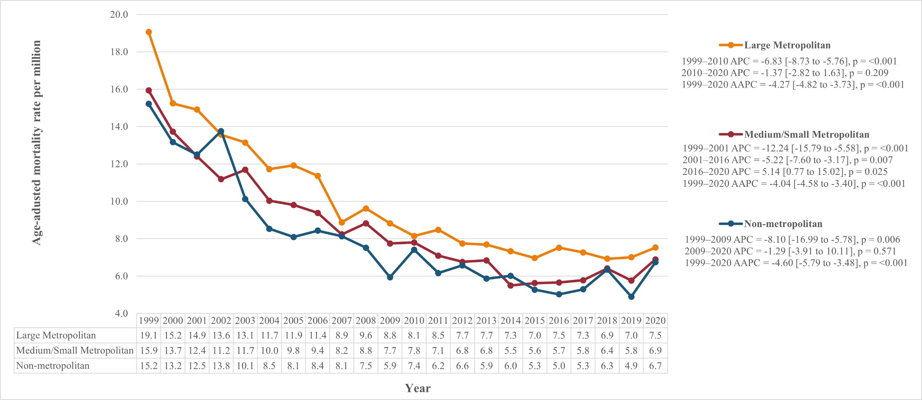
Supplementary Figure S2. Age-adjusted mortality rates per million, stratified by ICD-10 codes for tuberculosis
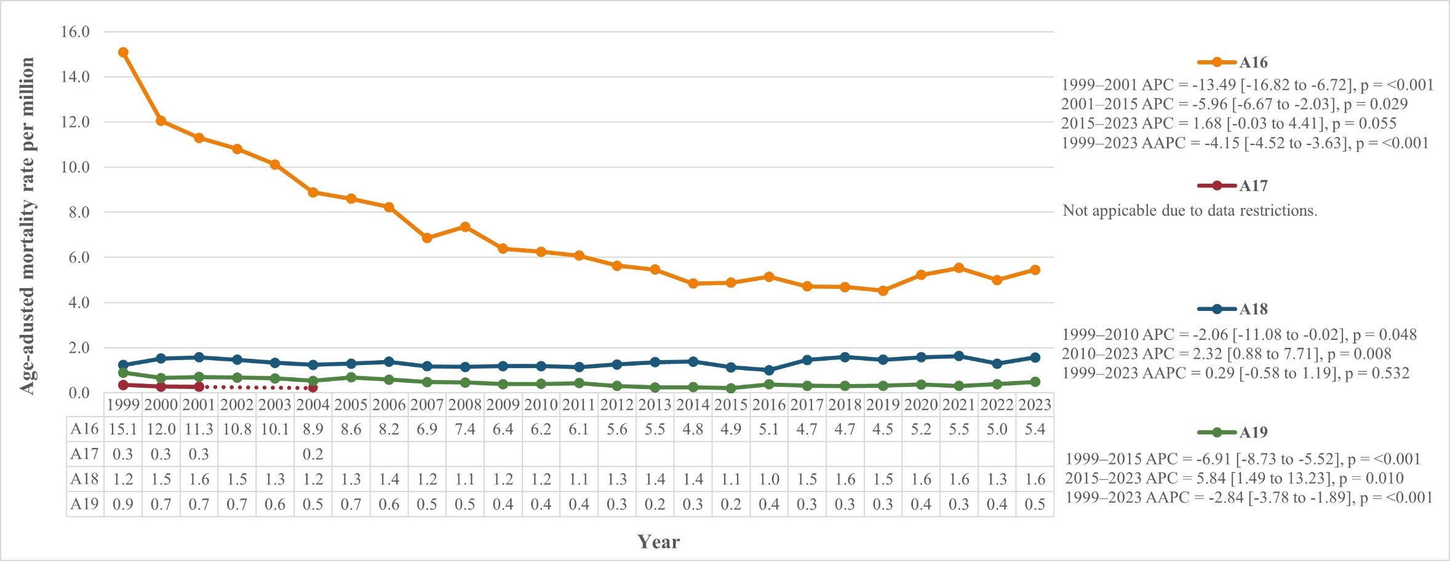
CDC suppresses the counts of fewer than 10 in CDC WONDER data to protect confidentiality, and death rates are marked unreliable for a count of less than 20. Our data had suppressed or unreliable data for subgroups with lower counts. This limitation has been indicated in the figure with dotted lines.

Supplementary Figure S3. Forecast 2: Projected tuberculosis mortality for 2024-2035 using ARIMA modeling trained on the full historical dataset (1999-2023)
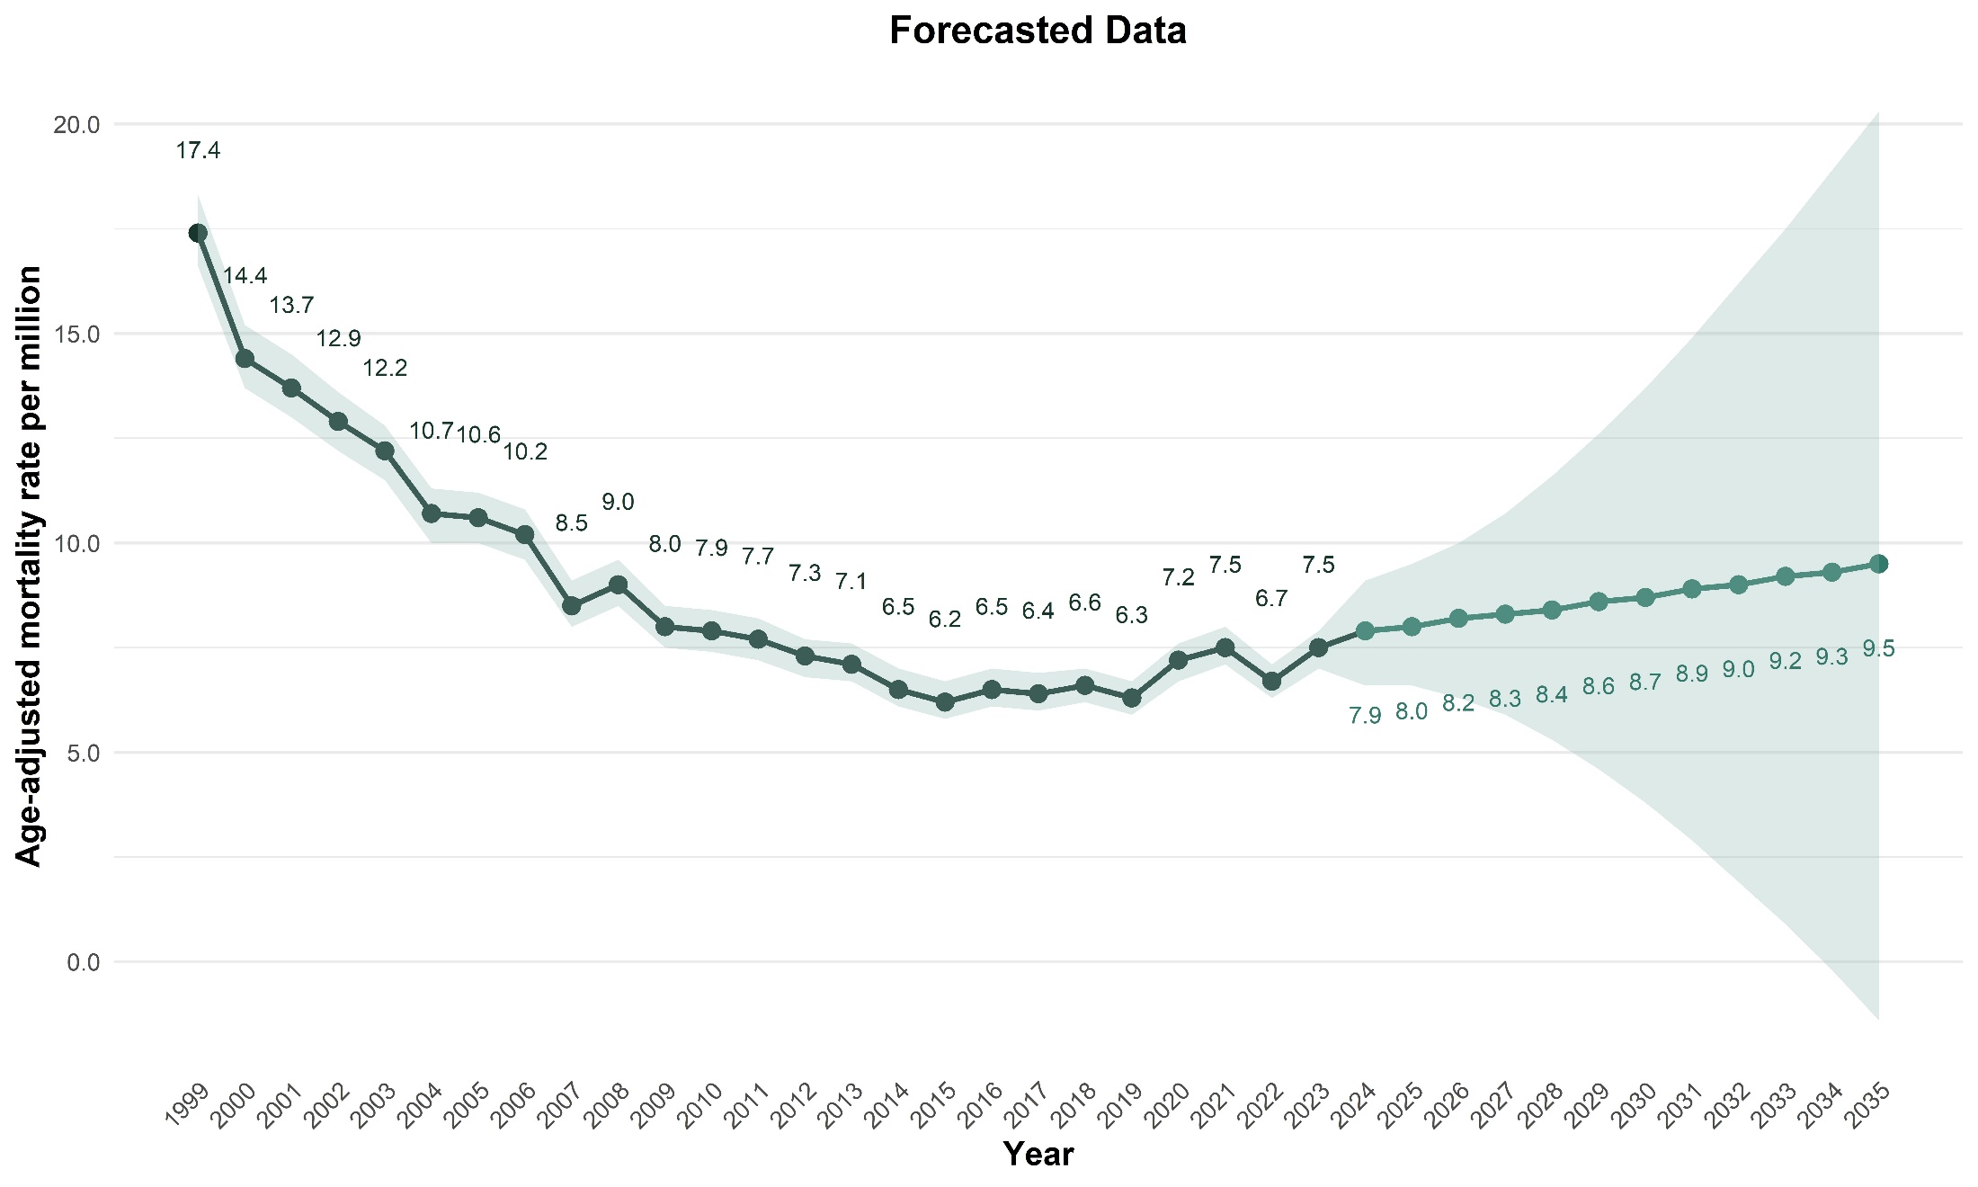
The shaded areas represent the 95% confidence intervals.

Supplementary Figure S4. Forecast 3: Projected tuberculosis mortality for 2024-2035 using ARIMA modeling trained on the most recent 15 years of data (2009-2023)
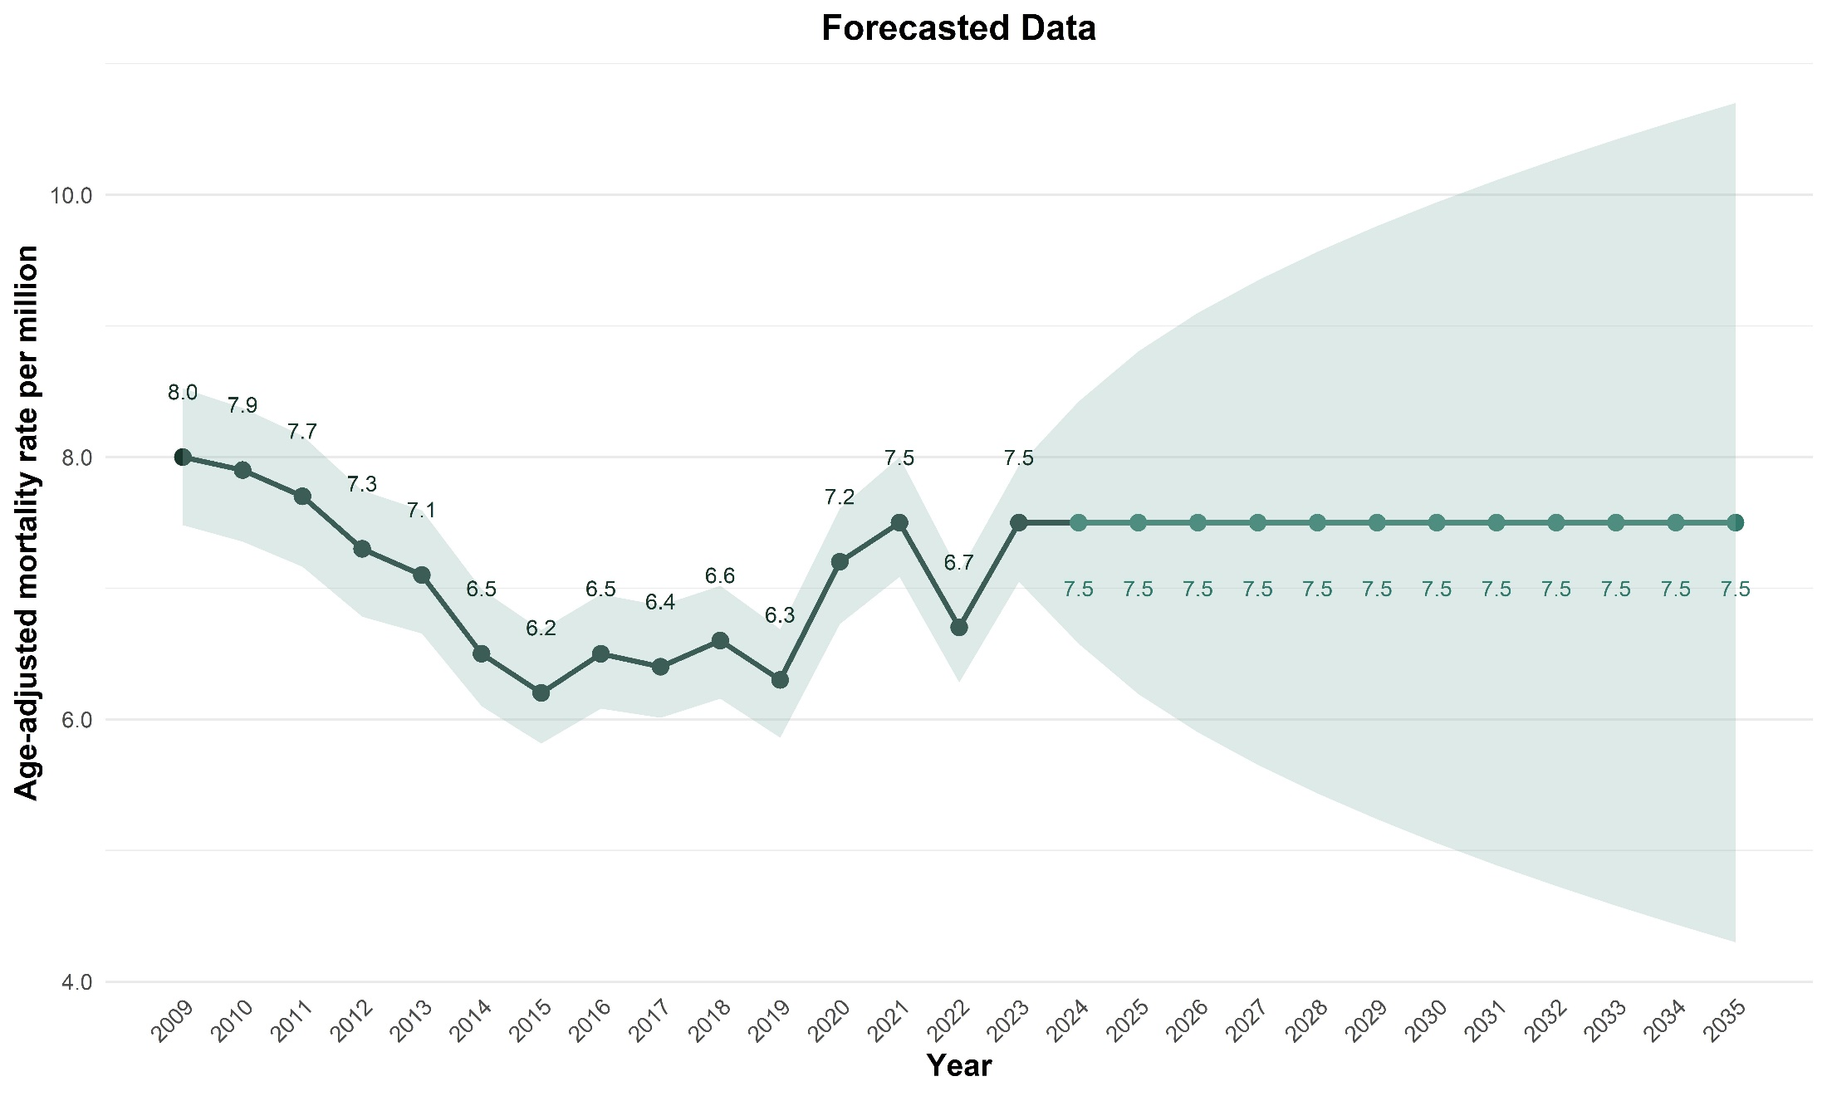
The shaded areas represent the 95% confidence intervals.

