Sensitive feedback triggered by sFES and pencil touch

Introduction
Series of experiments of open-loop (without BCI control) activations of surface functional electrical stimulation (sFES) were performed on several arm contralateral muscular groups (Section “sFES enhances motor imagery patterns” of main text). This study aimed to ensure that cortical activations provided by the surface electrical stimulation evoked sensory feedback and to investigate if the medullar lesion height and brain response were correlated.
To confirm that the observed brain response was not mediated by skin mechanoreceptors, we conducted 2 supplementary series of open-loop experiments a) activations of sFES with ipsilateral muscular groups in the same conditions as for contralateral muscular groups, and b) experiments with contralateral muscular groups but without sFES stimulation, applying pencil touches in sync with the cue. The pencil touch experiments were performed for contralateral fingers flexors and elbow flexors.

Methods
To compare with contralateral sFES evoked potentials, these supplementary data were analyzed similarly. Event related potential (ERP) were snipped over the 32 electrodes of the left implant, in the [-0.2 s, 0.6 s] time window for sFES trials and in the [0.1 s, 0.9 s] time window for touch trials. This difference in time windows is because pencil touches were applied manually by an experimenter, inducing a lag due to his reaction time after the presentation of the cue. Principal components of the ERP were then extracted using joint decorrelation and validated by permutation testing (described in section … Methods).

Results and discussion
Results of this analysis are presented in Supplementary figure 2.1. Contralateral sFES ERP components are shown in the figure for the sake of comparison.

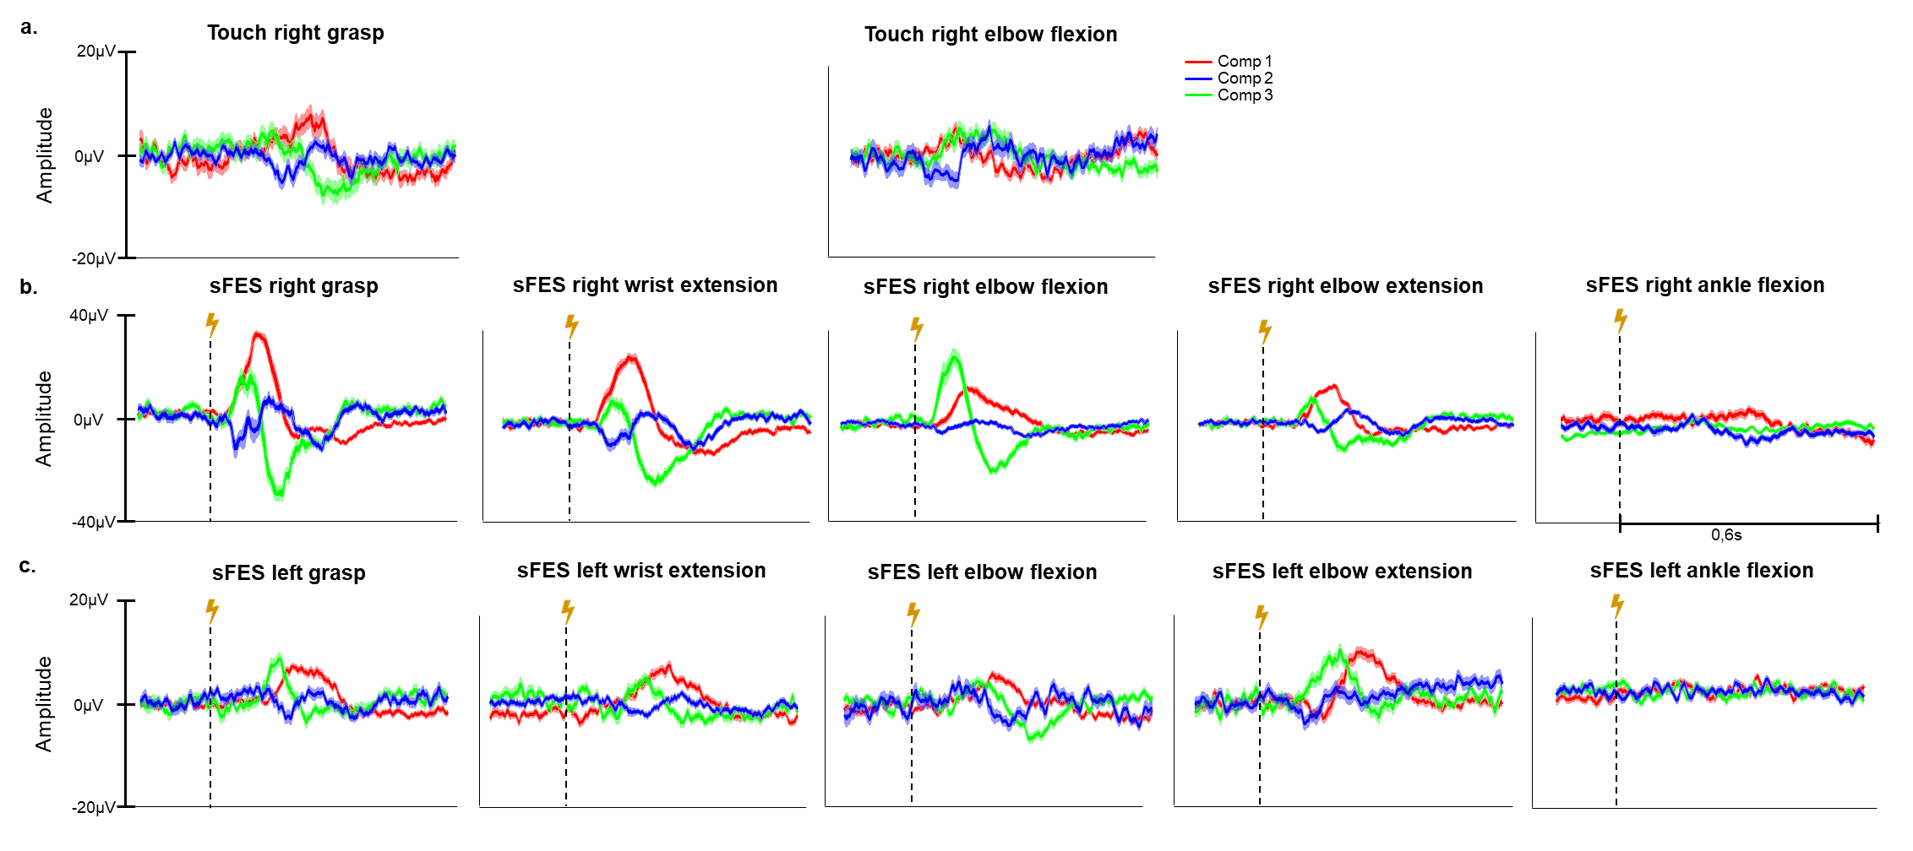
Supplementary figure 2.1: Three principal components of the touch (a), contralateral sFES (b) and ipsilateral sFES (c) evoked potential in open-loop experiment.
Regarding pencil touch condition, ERP decomposed into three significant components for both muscular group, which explained 62 % and 64 % of the total variance for grasp and elbow flexion respectively. Ipsilateral sFES ERP decomposed into three significant components for wrist extension, elbow extension and ankle flexion, and two significant components for grasp and elbow flexion. The three first components explained between 46 and 72 % of variance depending on the muscular group.
Despite the fact that some variability can have been introduced because touch stimulation was done by an experimenter, an evoked potential following the touch was present. However, it had a much lower amplitude than sFES evoked potential of the same muscles. This suggests that although some of the neural signals related to the sFES stimuli can have been transmitted via skin mechanoreceptors, the major part passed through muscular afferent paths.
This hypothesis is corroborated by the fact that sFES ipsilateral response had also a lower amplitude than contralateral one. If skin mechanoreceptors were the major pathway of transmission, it would reach the ipsilateral cortex with higher or similar amplitude and in the first place. In the contrary, when looking at peaks timing, it appears that ipsilateral response occurs after the contralateral.
Previous evidence clearly supports the assumption that the neural signals related to the sFES stimuli, are prevalently transmitted via afferent paths linked to muscle spindles and muscle cells discharge, rather than solely through afferent paths associated to skin mechanoreceptors.

