Long-term stability of ECoG signals measured with WIMAGINE implant

For a chronic BCI application, it is crucial to ensure the stability of the recorded signal. In comparison to non-invasive techniques and microelectrode arrays, ECoG recordings have shown promising potential in terms of signal longevity^{1,2}. In particular, using epidural ECoG WIMAGINE implant, stability of the recordings over 3 years have been demonstrated in 2021³ in the same patients who used the BCI-sFES neuroprosthesis in the current study. As they were implanted in 2017 and 2019 respectively, it is now possible to assess the quality of signals from WIMAGINE recording device in tetraplegic patients over 7- and 5-years post-implantation.
The ECoG signal stability was assessed for each implant from resting state recordings acquired since the implantation before each BCI session. To analyze the ECoG signal stability over the 64 electrodes of each implant, sessions obtained from two sessions with acquisition of 32 electrodes each were pooled together. Root mean square (RMS) value of the signal over the whole frequency range (0.5–292 Hz) was calculated, as well as the band-power (BP) for four frequency bands: 0.5–10 Hz, 10–40 Hz, 40–100 Hz and 100–200 Hz. To compensate for their different frequency bandwidths, BPs were normalized before being converted in dB. The signal-to-noise ratio, defined as the ratio of the power in the 0.5–292 Hz normalized by the power in the noise band (250–260 Hz), was also computed and converted in dB. Finally, the effective bandwidth (EFFBW) was assessed to evaluate the potential cut down of high frequencies. More details and formulas for these calculations are available in original study³. To assess changes throughout the clinical trial, linear regressions of the signal stability indicators were performed over three post-implantation periods: from 0 to 365 days, from 365 to 1000 days and from 1000 days to the last recording. Statistical significances of the regressions were assessed by p-value calculated using a t-distribution with n-2 degrees of freedom (n being the number of samples). Results are presented in Supplementary figure 4.1.
For patient 1, the mean RMS over 7 years was 16.7 μVrms (SD = 3.2) and 14.7 μVrms (SD = 4.1) for the left and right implant respectively. In addition, for the first year, the RMS values increased for patient 1 with a slope of 0.0122 µV/day for the left implant and 0.0059 µV/day for the right implant (p < 0.001). During the second period, the RMS values decreased with a slope of −0.0081 µV/day and −0.0066 µV/day for the left and right implant of patient 1 respectively. Although fewer points were acquired for patient 1 after the third year, stability of the RMS can be observed from the beginning of the third period (slope of -0.0019 µV/day and -0.0024 µV/day for the left and right implant respectively, p > 0.1). For patient 2, the mean RMS over the 5 years follow-up was 7.9 μVrms for the left implant. Variations over the course of the clinical trial were less pronounced, with significant slow increase in the second period and slow decrease during the third one (0.0008 and -0.0014 dB/day respectively, p < 0.01).

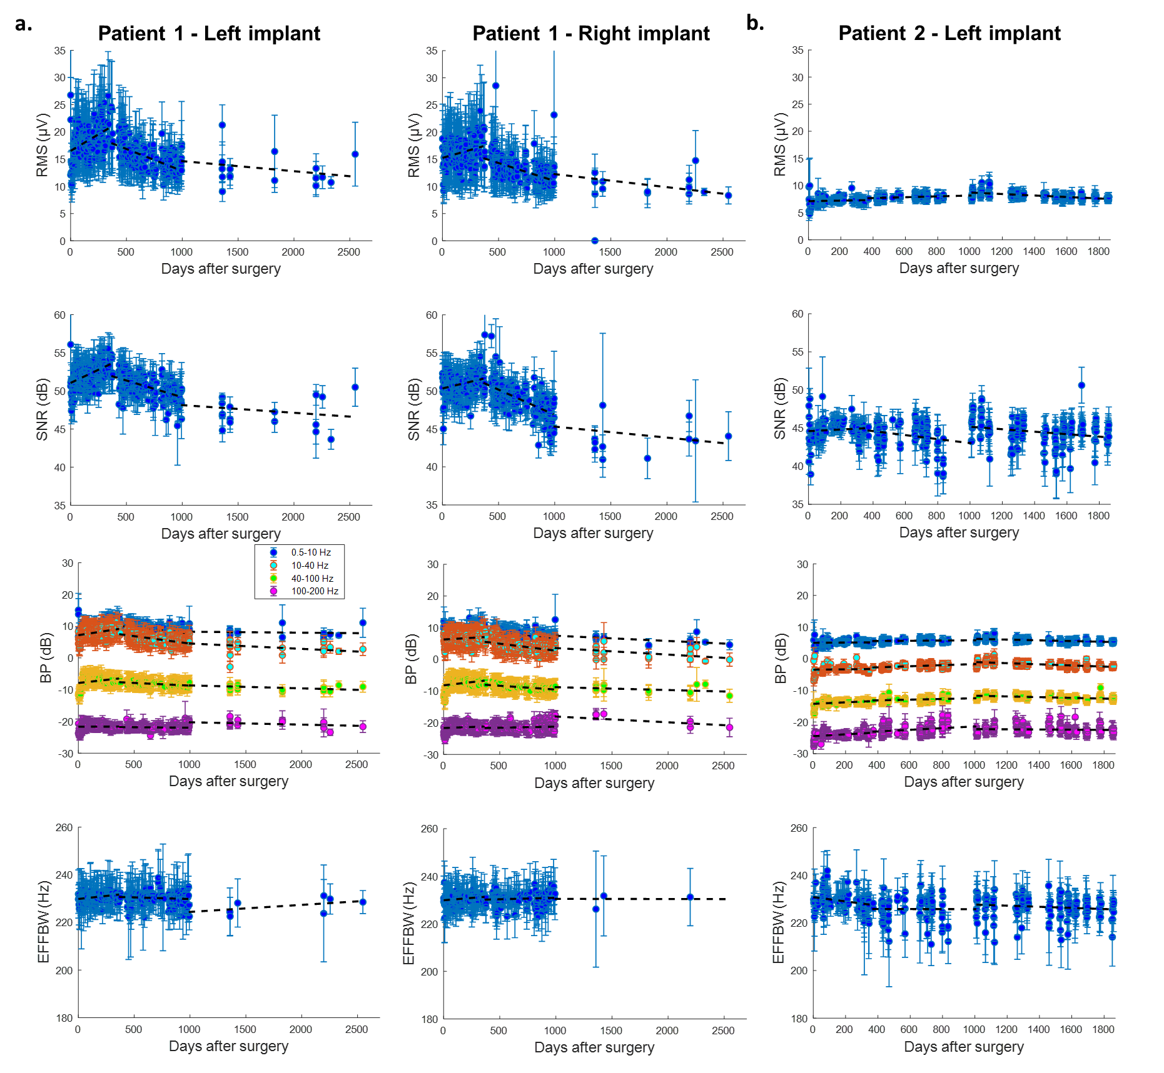
Supplementary figure 4.1: Signal stability indicators over the course of the clinical trial for patient 1 (a.) and 2 (b.). First line represents the RMS value of the signal in µV, second line the normalized SNR in dB, third line the BP of the different bands of interest in dB and fourth line the EFFBW of the signal in Hz. Color points represent the values at each session as average + standard deviation over the 64 electrodes. Black dotted lines are the regression lines for the three considered periods, first year, between 365 and 1000 days and from 1000 days onward post-implantation.
Regarding SNR for patient 1, mean values were equal to 51.1 and 49.5 dB for left and right implants respectively over the seven years. It followed the same slopes than RMS for the first two periods with slopes of 0.0069 and 0.0035 dB/day for left and right implants during first year and -0.0044 and -0.0066 dB/day for left and right implant during second period (p < 0.001). After 1000 days, SNR stabilized (slope of -0.0010 µV/day and -0.0014 dB/day for the left and right implant respectively, p > 0.1). For patient 2, mean SNR was 44.5 dB with significant slow decrease during the third period of recording (-0.0016 dB/day, p < 0.01).
The BP of the three lower bands (0.5–10 Hz, 10–40 Hz and 40–100 Hz) significantly increased during the first year for patient 1, with slopes of 0.0083, 0.0054 and 0.0039 dB/day (p < 0.001) for left implant and of 0.0051, 0.0021 and 0.0040 dB/day (p < 0.05) for right implant. During second period a significant decrease was measured for the same bands with slopes of -0.0038, -0.0047 and -0.0017 dB/day (p < 0.001) for left implant and of -0.0036, -0.0044 and -0.0024 dB/day (p < 0.001) for right implant. No significant changes were measured after 1000 days of recording. For left implant of patient 2, BP of 40–100 Hz and 100–200 Hz bands increased during the first two periods with slopes of 0.0024 and 0.0029 dB/day in first period and of 0.0011 and 0.0027 dB/day in second period (p < 0.05). BP of 10–40 Hz also increased in second period with slope of 0.0017 dB/day (p < 0.001). After 1000 days, BP of the three lower bands (0.5–10 Hz, 10–40 Hz and 40–100 Hz) significantly decreased with slopes of -0.0012, -0.0018, -0.0011 dB/day respectively (p < 0.001).
EFFBW was similar for the two patients over the course of the clinical trial with mean values of 229.2 and 228.4 Hz for left and right implants of patient 1 and 226.3 Hz for patient 2. It increased slowly during the first year of the clinical trial for patient 1 with a slope of 0.0051 and 0.0039 dB/day for left and right implants respectively (p < 0.01) and then remained globally stable. For patient 2 it decreased slowly in the same period with a slope of -0.0090 dB/day (p < 0.01).
Globally, epidural ECoG recorded from the WIMAGINE implants offered high signal stability in the two tetraplegic patients implanted for our BCI clinical protocol, as assessed by state-of-the-art indicators. Some variations could be identified during this long-term course follow-up. Overall, during the first-year post-surgery a slight increase in RMS and BP values was observed for both patients, which probably reflects post-op biological changes in the interface and stabilization of epidural contact due to tissue remodeling. During second year, this uptrend was reversed with a slight decrease of RMS and BP values. Importantly, after the beginning of third year, RMS and BP remained mainly stable, indicating a steady process at the dura-mater interface. For both patients, the SNR remained high. the maximum bandwidth was estimated at ∼230 Hz, a value that remained stable all along the patients’ follow up.
The difference of signal power between P1 and P2, namely, for frequencies below 40 Hz and in the RMS baseline, may be explained by difference between the two patients in term of the time between the trauma and the inclusion in the protocol. P1 was tetraplegic for 2 years whereas P2 had his accident 10 years before. The reorganization of neural circuits due to the spinal lesion could be associated to a signal reduction. This might also be attributed to a thicker dura mater for patient 2. The data of more patients should be analyzed for conclusions.
References
1. Chao. Long-term asynchronous decoding of arm motion using electrocorticographic signals in monkey. Front. Neuroengineering (2010) doi:10.3389/fneng.2010.00003.
2. Nurse, E. S. et al. Consistency of Long-Term Subdural Electrocorticography in Humans. IEEE Trans. Biomed. Eng. 65, 344–352 (2018).
3. Larzabal, C. et al. Long-term stability of the chronic epidural wireless recorder WIMAGINE in tetraplegic patients. J. Neural Eng. 18, 056026 (2021).

