Combining motor imagery and sFES elicits naturalistic movements

Introduction
To investigate the extent to which combining motor imagery (MI) with surface functional electrical stimulation (sFES) elicits neural patterns similar to natural movement, we conducted a series of open-loop experiments (i.e., without BCI control) with Patient 2. These experiments aimed to compare brain activity during MI, sFES, and their combination, with that observed during actual motor execution. The study focused on right elbow flexion—a movement over which Patient 2 retained partial voluntary control (ASIA motor score: 3). Six experimental blocks were conducted. In three blocks, trials of MI, sFES, and MI-sFES were randomly interleaved (as reported in the main text). In the other three blocks, the patient was asked to perform actual elbow flexion (motor execution, MR) in response to visual cues. Each condition (MI, sFES, MI-sFES, MR) included 30 trials. In the sFES condition, the sFES was delivered while the patient remained at rest. In the MI condition, the patient performed motor imagery of elbow flexion without any stimulation. In the MI-sFES condition, sFES was delivered while the patient simultaneously imagined elbow flexion. In the MR condition, the patient actively performed the elbow flexion movement. Although the primary objective was to compare MI-sFES with MR, all four conditions were included in the analysis to provide control data for interpretation.

Methods
ECoG recordings were collected from 32 electrodes on the left hemisphere implant. For each trial, a time window of [0.5 s, 1.25 s] after the cue was extracted—corresponding to the interval following the sFES-evoked potential and covering the full duration of voluntary elbow flexion in the MR condition. Then the four conditions were compared to each other following the same preprocessing and analysis pipeline described in the “Open-loop experiments: Analysis of sFES impact on motor intentions” section of the Methods. Time–frequency representations were computed for each of the 120 trials. These were then analyzed using Joint Decorrelation (JD) to extract principal components. The first component was then extracted for each trial, and frequency peaks were identified on the average component over trials. JD components of each condition were finally separated again and differences across conditions at the frequency peaks were tested using non-parametric Kruskal-Wallis test.

Results and discussion
Supplementary figure 3.1 presents the comparative results across the four experimental conditions. As reported in the main text, the MI-sFES condition showed a more pronounced beta-band desynchronization (at 30 Hz), comparable to MI alone and significantly stronger than sFES alone. MI-sFES also exhibited greater gamma-band activation, exceeding both MI and sFES individually. Notably, the MR condition demonstrated a spectral pattern remarkably similar to MI-sFES, with stronger beta suppression than sFES (p < 0.001) and higher gamma synchronization than both MI and sFES (p < 0.001). Furthermore, no significant difference between MR and MI-sFES in either beta or gamma bands were noted.
These findings suggest that combining motor imagery with sFES can closely replicate the cortical signatures of actual movement. This result support the hypothesis that coupling sFES with motor imagery enhances cortical activation in a way that closely resembles voluntary movement. This naturalistic activation pattern, particularly the similarity in beta desynchronization and gamma synchronization, highlights the potential of MI-sFES protocols in restoring functional and natural motor control in individuals with partial paralysis. Such findings have important implications for future BCI applications, as they suggest that sFES driven by MI could serve as an effective and intuitive means of motor restoration.
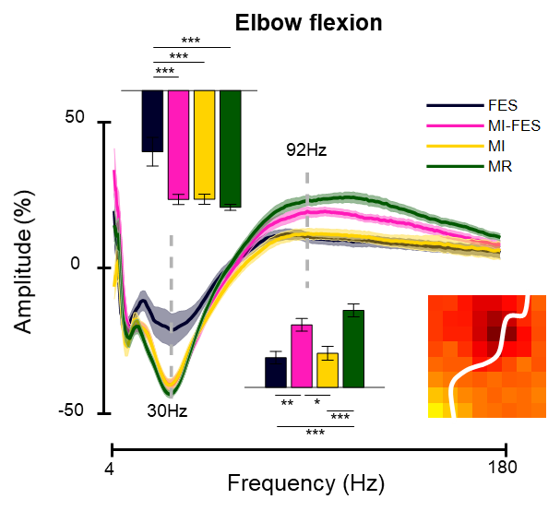
Supplementary figure 3.1. Combining motor imagery and sFES elicits naturalistic movements. Comparison of the four conditions using joint decorrelation pipeline in the frequency domain (cf. Methods), in the [0.5 1.25] s interval with respect to triggering of the task. Only first component of the joint decorrelation is depicted. Beta suppression (at 30 Hz) was comparable between MI, MI-FES and MR conditions (less suppression in FES), and gamma activation (peaking at 92 Hz) was higher in MI-FES and MR than in MI and in FES. No significant differences could be observed between MI-FES and MR conditions, confirming that the synchronization pattern of real movement and combination of sFES and motor imagery are similar. *p<0.05, **p<0.01, ***p<0.001.

