Exclusion of sFES evoked potential period

Introduction
Surface functional electrical stimulation (sFES) evokes a cortical potential within the cortex a few milliseconds after the onset of the stimulation. This sFES evoked cortical potential results into a high increase of the power in a wide frequency range that do not occur using solely motor intention (Supplementary figure 1.1). Although we argued that this evoked potential is a physiological response associated to afferent sensorimotor feedback, it is not relevant for BCI decoding as it happens as a consequence of an already decoded motor intention. Therefore, it can be considered as an artefact from the point of view of the decoder. Indeed, the presence of this evoked potential in training data could result in decoding model that struggles in detecting motor intention occurrence, which is the exact opposite of our objectives. Additionally, since our model is calibrating online, it is of major importance to be able to use online generated data in order to calibrate the model while the session progresses. Consequently, removing this evoked potential has to be done online without inducing major latency.
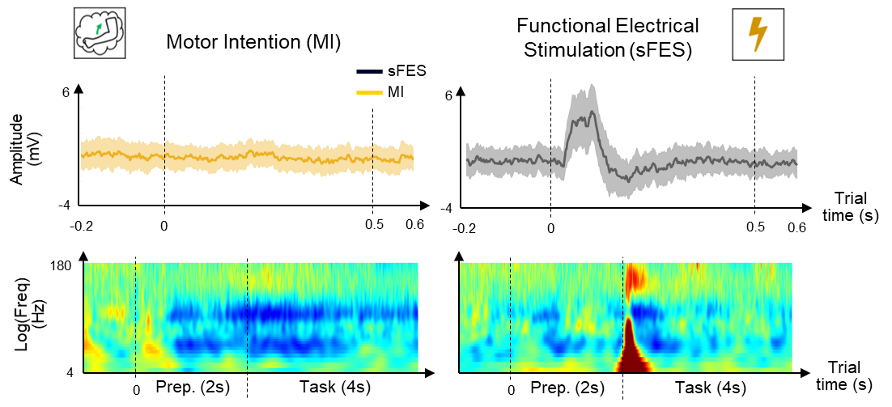
Supplementary figure 1.1: Time course of the motor intention (MI - left) and sFES (right) event-related potentials (ERP) in the [-0.2, 0.6s] time interval with respect to trial start. Spectrograms of MI and sFES only (Right) over the course of a trial. Average data over 30 trials for an example session of right elbow flexion.
In BCI and, more generally, for physiological signals processing, there are several artefact rejection strategies using filtering and spatial patterns¹. Filtering is a common approach to remove artefacts by attenuating specific frequency ranges. However, in our case, the artefact affects a wide frequency range overlapped with frequencies, generally, used for BCI decoding. This broadband nature of the artefact limits the effectiveness of filtering techniques. The most common spatial pattern approach is the Common Average Reference (CAR)^{2,3}, that aims to remove noise and artefacts common to all electrodes. This does not correspond to the case of the Event-Related Potential (ERP) we observe in this study. Spatial filtering methods such as Independent Component Analysis (ICA), can remove artefacts originating from areas not used for decoding. They are mostly used in electroencephalography (EEG)^{4–6} to remove the external signals and artefacts which often perturb EEG signals. However, the ERP in our study originate from the sensorimotor cortex, a region crucial for the decoding of motor intentions. Removing part of signals through ICA could potentially degrade BCI performance.
However, the ERPs we aim to remove are event-related, occurring within the short time interval of half a second approximately (Supplementary figure 1) after the stimulation start. Therefore, we used an exclusion procedure, which is relatively simple yet efficient method for such application. This method has already been used to remove sFES artefacts in invasive microelectrode arrays (MEA) based BCI⁷. However, the sFES ERPs induced to electrocortigography (ECoG) recordings are very different from artefacts registered using microelectrode arrays. While sFES resulted in regular spikes of neurons at each stimulation pulse during all the stimulation period in MEA recordings, it yields an ERP in ECoG in the first half of the second after the stimulation onset. This results in a difference in the exclusion procedure. We remove the entire ERP window from training data of our decoding model, and maintain the stimulation during this period in online use.

Offline preliminary study
Before moving to the online implementation, we first conducted an offline analysis to evaluate different exclusion methods and durations. For this analysis, we used previously recorded datasets containing ERP activity. These datasets were recorded in the same way as the binary BCI models (movement vs. rest) described in the main text, without online exclusion procedure. The models had been trained online with participant 2 and using the MotionStim8 device with the configuration described in the main text for stimulation.
The offline study must take into account online objectives and restrictions. Our decoding model is a Hidden Markov Model (HMM) estimating probability of each class at each time moment $t$ with step of 100 ms. Using HMM, decoding at time $t$depends on decoding at the previous decoding time $t-1$. Consequently, it is essential to determine the decoding value at $t-1$ when resuming decoding after an exclusion period. We investigated three potential methods of resuming decoding and their impact on performance:
- Continuous: predicting continues during the exclusion period and HMM decoder resumes after exclusion with the current decoding value at time moment $t-1$.
- Max: decoding is resumed setting the probability of the active class to 1 as the $t-1$decoding output.
- Skipped: decoding stops and resumes with the same probabilities than before exclusion period, typically slightly above 0.5 for the active class.
These different methods and their impact on the state probabilities after the exclusion period are illustrated in Supplementary figure 1.2.
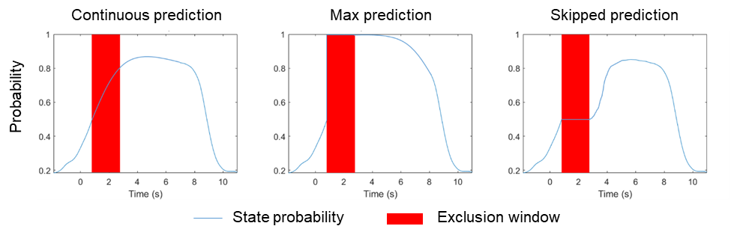
Supplementary figure 1.2: Illustration of the different exclusion strategies. In continuous prediction, state probability is still computed but not used as output and HMM decoder resumes with previous value. In max prediction the state probability resumes at 1 and in skipped prediction it resumes at the value before the exclusion period.
To evaluate these exclusion methods, we analyzed data from the brainswitch BCI models (movement vs. rest) recorded with participant 2. Online BCI models were trained following two conditions being BCI with visual feedback only (referred as BCI-v), and BCI conjugated with activation of sFES (referred as BCI-sFES). This preliminary study comprised two tasks: right elbow flexion and right grasp. No exclusion procedure was applied online. The procedures for online model training and testing were the same as those described in detail in the “Impact of sFES on brain patterns and BCI performances” section of the Methods, subsection “Closed-loop experiments”. Preliminary study dataset cumulated 2 sessions for each muscle with approximately 30 repetitions of 6 seconds cues of motor intention for online testing. BCI-sFES sessions corresponds to one session per muscle with online testing comprising approximately 30 repetitions of 6 seconds cues. Each session consisted in an online training set when then model was updated online and an online testing set when the model was used without updating it. We kept the same training and test sets for this offline study.
Using this dataset, we retrained BCI models offline, with the three exclusion procedures described above, with various exclusion window duration, ranging from 0.1 to 2.5 seconds. For the sake of comparison, we also retrained the models without exclusion procedure (referred as ‘retrained’ method).
To enable proper comparison, label of the excluded portions in the test were set to the ‘active’ class, regardless of the model's output for all methods, including the ‘retrained’ method.
The exclusion methods were then compared using three different metrics evaluated on the test sets:
- The balanced accuracies of the models assessing the global decoding performance. Balanced accuracies were computed offline, using the exclusion methods when an activation of the stimulation was triggered (or when a movement state became active for BCI-v condition),
- The recall of idle class, as one of the objectives is to implement an exclusion method that minimizes the number of false positives to limit unwanted muscle stimulations,
- The latency of the decoding, calculated as the average lag, as defined in the “BCI neuroprosthesis evaluation” section, “Decoding performance metrics” subsection of the methods, for each exclusion method and exclusion period duration.
Supplementary figure 1.3 summarizes the metrics for BCI-v and BCI-sFES conditions with respect to exclusion duration and methods. We observed a significant decrease in balanced accuracy for the model retrained offline without use of any exclusion, when stimulation was activated. As anticipated, exclusion procedure had no impact on performance in the absence of stimulation but did improve performance when stimulation was applied. In terms of exclusion method, both 'continuous' and 'max' performed well with comparable results. Although we did not achieve the same balanced accuracy as without exclusion procedure, the increase in accuracy was sufficient to justify an online implementation. Analysis of recall of idle state indicated that both 'continuous' and 'skipped' methods reduced the number of false positives. Regarding model latency, only ‘skipped’ method significantly increased the lag.

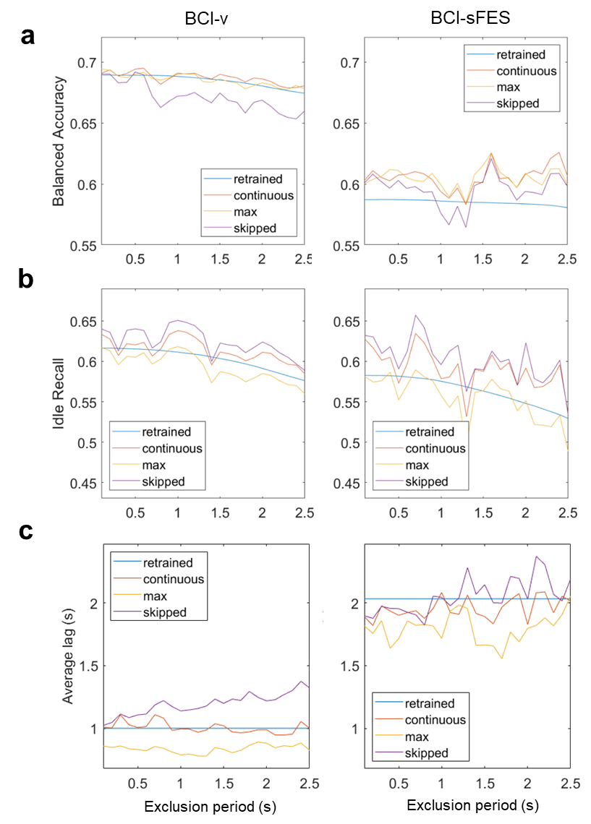
Supplementary figure 1.3: Impact of offline exclusion method and duration on the (a) balanced accuracy, (b) recall of idle class and (c) model latency, averaged over two brain-switch tasks being right hand elbow flexion and grasp. Left corresponds to performance of each method on BCI-v sessions (without sFES). Right corresponds to BCI-sFES sessions where sFES was activated upon reaching a decoding threshold, without any online exclusion method applied.
Considering all these elements, the 'continuous' method was selected due to its balance between performance and reduction of unnecessary stimulation during decoding. It is a favorable choice as it has no impact when ERP exclusion is not required, indicating good selectivity by affecting only the necessary data.
Regarding exclusion period, we hypothesized a peak around 1.5 seconds, also considering the stimulation event-related potential (ERP) duration of approximately 0.5 seconds and the retention of 1 second of data during decoding. Figure 3, corroborates this expectation leading to a choice for online exclusion time of 1.5 seconds.

Online implementation
Then, the exclusion procedure was implemented in the online experimental environment for patient use, where parameters identified in the offline study were selected (continuous method with 1.5 s exclusion).
To compare brainswitch BCI-sFES models trained with (BCI-sFES excl) and without exclusion procedure (BCI-sFES non-excl) and BCI model trained with visual feedback only (BCI-v), new series of experiment were performed. For right grasp and right elbow extension muscular groups, only BCI-sFES models with exclusion procedure were trained to supplement the previously recorded data. To expand the dataset, BCI-v, BCI-sFES excl and BCI-sFES non-excl conditions were repeated on two other muscular groups, namely right elbow extension and right wrist extension. The same online training and testing procedures were kept for this new series of experiments. In total, one session (grasp and elbow flexion) and two sessions (elbow extension, wrist extension) for BCI-sFES non-excl paradigm; two sessions of online BCI-sFES excl; and between two (elbow extension, wrist extension) and three (grasp, elbow flexion) sessions of BCI-v were recorded. Each session comprised around 30 trials.
This series of experiments allows comparing the balanced accuracy for each muscle and each condition, as shown in Supplementary figure 1.4. Online exclusion procedure has led to a clear improvement in overall decoding performance, equivalent to the BCI-v condition. The observed improvement surpasses initial expectations from offline study, which can be explained several factors. The most probable explanation is that the offline exclusion methodology only excluded the data influenced by online stimulation. In this way, given the suboptimal performance of the online decoder, the stimulated data segments were less accurate, regardless of the exclusion methods and parameters employed. Additionally, the human factor may contribute to this performance disparity. During the initial sessions, the patient may have been frustrated by the poor performance of the online model that could have led to a further decline in performance.
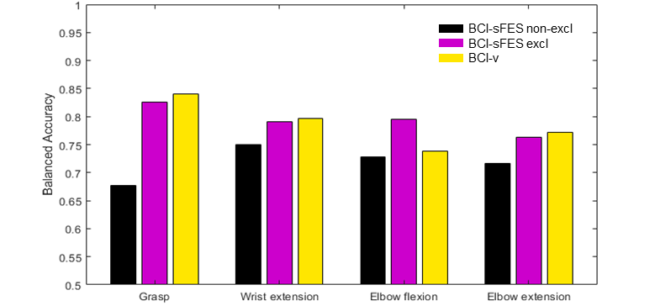
Supplementary figure 1.4: Average online balanced accuracy for each muscle and each condition. Online balanced accuracy has been computed after latency correction as in the main article. BCI-sFES non-excl corresponds to data where sFES has been used online without exclusion procedure. BCI-sFES excl corresponds to data where an online exclusion period of 1.5 s has been applied using the continuous decoding implementation. BCI-v corresponds to BCI with visual feedback only.
In conclusion, the implementation of exclusion procedure to mitigate the impact of sFES ERP on BCI performance has shown promising results. By analyzing data both with and without sFES, and testing various exclusion window duration offline, we observed a significant improvement in decoding performance when online exclusion procedure was applied. The 'continuous' and 'max' exclusion methods performed well, with 'continuous' being selected for its balance between performance and reduced unnecessary stimulation. An exclusion time of 1.5 seconds was chosen based on the stimulation ERP duration and decoding data retention, which was corroborated by offline performance analysis. These findings justified the online implementation of an exclusion method to enhance BCI performance during sFES, resulting in in a high increase of performance online.

References
1. Islam, Md. K., Rastegarnia, A. & Sanei, S. Signal Artifacts and Techniques for Artifacts and Noise Removal. in Signal Processing Techniques for Computational Health Informatics (eds. Ahad, M. A. R. & Ahmed, M. U.) vol. 192 23–79 (Springer International Publishing, Cham, 2021).
2. Ludwig, K. A. et al. Using a Common Average Reference to Improve Cortical Neuron Recordings From Microelectrode Arrays. J. Neurophysiol. 101, 1679–1689 (2009).
3. Liu, Y., Coon, W. G., Pesters, A. de, Brunner, P. & Schalk, G. The effects of spatial filtering and artifacts on electrocorticographic signals. J. Neural Eng. 12, 056008 (2015).
4. Jung, T.-P. et al. Removing electroencephalographic artifacts: comparison between ICA and PCA. in Neural Networks for Signal Processing VIII. Proceedings of the 1998 IEEE Signal Processing Society Workshop (Cat. No.98TH8378) 63–72 (IEEE, Cambridge, UK, 1998). doi:10.1109/NNSP.1998.710633.
5. Winkler, I., Haufe, S. & Tangermann, M. Automatic Classification of Artifactual ICA-Components for Artifact Removal in EEG Signals. Behav. Brain Funct. 7, 30 (2011).
6. Mammone, N., La Foresta, F. & Morabito, F. C. Automatic Artifact Rejection From Multichannel Scalp EEG by Wavelet ICA. IEEE Sens. J. 12, 533–542 (2012).
7. Young, D. et al. Signal processing methods for reducing artifacts in microelectrode brain recordings caused by functional electrical stimulation. J. Neural Eng. 15, 026014 (2018).

