Supplementary information (SI) for

Source apportionment, ecological and human health risks of toxic metals in road dust of densely populated capital and connected major highway of Bangladesh
Md. Morshedul Haque^{1*}, Sajin Sultana^{1,2}, Nahin Mostofa Niloy¹, Shamshad B. Quraishi³, Shafi M. Tareq^{1*}

¹Hydrobiogeochemistry and Pollution Control Laboratory, Department of Environmental Sciences, Jahangirnagar University, Dhaka 1342, Bangladesh
²Beximco Textile Limited Sarabo, Kashimpur, Gazipur, Dhaka 1702, Bangladesh
³Analytical Chemistry Laboratory, Chemistry Division, Atomic Energy Center, Bangladesh Atomic Energy Commission, Dhaka 1000, Bangladesh
*Correspondence to: Md. Morshedul Haque (morshedulhaq@gmail.com) or Shafi M. Tareq (smtareq@yahoo.com)
Contents of this file
Tables S1 to S3
Figures S1 to S3
Introduction
This supporting information provides different index values (Table S1) for discussion and methodological data on the calculation of human health risk assessment (Table S2 and S3). Similarly, spatial distribution of pollution index (Table S1) and ecological index (Table S3) and pollution load index with category (Figure S2).

Table S1. The classification of different indexes

Index | Category | Description | References
I_{geo} | I_{geo}$≤$0 | Practically uncontaminated | (Men et al., 2018)
I_{geo} | 0$<$I_{geo}$≤$1 | Uncontaminated to moderately contaminated | (Men et al., 2018)
I_{geo} | 1$<$I_{geo}$≤$2 | Moderately contaminated | (Men et al., 2018)
I_{geo} | 2$<$Igeo$≤$3 | Moderately to heavily contaminated | (Men et al., 2018)
I_{geo} | 3$<$I_{geo}$≤$4 | Heavily contaminated | (Men et al., 2018)
I_{geo} | 4$<$I_{geo}$≤$5 | Heavily to extremely contaminated | (Men et al., 2018)
I_{geo} | 5$<$I_{geo} | Extremely contaminated | (Men et al., 2018)
NIPI;PI | NIPI≤0.7; PI≤1 | Unpolluted | (Men et al., 2020)
NIPI;PI | 0.7<NIPI ≤ 1 | Warning limit of pollution | (Men et al., 2020)
NIPI;PI | 1<NIPI ≤ 2; 1<PI≤2 | Low polluted | (Men et al., 2020)
NIPI;PI | 2<NIPI ≤ 3; 2<PI≤3 | Moderately polluted | (Men et al., 2020)
NIPI;PI | NIPI>3; PI >3 | Strongly polluted | (Men et al., 2020)
PLI | PLI< 1 | Unpolluted | (Yesilkanat and Kobya, 2021)
PLI | PLI $≥$ 1 | Polluted | (Yesilkanat and Kobya, 2021)
PERI; $E_{r}^{i}$ | PERI≤150; $E_{r}^{i}$≤40 | Low risk | (Men et al., 2020)
PERI; $E_{r}^{i}$ | 150<PERI≤300; 40<$E_{r}^{i}$≤80 | Moderate risk | (Men et al., 2020)
PERI; $E_{r}^{i}$ | 300<PERI≤600;  80<$E_{r}^{i}$≤160 | Considerable risk | (Men et al., 2020)
PERI; $E_{r}^{i}$ | PERI>600;  160<$E_{r}^{i}$≤320 | High Risk | (Men et al., 2020)
PERI; $E_{r}^{i}$ | $E_{r}^{i}$>320 | Extreme Risk | (Men et al., 2020)
NIRI | 40<NIRI≤80; | Low Risk | (Men et al., 2020)
NIRI | 80<NIRI≤160 | Considerable Risk | (Men et al., 2020)
NIRI | 160<NIRI≤320 | High risk | (Men et al., 2020)
NIRI | NIRI >320 | Extreme risk | (Men et al., 2020)

Table S2. The reference values for all the parameters for non-carcinogenic risk assessment.
Symbol | Default value | References
IngR_{child} | 200 mg/day | (Rahman et al., 2019)
IngR_{adult} | 100 mg/day | (Rahman et al., 2019)
Inh R_{child} | 7.6 m³/day | (Rahman et al., 2019)
Inh R_{adult} | 20 m³/day | (Rahman et al., 2019)
EF | 230 day/yr (site specific) | (Rahman et al., 2019)
ED_{child} | 6 yrs ( site specific) | (Rahman et al., 2019)
ED_{adult} | 24 yrs | (Rahman et al., 2019)
BW_{child} | 15 kg | (Rahman et al., 2019)
BW_{adult} | 70kg | (Rahman et al., 2019)
AT | ED × 365 days | (Rahman et al., 2019)
PEF | 1.36×10⁹ m³/kg | (Rahman et al., 2019)
SL_{child} | 0.2 mg/cm²/day | (Rahman et al., 2019)
SL_{adult} | 0.07 mg/cm²/day | (Rahman et al., 2019)
SA_{child} | 2800 cm² | (Rahman et al., 2019)
SA_{adult} | 5700 cm² | (Rahman et al., 2019)
ABS | 0.03 (only for As) and 0.001 (except As) | (Rahman et al., 2019)

Table S3. The reference dose and slope factor of toxic metals in this study.

R_{f}d/SF₀ | Pb | As | Hg | Cr | Cd
R_{f}D_{ing} | 3.50E-03 | 3.00E-04 | 3.00E-04 | 3.00E-03 | 1.00E-03
R_{f}D_{inh} | 3.52E-03 | 3.01E-04 | 8.57E-05 | 2.86E-05 | 1.00E-03
R_{f}D_{dermal} | 5.25E-04 | 1.23E-04 | 2.10E-05 | 6.00E-05 | 1.00E-05
SF_{ing} | 8.50E-03 | 1.51E+01 | - | 5.00E-01 | 3.80E-01
SF_{inh} | 4.20E-02 | 1.50E+00 | - | 4.20E+01 | 6.30E+00
SF_{dermal} | 8.50E-06 | 3.66E+00 | - | - | -

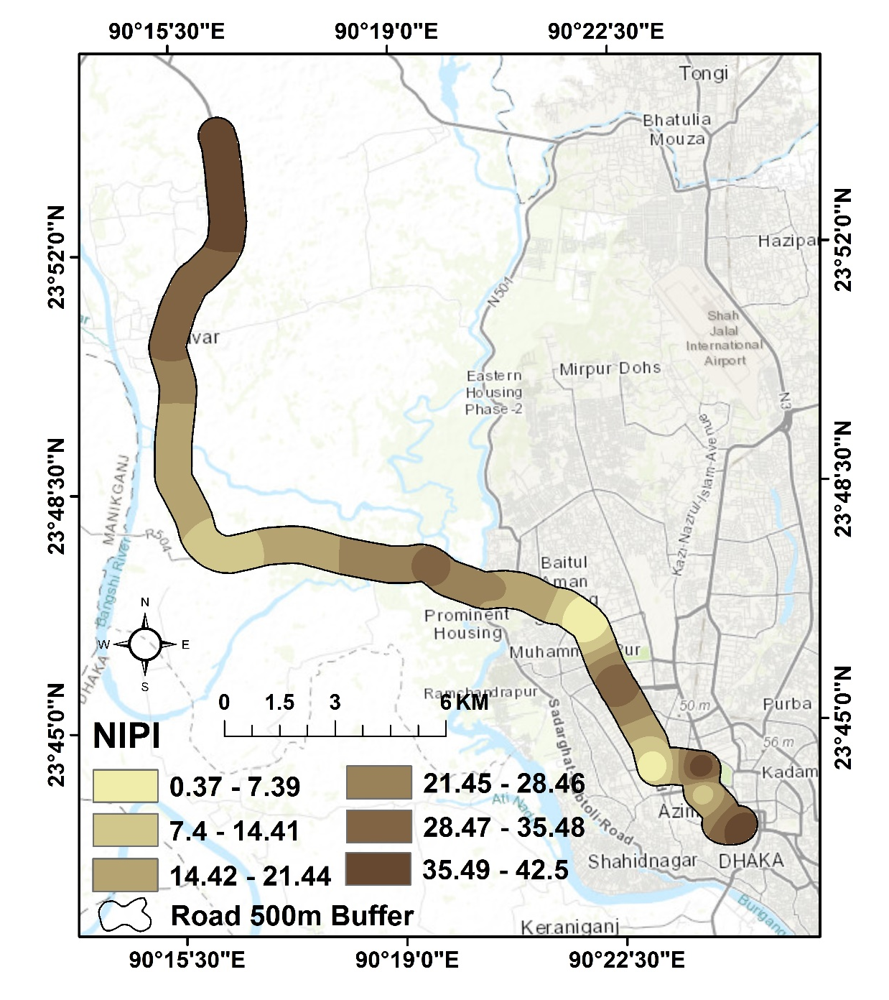
Fig. S1. Spatial distribution of nemerow integrated pollution index (NIPI)
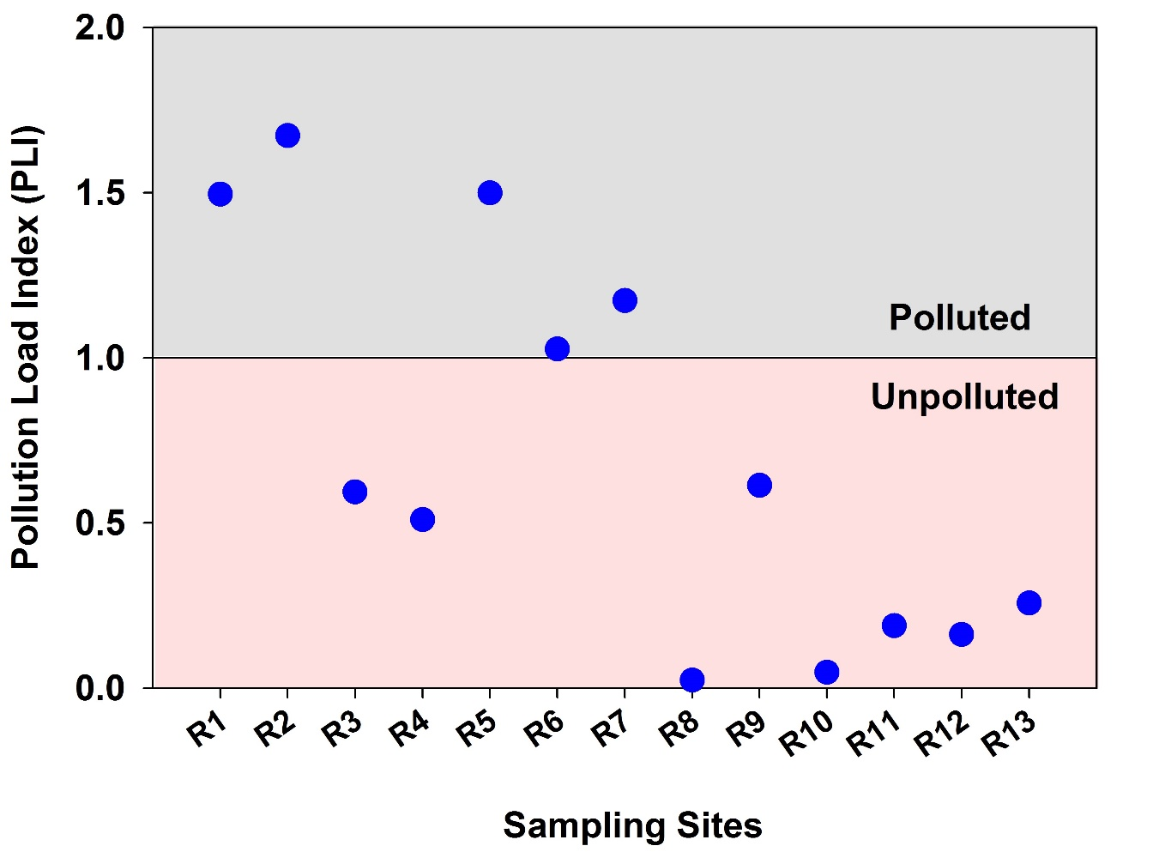
Fig. S2. Pollution load index (PLI) corresponding sampling sites
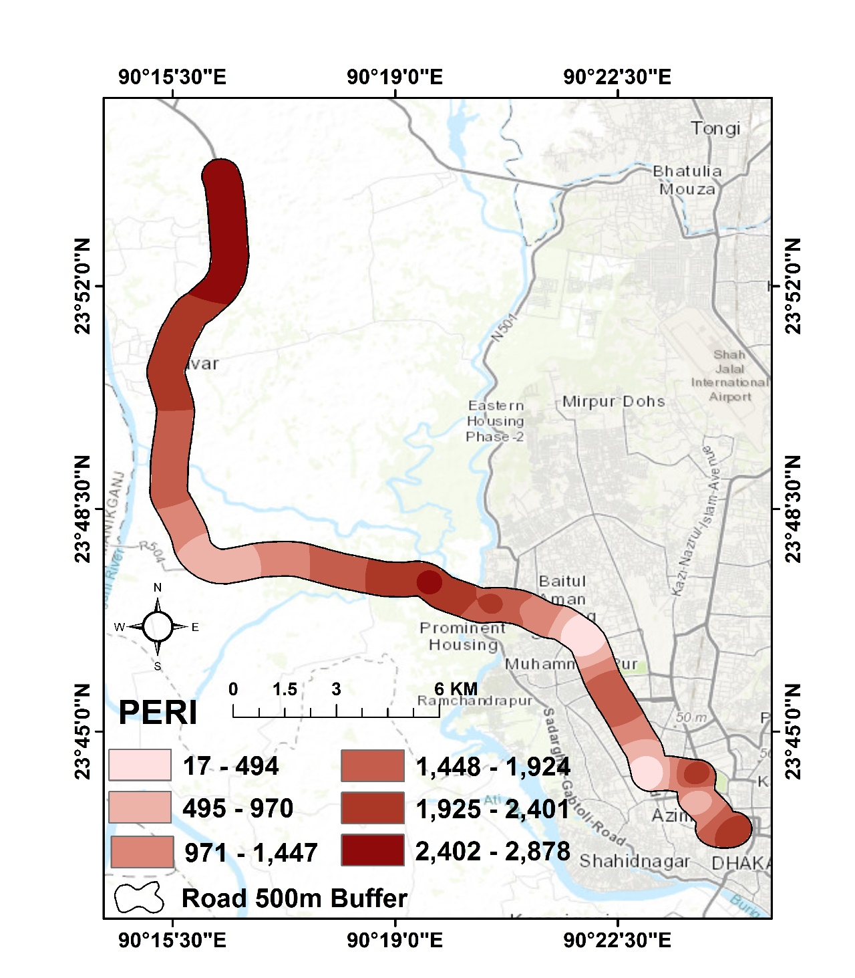
Fig. S3. Spatial distribution of potential ecological risk index (PERI)
References
Men, C., Liu, R., Xu, F., Wang, Q., Guo, L., Shen, Z., 2018. Pollution characteristics, risk assessment, and source apportionment of heavy metals in road dust in Beijing, China. Sci. Total Environ. 612, 138–147. https://doi.org/10.1016/j.scitotenv.2017.08.123
Men, C., Liu, R., Xu, L., Wang, Q., Guo, L., Miao, Y., Shen, Z., 2020. Source-specific ecological risk analysis and critical source identification of heavy metals in road dust in Beijing, China. J. Hazard. Mater. 388. https://doi.org/10.1016/j.jhazmat.2019.121763
Rahman, M.S., Khan, M.D.H., Jolly, Y.N., Kabir, J., Akter, S., Salam, A., 2019. Assessing risk to human health for heavy metal contamination through street dust in the Southeast Asian Megacity: Dhaka, Bangladesh. Sci. Total Environ. 660, 1610–1622. https://doi.org/10.1016/j.scitotenv.2018.12.425
Yesilkanat, C.M., Kobya, Y., 2021. Spatial characteristics of ecological and health risks of toxic heavy metal pollution from road dust in the Black Sea coast of Turkey. Geoderma Reg. 25, e00388. https://doi.org/10.1016/j.geodrs.2021.e00388

