Table A. Informative overview for each season and site for field coordinates, soil type, previous crops and field operations

 | 2022 |  | 2023 |  | 2024
Community / canton | Zürich | Thurgau | Zürich | Thurgau | Zürich | Thurgau
Field coordinates | 8.5189 E, 47.4304 N | 8.9047 E, 47.4813 N | 8.4981 E, 47.4404 N | 8.9092 E, 47.4831 N | 8.5318 E, 47.4311 N | 8.9148 E, 47.4856 N
Soil type | Heterogeneously drained endogleyic calceric Cambisol with  stagnic properties and a loam to silt loam texture. | Cambisols with normal  permeability | Partly drained endogleyic Cambisol with  stagnic properties and a loam texture | Cambisols with  influenced by backwater | heterogeneous drained endogleyic  Cambisol with a loam texture | Luvisols with normal permeability
Previous Crop | Maize | Winter wheat (followed by green manure with Phacelia) | Spring oats | Winter wheat  (followed by green manure with Phacelia) | Grass clover | Spelt (followed by green manure with Phacelia)
Plough | 22.12.2021 | 30.09.2021 | 2.02.2023 | 15.02.2023 | 1.03.2024 | 30.03.2024
Seed preparation | 07.03.2022 | 08.03.2022 | 28.02.2023 | 06.03.2023 | 5./6.04.2024 | 30.03.2024
Sowing date | 08.03.2022 | 09.03.2022 | 01.03.2023 | 23.03.2023 | 08.04.2024 | 12.04.2024
Mechanical weeding | 14.04; 26.04.2022 | 19.04.2022 | 5.04.2023 | 25.04.2023 | 3.05.2024 | 10.05.2024
Fertilization | 05.04.2022 | 06.04.2022 | 02.05.2023 | 15.05.2023 | 24.05.2024 | 22.05.2024
Harvest | 18.07.2022 | 28.07.2022 | 19.07.2023 | 09.08.2023 | 30.07.2024 | 06.08.2024

Table B. Overview for temperatures and precipitation for each year and location. Cumulative rain mm₁ (all growing seasons) and cumulative temperatures (C) ₂ (all growing seasons) is the sum of rain happened for each year from 1st of March until 31st of August. % with historic data for precipitation₃ and °C diff. by historical data₄ shows the percentage and difference of difference compared with historical data (average 1991-2020) obtained in climate diagrams and normal per station from the Swiss weather service MeteoSchweiz (Climate diagrams and normals per station - MeteoSwiss)

 |  | Cumulative rain (mm)¹ | Cumulative temperature (°C) ² | % with historic data for precipitation ³ | °C diff. by historical data ⁴
2022 – Reckenholz |  | 389 | 2859 | 34.1 | 8.7
2023 – Reckenholz |  | 575 | 2783 | 2.5 | 6.2
2024 – Reckenholz |  | 604.6 | 2786 | -3.2 | 8.1
2022 – Tänikon |  | 565.4 | 2685 | 14.9 | 8.0
2023 – Tänikon |  | 712.4 | 2628 | -7.3 | 6.1
2024 – Tänikon |  | 706.7 | 2684 | -6.4 | 9.7

Table C. Values for cumulative rain², mean temperatures (°C)³ and cumulative temperatures (°C)⁴, related to the growing season, from the date when experiments were drilled until harvest, corresponding to growing days₁.

Location | Sowing dates | Harvest | Growing days ¹ | Cumulative rain (mm) ² | Mean temperature (°C) ³ | Cumulative temperature (°C) ⁴
Re | 08.03.2022 | 18.07.2022 | 132 | 271.3 | 14.4 | 1925
Ta | 09.03.2022 | 28.07.2022 | 141 | 410.7 | 14.4 | 2027
Re | 01.03.2023 | 19.07.2023 | 140 | 356.4 | 13.9 | 1676
Ta | 23.03.2023 | 09.08.2023 | 139 | 533.8 | 14.6 | 1903
Re | 08.04.2024 | 30.07.2024 | 113 | 442.8 | 15.6 | 1778
Ta | 12.04.2024 | 06.08.2024 | 116 | 514.9 | 15.7 | 1828

Table D. Cumulative rain (mm) and mean temperature for the three seasons (2022, 2023, 2024) and both location (re = Reckenholz; ta = Tänikon), compared with the average values from 1991-2020 obtained by the Swiss weather service MeteoSchweiz (Climate diagrams and normals per station - MeteoSwiss)

 |  |  |  |  | average 1991-2020
Year | Month | Site | cumulative rain mm | mean temperature | cumulative rain mm | mean temperature
2022 | March | re | 20.9 | 6.34 | 65 | 5.7
2022 |  | ta | 17.6 | 5.09 | 80 | 4.8
2022 | Aprl | re | 92.1 | 9.33 | 73 | 9.6
2022 |  | ta | 126.7 | 8.24 | 85 | 8.6
2022 | May | re | 46 | 16.19 | 115 | 13.8
2022 |  | ta | 96.4 | 15.44 | 125 | 13
2022 | June | re | 97.1 | 19.7 | 112 | 17.5
2022 |  | ta | 136 | 18.98 | 124 | 16.7
2022 | July | re | 51 | 21.32 | 116 | 19.2
2022 |  | ta | 45.6 | 20.42 | 124 | 18.4
2022 | Aug | re | 81.9 | 20.31 | 109 | 18.7
2022 |  | ta | 143.1 | 19.35 | 126 | 18
2023 | March | re | 81 | 7.31 | 65 | 5.7
2023 |  | ta | 130.6 | 6.83 | 80 | 4.8
2023 | Aprl | re | 86.8 | 8.54 | 73 | 9.6
2023 |  | ta | 114.6 | 7.86 | 85 | 8.6
2023 | May | re | 90.2 | 14.38 | 115 | 13.8
2023 |  | ta | 122.8 | 13.33 | 125 | 13
2023 | June | re | 38.4 | 20.16 | 112 | 17.5
2023 |  | ta | 47.8 | 18.94 | 124 | 16.7
2023 | July | re | 135.5 | 20.42 | 116 | 19.2
2023 |  | ta | 141 | 19.54 | 124 | 18.4
2023 | Aug | re | 143.4 | 19.92 | 109 | 18.7
2023 |  | ta | 155.6 | 19.13 | 126 | 18
2024 | March | re | 116.9 | 7.87 | 65 | 5.7
2024 |  | ta | 118.9 | 7.3 | 80 | 4.8
2024 | Aprl | re | 78.2 | 9.67 | 73 | 9.6
2024 |  | ta | 86.4 | 9.18 | 85 | 8.6
2024 | May | re | 157.2 | 14.03 | 115 | 13.8
2024 |  | ta | 192.6 | 13.57 | 125 | 13
2024 | June | re | 148.2 | 17.84 | 112 | 17.5
2024 |  | ta | 130.7 | 17.32 | 124 | 16.7
2024 | July | re | 63.5 | 20.33 | 112 | 17.5
2024 |  | ta | 99.8 | 19.78 | 124 | 16.7
2024 | Aug | re | 40.6 | 21.12 | 109 | 18.7
2024 |  | ta | 78.3 | 20.38 | 126 | 18

Table F: Different stand production for three years and locations. Median values were estimated as t ha⁻¹. Tot = total dry grain yield; MAD = Median Absolute Error; HL Barley = partial hull-less barley grain yield; Lentil = lentil grain yield.

 |  | Reckenholz |  |  |  |  |  |  |  |  | Tänikon
 |  | N | Tot | MAD | N | HL Barley | MAD | N | Lentil | MAD | N | Tot | MAD | N | HL Barley | MAD | N | Lentil | MAD
Sole Barley | 2022 | 12 | 3.00 | 0.09 | 12 | 3.00 | 0.09 |  |  |  | 12 | 3.35 | 0.05 | 12 | 3.35 | 0.05
Sole Barley | 2023 | 11 | 3.50 | 0.06 | 11 | 3.50 | 0.06 |  |  |  | 12 | 0.85 | 0.06 | 12 | 0.85 | 0.06
Sole Barley | 2024 | 12 | 0.55 | 0.01 | 12 | 0.55 | 0.01 |  |  |  | 12 | 0.90 | 0.01 | 12 | 0.90 | 0.01
Sole Barley + Nitrogen | 2022 | 12 | 3.20 | 0.08 | 12 | 3.20 | 0.08 |  |  |  | 12 | 3.40 | 0.04 | 12 | 3.40 | 0.04
Sole Barley + Nitrogen | 2023 | 10 | 3.95 | 0.11 | 10 | 3.95 | 0.22 |  |  |  | 12 | 1.00 | 0.07 | 12 | 1.00 | 0.07
Sole Barley + Nitrogen | 2024 | 12 | 0.60 | 0.01 | 12 | 0.60 | 0.01 |  |  |  | 12 | 1.10 | 0.01 | 12 | 1.10 | 0.01
Mixed | 2022 | 48 | 2.70 | 0.04 | 48 | 1.60 | 0.04 | 48 | 1.05 | 0.04 | 47 | 3.10 | 0.04 | 47 | 1.70 | 0.04 | 47 | 1.50 | 0.04
Mixed | 2023 | 43 | 2.20 | 0.12 | 44 | 1.75 | 0.11 | 42 | 0.20 | 0.02 | 47 | 1.10 | 0.04 | 42 | 0.20 | 0.01 | 47 | 0.80 | 0.04
Mixed | 2024 | 46 | 1.00 | 0.04 | 45 | 0.10 | 0.00 | 46 | 0.90 | 0.04 | 48 | 1.25 | 0.07 | 48 | 0.30 | 0.01 | 48 | 0.80 | 0.06
Sole Lentil | 2022 | 16 | 2.25 | 0.10 |  |  |  | 16 | 2.25 | 0.10 | 16 | 2.25 | 0.07 |  |  |  | 16 | 2.25 | 0.07
Sole Lentil | 2023 | 16 | 0.55 | 0.04 |  |  |  | 16 | 0.55 | 0.04 | 16 | 1.45 | 0.05 |  |  |  | 16 | 1.45 | 0.05
Sole Lentil | 2024 | 16 | 1.45 | 0.04 |  |  |  | 16 | 1.45 | 0.04 | 16 | 1.5 | 0.04 |  |  |  | 16 | 1.50 | 0.04

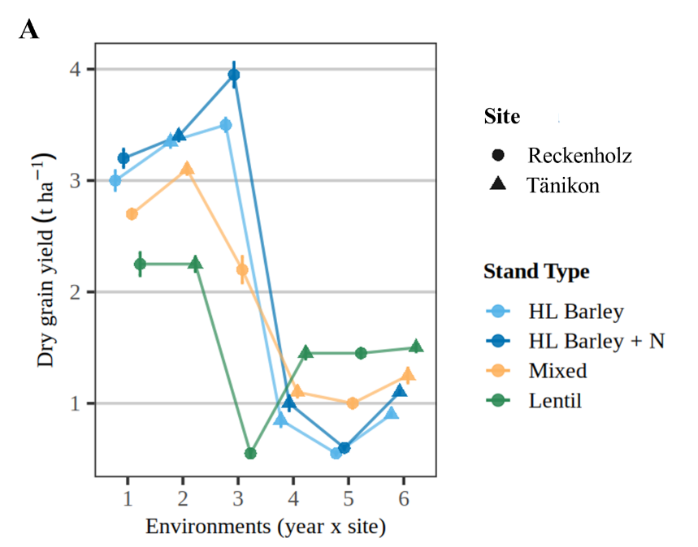

Figure A: Yield dynamics along 6 environments (year x site). Yield values (t ha⁻¹) are reported in Table F. MAD = median absolute error.
Environments:
- 1 (Reckenholz 2022); 2 (Tänikon 2022)
- 3 (Reckenholz 2023); 4 (Tänikon 2023)
- 5 (Reckenholz 2024); 6 (Tänikon 2024)
Stand type: Sole hull-less barley (HL Barley), sole hull-less barley + nitrogen fertilization (HL Barley + N), mixed cropping (Mixed), sole lentil (Lentil).

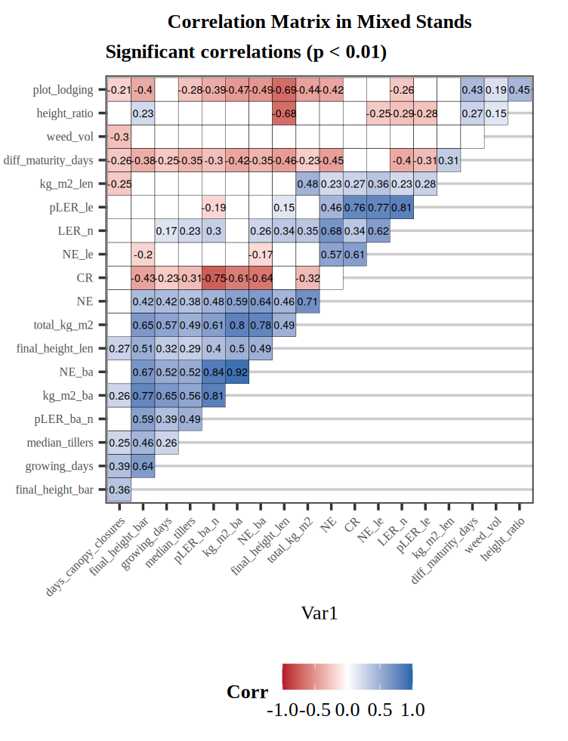
Figure B: Spearman’s correlation between variables in mixed cropping systems. Significant at p < 0.01. All values present are significant at p < 0.01. Missing values are exceeding p = 0.01. Plot lodging = plot lodging; Height ratio = difference between HL barley height and lentil height; Weed_vol = weed volume; Diff_maturity_days = Differences in days between species in reaching BBCH 55 (HL Barley) and BBCH 65 (Lentil); kg_m2_len = Dry grain yield for lentils; pLER_le = partial land equivalent ratio (LER) from lentils; LER_n = Land equivalent ratio ; NE_le = partial overyielding from lentils; CR = Competitive Ratio index; NE = overyielding index; total_kg_m2 = total dry grain yield per plot; final_height_len = final lentils height ; NE_ba= partial overyielding from HL barley; kg_m2_ba = dry grain yield for HL barley, pLER_ba_n = partial LER from HL barley; median_tillers = number of tillers; growing_days = length in days for each environment (year x site); final_height_bar = final HL barley height.

