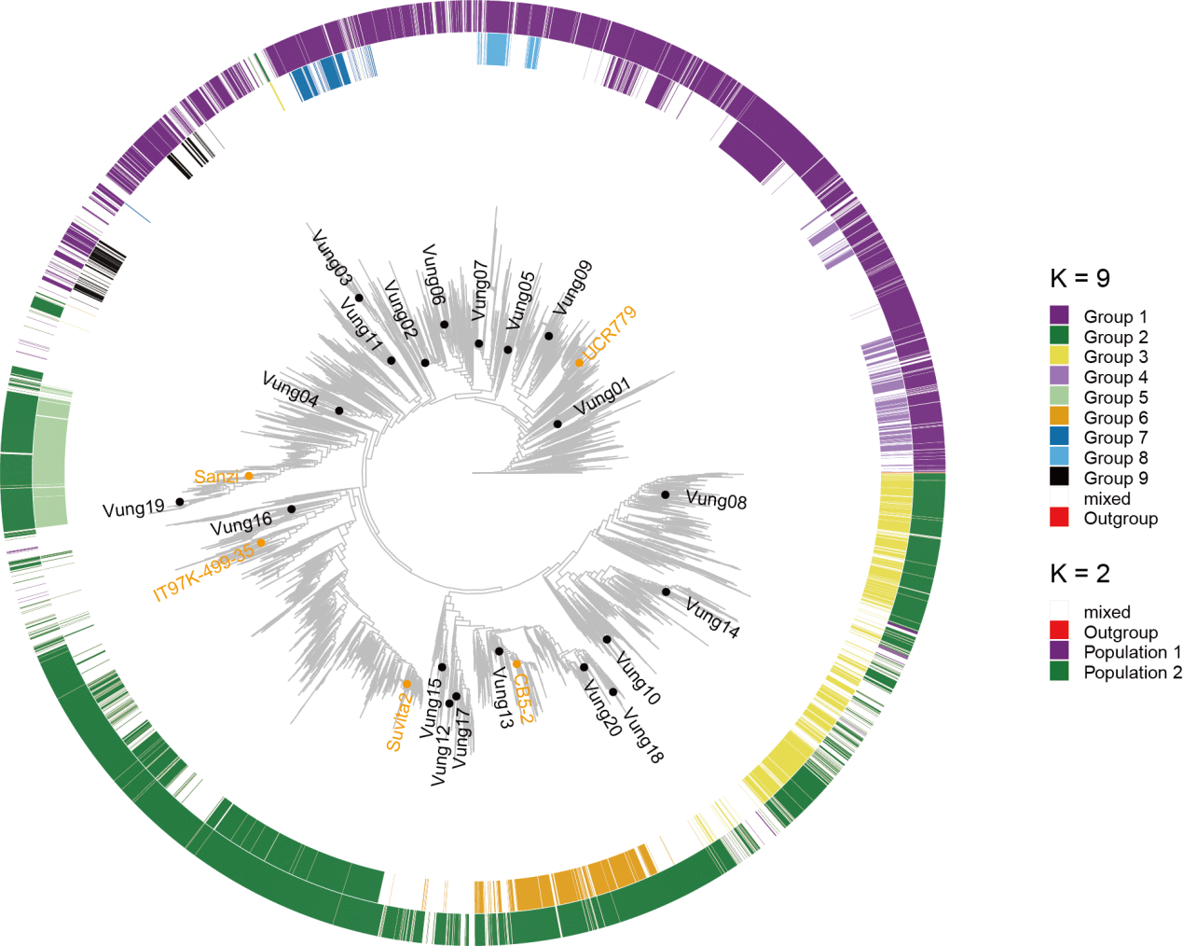

Supplementary Fig. 1. Identification of cowpea core germplasm and analysis of genetic linkage groups. From outer to inner circles: results of population structure analysis at K = 2 and K = 9, and the phylogenetic tree of 9,609 cowpea accessions. Black dots indicate the 20 representative lines selected for de novo genome sequencing in this study. Orange dots indicate the genome sequencing accessions reported in Liang et al.¹⁶.
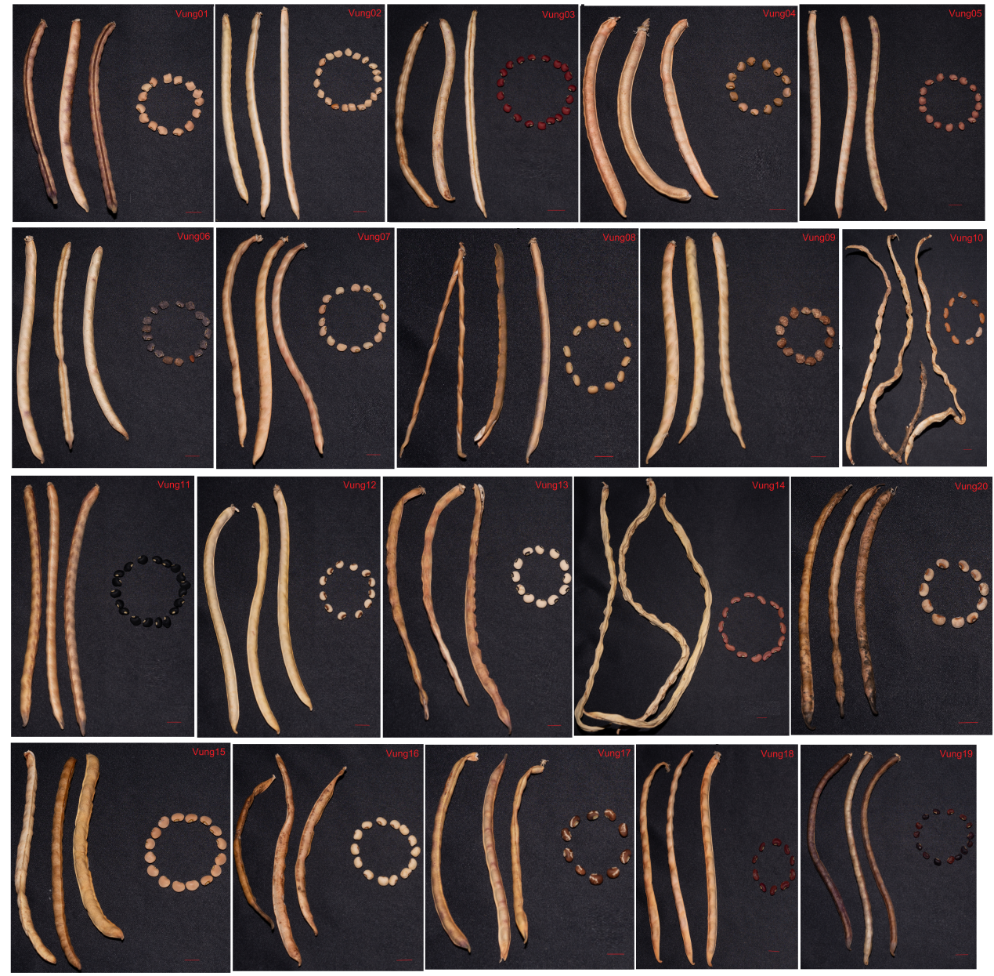
Supplementary Fig. 2. Photographs of phenotypic traits of mature pods and seeds from 20 cowpea accessions selected for genome sequencing, grown under field conditions.

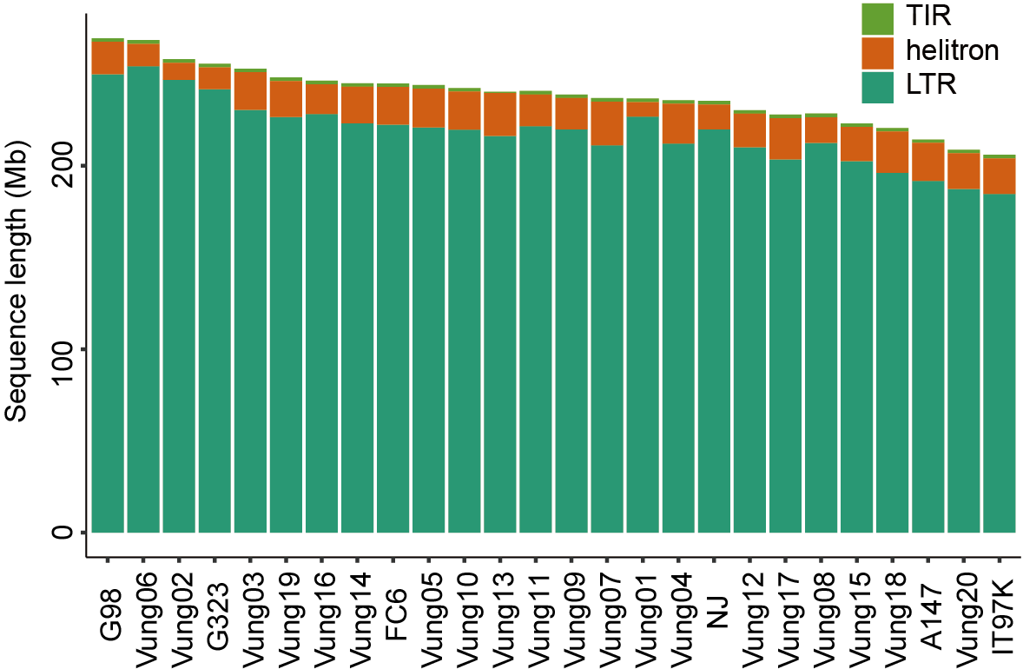

Supplementary Fig. 3. Length of TEs in each cowpea genome. Different colors represent distinct TE types.
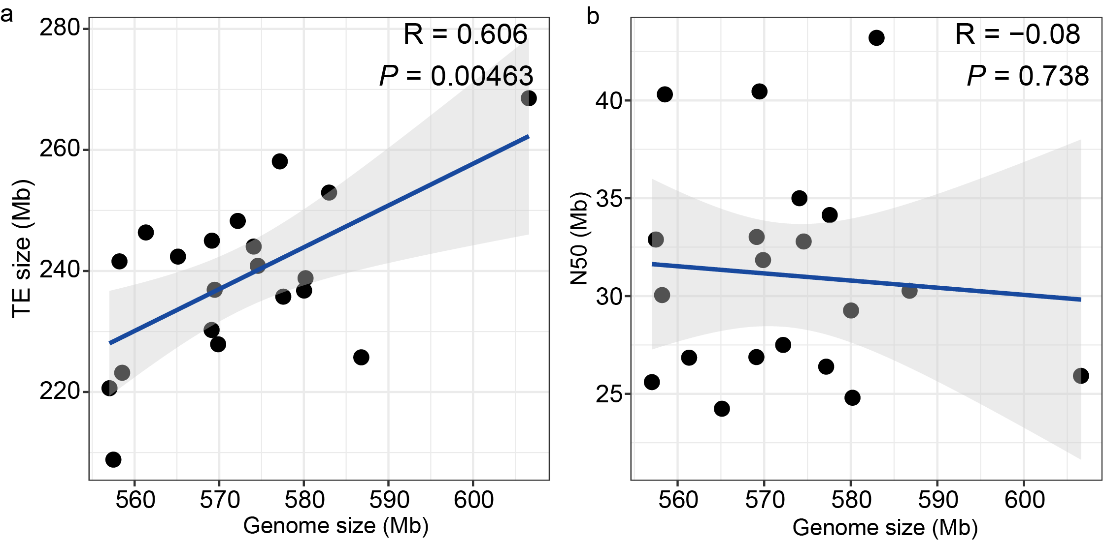

Supplementary Fig. 4. Correlation analysis of genome size with TE content and contig N50. a, Correlation between genome size and TE content across 20 cowpea genomes, with each point representing a genome. b, Correlation between genome size and contig N50 across 20 cowpea genomes, with each point representing a genome. Blue lines represent fitted linear regression curves, with grey shaded areas indicating the 95% confidence interval.
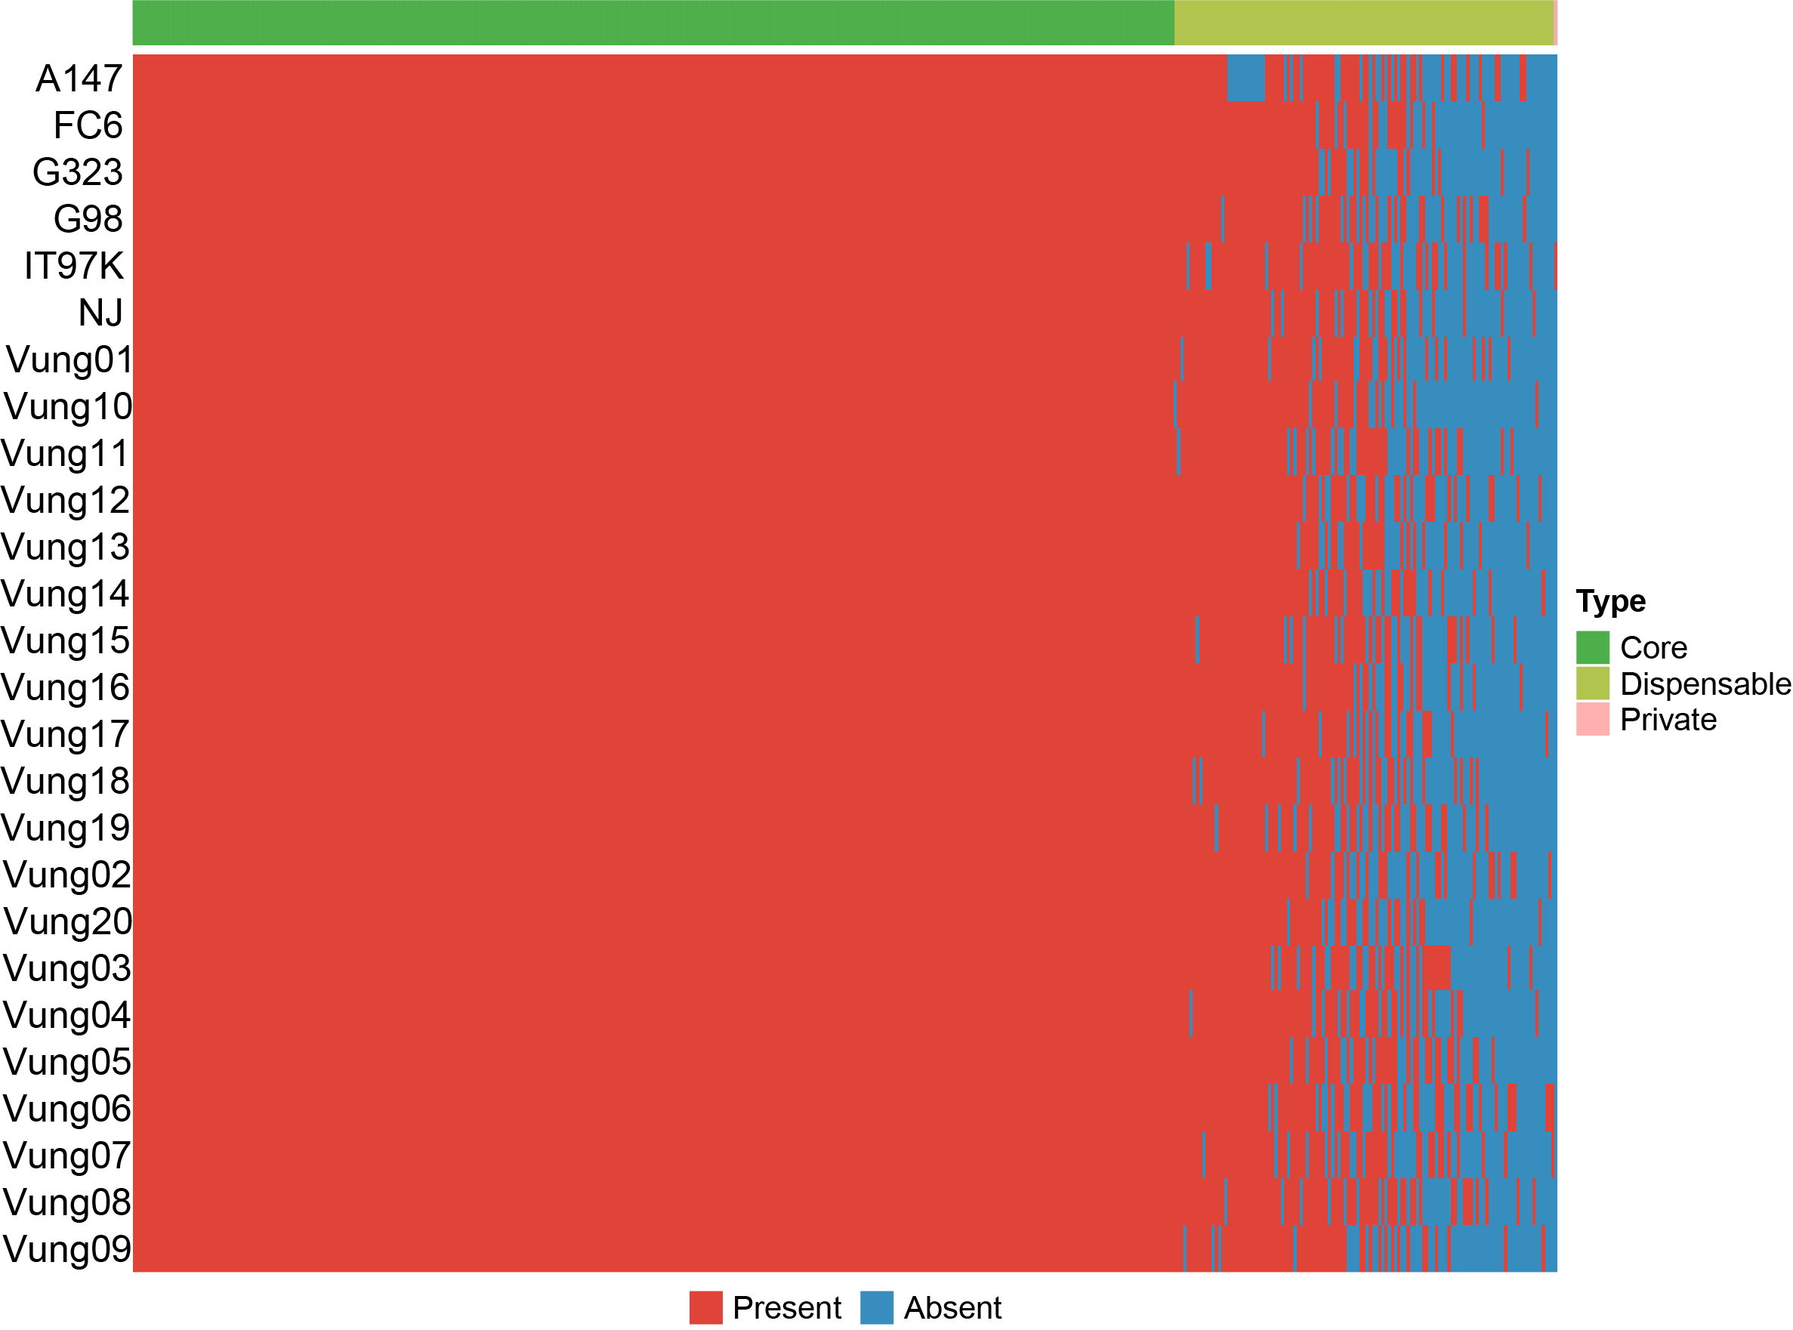
Supplementary Fig. 5. Gene family presence-absence variations (PAVs) across 26 cowpea accessions.
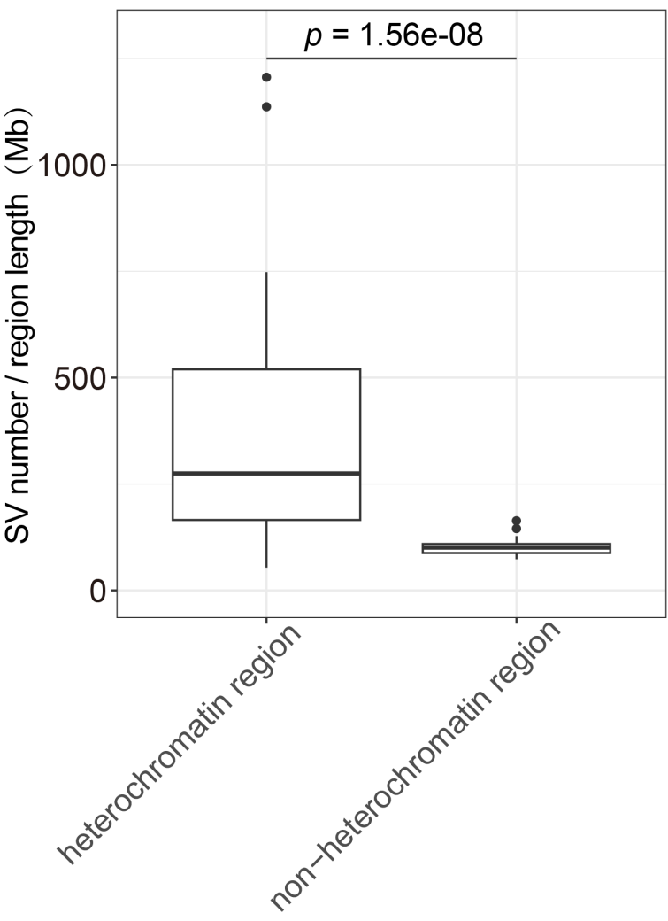

Supplementary Fig. 6. Comparison of SV counts between heterochromatic and non-heterochromatic regions. Centromeric and telomeric regions are defined as heterochromatic regions, while the remaining genomic regions are defined as non-heterochromatic regions. The box plots showing the median, 25th to 75th percentiles, and whiskers extending to 1.5× the interquartile range. Significance was determined by two-sided Wilcoxon tests.
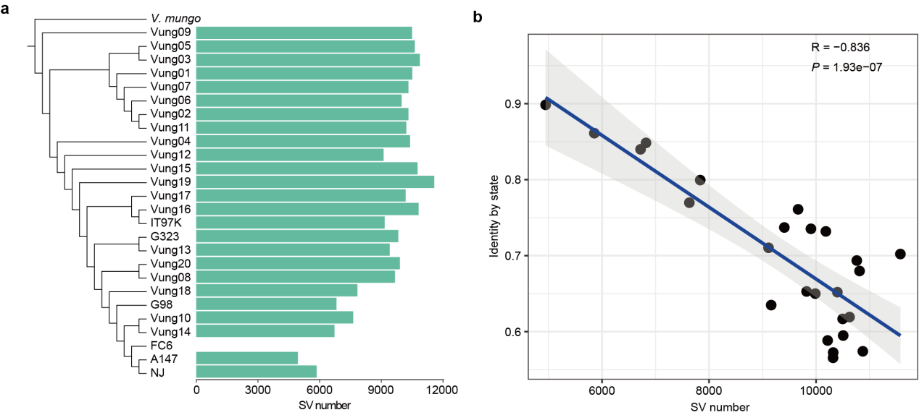

Supplementary Fig. 7. Correlation analysis of SV counts and genetic distance from the reference genome in cowpea accessions. a, Bar plot displaying the number of SVs across 20 cowpea accessions, with bar heights representing SV counts. b, Scatter plot showing the correlation between genetic distance from the FC6-T2T reference genome and SV counts across 20 cowpea accessions, with each point representing an accession. The blue line represents the fitted linear regression curve, with the grey shaded area indicating the 95% confidence interval.
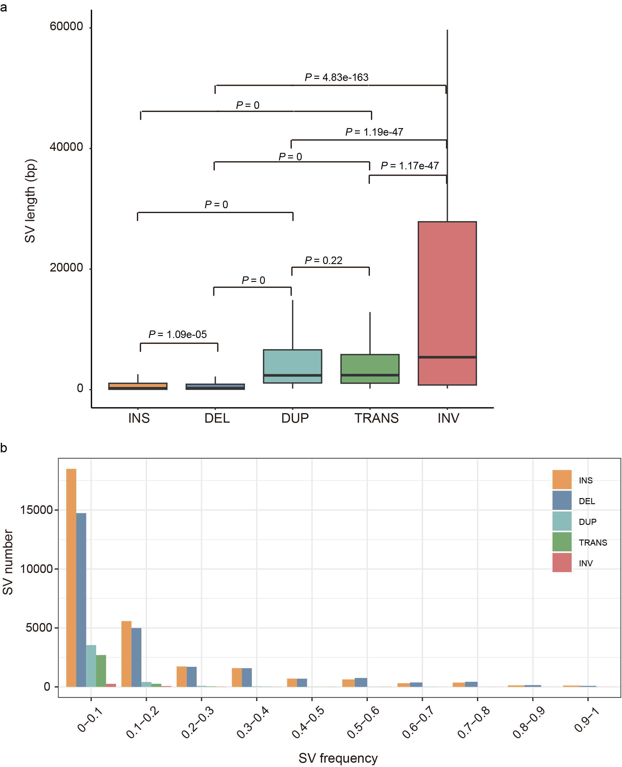
Supplementary Fig. 8. Length and frequency of different types of SVs in cowpea. a, Comparison of SV lengths by type across cowpea genomes. Box plots show the median, interquartile range (25th–75th percentiles), and whiskers extending to 1.5× the interquartile range. Statistical significance was assessed using two-sided Wilcoxon tests. b, Frequency distribution of different types of SVs across pan-genome accessions.
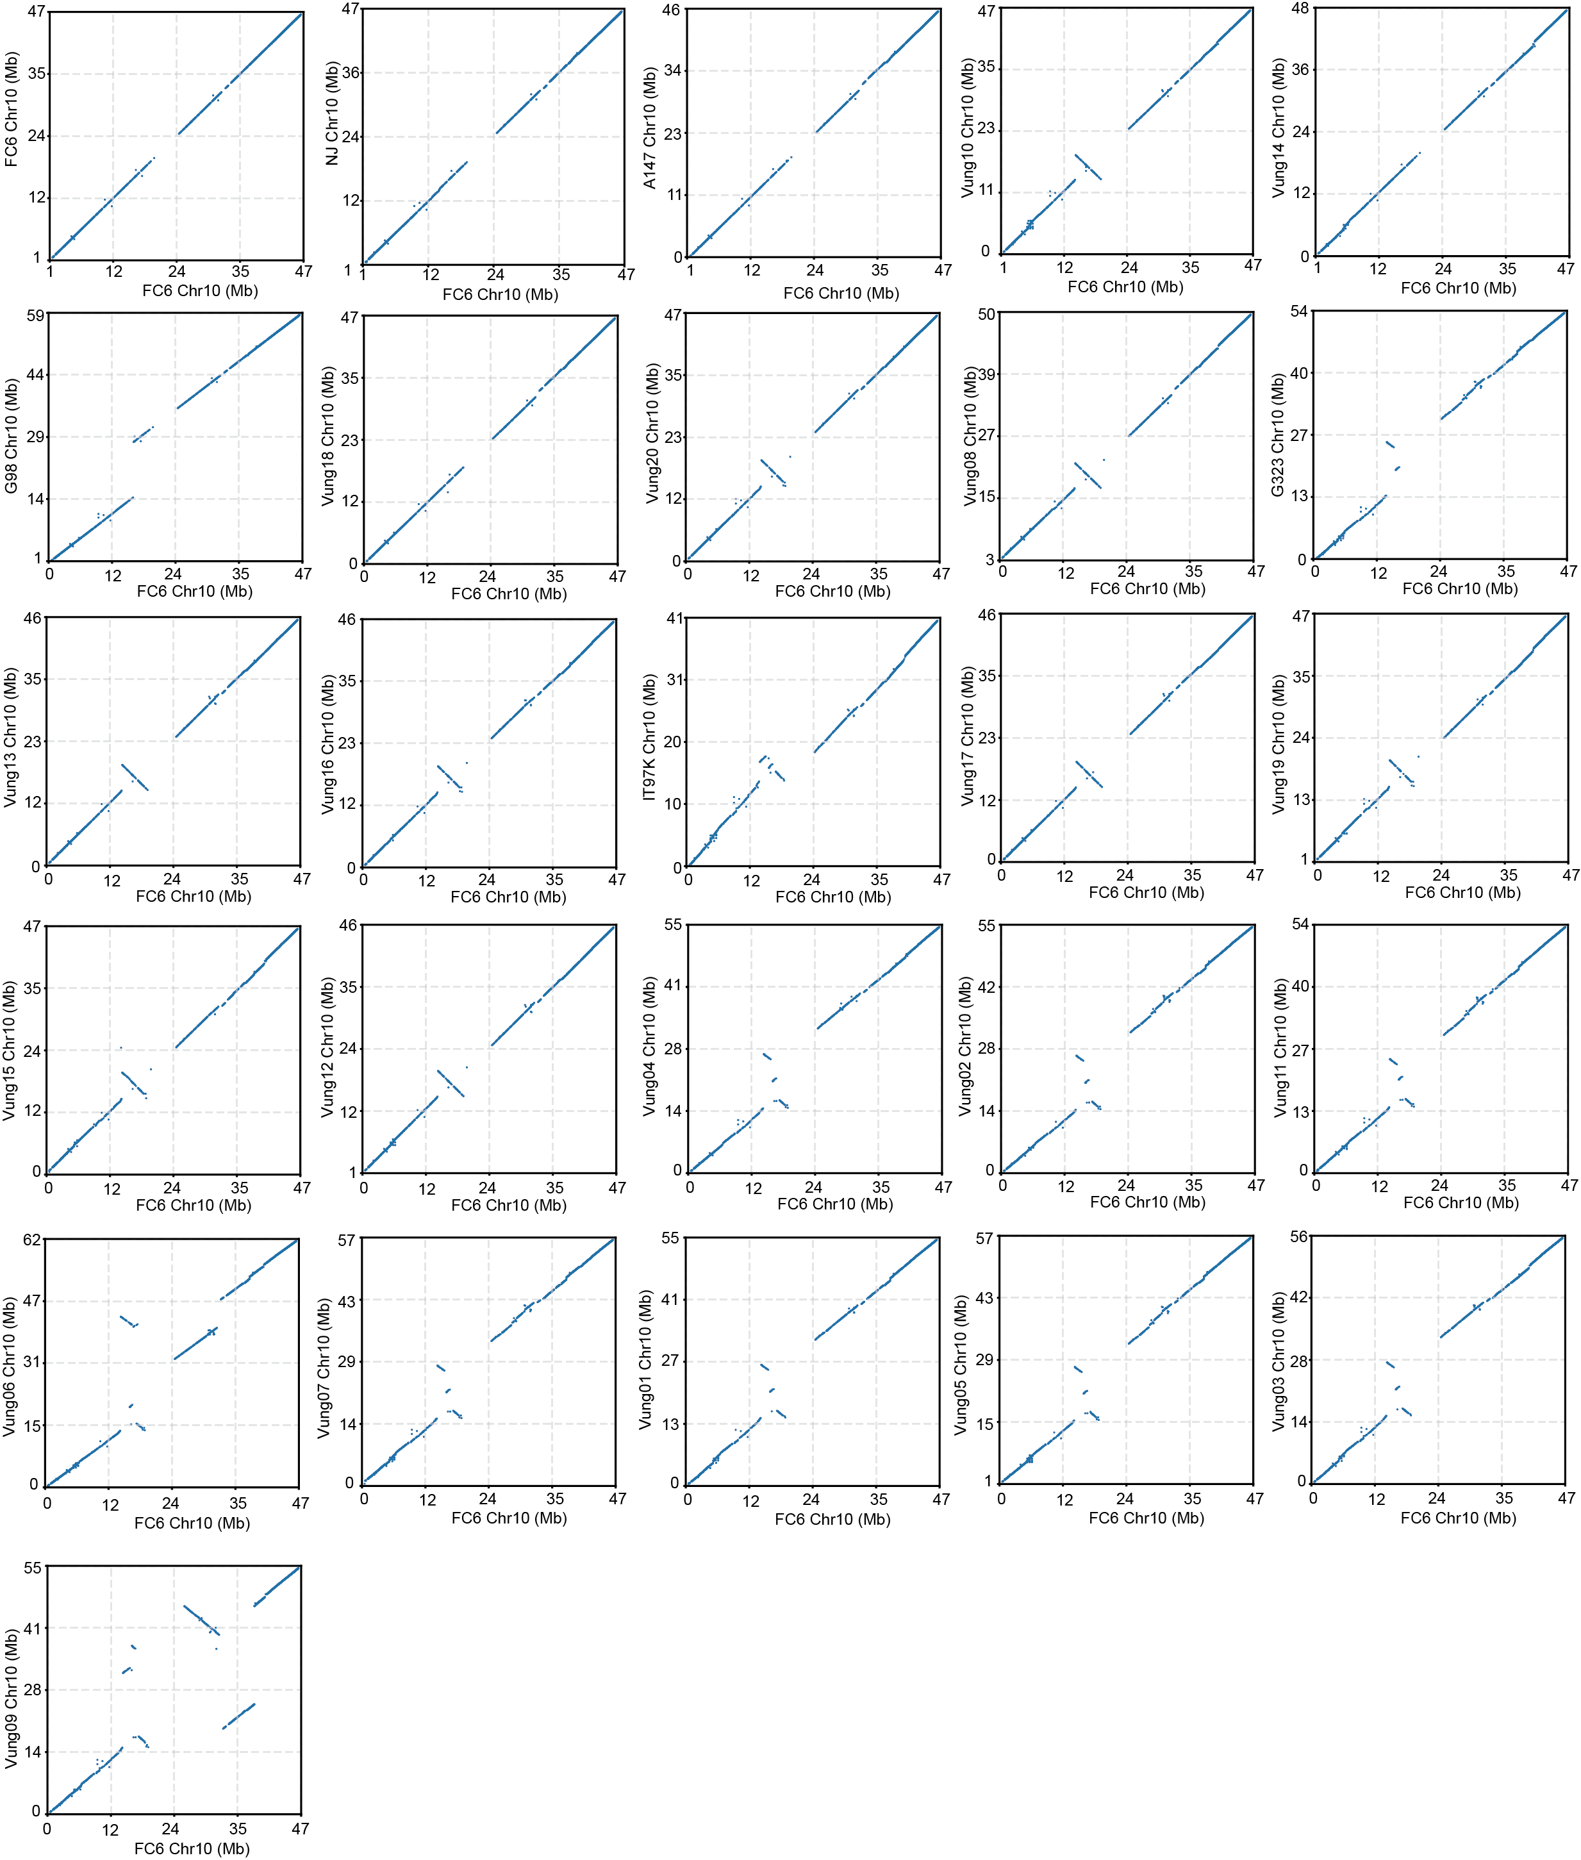
Supplementary Fig. 9. Dot plot of gene collinearity on chromosome 10 between FC6 and 25 cowpea genomes. The x-axis shows positions on FC6-T2T chromosome 10, and the y-axis shows the corresponding positions on chromosome 10 of each accession.
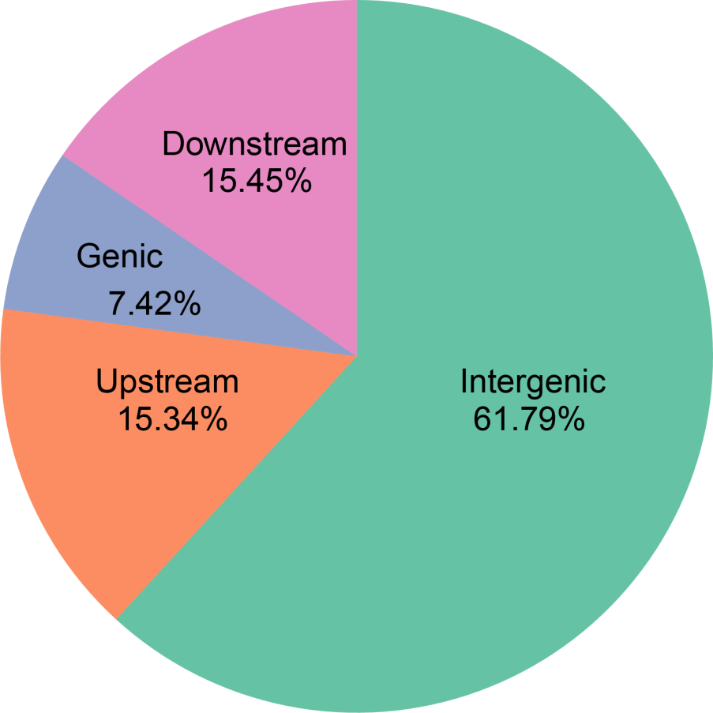
Supplementary Fig. 10. Distribution of SVs relative to genes in cowpea genomes. SVs are categorized based on their genomic location: upstream (within 5 kb of the transcription start site), downstream (within 5 kb of the stop codon), genic (within gene bodies), and intergenic regions. Pie chart percentages represent the proportion of SV counts in each category.
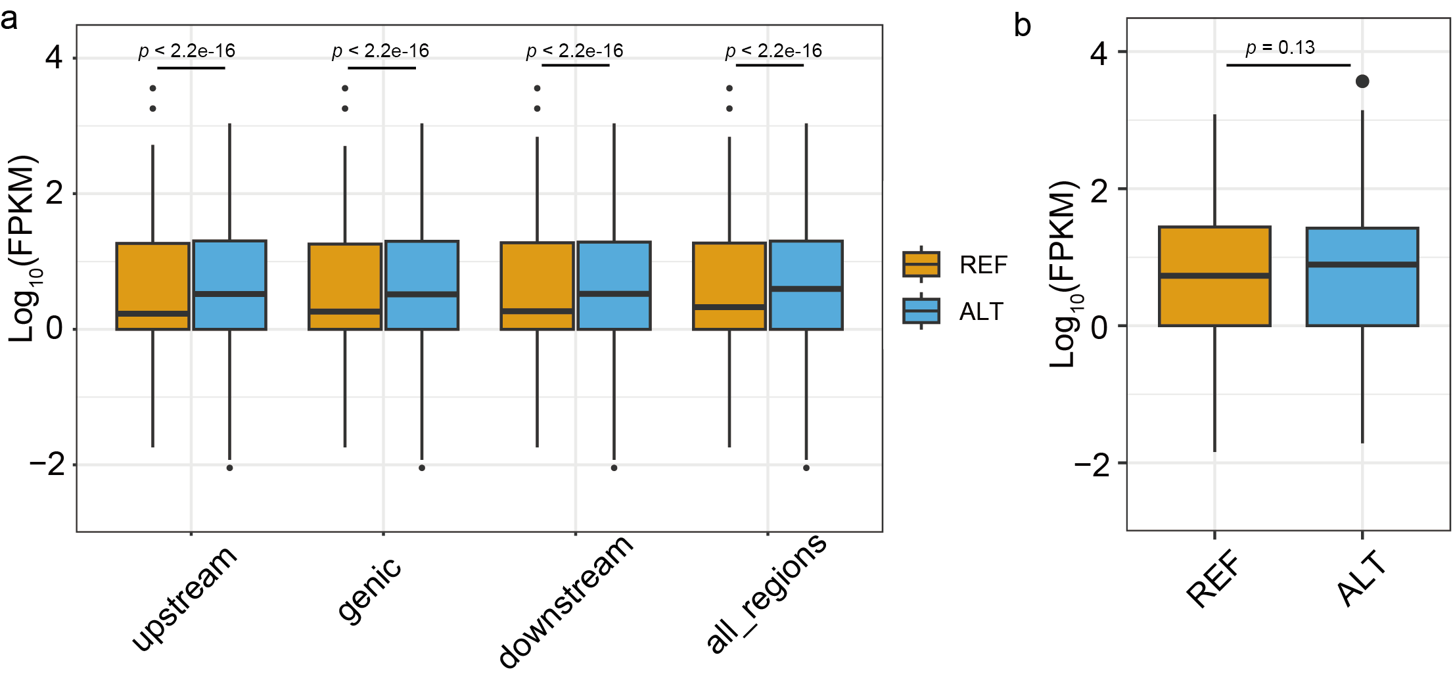
Supplementary Fig. 11. Impact of SVs on gene expression in leaves of cowpea. a, Effects of SVs at different genomic locations on gene expression, categorized as upstream (within 5 kb of the transcription start site), downstream (within 5 kb of the stop codon), and genic (within gene body). b, Comparison of gene expression levels between two cowpea accessions for genes without SVs. Box plots show the median, interquartile range (25th–75th percentiles), and whiskers extending to 1.5× the interquartile range. Statistical significance was assessed using two-sided Wilcoxon tests.
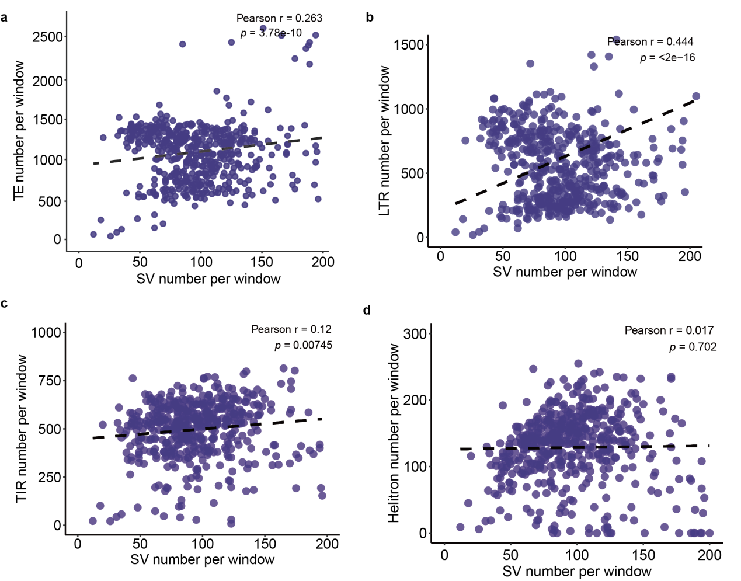
Supplementary Fig. 12. Pearson correlation coefficients between SV number and TE number per window. a, The correlation between SV number and total TE counts. b-d, The comparisons between LTR, TIR and Helitron number per window (1 Mb window size) and SV number per window, respectively. Total of 541 windows were plotted and the p-value was calculated using a two-sided t-test.
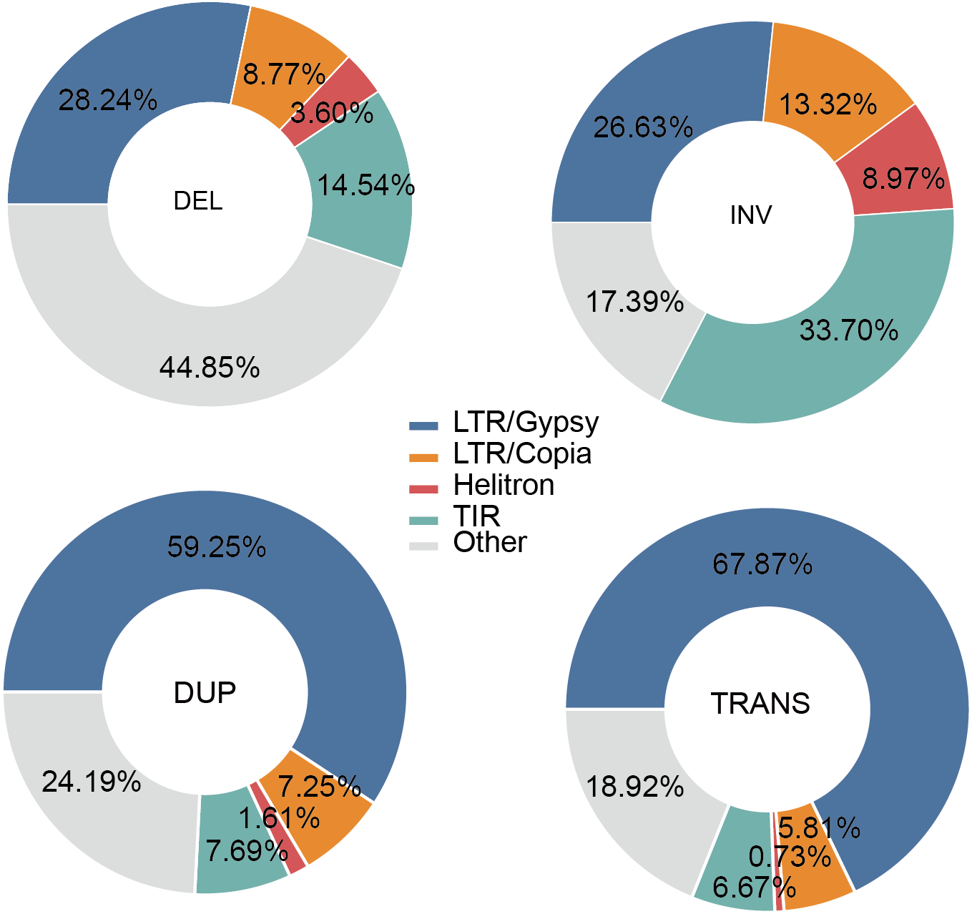
Supplementary Fig. 13. Proportion of different TE families associated with the four SV types. Pie charts show the percentage of TE families flanking TE-driven SVs, indicating that LTR is the predominant TE type across deletions (DEL), inversions (INV), duplications (DUP), and translocations (TRANS). Inserted sequences formed directly by TE movement are excluded from this analysis.
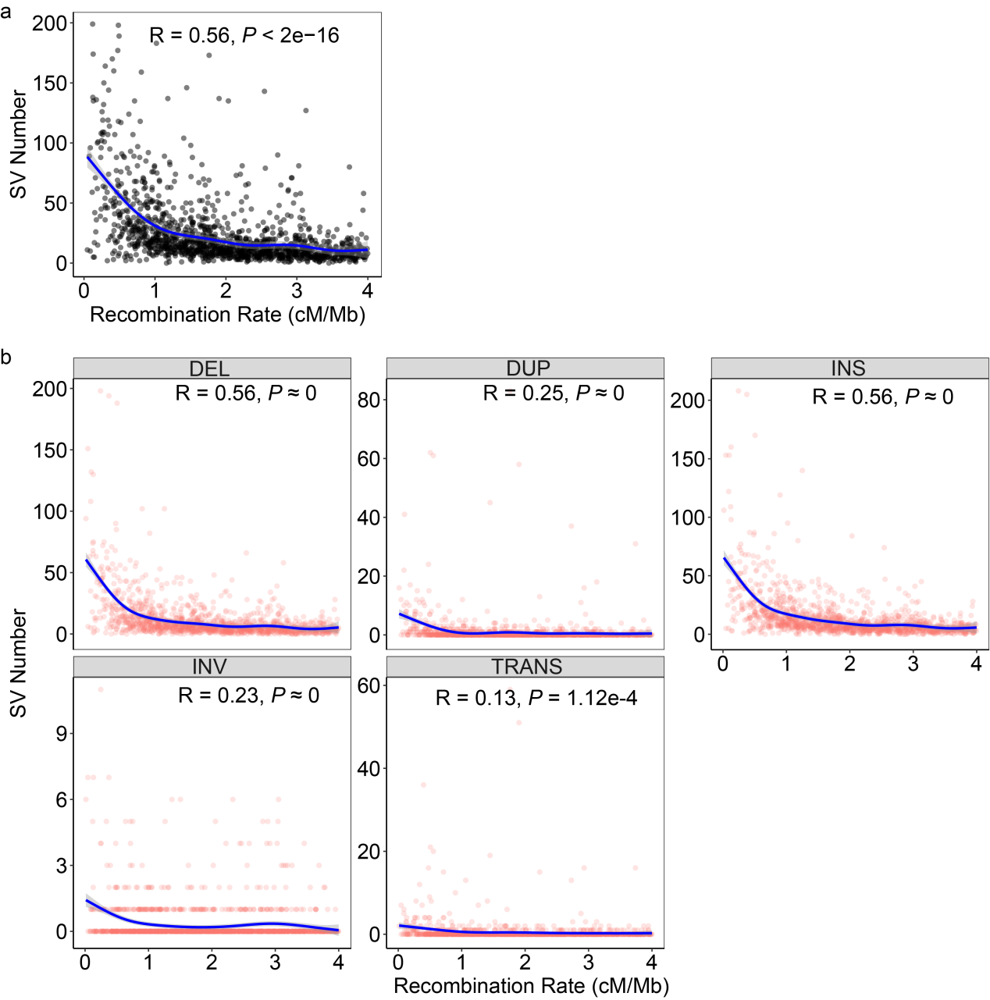
Supplementary Fig. 14. Impact of genomic recombination rate on SV counts in cowpea genomes. a, Scatter plot illustrating the Pearson correlation between genomic recombination rate and total SV counts. b, Scatter plots showing the Pearson correlation between genomic recombination rate and counts of five SV types (DEL: deletion, INV: inversion, DUP: duplication, TRANS: translocation, INS: insertion). Blue lines indicate fitted linear regression curves, with grey shaded areas representing 95% confidence intervals. P-values were calculated using two-sided t-tests.
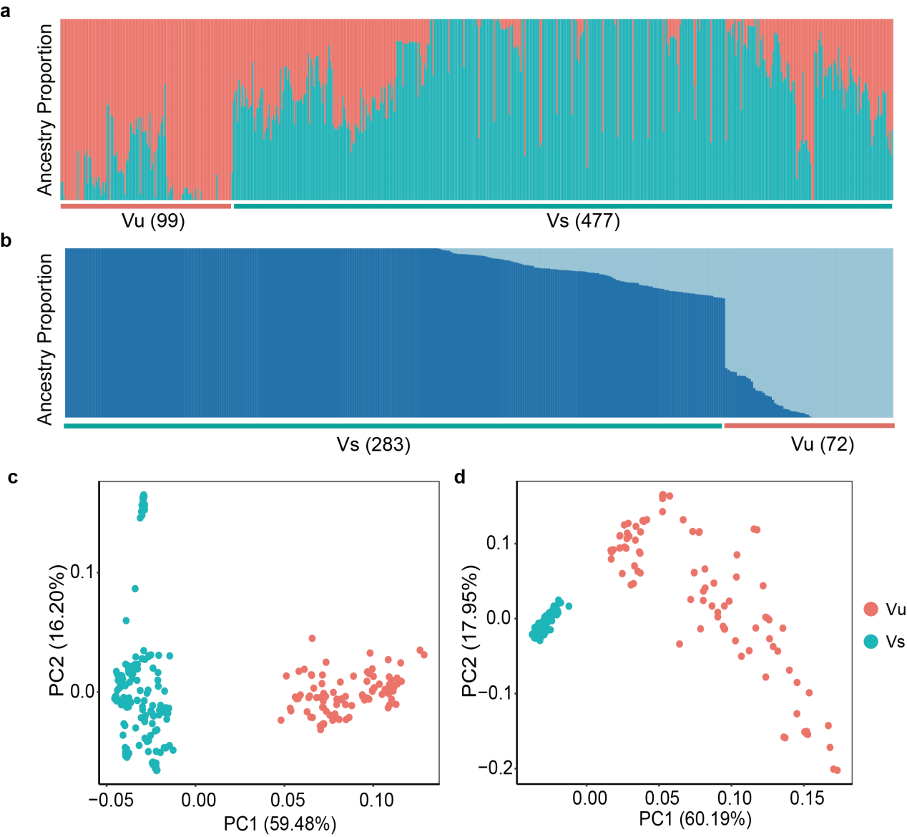

Supplementary Fig. 15. Sample screening for Vu and Vs genetic differentiation interval analysis in cowpea. a, Structure analysis of all re-sequencing samples (n = 577), displaying ancestry proportions for K = 2 inferred clusters. b, Structure analysis of the selected samples (n = 355), where samples with ancestry proportions exceeding 70% for a single cluster at K = 2 were retained. c, SNP-based principal component analysis (PCA) of the selected samples, with the first two principal components plotted. d, SV-based PCA of the selected samples, with the first two principal components plotted.
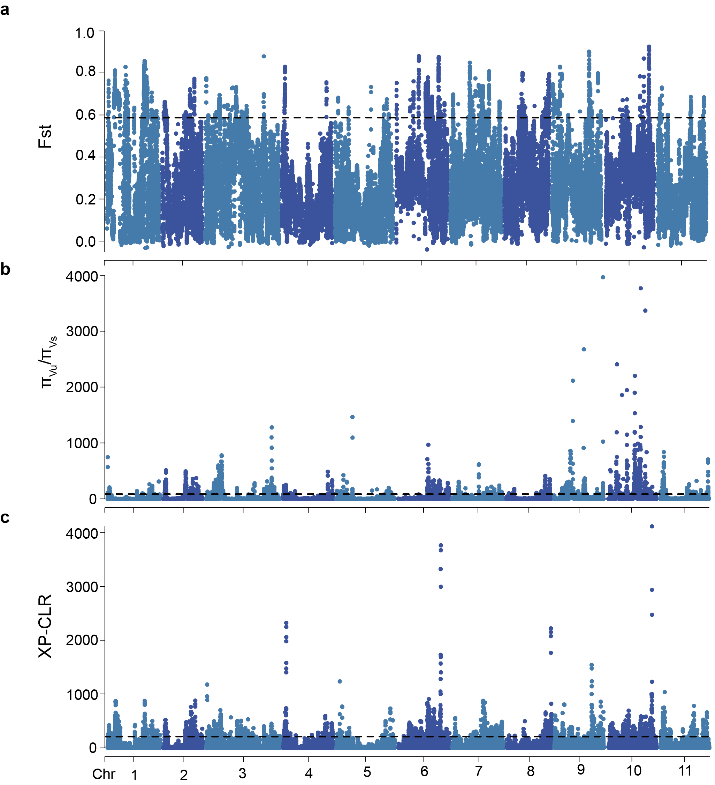
Supplementary Fig. 16. Identification of Vu and Vs differentiation intervals through selective sweep analysis in cowpea genomes. a, F_{ST} values across the cowpea genome. b, Pi-ratio (π_{Vu}/π_{Vs}) values across the cowpea genome. c, XP-CLR scores across the cowpea genome. The horizontal dotted lines indicate the top 5% threshold for identifying selective sweeps.
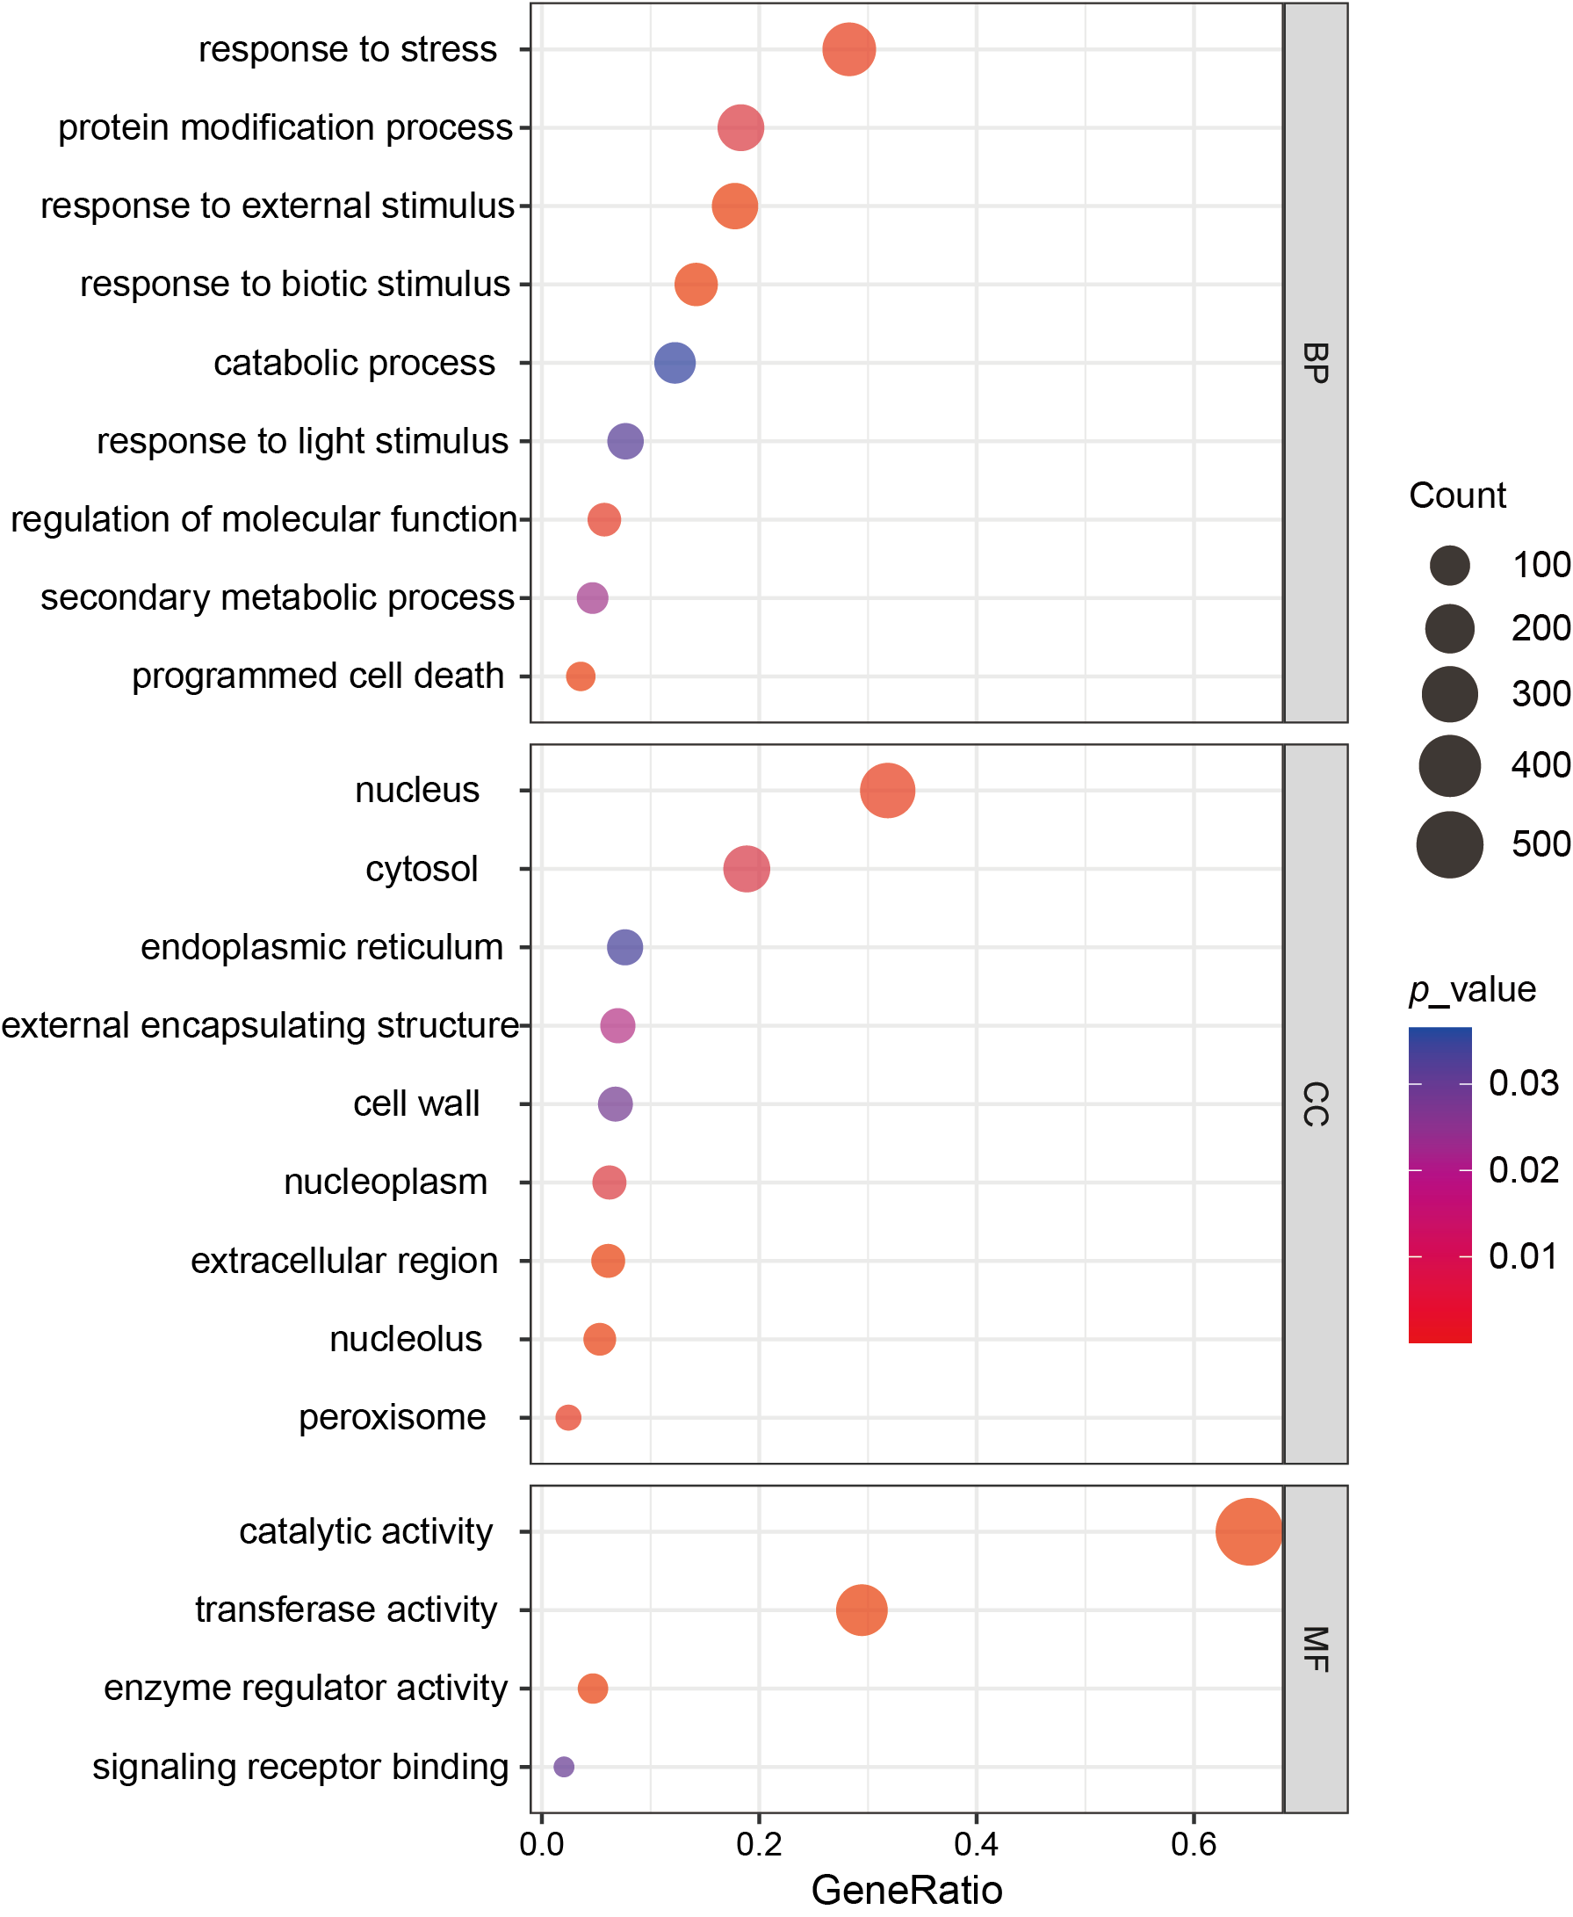
Supplementary Fig. 17. Overrepresented terms in genetic differentiation genes identified in cowpea genomes. Bubble plot displaying the enriched functional terms based on GOs for genes within selective sweep regions. Bubble size corresponds to the gene number. BP, biological process; CC, cellular component; MF, molecular function.
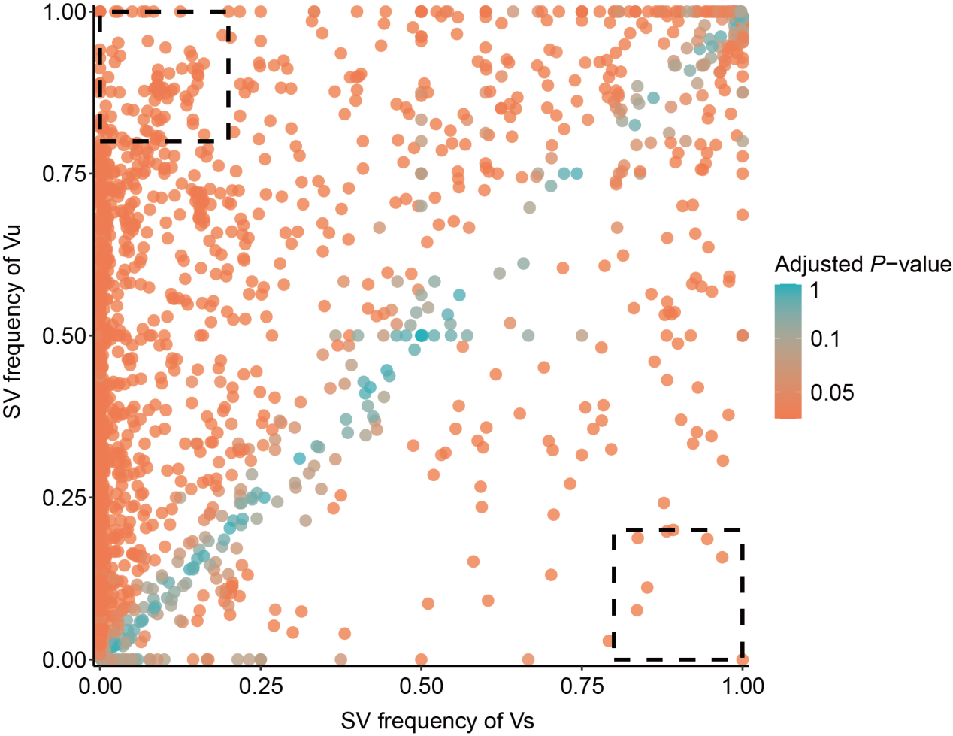
Supplementary Fig. 18. Two-dimensional frequency plot of fixed SVs in cowpea genomes. Two-dimensional frequency plot displaying the allele frequencies of SVs across Vu and Vs populations, with each point representing a single SV. The dashed box in the upper-left corner (Vu frequency > 0.8, Vs frequency < 0.2) indicates SVs fixed in the Vu population, while the dashed box in the lower-right corner (Vs frequency > 0.8, Vu frequency < 0.2) indicates SVs fixed in the Vs population. Point colors represent P-adjusted values, calculated from P-values obtained by two-tailed Fisher’s exact test.
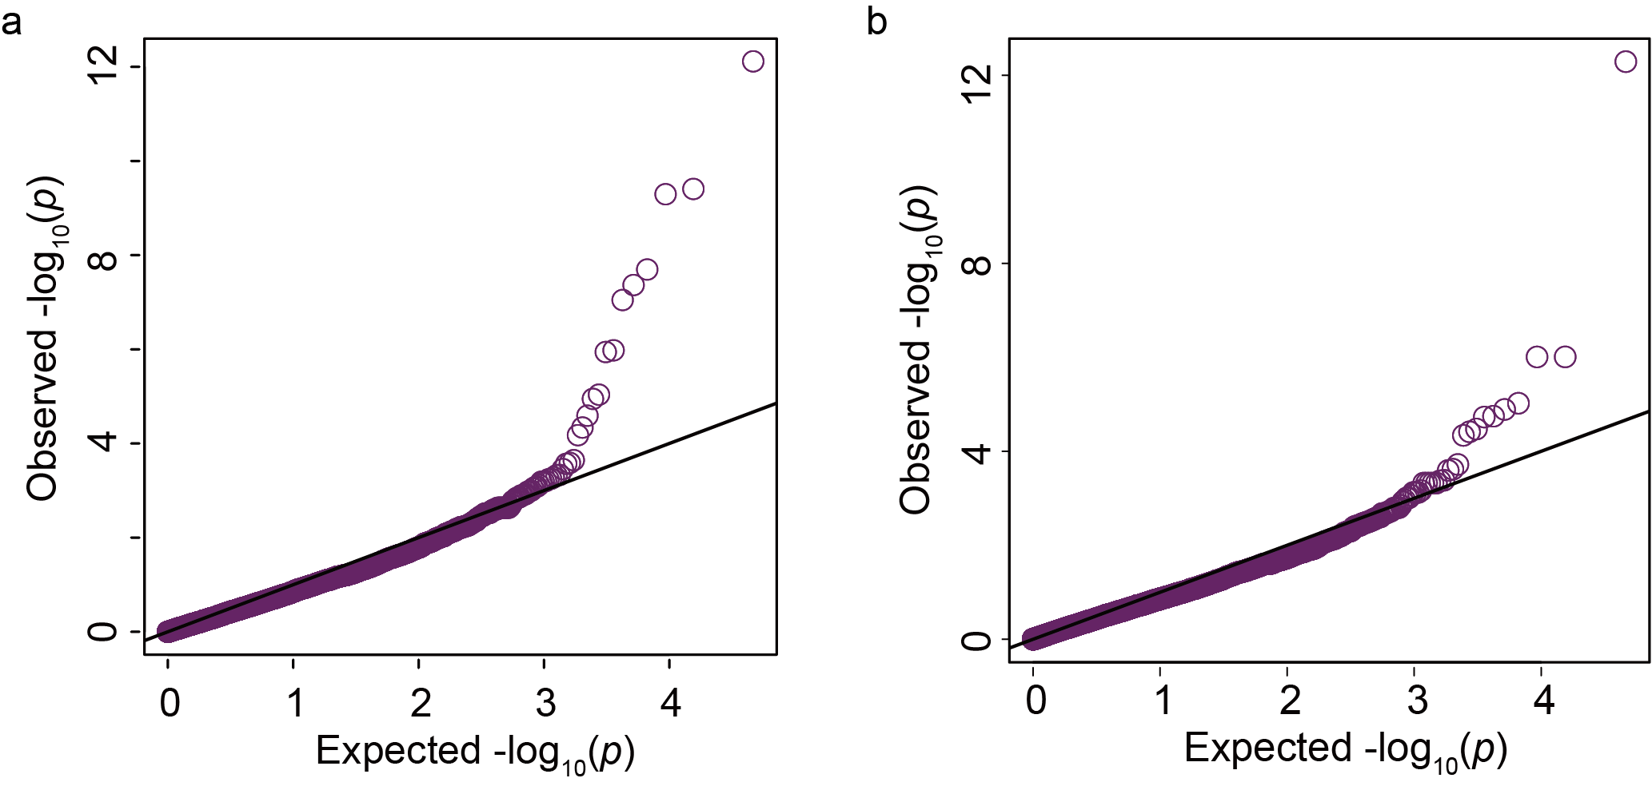
Supplementary Fig. 19. Quantile-quantile plot assessing the distribution of P-values for SVs in SV-based GWAS. a, QQ-plot for pod length SV-based GWAS. b, QQ-plot for seed number per pod SV-based GWAS.
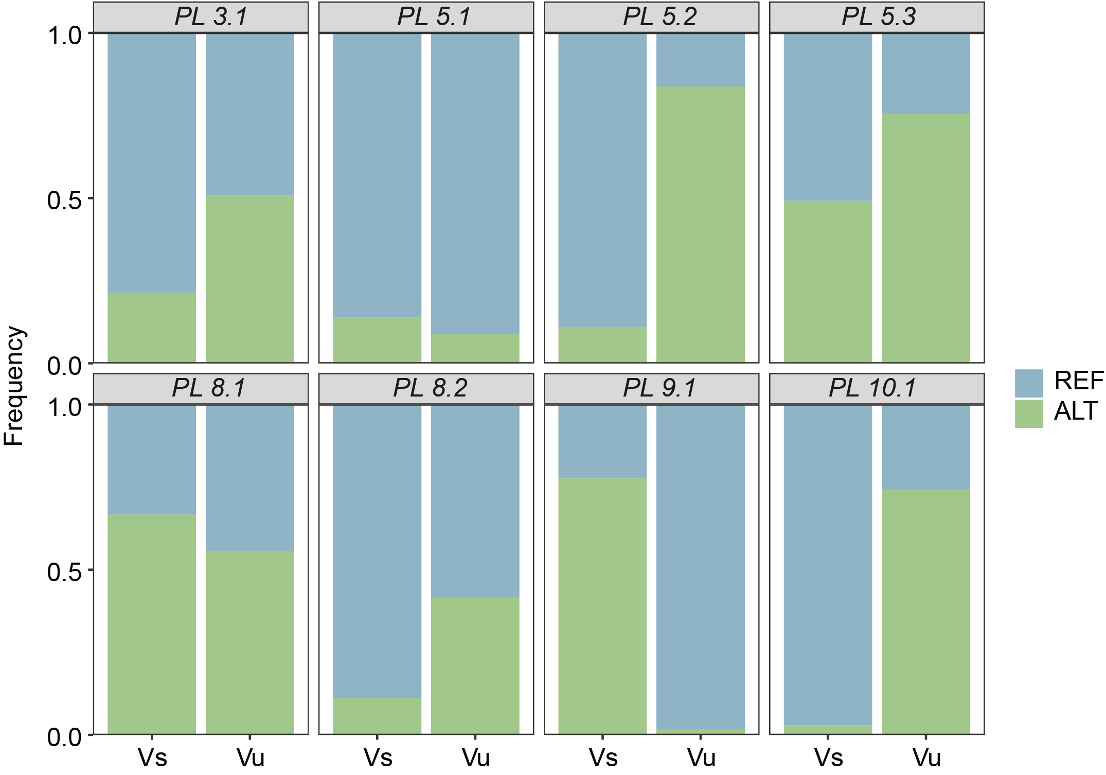
Supplementary Fig. 20. Allele frequencies of significant SV loci for pod length trait in Vu and Vs populations. Blue represents the reference (REF) genotype, while green represents the alternative (ALT) genotype.
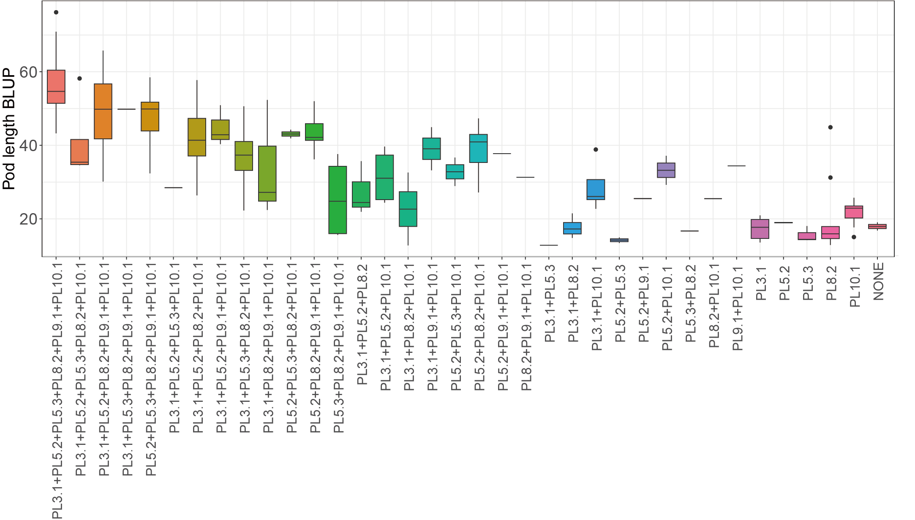
Supplementary Fig. 21. Box plots show the effects of favorable allelic combinations for pod length. NONE indicates accessions carrying no favorable allele. The upper and lower edges of the boxes represent the 75% and 25% quartiles, the central line denotes the median, and the whiskers extend to 1.5 × IQR.
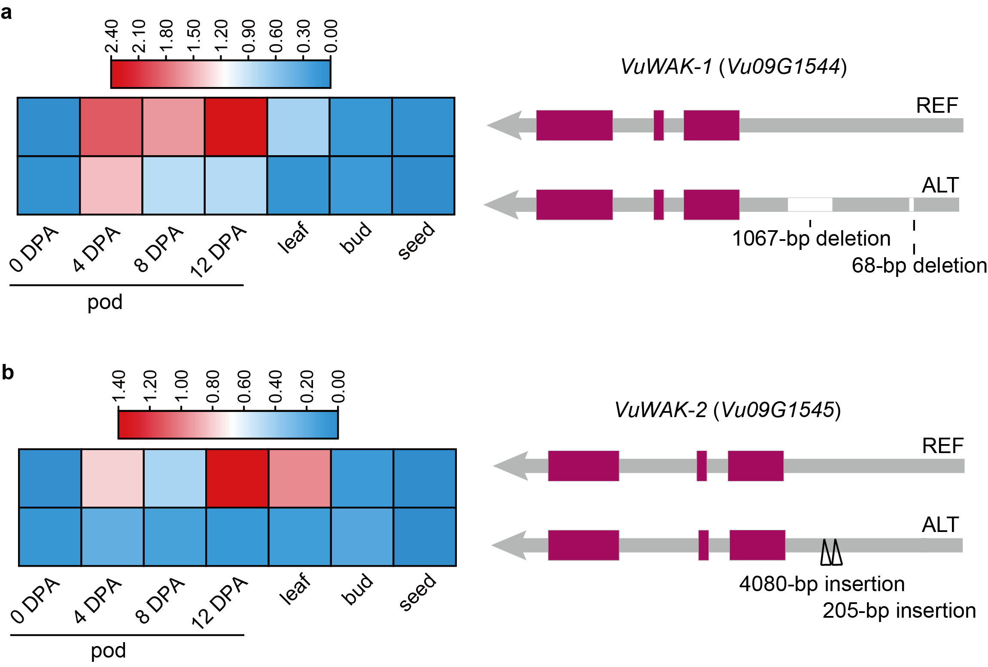
Supplementary Fig. 22. Expression patterns of VuWAK-1 and VuWAK-2 genes in leaves, flower buds, seeds, and pods at different developmental stages between two genotypes. a, Expression patterns of VuWAK-1. b, Expression patterns of VuWAK-2.
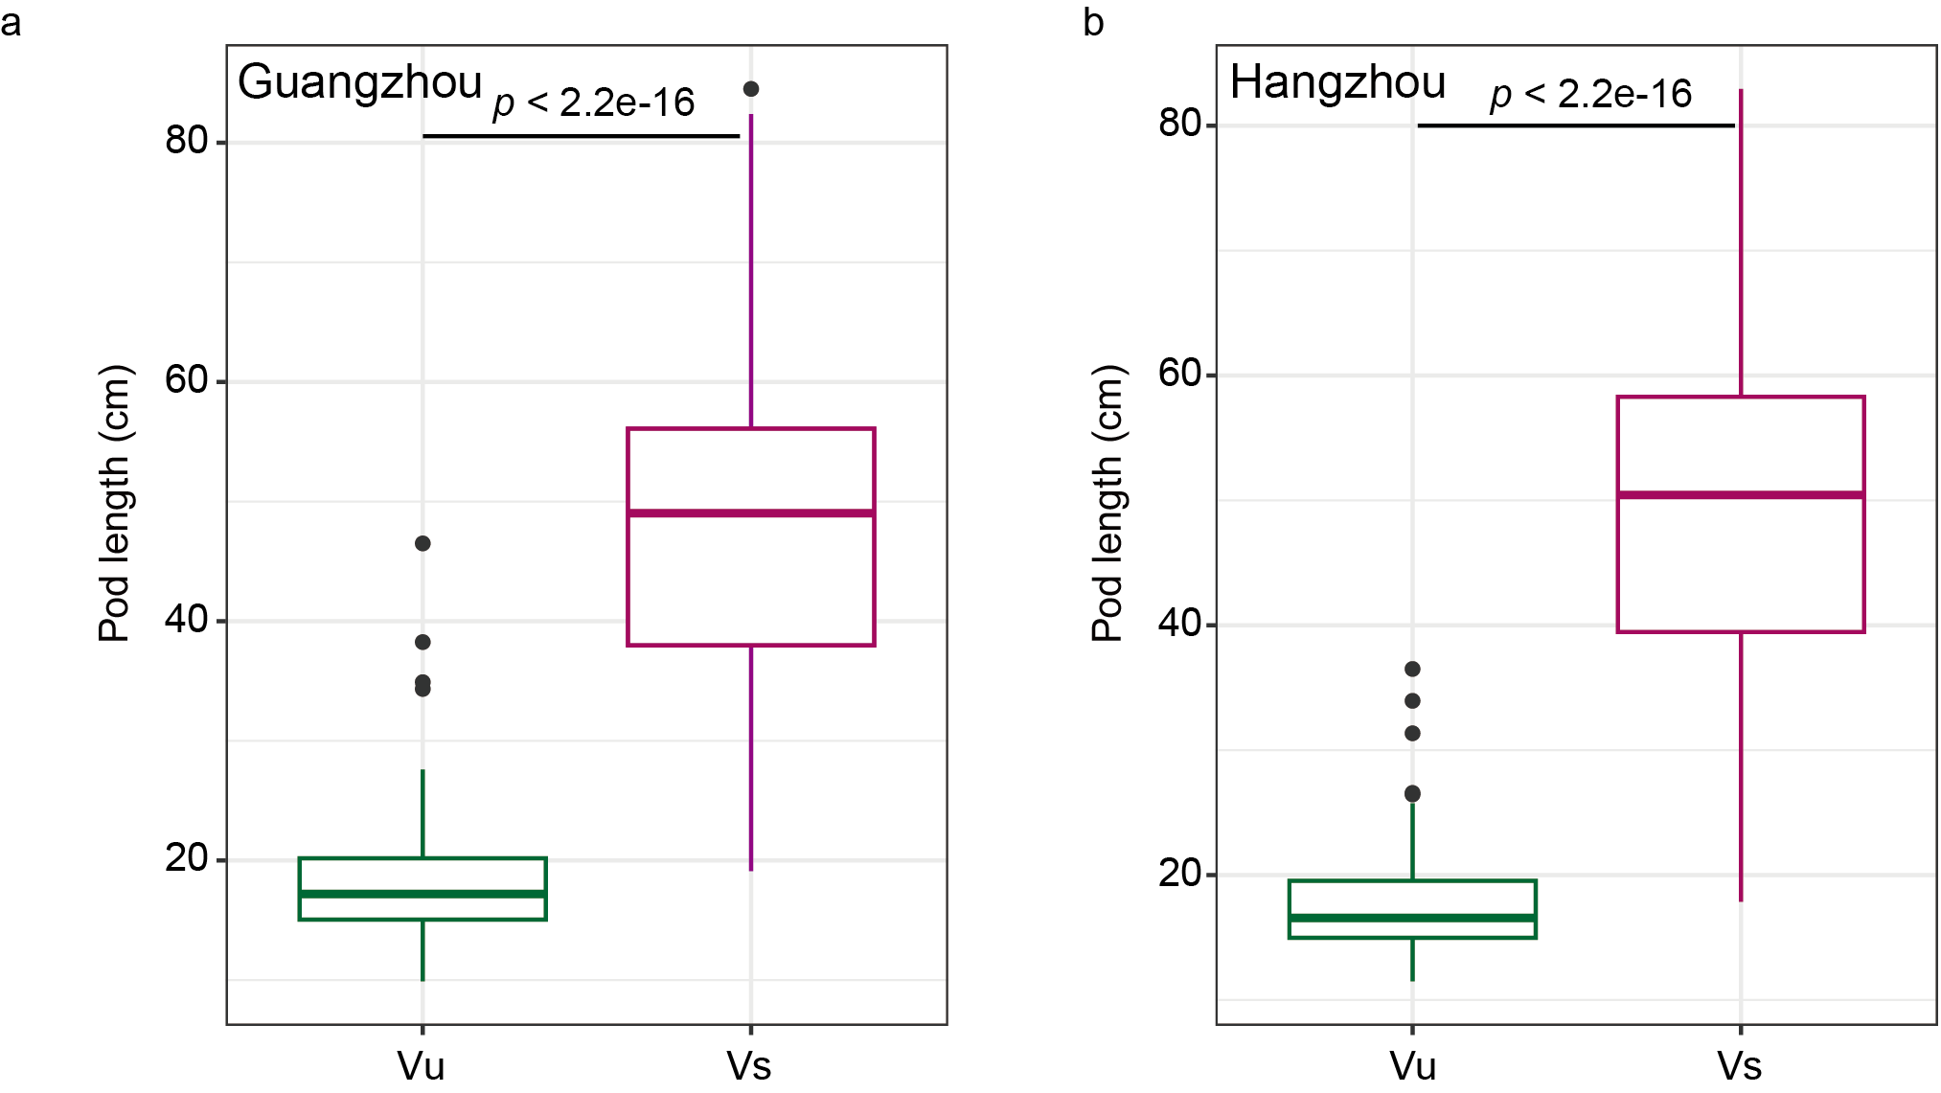
Supplementary Fig. 23. Comparison of pod length between Vu and Vs populations. a, Comparison of pod length between Vu and Vs populations grown in Guangzhou. b, Comparison of pod length between Vu and Vs populations grown in Hangzhou. In box plots, boxes span the 25th to 75th percentiles, with central lines at the median and whiskers extending to 1.5× the interquartile range. Statistical significance was determined using a two-sided Wilcoxon test.
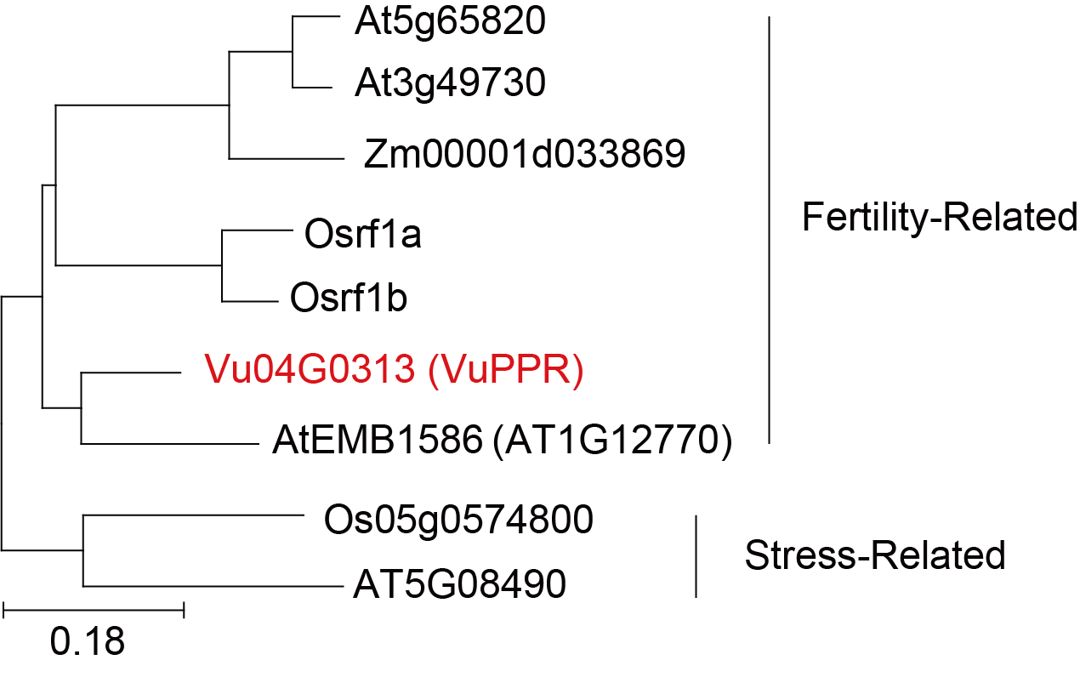
Supplementary Fig. 24. Phylogenetic tree of PPR proteins. The neighbor-joining phylogenetic tree was generated using PPR protein sequences from Arabidopsis thaliana (At), Oryza sativa (Os), Vigna unguiculata (Vu) and Zea mays (Zm).

