The following content is supplementary material to the main text, primarily covering the model selection process in machine learning.

The ATE and CATE formula are as follows:
$$ATE=E[Y(1)-Y(0)]$$
$$CATE(X)=E[Y(1)-Y(0)∣X]$$

Here, Y(1) is the outcome for an individual after receiving the intervention, while Y(0) is the outcome for the individual when not receiving the intervention. When examining how the treatment variable (peer relationships) affects the excessive rumination on sexual issues among rural children overall, we are concerned with the ATE value. In mechanism analysis, we are more interested in the variations and combinations of the CATE values.
There is a substantial body of research on causal inference using machine learning(Syrgkanis et al., 2021) (Zhao & Liu, 2023) (Feuerriegel et al., 2024) (Jiang & Kazmi, 2025), but there is still a gap in the field of sexual psychology. Compared to traditional linear regression models or general machine learning models, EconML meets the requirements of significance and variable interpretability in econometric regression, while also being able to explain the nonlinear relationships of the model like general machine learning models and allowing for certain correlations between variables. Most current machine learning tools are designed to predict what will happen next under the current strategy, but EconML can explain or predict the impact of specific behavioral changes. It incorporates the interactions between multiple influencing factors into the causal inference model, which technically and operationally better meets the ecological validity sought in psychological research. Essentially, it aligns more closely with the real-world scenarios of interest in psychological research, allowing for better extension to other similar contexts and subjects.
Model Selection and Effectiveness Improvement
Model Selection
In this study, we use the Cumulative Gain (CG) (Järvelin & Kekäläinen, 2002) (Gutierrez & Gérardy, 2017) algorithm to evaluate model performance and select models by comparing the CATE values across different models. The core idea of Cumulative Gain is to rank the predicted outcomes that differ due to the treatment variable, and to show the differential effects of various models as the sample size accumulates. This study uses CG to calculate the AUUC (Area Under Uplift Curve) and the area of cumulative gain, where a larger area indicates better discriminative performance of the model. Since this study involves three levels of treatment variables—general, better, and excellent peer relationships—model selection is conducted in three stages.
This study selected five machine learning methods from EconML: LinearDML, CausalForestDML, TLearner, LinearDRLearner, and XLearner to build models. Among them, LinearDML is a double machine learning method designed to estimate treatment effects by combining linear regression and machine learning to control for confounding factors, thereby reducing bias in causal inference. Therefore, this model assumes that there are linear relationships among all variables. The formula for LinearDML is as follows:
$$Y(LinearDML)=β0​+β1​T+f(X)+ϵ$$
Here, Y is the outcome variable, T is the treatment variable, X is the covariate, and f(X) is a nonparametric estimate of the covariate.
CausalForestDML is a causal inference model based on random forests, aimed at capturing the heterogeneity of treatment effects. CausalForestDML combines the double machine learning framework with the random forest algorithm to enhance the accuracy and robustness of estimates. This model assumes that the relationships among all variables are nonlinear. The formula is as follows:
$$Y(0)CausalForestDML=f0(X)+ϵ0​$$
$$Y(1)CausalForestDML=f1(X)+ϵ1Y(1)=f1(X)+ϵ1​$$
TLearner is a built-in meta-learner in the EconML framework that estimates CATE values by fitting treatment and control groups separately. This learner is widely used in the field of causal inference. TLearner can accommodate both linear and nonlinear data depending on the choice of base models. The formula is as follows:
$$Y(1)TLearner=f1(X)+ϵ1​$$
$$Y(0)TLearner=f0(X)+ϵ0Y(0)=f0(X)+ϵ0​$$
XLearner is also a meta-learning method that improves causal effect estimation for small sample groups by utilizing information from larger sample groups when there is a significant difference in sample size between treatment and control groups. XLearner can also accommodate both linear and nonlinear data. The formula is as follows:
$$Y(0)XLearner=fT=0(X)$$
$$Y(1)XLearner=fT=1(X)Y(1)=fT=1(X)$$
LinearDRLearner is a double regression learning method that combines the propensity score model with the outcome model. It improves the estimation accuracy of causal effects by adjusting for the bias in potential outcomes. LinearDRLearner typically requires that there are linear relationships among the data. The formula is as follows:
Propensity Score Model：
$$P(T=1∣X)=g(X)P(T=1∣X)=g(X)$$
Potential Outcomes Model：
$$Y(0)=h0(X),Y(1)=h1(X)Y(0)=h0(X),Y(1)=h1(X)$$

The AUUC curve calculated using Cumulative Gain (Cumulative Gain Curve) is shown in Fig. 1. We can observe that all models perform better than the random baseline at the bottom. The random baseline is a hypothetical curve representing the potential effect of randomly selecting users without any model intervention or prediction. Such results preliminarily validate the effectiveness of the model design. At the same time, we find that using TLearner, XLearner, and CausalForestDML methods generally yields better treatment effects than other models in most cases, which is attributed to the complex nonlinear relationships present in the data used in this study. Linear models tend to be overly sensitive to a few outliers, failing to capture the interactions among multiple variables that may exist in complex psychological phenomena and behavioral studies. The evaluation criterion for the Cumulative Gain Curve is that if a model can reach a maximum value with fewer gain samples (on the x-axis), it indicates that the model has better discriminative performance. Among the five models, TLearner exhibits a larger area of cumulative gain and reaches its peak value first before declining, indicating it has the best performance. As mentioned earlier, one of the advantages of the EconML model is its ability to output model significance to test the validity of the model. As shown in the table, both TLearner and XLearner meet the significance level of 0.1. Given that this study has a moderately sized sample and there is not a significant difference between treatment and control group sizes, we chose TLearner as the meta-learner to construct our model and enhance its performance. Details can be found in Table 1.

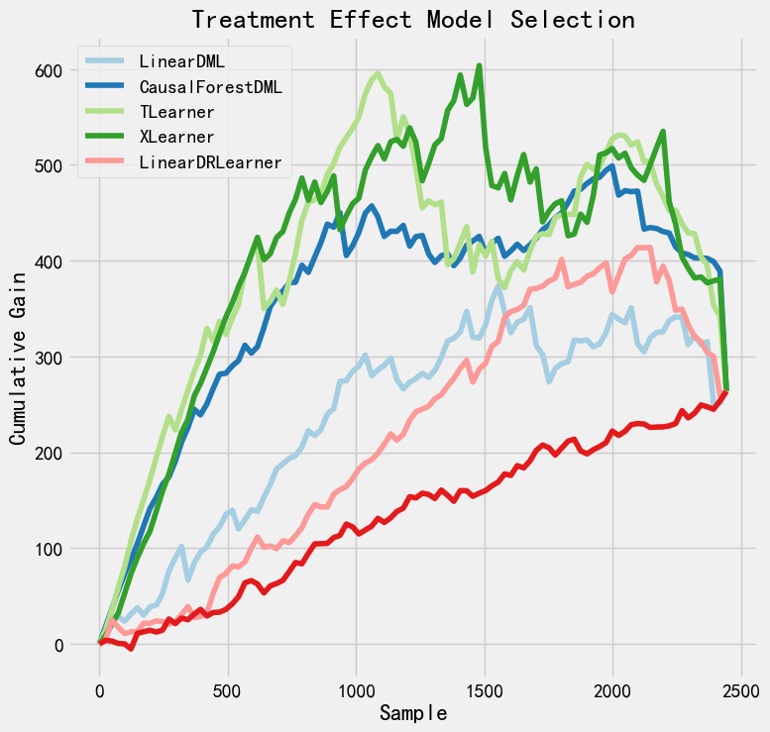

Fig. 1 AUUC Curves for Various Models

Table 1 Model Validity Significance
Model | Significance p
LinearDML | 0.67
CausalForestDML | 0.34
Tlearner | 0.07
XLearner | 0.02
LinearDRLearner | 0.43

Effectiveness Improvement
TLearner can accommodate various learning functions, taking into account the complex nonlinear relationships present in the data. In this study, Support Vector Regression (SVR) is used as the base learning function for the TLearner meta-learner. The advantage of SVR is that it predicts variables by constructing a loss function that is as flat as possible while minimizing it, allowing for a certain degree of error (ϵ-insensitivity) while using different kernel functions to achieve linear or nonlinear model predictions. This results in relatively accurate predictions without making the model overly complex. The formula is as follows:
$$min\frac{1}{2}|w|^{2}+c\sum_{i=1}^{n}{\left(ξ_{i}+ξ_{i}^{*}\right)}$$

Considering the characteristics of the data in this study, the Radial Basis Function (RBF) kernel is used for prediction. The core idea of the RBF kernel is to compute the Euclidean distance between two sample points, with closer distances indicating higher similarity. The formula is as follows:
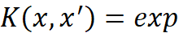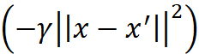
Here, K(x,x′) is the RBF kernel value for the input samples x and x′. 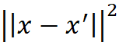 is the squared Euclidean distance between the sample points. 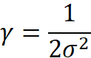​ is another commonly used hyperparameter that determines the shape of the RBF kernel. To enhance model performance, this study sets the regularization parameter C in the SVR model to 2 to relatively strongly reduce training error and improve model performance, while setting γ in the RBF function to 0.05 to moderately enhance control over the global trend of the model and improve local data sensitivity. The ϵϵ is set to 0.04 to control sensitivity to small fluctuations in data and avoid overfitting. After these adjustments, the model significance p-value reached 0.027 (<0.05).

