Optimization of Manganese Oxidation Engineering Bacteria BL21-pET-copA
Wenwei Tang^{a,b}, Qisen Qinª, Xiaoxuan Liª, Xinping Zeng^{c,*}
a School of Chemical Science and Engineering, Tongji University, Shanghai, 200092, China
b Shanghai Key Laboratory of Chemical Assessment and Sustainability, Tongji University, Shanghai, 200092, China
c School of Life Sciences and Technology, Tongji University, Shanghai, 200092, China
# Correspondence to:
Author Xinping Zeng
E-mail: zengxp@tongji.edu.cn

Table S1 Primers used in the experiment

Primer | Sequence (5′-3′)
infA-F | catgttagtcatgccccgc
infA-B | ctcactcattaggcaccggg
U-infA-F | gcgagcgatccagaagatct
U-infA-B | gggtaaaggatgccacagaca
D-infA-F | ggaaatgagcatccagtatggcc
D-infA-B | gtagtttttgcgcattttaccggag
16S-F | gagcgaacaggattagataccc
16S-B | cgtcgaattaagccacatgc

Table S2 Primer PCR amplification of infA gene and its upstream and downstream gene fragments, PCR reaction system

Component | Volume (μL)
Plasmid | 1.0
Forward Primer (10 μM) | 1.0
Reverse Primer (10 μM) | 1.0
2×TransStart® FastPfu PCR SuperMix | 25
Nuclease-free Water | 22
The PCR reaction conditions：
（1）infA gene. 95℃，2 min；95℃，30 sec；60℃，20 sec；72℃，20 sec， 30 cycles；72℃，5 min.
（2）Upstream homologous genes. 95℃，2 min；95℃，30 sec；58.3℃，20 sec；72℃，20 sec，30 cycles；72℃，5 min.
（3）Downstream homologous genes. 95℃，2 min；95℃，30 sec；61.2℃，20 sec；72℃，20 sec，30 cycles；72℃，5 min.

Table S3 Double enzyme digestion reaction system (unit: μL)

 | Hind III | Nde I | Buffer | ddH₂O | Total Volume
Gene of interest10 | 0.6 | 0.6 | 3.0 | 15.8 | 30
Plasmid 20 | 0.6 | 0.6 | 3.0 | 5.8 | 30

Table S4 Construction of 3 pairs of primers for domain deletion strains

Primer Name | Sequence (5’to3’) | Location
copA-1F | GGAATTCCATATGACCGCTAAGGAAAGTATGC | Domain 1 upstream primers
copA -1R | CCCAAGCTTTTAAGCATCCTTCGGCTCG | Domain 1 downstream primers
copA -2F | GGAATTCCATATGAAAGACTTTACTCTTGTGCTG | Domain 2 upstream primers
copA -2R | CCCAAGCTTTTAGGGAATTGCCAGAGATTTC | Domain 2 downstream primers
copA -3F | GGAATTCCATATGTCACTTGATGATCAATACGAC | Domain 3 upstream primers
copA -3R | CCCAAGCTTTTATCCATCGTATTTTACTTCTGAC | Domain 3 downstream primers

Table S5 The copA gene was used as a template to amplify the gene of interest, PCR reaction system

Component | Volume (μL)
Plasmid | 1.0
Forward Primer (10 μM) | 1.0
Reverse Primer (10 μM) | 1.0
2×TransStart® FastPfu PCR SuperMix | 25
Nuclease-free Water | 22
PCR reaction conditions：95℃，2 min；95℃，20 sec；55℃，20 sec；72℃，20 sec，30 cycles；72℃，5 min.

Table S6 4 pairs of primers for site-directed mutation

Primer Name | Sequence (5’to3’) | Function
copA -BF | GGTACGTACTGGTACAATTCCCACCA | Mutate the conserved site H162 to N162
copA -BR | TGTACCAGTACGTACCAGGTACATCT | Mutate the conserved site H162 to N162
copA -CF | TCGCCTGAAGACATTAACCCTATGCA | Mutate the conserved site H442 to N442
copA -CR | TAATGTCTTCAGGCGAACGATTCACCA | Mutate the conserved site H442 to N442
copA -DF | GGAAACTGGATGTTCAACTGTCATGA | Mutate the conserved site H494 to N494
copA -DR | TGAACATCCAGTTTCCTGGATTATCT | Mutate the conserved site H494 to N494

Table S7 Point mutation PCR reaction system

Component | Volume (μL)
Plasmid | 1.0
Forward Primer (10 μM) | 1.0
Reverse Primer (10 μM) | 1.0
2×TransStart® FastPfu PCR SuperMix | 25
Nuclease-free Water | 22
PCR reaction conditions: 94℃，3 min；94℃，20 sec；55℃，20 sec；72℃，3 min，23 cycles；72℃，10 min.

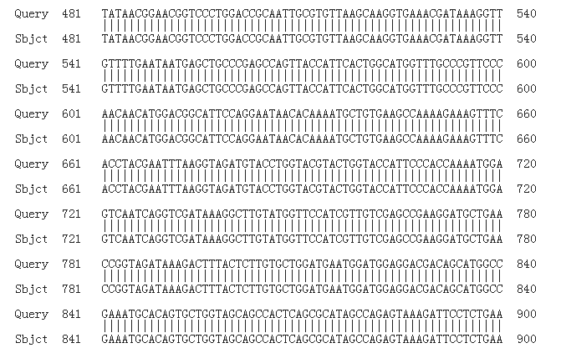
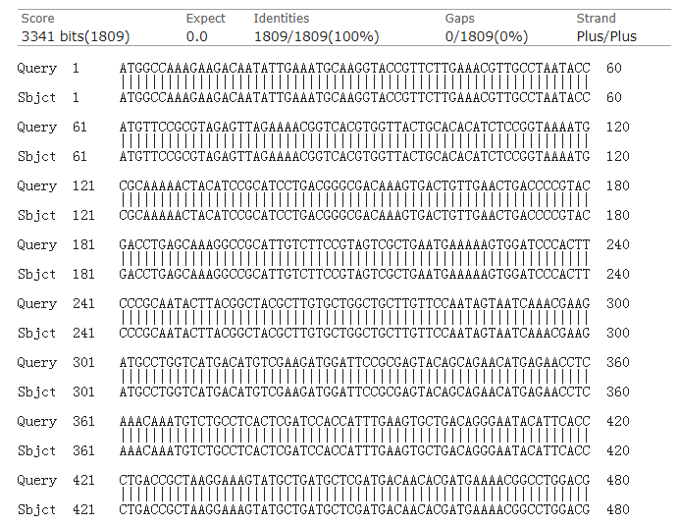
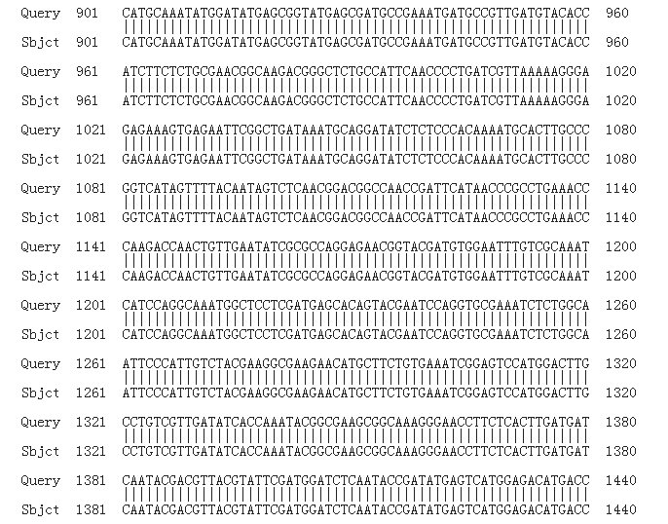
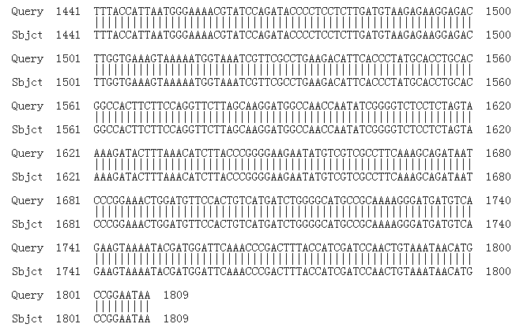
Figure S1 Sequencing results of engineering bacteria ATCC-pET- copA&infA
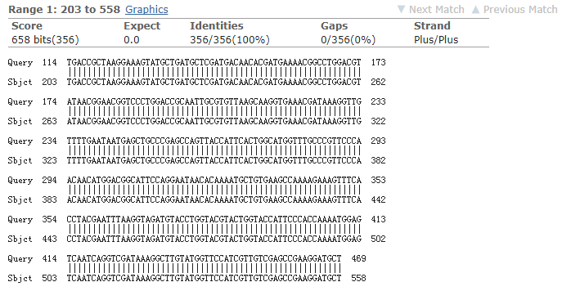
Figure S2 (1) Sequencing results of engineering bacteria BL21-pET-copA-△2&3

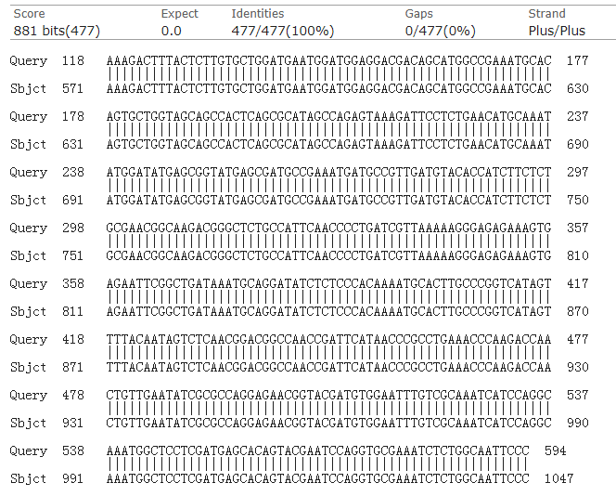
Figure S2 (2) Sequencing results of engineering bacteria BL21-pET-copA-△1&3
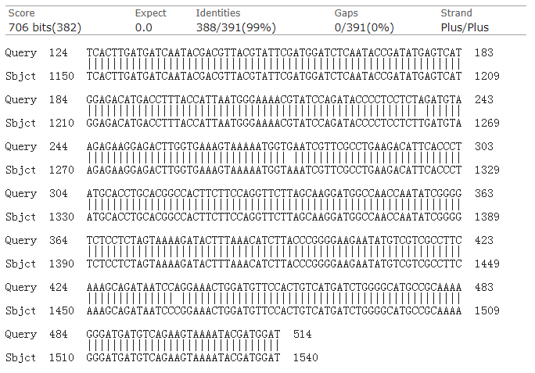
Figure S2 (3) Sequencing results of engineering bacteria BL21-pET-copA-△1&2
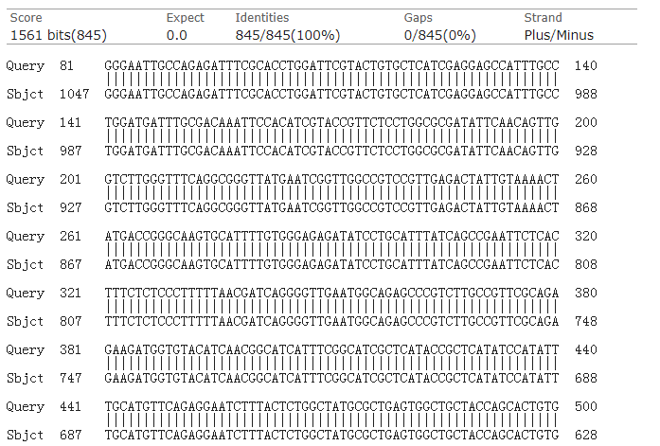
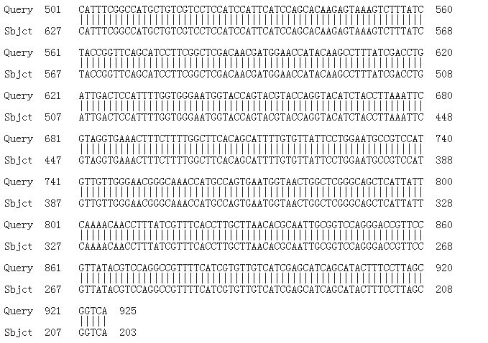
Figure S2 (4) Sequencing results of engineering bacteria BL21-pET-copA-△3

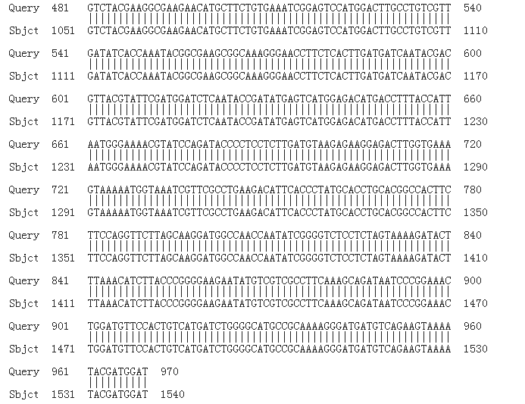
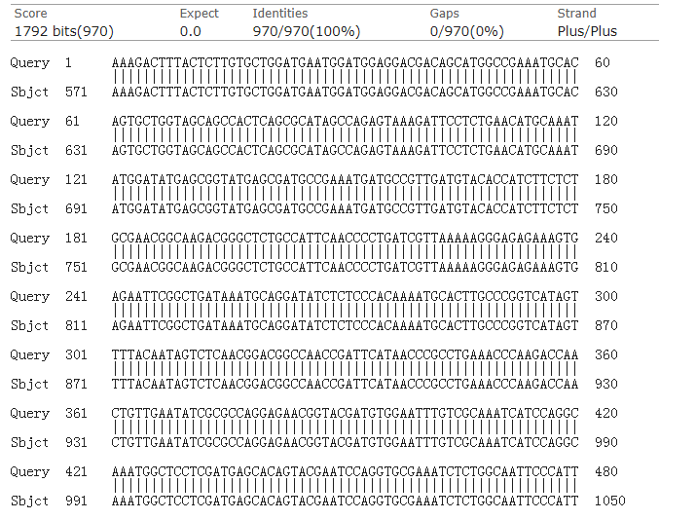
Figure S2 (5) Sequencing results of engineering bacteria BL21-pET-copA-△1

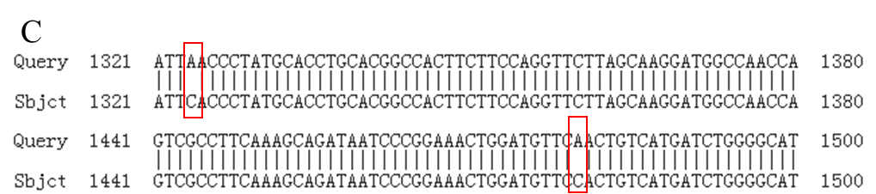
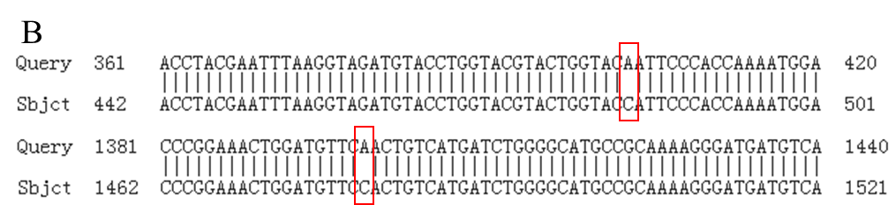
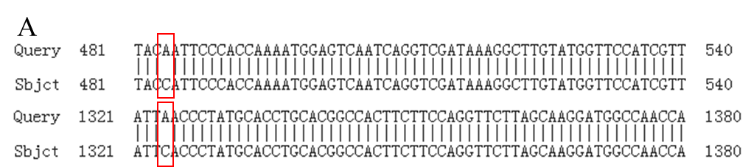
Figure S3 Sequencing results of three multi-point mutant strains. A: H162N/H442N; B: H162N/H494N; C: H442N/H494N

