Performance Evaluation of Input Scenarios for LSTM-based Water Stage Forecasting: A Case Study in Pajiang River Detention Basin
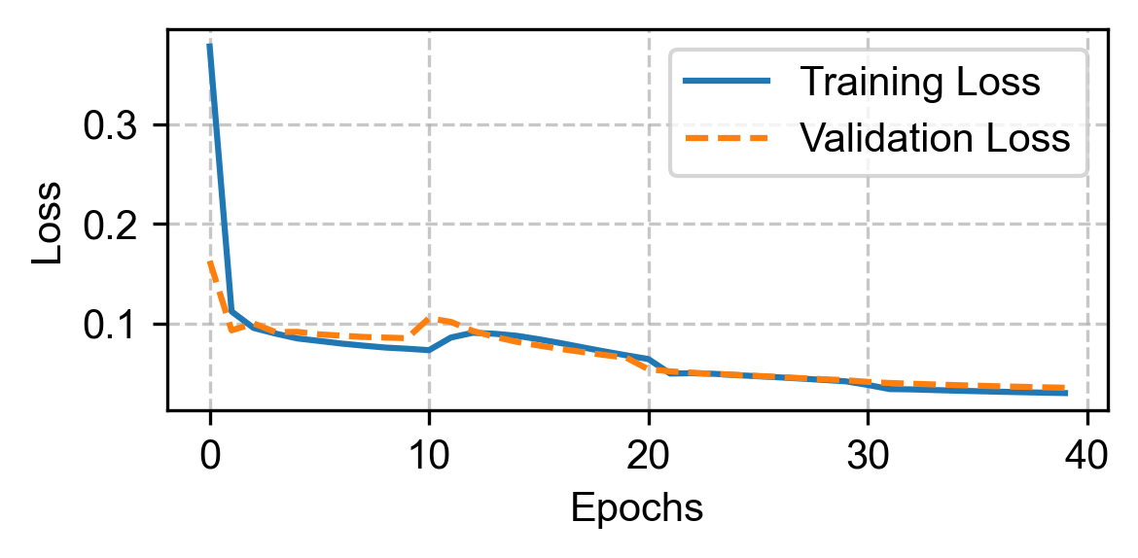
Figure S1. Epoch-loss plot

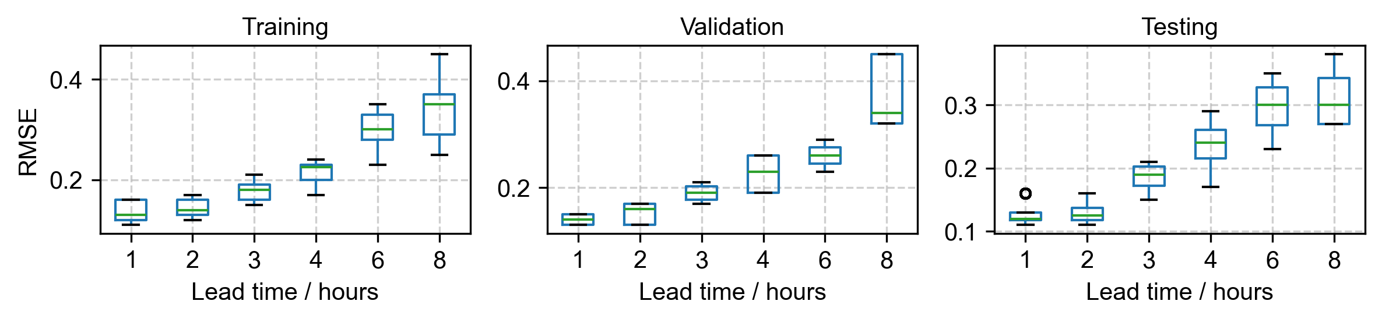
a) Scenario 1
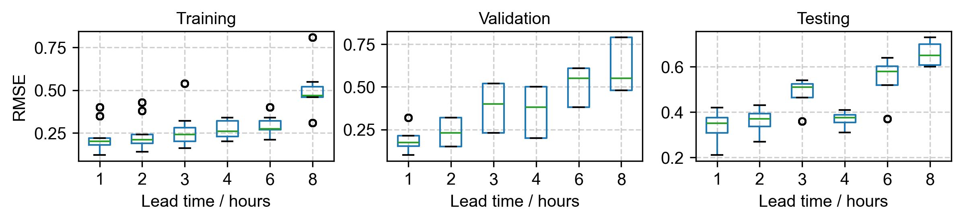
b) Scenario 2
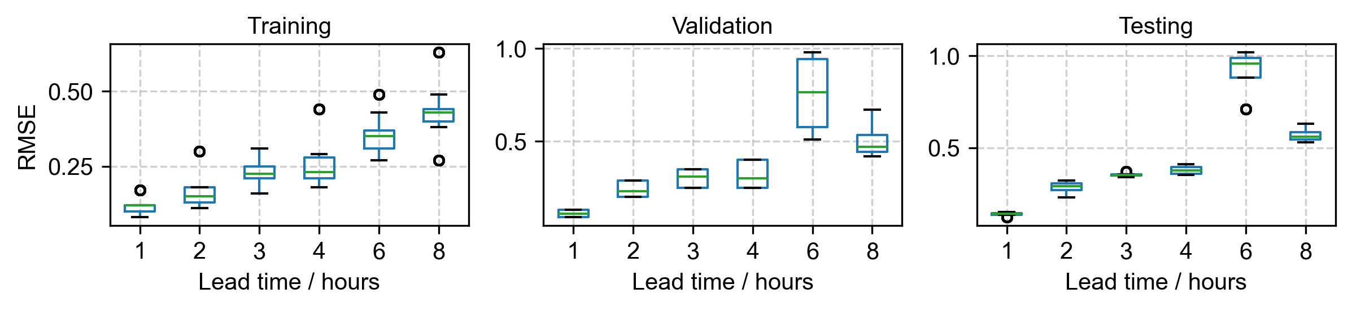
c) Scenario 3
Figure S2. Performance of water stage predictions across lead times of 1, 2, 3, 4, 6, and 8 hours, with a fixed input time step of 10 hours, during the training, validation, and testing stages.

