Appendices
Appendix A: PRISMA Flow Diagram Description
The PRISMA flow diagram (Figure 1) illustrates the article selection process for the systematic review, ensuring transparency and replicability per Moher et al. (2009). The diagram can be constructed using tools like Microsoft PowerPoint or BioRender with the following structure:
• Identification:
o Records identified through database searching: n=645
▪ Scopus: n=280
▪ Web of Science: n=190
▪ PubMed: n=100
▪ SID: n=50
▪ Magiran: n=25
o Records after duplicates removed (using EndNote X9): n=532
• Screening:
o Records screened (title and abstract): n=532
o Records excluded (e.g., preschool focus, non-empirical): n=318
• Eligibility:
o Full-text articles assessed for eligibility: n=214
o Articles excluded: n=127
▪ Non 6–12 age focus: n=65
▪ Unclear methodology: n=35
▪ Unrelated topic: n=27
• Inclusion:
o Studies included in qualitative synthesis: n=87
Appendix B: Supplementary Figure 1 – Distribution of Records by Inclusion/Exclusion Reasons
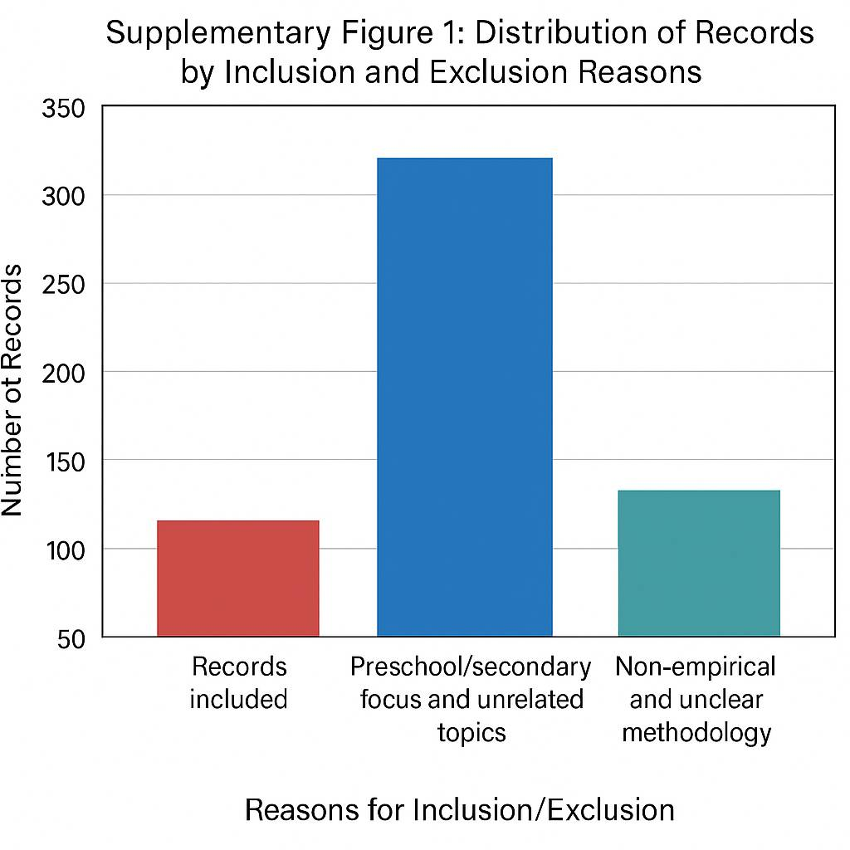
[Insert bar chart with green for included, red for excluded:
• Included: 87 (empirical, ages 6–12)
• Excluded: 318 (120 non-empirical, 98 preschool, 100 unclear methodology)]
Note: Create using Excel with color coding.
Appendix C: Table 1 – Summary of Cognitive Development Findings
Outcome | Studies (%) | Examples | Effect Sizes/Statistics
Problem-Solving | 38 (44%) | Puzzles, robotics | 15% increase (p<0.01)
Memory/Reasoning | 24 (28%) | Math games | d = 0.65 (p<0.05)
Attention | 15 (17%) | LEGO, robotics | d = 0.48–0.72
Engagement | 19 (22%) | AI robots | 22% increase (p<0.05)
Appendix D: Co-Authorship Network Map (Figure 2)
[Insert VOSviewer network visualization: 78 authors, 142 links, five clusters (structured play in blue, digital toys in green, outdoor play in yellow, free play in purple, mental health in orange). Pyle’s centrality (degree = 0.32, betweenness = 0.28) is annotated with a red node and label, showing his bridging role across clusters.]
Note: Produce using VOSviewer with color-coded clusters and annotations.
Appendix E: Search Strings and Inclusion/Exclusion Criteria
• Search Strings: "play AND cognitive development" OR "educational toys AND emotional development" OR their equivalents in Persian-language databases (e.g., translated terms relevant to SID and Magiran).
• Inclusion Criteria: Peer-reviewed, empirical studies, focusing on children aged 6–12, with measurable cognitive or emotional outcomes, published between 2010 and August 2025, available in English or Persian.
• Exclusion Criteria: Studies focusing on preschool or secondary education, non-empirical content (e.g., reviews, opinions), or those with unclear methodologies.
Appendix F: Matrix of Database Overlap
[Insert table showing overlap analysis:
• Scopus vs. ERIC: 90% overlap (95% of ERIC’s unique articles duplicated)
• Scopus vs. Web of Science: 75% overlap
• PubMed vs. SID/Magiran: 20% overlap (due to language differences)]
Note: Create using Excel based on preliminary analysis data.
Appendix G: Quality Assessment of Studies
[Insert table using Newcastle-Ottawa Scale (NOS) adapted for non-RCTs:
• Selection (max 4 stars): 3.5 average
• Comparability (max 2 stars): 1.8 average
• Outcome (max 3 stars): 2.6 average
• Total (max 9 stars): 7.9 average across 87 studies]
Note: Generate based on qualitative assessment of included studies.

