Matrix metalloproteinase-7 induces E-cadherin cleavage in acid-exposed primary human pharyngeal epithelial cells via the ROS/ERK/c-Jun pathway

Nu-Ri Im¹, Byoungjae Kim^{1,2}, Kwang-Yoon Jung¹, Seung-Kuk Baek¹
¹Department of Otorhinolaryngology-Head and Neck Surgery, Korea University, College of Medicine, Seoul, South Korea;
²Neuroscience Research Institute, Korea University, College of Medicine, Seoul, Republic of Korea

Supplementary Figure 1. Reactive oxygen species (ROS) and matrix metalloproteinase-7 (MMP-7) levels in human pharyngeal mucosal epithelial cells exposed to acidic media. (Full-length blots/gels of Figure 1)

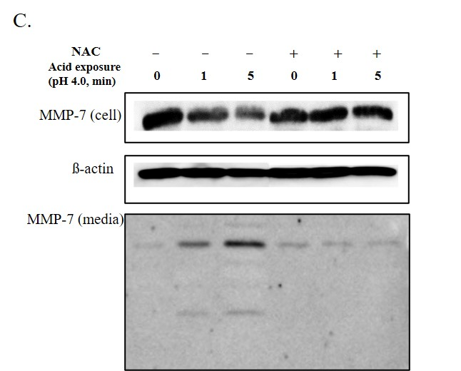

Supplementary Figure 2. Regulation of the mitogen-activated protein kinase (MAPK) pathway after acid treatment. (Full-length blots/gels of Figure 2)

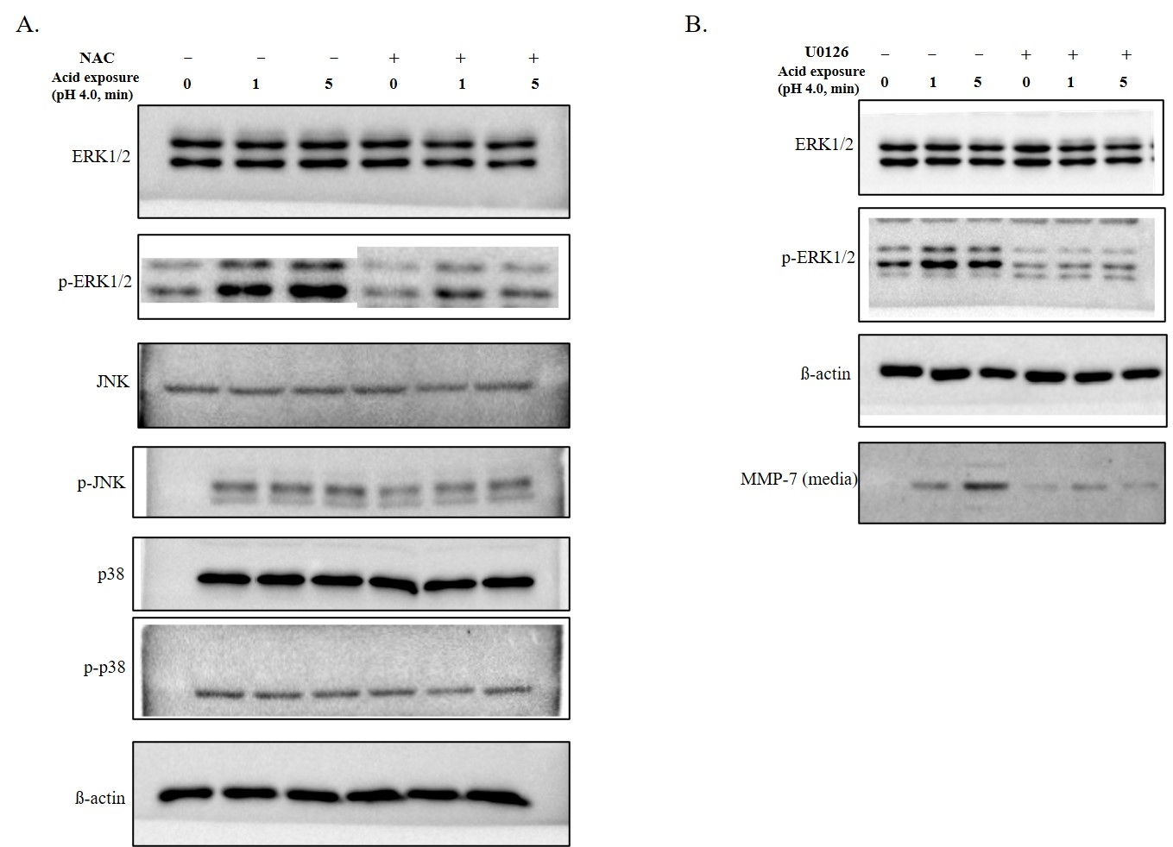
Supplementary Figure 3. Expression of transcription factors influenced by ERK inhibition. (Full-length blots/gels of Figure 3)

