Supporting Data

Source identification and risk assessment of potentially toxic elements in surface soil of townships in the northwest Hebei region
Zhanbin Wang^{a,†} , Daokun Chen^{a,†,*}, Xinbin Li^{a,b,*}, Ke Yangª, Dongxiang Jiangª, Donglin Wangª, Liannan Shangª, Yuekun Wangª, Tao He^{c}

ª Xi’an Mineral Resources Survey, China Geological Survey, Xi'an 710100 China
^{b} Qinling--Loess Plateau Transition Zone Observation and Research Station for Coupling of Soil and Water Elements and Conservation of Biological Resources
^{c} Research Center of Applied Geology of China Geological Survey, Chengdu 610036 China
* Corresponding author, e-mail: cdkun1008@163.com，lixinbin@mail.cgs.gov.cn
† These authors contributed equally to this work

Table S1
Grading criteria for potential ecological risk factor and potential ecological risk index
Grade classification（E^{i}_{r}） | Grade classification（RI） | Pollution level
$E_{r}^{i}$<40 | RI<150 | Low risk
40≤$E_{r}^{i}$＜80 | 150≤RI<300 | Moderate risk
80≤$E_{r}^{i}$＜160 | 300≤RI<600 | Considerable risk
160≤$E_{r}^{i}$＜320 | RI≥600 | High risk
$E_{r}^{i}$≥320 | - | Very high risk

Table S2
Reference values of exposure parameters for human health risk assessment[1]
Parameter | Parameter | Unit | adult | Children
IngR | Ingestion rate of soil | mg/day | 100 | 200
InhR | Inhalation rate of soil | m³/day | 14.5 | 7.5
EF | Exposure frequency | day/year | 350 | 350
ED | Exposure duration | year | 24 | 6
BW | Body weight | kg | 56.8 | 15.9
AT | Average exposure time  (carcinogens) | day | 25550 | 25550
AT | Average exposure time  ( non-carcinogens) | day | 8760 | 2190
PEF | Particle emission factor | m³/kg | 1.36E+09 | 1.36E+09
SA | Skin area available for soil contact | cm² | 5075 | 2448
AF | Soil-to-skin adherence factor | mg/cm²/day | 0.07 | 0.2
ABS | Absorption factor | - | 0.001 | 0.001

Table S3
Distributional characteristics of parameters in monte carlo simulations
Heavy metals | RfD（mg$/(kg∙d)$） |  |  |  | SF（$\left(kg∙d\right)/mg$）
Heavy metals | ingestion | inhalation | dermal  contact |  | ingestion | inhalation | dermal contact
Cr[1] | 3.00E-03 | 2.86E-05 | 6.00E-05 |  | 5.00E-01 | 4.20E+01 | 2.00E+01
Ni[1] | 2.00E-02 | 2.06E-02 | 5.40E-03 |  | 1.70E+00 | 8.40E-01 | 4.25E+01
As[2] | 3.00E-04 | 1.23E-04 | 3.00E-04 |  | 1.50E+00 | 1.51E+01 | 3.66E+00
Hg[2] | 1.60E-04 | 8.60E-05 | 3.00E-04 |  | - | - | -
Cu[3] | 4.00E-02 | 4.02E-02 | 1.20E-02 |  | - | - | -
Zn[3] | 3.00E-01 | 3.00E-01 | 6.00E-02 |  | - | - | -
Cd[3] | 1.00E-03 | 1.00E-05 | 1.00E-05 |  | 5.10E-01 | 6.30E+00 | 2.00E+01
Pb[3] | 3.50E-03 | 3.50E-03 | 5.25E-04 |  | 8.50E-03 | - | -

Table S4
Distribution settings for each parameter in the Monte Carlo simulation[4]
Parameter | Unit | Type
IngR | mg/day | lognormal
InhR | m3/day | lognormal
EF | day/year | trigular
ED | year | uniform
BW | kg | normal
AT | day | point
PEF | m3/kg | point
SA | cm2 | lognormal
AF | mg/cm2/day | Beta
ABS | - | point

Table S5
Principal component analysis of soil trace elements in the study area
PCA | Initial eigenvalue |  |  |  | Extract the sum of the squares of the loads |  |  |  | Rotational load square sum
PCA | Total | Var(%) | Acc(%) |  | Total | Var(%) | Acc(%) |  | Total | Var(%) | Acc(%)
1 | 3.870 | 48.38 | 48.38 |  | 3.870 | 48.38 | 48.38 |  | 3.294 | 41.17 | 41.17
2 | 1.398 | 17.48 | 65.86 |  | 1.398 | 17.48 | 65.86 |  | 1.080 | 13.50 | 54.67
3 | 0.952 | 11.91 | 77.76 |  | 0.952 | 11.91 | 77.76 |  | 1.040 | 13.00 | 67.67
4 | 0.659 | 8.24 | 86.00 |  | 0.659 | 8.24 | 86.00 |  | 1.019 | 12.73 | 80.41
5 | 0.556 | 6.95 | 92.95 |  | 0.556 | 6.95 | 92.95 |  | 1.004 | 12.55 | 92.95
6 | 0.252 | 3.15 | 96.11
7 | 0.195 | 2.43 | 98.54
8 | 0.117 | 1.46 | 100.00

Figure SI
The factor loading matrix after rotation
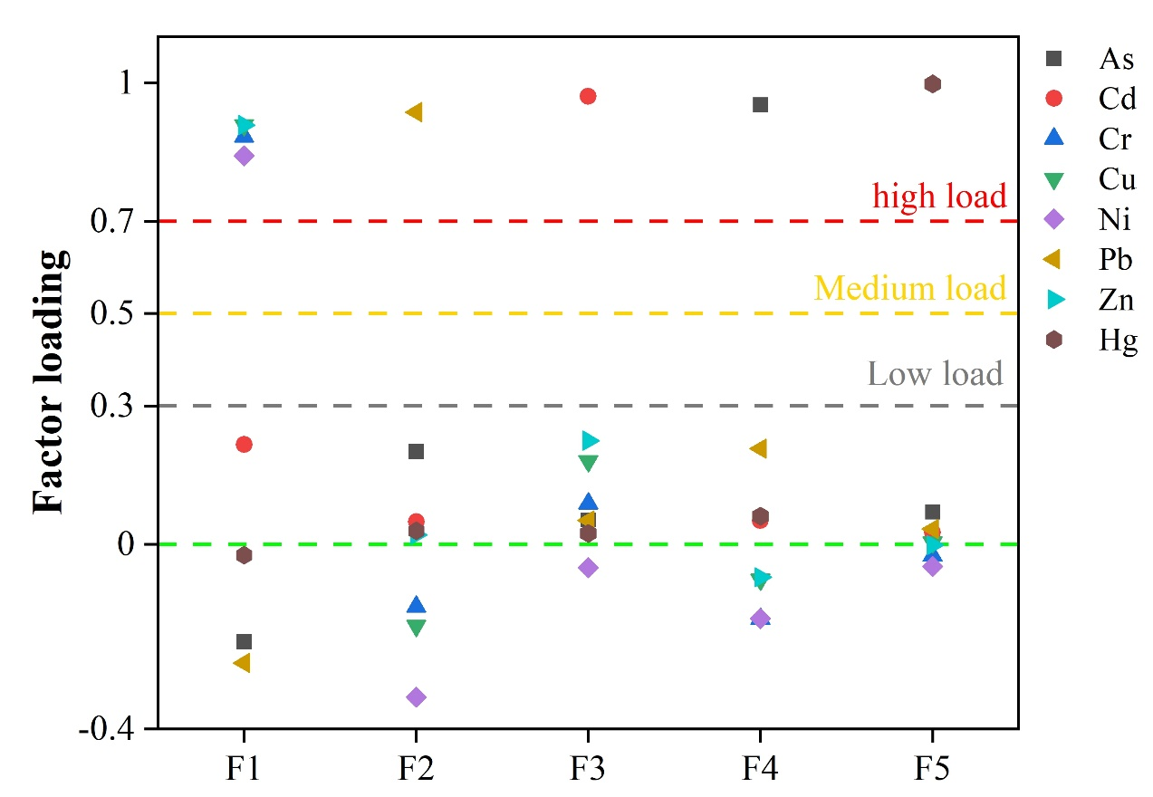

References
[1] Z. Liu, Q. Du, Q. Guan, H. Luo, Y. Shan, W. Shao, A Monte Carlo simulation-based health risk assessment of heavy metals in soils of an oasis agricultural region in northwest China, Sci. Total Environ. 857 (2023) 159543. https://doi.org/10.1016/j.scitotenv.2022.159543.
[2] C. Lin, W. Wang, G. Hu, R. Yu, H. Huang, D. Liao, Incorporating source apportionment and bioaccessibility into human health risk assessment of heavy metals in a soil-rice system in the Jiulong River basin, southeast China, Journal of Food Composition and Analysis 124 (2023) 105692. https://doi.org/10.1016/j.jfca.2023.105692.
[3] L. Liu, Y. Li, X. Gu, R.X.S. Tulcan, L. Yan, C. Lin, J. Pan, Priority sources identification and risks assessment of heavy metal(loid)s in agricultural soils of a typical antimony mining watershed, Journal of Environmental Sciences 147 (2025) 153–164. https://doi.org/10.1016/j.jes.2023.11.007.
[4] R. Ramesh, M. Subramanian, E. Lakshmanan, A. Subramaniyan, G. Ganesan, Human health risk assessment using Monte Carlo simulations for groundwater with uranium in southern India, Ecotoxicology and Environmental Safety 226 (2021) 112781. https://doi.org/10.1016/j.ecoenv.2021.112781.

