Supplement materials
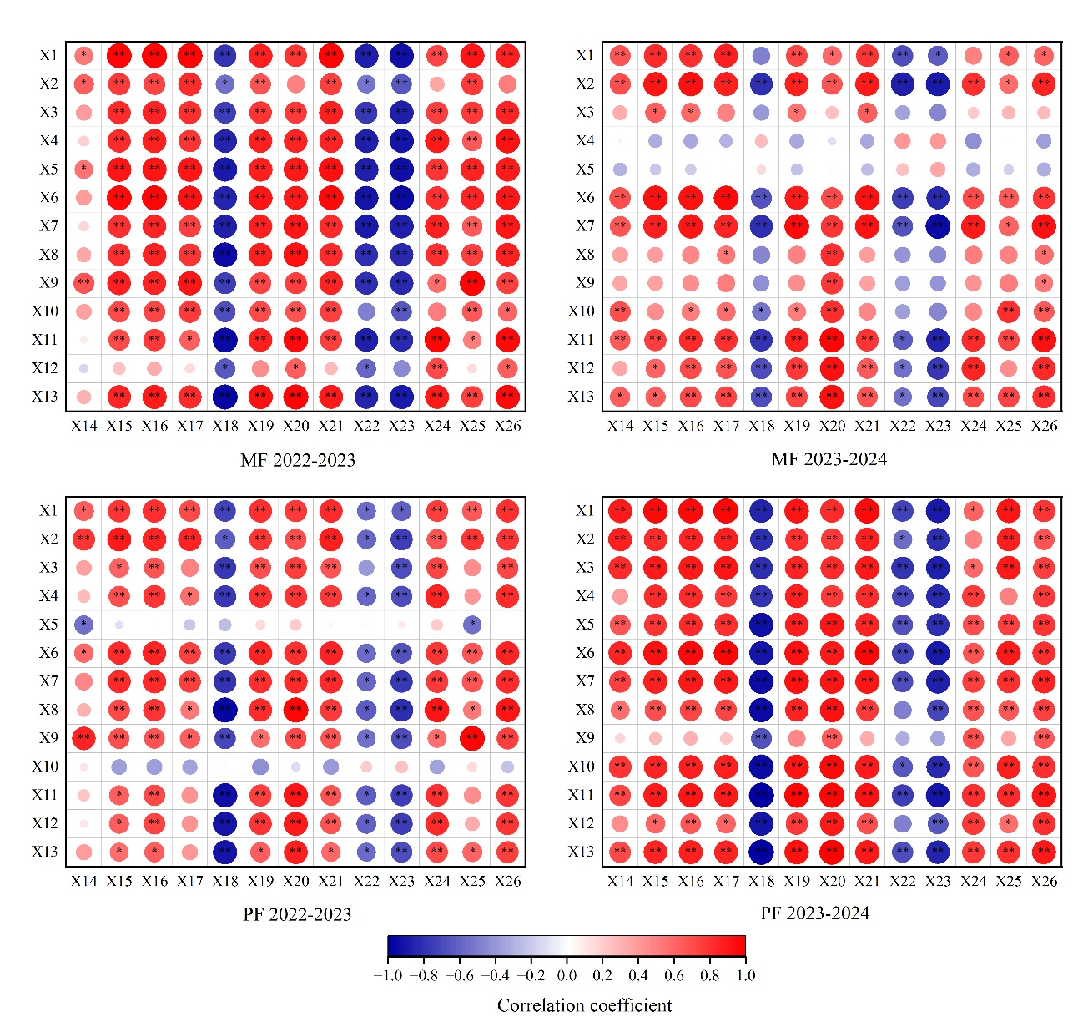
Sup1Fig. 1 Correlation analysis of grain yield, grain quality and N-related indices
X1-X5 represent grain yield, spike number, grain number per spike, 1000-grain weight and harvest index; X6-X13 represent grain protein yield, protein content, albumin, globulin, gliadin, glutenin, glutenin/gliadin and storage protein; X14-X16 represent plants N accumulation at jointing, anthesis and maturity; X17-X18 represent translocation amount and contribution rate to grain of pre-anthesis N; X19-X20 represent accumulation amount and contribution rate to grain of post-anthesis N; X21-X23 represent N accumulation amount in grain, N harvest index and N internal efficiency; X24-X26 represent nitrate-N residue in 0-100 cm, 100-200 cm and 0-200 cm soil depth; respectively. * and ** indicate significant correlations at the 0.05 and 0.01 level, respectively.

SupTable 1 Score coefficient and contribution rate of principal component
Indexes | MF 2022-2023 |  | MF 2023-2024 |  |  | PF 2022-2023 |  | PF 2023-2024
Indexes | Component 1  (C₁) | Component 2  (C₂) | Component 1  (C₁) | Component 2  (C₂) | Component 3  (C₃) | Component 1  (C₁) | Component 2  (C₂) | Component 1  (C₁) | Component 2  (C₂)
Grain yield | 0.048 | 0.048 | 0.044 | 0.221 | 0.027 | 0.048 | 0.083 | 0.044 | 0.160
Spike number | 0.046 | 0.119 | 0.049 | 0.011 | 0.025 | 0.039 | 0.223 | 0.043 | 0.214
Grain number per spike | 0.047 | -0.034 | 0.040 | 0.257 | -0.139 | 0.049 | 0.017 | 0.044 | 0.142
1000-grain weight | 0.046 | -0.089 | -0.032 | 0.235 | 0.380 | 0.047 | -0.072 | 0.041 | -0.150
Harvest index | -0.001 | -0.271 | -0.024 | 0.345 | -0.348 | 0.049 | 0.028 | 0.046 | 0.017
Grain protein yield | 0.049 | 0.038 | 0.049 | 0.093 | -0.011 | 0.049 | 0.023 | 0.045 | 0.118
Protein content | 0.050 | 0.031 | 0.048 | -0.101 | 0.019 | 0.047 | -0.099 | 0.046 | 0.019
Albumin | 0.049 | -0.078 | 0.048 | 0.108 | -0.035 | 0.048 | -0.028 | 0.046 | -0.027
Globulin | 0.038 | 0.204 | 0.046 | 0.157 | -0.074 | 0.043 | 0.113 | 0.026 | -0.427
Gliadin | -0.032 | 0.236 | 0.041 | 0.121 | 0.319 | 0.037 | 0.163 | 0.045 | 0.084
Glutenin | 0.046 | -0.100 | 0.049 | -0.055 | 0.048 | 0.042 | -0.187 | 0.046 | -0.026
Glutenin/gliadin | 0.043 | -0.147 | 0.045 | -0.173 | -0.135 | 0.021 | -0.307 | 0.042 | -0.206
Storage protein | 0.050 | 0.006 | 0.049 | 0.011 | 0.098 | 0.049 | -0.038 | 0.046 | -0.017
N accumulation at jointing | 0.030 | 0.255 | 0.036 | 0.117 | 0.453 | 0.025 | 0.261 | 0.035 | 0.324
N accumulation at anthesis | 0.050 | 0.039 | 0.049 | 0.045 | -0.091 | 0.048 | 0.066 | 0.046 | 0.030
N accumulation at maturity | 0.050 | 0.003 | 0.049 | 0.007 | -0.086 | 0.049 | 0.033 | 0.046 | 0.012
Translocation amount of pre-anthesis N | 0.048 | 0.089 | 0.049 | 0.072 | -0.042 | 0.047 | 0.115 | 0.045 | 0.119
Contribution rate to grain of pre-anthesis N | -0.050 | 0.044 | -0.048 | 0.092 | -0.049 | -0.047 | 0.102 | -0.046 | 0.038
Accumulation amount post-anthesis N | 0.050 | -0.055 | 0.049 | -0.069 | -0.074 | 0.048 | -0.047 | 0.046 | -0.037
Contribution rate to grain of post-anthesis N | 0.050 | -0.044 | 0.048 | -0.092 | 0.049 | 0.047 | -0.102 | 0.046 | -0.038
N accumulation amount in grain | 0.050 | 0.013 | 0.049 | -0.003 | -0.060 | 0.049 | 0.052 | 0.046 | 0.061
N harvest index | -0.049 | -0.007 | -0.046 | -0.067 | 0.201 | -0.047 | 0.071 | -0.043 | 0.205
N internal efficiency | -0.049 | -0.014 | -0.048 | 0.121 | 0.042 | -0.049 | 0.010 | -0.046 | 0.055
Nitrate-N residue in 0-200 cm | 0.050 | 0.001 | 0.047 | -0.146 | 0.101 | 0.047 | -0.098 | 0.042 | -0.212
Eigenvalue | 19.793 | 3.141 | 20.171 | 2.106 | 1.402 | 20.312 | 2.696 | 21.617 | 1.720
Contribution rate (%) | 82.470 | 13.087 | 84.044 | 8.776 | 5.840 | 84.633 | 11.233 | 90.072 | 7.166
Cumulative contribution rate (%) | 82.470 | 95.557 | 84.044 | 92.821 | 98.660 | 84.633 | 95.866 | 90.072 | 97.237
MF, moderate fertility field; PF, poor fertility field.

