Supplemental Online Appendix: From Regulation to Interconnection: Mapping the Evolution of the U.S. Interbank Market

Appendix A: Bank similarity network

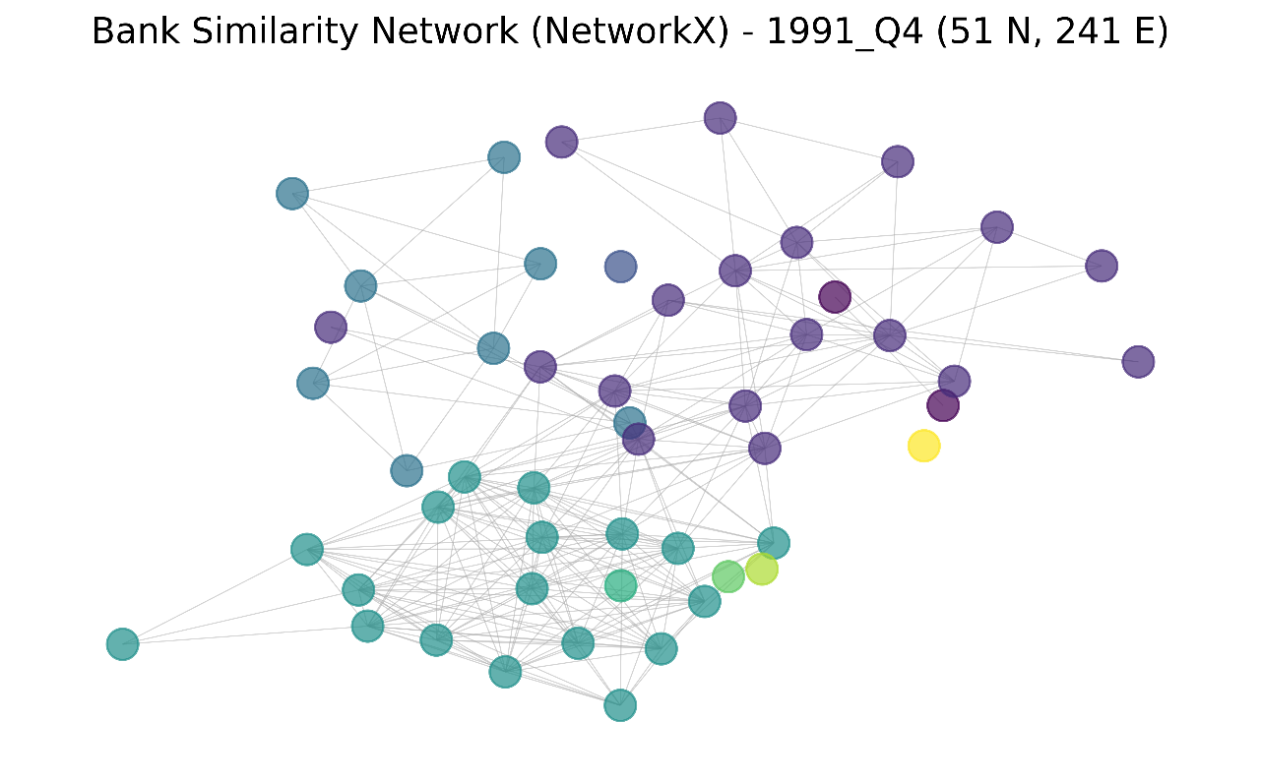
Figure A1. Network reveals a segmented but interconnected interbank system during this period. It involves 51 banks (nodes) and 241 connections.

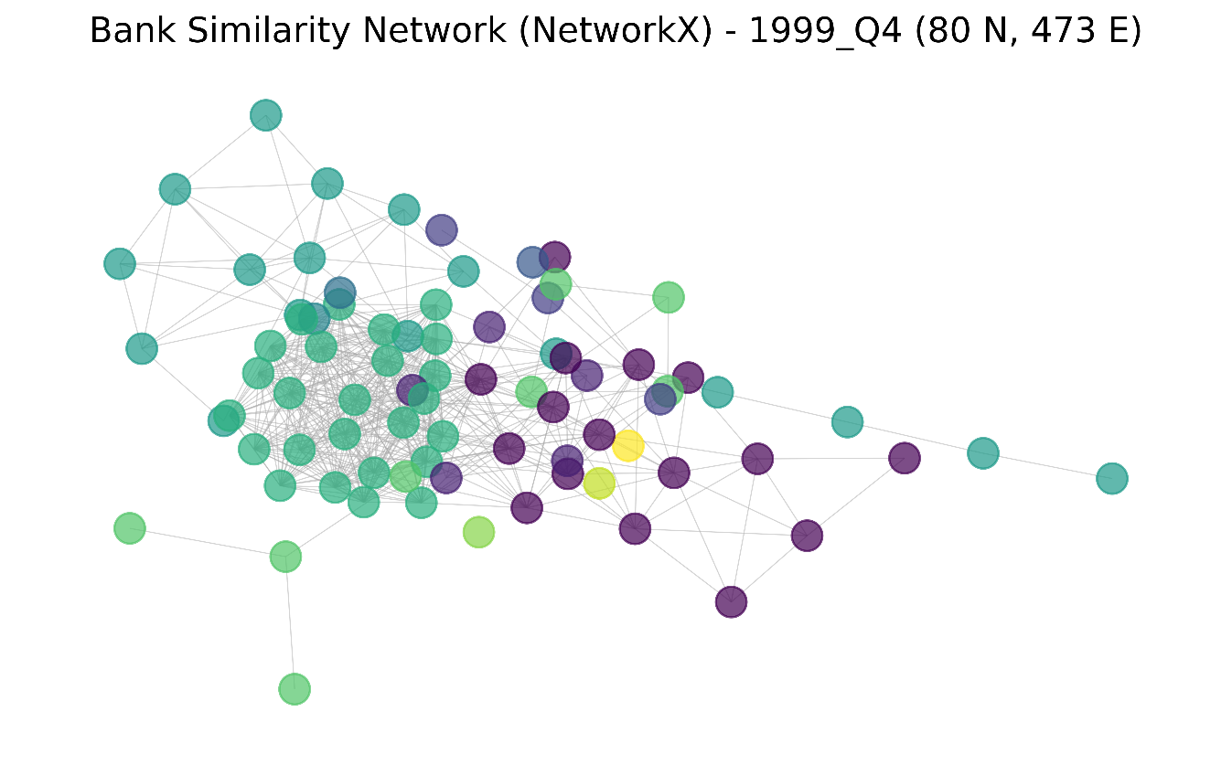
Figure A2. The network reflects an expanded and more integrated interbank system with richer connectivity and evolving structural complexity by 1999. It involves 80 banks (nodes) and 473 connections.
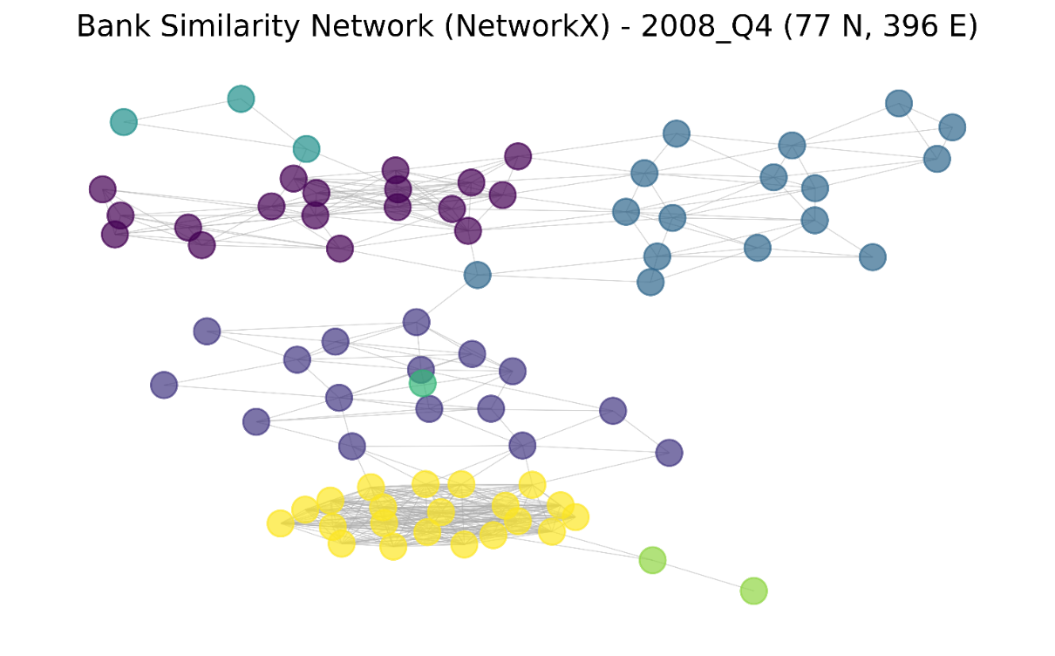
Figure A3. The network shows a modular and less densely interconnected system. It involves 77 banks (nodes) and 396 connections.

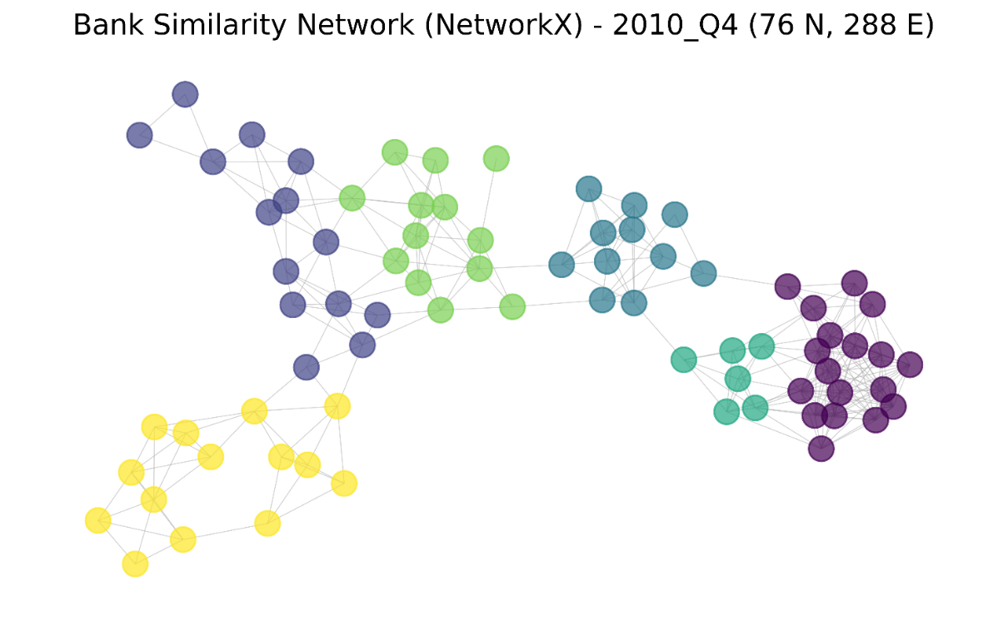
Figure A4. The network exhibits multiple distinct clusters with relatively strong internal connectivity and sparse links between groups. It involves 76 banks (nodes) and 288 connections.

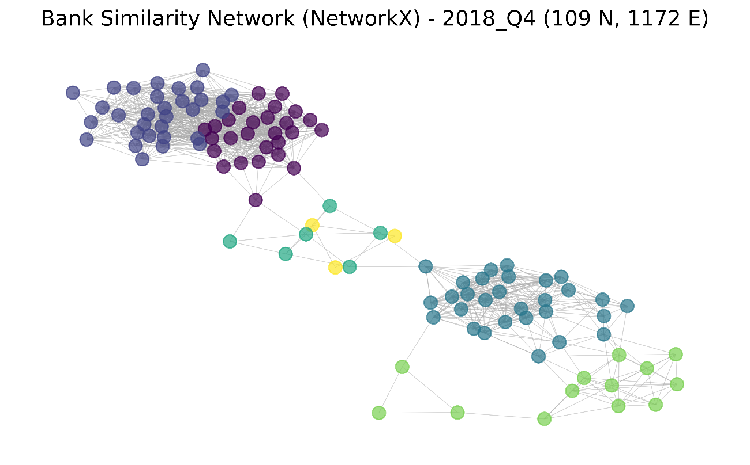
Figure A5. The network displays multiple large, densely connected clusters with strong intra-cluster connectivity, indicating groups of banks with high similarity in their balance sheets. It involves 109 banks (nodes) and 1172 connections.

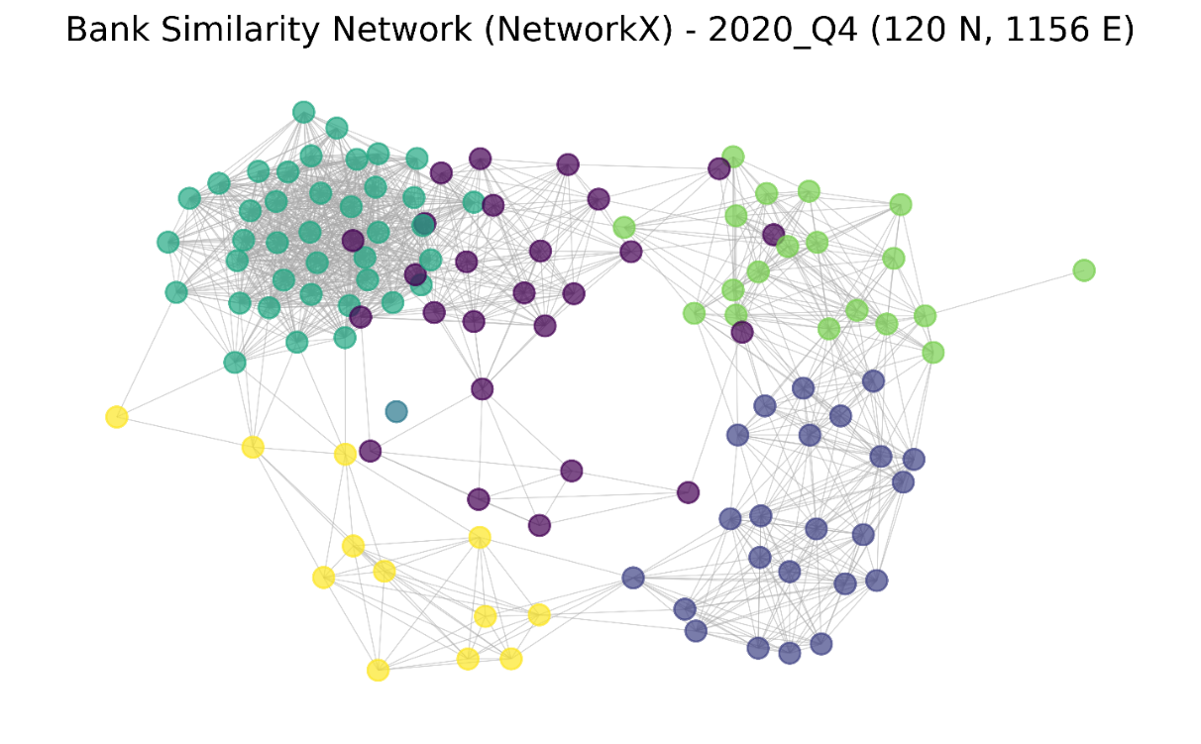
Figure A6. The network features several large, densely connected clusters with strong internal cohesion, reflecting groups of banks with similar balance sheet profiles. It involves 120 nodes (banks) and 1156 connections.

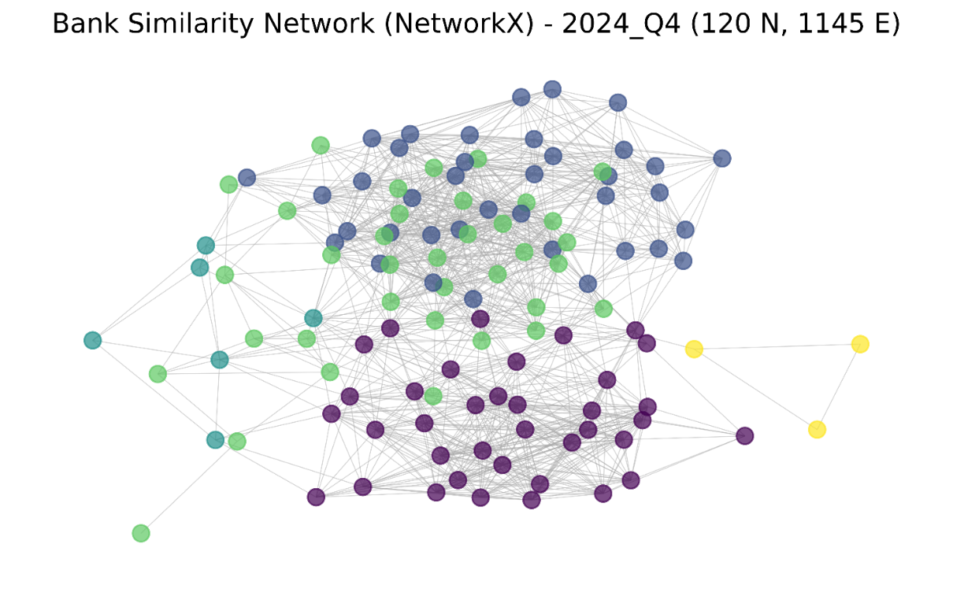
Figure A7. The network appears highly integrated with dense connections spanning most nodes, resulting in less distinct clustering and fewer isolated groups. It involves 120 banks (nodes) and 1145 connections.

Appendix B: Evolution of the interbank network structure

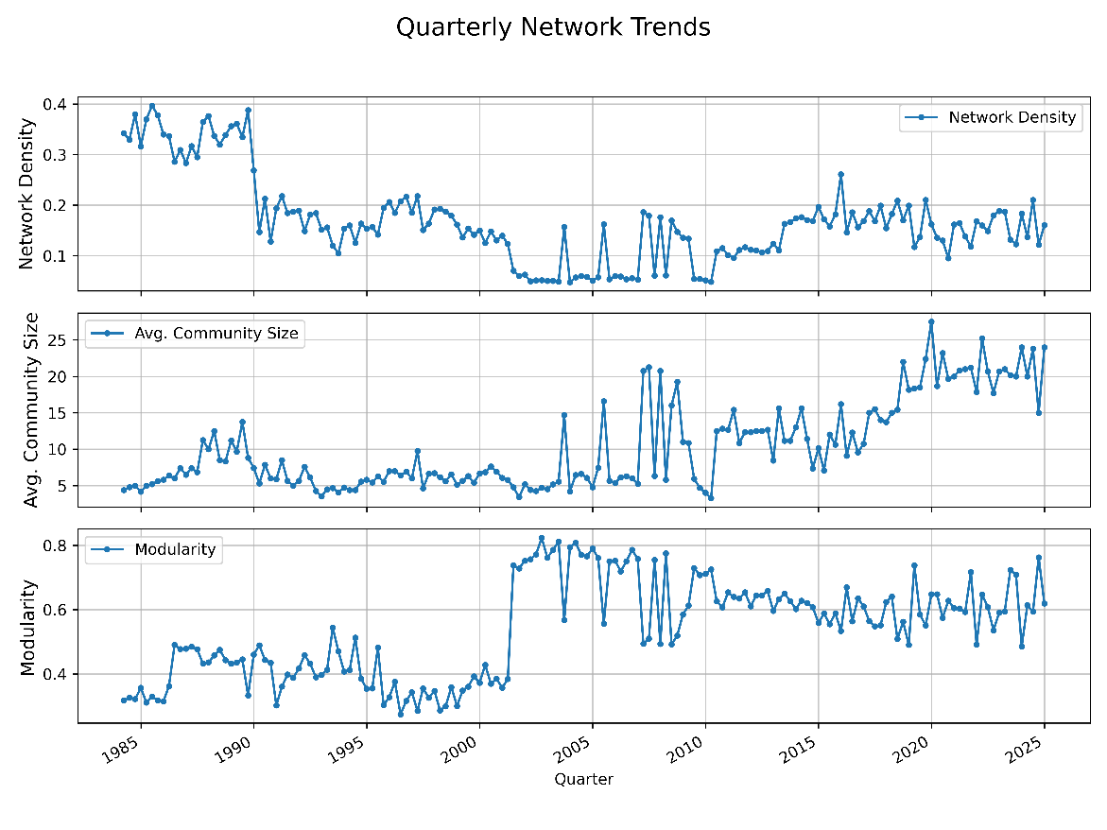
Figure B1. Quarterly network trends – modularity, average community, and network density.

Initially, the network was a dense, interconnected web, but the Riegle-Neal Act of 1994 began encouraging mergers. The most dramatic transformation came with the Gramm-Leach-Bliley Act of 1999, which allowed for the creation of financial “supermarkets.” This is visible in the charts as a sudden, massive spike in modularity, where the system abruptly reorganized from a single tangled web into a collection of distinct and separate banking communities. In the modern era, following the 2008 financial crisis, the Dodd-Frank Act and the Volcker Rule further solidified this structure while making the communities themselves much larger. As crisis-driven consolidation continued and stricter rules favored the largest institutions, these powerful ecosystems grew by absorbing more firms, causing the average community size to skyrocket in recent years. This transformed the banking system from a broadly interconnected network into a landscape dominated by a few massive, internally focused banking groups.

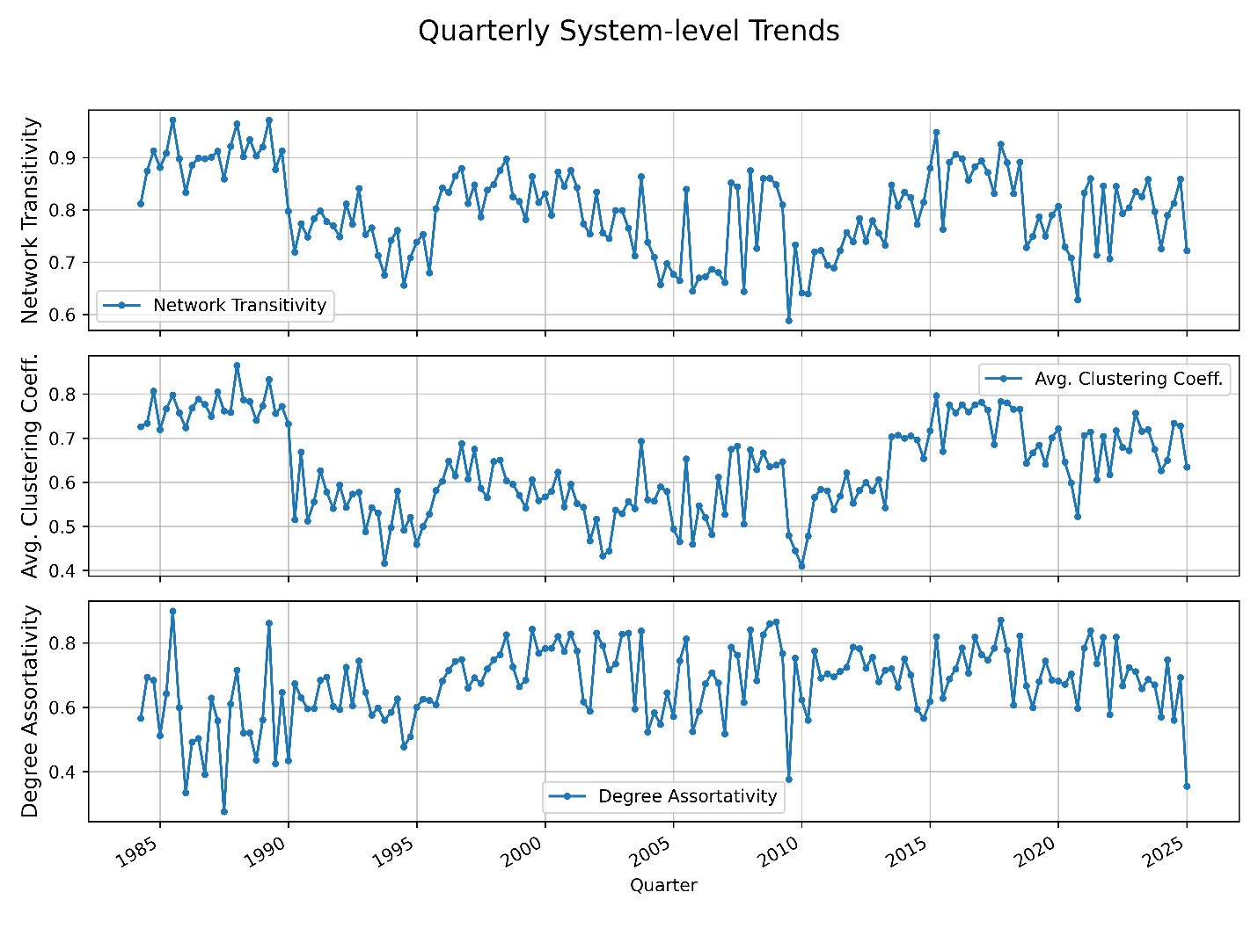
Figure B2. Quarterly system-level trends – degree assortativity, average clustering coefficient, and network transitivity (1984 to 2024).

This figure illustrates how banking regulations reshaped the very fabric of how banks interact, essentially creating and then solidifying a “rich club” of powerful institutions. In the early years, before major deregulation, the banking system was highly “cliquey,” with many local banks forming tight-knit groups, as shown by the very high network transitivity and clustering. The Riegle-Neal Act of 1994, which allowed for interstate mergers, began to change this by breaking up those local cliques, causing the overall “cliquey-ness” to drop. At the same time, this consolidation started building a “rich club” effect, where the newly powerful banks connected more among themselves, a trend visible in the rising degree assortativity. This was supercharged by the Gramm-Leach-Bliley Act, where the network was extremely tight-knit, but the savings and loan (S&L) crisis (Wang 2025) and subsequent regulations like FIRREA and FDICIA in the early 1990s temporarily broke down these close relationships, as seen in the clear dip in both transitivity and clustering. As the system recovered and the Riegle-Neal Act of 1994 fueled a wave of mergers, the network “re-clustered” into new, stable groups. The Gramm-Leach-Bliley Act of 1999 then strengthened the “rich club” effect, allowing for the creation of massive financial conglomerates that became even more central and interconnected with each other, pushing assortativity to a new, higher level. The most dramatic event is the 2008 financial crisis, which caused all three metrics to plunge as trust evaporated and relationships shattered; the especially sharp drop in assortativity shows the “rich club” itself fracturing under the strain. The subsequent Dodd-Frank Act reshaped the system, and as it recovered, a new, more heavily regulated version of this “cliquey,” “rich club” structure re-emerged, demonstrating a resilient but sensitive architecture that bends during crises but ultimately returns to its core form.

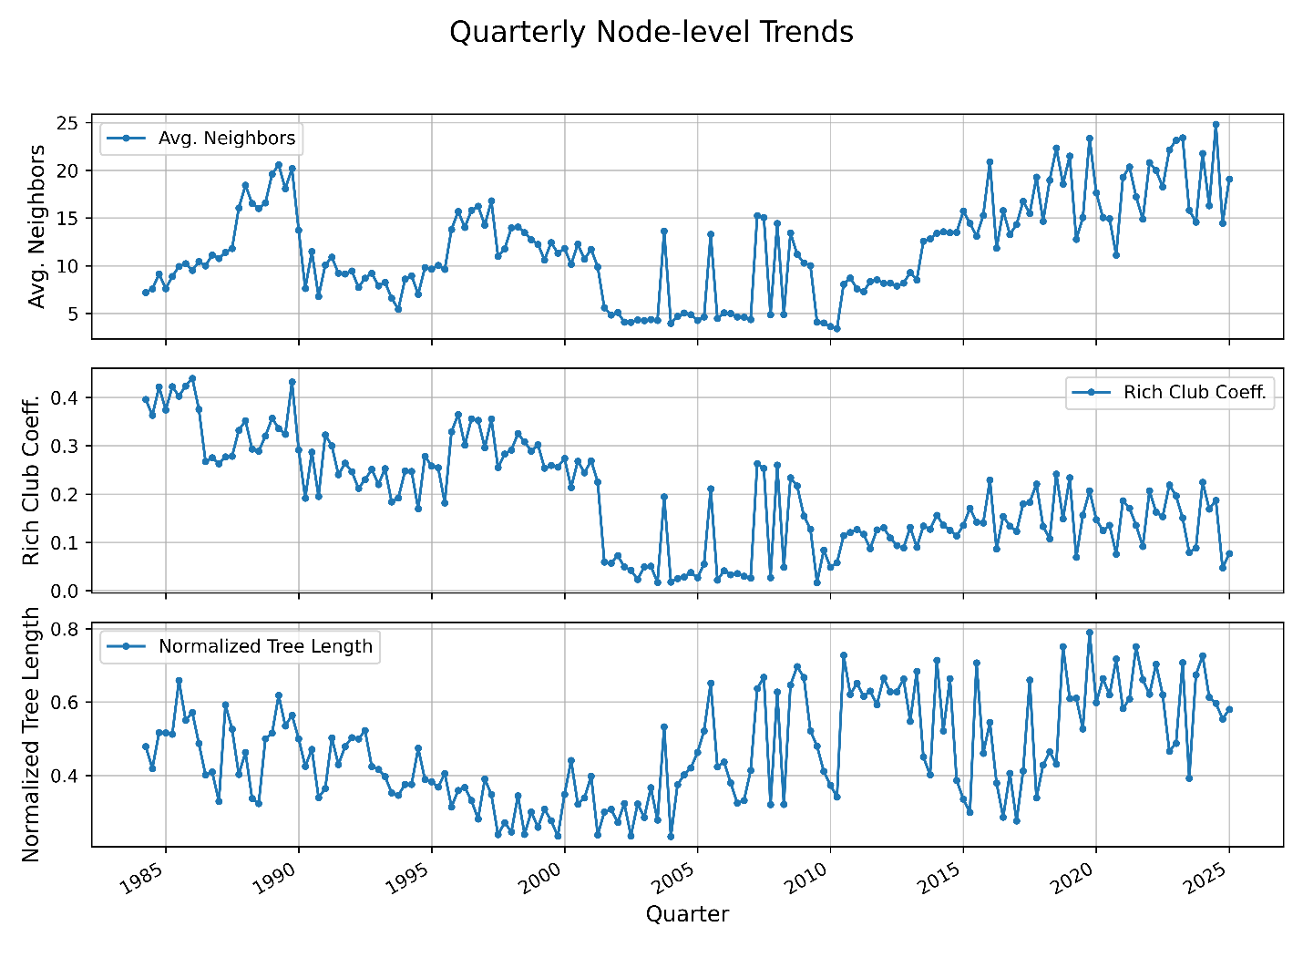
Figure B3. Quarterly node-level trends – average neighbors, rich club coefficient, and normalized tree length (1984 to 2024).

This figure illustrates how regulations and crises directly impacted the power dynamics of the banking system, particularly the formation and behavior of a “rich club” of the most connected banks. In the early 1990s, the S&L crisis (Wang 2025) and regulations like FIRREA caused a temporary breakdown in relationships, seen in the sharp dip in both the average number of bank connections and the internal cohesion of the “rich club.” The subsequent Riegle-Neal and Gramm-Leach-Bliley Acts then fueled the creation of massive, centralized “super-banks.” This is clearly visible as the network’s efficiency increased (a lower “tree length”), but it also led to a more insular system where these giants focused inward, causing a temporary drop in the “rich club” coefficient as they reorganized. The 2008 financial crisis is marked by a dramatic shattering of the system: trust evaporated, banks disconnected from each other (plummeting “average neighbors”), the “rich club” itself fractured (a collapsing coefficient), and the network’s structure became highly inefficient (a spiking “tree length”). In the post-crisis era, the heavy compliance costs of the Dodd-Frank Act favored the largest institutions, making them more central than ever. This is shown by the steady and dramatic rise in the average number of connections per bank, as smaller firms increasingly had to link up with the few remaining behemoths to operate, cementing the dominance of a reformed, but highly sensitive, “rich club.”

Appendix C: Temporal analysis of embedding features
Node level: Examples of the network structure at the node-level are degree centrality, betweenness centrality, closeness centrality, PageRank, local clustering coefficient, and initial node embeddings (if used as an input to TGNN). The node-level analysis will assist regulators with their oversight responsibilities of monitoring the temperature of the financial system and fashioning policy interventions to curtail any systemic risk and identify individual bank vulnerabilities in assessing localized systemic risks.

Metric | Description in banking
Degree centrality | Measures how many direct lending/borrowing relationships a bank has in the interbank network. This topology is used in Cont, Moussa, and Santos (2013), which explores how this network topology plays a role in shock propagation.
Betweenness centrality | Measures how often a bank acts as a bridge in interbank transactions or payment flows. A high level of this topology indicates a potential channel or a stymie to liquidity flow, which is important in systemic risk analysis. In the literature, Soramäki et al. (2007) find that this network topology has a low average path length and low connectivity.
Closeness centrality | Measures how quickly a bank can reach all other banks through interbank connections. High closeness indicates efficient access to liquidity and information within the network. According to Minoiu and Reyes (2013), financial connectedness expands and contracts with the cycle of global capital flow. It emphasizes that the 2008-2009 global financial crisis is the largest unusual perturbation to the global banking network.
PageRank | Measures the importance of a bank in the network, accounting for the quality of counterparties. It indicates key providers of liquidity or vulnerable nodes that go beyond the simple degree. Battiston et al. (2012) introduce debt rank as a new measure of systemic impact motivated by the feedback-centrality. They find that banks (22) that received the FED emergency loans formed a strongly connected graph where each node became systemically important at the height of the global financial crisis.
Local clustering coefficient | Measures the tendency of a bank’s counterparties to also trade among themselves. High clustering indicates a localized liquidity pool or risk of concentration. Iori et al. (2008) studied network topology, such as clustering coefficients and centrality, on the Italian overnight interbank market.
Community level: Detection algorithm (e.g., Louvain), number of communities, average community size, and distribution of community sizes. This level of analysis provides insights into how regulators identify troubled banks for interventions and prevent systemic risk. Similarly, it facilitates policy design and interventions tailored to specific banking community structures, enhancing financial stability.

Community metric | Explanation and literature
Community detection | It efficiently identifies communities within large networks and optimizes modularity, a measure that quantifies the density of connections within communities compared to connections between communities. Battiston et al. (2012) used the Louvian algorithm on the interbank network to uncover community structures that show systemic vulnerabilities. They also identify a cluster of financial institutions with similar risk profiles, which assist regulators in detecting potential contagion pathways.
Number of communities | It refers to the total clusters in a community network structure, providing insights into the network's fragmentation and integration, showing organizational patterns and interdependence among the nodes. Empirical support for this community structure is the work of Craig and von Peter (2014), who provide evidence of a tiered structure in the interbank market of the German banking system.
Average community size | It is the mean number of nodes per community. It indicates how network entities organize themselves, informing whether interactions typically occur within small, tightly-knit groups or larger, loosely-connected clusters. Fricke and Lux (2015) studied interbank lending networks using community detection algorithms and highlighted the average community size. Smaller community sizes corresponded to a fragmented interbank market, whereas larger sizes suggested greater systemic interdependencies.
Distribution of community sizes | Examining how community sizes vary across a network reveals the heterogeneity of network structures. It indicates whether a network comprises similarly sized communities or exhibits skewed distributions (many small communities with a few large ones). PÃ©rez (2014) examined community size distributions in interbank payment networks in Colombia. They found highly skewed distributions indicating a few large communities dominated by major financial institutions and numerous smaller peripheral communities.

System level (global): System-level analysis is essential for capturing interbank relationships’ complex interdependencies and feedback loops, enabling more effective risk management and policymaking to safeguard financial stability. Examples are below: network density, average degree, global clustering coefficient, modularity, characteristic path length, and diameter.

Feature | Description
Network density | Measures how connected the network of mid-size and large banks is relative to the maximum possible connections.
Average community size | If the network of mid-size and large banks is divided into communities, this is the average number of banks per community.
Modularity | Measures the strength of dividing a network of mid-size and large banks into communities. Higher modularity indicates a network of banks with well-defined, dense, sparsely connected communities.
Network transitivity | Measures the overall tendency for nodes (active mid-size and large banks) to cluster together. Higher transitivity means a more “cliquish” or tightly knit network of banks.
Average clustering coefficient | For each node (active bank), it measures how connected its neighbors are to each other. It’s a local measure of cliquishness.
Degree assortativity | Measures the preference for nodes (active banks) to attach to others similar in degree (number of connections).
Average neighbors | The average number of direct connections each bank has in the network. This is identical to the “average degree” from the system-level chart and reflects overall network connectivity.
Rich club coefficient | It measures the tendency of high-degree nodes (“rich” nodes) or systemically important banks to be more densely connected amongst themselves than lower-degree nodes or smaller or less important banks. A high coefficient indicates a “rich club” phenomenon where the most connected banks form a tight core.
Normalized tree length | “Tree length” in network analysis refers to characteristics of spanning trees or path lengths within tree-like substructures. A lower normalized tree length implies more efficient connections or a more compact core structure. Large banks are at the core and connected to smaller banks at the periphery.

Appendix D: Major U.S. regulations from 2014 to 2024

D1. Financial Institutions Reform, Recovery, and Enforcement Act (FIRREA) - 1989

This regulation was promulgated in response to the savings and loan crisis. FIRREA restructured the federal savings and loan regulatory system. It established the Resolution Trust Corporation to manage insolvent thrifts and transferred regulatory authority to the Office of Thrift Supervision. The act also introduced stricter oversight and capital requirements for savings institutions, and the enforcement date was 1989.

D2. Federal Deposit Insurance Corporation Improvement Act (FDICIA) -1991

FDICIA enhanced the FDIC’s authority, mandated risk-based deposit insurance premiums, and introduced prompt corrective action provisions. It also imposed stricter capital requirements and limited certain activities of insured state banks, and its enforcement date was 1991.

D3. Riegle-Neal Interstate Banking and Branching Efficiency Act (IBBEA) - 1994

This act allowed bank holding companies to acquire banks in any state and permitted interstate branching. It aimed to create a more efficient and competitive banking system by reducing geographic restrictions and came into force in 1994.

D4. Gramm-Leach-Bliley Act (GLBA) - 1999

GLBA repealed parts of the Glass-Steagall Act, allowing commercial banks, investment banks, and insurance companies to consolidate. It aimed to modernize the financial services industry and promote competition. The enforcement date was 1999.

D5. Dodd-Frank Wall Street Reform and Consumer Protection Act - 2010

Dodd-Frank introduced comprehensive financial regulatory reforms in response to the 2008 financial crisis. It established the Consumer Financial Protection Bureau, imposed stricter capital and liquidity requirements, and introduced the Volcker Rule, which restricted proprietary trading by banks.
The Volcker Rule is a key provision of the Dodd-Frank Wall Street Reform and Consumer Protection Act of 2010, enacted in response to the 2007–2009 financial crisis. Named after former Federal Reserve Chairman Paul Volcker, the rule aims to reduce excessive risk-taking by banks and safeguard the financial system from speculative activities that do not benefit customers or the broader economy. It was enforced in 2010.

Appendix E: Significance of detected anomalies and TGNN capacity to provide rarly warning signals

E1. Significance of detected anomalies

The bank behavior and events captured by the temporal graph neural network (TGNN)-detected anomalies are first, regulatory pressure, and legal events. To explain, banks under significant regulatory scrutiny or involved in major financial settlements and compliance issues exhibit high anomaly scores. For instance, JP Morgan recorded a high anomaly score associated with regulatory pressures, fines, and settlements due to its central role in interbank lending and derivatives markets, amplifying its interbank risk exposure (Acharya et al. 2014; Strahan 2013).
Another important TGNN-detected anomaly is eventful and significant mergers and acquisitions within the interbank relationships. The anomalies captured by TGNN include periods of substantial organizational restructuring, such as mergers or acquisitions. First Horizon Bank, which exhibited a notably high anomaly score, reflects such an event due to its acquisition of IberiaBank Corporation. This significantly changes its interbank market footprint and connectivity (Carlson and Mitchener 2005; Hassan and Giouvris 2021; Johnson and Rice 2008).
Moreover, the TGNN-detected anomaly captures systemically important financial activities such as large overnight interbank positions or other alternative market transactions indicative of potential liquidity stress or systemic risks. Banks labeled as “too-big-to-fail” or involved in substantial interconnectedness record an elevated anomaly score (Battiston et al. 2012; Craig and von Peter 2014; Fricke and Lux 2015).
Lastly, the anomalies detected by TGNN reflect significant expansions or contractions in a bank's geographic or market footprint. This causes shifts in their position and interconnectedness in the interbank network. This can arise from strategic expansions when there is regulatory relaxation or contraction due to regulatory tightening (Avery et al. 1999; Chen et al. 2025; Rice and Davis 2007).

E2. How early can TGNN-detected anomalies provide warning signals?

TGNN-generated anomaly scores offer proactive early warning signals of financial stress, often several quarters in advance: Anomaly signals consistently precede recognized financial stress or distress events several quarters ahead. Historical anomalies that identified JP Morgan and First Horizon emerged significantly prior to known mergers, regulatory events, and/or publicly reported financial stress. This implies, therefore, that the model’s ability to provide timely early warnings is plausible.
Moreover, this dynamic time-series model (TGNN) has the capacity to identify nuance changes in banks’ interbank relationships that precede broader financial stress and invariably provides crucial lead-time advantages. This helps regulators proactively intervene to mitigate systemic risks and manage potential contagion (Acemoglu et al. 2015; Eisenberg and Noe 2001; Gai and Kapadia 2010).
Lastly, it has been shown that high anomaly scores strongly correlate with elevated financial stress periods documented. This correlation enhances the credibility and usage of TGNN-based anomaly detection as a surveillance tool. This emphasizes the model’s efficacy in preemptively signaling financial vulnerabilities (Battiston et al. 2012; Gong et al. 2019; Wang et al. 2017).
In summary, the anomalies detected by TGNN provide valuable and timely signals concerning bank behaviors associated with regulatory pressures, significant mergers, systemic financial activities, and shifts in banking footprint. Also, these anomalies offer substantial advance warning signals (often several quarters ahead) regarding potential systemic risks or financial distress, emphasizing TGNN’s utility as a proactive regulatory monitoring tool.

