SUPPLEMENTARY MATERIAL
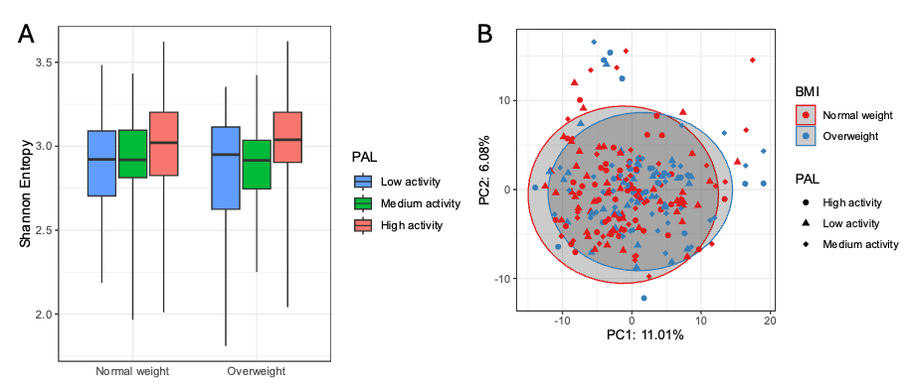

Supplementary Figure 1. Representation of diversity in relation to PALs. The bars represent the PAL: low activity (blue), medium activity (green), and high activity (red). The PALs were categorized based on the BMI of the participants (normal weight and overweight). The Wilcoxon test was utilized to evaluate statistical differences between the groups. The results indicate no significant differences in Shannon diversity among the various PALs, suggesting a similarity in microbial diversity irrespective of the individuals' levels of physical activity.

