Supporting information

Bioinformatics-Aided Identification, Characterization of Fungal Linalool Synthases and Applications in Linalool biosynthesis

Congqiang Zhang^{1*}, Xixian Chen¹, Raphael Tze Chuen Lee², Rehka T¹, Sebastian Maurer-Stroh^{2,3#}, Martin Rühl^{4#}
1. Singapore Institute of Food and Biotechnology Innovation (SIFBI), Agency for Science, Technology and Research (A*STAR), Singapore
2. Bioinformatics Institute (BII), Agency for Science Technology and Research (A*STAR), 30 Biopolis Street, #07-01 Matrix, 138671, Singapore
3. Department of Biological Sciences (DBS), National University of Singapore (NUS), Singapore
4. Institute of Food Chemistry and Food Biotechnology, Justus Liebig University Giessen, Giessen, Germany

#equal contribution
*To whom correspondence may be addressed. Email:
zcqsimon@outlook.com or congqiang_zhang@sifbi.a-star.edu.sg

Table of contents
Table S1. Predicted active sites of terpene synthases with 4LXW and 5NX5 as the templates.
Table S2. Comparison and combination of the predicted active sites of the two templates 4LXW and 5NX5.
Table S3. Summary of LSs and LNSs in this study.
Table S4. 3D alignment of active-site residues of Ap.LS, Sc.LNS and Ma.LS.
Table S5. Comparison of residues in the substrate-binding pockets of Ap.LS and Ap.LNS.
Table S6. Primers used for Ap.LS mutation.
Fig. S1. Nucleic acid sequence of AAE3_109435 in the genome.
Fig. S2. Mass spectra and retention indices for terpenes detected in this study.
Fig. S3. The alignment between Agrped_689675 and Galma_223690 and BLAST search results in UniProt database with Agrped_689675 (or Ap.LS).
Fig. S4. GCMS chromatograms and spectra for Galma_266794.
Fig. S5. Amino acid sequence alignment and identity table of LSs and LNSs from fungi, bacteria and plants.
Fig. S6. Expression and solubility analysis of the fungal LNSs and LS.
Fig. S7. The optimization of Aa.LNS solubility with the co-expression of chaperone proteins.
Fig. S8. The sequence alignment and their secondary structures of plant terpene synthases.
Fig. S9. The sequence alignment and their secondary structures of microbial terpene synthases.
Table S1. Predicted active sites of terpene synthases with 4LXW and 5NX5 as the templates.
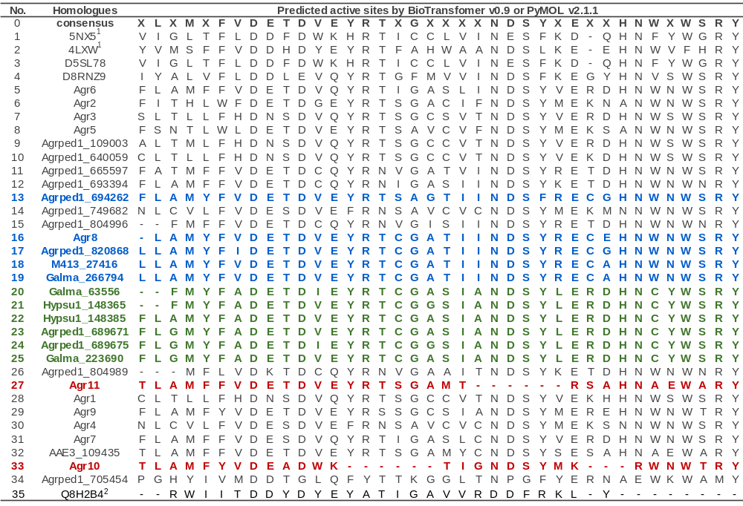
Murolene/cadinene synthase cluster and LS/LNS cluster predicted or characterized in this study were shown in blue and green, respectively (consistent with Fig. 2). The non-functional synthase Agr10 and Agr11 were highlighted in red.
¹ The two proteins were used as templates: D5SL78, Sc.LNS from Streptomyces clavuligerus, (PDB ID: 5NX5) and Q9K499, Epi-isozizaene synthase from Streptomyces coelicolor (PDB ID: 4LXW). For 4LXW, the ligands BTM, POP and MG were used for prediction of active sites. For 5NX5, the ligands 0FV and MG were used for prediction of active sites.
² Analyzed by PyMOL software version 2.1.1. The homologue model of Q8H2B4 was built on the structure of (+)-bornyl diphosphate synthase from Salvia officinalis (PDB entry ID, 1n1b/1n21) with Modeller software.

Table S2. Comparison and combination of the predicted active sites of the two templates 4LXW and 5NX5.
Index Position | 52 | 55 | 56 | 76 | 79 | 80 | 81 | 83 | 84 | 86 | 87 | 153 | 156 | 171 | 175 | 178 | 179 | 180 | 181 | 184 | 217 | 218 | 221 | 222 | 225 | 226 | 228 | 229 | 232 | 235 | 237 | 238 | 299 | 303 | 306 | 307 | 312
4LXW_position |  | 72 | 73 | 92 | 95 | 96 |  | 99 | 100 | 102 | 103 | 172 | 175 | 190 | 194 | 197 | 198 | 199 |  | 203 | 236 | 237 | 240 | 241 | 244 | 245 | 247 | 248 | 253 | 255 | 256 | 325 | 329 | 332 | 333 | 338 | 339
4LXW_residue |  | V | M | S | F | F |  | D | D | H | D | Y | E | Y | R | T | F | A |  | W | A | A | N | D | S | L | K | E | E | H | N | W | V | F | H | R | Y
5nx5_position | 49 | 52 |  | 72 | 75 | 76 | 77 | 79 | 80 |  | 83 |  |  |  | 172 | 175 | 176 | 177 | 178 | 181 | 214 |  | 218 |  | 222 |  | 225 | 226 | 229 | 231 |  |  | 295 | 299 | 302
5nx5_residue | V | I |  | L | T | F | L | D | D |  | D |  |  |  | R | T | I | C | C | L | V |  | N |  | S |  | K | D | Q | H |  |  | F | Y | W
5NX5_m¹ | V | I | G | L | T | F | L | D | D | F | D | W | K | H | R | T | I | C | C | L | V | I | N | E | S | F | K | D | Q | H | N | F | Y | W | G | R | Y
4LXW_m¹ | Y | V | M | S | F | F | V | D | D | H | D | Y | E | Y | R | T | F | A | H | W | A | A | N | D | S | L | K | E | E | H | N | W | V | F | H | R | Y

¹ Here, individual active sites of 4LXM and 5NX5 were predicted with BioTransformer v0.9, which are identical to PyMOL software prediction. Furthermore, to cover more broadly in our model, the active sites of the two templates were merged with each other to obtain 4LXW_m and 5NX5_m, respectively.

Table S3. Summary of LSs and LNSs in this study.
No. | Accession no. | Entry/Gene name | Protein function | Organism | Length
1 | Q84ZW8 | ACSS_MAIZE | Nerolidol synthase | Zea mays (Maize) | 590
2 | P0CV94 | NES1_FRAAN | Nerolidol synthase | Fragaria ananassa (Strawberry) (Fragaria chiloensis x Fragaria virginiana) | 519
3 | P0CV95 | NES2_FRAAN | Nerolidol synthase | Fragaria ananassa (Strawberry) (Fragaria chiloensis x Fragaria virginiana) | 578
4 | P0CV96 | NES1_FRAVE | Nerolidol synthase | Fragaria vesca (Woodland strawberry) (Potentilla vesca) | 580
5 | Q9SPN0 | LLOS1_ARTAN | R-linalool synthase | Artemisia annua (Sweet wormwood) | 567
6 | Q84UV0 | LINS_ARATH | S-linalool synthase | Arabidopsis thaliana (Mouse-ear cress) | 569
7 | Q6ZH94 | LINS_ORYSJ | S-linalool synthase | Oryza sativa subsp. japonica (Rice) | 595
8 | Q8H2B4 | LLOS_MENAQ | R-linalool synthase | Mentha aquatica (Water mint) | 606
9 | Q9SPN1 | LLOS5_ARTAN | R-linalool synthase | Artemisia annua (Sweet wormwood) | 583
10 | Q5SBP3 | LLOS_OCIBA | R-linalool synthase | Ocimum basilicum (Sweet basil) | 574
11 | Q96376 | LIS_CLABR | S-linalool synthase | Clarkia breweri (Fairy fans) (Eucharidium breweri) | 870
12 | Q2XSC5 | LALIN_LAVAN | R-linalool synthase | Lavandula angustifolia (Lavender) | 564
13 | R4I6S7 | R4I6S7_9MAGN | S-linalool synthase | Cinnamomum osmophloeum | 585
14 | Q29VN2 | TPS2_MAIZE | Nerolidol linalool synthase | Zea mays (Maize) | 581
15 | H6WBC5 | H6WBC5_VITVI | Nerolidol linalool synthase | Vitis vinifera (Grape) | 577
16 | A0A068B0N9 | A0A068B0N9_9ROSA | Nerolidol linalool synthase | Prunus cerasoides var. campanulata | 618
17 | A0A068B6B6 | A0A068B6B6_9ROSA | Nerolidol linalool synthase | Prunus cerasoides var. campanulata | 561
18 | A0A072UZ75 | A0A072UZ75_MEDTR | Nerolidol linalool synthase | Medicago truncatula (Barrel medic) (Medicago tribuloides) | 570
19 | B1NA84 | B1NA84_ANTMA | Nerolidol linalool synthase | Antirrhinum majus (Garden snapdragon) | 596
20 | B1NA83 | B1NA83_ANTMA | Nerolidol linalool synthase | Antirrhinum majus (Garden snapdragon) | 566
21 | Q5UB06 | Q5UB06_MEDTR | Nerolidol linalool synthase | Medicago truncatula (Barrel medic) (Medicago tribuloides) | 573
22 | G5CV39 | G5CV39_SOLLC | Nerolidol linalool synthase | Solanum lycopersicum (Tomato) (Lycopersicon esculentum) | 563
23 | G7KNU1 | G7KNU1_MEDTR | Nerolidol linalool synthase | Medicago truncatula (Barrel medic) (Medicago tribuloides) | 519
24 | E5GAH7 | E5GAH7_VITVI | Nerolidol linalool synthase | Vitis vinifera (Grape) | 545
25 | A0A1N7T9S5 | A0A1N7T9S5_GOSHI | Nerolidol linalool synthase | Gossypium hirsutum (Upland cotton) (Gossypium mexicanum) | 586
26 | A0A061GH69 | A0A061GH69_THECC | Nerolidol linalool synthase | Theobroma cacao (Cacao) (Cocoa) | 583
27 | E5GAH4 | E5GAH4_VITVI | Nerolidol linalool synthase | Vitis vinifera (Grape) | 545
28 | G7INZ1 | G7INZ1_MEDTR | Nerolidol linalool synthase | Medicago truncatula (Barrel medic) (Medicago tribuloides) | 806
29 | E5GAH1 | E5GAH1_VITVI | Nerolidol linalool synthase | Vitis vinifera (Grape) | 584
30 | E5GAI1 | E5GAI1_VITVI | Nerolidol linalool synthase | Vitis vinifera (Grape) | 820
31 | G7INZ4 | G7INZ4_MEDTR | Nerolidol linalool synthase | Medicago truncatula (Barrel medic) (Medicago tribuloides) | 819
32 | E5GAI0 | E5GAI0_VITVI | Nerolidol linalool synthase | Vitis vinifera (Grape) | 840
33 | A0A061GEP1 | A0A061GEP1_THECC | Nerolidol linalool synthase | Theobroma cacao (Cacao) (Cocoa) | 809
34 | E5GAH3 | E5GAH3_VITVI | Nerolidol linalool synthase | Vitis vinifera (Grape) | 577
35 | D8RNZ9 | MTS22_SELML | Nerolidol linalool synthase | Selaginella moellendorffii (Spikemoss) | 368
36 | D5SL78 | SCLAV_p1185 | Nerolidol linalool synthase | Streptomyces clavuligerus | 333
37 | MN146034 | AAE3_05024 | Not functional | Agrocybe aegerita (Cyclocybe aegerita) | 355
38 | MN954676 | AAE3_109435 | Nerolidol/linalool synthase | Agrocybe aegerita (Cyclocybe aegerita) | 384
39 | JGI ID: Agrped1_689671 | Agrped1_689671 | Nerolidol/linalool synthase | Agrocybe pediades | 343
40 | JGI ID: Agrped1_689675 | Agrped1_689675 | R-linalool synthase | Agrocybe pediades | 344
41 | A0A067THX9 | Galma_223690 | Nerolidol/linalool synthase | Galerina marginata | 343
42 | A0A067T8I8 | Galma_63556 | Possible nerolidol/linalool synthase | Galerina marginata | 330
43 | A0A0D2NA50 | Hypsu1_148365 | Possible nerolidol/linalool synthase | Hypholoma sublateritium | 337
44 | A0A0D2NH86 | Hypsu1_148385 | Nerolidol/linalool synthase | Hypholoma sublateritium | 344
45 | A0A348B793 | PpSTS25 | Myrcene/linalool synthase | Postia placenta | 332

Table S4. 3D alignment of active-site residues of Ap.LS, Sc.LNS and Ma.LS.
Conversed residues among the three enzymes are highlighted in green.
Yellow |  | Blue |  | Green
Ap.LS_pos | Ap.LS_res | Sc.LNS_pos | Sc.LNS_res | Ma.LS_pos | Ma.LS_res
54 | F
56 | L | 49 | V
77 | M | 72 | L | 360 | T
78 | N | 73 | G | 361 | A
79 | F | 74 | W | 362 | L
80 | Y | 75 | T | 363 | D
81 | F | 76 | F | 364 | D
82 | A | 77 | L | 365 | V
83 | F | 78 | F | 366 | Y
84 | D | 79 | D | 367 | D
85 | E | 80 | D | 368 | I
 |  | 82 | F
88 | D | 83 | D
149 | Y
153 | I | 150 | W | 438 | Y
156 | E | 153 | K | 441 | E
160 | R | 157 | R | 445 | Y
171 | Y
175 | R | 172 | R | 460 | A
178 | T | 175 | T | 463 | T
179 | C | 176 | I | 464 | I
 |  | 215 | I | 504 | R
219 | N | 218 | N | 507 | D
223 | S | 222 | S | 511 | T
227 | E | 226 | D | 515 | E
230 | R |  |  | 518 | R
235 | H
309 | Y | 309 | Y | 579 | A
315 | L | 316 | G | 586 | G

Table S5. Comparison of residues in the substrate-binding pockets of Ap.LS and Ap.LNS. The different residues of the same position are highlighted in green.
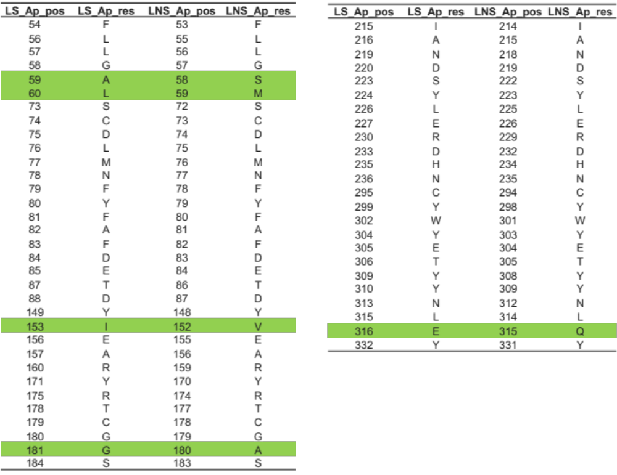

Table S6. Primers used for Ap.LS mutation. The mutational regions are highlighted in red and caps.
Mutations | Forward primers | Reverse primers
A59S | tgctgggtTCGctggttggtccgctgggtac | ccagCGAacccagcaggttgaaatcacatgc
L60M | tgggtgcaATGgttggtccgctgggtaccaa | caacCATtgcacccagcaggttgaaatcaca
V61I | tgcactgATTggtccgctgggtaccaaggaa | ggaccAATcagtgcacccagcaggttgaaat
G181A | ctgtggtgCgaaaccgtcgttctcgttctt | ggtttcGcaccacaggtgtcacggc
E316Q | aatggcctgCaaatccagaaaactcgtcaga | tctggatttGcaggccatttttaccgtaata
A59S-L60M | gggtTcaAtggttggtccgctgggtac | gaccaaccaTtgAacccagcaggttgaa
A59S-L60M-V61I | ggtTcaAtgAttggtccgctgggtacca | cggaccaaTcaTtgAacccagcaggttga

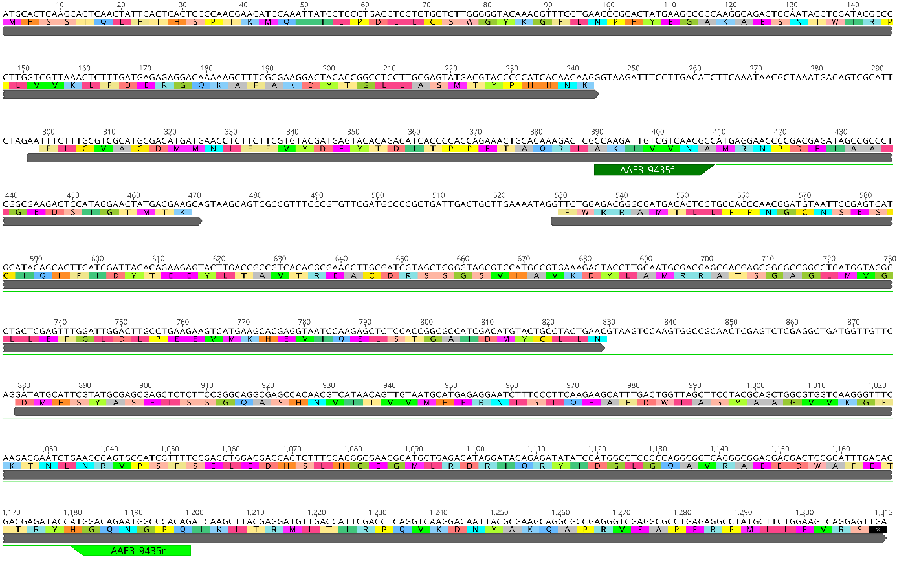
Fig. S1. Nucleic acid sequence of AAE3_109435 in the genome. The two primers (AAE3_9435f and AAE3_9435r) used for PCR amplification were highlighted here.

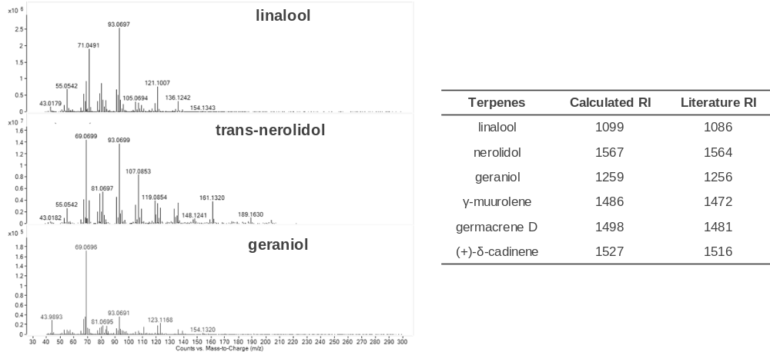
Fig. S2. Mass spectra and retention indices for terpenes detected in this study. Retention indices (RIs) were calculated by calibrating with GC-MS with a C8–C30 alkane mix and compared with literature data in National Institute of Standards and Technology database.

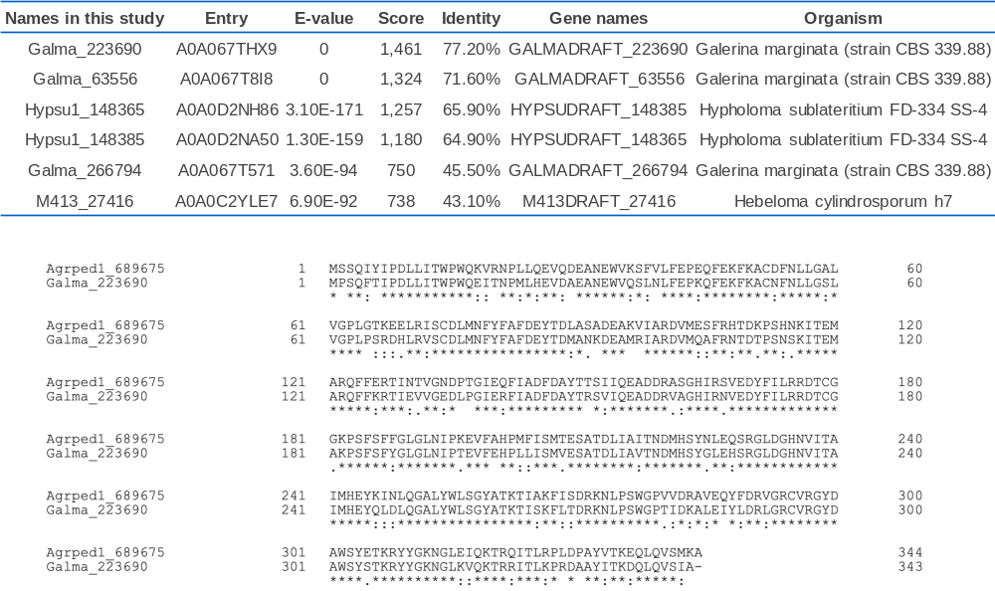
Fig. S3. The alignment between Agrped_689675 and Galma_223690 and BLAST search results in UniProt database with Agrped_689675 (or Ap.LS). The search was done in March-2018 with the top 6 proteins listed here. The results may change today as new proteins are being deposited into UniProt database.

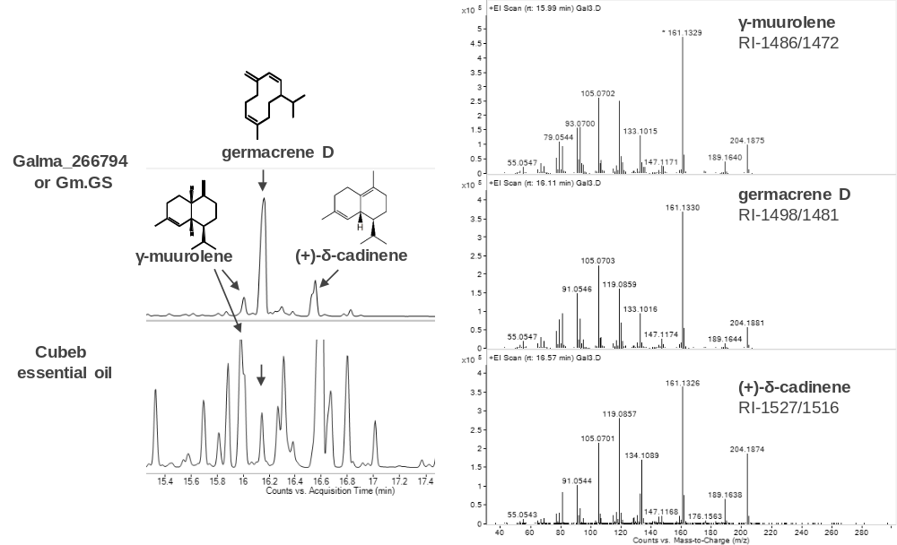
Fig. S4. GCMS chromatograms and spectra for Galma_266794. Retention indices (RIs) were listed with the calculated values on the left and literature values on the right. Germacrene D and γ-muurolene are further verified by Cubeb essential oil. Cedrela woods oil was used as the authentic standard of (+)-δ-cadinene ¹.

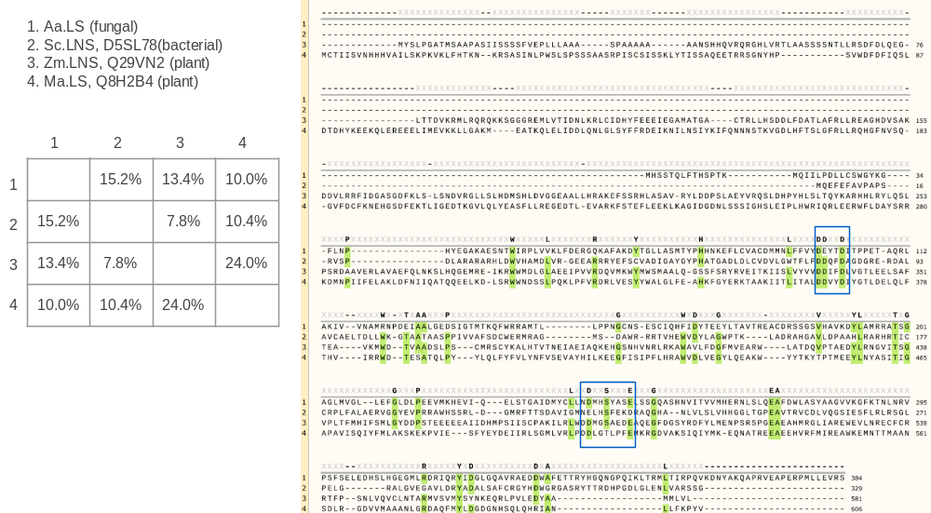
Fig. S5. Amino acid sequence alignment and identity table of LSs and LNSs from fungi, bacteria and plants. The two conserved regions, aspartate-rich motif and NSE triad were highlighted in blue boxes. The sequence identity table indicated the large difference of LSs among different kingdoms. The overall sequence identity is very low, and the fungal LS is slightly more similar to the bacterial LNS than to the plant LS and LNS. Alignment was done with Clustal Omega program v1.2.4.

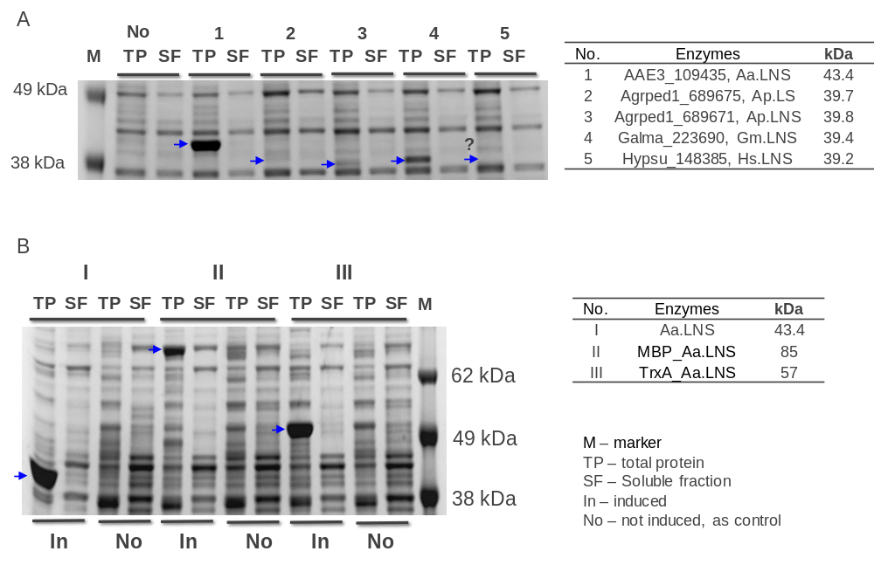
Fig. S6. (A) Expression and solubility analysis of the fungal LNSs and LS. (B) Solubility analysis for the fusion Aa.LNS with maltose binding protein (MBP) or thioredoxin (TrxA). M: protein ladder, TP: total proteins, SF: soluble fraction, In: induced cells, No: not induced as control.

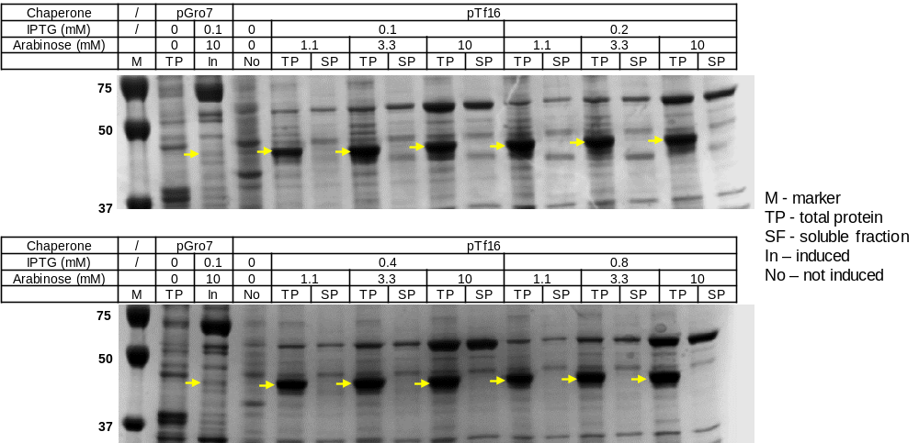
Fig. S7. The optimization of Aa.LNS solubility with the co-expression of chaperone proteins. Two chaperone systems were used here: pGro7 expressing groES-groEL proteins, pTf16 expressing the trigger factor protein (tig). IPTG and arabinose were used to induce the expression of Aa.LNS and chaperones, respectively. It was found arabinose concentration (or chaperone expression levels) has invisible effect on the solubility of Aa.LNS. Hence, 3.3mM arabinose and 0.1 mM IPTG were used for the large-scale expression and purification experiments. M: protein ladder, TP: total proteins, SF: soluble fraction, In: induced, No: not induced as control.

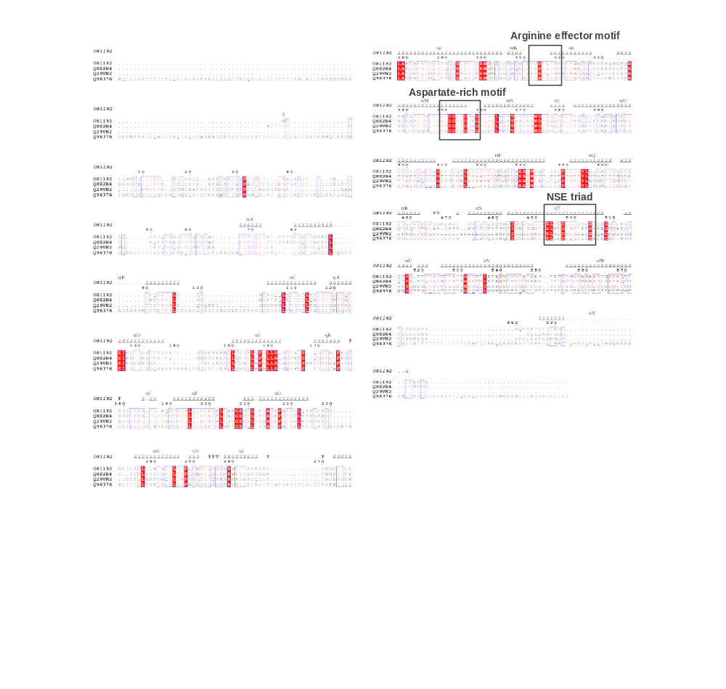
Fig. S8. The sequence alignment and their secondary structures of plant terpene synthases. The three regions, arginine effector motif, aspartate-rich motif and NSE triad, were highlighted in black boxes. The four proteins were (1) O81192, PDB ID 1n1b/1n24, (+)-bornyl diphosphate synthase from Salvia officinalis; (2) Q8H2B4, (R)-linalool synthase from Mentha aquatica (Water mint); (3) Q29VN2, linalool/nerolidol synthase from Zea mays (Maize); (4) Q96376, S-linalool synthase from Clarkia breweri (Fairy fans). The figure was prepared with the ESPript 3.0 ².

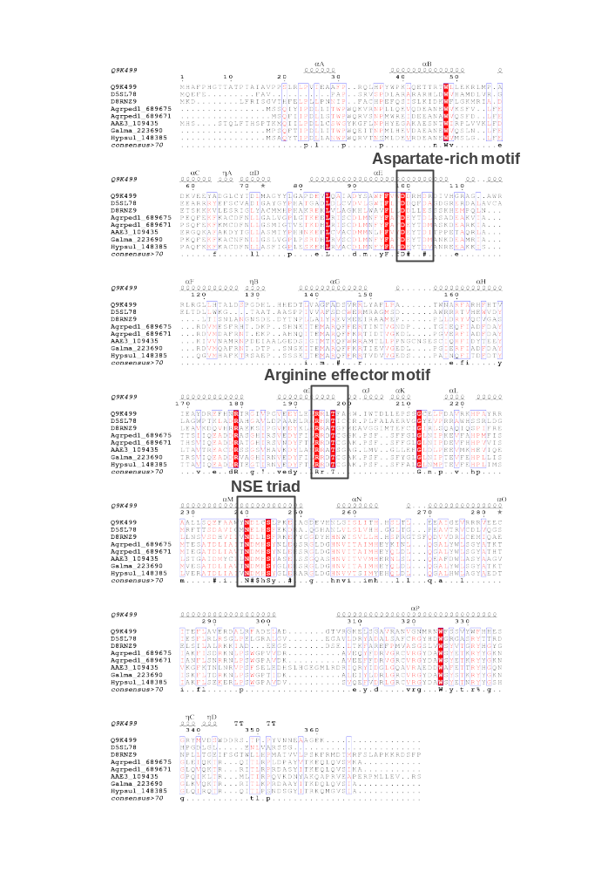
Fig. S9. The sequence alignment and their secondary structures of microbial terpene synthases. The three regions, arginine effector motif, aspartate-rich motif and NSE triad, were highlighted in black boxes. The eight proteins were (1) Q9K499 (PDB ID 4LXW), Epi-isozizaene synthase from Streptomyces coelicolor; (2) D5SL78, Sc.LNS from S. clavuligerus; (3) D8RNZ9, LNS from Spikemoss; (4) Ap.LS; (5) Ap.LNS; (6) Aa.LNS (7) Gm.LNS; (8) Hs.LNS. The figure was prepared with the ESPript 3.0 ².
Reference
1. Agger, S., Lopez-Gallego, F. & Schmidt-Dannert, C. Diversity of sesquiterpene synthases in the basidiomycete Coprinus cinereus. Molecular microbiology 72, 1181-1195 (2009).
2. Robert, X. & Gouet, P. Deciphering key features in protein structures with the new ENDscript server. Nucleic Acids Research 42, W320-W324 (2014).

