Supplement

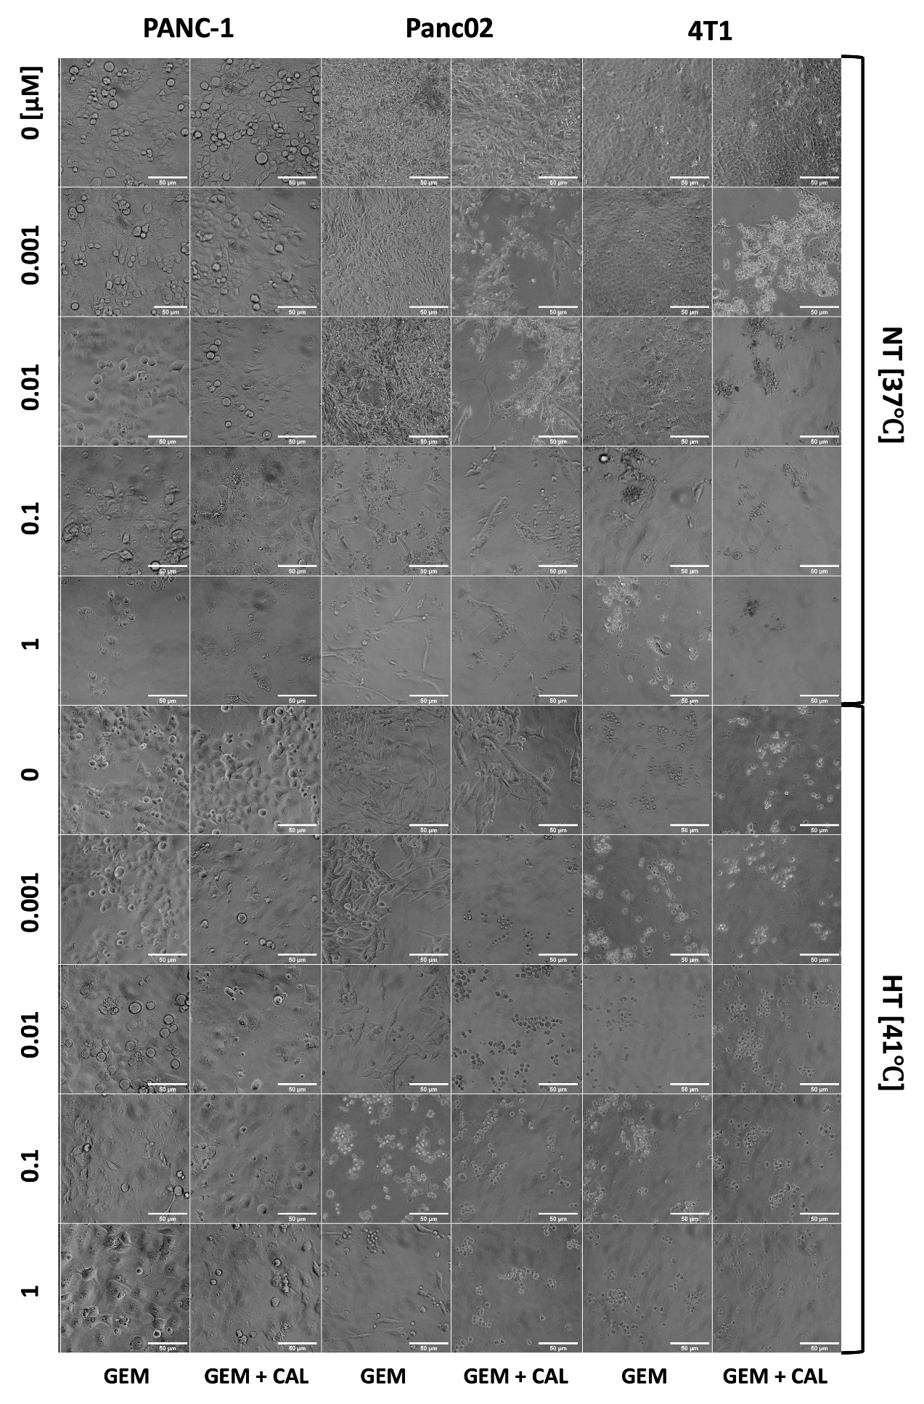
Fig. S1. Changes in the morphology of PANC-1, Panc02 and 4T1 cells after treatment with gemcitabine [0 - 1 µM], calcitriol [100 nM] and hyperthermia [41˚C] 72 hours after treatment. Magnification 200x, scale = 50 µm.

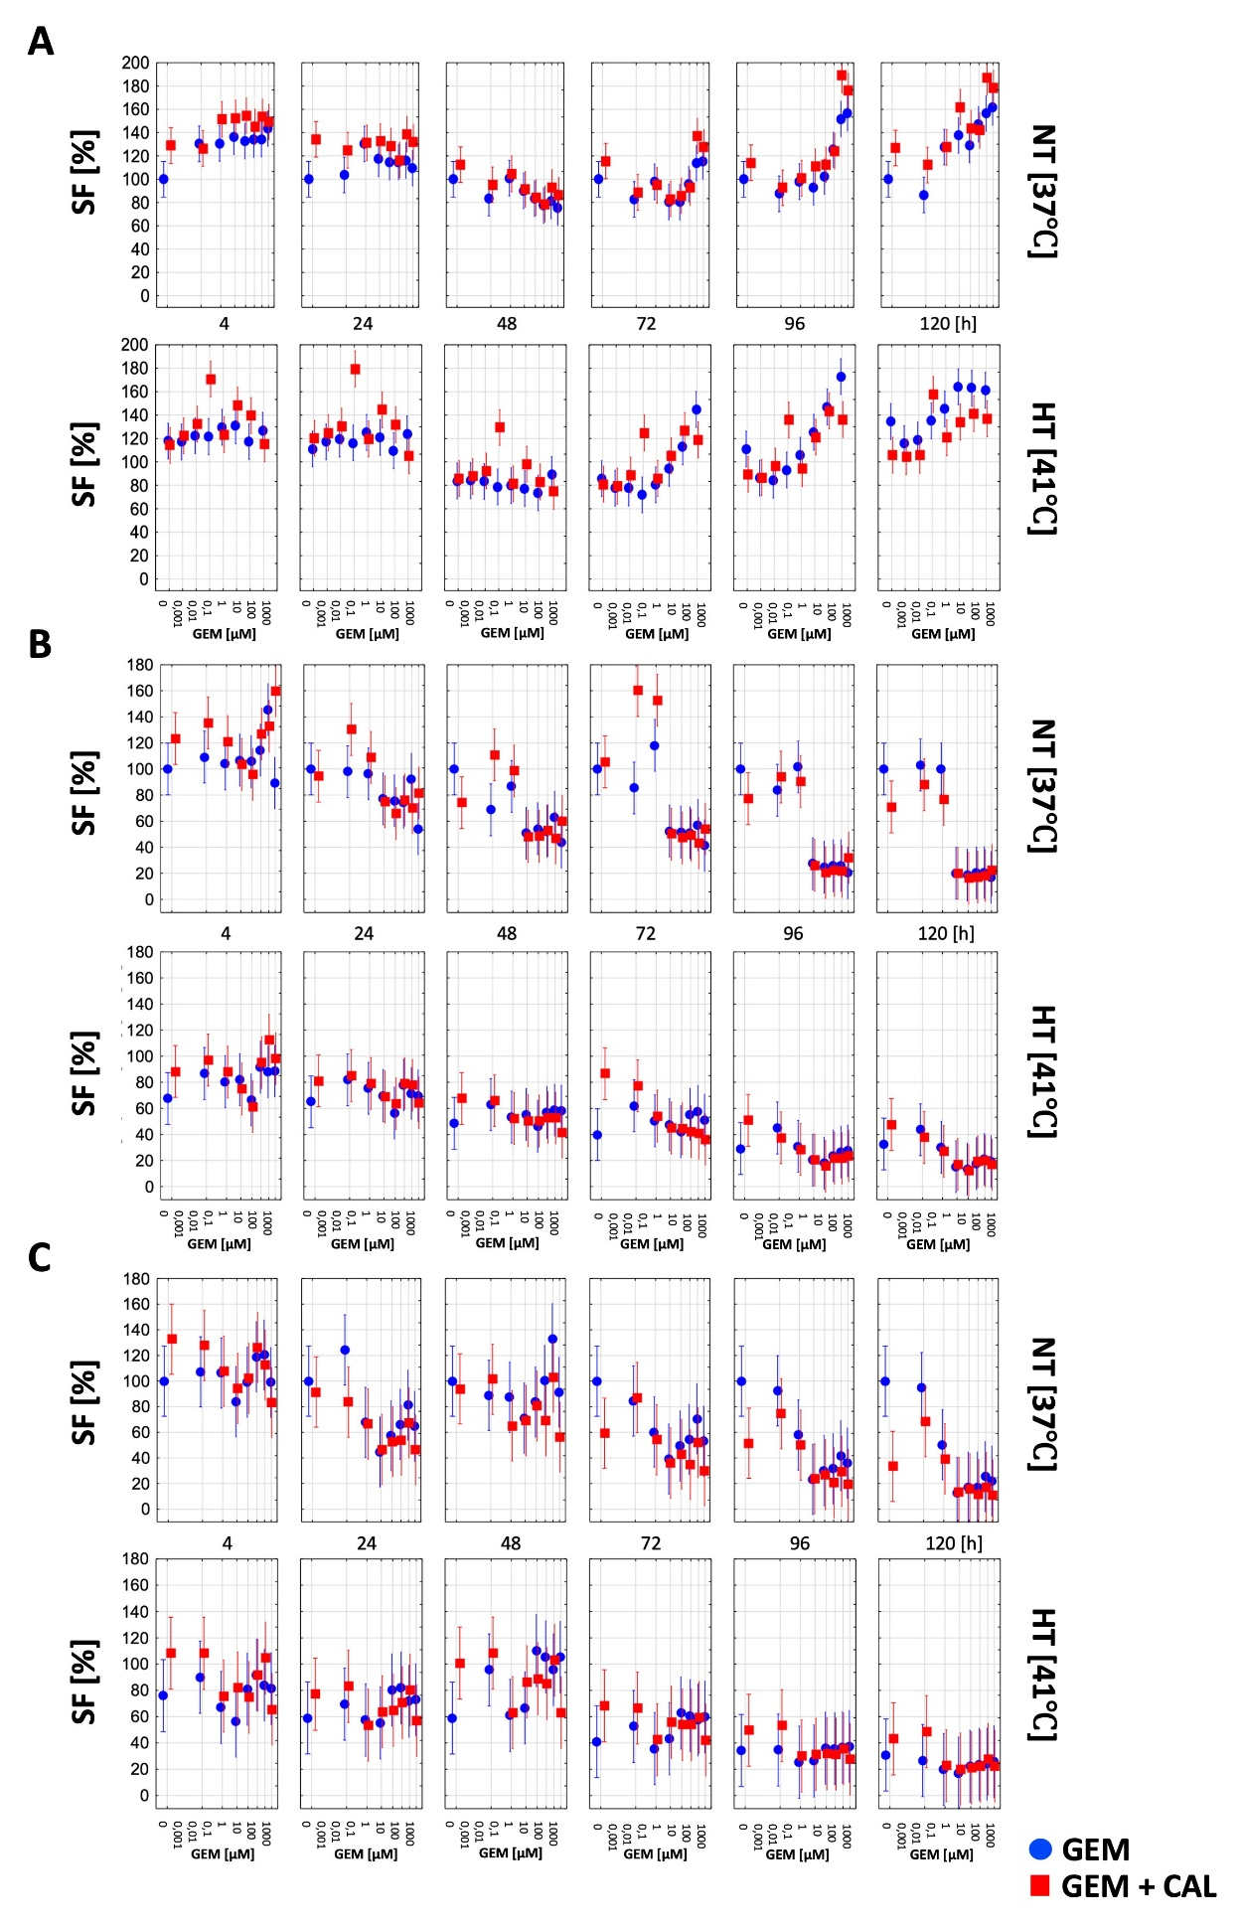
Fig. S2. Real-time Live Cell Imaging (A) PANC-1, (B) Panc02, (C) 4T1.

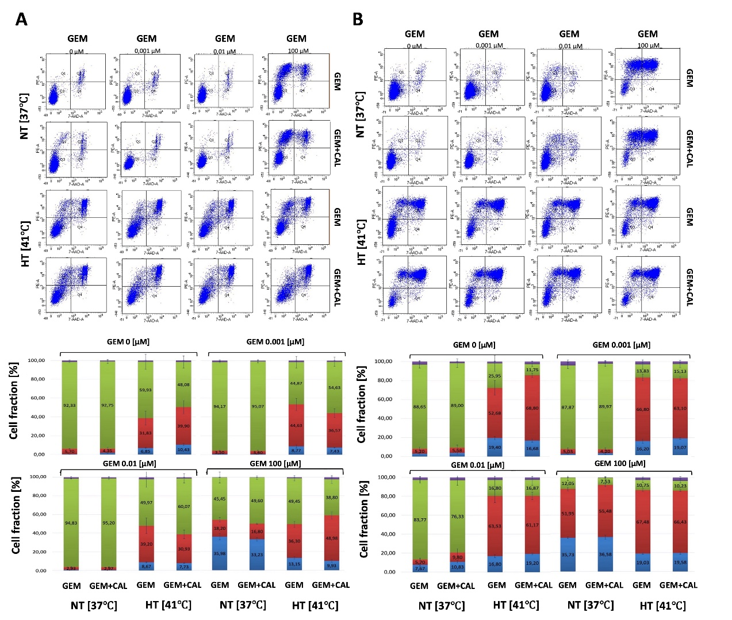
Fig. S3. Quantitative changes in the population of Panc02 (A) and 4T1 (B) cells in early (BLUE) and late (RED) apoptosis, viable (GREEN) and necrotic (PURPLE) cells 48 h after gemcitabine [0, 0.001, 0.01 and 100 µM], calcitriol [100 nM] and hyperthermia [41˚C]. Graphs show the distribution of cell populations after PE staining with annexin V and 7-amino-actinomycin (A) and percentage distribution of populations ± SEM (B) obtained by flow cytometry.

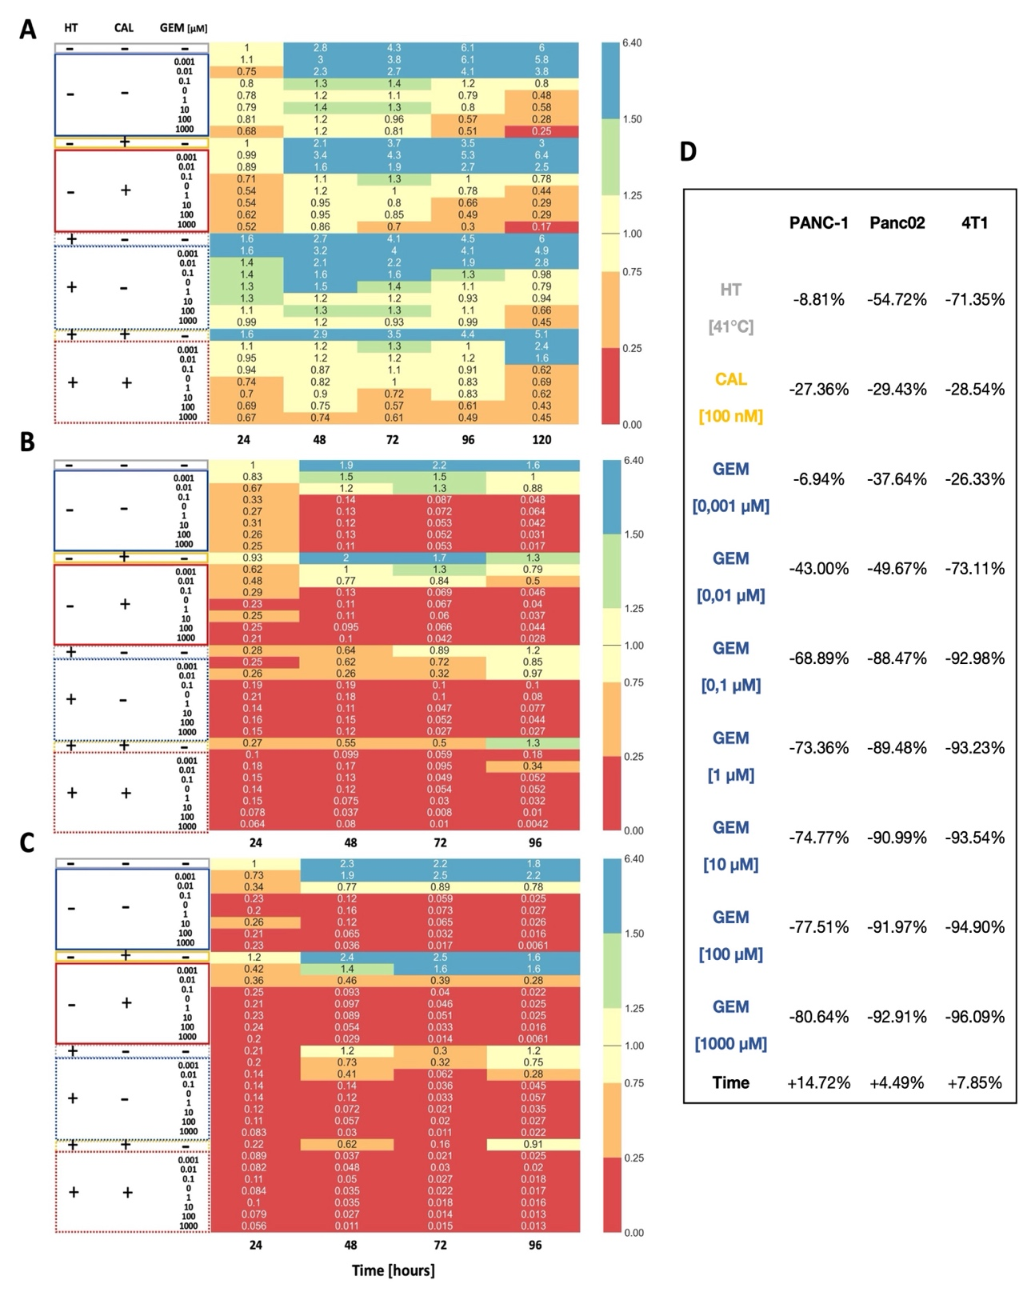
Fig. S4. Relative survival fraction (Cell Counting) of PANC-1 (A) Panc02 (B) 4T1 (C) treated with gemcitabine (0,001 µM - 1000 µM), calcitriol (100 nM), hyperthermia (41°C). (D) GEE regression coefficients (%) showing treatment effects on cell viability across three cancer cell lines.

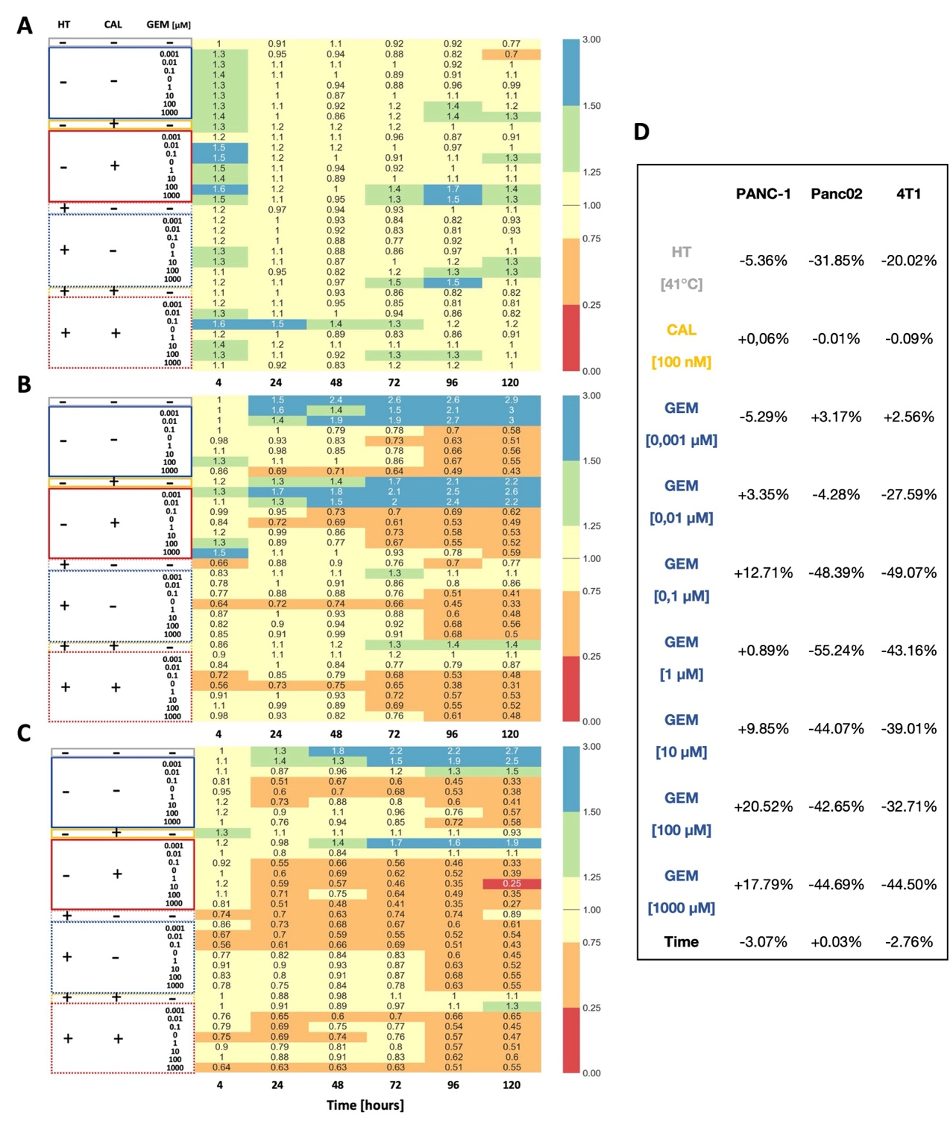
Fig. S5. Relative survival fraction (Fluorescence Live Cell Imaging) PANC-1 (A) Panc02 (B) 4T1 (C) treated with gemcitabine (0,001 µM - 1000 µM), calcitriol (100 nM), hyperthermia (41°C). (D) GEE regression coefficients (%) showing treatment effects on cell viability across three cancer cell lines.

