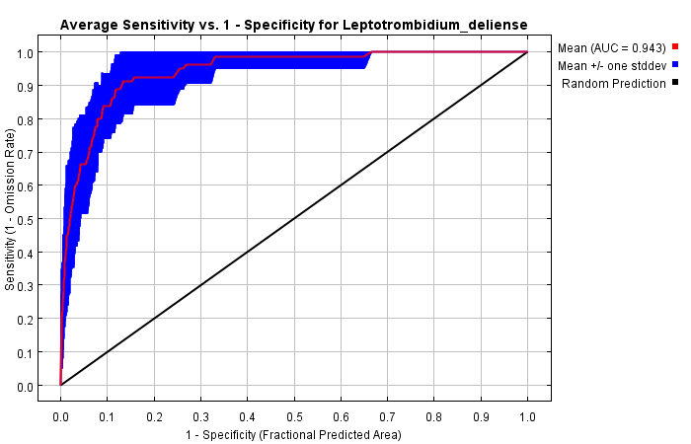
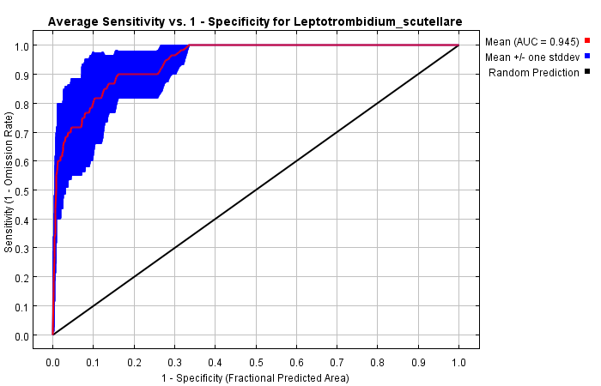
B
A

Figure S1. The validation of the Maxent models (Figure A: L. deliense; Figure B: L. scutellare).

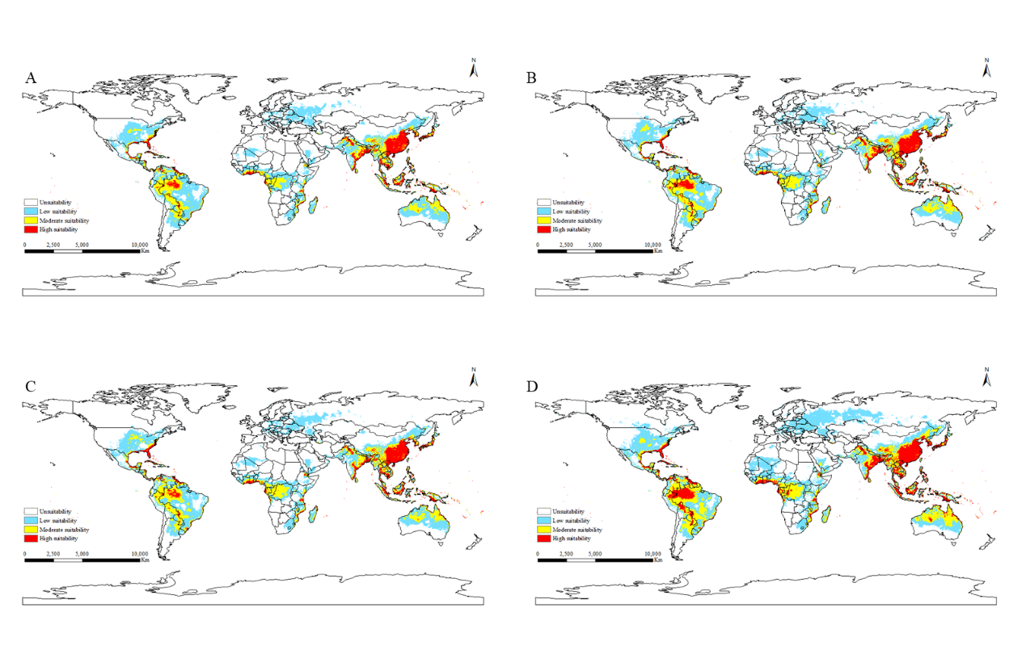

Figure S2. Potentially suitable area of L. deliense under future climate scenarios (A: SPSS126: 2021-2040; B: SPSS126: 2041-2060; C: SPSS585: 2021-2040; D: SPSS585: 2041-2060).

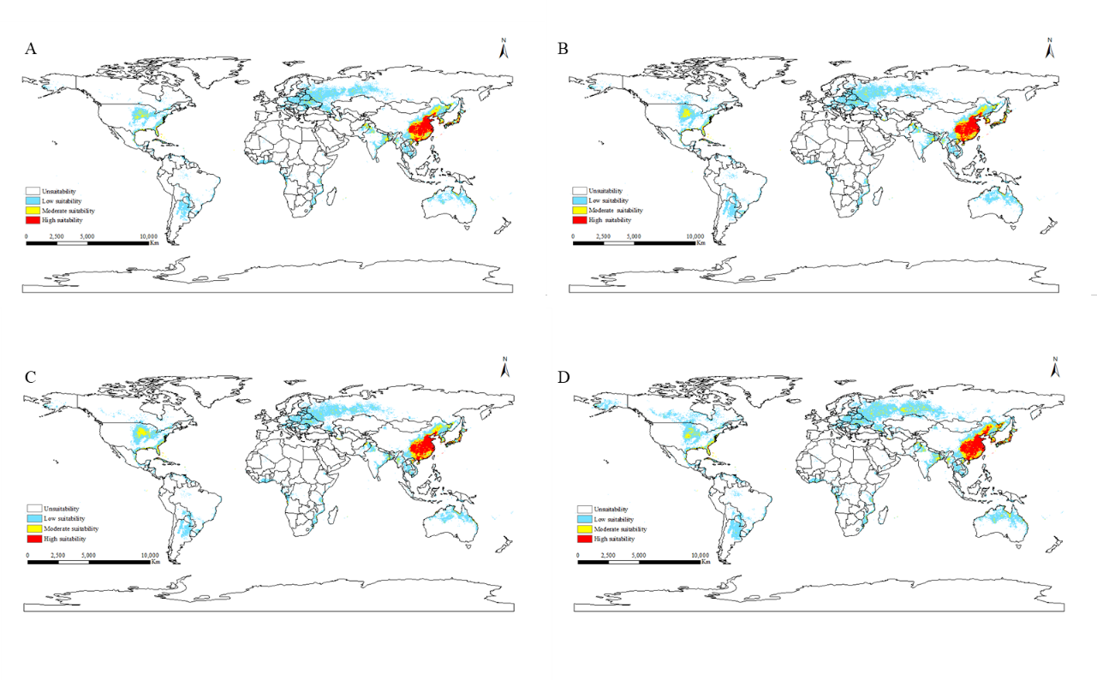
Figure S3. Potentially suitable area of L. scutellare under future climate scenarios (A: SPSS126: 2021-2040; B: SPSS126: 2041-2060; C: SPSS585: 2021-2040; D: SPSS585: 2041-2060).

