Supplementary files 1

Insights from transcriptomic profiling identify the CYP6Z gene family as key drivers of pyrethroid resistance escalation in Anopheles gambiae from Cameroon

Arnaud Tepa ^{1,2,}*, Mersimine Kouamo¹, Jonas A. Kengne-Ouafo¹, Magellan Tchouakui ¹, Constant A. Pieme ² and Charles S. Wondji ^{1,3,4}*

Figure S1.1 : Mapping statistic

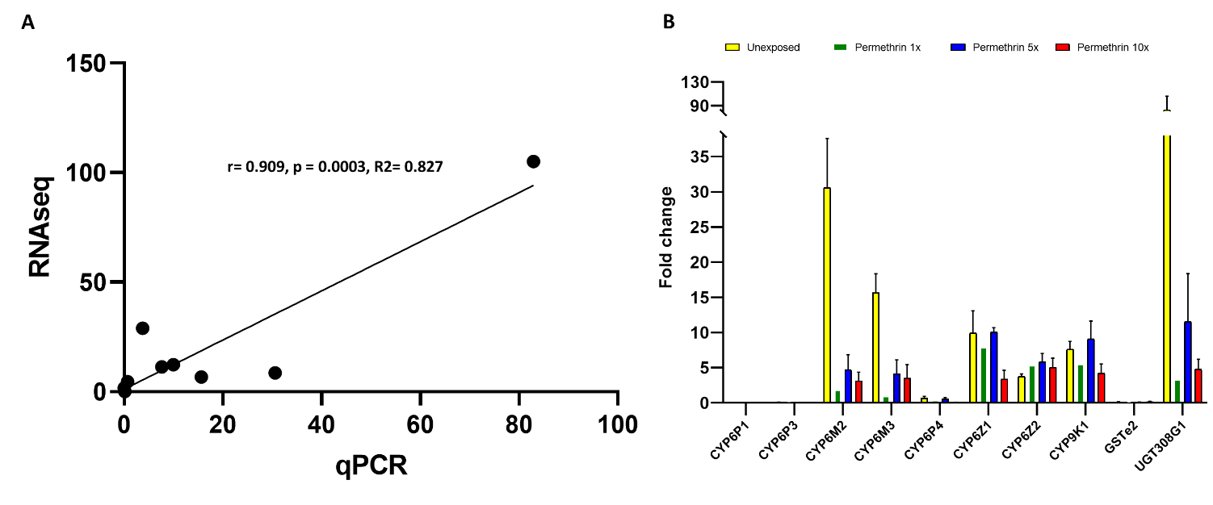
Figure S1.2 : A. Correlation curve between RNA-seq data and qRT-PCR: The dots represent fold changes in control versus susceptible groups, respectively, in RNA-seq and qRT-PCR. B. Expression profiles of key detoxification genes associated with permethrin resistance in Anopheles gambiae mosquitoes from mangoum, compared to the sensitive Kisumu strain. The data are presented as fold changes relative to the kisumu population, with four different conditions: Unexposed (yellow), Permethrin 1x (green), Permethrin 5x (blue), and Permethrin 10x (red).

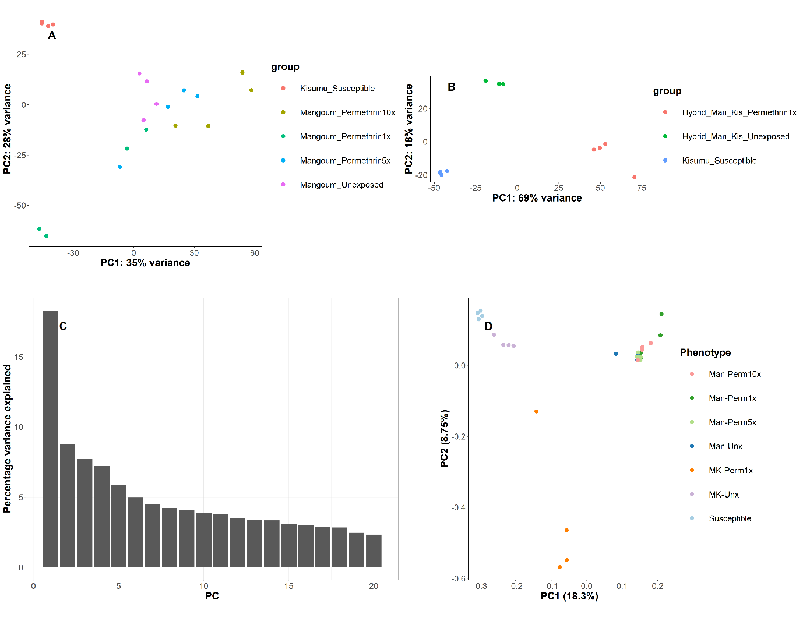
Figure S1.3: Exploratory clustering of samples. A. Principal Component Analysis (PCA) of normalized read data from Mangoum F1 progeny. B. PCA of normalized read data from Mangoum X Kisumu F4 progeny. C. Histogram showing the percentage of overall variance related to the genetic polymorphism of Anopheles gambiae in field populations and hybrids compared to susceptible strains. D. PCA plot of principal components 1 and 2 illustrating the clustering of samples based on gene polymorphism.

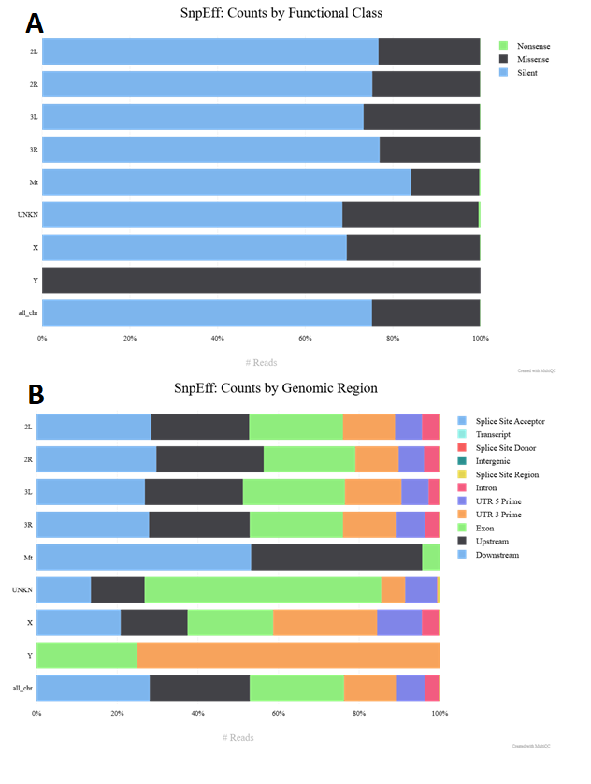
Figure S1.4 : Distribution of SnpEff-annotated Reads by Functional Class and Genomic Region. Panel A illustrates the proportion of reads categorized by functional class—Nonsense, Missense, and Silent—across various genomic regions, indicating a predominance of Silent mutations. Panel B displays the distribution of reads across different genomic regions, highlighting the most common sites such as Exons, UTRs, and splice sites, with a notable enrichment of certain annotations like UTRs and splice sites in specific regions.

Table S1.1 : Differential expression of candidate resistance genes in hybrid Mangoum x Kisumu F4 mosquitoes between different comparisons.
GeneID | Gene | Chr. | Fold change |  |  | Read Count |  |  | Annotation
GeneID | Gene | Chr. | RS | RC | CS | S | C | R
AGAP008210 | CYP6N1 | 3R | 5.7 |  | 3.1 | 33 | 125 | 213 |  | Cytochrome P450
AGAP013224 | CYP4H26 | 2R | 5.2 |  | 2.4 | 7 | 40 | 56 |  | Cytochrome P450
AGAP002207 | CYP325C1 | 2R | 5.0 | 3.5 |  | 19 | 25 | 108 |  | Cytochrome P450
AGAP008209 | CYP6M1 | 3R | 4.4 | 2.1 |  | 373 | 754 | 1747 |  | Cytochrome P450
AGAP009241 | AGAP009241 | 3R | 4.3 | 2.0 |  | 110 | 222 | 528 |  | Cytochrome P450
AGAP008218 | CYP6Z2 | 3R | 3.9 | 2.1 |  | 476 | 852 | 2006 |  | Cytochrome P450
AGAP001039 | CYP307A1 | X | 3.8 | 4.1 |  | 155 | 137 | 682 |  | Cytochrome P450
AGAP008219 | CYP6Z1 | 3R | 3.7 |  | 3.7 | 1520 | 6193 | 5962 |  | Cytochrome P450
AGAP000818 | CYP9K1 | X | 2.9 | 2.1 |  | 16198 | 21391 | 50505 |  | Cytochrome P450
AGAP012291 | CYP9J3 | 3L | 2.9 |  | 2.6 | 1490 | 4170 | 4447 |  | Cytochrome P450
AGAP000284 | CYP315A1 | X | 2.4 | 1.8 |  | 267 | 362 | 667 |  | Cytochrome P450
AGAP011029 | CYP6AF2 | 3L | 2.2 |  | 2.3 | 9 | 34 | 26 |  | Cytochrome P450
AGAP012292 | CYP9J4 | 3L | 2.1 |  | 2.2 | 2821 | 6511 | 6070 |  | Cytochrome P450
AGAP012957 | CYP4D17 | 2R | 2.1 | 1.9 |  | 1094 | 1194 | 2357 |  | Cytochrome P450
AGAP001789 | AGAP001789 | 2R | 7.6 | 4.0 |  | 27 | 49 | 217 |  | Cytochrome P450 reductase
AGAP012732 | AGAP012732 | UNKN | 2.5 | 2.6 |  | 122 | 114 | 324 |  | Cytochrome P450 reductase
AGAP005372 | COEBE3C | 2L | 11.4 | 8.0 |  | 736 | 1019 | 8924 |  | carboxylesterase
AGAP013509 | AGAP013509 | 2R | 7.5 | 3.0 | 2.1 | 337 | 822 | 2683 |  | carboxylesterase
AGAP011509 | COEunkn | 3L | 3.1 | 2.7 |  | 306 | 324 | 1029 |  | carboxylesterase
AGAP010390 | COE12O | 3L | 2.8 | 3.4 |  | 307 | 249 | 901 |  | carboxylesterase
AGAP006723 | COEAE2G | 2L | 2.7 | 2.2 |  | 734 | 855 | 2340 |  | carboxylesterase
AGAP007990 | UGT308G1 | 3R | 13.0 |  | 20.6 | 710 | 16029 | 10039 |  | glucosyltransferase
AGAP008404 | UGT301C1 | 3R | 7.2 | 13.9 |  | 764 | 396 | 5754 |  | glucosyltransferase
AGAP007920 | UGT36C2 | 3R | 4.0 |  | 5.3 | 1467 | 8063 | 5960 |  | glucosyltransferase
AGAP007374 | UGT49A3 | 2L | 3.1 |  | 2.0 | 1307 | 2778 | 4190 |  | glucosyltransferase
AGAP005764 | AGAP005764 | 2L | 3.0 | 1.8 |  | 174 | 283 | 542 |  | glucosyltransferase
AGAP005752 | UGT308A2 | 2L | 2.9 |  | 2.2 | 3662 | 8847 | 11177 |  | glucosyltransferase
AGAP006222 | UGT302A1 | 2L | 2.9 | 1.6 |  | 725 | 1271 | 2216 |  | glucosyltransferase
AGAP006383 | AGAP006383 | 2L | 2.4 | 1.9 |  | 2900 | 3693 | 7117 |  | glucosyltransferase
AGAP008491 | AGAP008491 | 3R | 2.3 | 2.0 |  | 984 | 1132 | 2336 |  | glucosyltransferase
AGAP004267 | AGAP004267 | 2R | 2.0 | 1.8 |  | 174 | 196 | 359 |  | glucosyltransferase
AGAP004164 | GSTD1-4 | 2R | 3.4 | 2.3 |  | 9318 | 13508 | 32479 |  | Glutathione S-transferase
AGAP000165 | GSTMS1 | X | 3.2 | 1.9 |  | 2748 | 4540 | 9193 |  | Glutathione S-transferase
AGAP000888 | GSTT2 | X | 3.1 | 1.8 |  | 487 | 823 | 1568 |  | Glutathione S-transferase
AGAP009342 | GSTU3 | 3R | 3.0 |  | 5.6 | 110 | 640 | 340 |  | Glutathione S-transferase
AGAP005749 | GSTO1 | 2L | 2.7 | 2.1 |  | 2089 | 2611 | 5876 |  | Glutathione S-transferase
AGAP009197 | GSTE3 | 3R | 2.4 | 2.5 |  | 1230 | 1148 | 3169 |  | Glutathione S-transferase
AGAP004379 | GSTD6 | 2R | 2.2 | 2.0 |  | 84 | 88 | 203 |  | Glutathione S-transferase
AGAP002898 | GSTZ1 | 2R | 2.1 | 2.0 |  | 2327 | 2437 | 5120 |  | Glutathione S-transferase
AGAP009192 | GSTE5 | 3R | 2.0 | 2.2 |  | 1014 | 896 | 2164 |  | Glutathione S-transferase
AGAP008052 | SAP2 | 3R | 26.1 | 3.6 | 3.9 | 28 | 164 | 853 |  | Chemosensory protein
AGAP008055 | CSP3 | 3R | 9.9 |  | 13.6 | 33 | 490 | 352 |  | Chemosensory protein
AGAP008051 | SAP1 | 3R | 4.0 |  | 2.6 | 1446 | 4123 | 6109 |  | Chemosensory protein
AGAP008059 | CSP1 | 3R | 3.8 |  | 2.4 | 525 | 1358 | 2082 |  | Chemosensory protein
AGAP028013 | CPLCP25 | 3L | 16.8 | 2.9 |  | 4 | 17 | 80 |  | Cuticular
AGAP028044 | CPLCP23 | 3L | 7.5 | 2.8 |  | 2 | 3 | 25 |  | Cuticular
AGAP008444 | CPLCG1 | 3R | 6.8 |  | 3.7 | 8822 | 40540 | 66696 |  | Cuticular
AGAP004690 | CPF3 | 2L | 5.6 | 6.8 |  | 315 | 247 | 2197 |  | Cuticular
AGAP010887 | CPR113 | 3L | 4.8 |  | 7.4 | 352 | 2682 | 1747 |  | Cuticular
AGAP006009 | CPR30 | 2L | 4.1 | 5.1 |  | 141 | 111 | 628 |  | Cuticular
AGAP009877 | CPR79 | 3R | 3.6 | 1.6 |  | 336 | 714 | 1269 |  | Cuticular
AGAP009871 | CPR75 | 3R | 3.5 |  | 3.0 | 13583 | 51663 | 54352 |  | Cuticular
AGAP010123 | CPR131 | 3R | 3.4 | 16.3 |  | 443 | 98 | 2064 |  | Cuticular
AGAP028008 | CPLCP19 | 3L | 3.3 | 1.9 |  | 9 | 7 | 63 |  | Cuticular
AGAP000877 | CYP4G17 | X | 3.2 |  | 4.1 | 3456 | 15587 | 11713 |  | Cuticular
AGAP001076 | CYP4G16 | X | 3.0 | 2.0 |  | 14939 | 21473 | 50584 |  | Cuticular
AGAP006369 | CPR144 | 2L | 2.6 |  | 2.4 | 126 | 392 | 387 |  | Cuticular
AGAP011505 | AGAP011505 | 3L | 2.4 | 2.2 |  | 908 | 937 | 2425 |  | Cuticular
AGAP009879 | CPR81 | 3R | 2.1 |  | 2.1 | 1638 | 3959 | 3738 |  | Cuticular
AGAP006370 | AGAP006370 | 2L | 2.0 | 1.8 |  | 1653 | 1867 | 3546 |  | Cuticular
AGAP004962 | AGAP004962 | 2L | 9.4 | 4.5 |  | 134 | 242 | 1587 |  | cyclin B
AGAP004963 | AGAP004963 | 2L | 6.8 | 7.6 |  | 471 | 418 | 3621 |  | cyclin B
AGAP002478 | AGAP002478 | 2R | 2.3 | 2.3 |  | 357 | 334 | 880 |  | cyclin B

