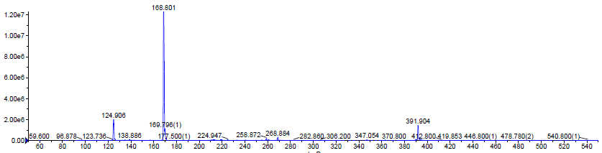
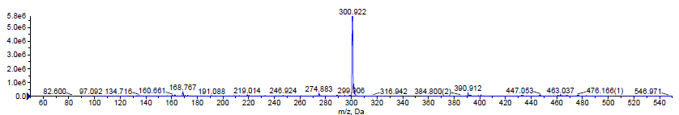
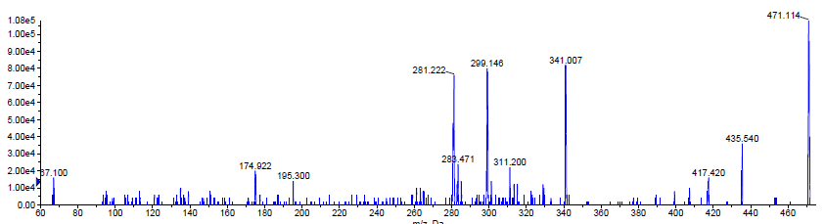
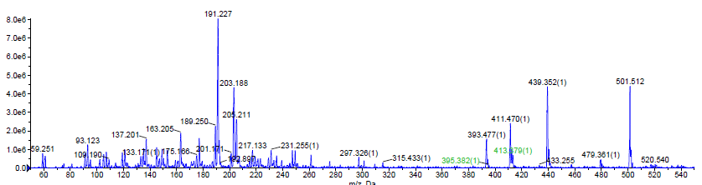
EA
GA
UA
WA
g- :EA- ELLAGIC ACID, GA- GALLIAC ACID, UA- URSOLIC ACID, WA- WITHAFERIN A

