Supplementary information
SI 1- Protocols laboratory procedures for trait measurement.
Carbon estimation. The total carbon present in the plant was oxidized to carbon dioxide by heating it to 900°C in a gas stream containing pure oxygen, free of CO₂. The released carbon dioxide was then measured using an NDIR infrared detector. When the sample is heated to 900°C, any inorganic carbon present is also completely decomposed. To determine the TOC, it is necessary to know the inorganic carbon content and subtract it from the total carbon. Inorganic carbon is determined similarly by first acidifying the sample and heating it to 200°C, conditions under which only carbonates are oxidized to CO₂ and can be measured by the NDIR detector.
Pigment content protocol. The extraction methodology involved grinding a known amount of plant material in a mortar with a small quantity of sodium bicarbonate. Acetone 100% was used as the extraction solvent. Following centrifugation, the samples were analysed using a Hach DR3900 UV-vis spectrophotometer. The formulas to estimate the pigment content are the following:
Chl A (μg ml⁻¹) = [11.24*(A662 – A710) – 2.04*(A645-A710)]
Chl B (μg ml⁻¹) = [20.13*(A645-A710) – 4.19*(A662-A710)]
Bulk Carotenoids (μg ml⁻¹) = [(1000*(A470-A710) – 1.90Chl A – 63.14Chl B)/214]
Nitrogen protocol. The process involves acid digestion with a catalyst, converting nitrogen into ammonium ions. These ions are then treated with a strong base (sodium hydroxide), releasing ammonia, which is collected through steam distillation. The ammonia is trapped in boric acid and titrated with hydrochloric acid of known concentration to quantify the Kjeldahl nitrogen percentage. Protein content is estimated by multiplying the nitrogen content by a conversion factor of 6.25, assuming nitrogen makes up 16% of proteins.
Phosphorus protocol. The method is based on the formation of a yellow, water-soluble heteropoly acid with the vanado-molybdate reagent, which absorbs light at 420 nm. By comparing the light absorption of the sample with a calibration curve, the concentration of total phosphorus is expressed in mg/kg. The analysis was performed using a JASCO V730 spectrophotometer, with appropriate sample preparation and dilution steps carried out according to standard laboratory protocols.
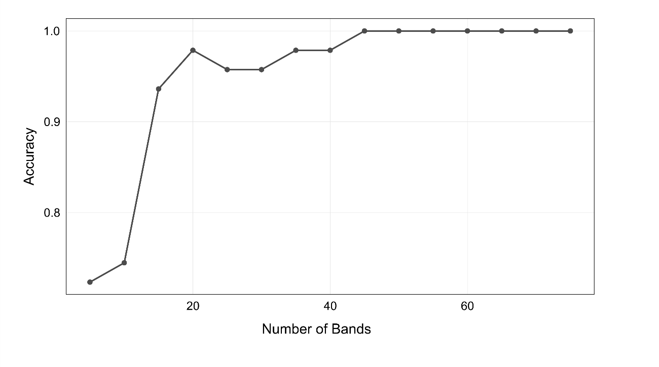
SI 2: Learning curve from the discriminant analysis. Assessing the accuracy depending on the number of bands included in the model. The order of bands selected is the same for all the points, and it was calculated based on the number of significant pairs of species.

SI 3: Confusion matrix for the validation of the species identification by the discriminant analysis. The species code are the following Aster tripolium (At), Bolboschoenus maritimus (Bm), Halimione portulacoides (Hp), Inula crithmoides (Ic), Juncus maritimus (Jm), Limonium dodartii (Ld), Limonium humile (Lh), Limonium vulgare (Lv), Phragmites australis (Pa), Plantago maritima (Plm), Puccinellia maritima (Pum), Salicornia ramosissima (Sl), Sarcocornia perennis (Sr), Spartina alterniflora (Sal), Spartina anglica (San), Spartina maritima (Spm), Suaeda maritima (Sum), Zostera marina (Zm), Zostera noltei (Zn).
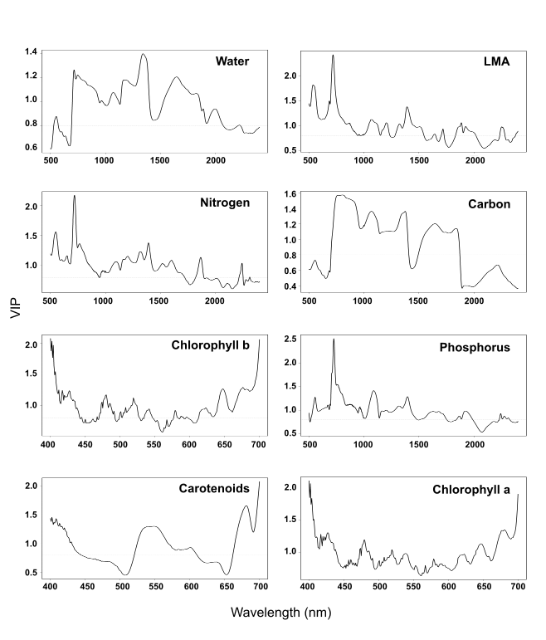
SI 4: Variable Importance in Projection (VIP) scores across wavelengths for all traits. This graph shows which wavelengths contribute most to the PLSR for each of the traits modelled. VIP highlights the significance of a specific wavelength in predicting the target trait. A VIP value greater than 0.8 generally signifies a highly influential variable in the model's prediction.

SI 5: Functional diversity of the vascular plant species in Northern Spain. The value of each functional trait is standardized due to different magnitudes and displayed in the bar graph. These traits are proxies of ecological processes.

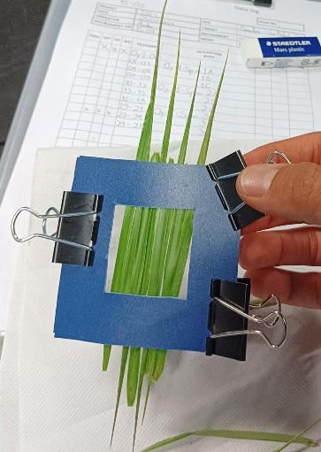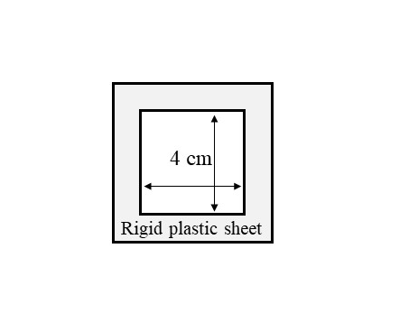
SI 6: Sampling port used to place the leaves´ blades for the readings.
Date | Site | Herbarium Code | Species | Latitude | Longitude | Identified by
27/07/2023 | Oyambre | Oy-II-Pu3 | Puccinellia maritima | 43.37214 | -4.31698 | Dr. Cristina Galván
27/07/2023 | Oyambre | Oy-II-Ph3 | Phragmites australis | 43.37143 | -4.31699 | MSc. Andre Costa Neves
20/07/2023 | Santander | BS-I-Spa2 | Spartina maritima | 43.43335 | -3.7579 | Dr. Jesús Castillo
15/10/2024 | Joyel | JOZO-L2 | Spartina alterniflora | 43.48735 | -3.55053 | Dr. Olivier Coriton
15/10/2024 | Joyel | JOZO-L1 | Spartina anglica | 43.48735 | -3.55015 | Dr. Olivier Coriton
26/07/2023 | Oyambre | Oy-I-Lisp1 | Limonium vulgare | 43.38345 | -4.32059 | MSc. Andre Costa Neves
04/08/2023 | Santander | BS-III-Zm4 | Zostera marina | 43.43193 | -3.81177 | Dr. Bárbara Ondiviela
04/08/2023 | Santoña | BS-III-Zn4 | Zostera noltii | 43.4411 | -3.47278 | Dr. Bárbara Ondiviela
27/07/2023 | Oyambre | Oy-II-Jm3 | Juncus maritimus | 43.37208 | -4.31745 | MSc. Andre Costa Neves
28/09/2023 | Oyambre | Oy-I-Sarco2 | Sarcocornia perennis | 43.38261 | -4.31768 | MSc. Andre Costa Neves
24/07/2023 | Oyambre | Oy-I-Hp2 | Halimione portulacoides | 43.38467 | -4.32084 | MSc. Andre Costa Neves
26/07/2023 | Oyambre | Oy-I-Ld1 | Limonium dodartii | 43.38444 | -4.3209 | MSc. Andre Costa Neves
24/07/2023 | Oyambre | Oy-I-Li3 | Limonium humile | 43.38366 | -4.31978 | Dr. Cristina Galván
18/07/2023 | Santander | BS-I-Sum2 | Suaeda maritima | 43.43192 | -3.75181 | Dr. Cristina Galván
26/07/2023 | Oyambre | Oy-I-Ic3 | Inula crithmoides | 43.38283 | -4.32033 | MSc. Andre Costa Neves
26/07/2023 | Oyambre | Oy-I-Plm1 | Plantago maritima | 43.38332 | -4.31981 | MSc. Andre Costa Neves
05/10/2023 | Oyambre | Oy-II-Bo4 | Bolboschoenus maritimus | 43.36982 | -4.31474 | MSc. Andre Costa Neves
28/09/2023 | Oyambre | Oy-I-Sali4 | Salicornia ramosissima | 43.38287 | -4.31788 | MSc. Andre Costa Neves
28/09/2023 | Oyambre | Oy-I-At4 | Aster tripolium | 43.48288 | -3.55056 | MSc. Andre Costa Neves
SI 7: List of reference specimens collection details. The list contains the name of the species name, collection date, the researcher who identified and geographic coordinates. Voucher specimens (exsiccates) are curated at the IHCantabria herbarium collection and are available upon request to the corresponding authors.

