Table 1, Carcinogenicity Risk Prediction of Diisobutyl phthalate (DIBP).
Method | CDK | CDKExt | CDKGraph | KR | KRC | MACCS | Pubchem | Average | Class
MOL000057 | 0.42 | 0.45 | 0.4 | 0.48 | 0.49 | 0.45 | 0.64 | 0.48 | Non-Carcinogen

Table 2, Predicted toxicological and molecular interaction profile of Diisobutyl phthalate (DIBP) across various organ toxicity, toxicity endpoints, nuclear receptor signaling, stress response pathways, and molecular initiating events.
Classification | Target | Shorthand | Prediction | Probability
Organ toxicity | Hepatotoxicity | dili | Inactive | 0.68
Organ toxicity | Neurotoxicity | neuro | Inactive | 0.83
Organ toxicity | Nephrotoxicity | nephro | Active | 0.56
Organ toxicity | Respiratory toxicity | respi | Inactive | 0.97
Organ toxicity | Cardiotoxicity | cardio | Inactive | 0.8
Toxicity end points | Carcinogenicity | carcino | Active | 0.51
Toxicity end points | Immunotoxicity | immuno | Inactive | 0.99
Toxicity end points | Mutagenicity | mutagen | Inactive | 0.94
Toxicity end points | Cytotoxicity | cyto | Inactive | 0.86
Toxicity end points | BBB-barrier | bbb | Active | 0.85
Toxicity end points | Ecotoxicity | eco | Inactive | 0.57
Toxicity end points | Clinical toxicity | clinical | Inactive | 0.71
Toxicity end points | Nutritional toxicity | nutri | Inactive | 0.88
Tox21-Nuclear receptor | Aryl hydrocarbon Receptor (AhR) signalling pathways | nr_ahr | Inactive | 0.99
Tox21-Nuclear receptor | Androgen Receptor (AR) signalling pathways | nr_ar | Inactive | 1.0
Tox21-Nuclear receptor | Androgen Receptor Ligand Binding Domain signalling pathways (AR-LBD) | nr_ar_lbd | Inactive | 1.0
Tox21-Nuclear receptor | Aromatase signalling pathways | nr_aromatase | Inactive | 0.99
Tox21-Nuclear receptor | Estrogen Receptor Alpha (ER) signalling pathways | nr_er | Active | 1.0
Tox21-Nuclear receptor | Estrogen Receptor Ligand Binding Domain signalling pathways (ER-LBD) | nr_er_lbd | Inactive | 0.97
Tox21-Nuclear receptor | PPAR-Gamma signalling pathways | nr_ppar_gamma | Inactive | 0.99
Tox21-Stress response | NRF2/ARE pathway | sr_are | Inactive | 0.99
Tox21-Stress response | Heat shock factor response element (HSE) pathways | sr_hse | Inactive | 0.99
Tox21-Stress response | Mitochondrial Membrane Potential (MMP) pathways | sr_mmp | Inactive | 0.99
Tox21-Stress response | Tumor suppressor p53 pathways | sr_p53 | Inactive | 0.99
Tox21-Stress response | ATPase family AAA domain-containing protein 5 (ATAD5) | sr_atad5 | Inactive | 0.99

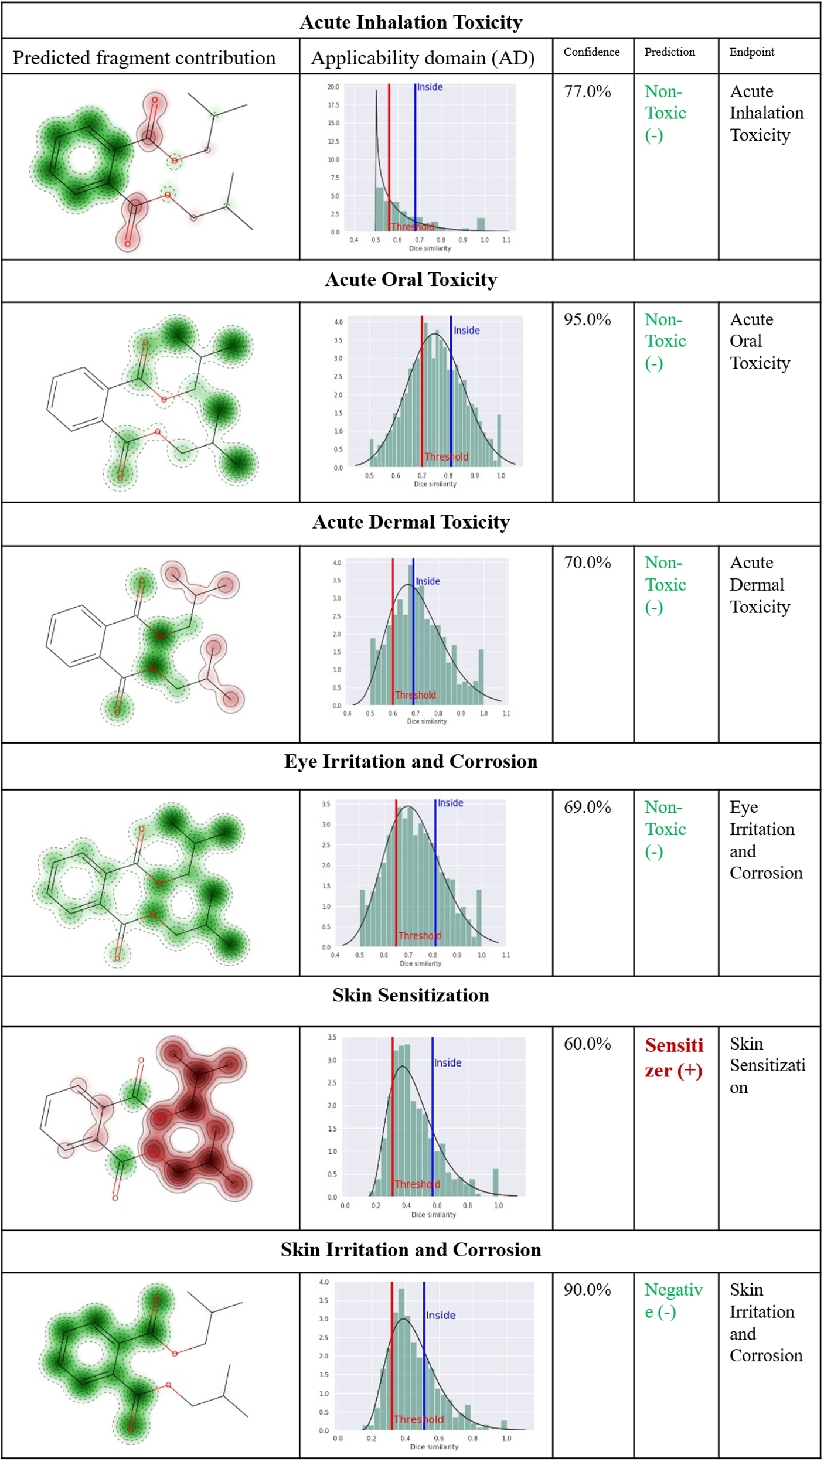

Figure 11, ADMET and toxicity profile of the selected compound as predicted by in silico models. In the fragment contribution maps, green regions indicate non-toxic or safe molecular fragments, whereas red regions denote toxic or reactive substructures contributing to predicted adverse effects. The applicability domain (AD) graphs display structural similarity distributions with training set data; blue lines indicate the query compound is within the applicability domain, while red lines represent the toxicity prediction threshold.

