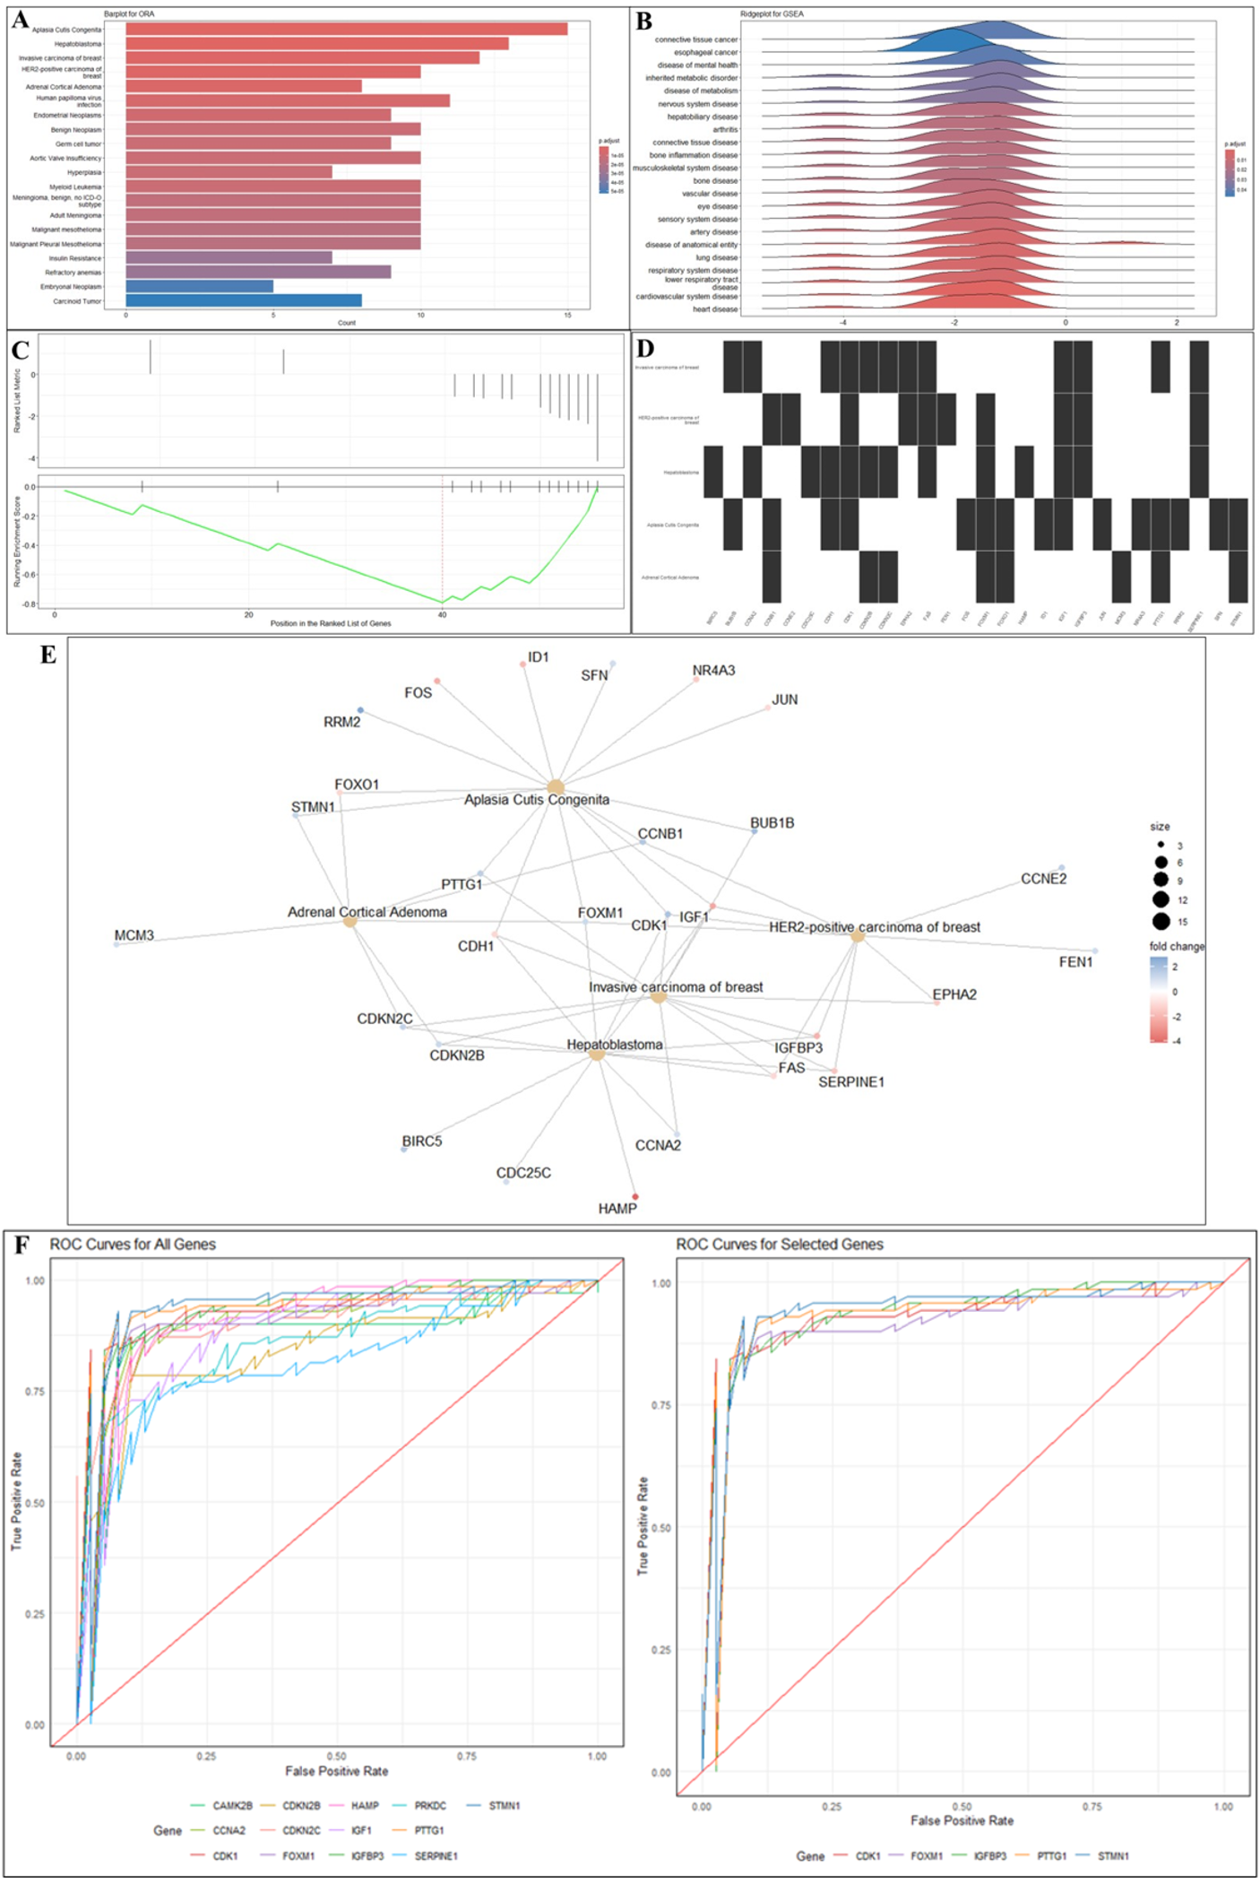
Figure 4, ORA, GSEA, and ROC analysis for hub gene identification in hepatocellular carcinoma (HCC). (A–B) ORA and GSEA enrichment plots of 13 candidate genes in HCC-related diseases. (C) GSEA enrichment plot for ranked gene list. (D) Binary heatmap of gene presence across disease terms. (E) Gene–disease interaction network. (F) ROC curves showing diagnostic power of all candidate genes (left) and five selected real hub genes (right).

