Supplementary Information

Comparative physicochemical and biomedical evaluation of silver nanoparticles synthesized using seed and pod extracts of Amomum aromaticum

Authors: P. Naveen, Dr. Gopi Mamidi

Figures
Figure S1. UV–Vis raw absorbance spectra of Seed-AgNPs and Pod-AgNPs

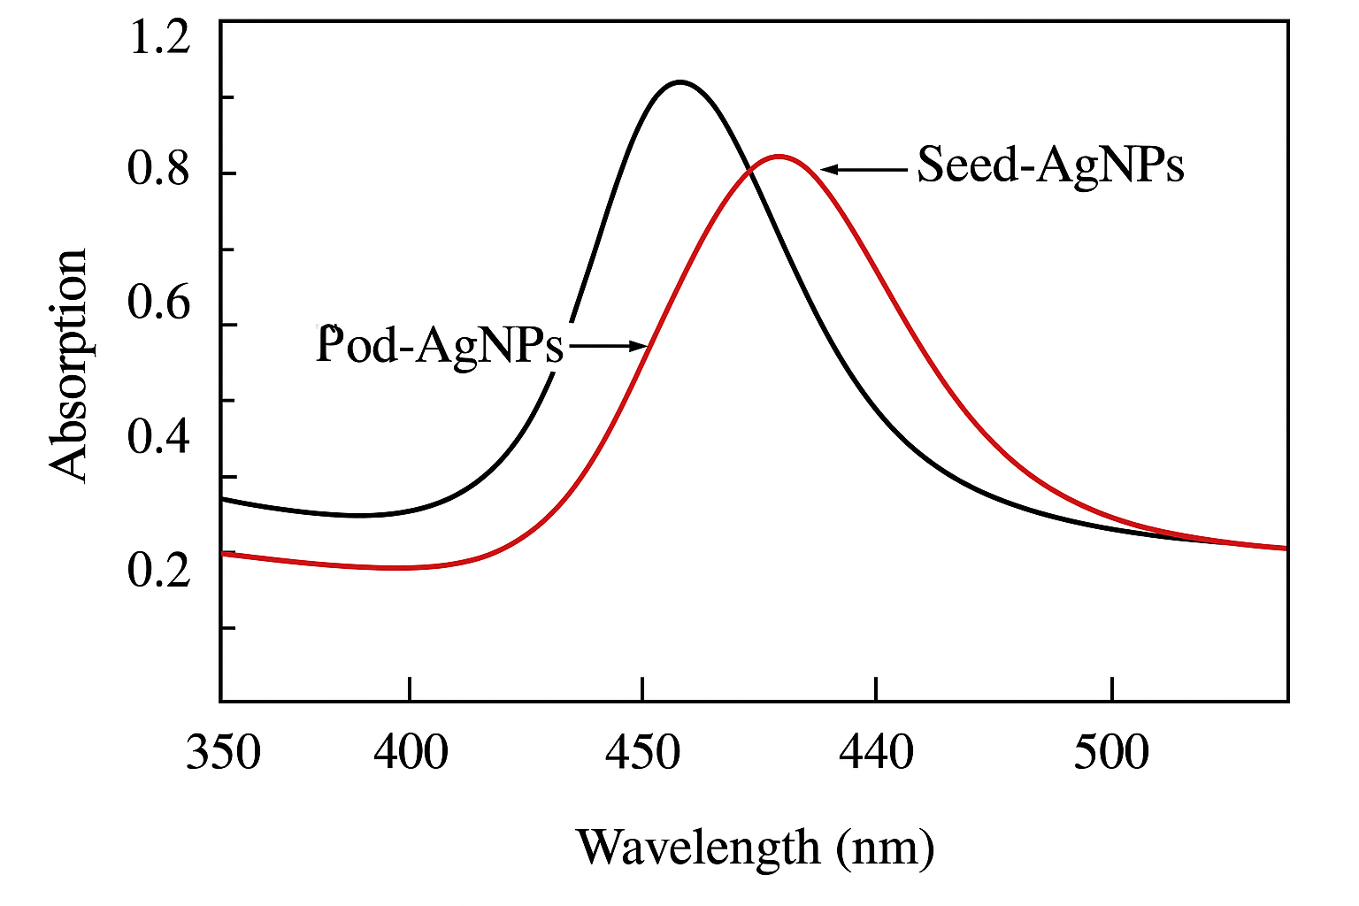
Figure S2. FTIR spectra of seed and pod extracts, and corresponding AgNPs

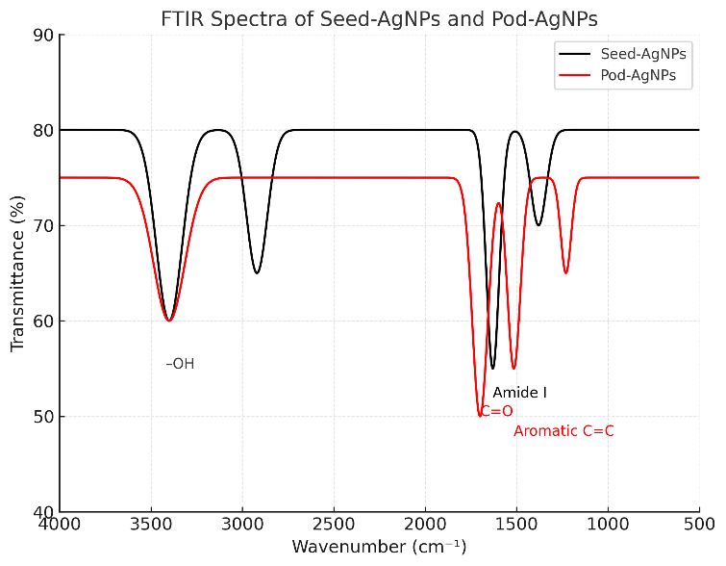

- Figure S3. XRD diffractograms showing full 2θ range for Seed-AgNPs and Pod-AgNPs

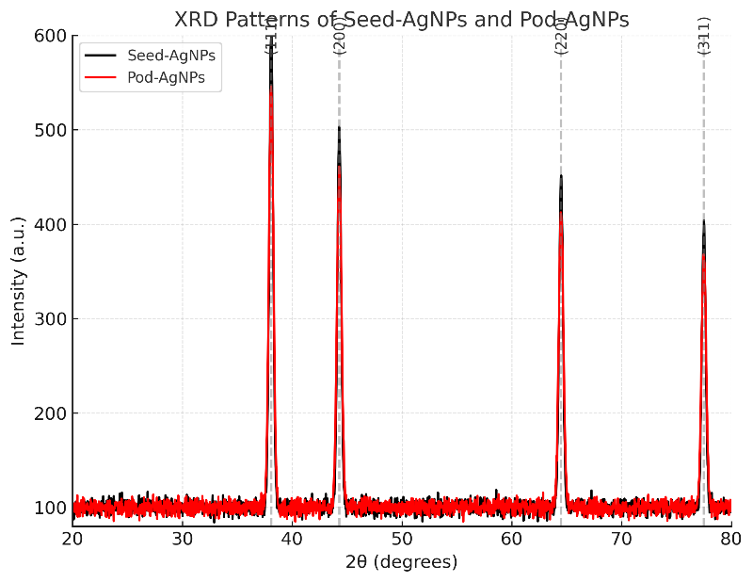

- Figure S4. TEM micrographs at multiple magnifications with original scale bars .

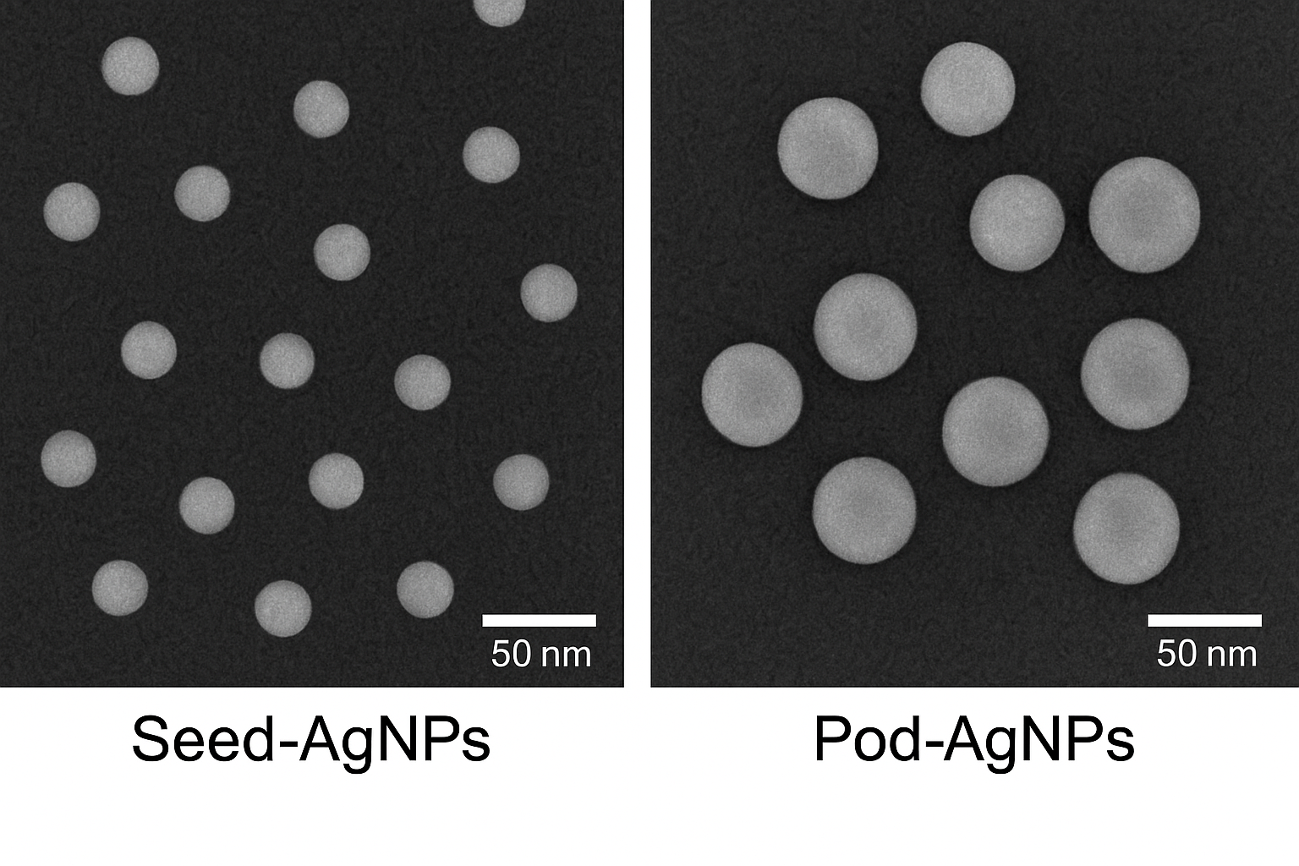

- Figure S5. Zeta potential distribution plots for Seed-AgNPs and Pod-AgNPs.
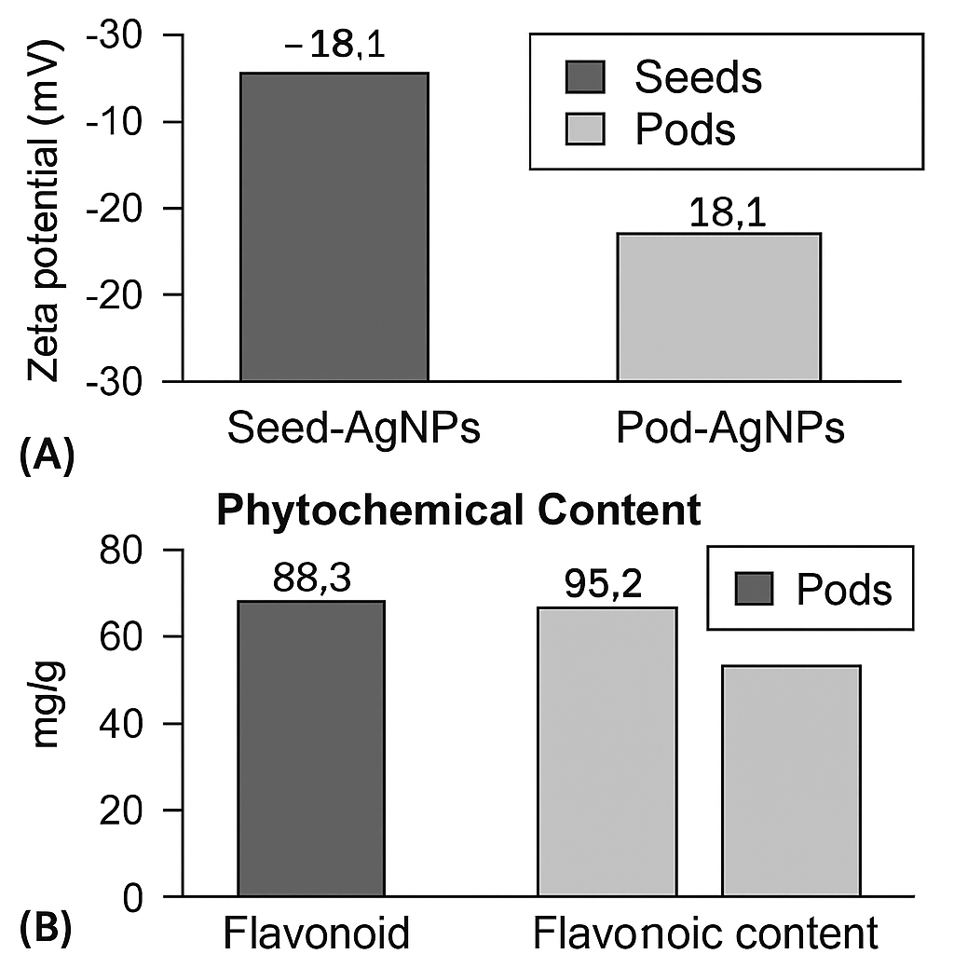

Figure S6: Biological Activities:

