Supplementary Material

- sFigure 1. Cohort flow diagram
- sTable 1. Included Physical and Mental LTCs
- sTable 2. BIC Values for Different Latent Class Models in ADHD and Non-ADHD Group
- sFigure 2A. No-ADHD Group BIC Values
- sFigure 2B. No-ADHD Group BIC Values
- sTable 3. Probabilities of LTCs, and Numbers and Percentages of Individuals with those Conditions in Each Cluster

sFigure 1. Cohort flow diagram

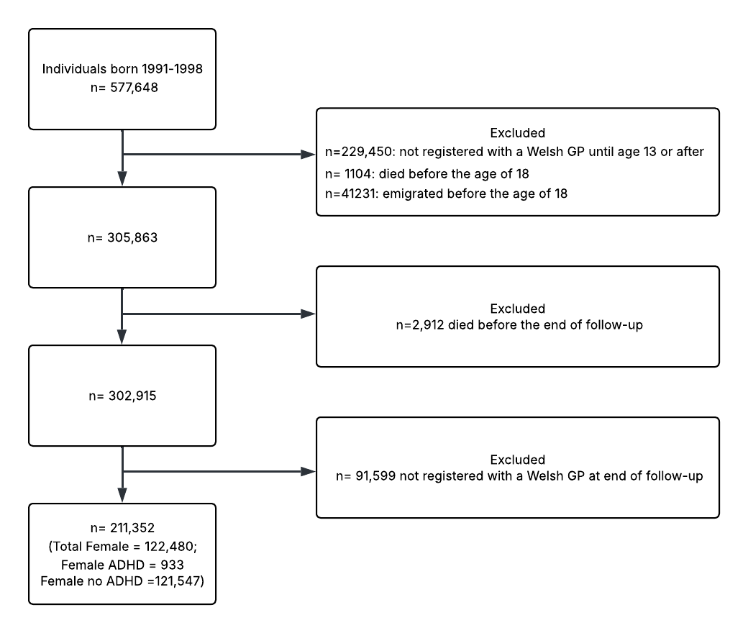

sTable 1. Included Physical and Mental LTCs

Included Physical Long-Term Conditions
Neoplasms | Musculoskeletal Conditions
Cervical carcinoma in situ | Enthesopathies and synovial disorders
Primary malignancy breast | Fibromyalgia
Primary malignancy other skin and subcutaneous tissue | Gout
Primary malignancy others | Intervertebral disc disorders
Haematological Conditions | Osteoarthritis
Iron deficiency with and without anaemia | Osteoporosis
Other anaemias | Rheumatoid arthritis
Vitamin B12 deficiency with and without anaemia | Spondylosis
Endocrine/Metabolic Conditions | Genitourinary Conditions
Obesity | Chronic kidney disease
Polycystic ovarian syndrome | Dysmenorrhoea
Thyroid disease | Endometriosis
Type 2 diabetes | Erectile dysfunction
Neurological Conditions | Female genital prolapse
Chronic fatigue | Female infertility
Epilepsy | Male infertility
Painful conditions | Menorrhagia and polymenorrhoea
Sleep apnoea | Urinary incontinence
Eye Conditions | Urolithiasis
Diabetic eye disease | Gastrointestinal Conditions
Visual impairment and blindness | Constipation
Ear Conditions | Cholelithiasis
Hearing loss | Diverticular disease of intestine
Migraine | Gastritis and duodenitis
Tinnitus | Gastro-oesophageal reflux disease
Cardiovascular Conditions | Irritable bowel syndrome
Atrial fibrillation and flutter | Non-alcoholic fatty liver disease and steatohepatitis
Cerebrovascular disease | Oesophagitis and oesophageal ulcer
Coronary heart disease | Peptic ulcer disease
Heart failure | Dermatological Conditions
Heart valve disease non-rheumatic | Atopic Dermatitis
Hypertension | Chronic ulcer of the skin
Peripheral venous and lymphatic disease | Psoriasis
Venous thromboembolism | Rosacea
Respiratory Conditions | Seborrheic dermatitis
Allergic and chronic rhinitis | Urticaria
Asthma
Chronic obstructive pulmonary disease
Chronic sinusitis
Included Mental Long-Term Conditions
Common Mental Disorders | Severe and Enduring Mental Illnesses
Anxiety | Bipolar Affective Disorder
Depression | Personality Disorders
Eating Disorders | Psychotic Disorders
Obsessive Compulsive Disorder | Addiction Disorders
PTSD | Alcohol Use Disorder
Somatoform Disorders | Drug Use Disorder

sTable 2. BIC Values for Different Latent Class Models in ADHD and Non-ADHD Group

Number of Classes | BIC Values
Number of Classes | No ADHD Group | ADHD Group
1 | 118290.1 | 17602.50
2 | 116636.4 | 17531.84
3 | 115252.9 | 18285.41
4 | 115481.1 | 18094.72
5 | 115507.7 | 18328.45
6 | 116475.0 | 18776.61
7 | 116465.7 | 19050.20
8 | 116623.5 | 19349.38
9 | 117317.3 | 19664.85
10 | 118743.2 | 20051.18

sTable 3. Probabilities of LTCs, and Numbers and Percentages of Individuals with those Conditions in Each Cluster
Cluster
ADHD 1 |  |  |  | ADHD 2 |  |  |  | No ADHD 1 |  |  |  | No ADHD 2 |  |  |  | No ADHD 3
LTC | Prob | n | % | LTC | Prob | n | % | LTC | Prob | n | % | LTC | Prob | n | % | LTC | Prob | n | %
Depression | 0.944 | 294 | 95.5 | Depression | 0.503 | 290 | 50.8 | Depression | 0.786 | 2308 | 83 | Depression | 0.786 | 1263 | 77.4 | Obesity | 0.306 | 1174 | 31.5
Anxiety | 0.905 | 282 | 91.6 | Anxiety | 0.477 | 275 | 48.2 | Anxiety | 0.73 | 2079 | 74.8 | Anxiety | 0.73 | 1213 | 74.3 | Dermatitis | 0.282 | 1069 | 28.7
Obesity | 0.531 | 167 | 54.2 | Obesity | 0.291 | 166 | 29.1 | Dermatitis | 0.243 | 659 | 23.7 | Obesity | 0.53 | 890 | 54.5 | Asthma | 0.136 | 519 | 13.9
Dermatitis | 0.523 | 164 | 53.2 | Dermatitis | 0.252 | 145 | 25.4 | Obesity | 0.216 | 571 | 20.5 | Dermatitis | 0.51 | 856 | 52.5 | Ch. Rhinitis | 0.115 | 441 | 11.8
Asthma | 0.422 | 134 | 43.5 | Asthma | 0.205 | 116 | 20.3 | PTSD | 0.134 | 372 | 13.4 | Asthma | 0.309 | 532 | 32.6 | Ch. Sinusitis | 0.086 | 331 | 8.9
SUD | 0.354 | 115 | 37.3 | Menorrhagia | 0.101 | 59 | 10.3 | Asthma | 0.138 | 360 | 12.9 | Migraine | 0.258 | 446 | 27.3 | Anxiety | 0.109 | 331 | 8.9
Personality Dis. | 0.324 | 109 | 35.4 | Ch. Rhinitis | 0.104 | 58 | 10.2 | Migraine | 0.103 | 278 | 10 | Somat. Dis. | 0.257 | 443 | 27.1 | Migraine | 0.088 | 324 | 8.7
PTSD | 0.322 | 105 | 34.1 | PTSD | 0.092 | 50 | 8.8 | SUD | 0.104 | 273 | 9.8 | Menorrhagia | 0.253 | 434 | 26.6 | Menorrhagia | 0.074 | 271 | 7.3
GORD | 0.271 | 89 | 28.9 | Ch. Sinusitis | 0.081 | 47 | 8.2 | Menorrhagia | 0.094 | 259 | 9.3 | PTSD | 0.246 | 415 | 25.4 | Seb. Dermatitis | 0.062 | 240 | 6.4
Menorrhagia | 0.272 | 85 | 27.6 | Migraine | 0.081 | 46 | 8.1 | Ch. Sinusitis | 0.08 | 209 | 7.5 | GORD | 0.228 | 397 | 24.3 | Ch. Skin Ulcer | 0.062 | 239 | 6.4
Migraine | 0.264 | 84 | 27.3 | IBS | 0.079 | 45 | 7.9 | Ch. Rhinitis | 0.075 | 197 | 7.1 | Ch. Rhinitis | 0.234 | 395 | 24.2 | IBS | 0.054 | 204 | 5.5
Ch. Rhinitis | 0.2 | 64 | 20.8 | SUD | 0.065 | 35 | 6.1 | IBS | 0.062 | 168 | 6 | Ch. Sinusitis | 0.229 | 388 | 23.8 | Epilepsy | 0.049 | 187 | 5
Somat. Dis. | 0.195 | 64 | 20.8 | Epilepsy | 0.063 | 34 | 6 | Ensethopathy | 0.055 | 156 | 5.6 | IBS | 0.213 | 364 | 22.3 | Ensethopathy | 0.046 | 166 | 4.5
IBS | 0.199 | 63 | 20.5 | Seb. Dermatitis | 0.058 | 33 | 5.8 | PCOS | 0.04 | 116 | 4.2 | ME | 0.19 | 328 | 20.1 | PTSD | 0.044 | 158 | 4.2
Gastritis | 0.143 | 45 | 14.6 | RA | 0.054 | 31 | 5.4 | Dysmenorrhoea | 0.037 | 99 | 3.6 | SUD | 0.163 | 275 | 16.9 | Depression | 0.060 | 63 | 1.7

