Controlled Synthesis of Topologically Diverse Polyrotaxanes by Ring-Opening Polymerization of Mechanically Interlocked Monomers
Jinlei Zhou^{1,6}, Wenseng Chen^{2,3,6}, Zengquan Tian⁵, Libo Jing¹, Jingyao Yang¹, Zihang Song¹, Kaiyuan Wang⁴, Zhenjie Zhang⁴, Dong-Sheng Guo⁵, Ke Zhang^{2,3}, Kang Cai¹
¹ College of Chemistry, State Key Laboratory of Elemento-Organic Chemistry, Frontiers Science Center for New Organic Matter, Nankai University, 94 Weijin Road, Nankai District, Tianjin 300071, China.
² Laboratory of Polymer Physics and Chemistry, Beijing National Laboratory for Molecular Sciences, Institute of Chemistry, The Chinese Academy of Sciences, Beijing 100190, P. R. China..
³ University of Chinese Academy of Sciences, Beijing 100049, China.
⁴ State Key Laboratory of Medicine Chemistry Biology, College of Chemistry, Nankai University, Tianjin 300071, China.
⁵ Key Laboratory of Functional Polymer Materials (Ministry of Education), Collaborative Innovation Center of Chemical Science and Engineering, State Key Laboratory of Elemento-Organic Chemistry, Nankai University, Tianjin 300071, China.
⁶ These author contribute equally to this work. Correspondence and requests for materials should be addressed to K. C. (Email: kangcai@nankai.edu.cn) and K. Z. (Email: kzhang@iccas.ac.cn)
Table of Contents
1. General Methods 2
2. Synthetic Protocols 3
3. NMR Spectroscopy 14
4. Homopolymerization 31
5. Crystallographic Characterization 38
6. Molecular dynamics simulations 39
7. Theoretical Calculations 40
8. References 54
1. General Methods
All reagents were purchased from commercial suppliers and used without further purification. Compound F, X-1, X-2, P-OH, Ts-5 and Boc-1 were synthesized according to previous literature. Thin-layer chromatography (TLC) was performed on silica gel HSGF254. Nuclear magnetic resonance (NMR) spectra were recorded on a Bruker AV 400 spectrometer at 400 MHz (¹H NMR), 101 MHz (¹³C NMR) and 376 MHz (¹⁹F NMR). High-resolution electrospray ionization-mass spectra (HR-ESI-MS) were recorded on a Bruker Apex IV Fourier transformation mass spectrometer.
Gel permeation chromatography (GPC) in DMF was conducted on a system comprised of a Waters 515 HPLC pump, and a Waters 2414 RI detector equipped with two Agilent mixed columns (one PLgel MIXED-C and one PLgel MIXED-D). DMF with 0.01 M LiBr was used as the eluent at a flow rate of 1.0 mL/min. Polystyrene standards were used for the calibration.
Molecular dynamics (MD) simulations were carried out using GROMACS 2022.2. A cubic simulation box was constructed and filled with DMF solvent molecules, into which a single M1 or M2 molecule was inserted. The system underwent energy minimization, followed by NVT and NPT equilibration at 363.15 K. Subsequently, a 20 ns MD simulation was performed under periodic boundary conditions. For trajectory analysis, the gmx mindist tool was used to compute the minimum distance between the carbonate and crown ether groups over time.

2. Synthetic Protocols
Scheme S1. Synthetic Protocols for I-NH₂
Compound I-1 and I-2 were purchased from Aladdin and Macklin, and used directly without further purification.
I-Boc: To a stirred solution of compound I-1 (2.06 g, 10.0 mmol) and compound I-2 (2.37 g, 10.0 mmol) in MeCN (30 mL) was added potassium carbonate (2.76 g, 20.0 mmol). The reaction was carried out at 80 °C overnight. The reaction mixture was then filtered and concentrated to give a residue, which was purified by column chromatography (SiO₂, PE : EA = 5:1, v/v) to afford I-Boc as a white solid (3.19 g, 88%). ¹H NMR (400 MHz, CDCl₃) δ 7.04 (t, J = 1.7 Hz, 1H), 6.76 (d, J = 1.7 Hz, 2H), 4.86 (s, 1H), 4.04 (t, J = 5.9 Hz, 2H), 3.35 (q, J = 6.4 Hz, 2H), 1.99 (p, J = 6.2 Hz, 2H), 1.45 (s, 9H), 1.32 (s, 18H). ¹³C NMR (101 MHz, CDCl₃) δ 158.4, 156.2, 152.4, 115.24, 108.9, 65.8, 38.4, 35.1, 31.6, 29.7, 28.6. ESI HRMS for I-Boc: Calcd for C₂₂H₃₇NO₃Na: m/z = 386.2671 [M + Na]⁺; found: 386.2672.
I-NH₂: Compound I-Boc (1.82 g, 5.00 mmol) was dissolved in a mixture of DCM (10 mL) and TFA (10 mL). The reaction was stirred at room temperature for 30 minutes and then concentrated under reduced pressure. The residue was dissolved in DCM (10 mL) and washed twice with NaOH_{aq} (40%, w/w, 10 mL). Removal of the solvent afforded I-NH₂ as a colourless solid (1.26g, 96%). ¹H NMR (400 MHz, CDCl₃) δ 7.03 (t, J = 1.7 Hz, 1H), 6.77 (d, J = 1.6 Hz, 2H), 4.07 (t, J = 6.1 Hz, 2H), 2.94 (t, J = 6.8 Hz, 2H), 2.00–1.90 (m, 2H), 1.68 (s, 2H), 1.32 (s, 18H). ¹³C NMR (101 MHz, CDCl₃) δ 158.6, 152.3, 115.1, 108.9, 65.7, 39.4, 35.1, 33.2, 31.6. ESI HRMS for I-NH₂: Calcd for C₁₇H₃₀NO: m/z = 264.2327 [M + H]⁺; found: 264.2332.
Scheme S2. Synthetic Protocols for DB-CC
Compound 6-eo was purchased from Aladdin, and used directly without further purification. Compound F was synthesized according to previous literature ^{S1}.
F-TBS: A solution of bis(trichloromethyl) carbonate (5.92 g, 20.0 mmol) in THF (50.0 mL) was cooled to 0 °C, and pyridine (3.16 g, 40.0 mmol) was added slowly. A solution of compound 6-eo (4.48 g, 40.0 mmol) in THF (20.0 mL) was then added dropwise, and the mixture was stirred at 0 °C for 1 h. The reaction mixture was filtered and concentrated to afford a reactive intermediate, which was used directly in the next step. Compound F (18.4 g, 50.0 mmol) and TEA (7.57 g, 75.0 mmol) were dissolved in DCM (100 mL), and the resultant reactive intermediate was added. After stirring at room temperature for 0.5 h, the reaction was concentrated and the crude product was purified by column chromatography (SiO₂, PE : EA = 10:1, v/v) to give F-TBS as a colourless oil (12.1 g, 60%). ¹H NMR (400 MHz, CDCl₃) δ 6.97 (s, 1H), 4.24 (t, J = 6.6 Hz, 2H), 3.49 (t, J = 7.3 Hz, 2H), 2.58 (s, 3H), 2.24 (s, 3H), 2.20 (td, J = 6.9, 2.6 Hz, 2H), 2.05 (t, J = 7.3 Hz, 2H), 1.93 (t, J = 2.6 Hz, 1H), 1.74 (p, J = 6.8 Hz, 2H), 1.60–1.45 (m, 10H), 0.82 (s, 9H), -0.04 (s, 6H). ¹³C NMR (101 MHz, CDCl₃) δ 153.1, 144.3, 141.7, 141.4, 138.0, 133.7, 128.8, 84.1, 69.4, 68.6, 60.4, 45.6, 39.9, 31.0, 28.1, 28.0, 25.9, 25.1, 24.7, 18.3, 18.2, 17.1, -5.4. ESI HRMS for F-TBS: Calcd for C₂₇H₄₄NO₆Si: m/z = 506.2938 [M + H]⁺; found: 506.2936.
F-COOH: Compound F-TBS (10.1 g, 20.0 mmol) was dissolved in methanol (200 mL) and Amberlyst 15 (14.6 g, 80 mmol) was added. The reaction was stirred at room temperature for 1 h. The mixture was filtered and concentrated. The crude product was dissolved in DMF (150 mL), in which Celite 545RV (60.0 g) and pyridinium dichromate (60.0 g, 160 mmol) were added. After stirring at room temperature overnight, 150 mL diethyl ether was added. The mixture was filtered through diatomite and the pH of the filtrate was adjusted to 3 by addition of 1 M HCl aqueous solution. After two washes with water, the filtrate was concentrated and the residue was purified by column chromatography (SiO₂, PE : EA = 3:1, v/v) to furnish F-COOH as a yellow solid (5.92 g, 73%). ¹H NMR (400 MHz, CDCl₃) δ 6.99 (s, 1H), 4.26 (t, J = 5.7 Hz, 2H), 2.86 (s, 2H), 2.60 (s, 3H), 2.31–2.17 (m, 5H), 1.95 (t, J = 2.6 Hz, 1H), 1.75 (p, J = 6.9 Hz, 2H), 1.64–1.47 (m, 11H). ¹³C NMR (101 MHz, CDCl₃) δ 176.4, 153.4, 144.1, 141.51, 141.46, 137.2, 134.0, 129.5, 84.3, 69.7, 68.6, 39.4, 30.8, 28.13, 28.07, 25.3, 24.8, 18.4, 17.5. ESI HRMS for F-COOH: Calcd for C₂₁H₂₇NO₇Na: m/z = 428.1685 [M + Na]⁺; found: 428.1688.
DB-CC: To a stirred solution of compound F-COOH (4.05 g, 10.0 mmol) in THF (30 mL) were added pentafluorophenol (3.66 g, 20.0 mmol), EDC⸱HCl (5.73 g, 30.0 mmol) and DMAP (366 mg, 3.00 mmol). The reaction was performed at room temperature overnight. The reaction mixture was concentrated and the crude product was purified by column chromatography (SiO₂, PE : EA = 10:1, v/v) to afford DB-CC as a colourless solid (3.71 g, 65%). ¹H NMR (400 MHz, CDCl₃) δ 7.02 (s, 1H), 4.29 (t, J = 6.6 Hz, 2H), 3.22 (s, 2H), 2.63 (s, 3H), 2.28 (s, 3H), 2.21 (td, J = 6.7, 2.6 Hz, 2H), 1.94 (t, J = 2.7 Hz, 1H), 1.77 (p, J = 6.8 Hz, 2H), 1.67 (s, 6H), 1.62–1.51 (m, 4H). ¹³C NMR (101 MHz, CDCl₃) δ 167.1, 153.0, 144.2, 141.6, 141.2, 136.3, 134.1, 129.9, 84.2, 69.8, 68.6, 46.7, 39.7, 30.6, 28.1, 28.0, 25.3, 24.8, 18.4, 17.5. ¹⁹F NMR (376 MHz, CDCl₃) δ -152.1 – -152.4 (m, 2F), -158.0 (t, J = 21.5 Hz, 1F), -162.2 – -162.5 (m, 2F). ESI HRMS for DB-CC: Calcd for C₂₇H₂₆NO₇NaF₅: m/z = 594.1527 [M + Na]⁺; found: 594.1529.
Scheme S3. Synthetic Protocols for Stopper-N₃
Compound X-1 and X-2 were synthesized according to previous literature ^{S2,S3}
To a solution of compound X-1 (5.26 g, 20.0 mmol) in MeOH (100 mL) was added compound X-2 (2.28 g, 20.0 mmol). The reaction mixture was heated to reflux for 24 h. After cooling to room temperature, NaBH₄ (1.48 g, 40.0 mmol) was added portionwise over 0.5 h in an ice water bath. The mixture was stirred at room temperature for 24 h and then quenched with H₂O (1.00 mL). MeOH was removed in vacuo and the residue was diluted with DCM (100 mL). The resulting biphasic mixture was stirred vigorously at room temperature for 30 min. The organic phase was separated and the aqueous phase was extracted with DCM (50.0 mL × 2). The combined organic layers were washed with brine (500 mL), dried over MgSO₄ and concentrated in vacuo. Concentrated HCl (4.00 mL) was then added dropwise to the crude residue and the mixture was stirred for 1 h. The reaction mixture was filtered and the solid residue was washed with water (50.0 mL × 3). The residue was dispersed in acetone and heated to 50 °C. Addition of excess saturated aqueous NH₄PF₆ (5.00 mL) led to dissolution of the desired crude product. The acetone was evaporated, the residue suspended in water was extracted with DCM (100 mL). The organic phase was dried over Na₂SO₄ and the solvent removed under reduced pressure. The crude product was purified by column chromatography (SiO₂, PE : EA = 5:1, v/v) to afford Stopper-N₃ as a white solid (7.10 g, 70%). ¹H NMR (400 MHz, CDCl₃) δ 7.71 (t, J = 1.8 Hz, 1H), 7.61 (t, J = 1.8 Hz, 1H), 6.24 (s, 2H), 4.10 (s, 2H), 3.40 (t, J = 5.6 Hz, 2H), 3.28–3.13 (m, 2H), 1.88 (p, J = 7.1 Hz, 2H), 1.71 (p, J = 6.9 Hz, 2H), 1.43 (d, J = 1.5 Hz, 9H), 1.36 (d, J = 1.5 Hz, 9H). ¹³C NMR (101 MHz, CDCl₃) δ 155.2, 148.6, 142.1, 128.2, 127.6, 122.0, 50.7, 49.4, 48.7, 36.3, 35.4, 30.83, 30.77, 25.8, 23.7. ESI HRMS for Stopper-N₃: Calcd for C₁₉H₃₃N₅O₂F₆P: m/z = 508.2276 [M + H]⁺; found: 508.2278.
Scheme S4. Synthetic Protocols for Cown-BocNH₂
P-OH, Ts-5 were synthesized according to previous literature ^{S4,S5}.
Crown-ene: Sodium hydride (1.9 g, 80 mmol) was suspended in THF (1000 ml), and a solution of P-OH (3.9 g, 20 mmol) and Ts-5 (11.8 g, 20 mmol) in THF (50 ml) was added dropwise over 12 h at 70 °C. The reaction was continued for an additional 12 h. The mixture was cooled to room temperature and H₂O (5 ml) was added to quench the reaction. The resulting mixture was filtered and the solvent removed by rotary evaporation. The crude product was purified by column chromatography (SiO₂, MeOH : DCM = 15:1, v/v) to give Crown-ene as a colourless oil (2.7 g, 31%). ¹H NMR (400 MHz, CDCl₃) δ 6.93 (s, 2H), 6.03 (m, 1H), 5.42 (d, J = 17.3, 1H), 5.31 (d, J = 17.3 Hz, 1H), 4.67–4.58 (m, 6H), 3.75–3.54 (m, 24H). ¹³C NMR (101 MHz, CDCl₃) δ 166.0, 159.8, 132.3, 118.2, 107.0, 73.9, 70.8, 70.62, 70.59, 70.0, 68.5. ESI HRMS for P-ene: Calcd for C₂₂H₃₆NO₈: m/z = 442.2441 [M + H]⁺; found: 442.2444.
Crown-BocNH₂: Palladium (64 mg, 0.6 mmol), ammonium formate (3.8 g, 60 mmol) and Crown-ene (2.6 g, 6 mmol) were combined in MeOH (20 ml) and the mixture was stirred at 70 °C for 12 h. After cooling to room temperature, the solvent was removed under reduced pressure. The residue was dissolved in DCM (20 ml), filtered, and the filtrate concentrated under reduced pressure. The crude product was dissolved in MeCN (20 ml), then tert-Butyl 3-bromopropylcarbamate (2.9 g, 12 mmol) and potassium carbonate (1.7 g, 12 mmol) were added. The mixture was stirred at 80 °C for 12 h and then cooled to room temperature. The mixture was filtered and the filtrate concentrated under reduced pressure. Purification by column chromatography (SiO₂, MeOH : DCM = 10:1, v/v) afforded Crown-BocNH₂ as a colourless oil (2.5 g, 73%). ¹H NMR (400 MHz, CDCl₃) δ 6.89 (s, 2H), 5.02 (s, 1H), 4.60 (s, 4H), 4.08 (t, J = 6.0 Hz, 2H), 3.70–3.51 (m, 24H), 3.28 (q, J = 6.5 Hz, 2H), 1.96 (p, J = 6.5 Hz, 2H), 1.40 (s, 9H). ¹³C NMR (101 MHz, CDCl₃) δ 106.8, 73.8, 70.64, 70.61, 70.5, 69.9, 65.5, 37.5, 29.3, 28.4. ESI HRMS for Crown-BocNH₂: Calcd for C₂₇H₄₇NO₁₀: m/z = 559.3231 [M + H]⁺; found: 559.3231.
Scheme S5. Synthetic Protocols for MIM-1 and MIM-2
Compound 24-Crown-8 was purchased from Aladdin, Compound Boc-1 were synthesized according to previous literature^{S6}
Rox-1: Compound Stopper-N₃ (1.01 g, 2.00 mmol), compound Crown-BocNH₂ (1.40 g, 2.50 mmol), compound DB-CC (1.14 g, 2.00 mmol) and Cu(MeCN)₄PF₆ (74.4 mg, 0.200 mmol) were dissolved in DCM (20 ml) and the mixture was stirred under N₂ at room temperature for 12 h. The solvent was removed and the crude product was purified by column chromatography (SiO₂, THF : DCM = 5:1, v/v) to yield Rox-1 as a white solid (2.49 g, 76%). ¹H NMR (400 MHz, CDCl₃) δ 8.42 (s, 2H), 7.70 (d, J = 1.9 Hz, 1H), 7.62–7.47 (m, 2H), 7.02 (s, 1H), 6.72 (s, 2H), 4.94 (t, J = 6.2 Hz, 1H), 4.42–4.35 (m, 4H), 4.27 (t, J = 6.5 Hz, 2H), 4.18–4.01 (m, 4H), 3.75–3.42 (m, 24H), 3.33–3.17 (m, 6H), 2.71–2.60 (m, 5H), 2.27 (s, 3H), 1.98 (p, J = 6.4 Hz, 2H), 1.88 (p, J = 7.9 Hz, 2H), 1.66 (m, 14H), 1.47–1.35 (m, 21H), 1.08 (s, 9H). ¹³C NMR (101 MHz, CDCl₃) δ 167.1, 166.5, 158.0, 156.1, 153.0, 152.8, 147.9, 144.0, 141.4, 141.2, 140.7, 136.2, 134.0, 129.6, 126.5, 125.8, 124.7, 109.0, 73.8, 70.9, 70.8, 70.7, 70.5, 70.4, 70.3, 69.8, 66.3, 49.2, 48.7, 47.5, 46.6, 39.6, 39.5, 36.1, 35.2, 31.1, 30.9, 30.8, 30.7, 30.5, 29.3, 29.0, 28.4, 28.2, 27.3, 25.4, 25.14, 25.10, 23.0, 17.4. ESI HRMS for Rox-1: Calcd for C₇₃H₁₀₅N₈O₁₉F₁₁P: m/z = 1637.7058 [M + H]⁺; found: 1637.7057.
Rox-2: Compound Rox-1 (2.00 g, 1.22 mmol), acetic anhydride (1.24 g, 12.2 mmol) and triethylamine (2.46 g, 24.4 mmol) were dissolved in DCM (20 ml) and stirred at room temperature for 12 h. The solvent was removed and the crude product was purified by column chromatography (SiO₂, THF : DCM = 2:1, v/v) to afford Rox-2 as a white solid (1.59 g, 85%). ¹H NMR (400 MHz, CDCl₃) δ 7.64 (d, J = 44.0 Hz, 1H), 7.40 (dd, J = 30.9, 1.9 Hz, 1H), 7.03 – 6.91 (m, 2H), 6.81 (s, 2H), 6.34 (d, J = 47.4 Hz, 1H), 4.47 (s, 4H), 4.36 (d, J = 11.0 Hz, 2H), 4.21 (t, J = 6.8 Hz, 2H), 4.15–4.00 (m, 4H), 3.56–3.16 (m, 31H), 2.66–2.56 (m, 5H), 2.21 (s, 3H), 2.18 (s, 2H), 1.96–1.88 (m, 3H), 1.76 – 1.56 (m, 14H), 1.37–1.23 (m, 30H). ¹³C NMR (101 MHz, CDCl₃) δ 171.3, 171.1, 167.0, 156.5, 153.1, 152.8, 152.2, 147.6, 146.2, 144.0, 141.4, 141.07, 141.05, 140.0, 136.1, 134.0, 129.6, 129.3, 124.2, 123.7, 121.9, 121.1, 78.5, 71.1, 71.02, 70.95, 70.92, 70.87, 70.8, 70.5, 70.4, 70.2, 70.0, 69.81, 69.7, 49.4, 48.9, 47.6, 46.5, 44.2, 39.5, 36.7, 36.0, 35.9, 35.1, 34.9, 31.1, 30.90, 30.86, 30.5, 29.6, 29.1, 29.0, 28.8, 28.5, 28.4, 28.3, 26.1, 25.9, 25.5, 25.11, 25.06, 24.99, 24.96, 24.3, 21.5, 21.2, 17.3. ESI HRMS for Rox-2: Calcd for C₇₅H₁₀₆N₈O₂₀F₅: m/z = 1533.7444 [M + H]⁺; found: 1533.7430.
MIM-1: Compound Rox-2 (1.53 g, 1.00 mmol) was dissolved in a mixture of DCM (10 mL) and TFA (10 mL). The reaction was stirred at room temperature for 30 minutes and then concentrated. The residue was dissolved in DCM (20 mL) and this solution was added dropwise over 3 h by syringe pump to a large volume of DCM (1000 mL) containing TEA (5.05 g, 50 mmol) at room temperature. The solvent was removed and the residue was purified by column chromatography (SiO₂, THF : DCM = 2:1, v/v) to give MIM-1 as a white solid (873 mg, 70%). ¹H NMR (400 MHz, DMSO-d₆, 353K) δ 7.58 (s, 1H), 7.53 (s, 1H), 7.29 (s, 1H), 7.17 (s, 1H), 7.09 (s, 1H), 6.83 (s, 2H), 4.48 – 4.41 (m, 4H), 4.31 (d, J = 10.9 Hz, 2H), 4.17 (s, 2H), 4.05 – 3.95 (m, 4H), 3.64 – 3.58 (m, 2H), 3.58 – 3.53 (m, 2H), 3.52 – 3.33 (m, 24H), 3.17 (q, J = 6.3 Hz, 2H), 2.61 (d, J = 4.9 Hz, 6H), 2.55 (t, J = 7.7 Hz, 2H), 2.23 (s, 3H), 1.84 (p, J = 6.5 Hz, 2H), 1.68 – 1.55 (m, 8H), 1.52 (s, 6H), 1.37 (s, 11H), 1.32 (s, 9H). ¹³C NMR (101 MHz, DMSO-d₆, 298K) δ 170.2, 169.7, 158.0, 152.2, 152.1, 146.9, 146.0, 143.5, 141.9, 140.3, 139.6, 138.2, 133.4, 129.1, 128.0, 123.8, 121.4, 120.8, 109.0, 74.0, 70.5, 70.41, 70.36, 70.3, 70.1, 69.9, 69.7, 69.6, 69.4, 65.5, 48.6, 48.5, 47.4, 43.9, 35.7, 35.6, 35.0, 34.8, 34.7, 30.71, 30.67, 30.49, 30.46, 30.1, 28.5, 28.4, 27.6, 26.0, 25.03, 24.97, 24.8, 24.7, 21.0, 16.5. ESI HRMS for MIM-1: Calcd for C₇₅H₁₀₆N₈O₂₀F₅: m/z = 1533.7444 [M + H]⁺; found: 1533.7430.
Rox-3: Compound Stopper-N₃ (1.52 g, 3.00 mmol), compound 24-crown-8 (1.41 g, 4.00 mmol), compound DB-CC (1.71 g, 2.00 mmol) and Cu(MeCN)₄PF₆ (112 mg, 0.300 mmol) were dissolved in DCM (25 ml) and stirred under N2 at room temperature for 12 h. The solvent was removed and the crude product was purified by column chromatography (SiO₂, THF : DCM = 5:1, v/v) to furnish Rox-3 as a white solid (3.21 g, 75%). ¹H NMR (400 MHz, CDCl₃) δ 7.65 (s, 1H), 7.56 (s, 2H), 7.17 (s, 2H), 6.98 (s, 1H), 4.43 (t, J = 6.6 Hz, 2H), 4.39–4.32 (m, 2H), 4.23 (t, J = 6.5 Hz, 2H), 3.54–3.40 (m, 32H), 3.29–3.17 (m, 4H), 2.67 (t, J = 7.7 Hz, 2H), 2.59 (s, 3H), 2.22 (s, 3H), 1.95 (p, J = 8.0 Hz, 2H), 1.77–1.59 (m, 13H), 1.48–1.40 (m, 2H), 1.34 (s, 10H), 1.29 (s, 10H). ¹³C NMR (101 MHz, CDCl₃) δ 167.2, 153.2, 152.9, 141.5, 141.3, 140.9, 136.3, 134.1, 126.7, 126.4, 77.6, 77.5, 77.3, 77.2, 76.9, 76.8, 70.5, 69.9, 49.2, 47.9, 46.7, 39.6, 36.2, 35.4, 31.1, 30.8, 30.6, 28.3, 27.2, 25.2, 23.0, 17.4. ESI HRMS for Rox-3: Calcd for C₆₂H₉₀N₆O₁₇F₁₁PNa: m/z = 1453.5822 [M + Na]⁺; found: 1453.5808.
Rox-4: Compound Rox-3 (3.00 g, 2.10 mmol), compound Boc-1 (7.56 g, 21.0 mmol) and triethylamine (4.24 g, 42.0 mmol) were dissolved in DCM (50 ml) and stirred at room temperature for 12 h. The solvent was removed and the residue was purified by column chromatography (SiO₂, THF : DCM = 2:1, v/v) to afford Rox-4 as a white solid (2.38 g, 78%). ¹H NMR (400 MHz, CDCl₃) δ 7.73 (s, 1H), 7.43 (d, J = 17.2 Hz, 1H), 6.98 (d, J = 8.5 Hz, 2H), 5.61 (d, J = 6.1 Hz, 1H), 4.60–4.41 (m, 4H), 4.24 (t, J = 6.7 Hz, 2H), 3.45 (s, 36H), 3.19 (s, 2H), 2.81 (t, J = 5.8 Hz, 2H), 2.69 (t, J = 7.6 Hz, 2H), 2.61 (s, 3H), 2.25 (s, 3H), 2.10–1.99 (m, 2H), 1.93–1.83 (m, 2H), 1.80–1.63 (m, 10H), 1.45–1.34 (m, 20H), 1.27 (s, 9H). ¹³C NMR (101 MHz, CDCl₃) δ 172.8, 167.0, 156.0, 152.9, 152.3, 147.6, 146.3, 144.0, 141.4, 141.1, 140.1, 136.1, 134.0, 129.3, 123.9, 121.6, 78.5, 71.1, 70.9, 69.7, 50.0, 48.2, 46.5, 44.4, 39.5, 36.6, 35.9, 35.0, 33.2, 31.1, 30.92, 30.87, 30.5, 29.0, 28.43, 28.38, 28.3, 26.4, 25.5, 25.3, 25.2, 25.0, 17.4. ESI HRMS for Rox-4: Calcd for C₇₀H₁₀N₇O₂₀F₅: m/z = 1456.7178 [M + H]⁺; found: 1456.7169.
MIM-2: Compound Rox-4 (2.18 g, 1.50 mmol) was dissolved in a mixture of DCM (15 mL) and TFA (15 mL). The reaction was stirred at room temperature for 30 minutes and then concentrated. The residue was dissolved in DCM (30 mL), and this solution was added dropwise over 3 h by syringe pump to a large volume of DCM (1500 mL) containing TEA (5.05 g, 50 mmol) at room temperature. The solvent was removed and the residue was purified by column chromatography (SiO₂, THF : DCM = 2:1, v/v) to yield MIM-2 as a white solid (1.12 g, 65%). ¹H NMR (400 MHz, DMSO-d₆, 353K) δ 7.79 (s, 1H), 7.50 (s, 1H), 7.36 (s, 1H), 7.16 (s, 1H), 6.98 (d, J = 2.0 Hz, 1H), 4.47–4.37 (m, 4H), 4.21 (t, J = 6.0 Hz, 2H), 3.47–3.38 (m, 34H), 3.29–3.23 (m, 2H), 2.75 (t, J = 6.7 Hz, 2H), 2.69 (t, J = 6.3 Hz, 2H), 2.62 (s, 2H), 2.58 (s, 3H), 2.23 (s, 3H), 2.09–2.03 (m, 2H), 1.86–1.76 (m, 2H), 1.72–1.63 (m, 4H), 1.50–1.41 (m, 8H), 1.37 (s, 9H), 1.30 (s, 9H). ¹³C NMR (101 MHz, DMSO-d₆, 298K) δ 171.3, 169.6, 152.4, 152.1, 147.1, 145.4, 143.3, 141.8, 140.4, 139.6, 138.2, 133.5, 129.0, 128.1, 123.7, 122.6, 121.4, 70.2, 70.1, 70.0, 49.4, 46.9, 42.6, 35.6, 34.8, 34.7, 32.4, 30.7, 30.5, 30.1, 29.0, 28.8, 26.0, 25.7, 25.2, 25.1, 24.9, 16.6. ESI HRMS for MIM-2: Calcd for C₅₉H₉₄N₇O₁₇: m/z = 1172.6706 [M + H]⁺; found: 1172.6694.

3. NMR Spectroscopy
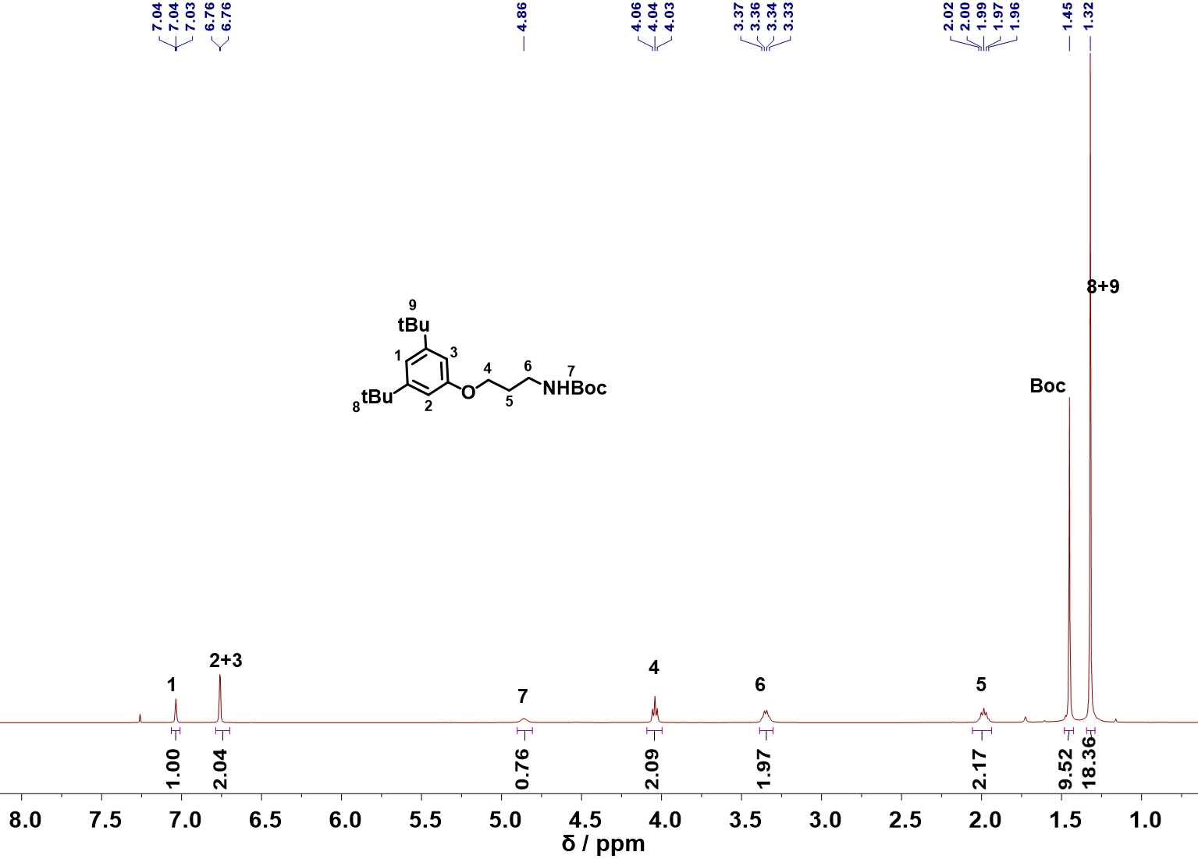
Figure S1. ¹H NMR Spectrum (400 MHz, CDCl₃, 298 K) of I-Boc.
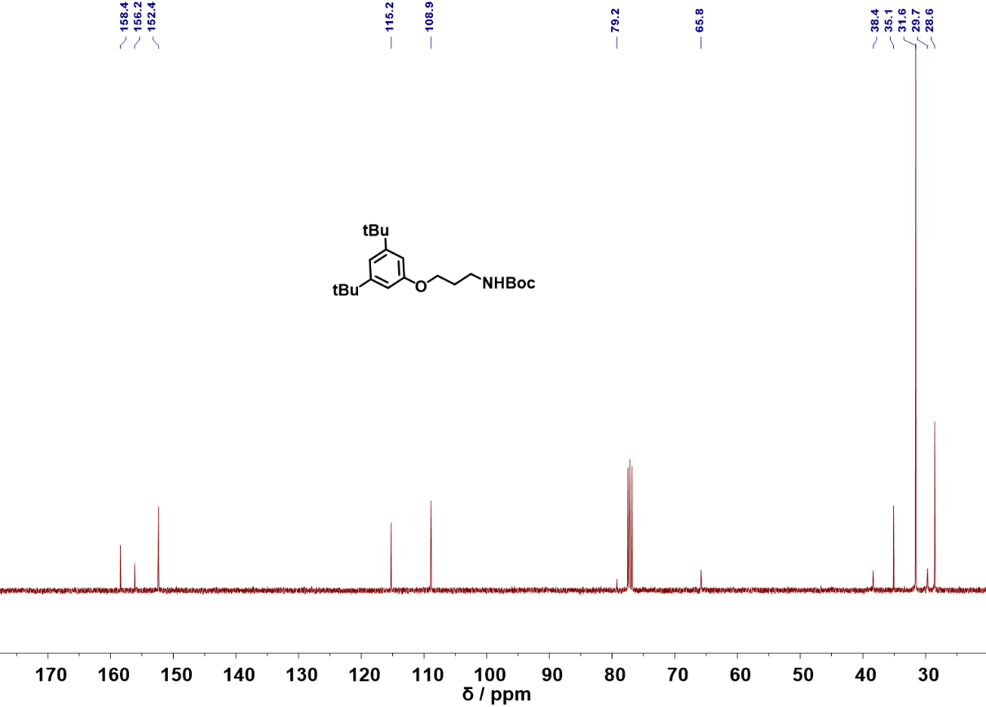
Figure S2. ¹³C NMR Spectrum (101 MHz, CDCl₃, 298 K) of I-Boc.
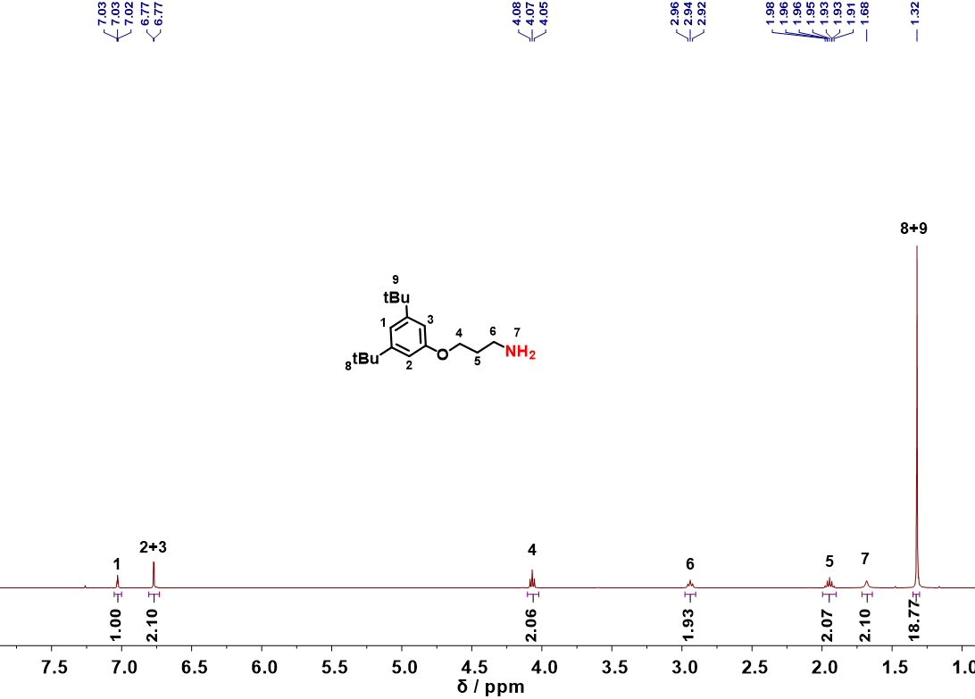
Figure S3. ¹H NMR Spectrum (400 MHz, CDCl₃, 298 K) of I-NH₂.
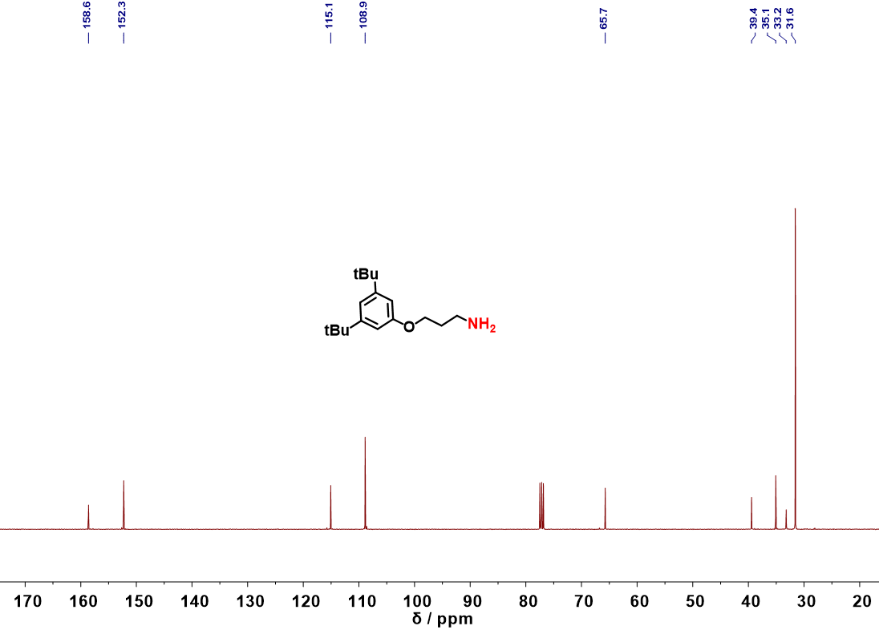
Figure S4. ¹³C NMR Spectrum (101 MHz, CDCl₃, 298 K) of I-NH₂.

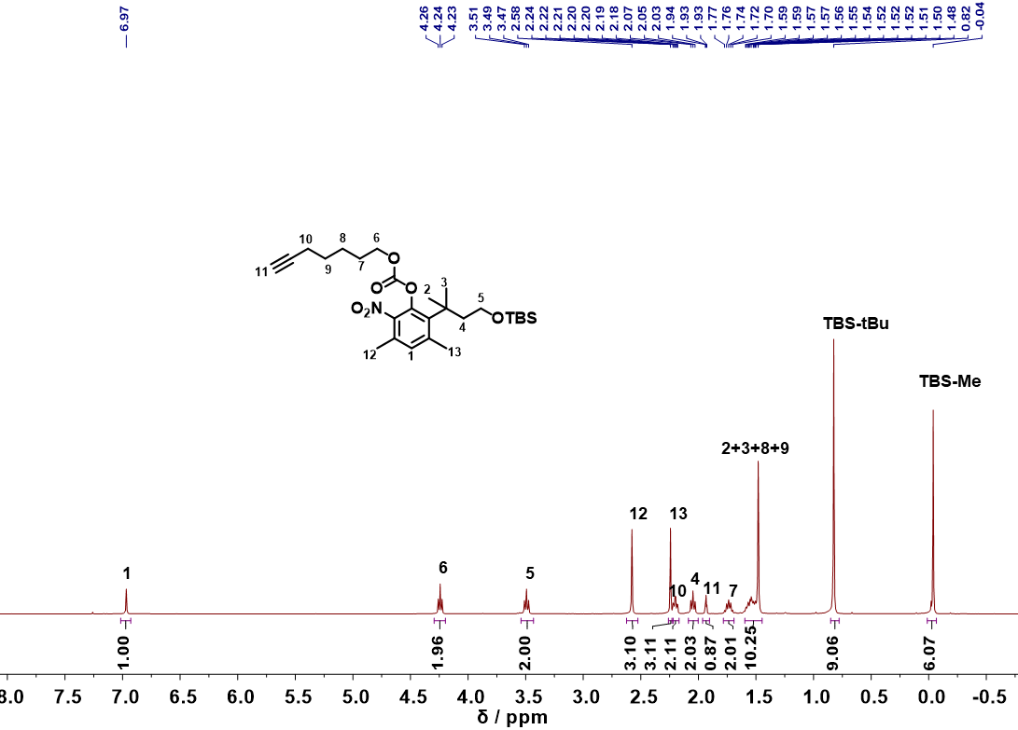
Figure S5. ¹H NMR Spectrum (400 MHz, CDCl₃, 298 K) of F-TBS.
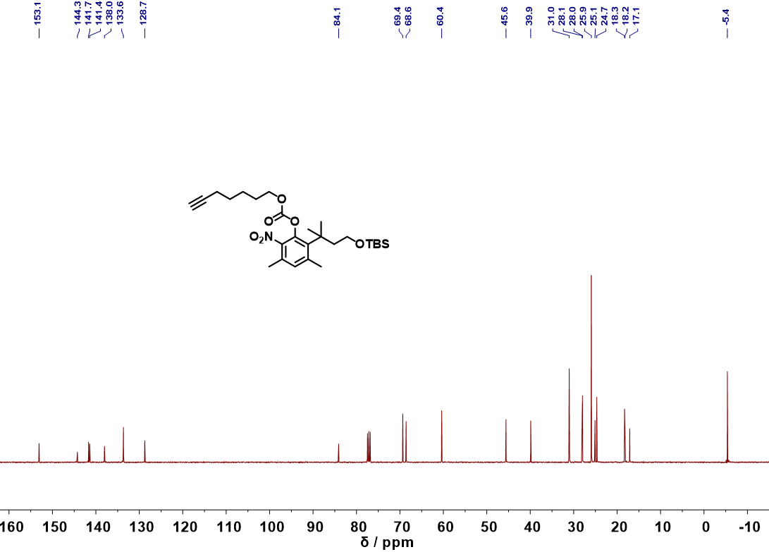
Figure S6. ¹³C NMR Spectrum (101 MHz, CDCl₃, 298 K) of F-TBS.
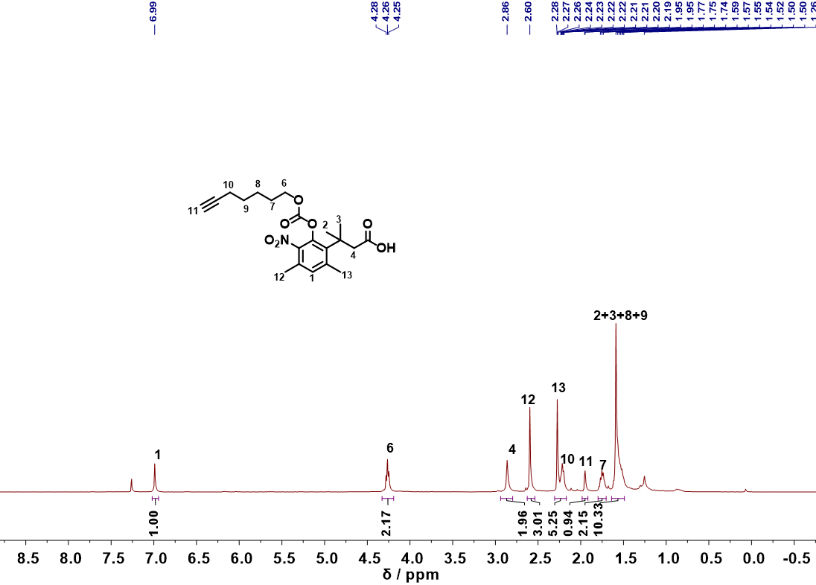
Figure S7. ¹H NMR Spectrum (400 MHz, CDCl₃, 298 K) of F-COOH.
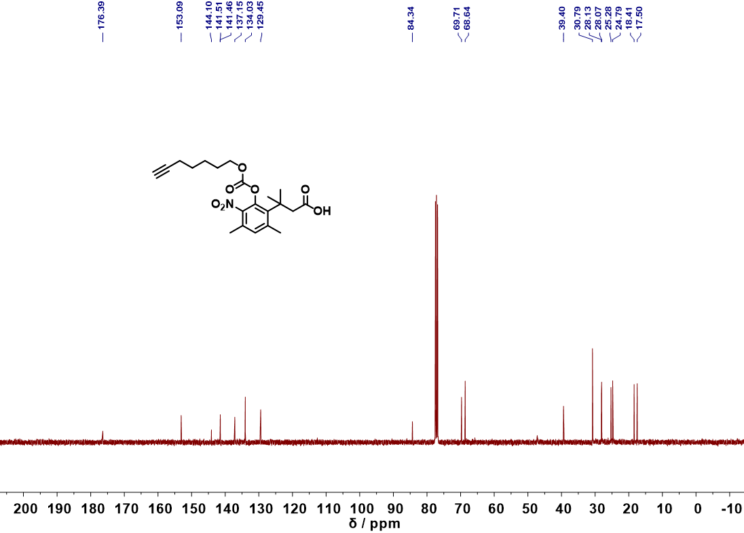
Figure S8. ¹³C NMR Spectrum (101 MHz, CDCl₃, 298 K) of F-COOH.
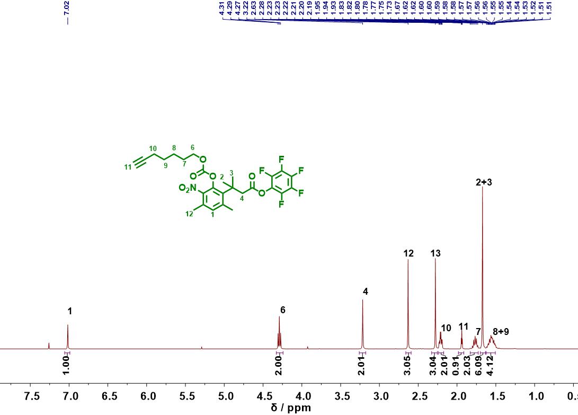
Figure S9. ¹H NMR Spectrum (400 MHz, CDCl₃, 298 K) of DB-CC.
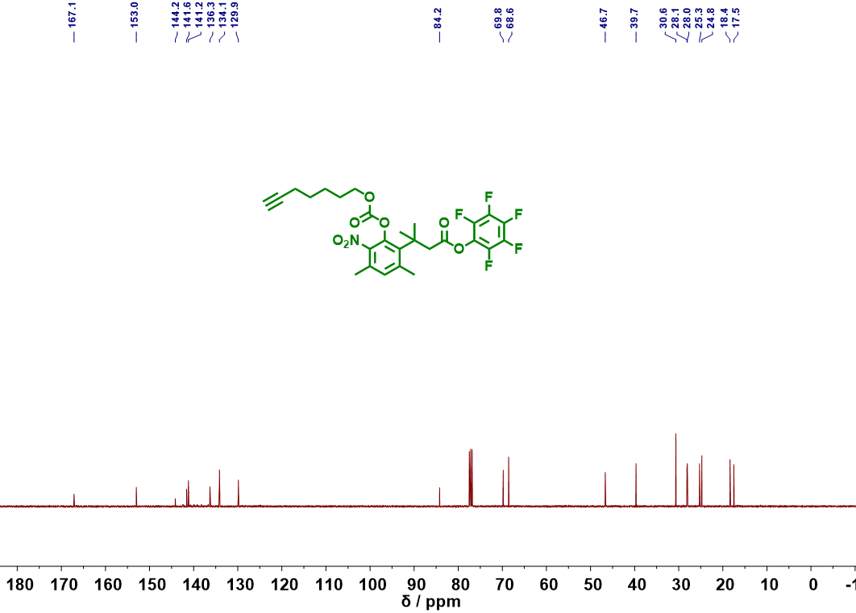
Figure S10. ¹³C NMR Spectrum (101 MHz, CDCl₃, 298 K) of DB-CC.
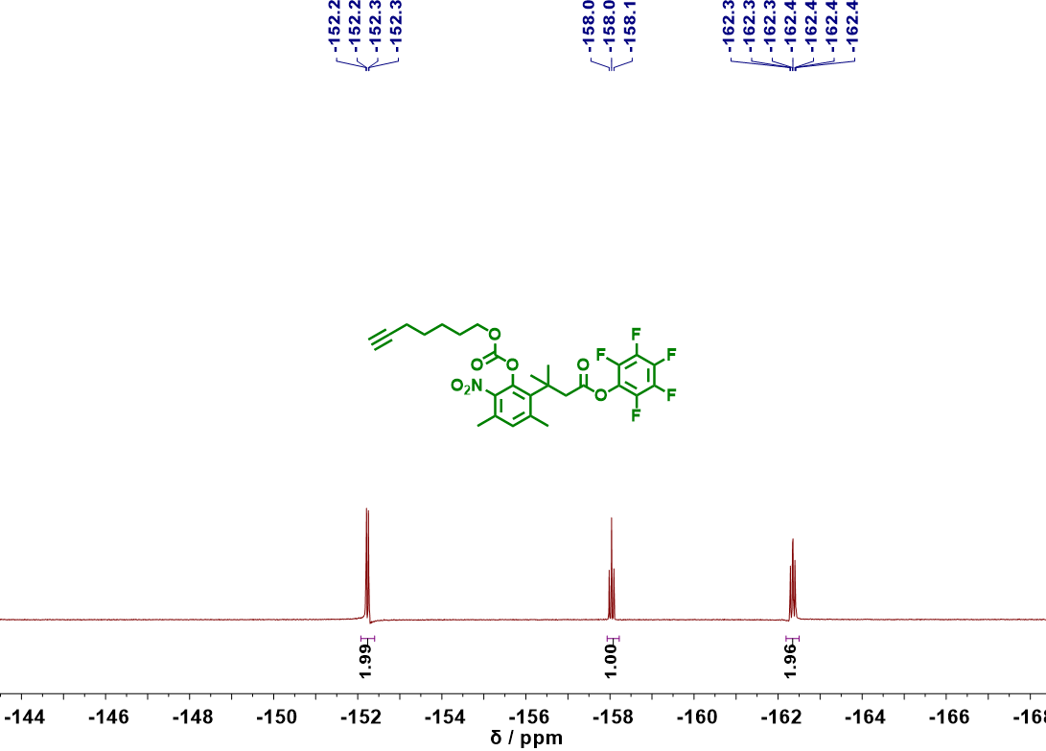
Figure S11. ¹⁹F NMR Spectrum (376 MHz, CDCl₃, 298 K) of DB-CC.
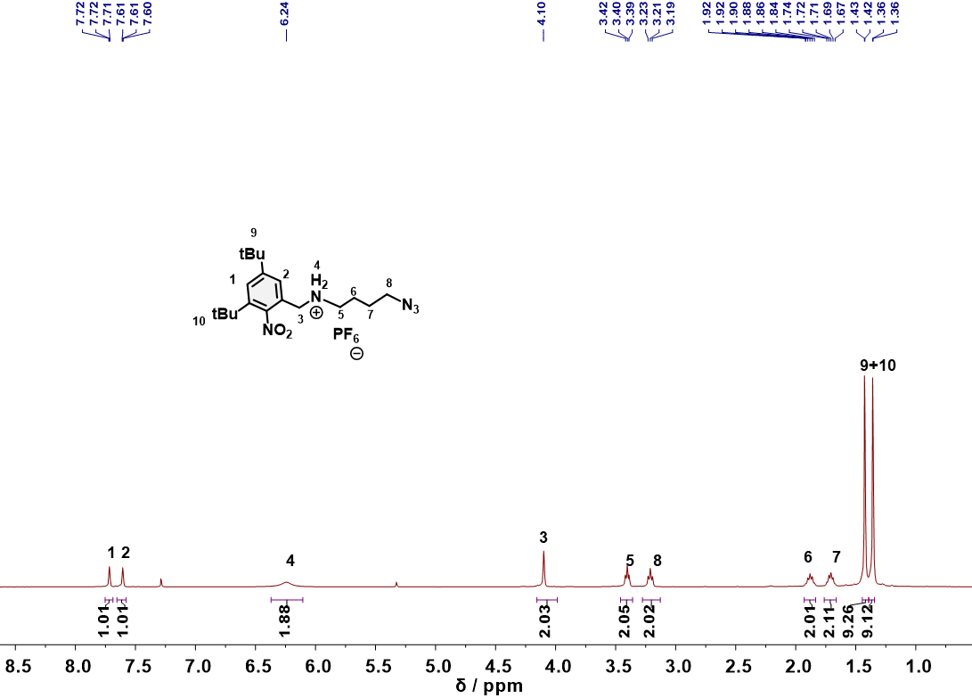
Figure S12. ¹H NMR Spectrum (400 MHz, CDCl₃, 298 K) of Stopper-N₃.

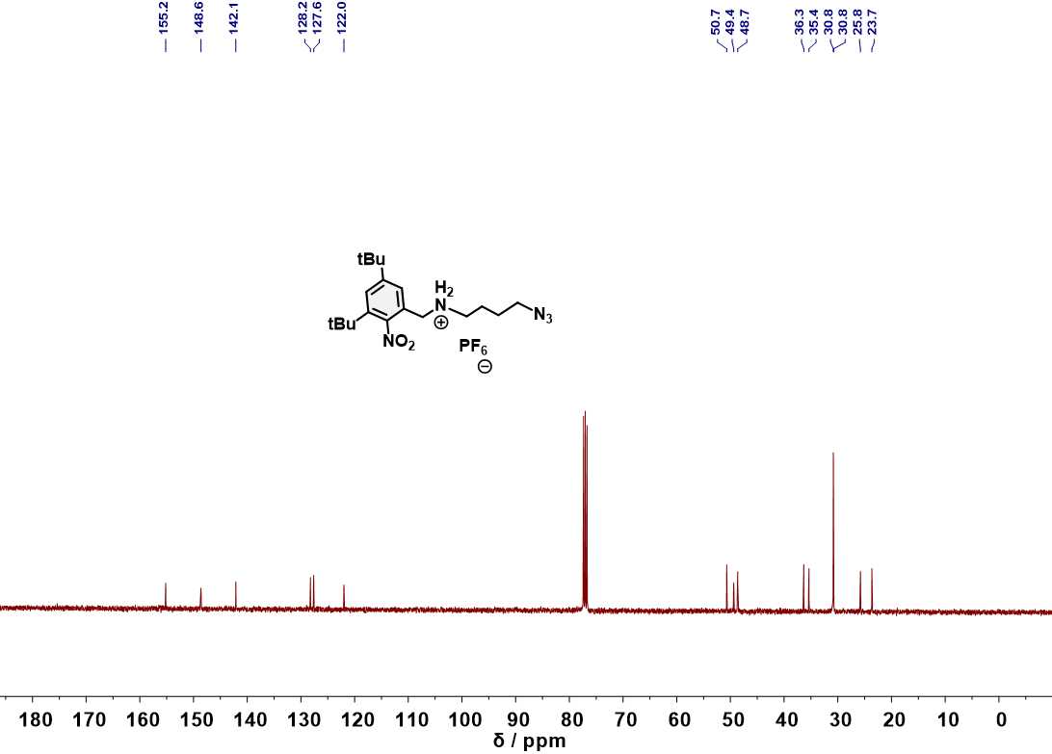
Figure S13. ¹³C NMR Spectrum (101 MHz, CDCl₃, 298 K) of Stopper-N₃.
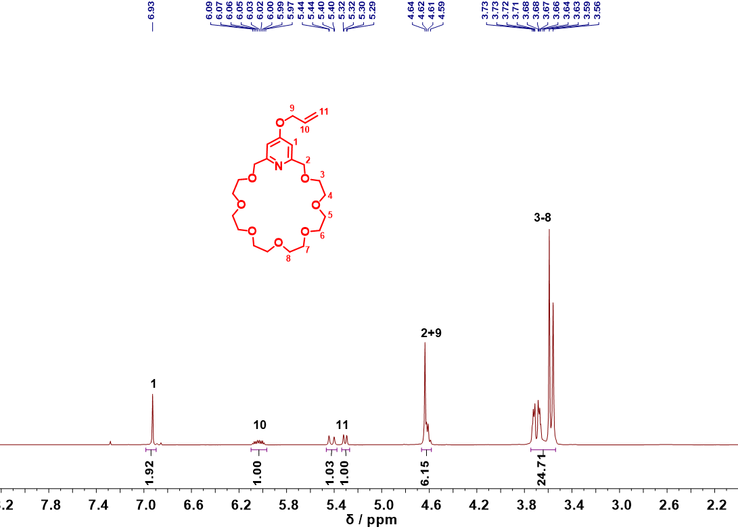
Figure S14. ¹H NMR Spectrum (400 MHz, CDCl₃, 298 K) of Crown-ene.

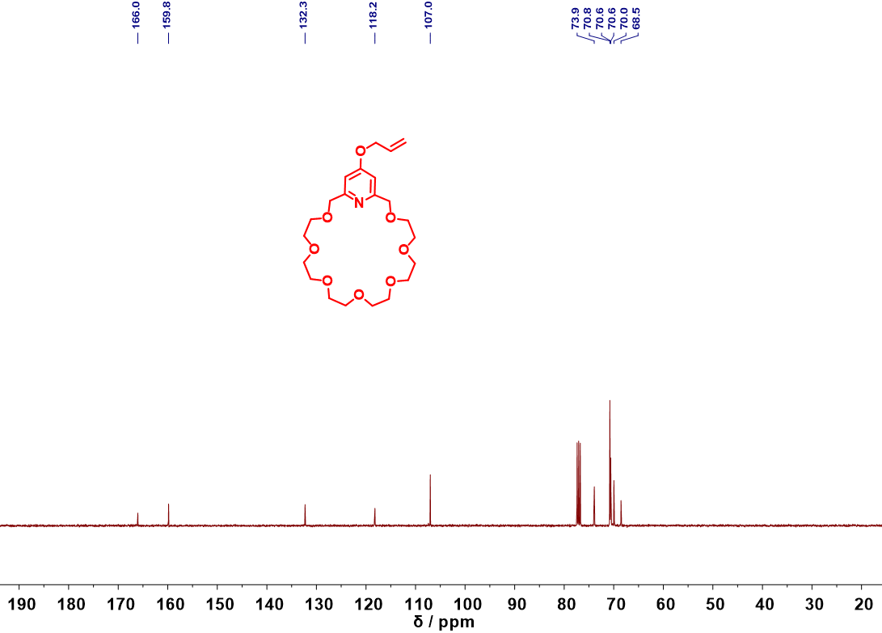
Figure S15. ¹³C NMR Spectrum (101 MHz, CDCl₃, 298 K) of Crown-ene.
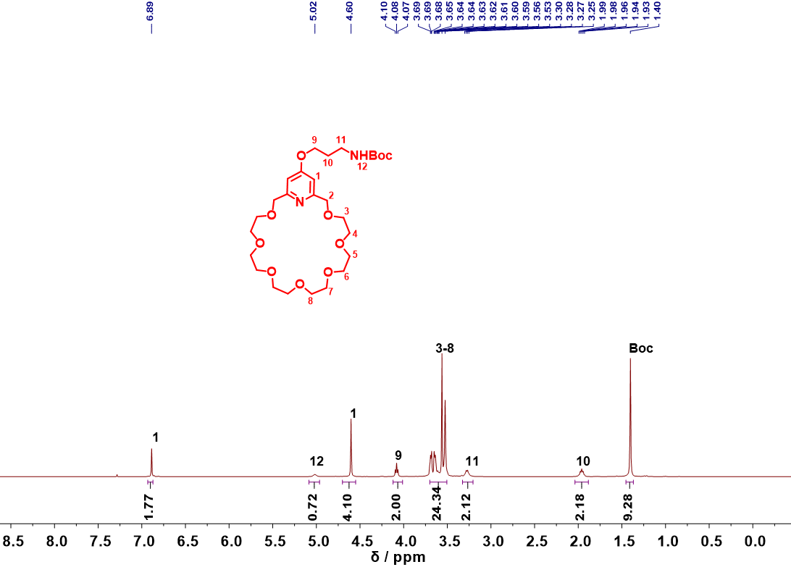
Figure S16. ¹H NMR Spectrum (400 MHz, CDCl₃, 298 K) of Crown-BocNH₂.
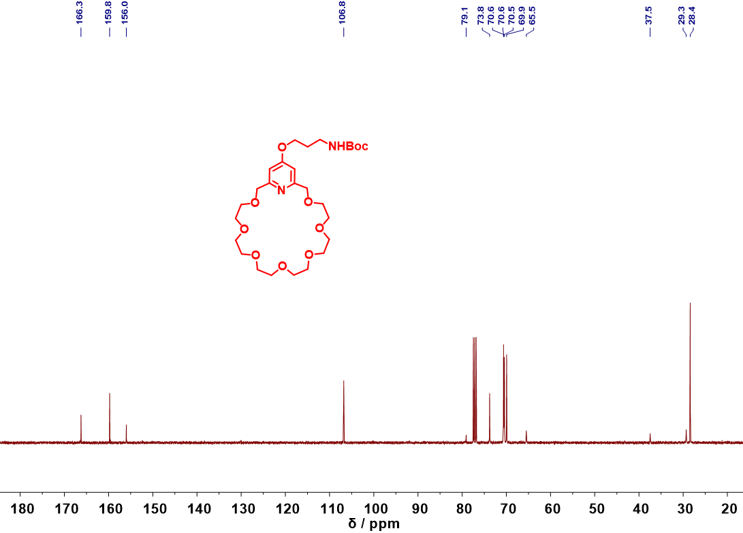
Figure S17. ¹³C NMR Spectrum (101 MHz, CDCl₃, 298 K) of Crown-BocNH₂.
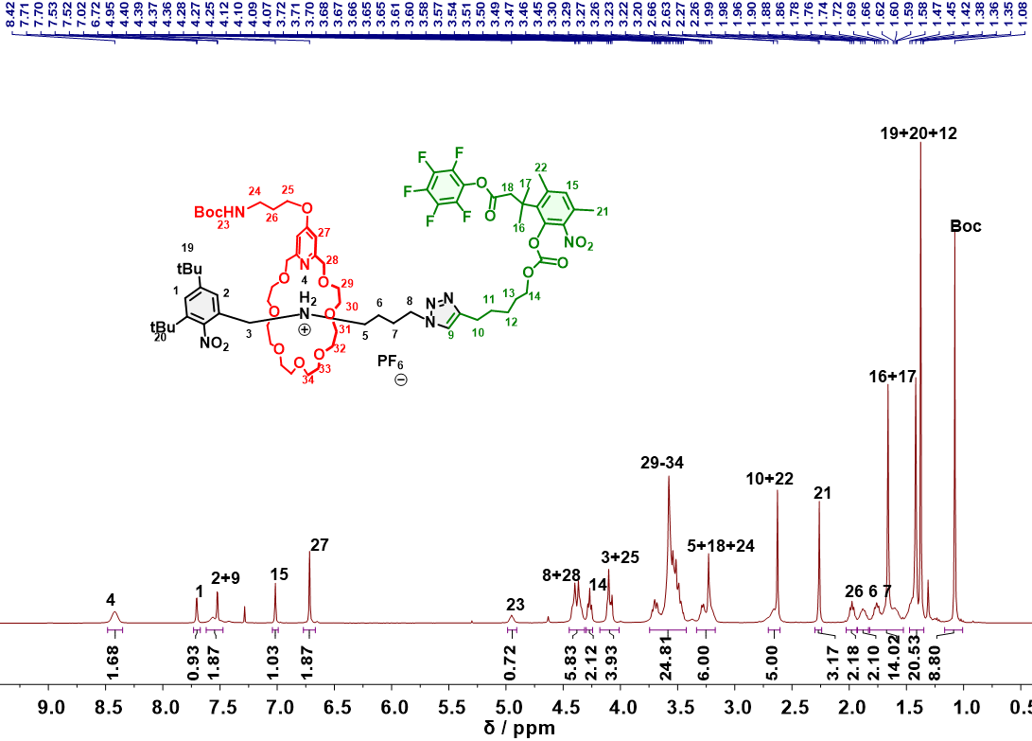
Figure S18. ¹H NMR Spectrum (400 MHz, CDCl₃, 298 K) of Rox-1.
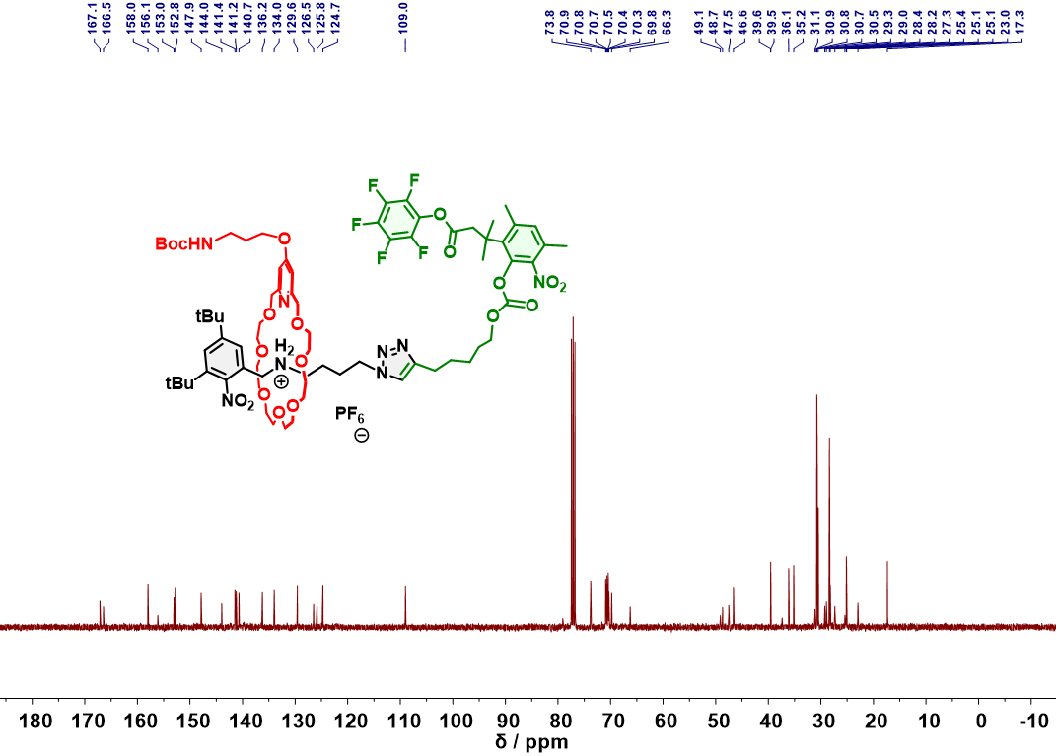
Figure S19. ¹³C NMR Spectrum (101 MHz, CDCl₃, 298 K) of Rox-1.
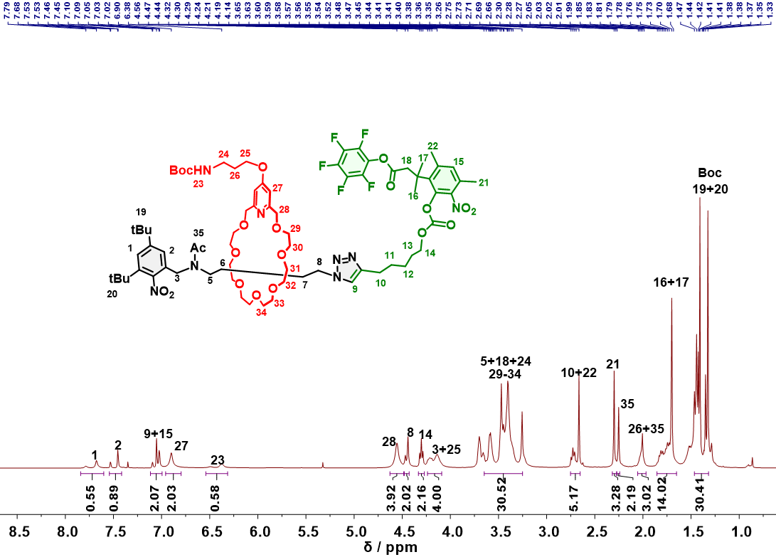
Figure S20. ¹H NMR Spectrum (400 MHz, CDCl₃, 298 K) of Rox-2.
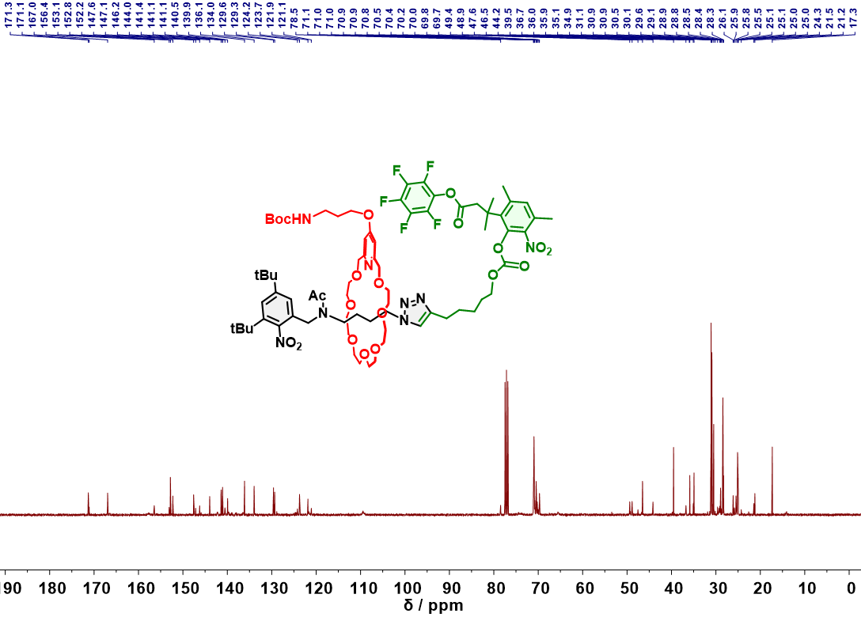
Figure S21. ¹³C NMR Spectrum (101 MHz, CDCl₃, 298 K) of Rox-2.
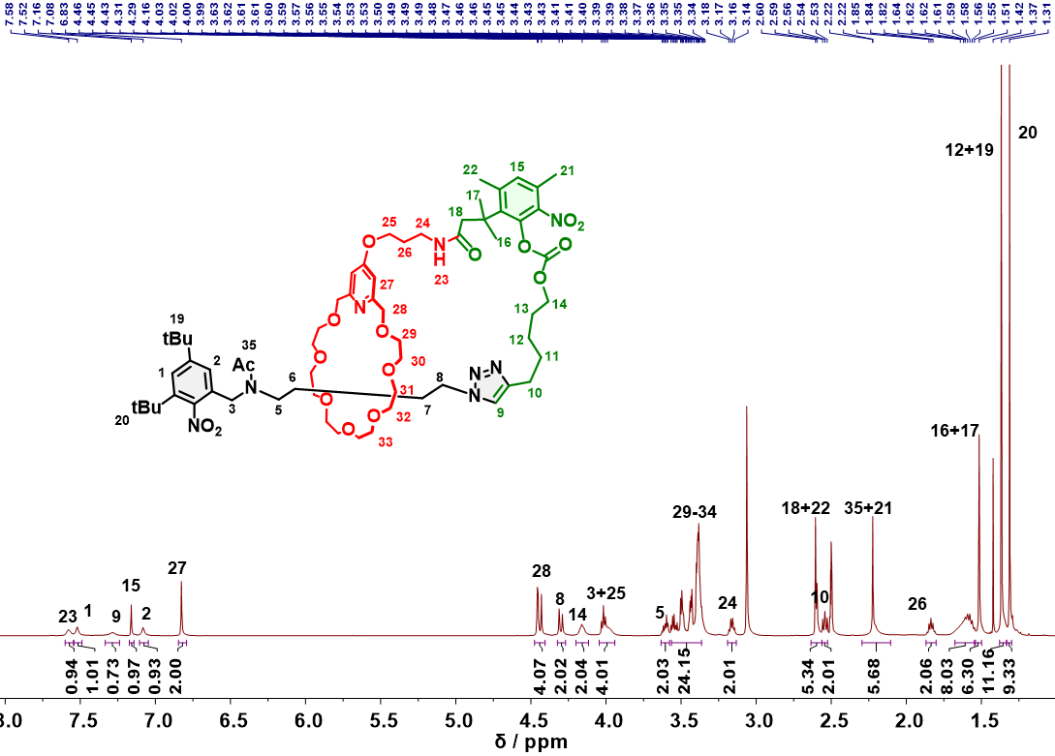
Figure S22. ¹H NMR Spectrum (400 MHz, DMSO-d₆, 353 K) of MIM-1.
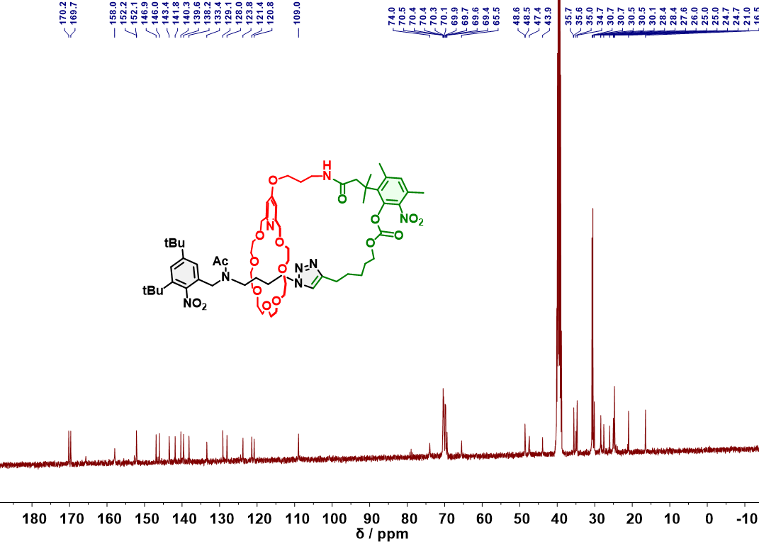
Figure S23. ¹³C NMR Spectrum (101 MHz, DMSO-d₆, 298 K) of MIM-1.
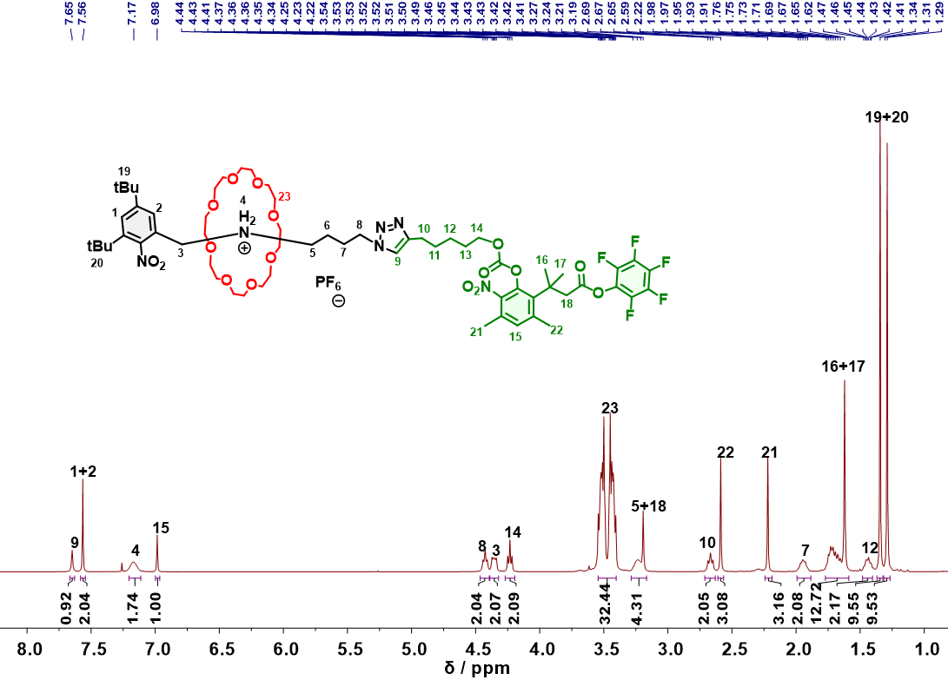
Figure S24. ¹H NMR Spectrum (400 MHz, CDCl₃, 298 K) of Rox-3.
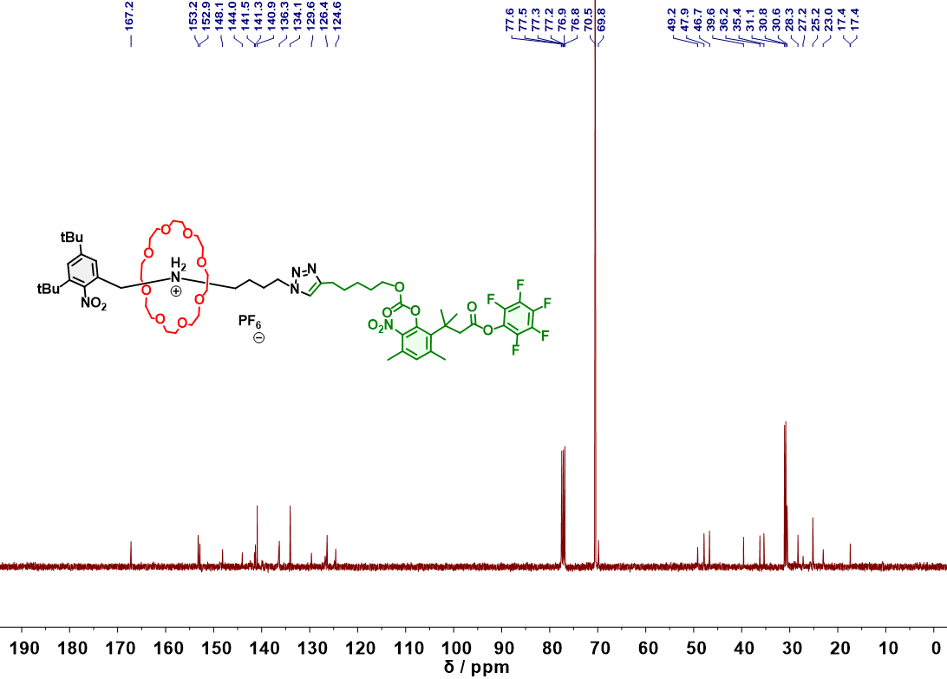
Figure S25. ¹³C NMR Spectrum (101 MHz, CDCl₃, 298 K) of Rox-3.
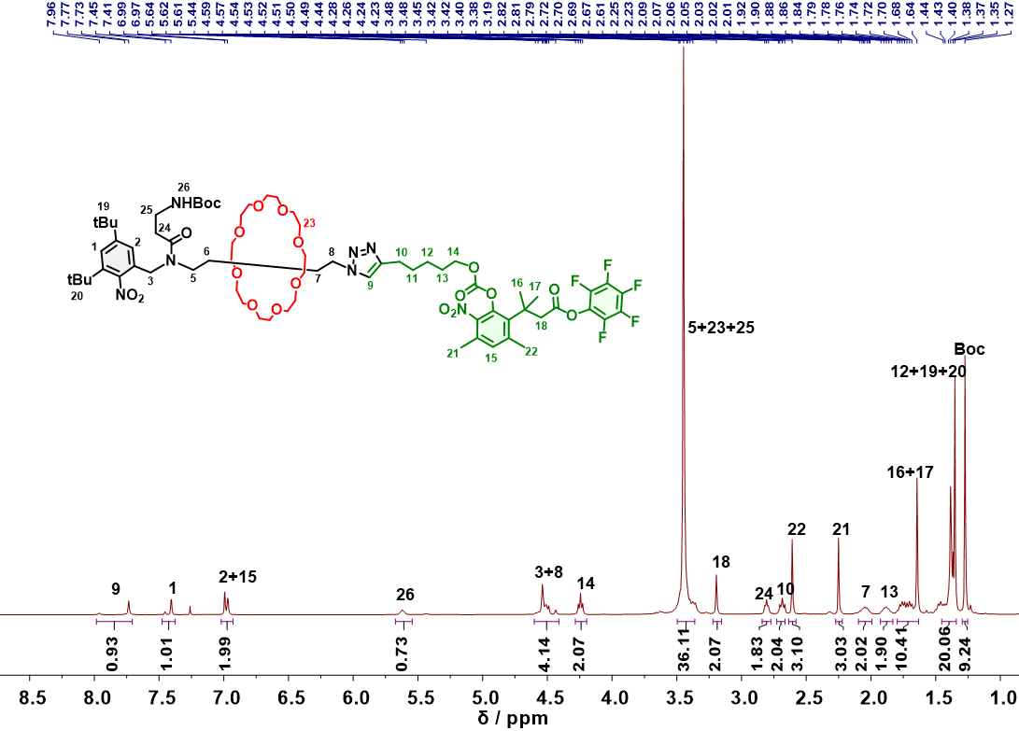
Figure S26. ¹H NMR Spectrum (400 MHz, CDCl₃, 298 K) of Rox-4.
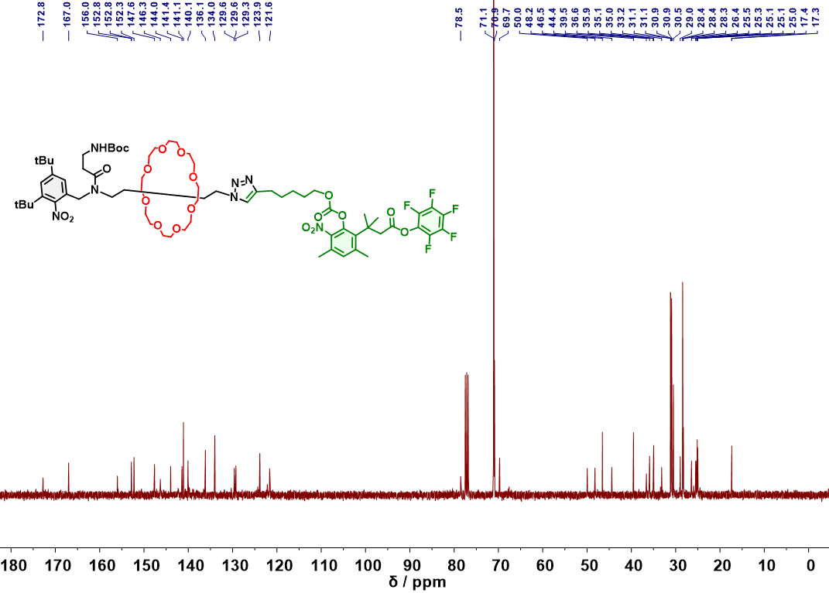
Figure S27. ¹³C NMR Spectrum (101 MHz, CDCl₃, 298 K) of Rox-4.

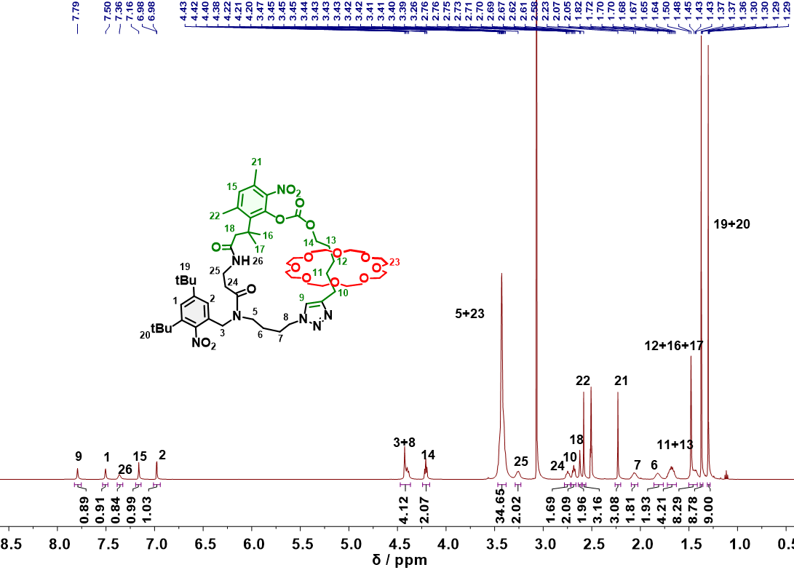
Figure S28. ¹H NMR Spectrum (400 MHz, DMSO-d₆, 353 K) of MIM-2.
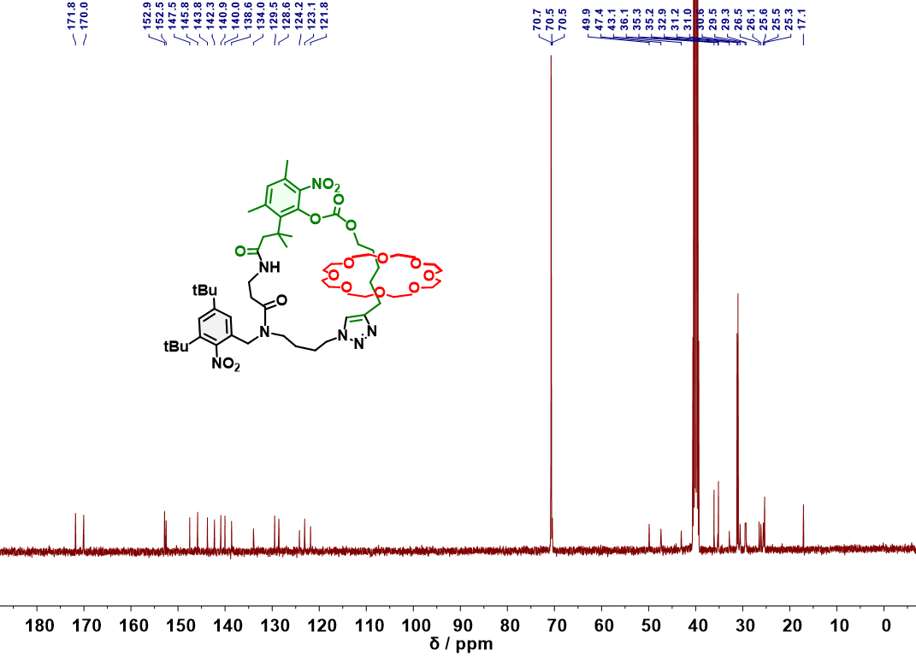
Figure S29. ¹³C NMR Spectrum (101 MHz, DMSO-d₆, 298 K) of MIM-2.

The ¹H-¹H gCOSY NMR spectrum (Figure S16) of MIM-1 exhibits that the ¹H-¹H correlations between adjacent protons, such as H₁₀/H₁₁, H₁₃/H₁₄, H₂₃/H₂₄, H₂₆/H_{24,25}, H₂₇/H₂₈, which further helps to verify the assignment of 1D ¹H NMR spectrum of MIM-1.
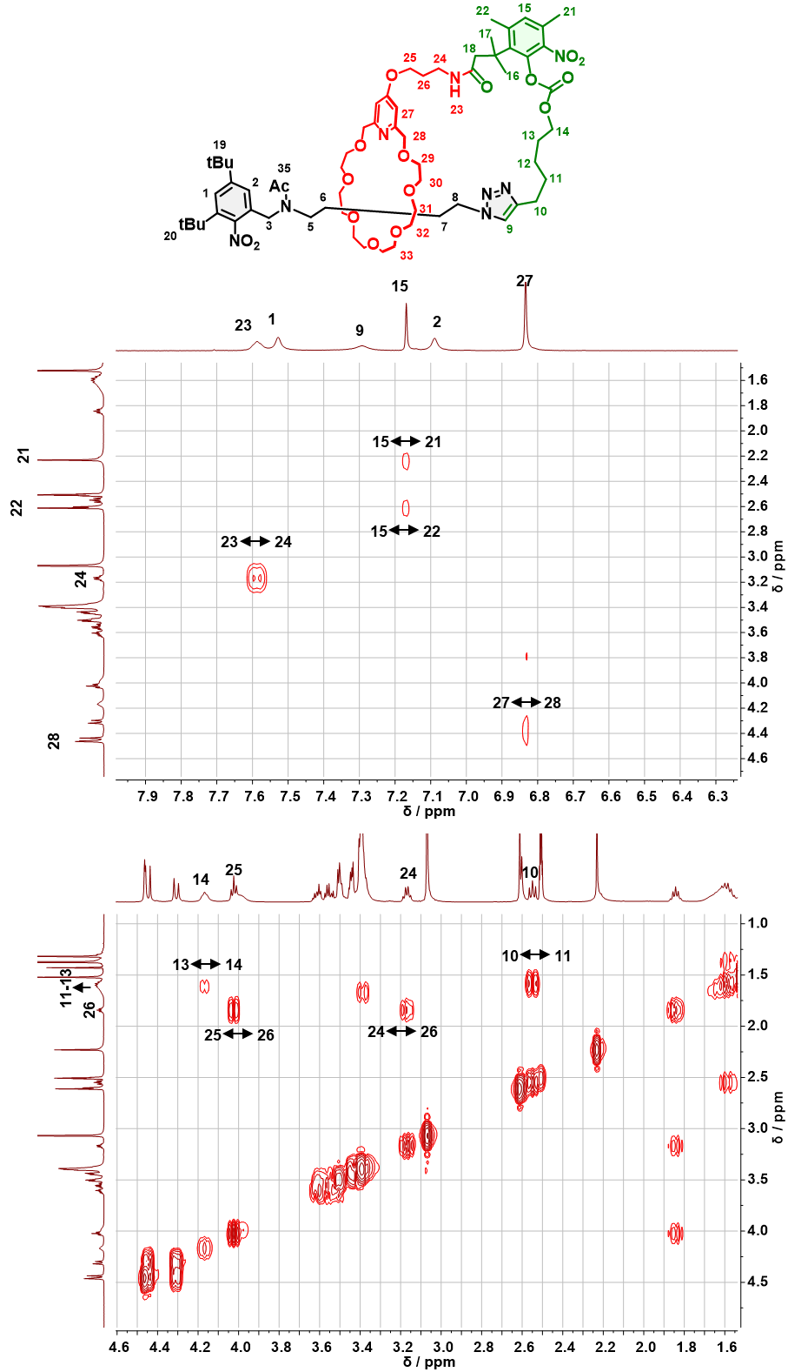
Figure S30. ¹H-¹H gCOSY NMR Spectrum (400 MHz, DMSO-d₆, 353 K) of MIM-1.

The ¹H-¹H gCOSY NMR spectrum (Figure S16) of MIM-2 exhibits that the ¹H-¹H correlations between adjacent protons, such as H₂/H₃, H₅/H₆, H₈/H₇, H₁₀/H_{9,11}, H₁₃/H₁₄, H₁₅/H_{21,22}, H₂₅/H_{24,26}, which further helps to verify the assignment of 1D ¹H NMR spectrum of MIM-2.
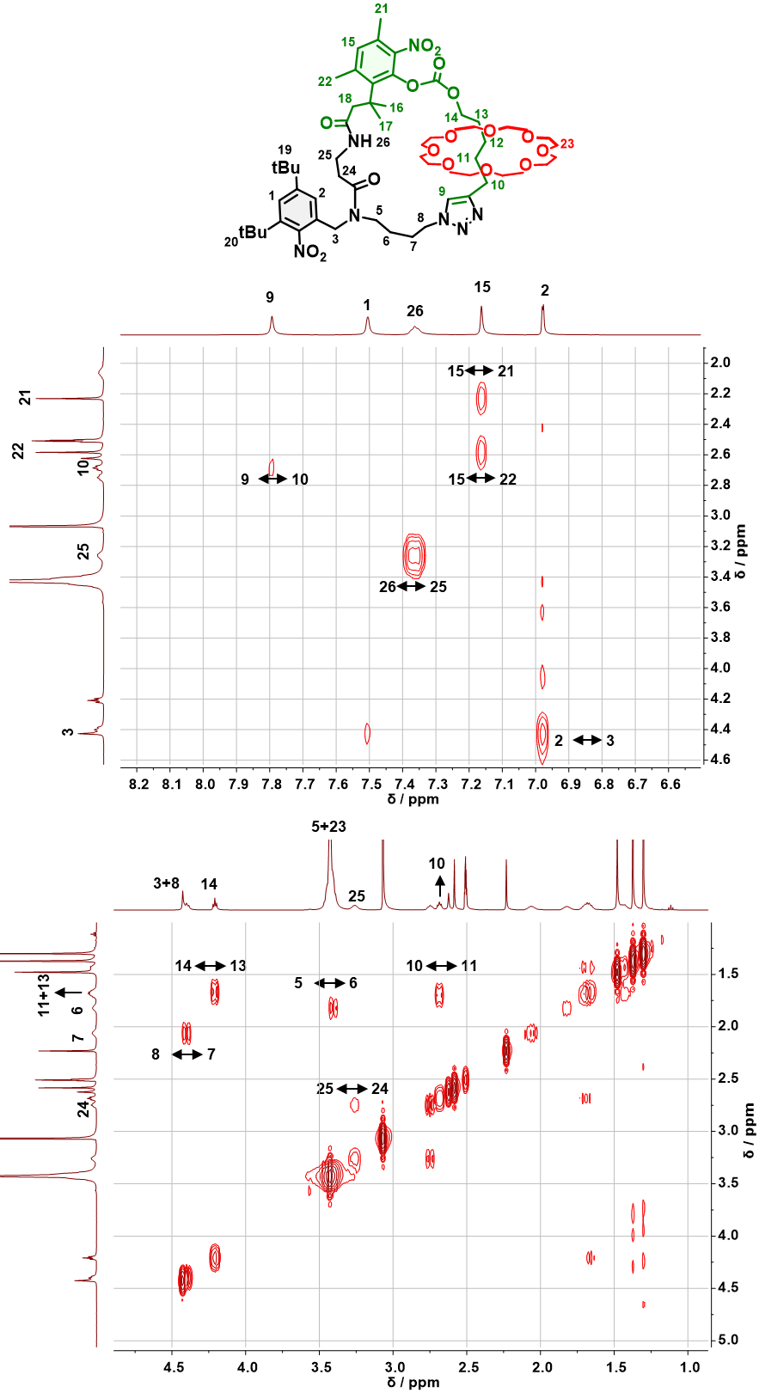

Figure S31. ¹H-¹H gCOSY NMR Spectrum (400 MHz, DMSO-d₆, 353 K) of MIM-2.
The 2D NOE NMR spectrum (Figure S31) of MIM-2 exhibits that there are NOE correlations between H₁/H_{19,20}, H₂/H_{3,5,19}, H₁₅/H₂₂, H₂₃/H_{9,26}, H₈/H_{6,7,23}, H₁₄/H_{11,23}, which further helps to verify the assignment of 1D ¹H NMR spectrum of MIM-1.

4. Homopolymerization
4.1 General polymerization procedure
3-(3,5-ditert-butylphenoxy)propan-1-amine was used as initiator for all polymerization reactions. After dissolving monomer in designed solvent with designed initial monomer concentration and feed ratio, initiator was added to initiate the polymerization at designed temperature. The polymerization aliquots were taken at the designed reaction time for in-situ ¹H NMR analysis to determine monomer conversion and for GPC analysis to determine M_{n,} and Ð. The resultant polymer could be purified by precipitation.
4.2 Polymerization of MIM-1 for evaluating its polymerization kinetics
Scheme S6. ROP of MIM-1.
MIM-1 polymerization with [MIM-1]₀/[I]₀=15:1. In a 2 mL Agilent injection bottle, MIM-1 (125 mg, 0.100 mmol) and 3-(3,5-ditert-butylphenoxy)propan-1-amine (1.75 mg, 6.70 μmol) were dissolved in 125 μL DMF. The polymerization was performed at the designed temperature of 90 °C. The polymerization aliquots were taken at the designed reaction time for in-situ ¹H NMR analysis to determine MIM-1 conversion and for GPC analysis to determine M_{n,GPC} and Ð.
MIM-1 polymerization with [MIM-1]₀/[I]₀=25:1. In a 2 mL Agilent injection bottle, MIM-1 (125 mg, 0.100 mmol) and 3-(3,5-ditert-butylphenoxy)propan-1-amine (1.05 mg, 4.00 μmol) were dissolved in 125 μL DMF. The polymerization was performed at 90 °C. Polymerization aliquots were taken at the designed reaction time for in-situ ¹H NMR analysis to determine MIM-1 conversion and for GPC analysis to determine M_{n,GPC} and Ð.
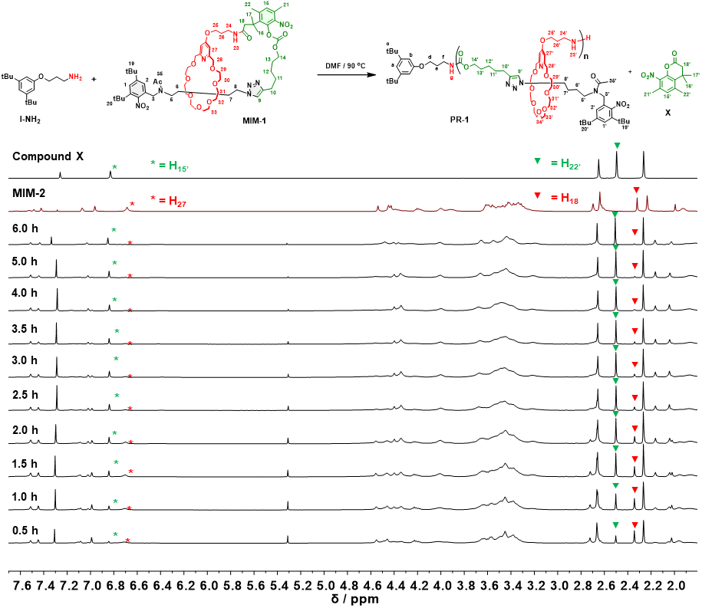
Figure S32. ¹H NMR spectra (400 MHz, CDCl₃, 298 K) of compound X, MIM-1, crude polymerization solution of MIM-1 after 0.5-6.0 h reaction ([MIM-1]₀/[I]₀=15:1). MIM-1 conversion was calculated by [Area(15’) + Area(22’)/3]/[Area(27)/2 + Area(15’) + Area(22’)/3 + Area(18)/2].
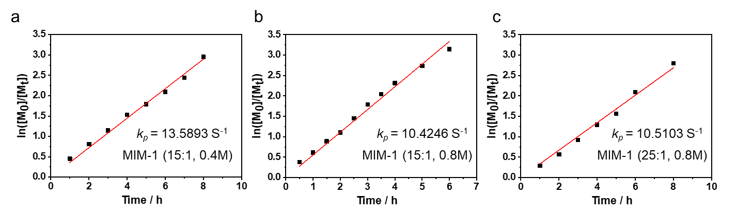
Figure S33. The k_{p} value of polymerization reaction of MIM-1 with [MIM-1]₀/[I]₀=15:1 in 0.4 M (a), [MIM-1]₀/[I]₀=15:1 in 0.8 M (b) and [MIM-1]₀/[I]₀=25:1 in 0.8 M (c).
4.3 Polymerization of MIM-2 for evaluating its polymerization kinetics
Scheme S7. ROP of MIM-2.
MIM-2 polymerization with [MIM-2]₀/[I]₀=15:1. In a 2 mL Agilent injection bottle, MIM-2 (117 mg, 0.100 mmol) and 3-(3,5-ditert-butylphenoxy)propan-1-amine (1.75 mg, 6.70 μmol) were dissolved in 250 μL DMF. The polymerization was performed at 90 °C. Polymerization aliquots were taken at the designed reaction time for in-situ ¹H NMR analysis to determine MIM-2 conversion and for GPC analysis to determine M_{n,GPC} and Ð.
MIM-2 polymerization with [MIM-2]₀/[I]₀=25:1. In a 2 mL Agilent injection bottle, MIM-2 (117 mg, 0.100 mmol) and 3-(3,5-ditert-butylphenoxy)propan-1-amine (1.05 mg, 4.00 μmol) were dissolved in 250 μL DMF. The polymerization was performed at 90 °C. Polymerization aliquots were taken at the designed reaction time for in-situ ¹H NMR analysis to determine MIM-2 conversion and for GPC analysis to determine M_{n,GPC} and Ð.
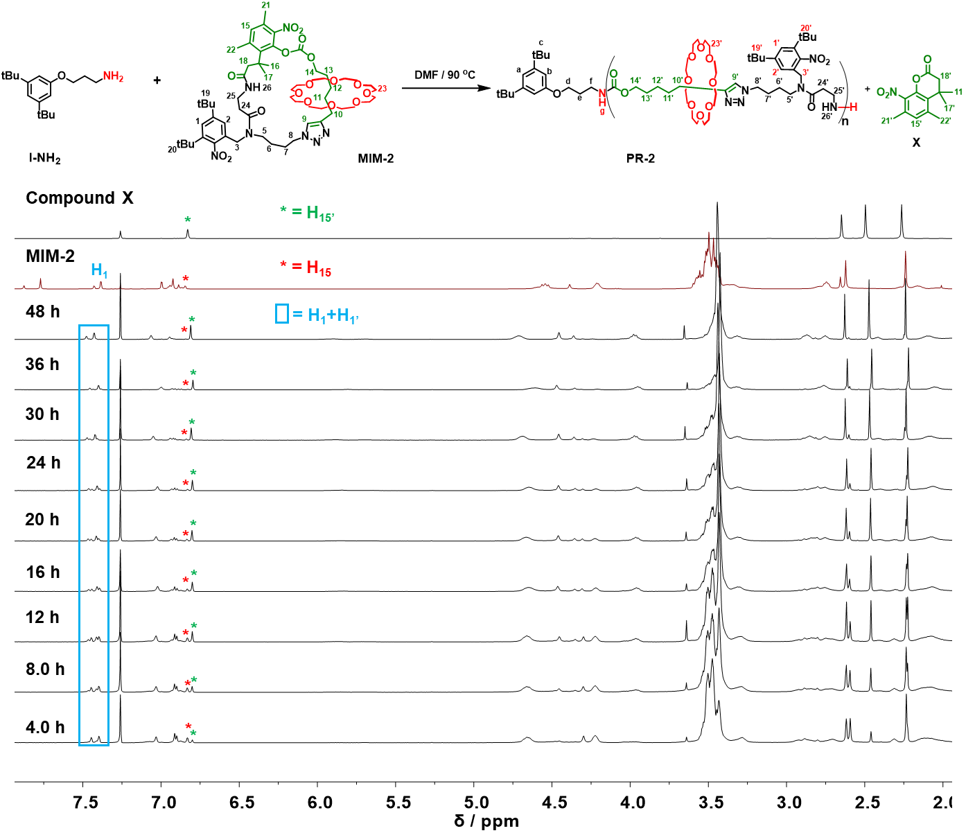
Figure S34. ¹H NMR spectra (400 MHz, CDCl₃, 298 K) of compound X, MIM-2, crude polymerization solution of MIM-2 after 4.0-48 h reaction ([MIM-2]₀/[I]₀=15:1). MIM-2 conversion was calculated by Area(15’)/ [Area(1)+Area(1’)].

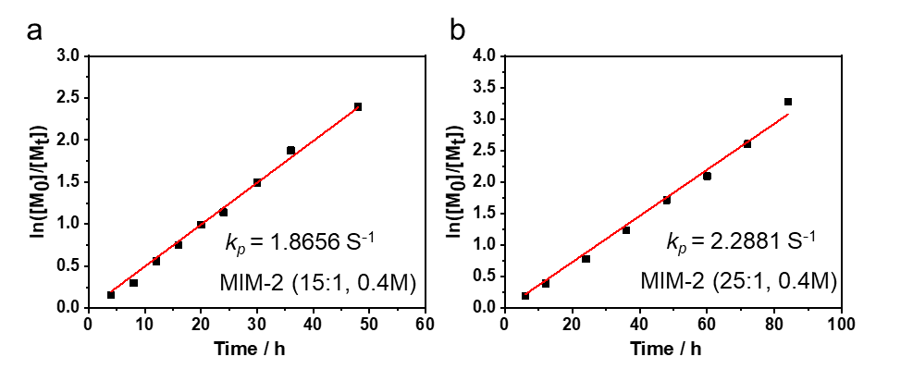
Figure S35. The k_{p} value of polymerization reaction of MIM-2 with [MIM-2]₀/[I]₀=15:1 in 0.40 M (a) and [MIM-1]₀/[I]₀=25:1 in 0.40 M (b).
4.4 Preparation of diblock copolymer
Scheme S8. Preparation of PR-1₁₅-b-PEG₁₅.
In a 2 mL Agilent injection bottle, MIM-1 (125 mg, 0.100 mmol) and 3-(3,5-ditert-butylphenoxy)propan-1-amine (1.75 mg, 6.70 μmol) were dissolved in 100 μL DMF. The polymerization of MIM-1 was performed in DMF at 90 °C for 6.5 h. In this condition, ¹H-NMR analysis shows MIM-1 conversion reached above 98.0%. GPC analysis produced M_{n,GPC} = 21350 and Ð = 1.09 for PR-1₁₅. Then, MEG (55.6 mg, 0.100 mmol) was added directly into the polymerization solution to extend the polymer chain by polymerizing MEG. The polymerization reaction was further performed at 90 °C for another 3 h. In this condition, ¹H-NMR analysis shows MEG conversion reached above 99.0%. GPC analysis produced M_{n,GPC} = 31932 and Ð = 1.12 for the resultant PR-1₁₅-PEG₁₅.
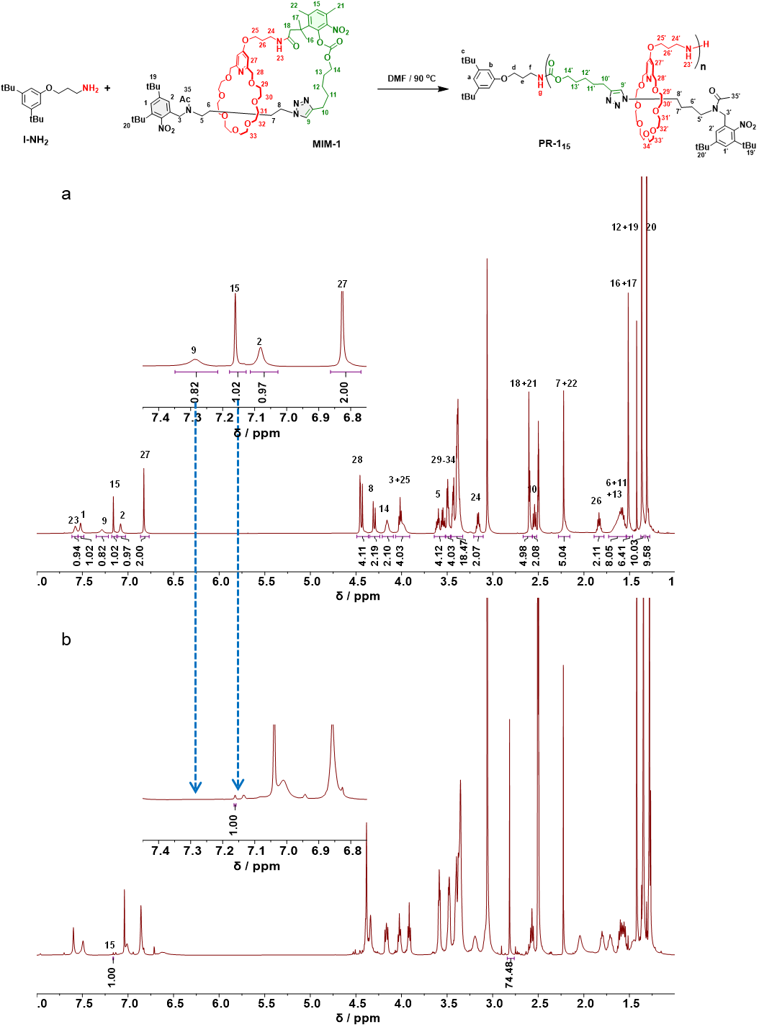
Figure S36. ¹H NMR spectra (400 MHz, DMSO-d₆, 353 K) of MIM-1 (a) and the crude polymerization solution of MIM-1 with 6.5 h reaction (b). The nearly quantitative MIM-1 conversion was indicated by the disappearance of its characteristic peaks 9 and 15.
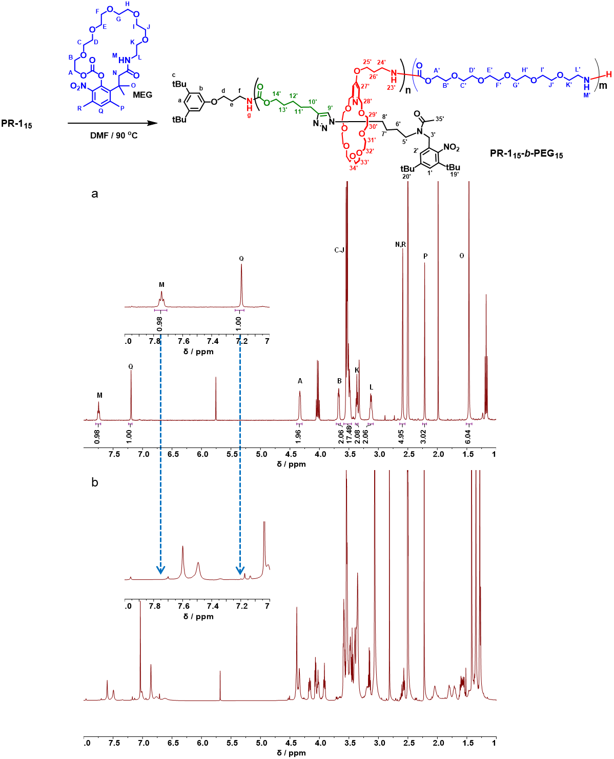
Figure S37. ¹H NMR spectra (400 MHz, DMSO-d₆, 353 K) of MEG (a) and the crude polymerization solution of MEG in 3 h (b). The nearly quantitative MEG conversion was indicated by the disappearance of its characteristic peaks M and Q.

5. Crystallographic Characterization
Crystallographic data for have been deposited in the Cambridge Crystallographic Data Center (CCDC) under accession numbers CCDC: 2481822. All crystallographic data are available free of charge from the Cambridge Crystallographic Data Centre via www.ccdc.cam.ac.uk/data_request/cif .
5.1 Methods. Single crystals of MIM-2 were grown in DMSO-d₆ over one week. The crystallographic data were collected on Rigaku Xtalab Synergy R with a rotation-anode generator Cu Kα radiation (λ= 1.54178 Å), a 4-circle kappa goniometer, and a HyPix-6000C Photon Detector. The collection temperature was controlled via an Oxford Cryo 1000 stream system at 100 K for MIM-2, respectively. Data reduction and analysis were both performed with the CrysAlisPro software. The structures were solved by direct methods using ShelXT program and refined anisotropically by full-matrix least squares techniques based on F2 using the SHELXL installed on Olex 2. Anisotropic thermal parameters were used for the non-hydrogen atoms and isotropic parameters for the hydrogen atoms. Hydrogen atoms were added geometrically and refined using a riding model and the weighting schemes were refined.
5.2 Crystal data. C₅₉H₉₃N₇O₁₇ (M =1172.40 g/mol): triclinic, space group P-1 (no. 2), a = 8.94590(10) Å, b = 17.2753(2) Å, c = 21.8372(3) Å, α = 110.1070(10)°, β = 91.7090(10)°, γ = 93.8590(10)°, V = 3156.86(7) Å³, Z = 2, T = 100.00(10) K, μ(Cu Kα) = 0.744 mm⁻¹, Dcalc = 1.233 g/cm³, 40532 reflections measured (4.316° ≤ 2Θ ≤ 153.088°), 12687 unique (R_{int} = 0.0749, R_{sigma} = 0.0573) which were used in all calculations. The final R₁ was 0.0730 (I > 2σ(I)) and wR₂ was 0.2149 (all data).
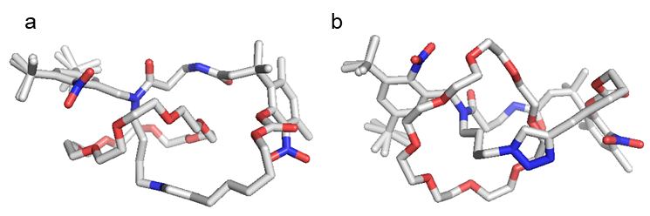
Figure S38. (a) Top-down view and (b) Side-on view of crystal structure of MIM-2.

6. Molecular dynamics simulations
Molecular dynamics (MD) simulations were carried out using GROMACS 2022.2. A cubic simulation box was constructed and filled with DMF solvent molecules, into which a single MIM-1 or MIM-2 molecule was inserted. The system underwent energy minimization, followed by NVT and NPT equilibration at 363.15 K. Subsequently, a 20 ns MD simulation was performed under periodic boundary conditions. For trajectory analysis, the gmx mindist tool was used to compute the minimum distance between the carbonate and crown ether groups over time.
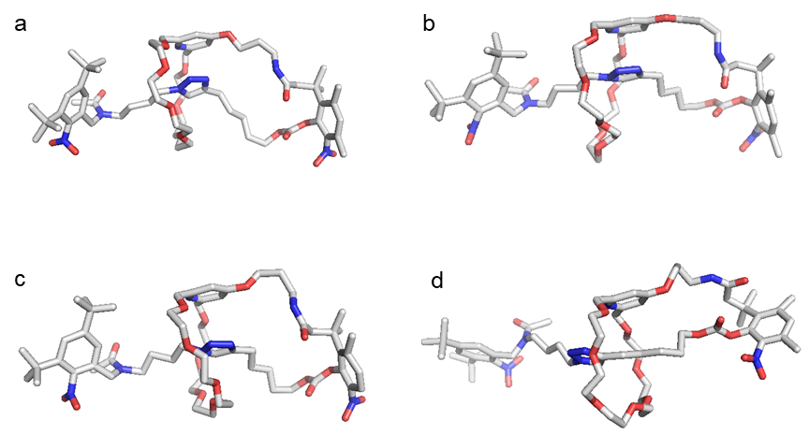
Figure S39. Conformational evolution of MIM-1 at 0 ns (a), 5 ns (b), 10 ns (c) and 15 ns (d) during molecular dynamics simulations.
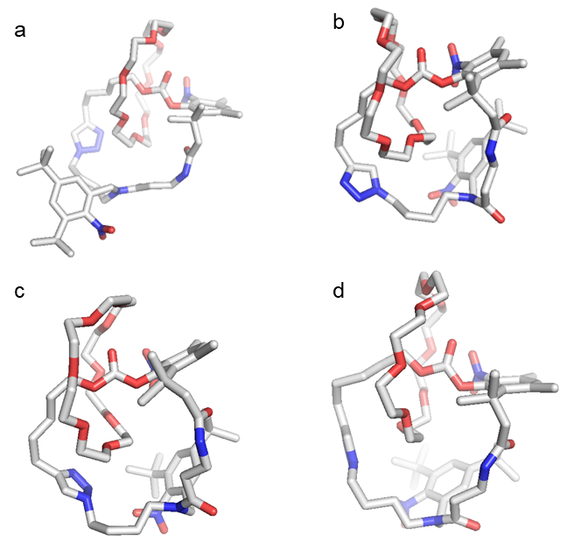
Figure S40. Conformational evolution of MIM-2 at 0 ns (a), 5 ns (b), 10 ns (c) and 15 ns (d) during molecular dynamics simulations.

7. Theoretical Calculations
Molecular Theoretical calculations were performed with the Gaussian16 program suite^{S7}. The molecular geometry optimizations were carried out with the m062x method at the 6-31G(d) level, and use the scf=novaracc solvent model to calculate the optimal conformation in aqueous solution. The results were visualized using a PyMOL software.

7.1 Optimized conformations of MIM-1 and MIM-2
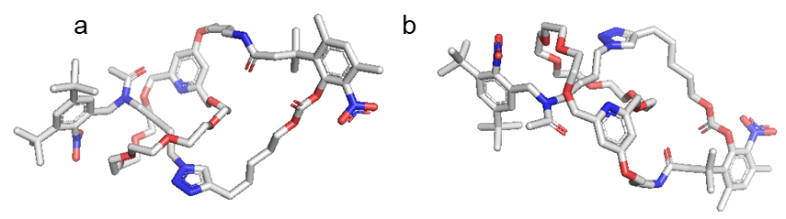
Figure S41. (a) Side-on view and (b) Top-down view of the optimized conformations of MIM-1.

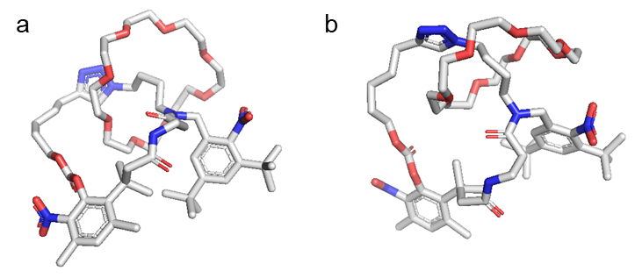
Figure S42. (a) Side-on view and (b) Top-down view of the optimized conformations of MIM-2.
7.2 Optimized geometry coordinates
MIM-1
C -3.183163 -2.085941 1.356538
C -3.946517 -3.081490 0.886045
C -3.833020 -3.653869 -0.331983
C -2.860615 -3.176688 -1.163014
C -2.040297 -2.191387 -0.703237
C -2.219648 -1.677832 0.524814
C -0.848283 -1.683855 -1.524030
N 0.063117 -0.874427 -0.715970
C 1.091361 -1.657186 -0.015772
C 2.360795 -1.737749 -0.874340
C 3.541045 -2.454478 -0.201545
C 4.789468 -2.417184 -1.098207
N 5.999358 -2.907941 -0.412645
C 6.972395 -2.131240 -0.178573
C 7.858881 -2.945710 0.406196
N 7.388160 -4.119036 0.489454
N 6.244665 -4.052023 -0.026696
O 3.955927 5.743673 0.081923
C 5.229781 6.270113 -0.224787
C 6.337213 5.522236 0.516929
C 7.761045 6.084084 0.367122
C 9.247262 -2.634598 0.894390
O 1.150613 -5.657289 -0.659134
O 1.372251 -4.366068 -3.207320
O 2.156770 -1.820046 -4.496043
O 2.857408 0.935499 -3.330475
O 3.407041 0.516394 1.952692
O 2.803158 -2.157959 3.249089
O 1.540188 -4.645155 2.175163
C 2.963976 -0.779686 -4.996380
C 2.390753 0.575948 -4.608296
C 2.428715 2.230889 -2.946562
C 3.973630 2.141958 0.248734
C 4.452657 1.022321 1.144307
C 3.888538 -0.037843 3.152365
C 2.799481 -0.869057 3.814508
C 1.948894 -3.047840 3.922607
C 2.190289 -4.459674 3.408752
C 1.756643 -5.936885 1.655734
C 0.738095 -6.220745 0.563084
C 0.101657 -5.651077 -1.596824
C 0.635926 -5.550935 -3.015346
C 1.698469 -4.189302 -4.566251
C 2.725062 -3.083087 -4.751275
N 3.486812 1.808741 -0.871321
C 3.072831 2.706243 -1.660613
C 3.205899 4.014957 -1.381944
C 3.805660 4.419492 -0.249248
C 4.108120 3.427189 0.605904
C 8.725427 5.121582 1.081703
N 10.123399 5.552856 1.027521
O 14.723344 3.321260 -0.802799
C 14.398980 2.256373 0.004401
O 14.062857 1.092281 -0.632759
O 14.345075 2.383297 1.211168
C 12.530041 5.287682 1.261054
C 15.432320 4.360579 -0.258287
C 16.786057 4.232903 -0.131021
C 17.489839 5.245974 0.418120
C 16.811872 6.323149 0.831115
C 15.484548 6.469928 0.704911
C 14.756610 5.493514 0.106786
C 13.196021 5.638942 -0.095189
C 12.769399 7.066291 -0.545129
C 12.544601 4.785180 -1.228441
C 14.953837 7.757743 1.308380
C 18.991449 5.256831 0.653216
C 11.147027 4.662173 1.206352
O 10.966525 3.474189 1.323326
C 13.546348 -0.000604 0.085226
C 9.902470 -1.439076 0.185757
C 11.384735 -1.274280 0.568993
C 12.030652 -0.064074 -0.123352
N -2.654778 -3.578961 -2.343079
O -3.218582 -4.557649 -3.000366
O -1.804622 -3.071950 -3.209522
C -4.844453 -4.789534 -0.655685
C -5.867402 -5.122152 0.480717
C -4.104130 -6.141070 -0.825251
C -5.785660 -4.385537 -1.819201
C -3.339035 -1.446636 2.743147
C -4.538992 -1.982790 3.557631
C -2.060553 -1.710080 3.570414
C -3.551098 0.077184 2.583709
O 0.724559 1.139835 0.118527
C -0.011673 0.497241 -0.589895
C -1.104545 1.195821 -1.389024
N 17.388193 3.194811 -0.528122
O 16.849696 2.128505 -1.071360
O 18.683273 2.979764 -0.505707
H -4.717313 -3.425751 1.578093
H -1.556091 -0.889867 0.899775
H -0.221143 -2.532486 -1.878315
H -1.181143 -1.084413 -2.399081
H 1.319833 -1.204561 0.975473
H 0.726805 -2.684514 0.220035
H 2.670629 -0.700260 -1.130859
H 2.127073 -2.252732 -1.833170
H 3.774783 -1.957206 0.767038
H 3.265369 -3.509923 0.028546
H 4.942881 -1.381648 -1.483686
H 4.611103 -3.055734 -1.993699
H 7.023545 -1.066641 -0.428179
H 5.226150 7.341379 0.083350
H 5.387570 6.228515 -1.327125
H 6.086282 5.494109 1.604939
H 6.374256 4.473823 0.136207
H 7.824326 7.102980 0.815855
H 8.033124 6.164809 -0.711778
H 9.205650 -2.433749 1.991226
H 9.881286 -3.541521 0.744053
H 2.980374 -0.856496 -6.109850
H 4.005478 -0.886534 -4.614456
H 2.745165 1.336402 -5.343827
H 1.276852 0.557653 -4.614789
H 2.686632 2.952174 -3.755627
H 1.323964 2.221393 -2.807437
H 5.278499 1.413374 1.781263
H 4.878446 0.188492 0.542585
H 4.184613 0.802571 3.824607
H 4.783889 -0.672099 2.955391
H 1.795165 -0.403442 3.690035
H 3.031295 -0.949079 4.902655
H 2.183760 -3.026370 5.012837
H 0.889608 -2.737675 3.773856
H 3.281041 -4.658130 3.295612
H 1.765802 -5.181499 4.146623
H 1.612458 -6.689477 2.466338
H 2.799796 -6.017392 1.272994
H -0.257492 -5.816716 0.860851
H 0.647015 -7.324050 0.418908
H -0.573807 -4.801591 -1.358084
H -0.485255 -6.596818 -1.520193
H -0.227907 -5.567104 -3.721276
H 1.291932 -6.427805 -3.226748
H 2.136206 -5.136481 -4.962092
H 0.772433 -3.954783 -5.141153
H 3.599674 -3.238419 -4.079999
H 3.079035 -3.121166 -5.808791
H 2.838171 4.769054 -2.096922
H 4.520257 3.668777 1.599248
H 8.439158 5.023213 2.155395
H 8.623774 4.117856 0.605235
H 10.339236 6.547902 0.969708
H 13.171842 4.554367 1.800288
H 12.477267 6.164315 1.942360
H 17.386877 7.134002 1.308059
H 11.714335 7.120722 -0.892305
H 12.755045 7.829820 0.253977
H 13.407688 7.426262 -1.383987
H 11.503987 5.092290 -1.473840
H 13.116932 4.873377 -2.180433
H 12.387778 3.715421 -0.975439
H 14.040387 7.604462 1.917715
H 15.650679 8.211165 2.047869
H 14.813214 8.536828 0.526032
H 19.303426 4.422463 1.321403
H 19.550699 5.227183 -0.309287
H 19.352013 6.176482 1.164915
H 14.016882 -0.921413 -0.332361
H 13.812438 0.034298 1.162213
H 9.354011 -0.499780 0.436764
H 9.825940 -1.588036 -0.918158
H 11.482437 -1.157362 1.674612
H 11.934913 -2.202052 0.281381
H 11.819683 -0.122342 -1.218604
H 11.564028 0.878414 0.252582
H -6.556275 -5.944905 0.181240
H -5.380729 -5.481866 1.415761
H -6.533678 -4.265647 0.732358
H -3.277985 -6.165110 -1.558795
H -3.624410 -6.445859 0.133055
H -4.804013 -6.953828 -1.124295
H -6.470583 -5.218466 -2.096773
H -6.417127 -3.515580 -1.526500
H -5.303988 -4.066708 -2.760845
H -4.620452 -1.470033 4.542822
H -5.506004 -1.808445 3.032964
H -4.441021 -3.068720 3.783124
H -1.151139 -1.257863 3.116462
H -2.145562 -1.283206 4.595316
H -1.873272 -2.803131 3.675736
H -3.711402 0.570827 3.568747
H -2.683488 0.594186 2.118210
H -4.444350 0.289156 1.952635
H -0.903506 1.134909 -2.481963
H -2.111824 0.782927 -1.158006
H -1.139390 2.278788 -1.132233
MIM-2
C -0.88400000 5.97700000 0.18700000
C 0.43700000 6.34600000 0.16000000
O 1.40000000 5.37500000 0.36900000
C -1.35500000 4.48700000 0.40600000
N -1.47400000 1.91100000 2.57700000
C -2.27700000 2.99300000 2.35000000
C -1.54000000 4.26100000 1.92700000
N -0.88200000 -1.90800000 0.54000000
C -0.95600000 -0.69700000 1.20600000
N 4.64000000 -2.43500000 -1.04800000
C 6.05900000 1.43500000 -1.08200000
C 6.78200000 0.25400000 -1.74800000
C 4.46500000 4.28400000 -1.29900000
C 5.80500000 3.92900000 -0.63700000
C 6.62100000 2.83700000 -1.36400000
C 2.32000000 5.13400000 -0.63500000
O 3.48800000 4.49600000 -0.30900000
C 0.81500000 7.65000000 -0.03600000
C -0.12600000 8.59300000 -0.25600000
C -1.40700000 8.22200000 -0.18500000
C -1.80500000 6.96800000 0.06600000
C -0.39400000 3.38600000 -0.11900000
C -2.65000000 4.11300000 -0.36900000
O -3.47300000 2.96200000 2.49500000
O 2.06100000 5.49200000 -1.76600000
N 5.65000000 -2.72300000 -0.40500000
N 6.55700000 -1.86700000 -0.57200000
C 6.06000000 -1.01100000 -1.36200000
C 4.81400000 -1.36400000 -1.70000000
C -1.90900000 -2.95700000 0.58600000
C -3.25500000 -2.57000000 -0.05000000
C -3.22500000 -1.49500000 -0.86000000
C -4.32400000 -0.93900000 -1.38100000
C -5.47200000 -1.54200000 -1.04700000
C -5.59000000 -2.64700000 -0.28200000
C -4.44100000 -3.19600000 0.21200000
C 0.13700000 10.06500000 -0.52900000
C -3.31000000 6.84000000 0.22700000
C -2.19500000 -0.43300000 2.06300000
C -1.96300000 0.64500000 3.14000000
O -0.10800000 0.15600000 1.12100000
C 0.30000000 -2.28500000 -0.24000000
C 1.20700000 -3.28000000 0.50200000
C 2.70900000 -2.98400000 0.37400000
C 3.31000000 -3.08100000 -1.03500000
N -4.41800000 -4.27000000 0.87800000
O -5.40000000 -5.04500000 1.26000000
O -3.35100000 -4.91500000 1.28900000
C -7.03900000 -3.16600000 -0.05500000
C -7.26200000 -4.52400000 -0.76800000
C -8.17500000 -2.28900000 -0.68300000
C -7.41500000 -3.11400000 1.45000000
C -4.31600000 0.32700000 -2.24800000
C -4.97500000 0.03300000 -3.61400000
C -2.90400000 0.88200000 -2.54200000
C -5.10400000 1.43600000 -1.51500000
N 2.02400000 8.01700000 0.00200000
O 3.03800000 7.23900000 0.29800000
O 2.51600000 9.22500000 -0.15100000
H -0.49900000 1.93800000 2.27200000
H -2.11800000 5.11100000 2.35700000
H -0.55200000 4.29900000 2.44300000
H 6.05300000 1.26200000 0.02100000
H 5.00700000 1.41900000 -1.43700000
H 7.84500000 0.21800000 -1.41600000
H 6.77100000 0.36200000 -2.85700000
H 4.58900000 5.20100000 -1.91900000
H 4.11200000 3.46500000 -1.96300000
H 6.42000000 4.86000000 -0.56900000
H 5.64400000 3.60500000 0.41800000
H 6.63900000 3.04000000 -2.46000000
H 7.67800000 2.86300000 -1.00600000
H -2.17300000 9.00500000 -0.31200000
H 0.47100000 3.20300000 0.54800000
H -0.06300000 3.61000000 -1.15800000
H -0.84800000 2.37300000 -0.14900000
H -2.60700000 4.46100000 -1.42600000
H -3.59600000 4.43600000 0.10300000
H -2.82900000 3.01900000 -0.40800000
H 4.07300000 -0.86500000 -2.33000000
H -1.55000000 -3.86100000 0.04300000
H -2.00200000 -3.21700000 1.66400000
H -2.26100000 -1.02600000 -1.08900000
H -6.36000000 -1.06000000 -1.46400000
H 0.76600000 10.20400000 -1.43800000
H -0.78800000 10.64400000 -0.74700000
H 0.58900000 10.56800000 0.35600000
H -3.80700000 7.80900000 0.45700000
H -3.79300000 6.48900000 -0.71100000
H -3.59000000 6.23200000 1.11300000
H -3.01800000 -0.08700000 1.39500000
H -2.53000000 -1.35400000 2.59100000
H -2.88400000 0.80000000 3.74800000
H -1.18200000 0.27800000 3.84700000
H -0.00900000 -2.70700000 -1.22200000
H 0.89400000 -1.38900000 -0.50000000
H 1.00700000 -4.31400000 0.14600000
H 0.94500000 -3.24700000 1.58600000
H 3.28100000 -3.66800000 1.04200000
H 2.87400000 -1.95300000 0.75700000
H 2.62500000 -2.60000000 -1.76600000
H 3.41300000 -4.14800000 -1.33600000
H -7.18900000 -4.40100000 -1.87200000
H -6.54000000 -5.32900000 -0.54200000
H -8.27000000 -4.94100000 -0.54200000
H -8.12900000 -2.23800000 -1.79500000
H -9.18300000 -2.70600000 -0.46100000
H -8.19600000 -1.25000000 -0.28200000
H -8.41800000 -3.56200000 1.63500000
H -6.72700000 -3.61100000 2.15600000
H -7.44600000 -2.05900000 1.80800000
H -4.95100000 0.92800000 -4.27500000
H -4.44300000 -0.79100000 -4.14200000
H -6.04400000 -0.26100000 -3.52800000
H -2.34800000 1.13400000 -1.61300000
H -2.30100000 0.16200000 -3.13600000
H -2.94700000 1.81900000 -3.14200000
H -5.05800000 2.40200000 -2.06500000
H -6.18300000 1.19300000 -1.39800000
H -4.69200000 1.60500000 -0.49400000
O 0.30800000 -5.78000000 -2.21700000
O 0.31200000 -6.71500000 0.80200000
O 1.47200000 -5.38800000 3.05600000
O 2.67900000 -2.92900000 3.87500000
O 2.44600000 -0.10300000 2.56500000
O 2.51600000 0.51600000 -0.40000000
O 1.36900000 -0.49500000 -2.95400000
O 0.87100000 -3.36100000 -3.55600000
C 2.30600000 -5.28000000 4.18400000
C 3.33000000 -4.17300000 3.98200000
C 3.58400000 -1.84800000 3.86700000
C 2.81800000 -0.53100000 3.85500000
C 3.50300000 0.47500000 1.83200000
C 2.95300000 1.30700000 0.68200000
C 2.15500000 1.28700000 -1.52700000
C 0.98300000 0.68400000 -2.28700000
C 0.31600000 -1.02600000 -3.72400000
C 0.75400000 -2.28500000 -4.45700000
C 0.95900000 -4.59900000 -4.21700000
C 1.27800000 -5.71800000 -3.23600000
C 0.29900000 -7.03200000 -1.56900000
C -0.53400000 -6.96600000 -0.29500000
C -0.39600000 -6.45500000 1.98800000
C 0.56000000 -6.45400000 3.17200000
H 1.68600000 -5.06000000 5.08400000
H 2.83900000 -6.24800000 4.33800000
H 4.01100000 -4.16000000 4.86500000
H 3.93900000 -4.36200000 3.06900000
H 4.18600000 -1.88900000 4.80500000
H 4.28000000 -1.94400000 3.00500000
H 1.87600000 -0.64800000 4.44100000
H 3.39000000 0.27500000 4.36600000
H 4.07800000 1.16400000 2.49400000
H 4.20200000 -0.30500000 1.46000000
H 2.11300000 1.93300000 1.05400000
H 3.75700000 1.98500000 0.32600000
H 1.87300000 2.31500000 -1.21500000
H 3.02800000 1.37600000 -2.21000000
H 0.13400000 0.47700000 -1.59900000
H 0.63600000 1.42700000 -3.04500000
H 0.00100000 -0.26400000 -4.47500000
H -0.55000000 -1.26100000 -3.06500000
H 1.72800000 -2.12300000 -4.97200000
H -0.02200000 -2.53200000 -5.22000000
H -0.01400000 -4.81200000 -4.72000000
H 1.76400000 -4.55000000 -4.98800000
H 1.29600000 -6.68000000 -3.80200000
H 2.27800000 -5.56200000 -2.77200000
H 1.34000000 -7.35100000 -1.33400000
H -0.15000000 -7.77500000 -2.27000000
H -1.04000000 -7.94600000 -0.12300000
H -1.31300000 -6.17500000 -0.37600000
H -1.16800000 -7.24400000 2.14100000
H -0.89500000 -5.46300000 1.90700000
H 1.11600000 -7.41800000 3.21400000
H -0.02900000 -6.33200000 4.11100000
C 0.41000000 7.28300000 3.42400000
H -0.62400000 7.25200000 3.01500000
H 0.95500000 8.15000000 2.98700000
H 0.36700000 7.39000000 4.53100000
H 0.94300000 6.34100000 3.16400000

8. References
[S1] Chen, W., Guo, C., Ding, H., Yang, X. & Zhang, K. Controlled ring-opening polymerization of macrocyclic monomers based on ring-opening/ring-closing cascade reaction. J. Am. Chem. Soc. 145, 25022–25030 (2023).
[S2] Newman, S. G. & Lautens, M. The Role of Reversible Oxidative Addition in Selective Palladium(0)-Catalyzed Intramolecular Cross-Couplings of Polyhalogenated Substrates: Synthesis of Brominated Indoles. J. Am. Chem. Soc. 132, 11416–11417 (2010).
[S3] Cheng, Z. et al. Multivalency for Modularity: A Versatile Adhesive with Cooperatively Activated Fast Dismantlability. ACS Appl. Polym. Mater. 4, 6812–6816 (2022).
[S4] Kupai, J., Rojik, E., Huszthy, P. & Szekely G. Role of Chirality and Macroring in Imprinted Polymers with Enantiodiscriminative Power. ACS Appl. Mater. Interfaces. 7, 9516–9525 (2015).
[S5] Rodríguez-Rubio, A., Savoini, A., Modicom, F., Butler, P. & Goldup, S. M. A Co-conformationally “Topologically” Chiral Catenane. J. Am. Chem. Soc. 144, 11927–11932 (2022).
[S6] Stenström, P. et al. Synthesis and in Vitro Evaluation of Monodisperse Amino-Functional Polyester Dendrimers with Rapid Degradability and Antibacterial Properties. Biomacromolecules 18, 4323–4330 (2017).
[S7] Frisch, M. J., Trucks, G. W., Schlegel, H. B., Scuseria, G. E., Robb, M. A., Cheeseman, J. R., Scalmani, G., Barone, V., Petersson, G. A., Nakatsuji, H., Li, X., Caricato, M., Marenich, A. V., Bloino, J., Janesko, B. G., Gomperts, R., Mennucci, B., Hratchian, H. P., Ortiz, J. V., Izmaylov, A. F., Sonnenberg, J. L., Williams-Young, D., Ding, F., Lipparini, F., Egidi, F., Goings, J., Peng, B., Petrone, A., Henderson, T., Ranasinghe, D., Zakrzewski, V. G., Gao, J., Rega, N., Zheng, G., Liang, W., Hada, M., Ehara, M., Toyota, K., Fukuda, R., Hasegawa, J., Ishida, M., Nakajima, T., Honda, Y., Kitao, O., Nakai, H., Vreven, T., Throssell, K., Montgomery, J. A., Jr., Peralta, J. E., Ogliaro, F., Bearpark, M. J., Heyd, J. J., Brothers, E. N., Kudin, K. N., Staroverov, V. N., Keith, T. A., Kobayashi, R., Normand, J., Raghavachari, K., Rendell, A. P., Burant, J. C., Iyengar, S. S., Tomasi, J., Cossi, M., Millam, J. M., Klene, M., Adamo, C., Cammi, R., Ochterski, J. W., Martin, R. L., Morokuma, K., Farkas, O., Foresman, J. B. & Fox, D. J. Gaussian, Inc., Wallingford CT, 2016.

