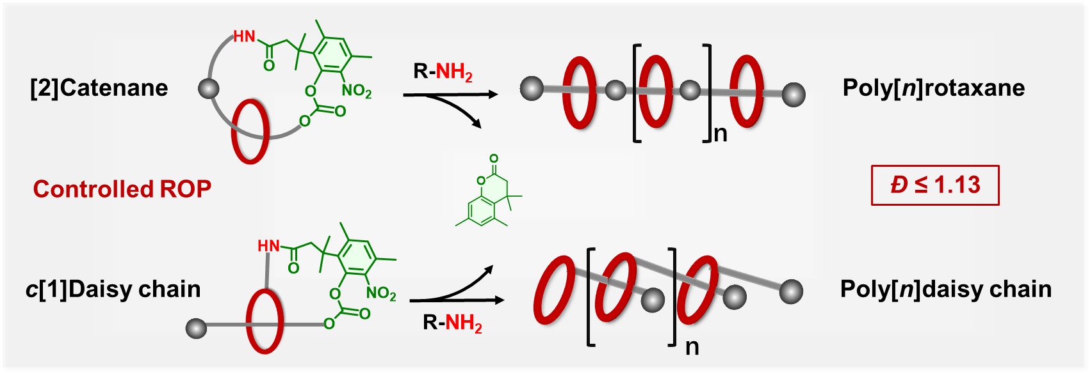
¹ College of Chemistry, State Key Laboratory of Elemento-Organic Chemistry, Frontiers Science Center for New Organic Matter, Nankai University, 94 Weijin Road, Nankai District, Tianjin 300071, China. ² Laboratory of Polymer Physics and Chemistry, Beijing National Laboratory for Molecular Sciences, Institute of Chemistry, The Chinese Academy of Sciences, Beijing 100190, P. R. China. ³ University of Chinese Academy of Sciences, Beijing 100049, China. ⁴ State Key Laboratory of Medicine Chemistry Biology, College of Chemistry, Nankai University, Tianjin 300071, China. ⁵ Key Laboratory of Functional Polymer Materials (Ministry of Education), Collaborative Innovation Center of Chemical Science and Engineering, State Key Laboratory of Elemento-Organic Chemistry, Nankai University, Tianjin 300071, China. ⁶ These author contribute equally to this work. Correspondence and requests for materials should be addressed to K. C. (email: kangcai@nankai.edu.cn) and K. Z. (email: kzhang@iccas.ac.cn)

