Supplementary
Deconvolution Results:
Cibersortx: 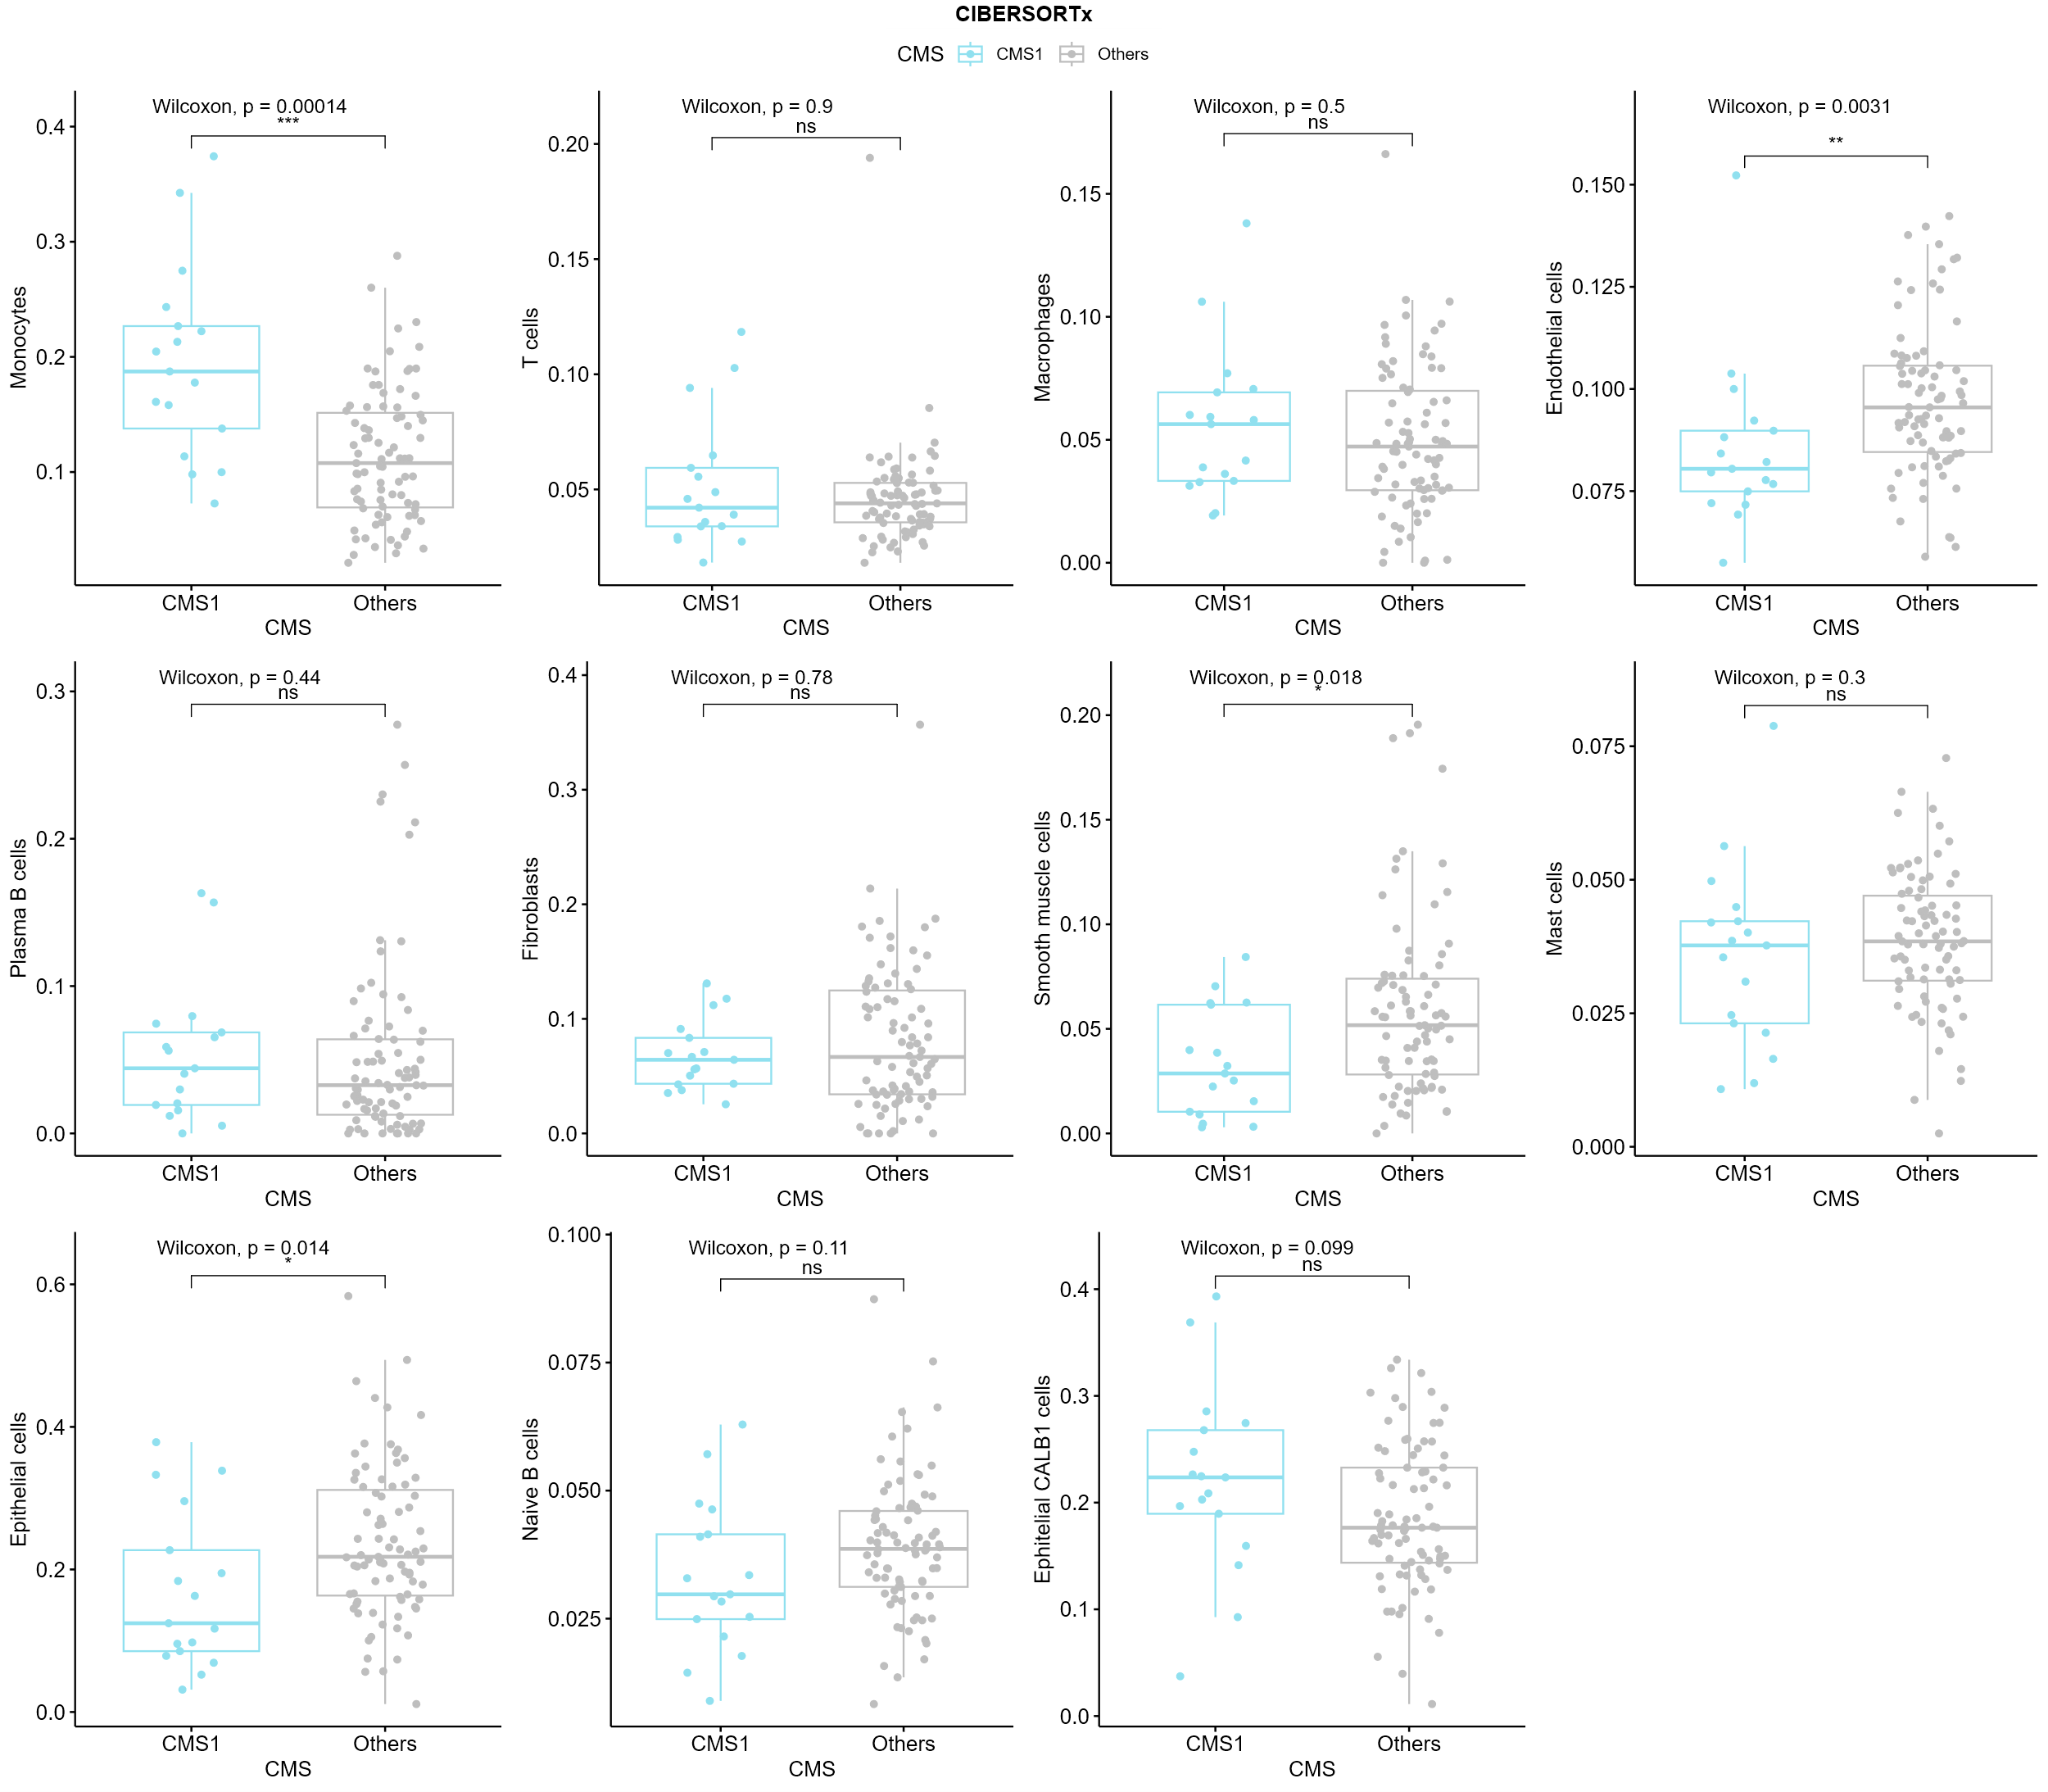
Supplementary 1 CIBERSORTx statistical comparison of cell type proportions in CMS1 versus others.
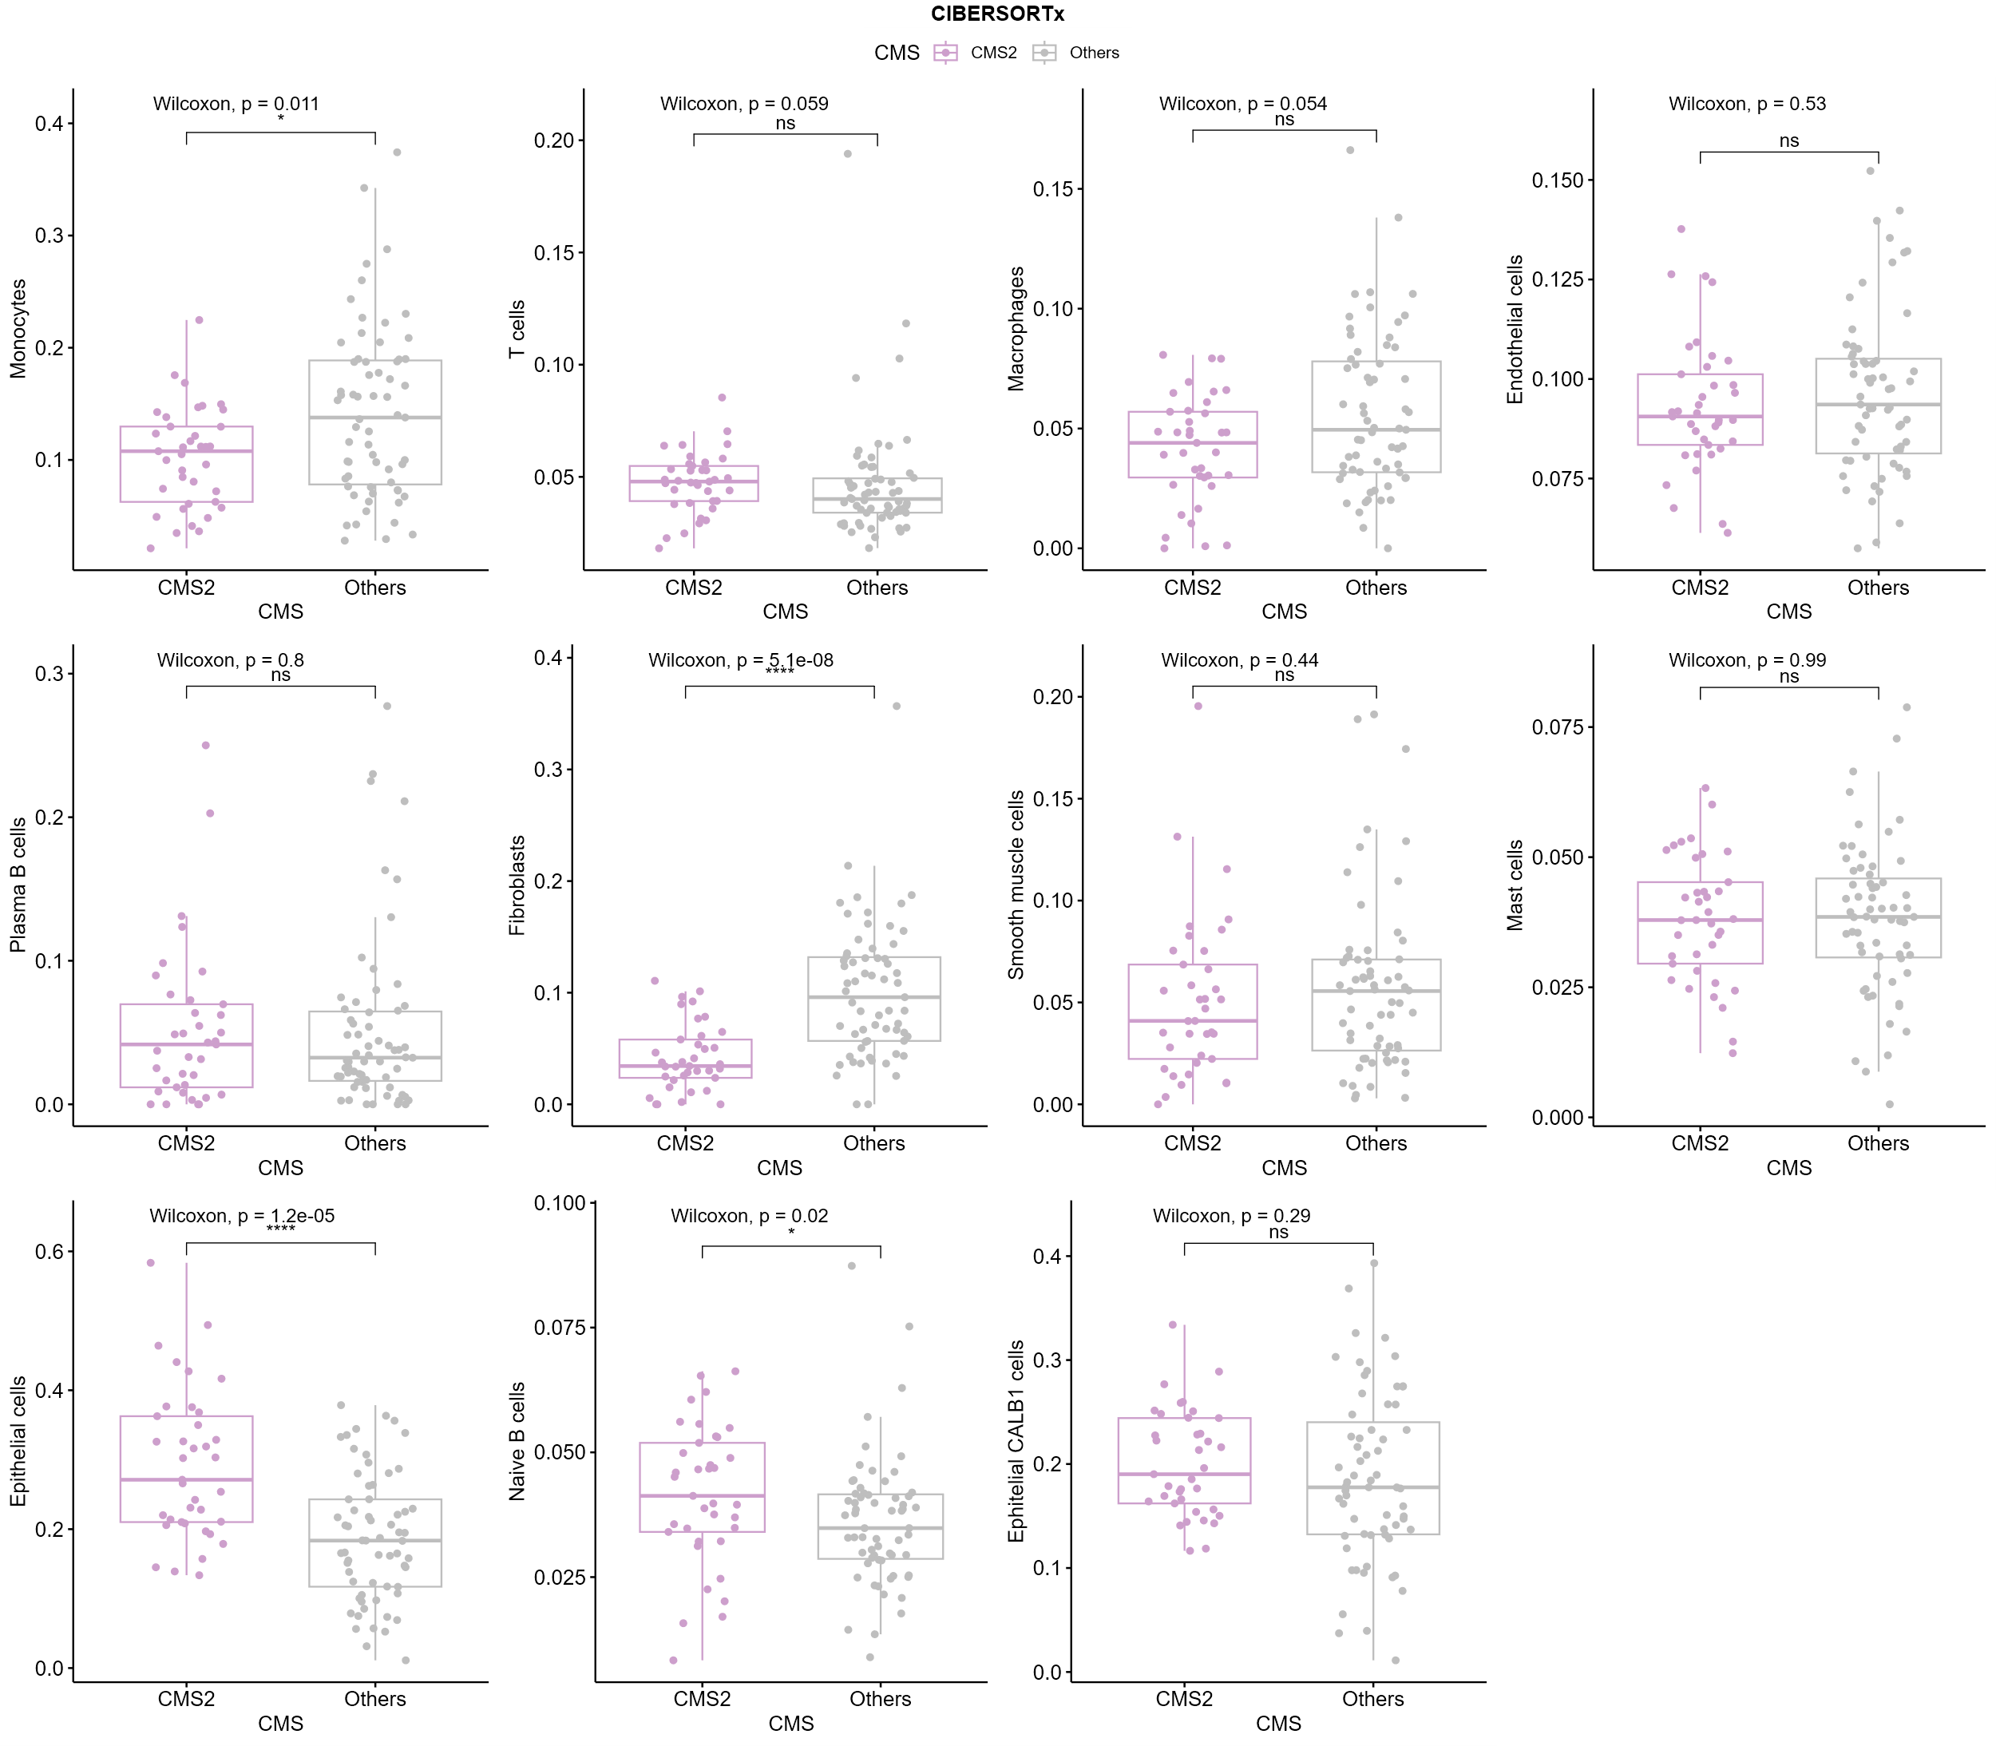
Supplementary 2 CIBERSORTx statistical comparison of cell type proportions in CMS2 versus others.
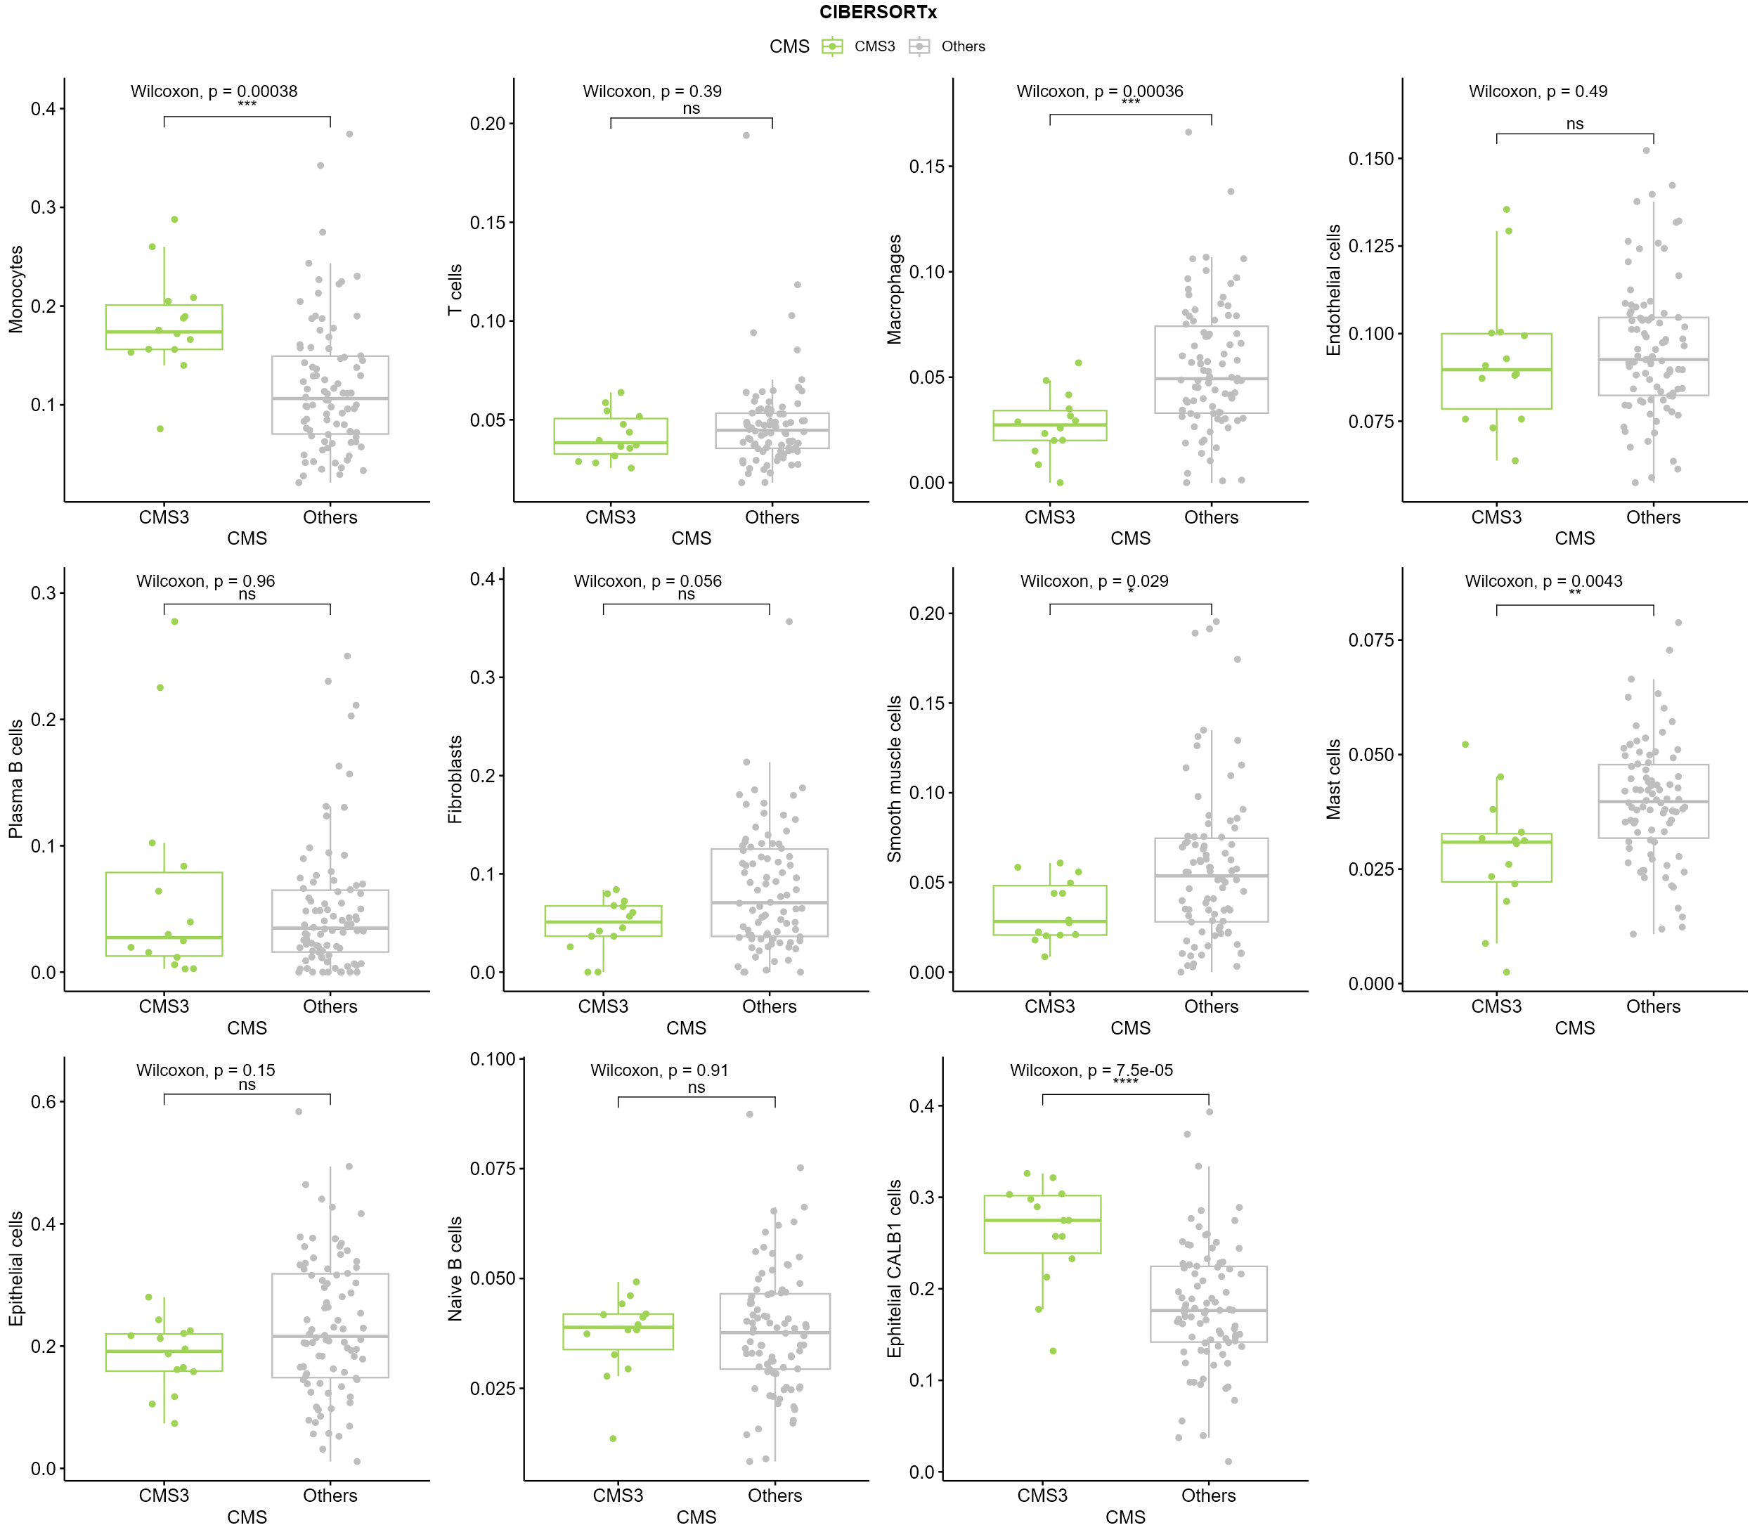
Supplementary 3 CIBERSORTx statistical comparison of cell type proportions in CMS3 versus others.
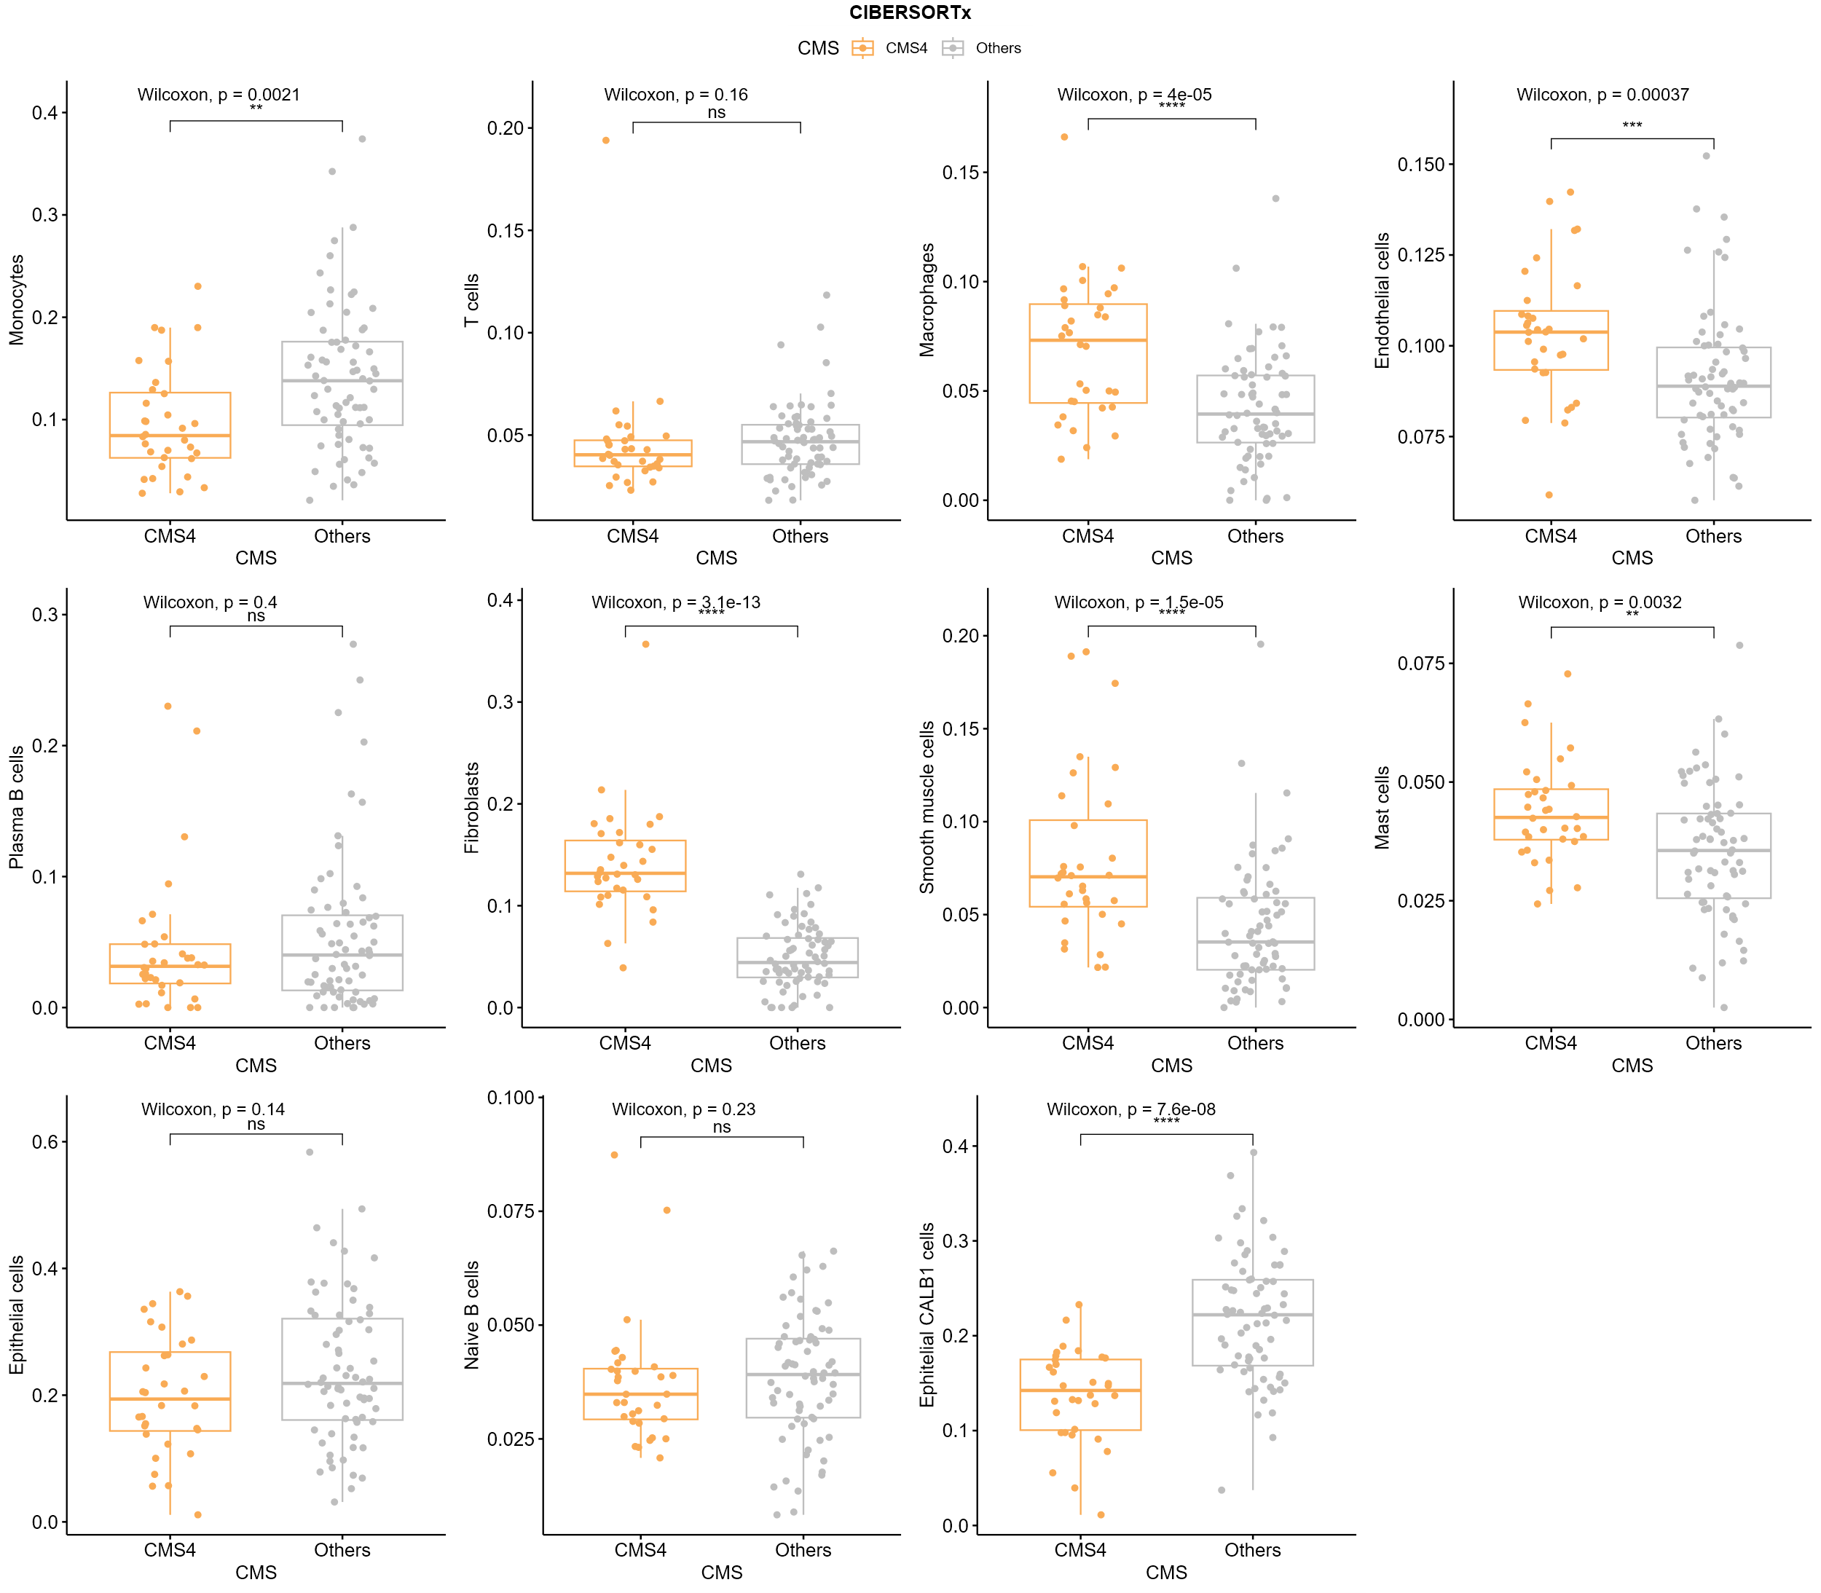
Supplementary 4 CIBERSORTx statistical comparison of cell type proportions in CMS4 versus others;
MuSIC:
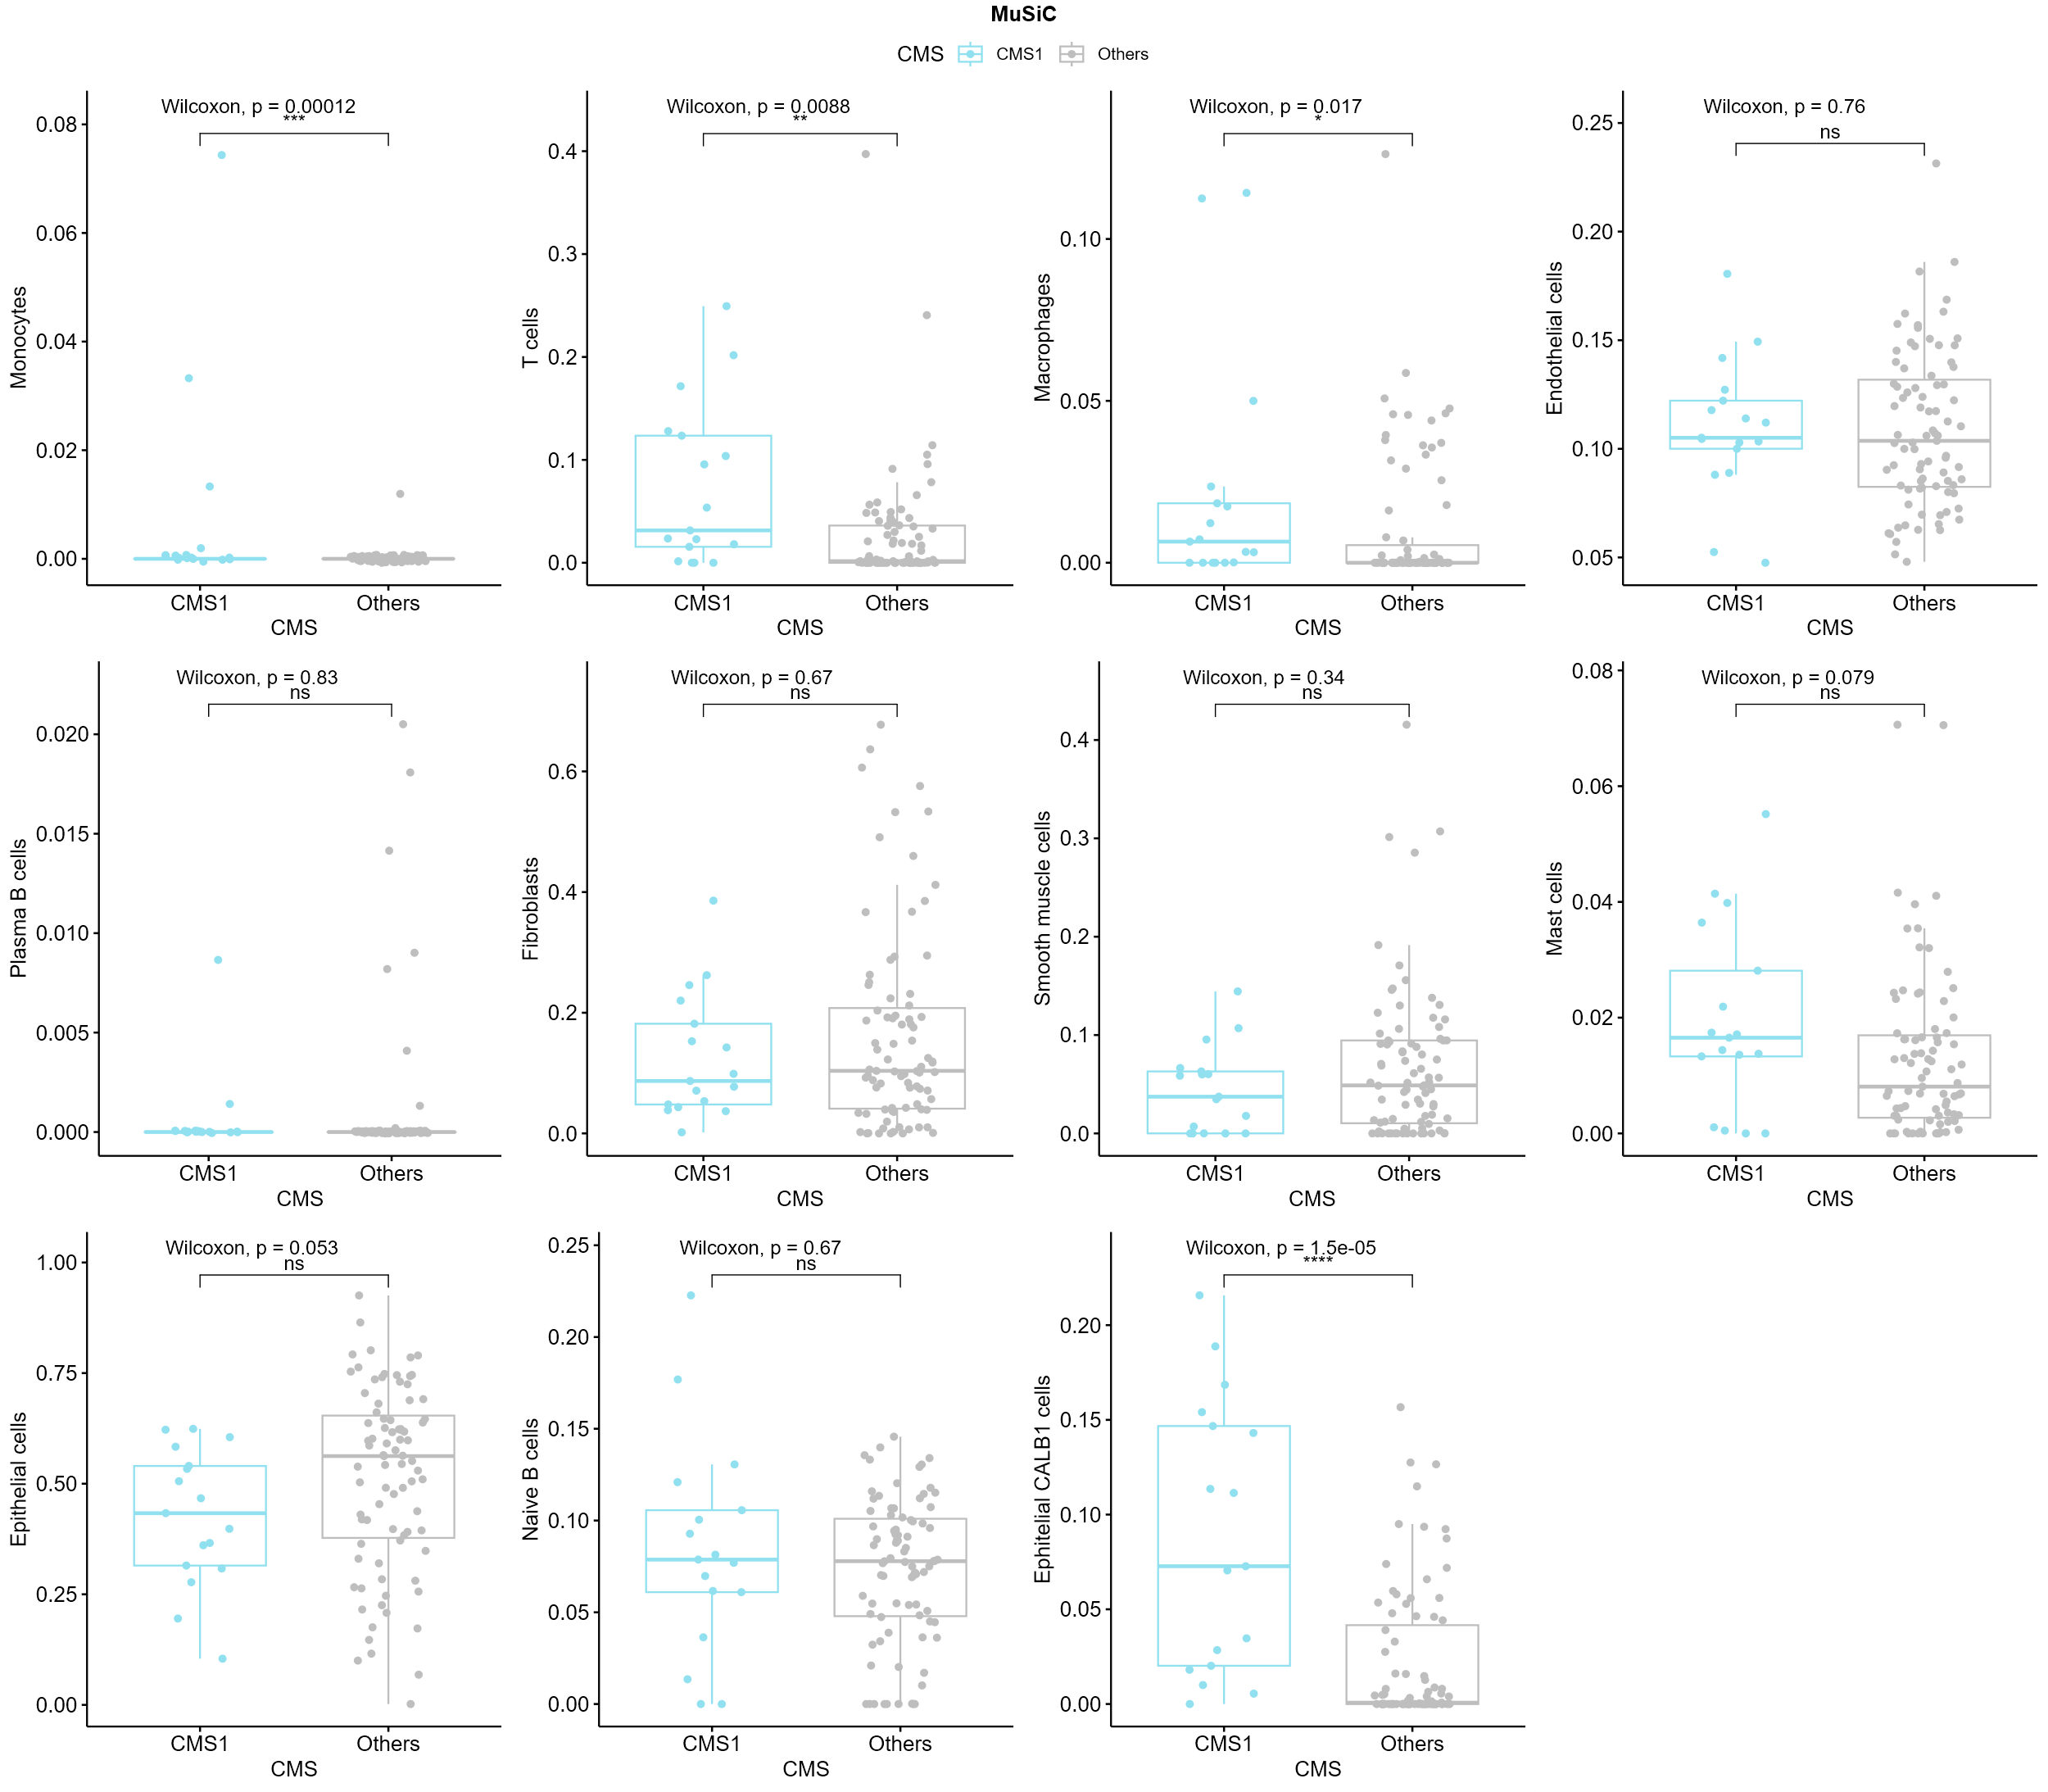
Supplementary 5 MuSIC statistical comparison of cell type proportions in CMS1 versus others;
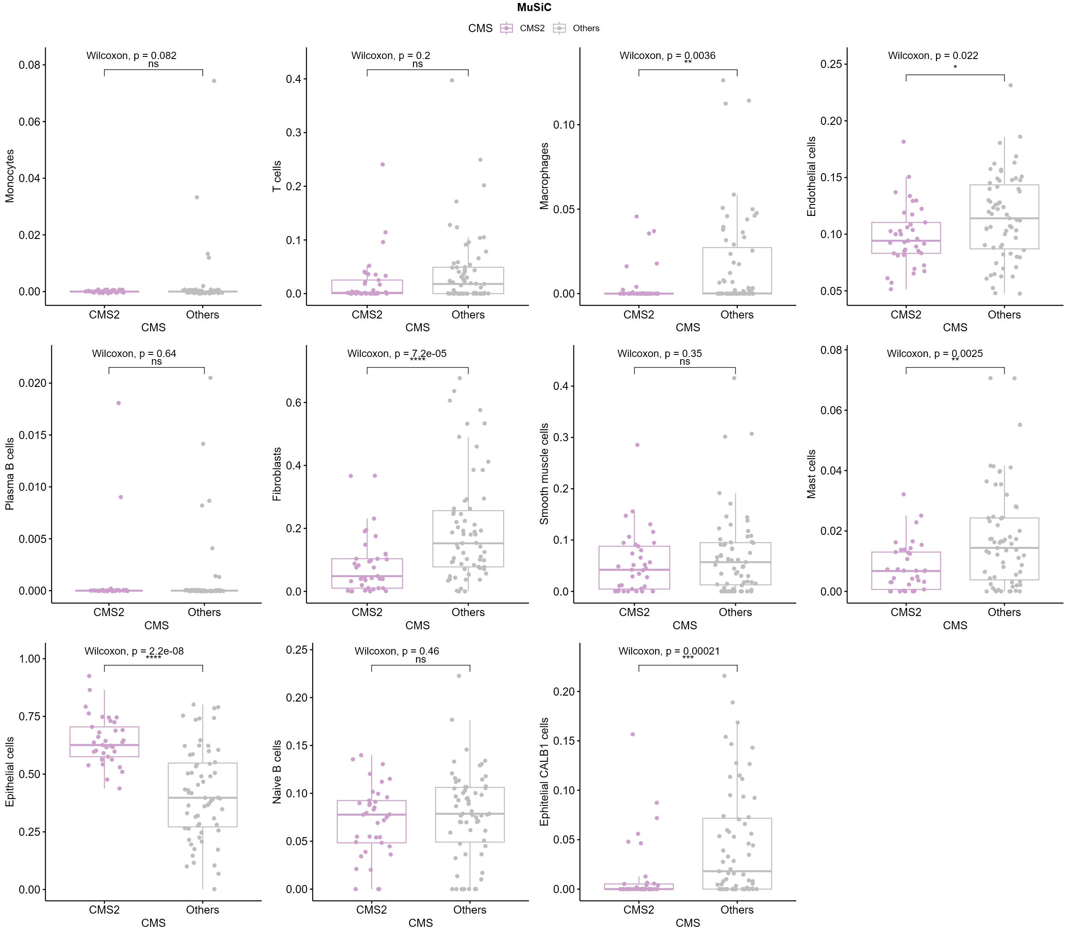
Supplementary 6 MuSIC statistical comparison of cell type proportions in CMS2 versus others;
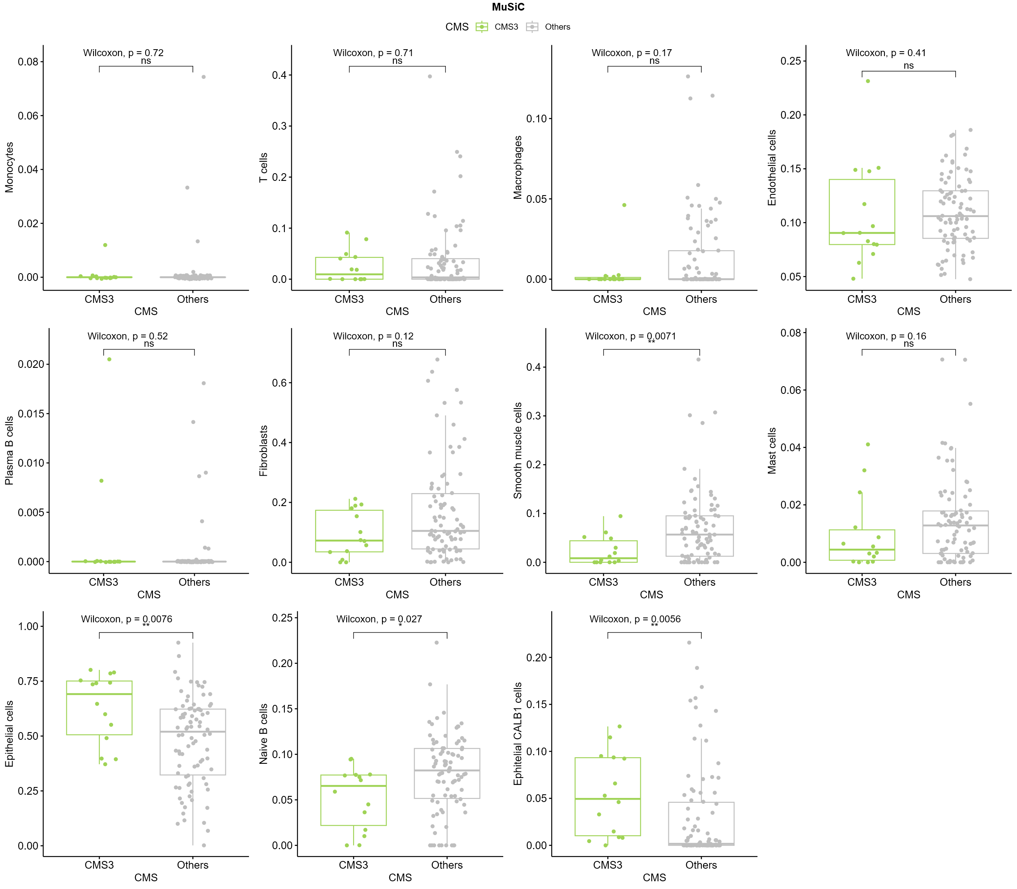
Supplementary 7 MuSIC statistical comparison of cell type proportions in CMS3 versus others;
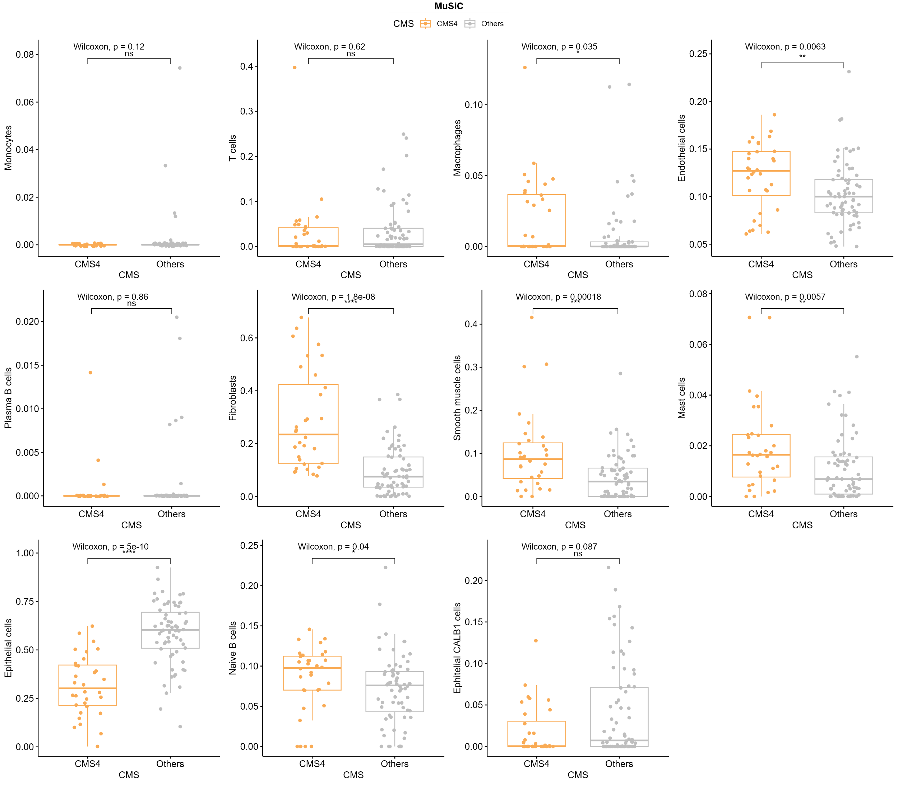
Supplementary 8 MuSIC statistical comparison of cell type proportions in CMS4 versus others;
Bayes Prism:
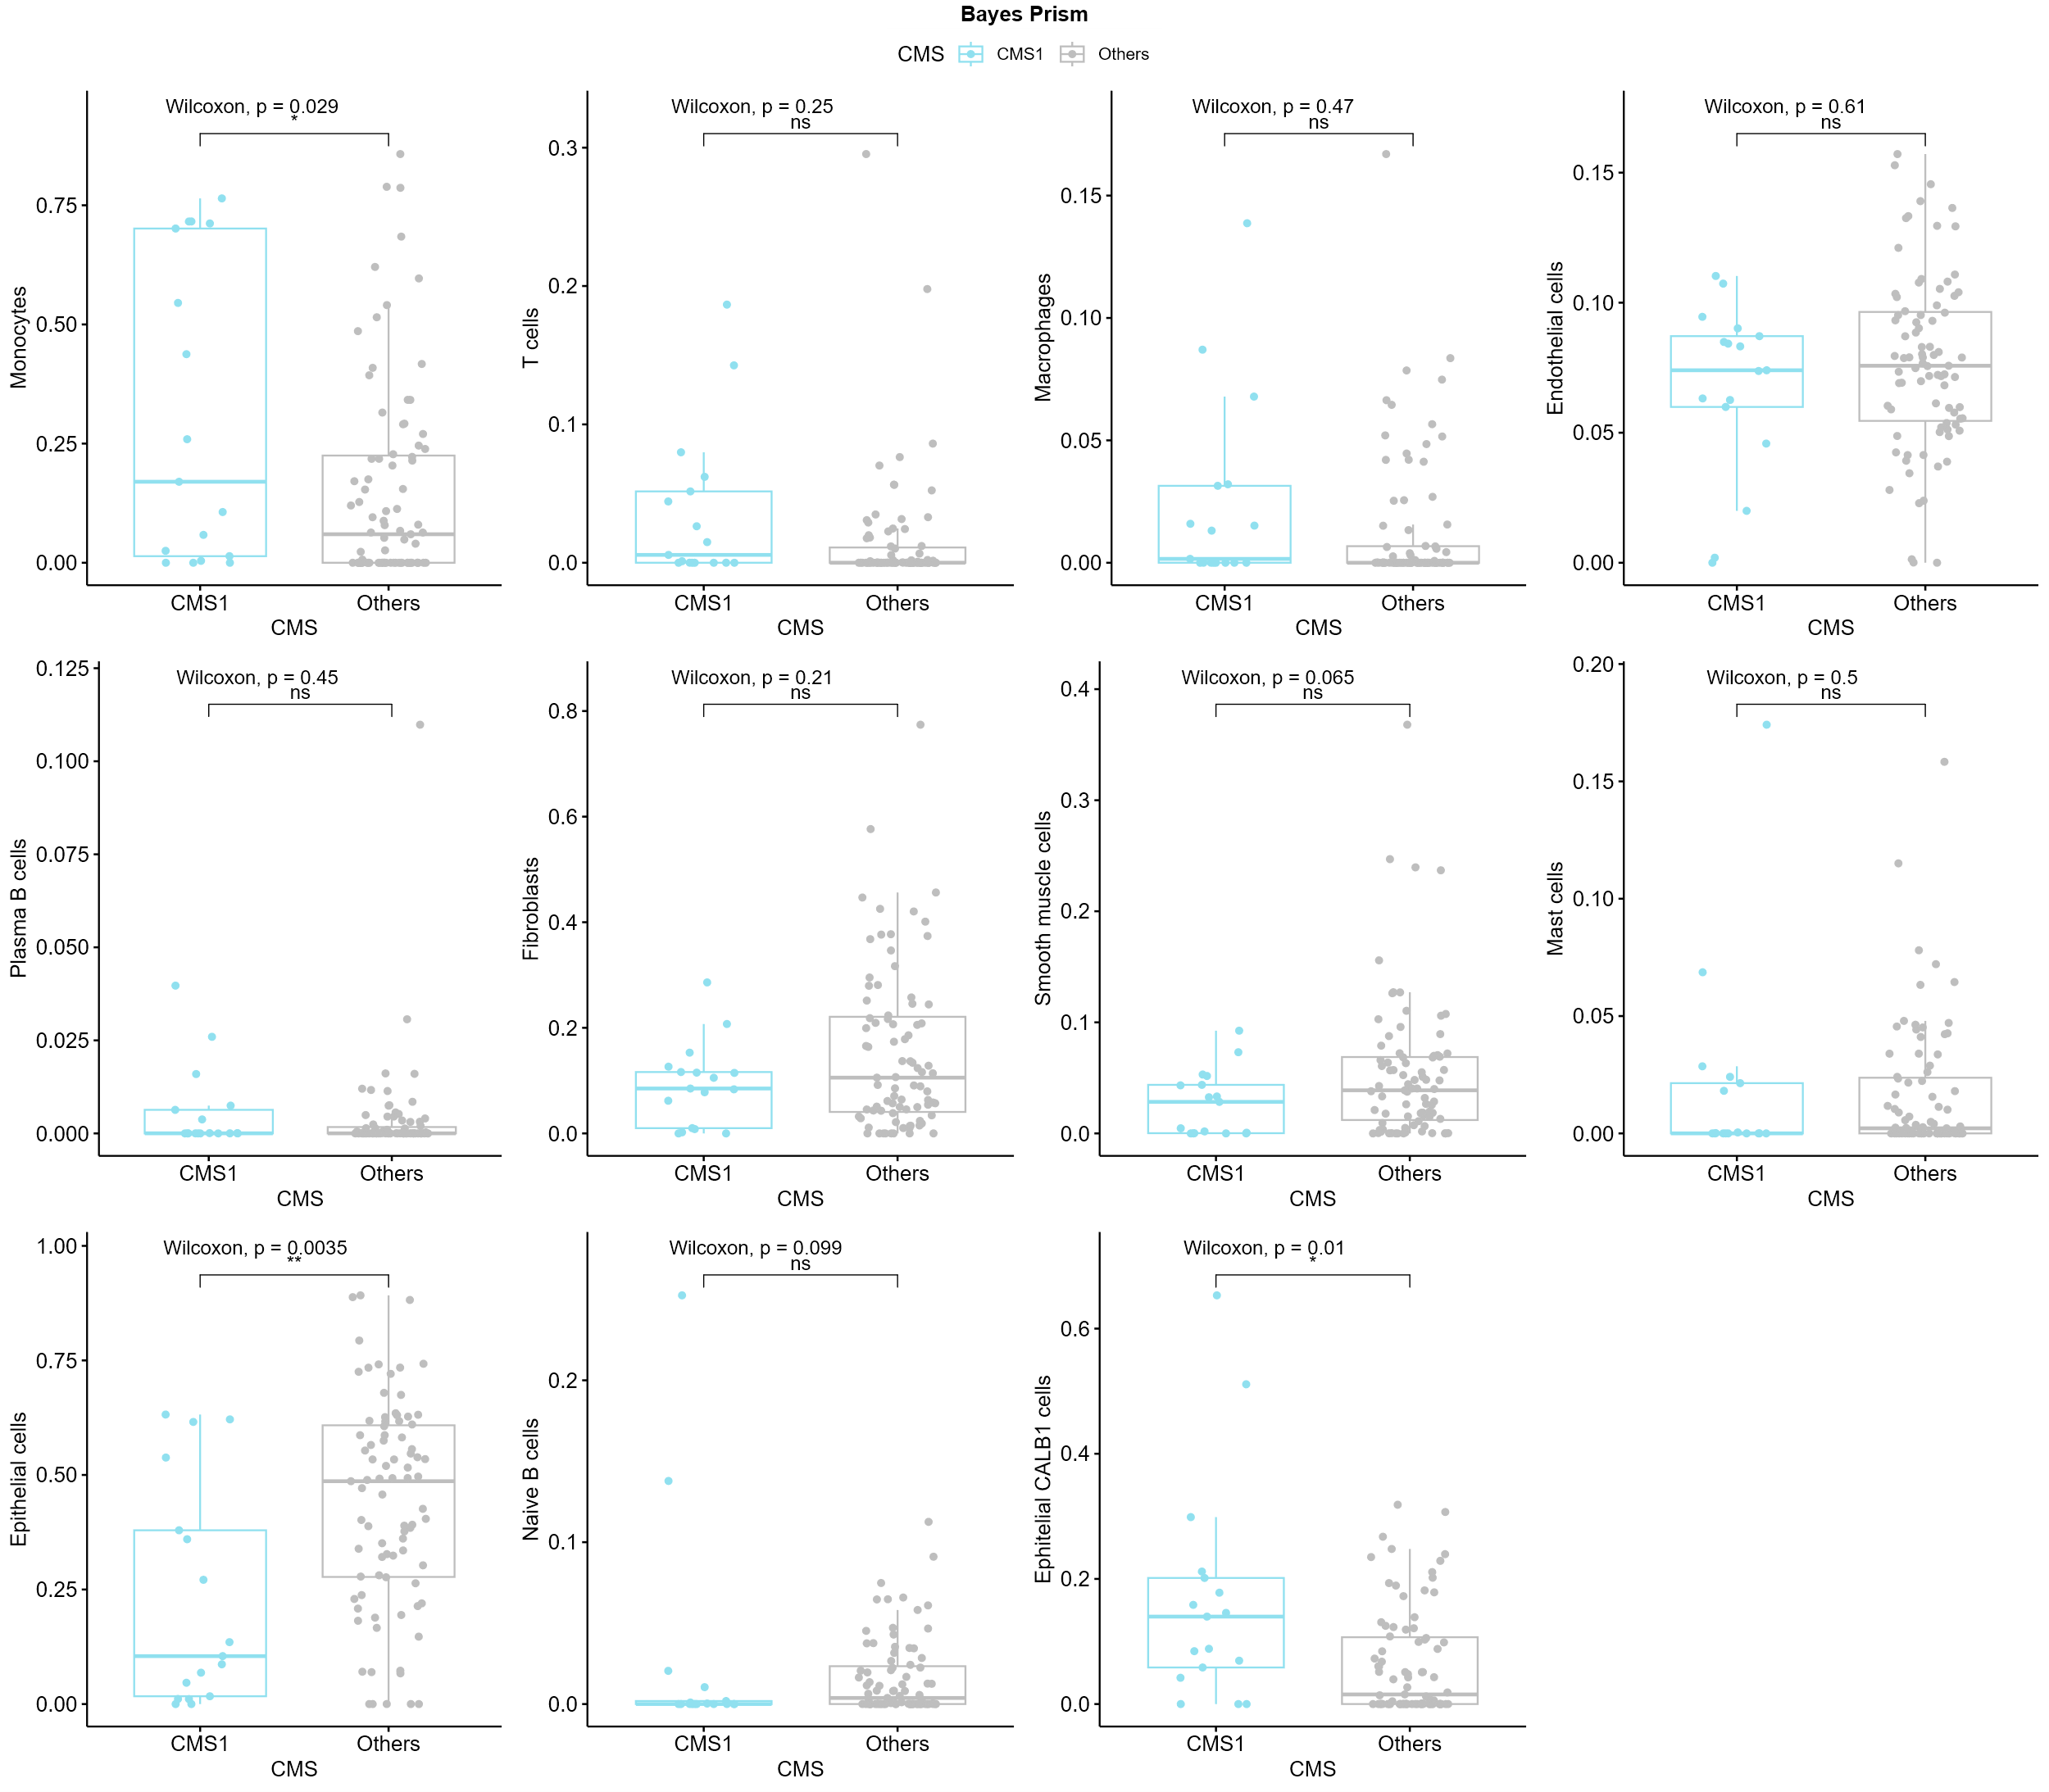
Supplementary 9 Bayes Prism statistical comparison of cell type proportions in CMS1 versus others;
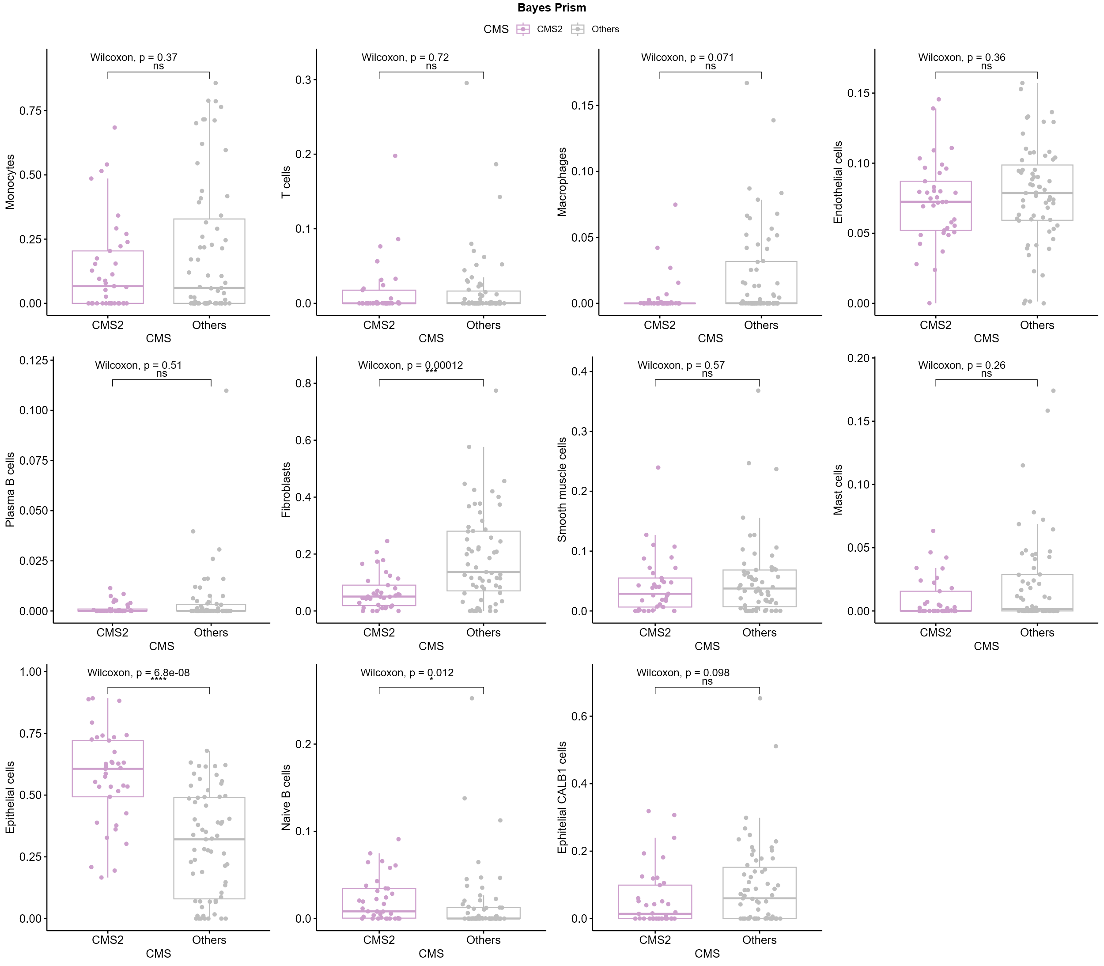
Supplementary 10 Bayes Prism statistical comparison of cell type proportions in CMS2 versus others;
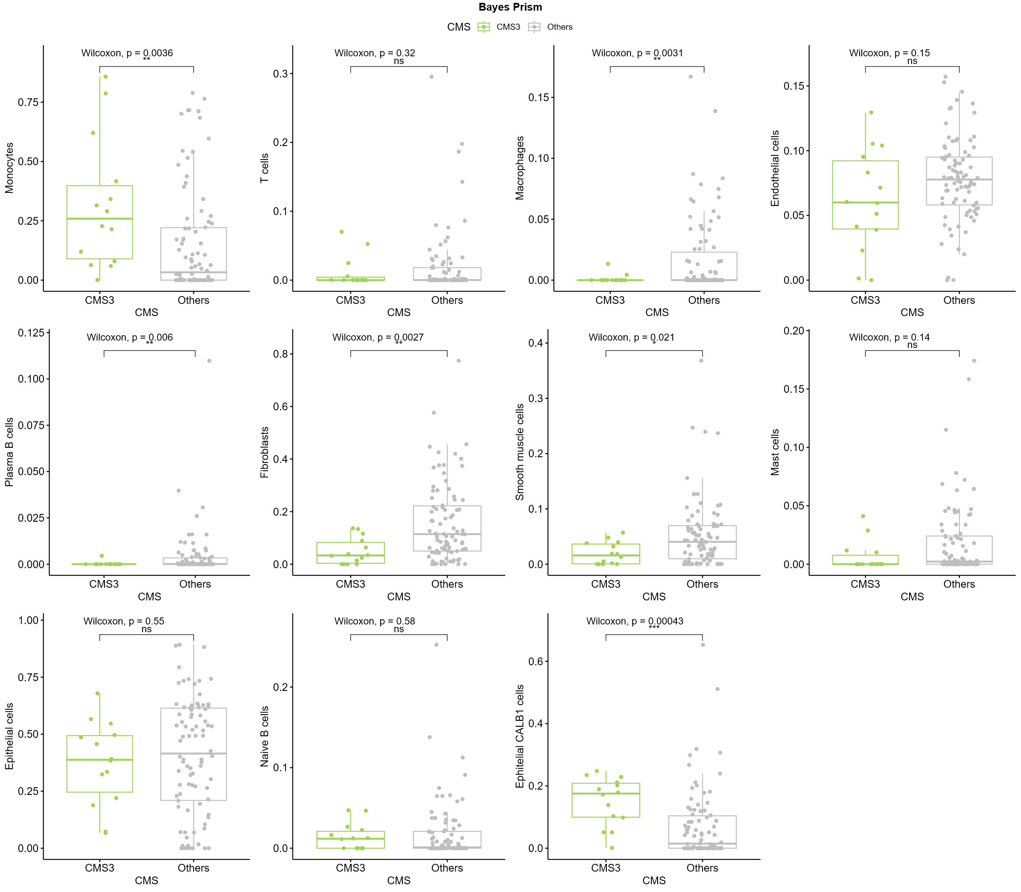
Supplementary 11 Bayes Prism statistical comparison of cell type proportions in CMS3 versus others;
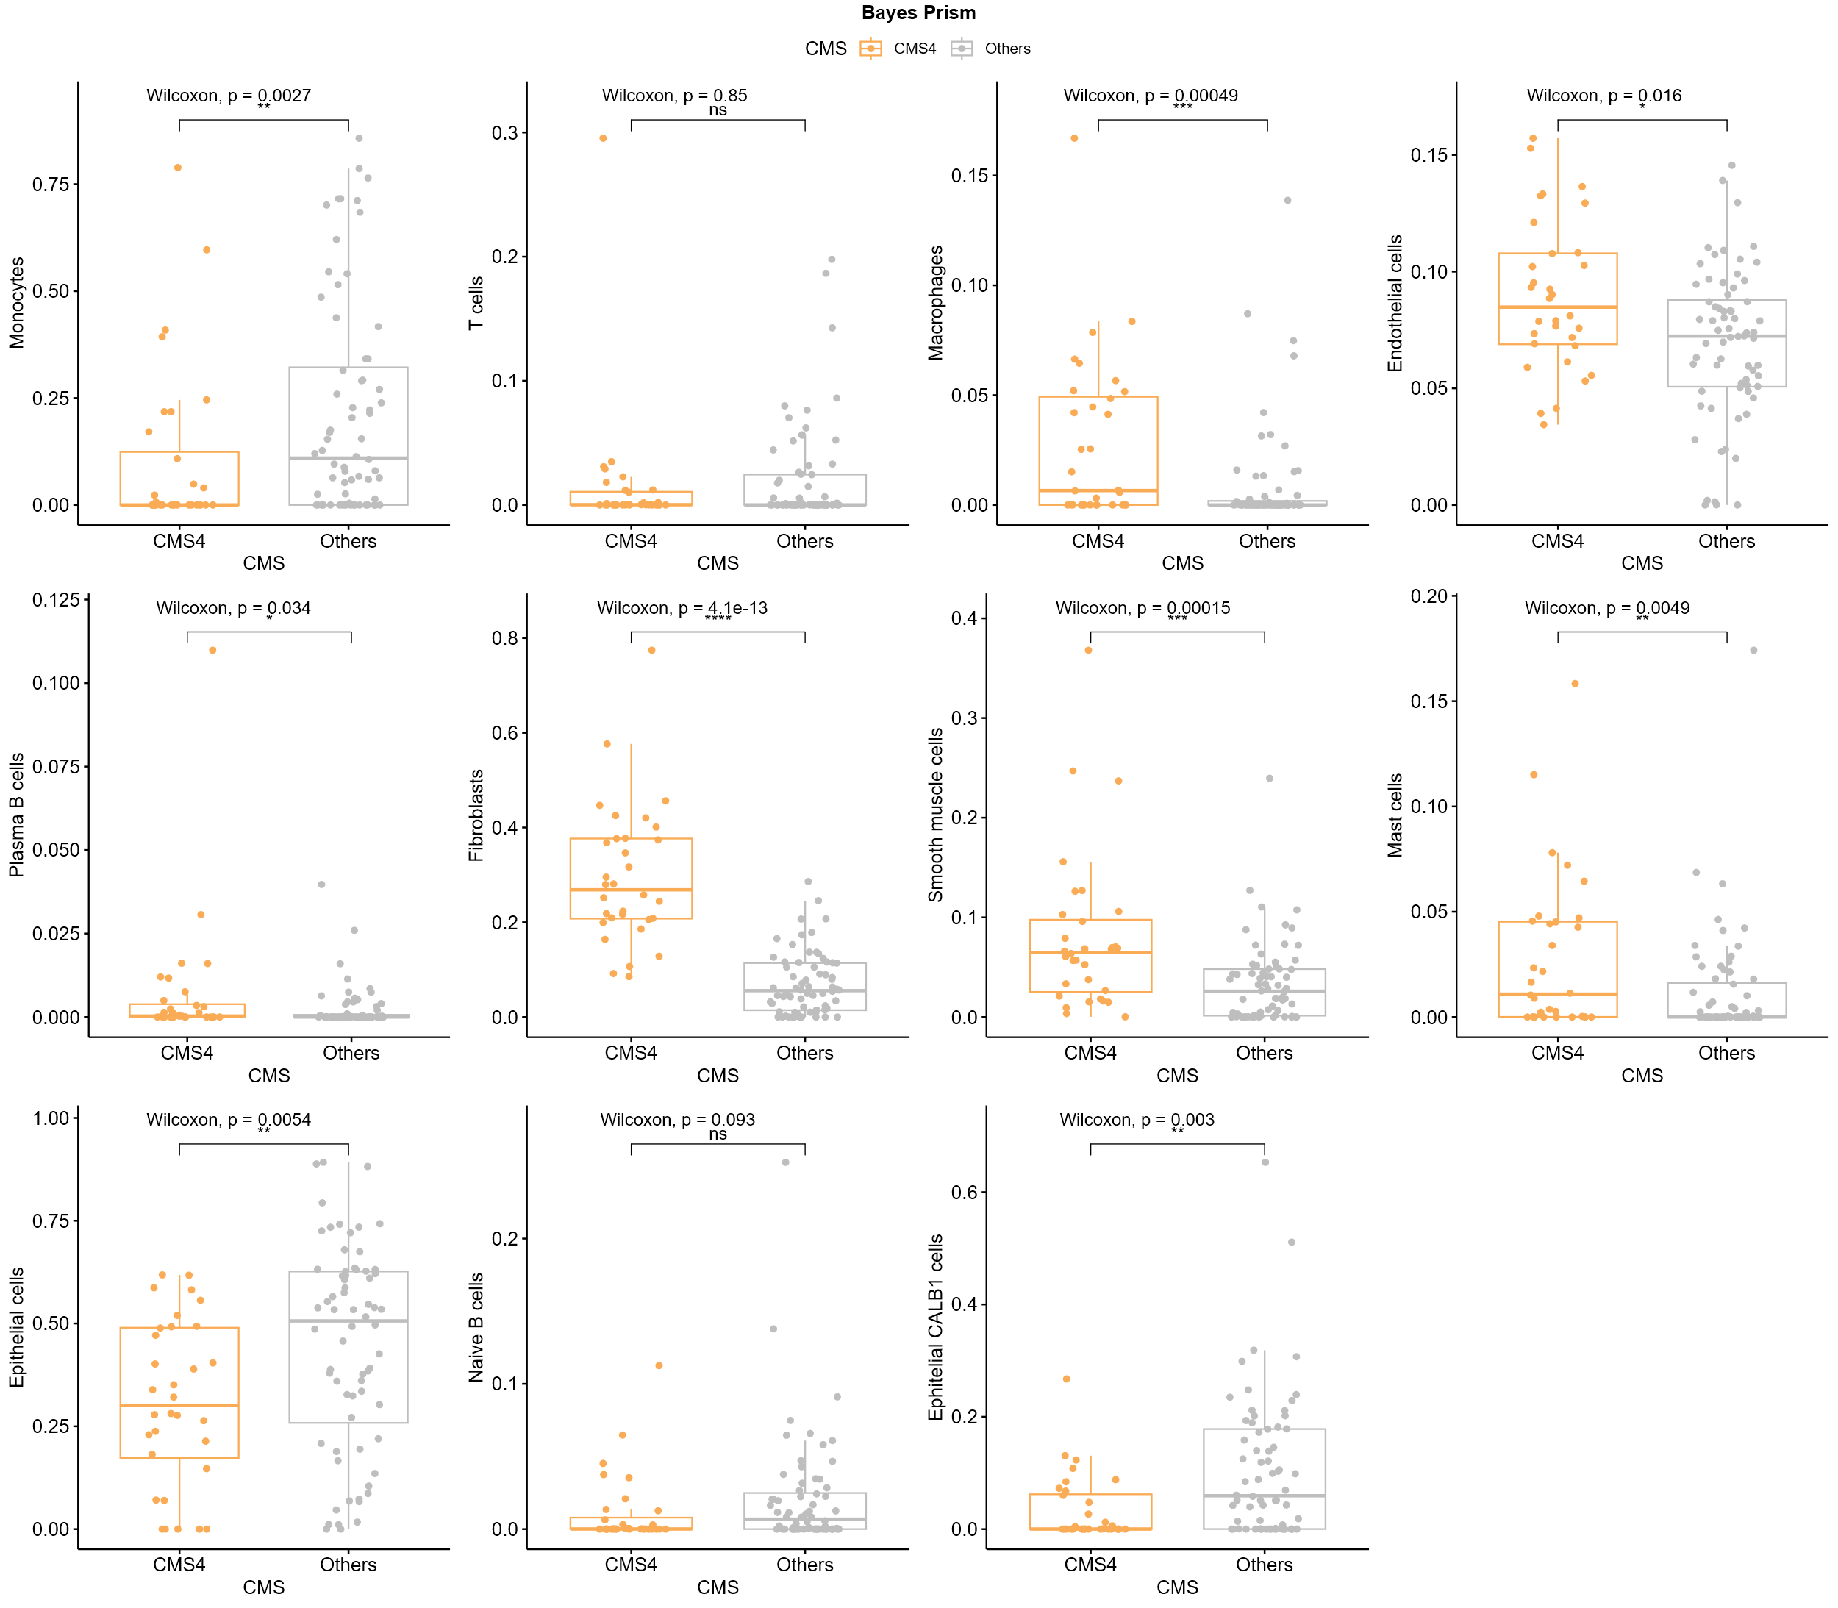
Supplementary 12 Bayes Prism statistical comparison of cell type proportions in CMS4 versus others;
Editing Global Statistic
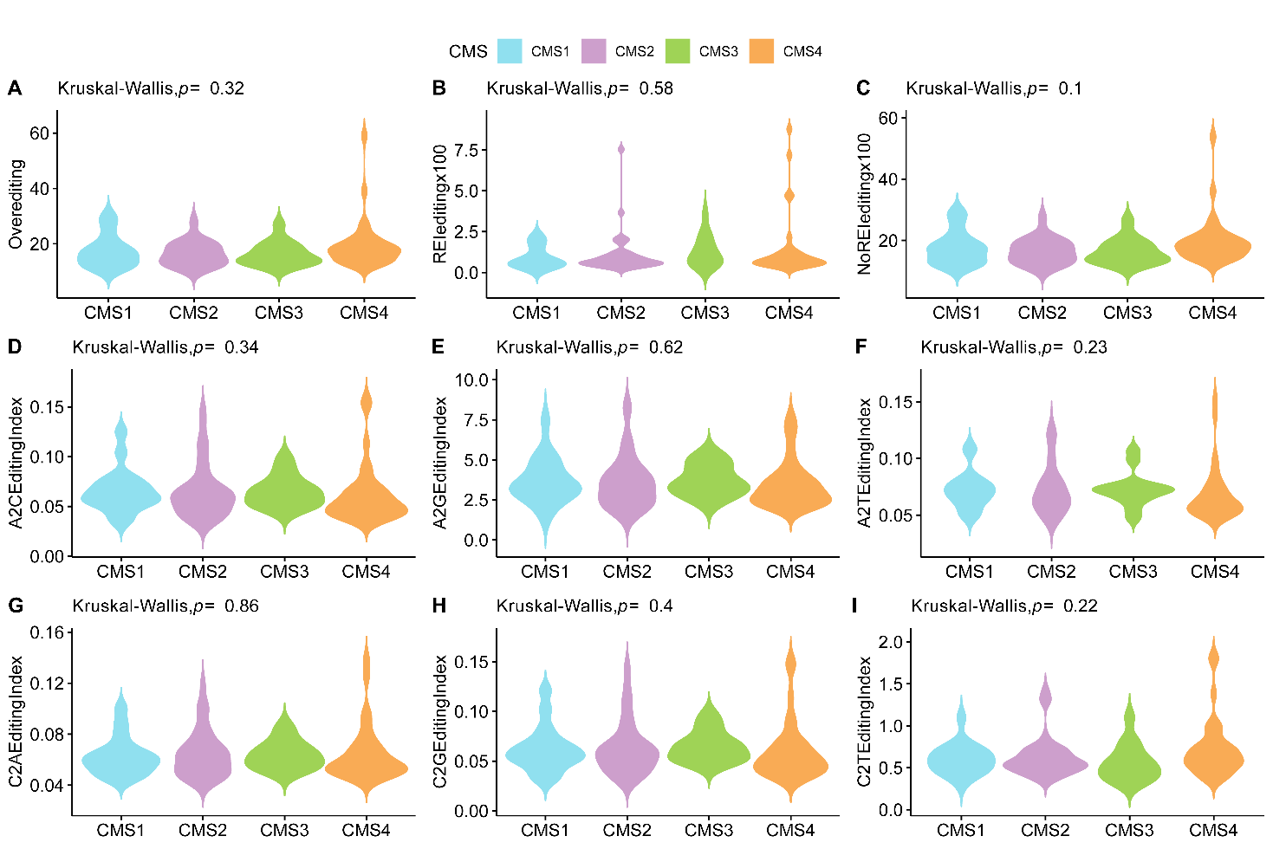
Supplementary 13 Violin plot showing the results of RNA editing statistics between CMS subtype, The statistical test applied was Kruskal-Wallis, followed by Dunn's post-hoc test. Asterisks indicate statistical significance: ns = not significant, p ≤ 0.05 (), p ≤ 0.01 (), p ≤ 0.001 (), p ≤ 0.0001 (****). A Results from GetOverall, B results from GetREI, C results from GetNoREI, D to I results from the RNAEditingIndex tool.
CeRNA networks
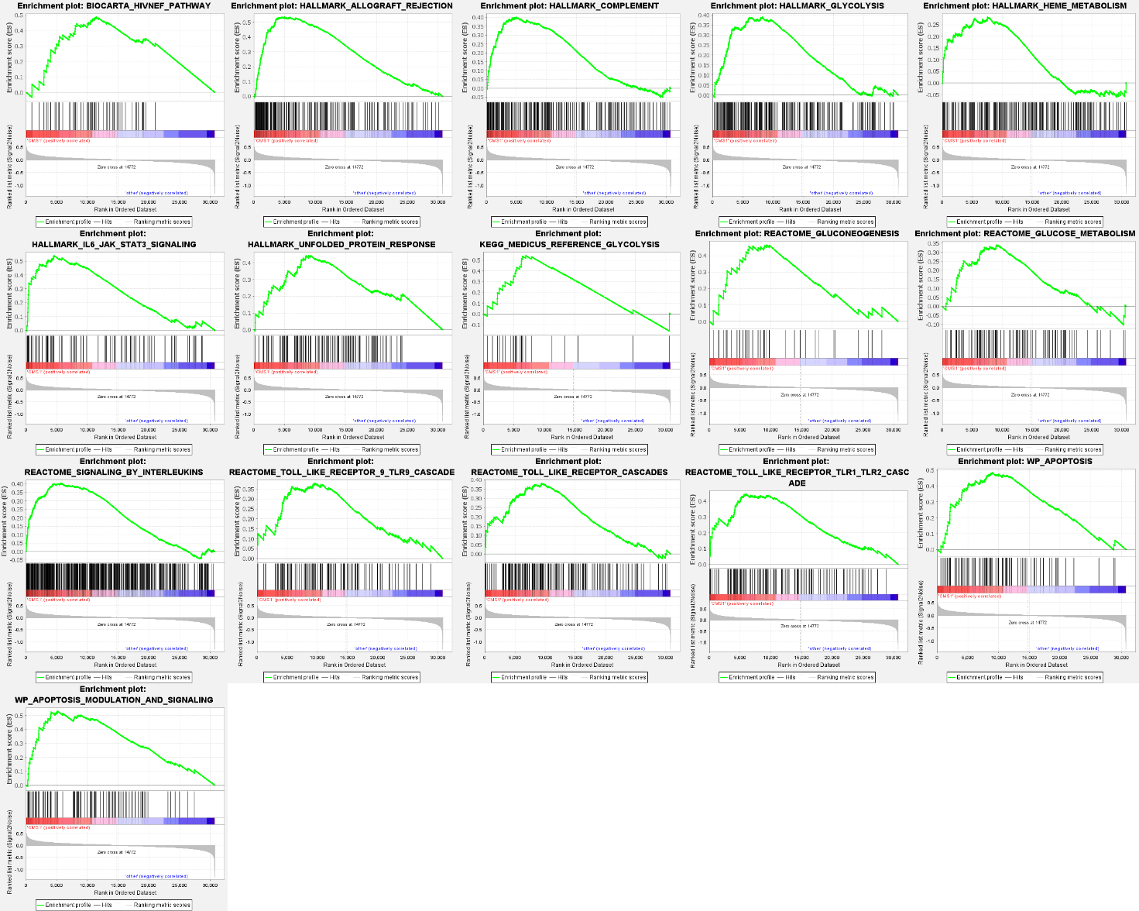
Supplementary 14 GSEA enrichment results used to construct the CMS1 network

Edited lncRNA in CMS1 Subtype
Position | Editing | lncRNA | Dunn_P_Value | Z_score | Result
chr1:174013645 | T_C | RC3H1-IT1 | 0.0001 | -3.9171 | CMS3 > CMS1
chr1:174013646 | T_C | RC3H1-IT1 | 0.00004 | -4.1538 | CMS3 > CMS1
Supplementary Table 1 The Long Non coding edited in CMS1 network

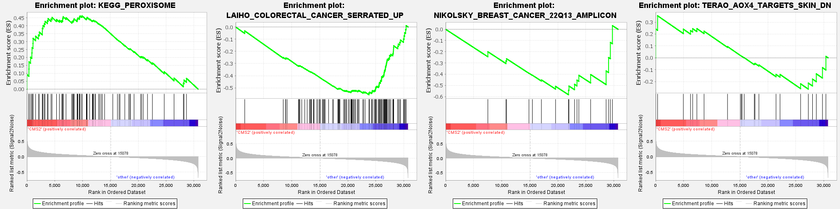
Supplementary 15 GSEA enrichment results used to construct the CMS2 network

Edited lncRNA in CMS2 Subtype
Position | Editing | lncRNA | Dunn_P_Value | Z_score | Result
chr13:110899024 | T_C | ANKRD10-IT1 | 0.00155 | -3.4773 | CMS4 > CMS2
chr2:186119862 | T_C | LINC01473 | 0.0082 | 2.9925 | CMS2 > CMS4
chr2:186135339 | T_C | LINC01473 | 0.0086 | 2.7626 | CMS2 > CMS4
chr2:186135345 | T_C | LINC01473 | 0.0007 | 3.4658 | CMS2 > CMS4
chr2:186135439 | T_C | LINC01473 | 0.0017 | 3.4415 | CMS2 > CMS4
chr2:186135447 | T_C | LINC01473 | 0.0020 | 3.3975 | CMS2 > CMS4
chr2:186181060 | T_C | LINC01473 | 0.0040 | 3.20411 | CMS2 > CMS4
chr2:186301889 | T_C | LINC01473 | 0.0096 | 2.94520 | CMS2 > CMS4
Supplementary Table 2 The Long Non coding edited in CMS2 network.

Edited lncRNA in CMS3 Subtype
Position | Editing | lncRNA | Dunn_P_Value | Z_score | Result
chr1:174012594 | T_C | RC3H1-IT1 | 0.0069 | 3.0479 | CMS3 > CMS4
chr1:174013645 | T_C | RC3H1-IT1 | 0.00002 | 4.4942 | CMS3 > CMS4
chr1:174013646 | T_C | RC3H1-IT1 | 0.00004 | 4.3342 | CMS3 > CMS4
chr1:174015480 | T_C | RC3H1-IT1 | 0.0029 | 3.2966 | CMS3 > CMS4
chr1:174016141 | T_C | RC3H1-IT1 | 0.0072 | 3.0354 | CMS3 > CMS4
chr1:174013645 | T_C | RC3H1-IT1 | 0.0001 | -3.9171 | CMS3 > CMS1
chr1:174013645 | T_C | RC3H1-IT1 | 0.0009 | -3.2965 | CMS3 > CMS2
chr1:174013646 | T_C | RC3H1-IT1 | 0.00004 | -4.1538 | CMS3 > CMS1
chr1:174013646 | T_C | RC3H1-IT1 | 0.0010 | -3.2736 | CMS3 > CMS2
chr12:123577817 | T_C | TMED2-DT | 0.0043 | 3.1817 | CMS3 > CMS4
chr16:89713061 | A_G | VPS9D1-AS1 | 0.0007 | 3.6460 | CMS3 > CMS4
chr16:89713062 | A_G | VPS9D1-AS1 | 0.0055 | 3.1123 | CMS3 > CMS4
chr16:89713421 | A_G | VPS9D1-AS1 | 0.0068 | 3.0516 | CMS3 > CMS4
chr16:89715860 | A_G | VPS9D1-AS1 | 0.0074 | 2.8081 | CMS3 > CMS4
chr17:77089870 | A_G | SNHG20 | 0.0014 | 3.4893 | CMS3 > CMS4
chr17:77090153 | A_G | SNHG20 | 0.0078 | 3.0110 | CMS3 > CMS4
chr17:77091181 | A_G | SNHG20 | 0.0059 | 3.0930 | CMS3 > CMS4
chr17:77091308 | A_G | SNHG20 | 0.0024 | 3.3424 | CMS3 > CMS4
chr17:77091995 | A_G | SNHG20 | 0.0005 | 3.7491 | CMS3 > CMS4
chr17:82477703 | A_G | NARF-AS1 | 0.0097 | 2.9444 | CMS3 > CMS4
chr19:54445376 | T_C | LENG8-AS1 | 0.0001 | 3.8672 | CMS3 > CMS4
chr19:54447902 | T_C | LENG8-AS1 | 0.0069 | 3.0477 | CMS3 > CMS4
chr22:25109927 | A_G | KIAA1671-AS1 | 0.0024 | 3.3445 | CMS3 > CMS4
chr3:47167574 | A_G | KIF9-AS1 | 0.0063 | 3.0720 | CMS3 > CMS4
chr3:47167622 | A_G | KIF9-AS1 | 0.0013 | 3.5176 | CMS3 > CMS4
chr3:47168658 | A_G | KIF9-AS1 | 0.0086 | 2.9806 | CMS3 > CMS4
chr3:47175319 | A_G | KIF9-AS1 | 0.0053 | 3.1226 | CMS3 > CMS4
chr3:47179568 | A_G | KIF9-AS1 | 0.0024 | 3.3456 | CMS3 > CMS4
chr3:47182562 | A_G | KIF9-AS1 | 0.0066 | 3.0579 | CMS3 > CMS4
chr3:47182591 | A_G | KIF9-AS1 | 0.0036 | 3.2349 | CMS3 > CMS4
chr3:47192210 | A_G | KIF9-AS1 | 0.0006 | 3.6968 | CMS3 > CMS4
chr3:47218144 | A_G | KIF9-AS1 | 0.0001 | 4.0689 | CMS3 > CMS4
chr3:47232485 | A_G | KIF9-AS1 | 0.0019 | 3.4046 | CMS3 > CMS4
chr3:47167574 | A_G | KIF9-AS1 | 0.0088 | -2.7520 | CMS3 > CMS2
chr3:47167622 | A_G | KIF9-AS1 | 0.0052 | -2.9210 | CMS3 > CMS2
chr3:47218144 | A_G | KIF9-AS1 | 0.0003 | -3.6126 | CMS3 > CMS1
chr3:47218144 | A_G | KIF9-AS1 | 0.0002 | -3.762208 | CMS3 > CMS2
chr3:47232485 | A_G | KIF9-AS1 | 0.0080 | -2.785544 | CMS3 > CMS2
chr4:2960151 | T_C | NOP14-AS1 | 0.0037 | 3.228266 | CMS3 > CMS4
chr4:2960236 | T_C | NOP14-AS1 | 0.0034 | 2.9247 | CMS3 > CMS4
chr9:137617194 | A_G | ARRDC1-AS1 | 0.0076 | 3.0175 | CMS3 > CMS4
Supplementary Table 3 The Long Non coding edited in CMS3 network

Edited lncRNA in CMS4 Subtype
Position | Editing | lncRNA | Dunn_P_Value | Z_score | result
chr13:110899024 | T_C | ANKRD10-IT1 | 0.0015 | -3.4773 | CMS4 > CMS2
chr2:186119862 | T_C | LINC01473 | 0.0082 | 2.9925 | CMS2 > CMS4
chr2:186119862 | T_C | LINC01473 | 0.00581 | 2.8855 | CMS3 > CMS4
chr2:186135339 | T_C | LINC01473 | 0.0086 | 2.7626 | CMS2 > CMS4
chr2:186135345 | T_C | LINC01473 | 0.00071 | 3.4658 | CMS2 > CMS4
chr2:186135345 | T_C | LINC01473 | 0.0002 | 3.9439 | CMS3 > CMS4
chr2:186135439 | T_C | LINC01473 | 0.0017 | 3.4415 | CMS2 > CMS4
chr2:186135447 | T_C | LINC01473 | 0.0020 | 3.3975 | CMS2 > CMS4
chr2:186181060 | T_C | LINC01473 | 0.0040 | 3.2041 | CMS2 > CMS4
chr2:186241729 | T_C | LINC01473 | 0.0011 | 3.5504 | CMS3 > CMS4
chr2:186301889 | T_C | LINC01473 | 0.0096 | 2.9452 | CMS2 > CMS4
chr2:217685146 | T_C | DIRC3 | 0.0014 | 3.4828 | CMS3 > CMS4
chr2:217685197 | T_C | DIRC3 | 0.0025 | 3.3377 | CMS3 > CMS4
chr5:149418603 | A_G | CARMN | 0.0043 | -3.1874 | CMS4 > CMS3
chr5:149426766 | A_G | CARMN | 0.0076 | 3.0176 | CMS3 > CMS4
chr5:149427913 | A_G | CARMN | 0.0046 | 3.1653 | CMS3 > CMS4
chr7:117120557 | A_G | ST7-AS2 | 0.0095 | 2.9488 | CMS3 > CMS4
chr7:117120676 | A_G | ST7-AS2 | 0.0087 | 2.9756 | CMS3 > CMS4
chr7:117120705 | A_G | ST7-AS2 | 0.0098 | 2.9406 | CMS3 > CMS4
chr7:117122131 | A_G | ST7-AS2 | 0.0015 | 3.4741 | CMS3 > CMS4
Supplementary Table 4 The Long Non coding edited in CMS4 network

Survival Analysis
Characteristic | N | HR | 95% CI | p-value
Sex | 100
F |  | — | —
M |  | 1.33 | 0.74, 2.41 | 0.34
Age | 100 | 0.99 | 0.97, 1.02 | 0.49
Sideness | 100
left |  | — | —
right |  | 1.05 | 0.58, 1.90 | 0.86
Stage | 100
I |  | — | —
II |  | 1.40 | 0.16, 12.6 | 0.76
III |  | 4.28 | 0.57, 32.1 | 0.16
IV |  | 7.54 | 1.01, 56.1 | 0.049
CMS | 100
CMS1 |  | — | —
CMS2 |  | 0.84 | 0.30, 2.33 | 0.74
CMS3 |  | 0.91 | 0.26, 3.24 | 0.89
CMS4 |  | 3.25 | 1.33, 7.95 | 0.010
iCMS | 100
iCMS2 |  | — | —
iCMS3 |  | 1.64 | 0.89, 3.00 | 0.11
MSI | 100
MSI-H |  | — | —
MSS |  | 1.58 | 0.56, 4.41 | 0.39
KRAS | 100
mut |  | — | —
wt |  | 0.86 | 0.48, 1.56 | 0.62
BRAF | 100
mut |  | — | —
wt |  | 1.45 | 0.52, 4.05 | 0.48
PIK3CA | 100
mut |  | — | —
wt |  | 0.91 | 0.47, 1.78 | 0.79
Overediting | 100 | 1.01 | 0.98, 1.05 | 0.52
REIeditingx100 | 100 | 0.83 | 0.63, 1.10 | 0.19
NoREIeditingx100 | 100 | 1.02 | 0.98, 1.05 | 0.39
ADAR | 100 | 2.46 | 1.21, 5.00 | 0.013
ADARB1 | 100 | 3.69 | 2.12, 6.42 | <0.001
ADARB2 | 100 | 0.81 | 0.64, 1.04 | 0.10
APOBEC2 | 100 | 0.90 | 0.60, 1.34 | 0.60
APOBEC3A | 100 | 0.87 | 0.61, 1.23 | 0.43
chr1_160332454_TC_COPA | 100 | 7.01 | 1.46, 33.8 | 0.015
chr19_57813360_TC_ZNF552 | 100 | 0.04 | 0.00, 0.82 | 0.037
chr3_62438132_TC_CADPS | 100 | 2.06 | 0.56, 7.53 | 0.27
chr4_57110068_TC_IGFBP7 | 100 | 8.36 | 1.17, 60.0 | 0.035
chr9_127183878_AG_RALGPS1 | 100 | 0.41 | 0.03, 5.86 | 0.51
chr9_127183894_AG_RALGPS1 | 100 | 0.32 | 0.02, 5.06 | 0.42
chr12_123577817_TC_TMED2_DT | 100 | 0.00 | 0.00, Inf | >0.99
chr13_110899024_TC_ANKRD10_IT1 | 100 | 13.0 | 2.36, 71.4 | 0.003
chr16_89713061_AG_VPS9D1_AS1 | 100 | 0.85 | 0.16, 4.60 | 0.85
chr16_89713062_AG_VPS9D1_AS1 | 100 | 0.64 | 0.13, 3.13 | 0.58
chr16_89713421_AG_VPS9D1_AS1 | 100 | 0.00 | 0.00, Inf | >0.99
chr16_89715860_AG_VPS9D1_AS1 | 100 | 0.18 | 0.04, 0.88 | 0.034
chr17_77089870_AG_SNHG20 | 100 | 0.03 | 0.00, 0.32 | 0.004
chr17_77090153_AG_SNHG20 | 100 | 0.28 | 0.09, 0.92 | 0.035
chr17_77091181_AG_SNHG20 | 100 | 0.31 | 0.08, 1.25 | 0.10
chr17_77091308_AG_SNHG20 | 100 | 0.05 | 0.01, 0.35 | 0.002
chr17_77091995_AG_SNHG20 | 100 | 0.31 | 0.07, 1.40 | 0.13
chr17_82477703_AG_NARF_AS1 | 100 | 0.03 | 0.00, 4.47 | 0.17
chr19_54445376_TC_LENG8_AS1 | 100 | 0.30 | 0.09, 0.99 | 0.048
chr19_54447902_TC_LENG8_AS1 | 100 | 0.34 | 0.04, 3.39 | 0.36
chr1_174012594_TC_RC3H1_IT1 | 100 | 0.13 | 0.02, 0.74 | 0.022
chr1_174013645_TC_RC3H1_IT1 | 100 | 0.19 | 0.05, 0.72 | 0.014
chr1_174013646_TC_RC3H1_IT1 | 100 | 0.23 | 0.06, 0.92 | 0.038
chr1_174015480_TC_RC3H1_IT1 | 100 | 0.05 | 0.00, 0.64 | 0.020
chr1_174016141_TC_RC3H1_IT1 | 100 | 0.06 | 0.01, 0.41 | 0.004
chr22_25109927_AG_KIAA1671_AS1 | 100 | 0.39 | 0.11, 1.36 | 0.14
chr2_186119862_TC_LINC01473 | 100 | 0.18 | 0.03, 0.94 | 0.042
chr2_186135339_TC_LINC01473 | 100 | 0.69 | 0.12, 3.93 | 0.68
chr2_186135345_TC_LINC01473 | 100 | 0.37 | 0.15, 0.93 | 0.034
chr2_186135439_TC_LINC01473 | 100 | 0.27 | 0.07, 1.08 | 0.065
chr2_186135447_TC_LINC01473 | 100 | 0.31 | 0.07, 1.30 | 0.11
chr2_186181060_TC_LINC01473 | 100 | 0.07 | 0.00, 2.56 | 0.14
chr2_186241729_TC_LINC01473 | 100 | 0.56 | 0.04, 8.58 | 0.68
chr2_186301889_TC_LINC01473 | 100 | 0.02 | 0.00, 1.18 | 0.060
chr2_217685146_TC_DIRC3 | 100 | 0.00 | 0.00, Inf | >0.99
chr2_217685197_TC_DIRC3 | 100 | 0.02 | 0.00, 0.84 | 0.040
chr3_47167574_AG_KIF9_AS1 | 100 | 0.00 | 0.00, Inf | >0.99
chr3_47167622_AG_KIF9_AS1 | 100 | 0.85 | 0.04, 17.8 | 0.91
chr3_47168658_AG_KIF9_AS1 | 100 | 0.14 | 0.03, 0.67 | 0.014
chr3_47175319_AG_KIF9_AS1 | 100 | 0.16 | 0.03, 0.80 | 0.025
chr3_47179568_AG_KIF9_AS1 | 100 | 0.25 | 0.03, 2.47 | 0.24
chr3_47182562_AG_KIF9_AS1 | 100 | 0.01 | 0.00, 0.87 | 0.043
chr3_47182591_AG_KIF9_AS1 | 100 | 0.06 | 0.00, 1.44 | 0.083
chr3_47192210_AG_KIF9_AS1 | 100 | 0.02 | 0.00, 1.01 | 0.050
chr3_47218144_AG_KIF9_AS1 | 100 | 0.61 | 0.03, 12.9 | 0.75
chr3_47232485_AG_KIF9_AS1 | 100 | 0.00 | 0.00, Inf | >0.99
chr4_2960151_TC_NOP14_AS1 | 100 | 0.22 | 0.02, 2.15 | 0.19
chr4_2960236_TC_NOP14_AS1 | 100 | 0.01 | 0.00, 0.22 | 0.006
chr5_149418603_AG_CARMN | 100 | 1.80 | 0.37, 8.78 | 0.47
chr5_149426766_AG_CARMN | 100 | 0.10 | 0.01, 1.18 | 0.068
chr5_149427913_AG_CARMN | 100 | 0.03 | 0.00, 1.55 | 0.083
chr7_117120557_AG_ST7_AS2 | 100 | 0.67 | 0.13, 3.39 | 0.63
chr7_117120676_AG_ST7_AS2 | 100 | 0.31 | 0.09, 1.10 | 0.071
chr7_117120705_AG_ST7_AS2 | 100 | 0.22 | 0.06, 0.75 | 0.016
chr7_117122131_AG_ST7_AS2 | 100 | 0.00 | 0.00, Inf | >0.99
chr9_137617194_AG_ARRDC1_AS1 | 100 | 0.04 | 0.00, 3.18 | 0.15
Abbreviations: CI = Confidence Interval, HR = Hazard Ratio
Supplementary Table 5 Univariate Cox analysis: hazard ratios (HR) with 95% confidence intervals for each variable.
Feature Selection: Correlation methods: 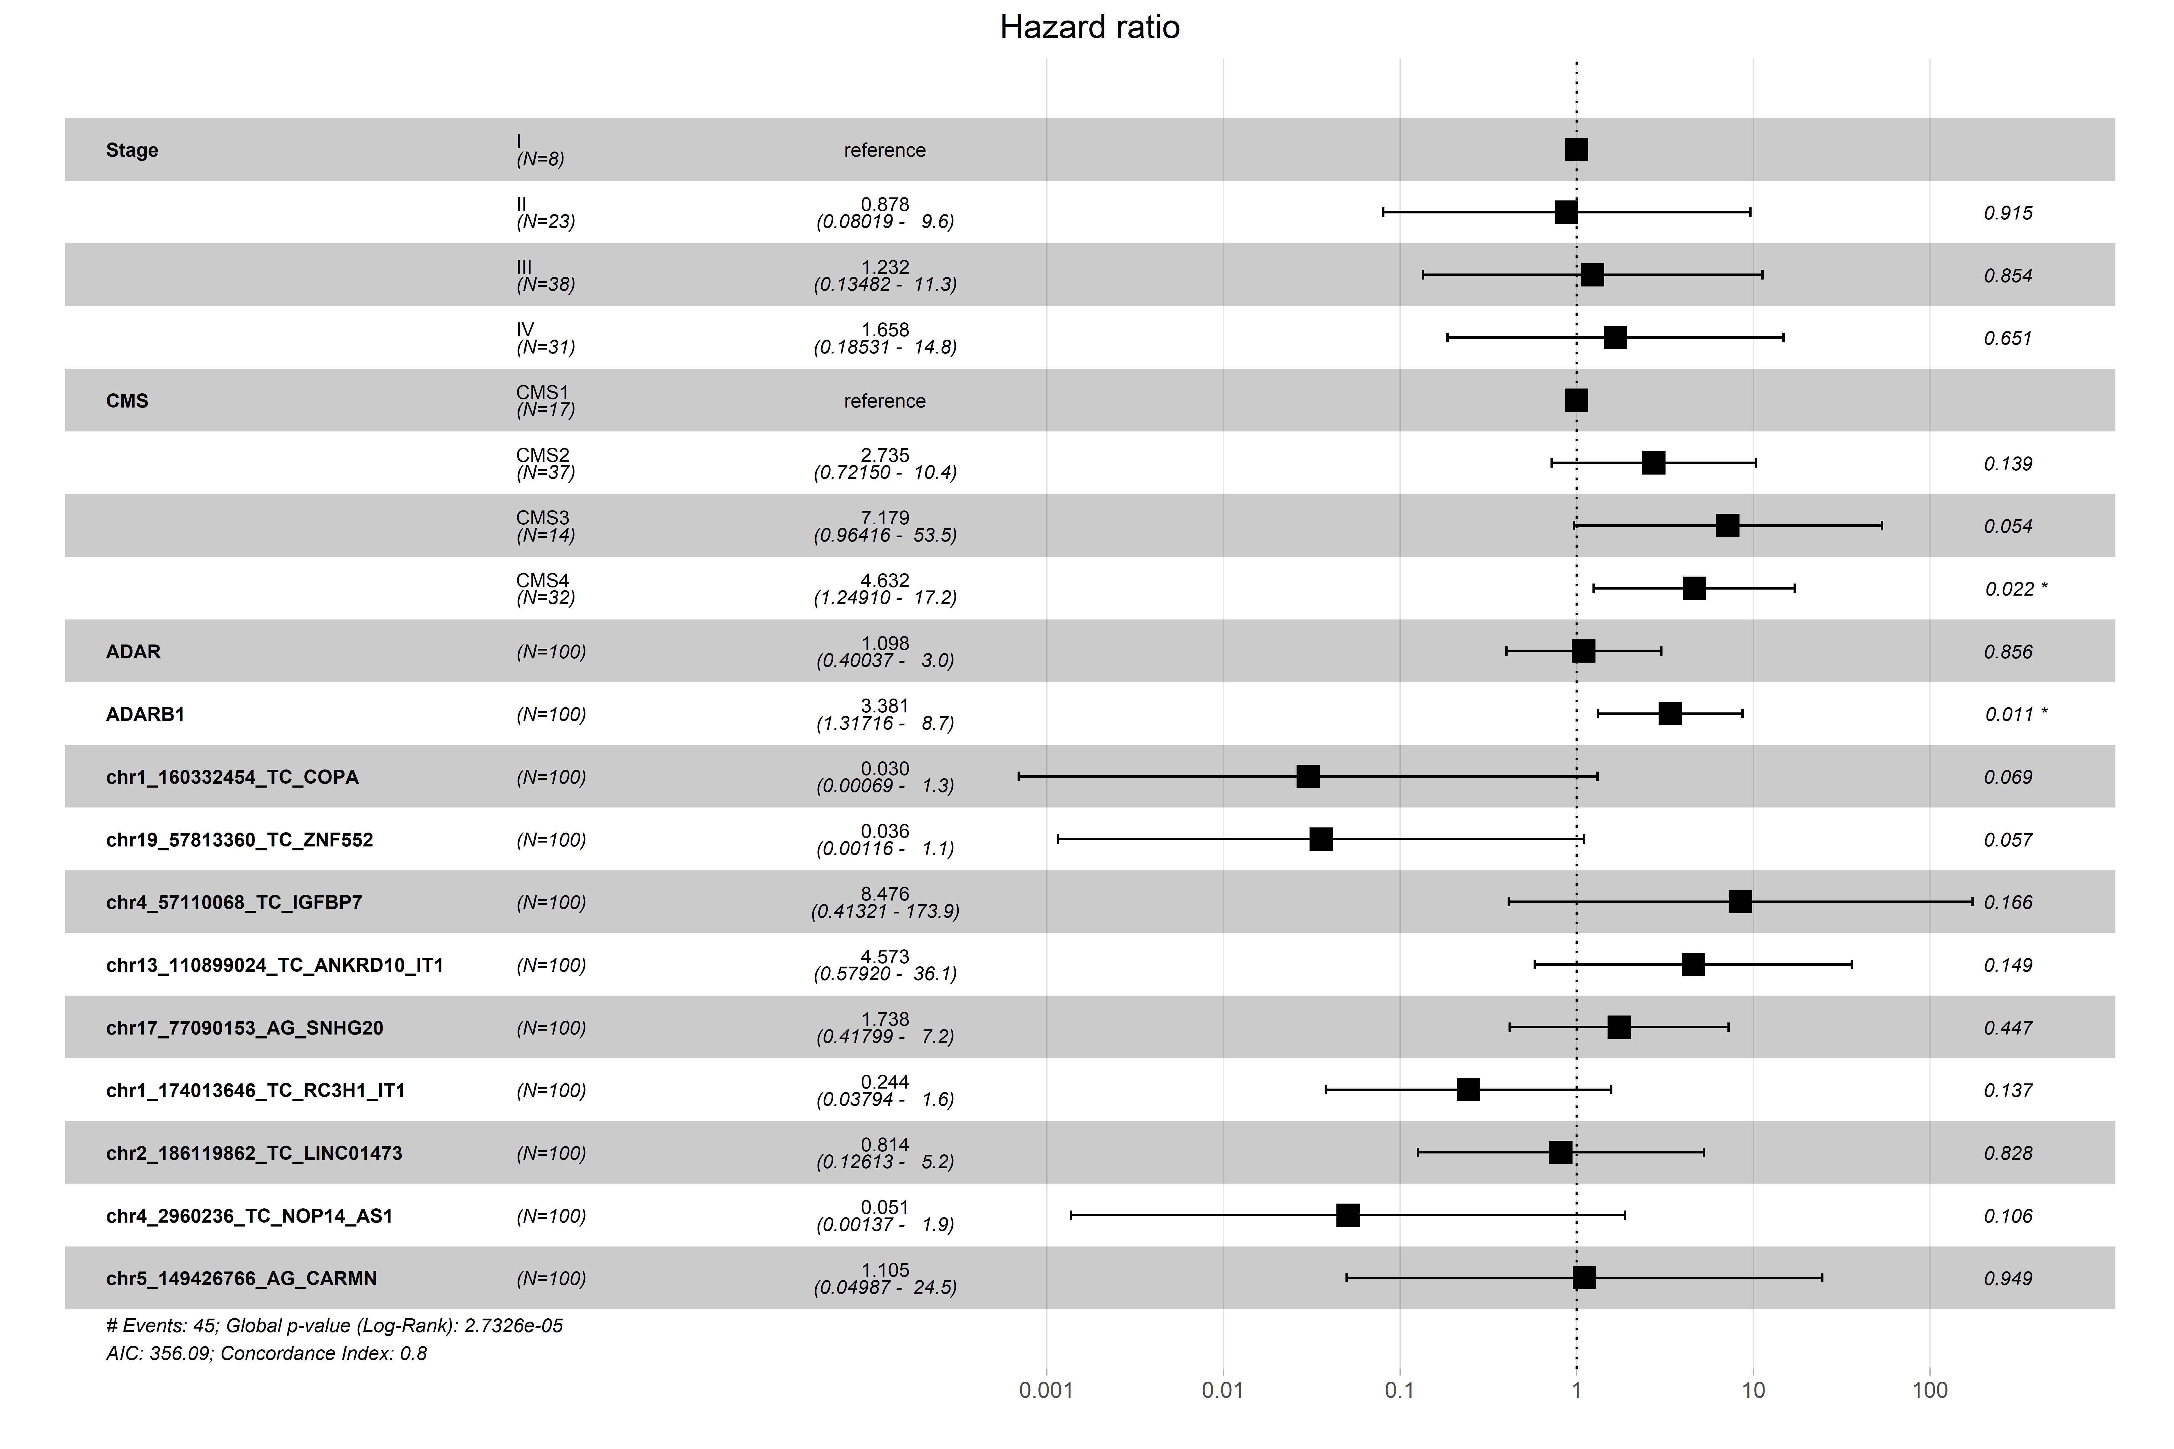
Supplementary 18 Multivariate Cox proportional hazards model based on features selected only variables that present a r < |0.6|.
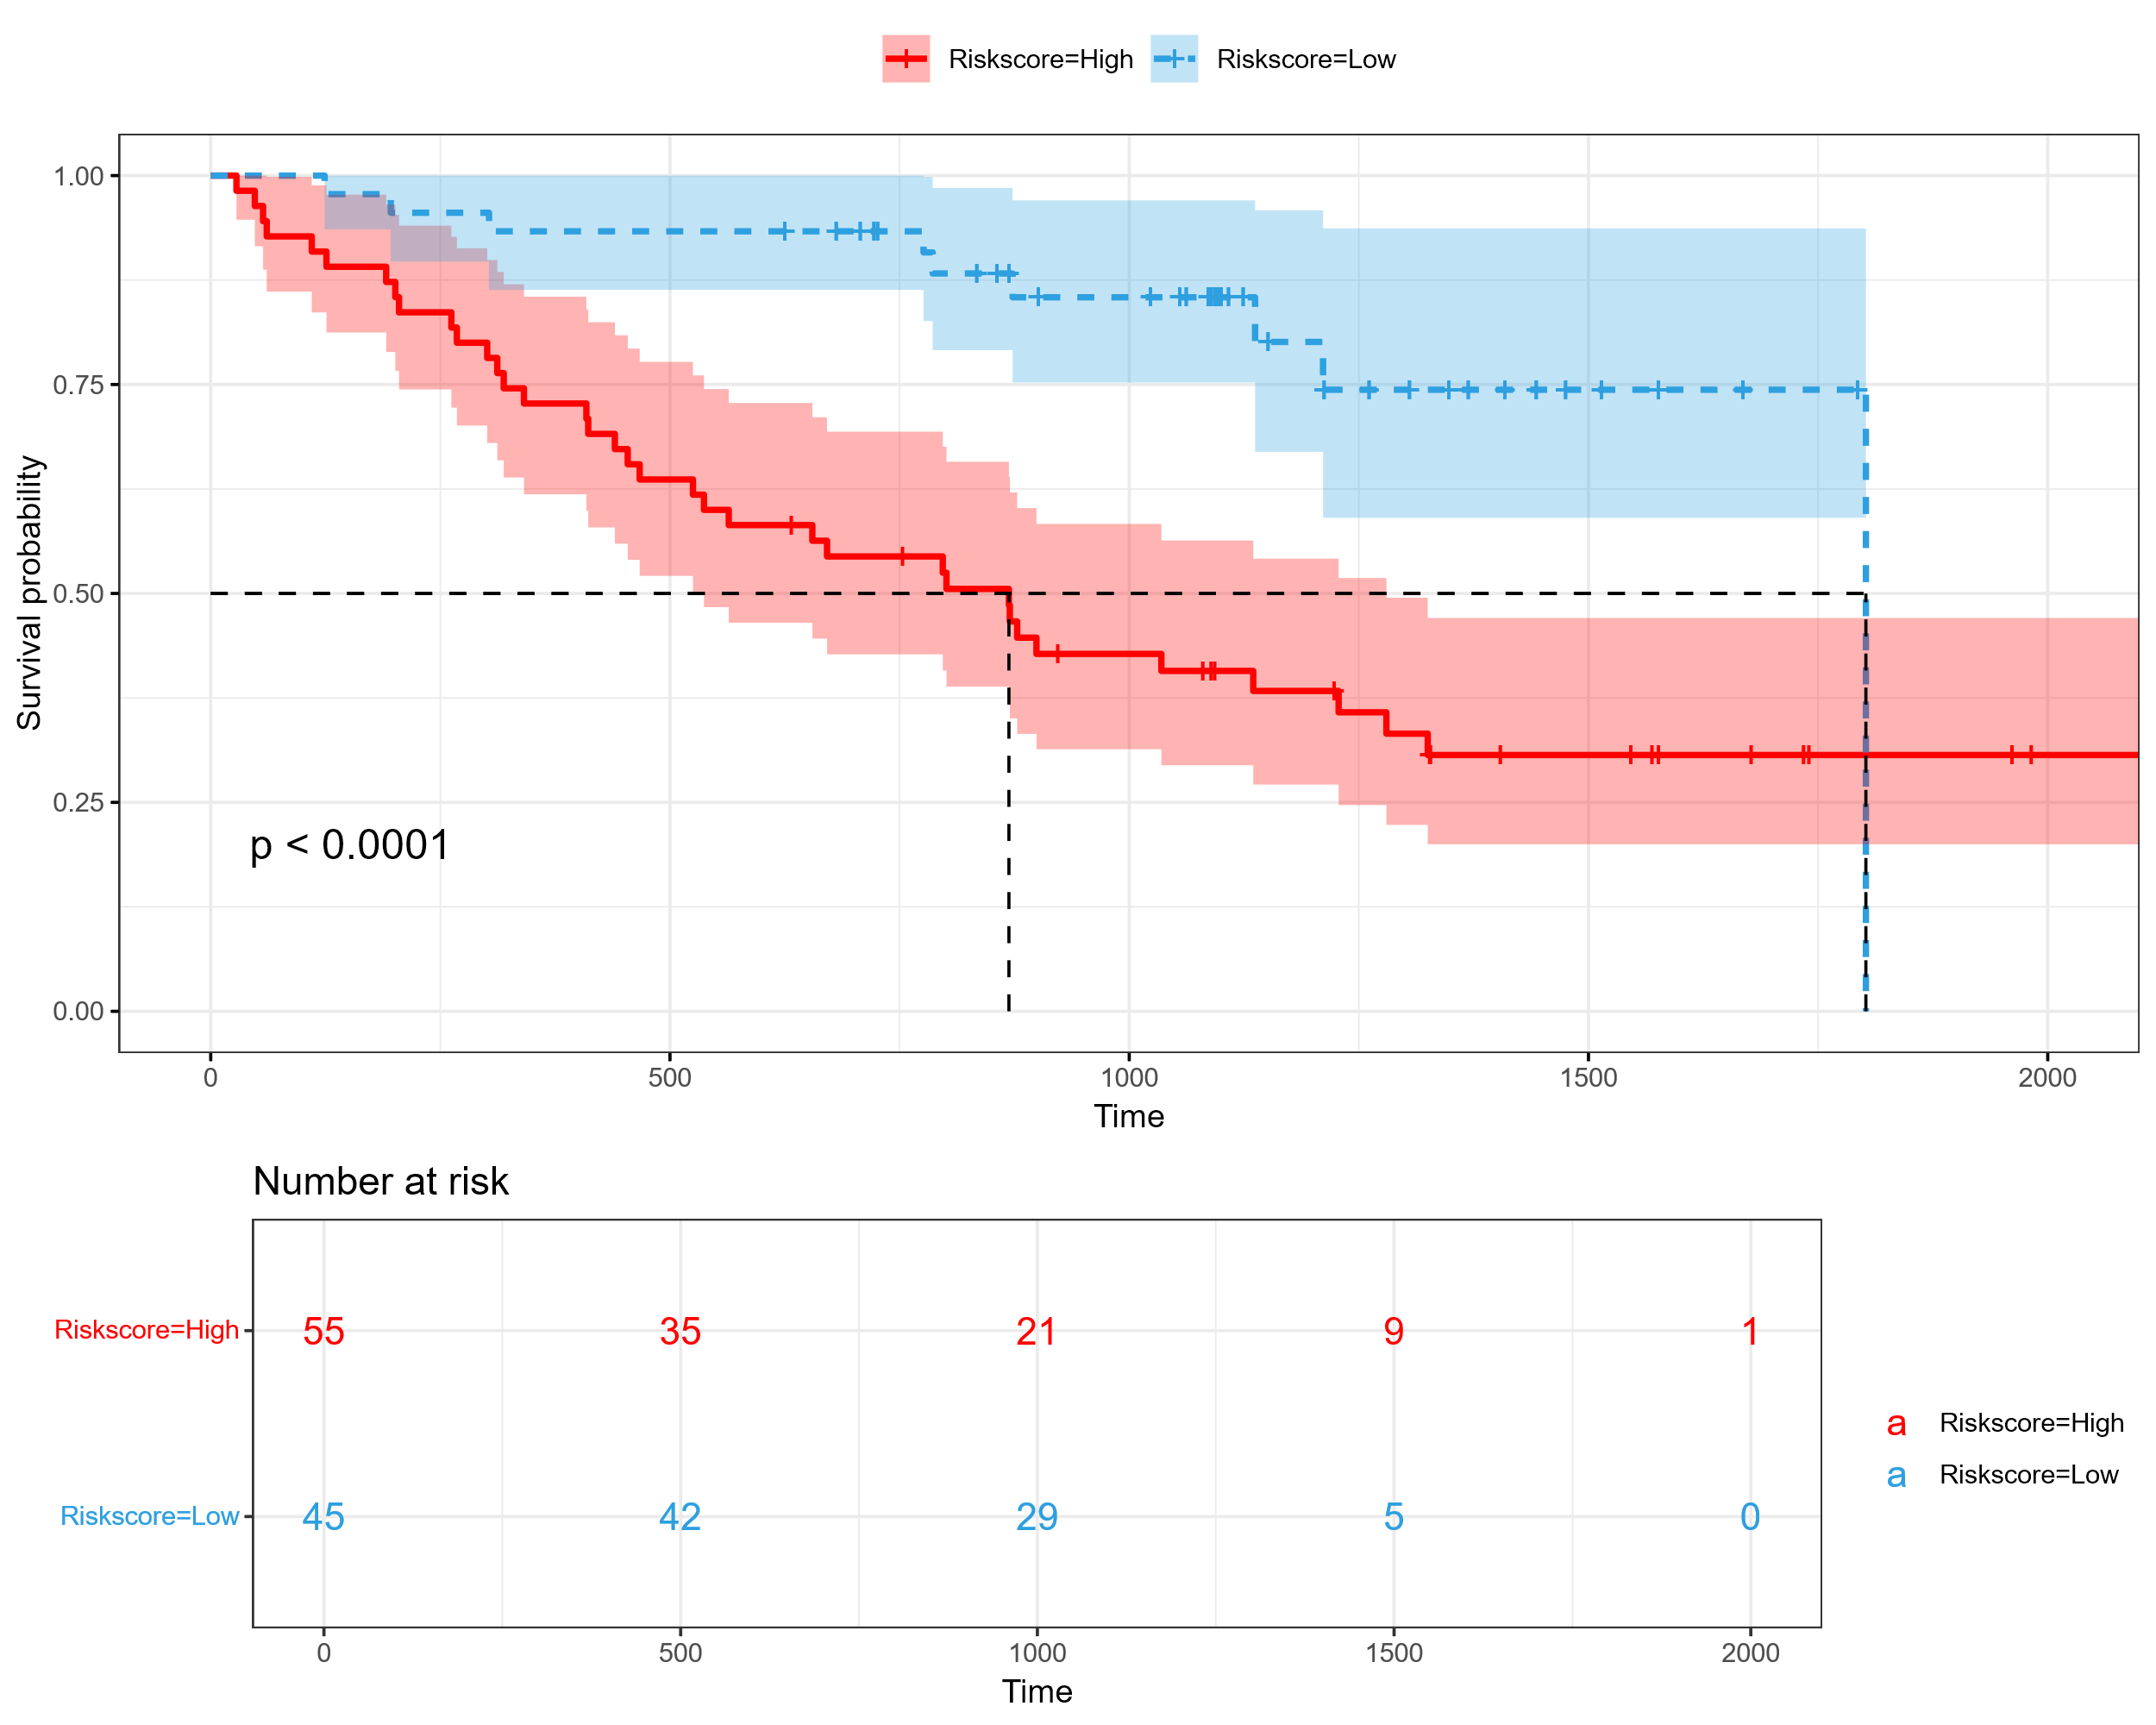
Supplementary 19 illustrates the Kaplan–Meier survival curves stratified by risk score derived from the multivariate Cox model.
Feature Selection: Lasso methods:
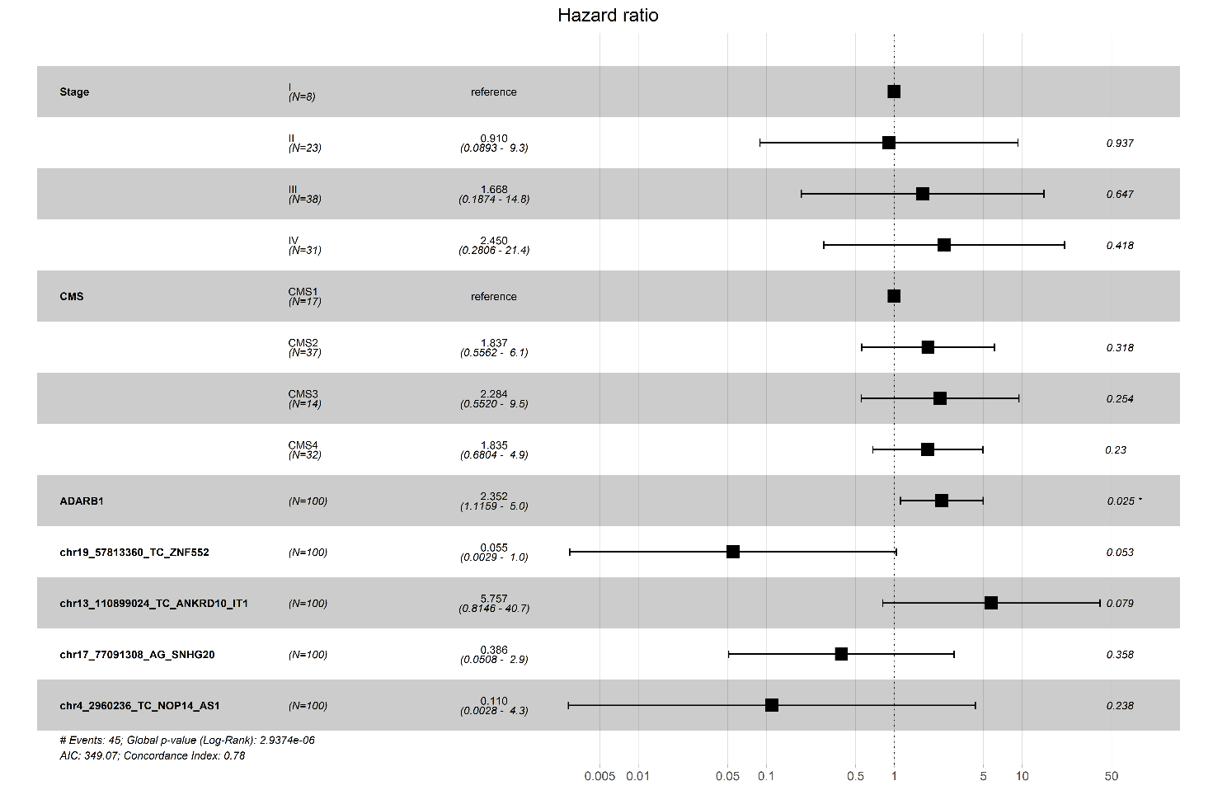
Supplementary 20 Multivariate Cox proportional hazards model based on features selected by Lasso Selection.
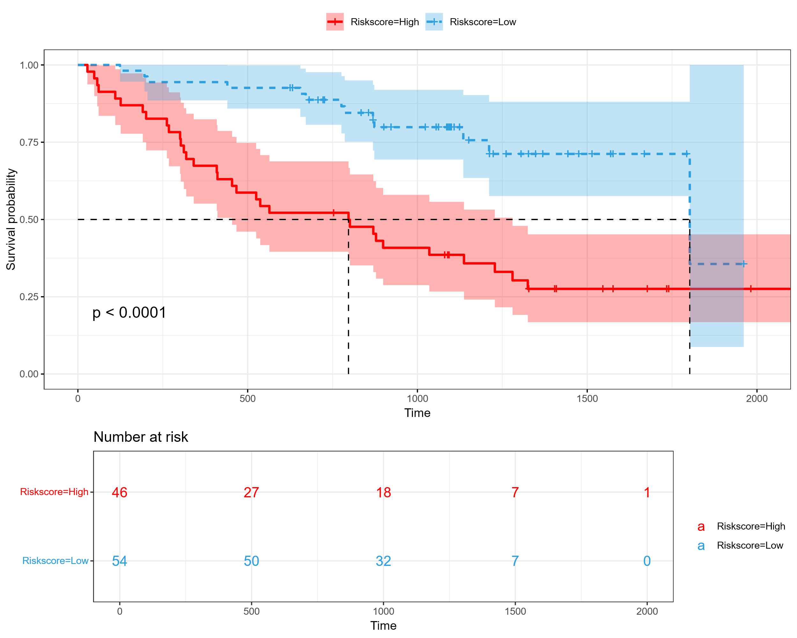
Supplementary 21 illustrates the Kaplan–Meier survival curves stratified by risk score derived from the multivariate Cox model.

