Biogeography of Hydrothermal Vent-Specific Bacterial Community Constrained by Tectonic History and Ocean Oxygenation

Submitted to Nature Geoscience

Table S1 Electron donors and acceptors of isolates in the CAT families
Phylum | Family | Representatives | e- donor | e- acceptor | OGT
Thermosulfidibacterota | Thermosulfidibacteraceae | Thermosulfidibacter takaii | H₂ | S⁰ | 70 ºC ¹
Thermosulfidibacterota | B14-G1 | no cultures
Aquificota | Desulfurobacteriaceae | Phorcysia thermohydrogeniphila | H₂ | S⁰, NO₃⁻ (NH₄⁻) | 75 ºC ²
Aquificota | Desulfurobacteriaceae | Desulfurobacterium atlanticum, Desulfurobacterium pacificum, Desulfurobacterium thermolithotrophum | H₂ | S⁰, S₂O₃²⁻, SO₃²⁻, NO₃⁻ (NH₄⁻) | 70 ºC ^{3,4}
Aquificota | Desulfurobacteriaceae | Thermovibrio amonificans, Thermovibrio guaymasensis, Thermovibrio ruber | H₂ | S⁰, NO₃⁻ (NH₄⁻) | 75 ºC ⁴⁻⁶
Aquificota | Desulfurobacteriaceae | Balnearium lithotrophicum | H₂ | S⁰ | 70-75 ºC ⁷
Aquificota | Hydrogenothermaceae | Persephonella atlantica, Persephonella marina, Persephonella guaymasensis | H₂, S⁰, S₂O₃²⁻ | O₂, NO₃⁻ (N₂) | 65-75 ºC ^{8,9}
Aquificota | Hydrogenothermaceae | Hydrogenothermus marinus | H₂ | O₂ | 45-80 ºC ¹⁰
Aquificota | QOAS01 | no cultures
Aquificota | Aquificaceae | Hydrogenivirga caldilitoris, Hydrogenivirga okinawensis | H₂, S⁰, S₂O₃²⁻ | O₂, NO₃⁻ (N₂O, N₂) | 70-75 ºC ^{11,12}
Aquificota | Aquificaceae | Aquifex pyrophilus, Aquifex aeolicus | H₂, S⁰, S₂O₃²⁻ | S⁰, O₂, NO₃⁻ (N₂) | 85 ºC ^{13,14}
Campylobacterota | Hippeaceae | Hippea maritima, Hippea jasonia, Hippea alviniae | H₂, acetate, ethanol, saturated fatty acids | S⁰ | Shallow, 52-54 ^{15,16}
Campylobacterota | Desulfurellaceae | Desulfurella acetivorans from Kamchatka hot spring, Desulfurella multipotens New Zealand volcanic lake, Desulfurella amilsii from Italy acid river sediment | H₂, acetate, pyruvate | S⁰, S₂O₃²⁻ | 58-60, isolated from none-hydrothermal environments ^{17,18}
Campylobacterota | Nautiliaceae | Nautilia lithotrophica, Nautilia profundicola, Nautilia nitratireducens | H₂, formate | S⁰, SO₃²⁻ (not all species), NO₃⁻ (NH₄⁻, not all species) | Deep, 53 ¹⁹⁻²²
Campylobacterota | Nautiliaceae | Lebetimonas natsushimae, Lebetimonas acidiphila | H₂, formate | S⁰, NO₃⁻ (NH₄⁻, not all species) selenate | Deep, 55 ^{23,24}
Campylobacterota | Nautiliaceae | Caminibacter hydrogeniphilus, Caminibacter profundus, Caminibacter mediatlanticus | H₂ | S⁰, NO₃⁻ (NH₄⁻), O₂ (only by C. profundus) | EPR, 60 ²⁵⁻²⁷
Campylobacterota |  | Cetia pacifica | H₂ | S⁰, NO₃⁻ (NH₄⁻) | Deep, 55-60 ²⁸
Campylobacterota | Nitratiruptoraceae | Nitratiruptor tergarcus, Nitratiruptor labii | H₂ | S⁰, N₂O, NO₃⁻ (N₂), O₂ | Deep, 55 ^{29,30}
Campylobacterota | Nitratiruptoraceae | Nitrosophilus alvini, Nitrosophilus kaiyonis | H₂, S⁰, S₂O₃²⁻ SO₃²⁻ | NO₃⁻ (N₂), N₂O, S₂O₃²⁻, O₂ | Deep EPR, Okinawa 52-55 ^{31,32}
Campylobacterota | Hydrogenimonadaceae | Hydrogenimonas thermophila, Hydrogenimonas urashimensis | H₂ | S⁰, S₂O₃²⁻, NO₃⁻ (NH₄⁻, used by H. thermophila) , O₂ | Mariana, 55 ^{33,34}
Campylobacterota | Sulfurovaceae | Nitratifractor salsuginis | H₂ | NO₃⁻⁻ (N₂), O₂ | Okinawa, 37 ²⁹
Campylobacterota | Sulfurovaceae | Sulfurovum lithotrophicum, Sulfurovum indicum, Sulfurovum aggregans, Sulfurovum denitrificans | H₂, S⁰, H₂S, S₂O₃²⁻ | S⁰, S₂O₃²⁻, NO₃⁻ (N₂), O₂ | Okinawa, 28-30 ³⁵⁻³⁸
Campylobacterota | Sulfurimonadaceae | Sulfurimonas autotrophica, Sulfurimonas indica, Sulfurimonas paralvinellae, Sulfurimonas hydrogeniphila, Sulfurimonas sediminis | H₂, H₂S, S⁰, S₂O₃²⁻ | S⁰, NO₃⁻ (N₂), O₂ | 25-33 ³⁹⁻⁴³

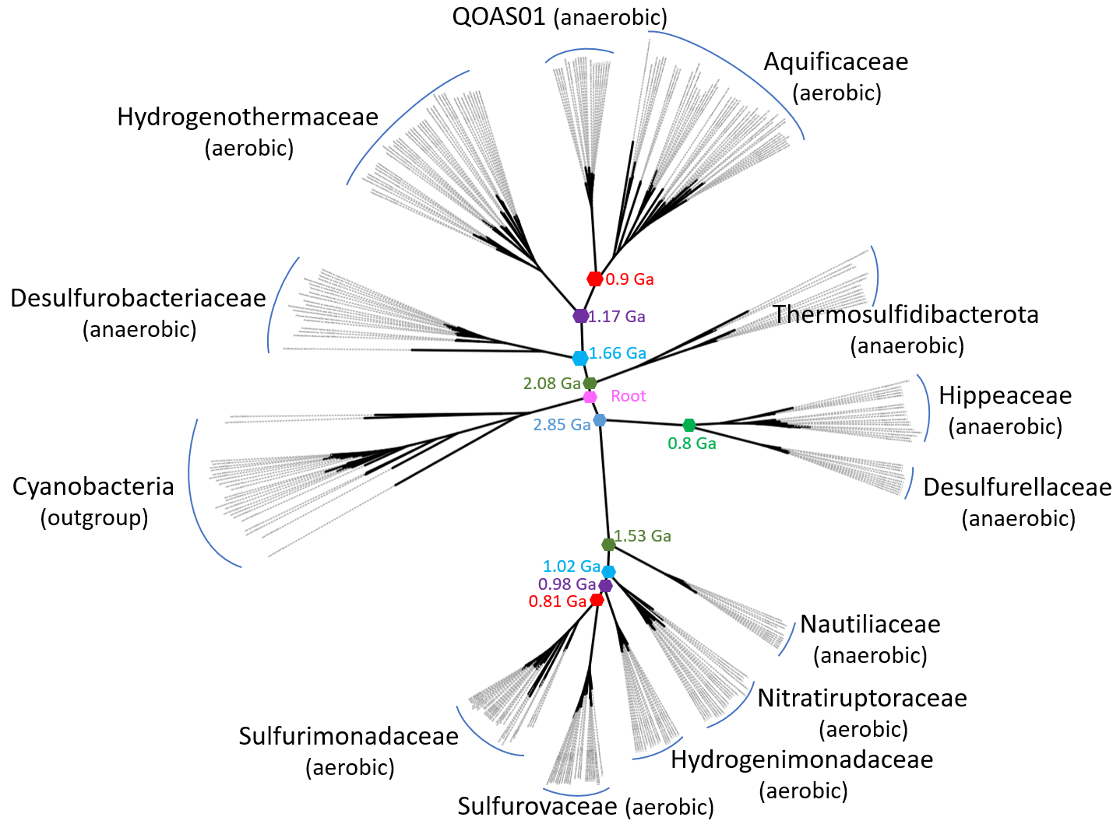

Fig. S1 Phylogenetic relations among the CAT families constructed with 120-concatenated-protein sequences. The divergence times were retrieved from the online TimeTree resource and references therein⁴⁴.

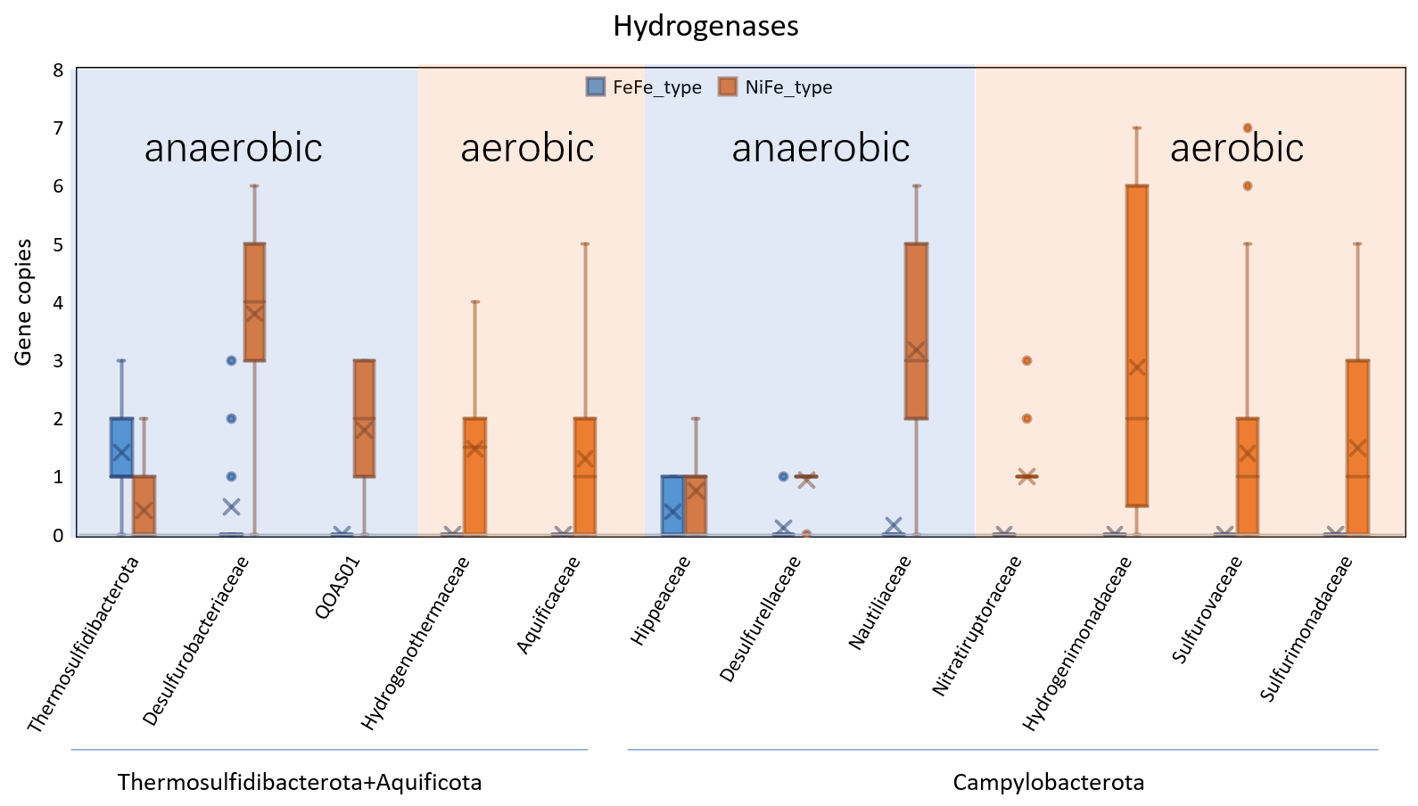

Fig. S2 Box plot showing the distribution of two hydrogenase types in CAT families
Short dashes represent the median number of gene copies; crosses represent the average of gene copies; error bars represent the range of the minimum to maximum values of the gene copies; boxes represent the interquartile range of the gene copies; the dots represent the outliers. Only early-evolved anaerobic taxa (Thermosulfidibacterota, Hippeaceae, Desulfurobacteriaceae, and Desulfurellaceae) contain FeFe-type hydrogenases. The late-evolved both anaerobic and facultatively aerobic taxa (including anaerobic QOAS01, Nautiliceae, and aerobic Hydrogenothermaceae, Aquificaceae, Nitratiruptoraceae, Hydrogenimonadaceae, Sulfurovaceae, and Sulfurimonadaceae) only contained NiFe-type hydrogenases.

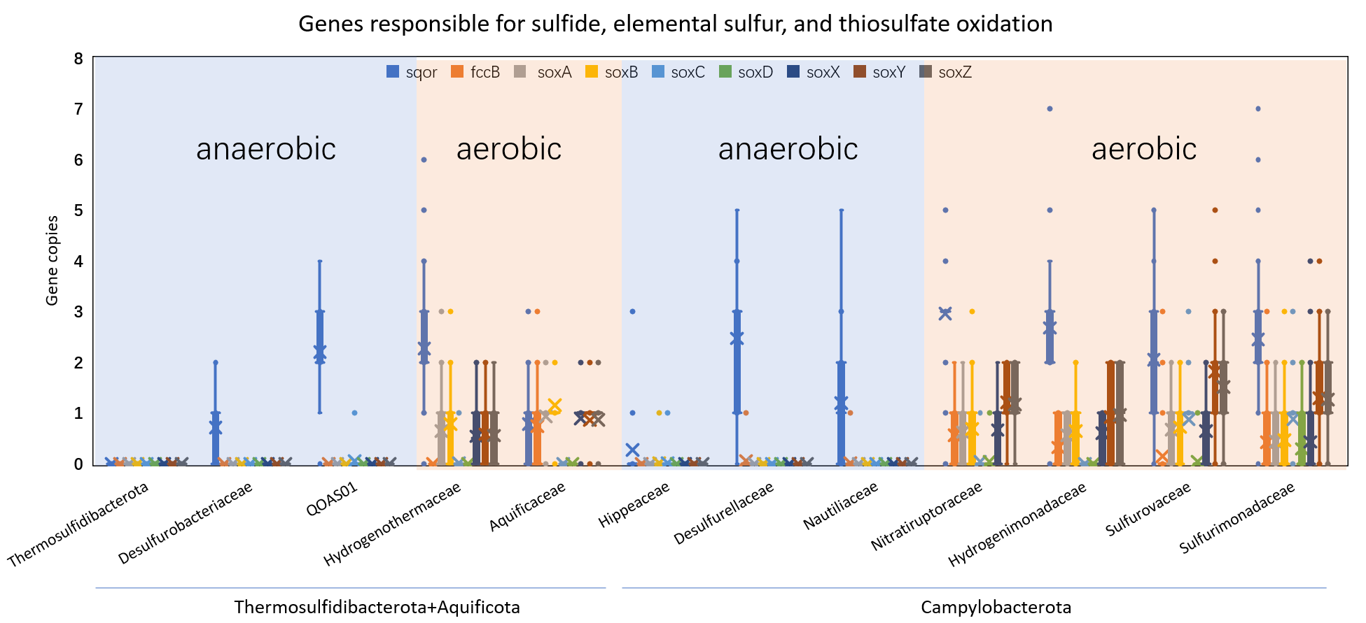

Fig. S3 Box plot showing the sulfur-oxidizing genes distribution in CAT families
Gene sqor (encoding sulfide quinone oxidoreductases) and fccB (encoding Flavocytochrome c sulfide dehydrogenase subunit B) are responsible for the oxidation of sulfide to sulfur. Gene soxC, encoding sulfur dehydrogenases, is responsible for sulfur oxidation. Other sox genes are responsible for the oxidation of thiosulfate. Sulfide-oxidizing genes are universal in the CAT families except for Thermosulfidibacterota and Hippeceae. The sulfur-oxidizing gene is found in the families of Sulfurovaceae and Sulfurimonadaceae. The thiosulfate-oxidizing pathway is present in the facultatively aerobic CAT families.

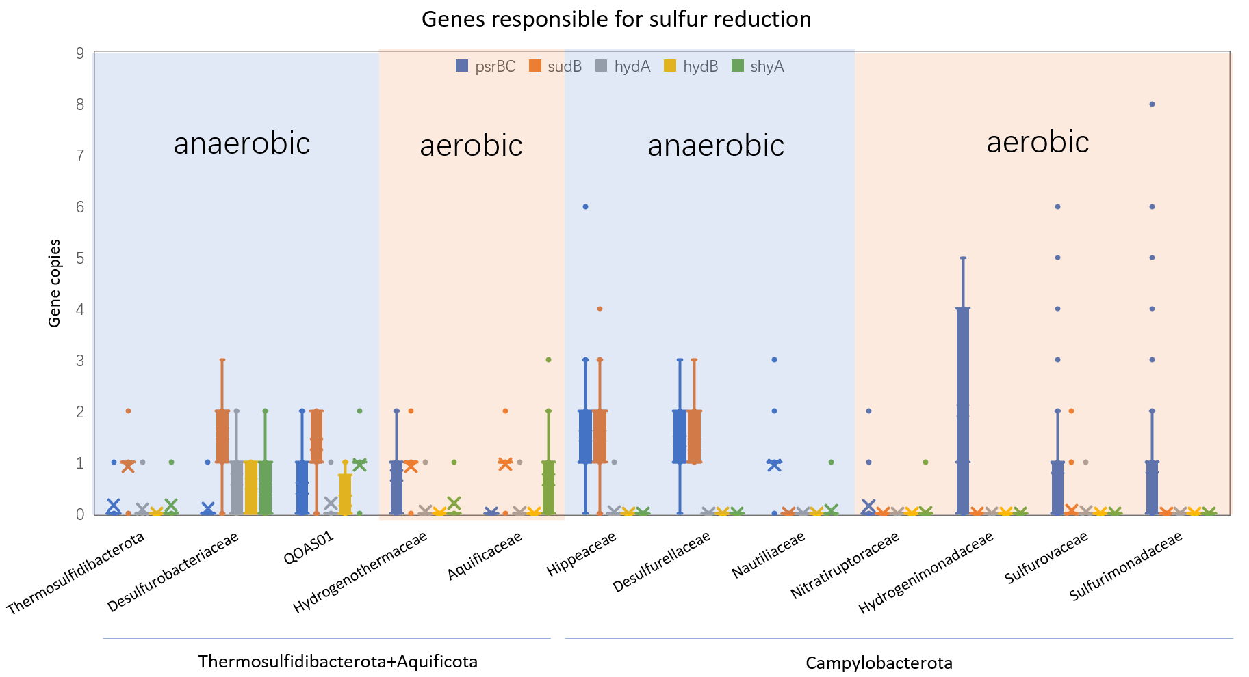

Fig. S4 Box plot showing the sulfur-reducing genes distribution in CAT families
Gene psrBC, encoding quinone reductase, is responsible for polysulfide reduction. Genes sudB, hydAB, and shyA encode enzymes capable of sulfur reduction. Gene psrBC is more common in the phylum Campylobacterota than in the other two phyla. Genes hydAB and shyA occur frequently in the phylum Aquificota.

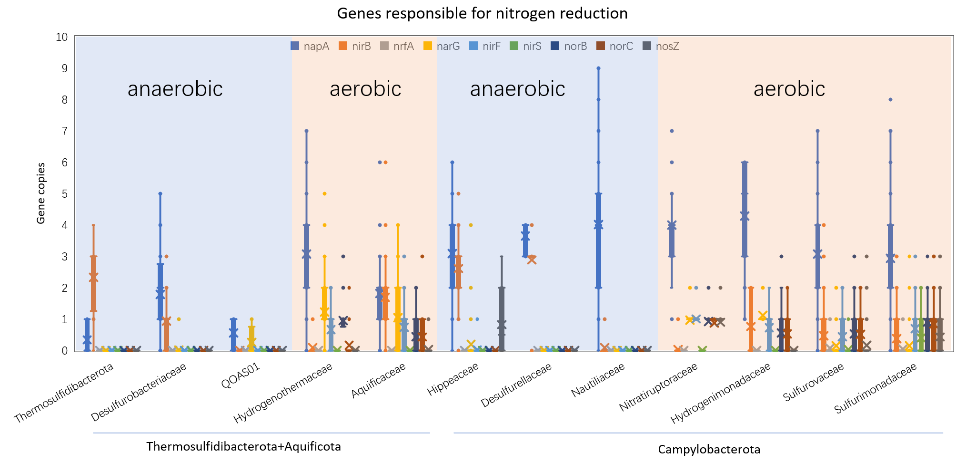

Fig. S5 Box plot showing the nitrate-reduction genes in CAT families
DNRA and denitrification are two pathways related to nitrogen respiration. The gene nirB, as a marker gene for DNRA encoding enzymes for the reduction of nitrite to ammonium, is ubiquitous in early-evolved anaerobic CAT families. The nirF and nirS genes are responsible for nitrite reduction to nitrogen monoxide (NO), which are marker genes of denitrification and are ubiquitous in late-evolved aerobic families.
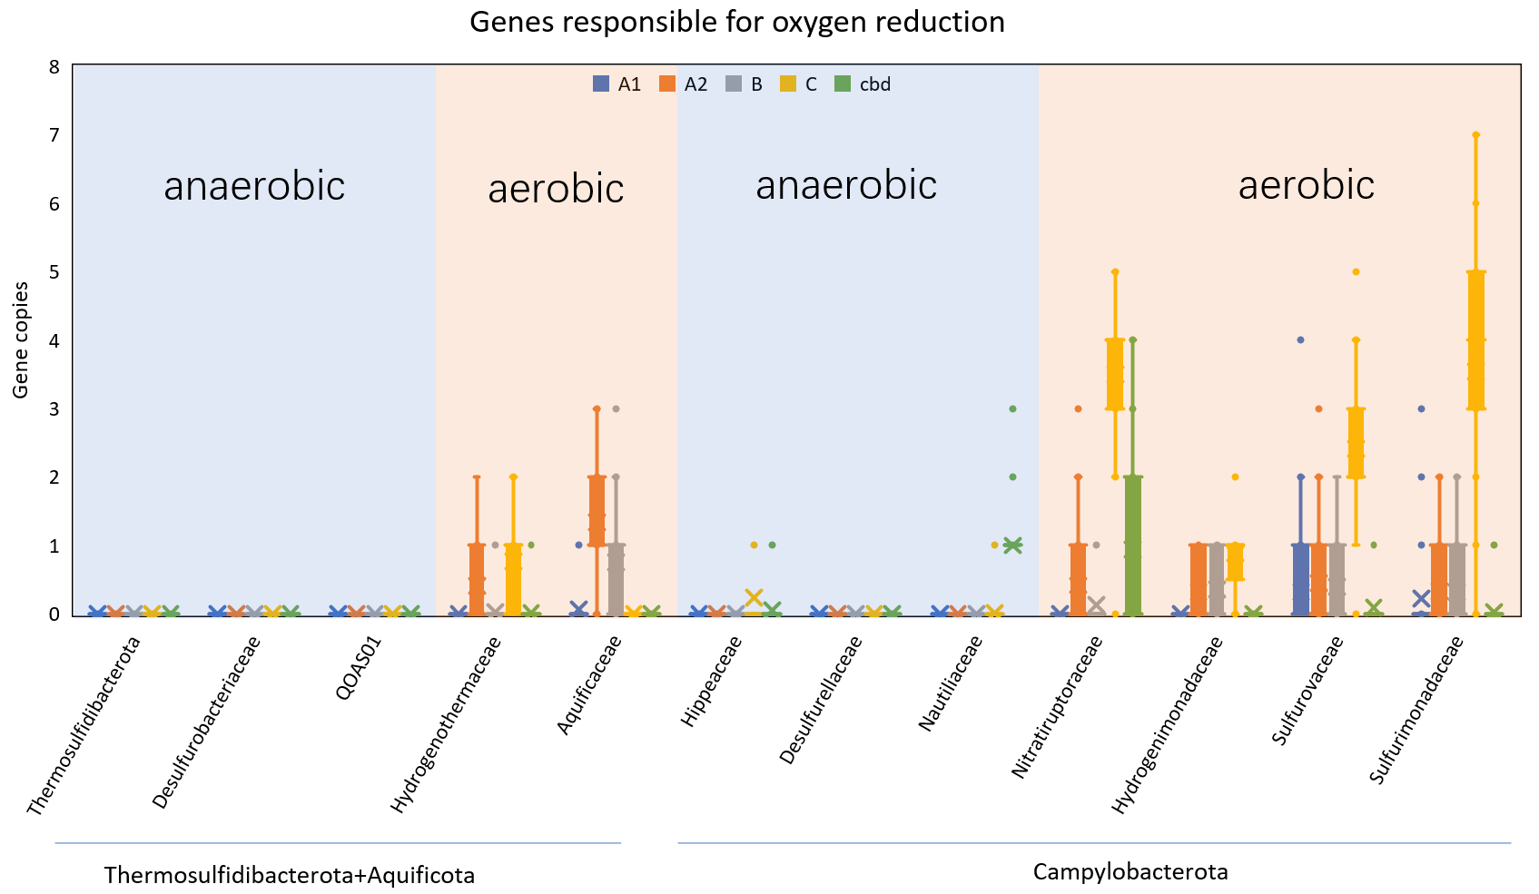

Fig. S6 Box plot showing the oxygen-reduction genes in CAT families
Oxygen reductases are essential enzymes for oxygen respiration. The heme- and copper-containing terminal oxidases (HCOs) superfamily contains most types of oxygen reductases. A1, A2, B, and C types of HCO all occurred in facultatively aerobic CAT families. Cytochrome bd, encoding a non-homologous respiratory quinol:O₂ oxidoreductase to HCOs, the only oxygen reductase in Nautiliaceae, is potentially used for O₂ removal.

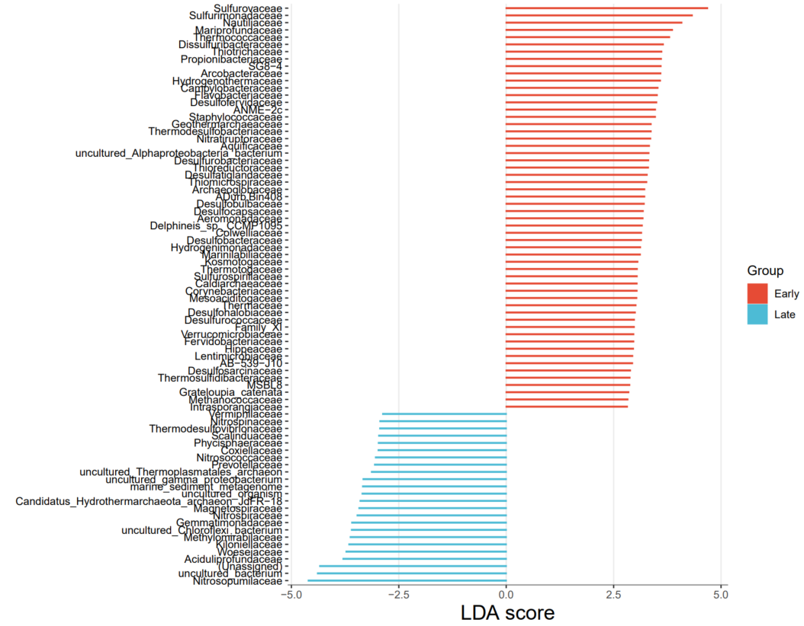

Fig. S7 Histogram of linear discriminant analysis (LDA) showing contrasting relative abundances of hydrothermal microbes between the early-originated oceans (the Pacific Ocean, Arctic Ocean, and Mediterranean Sea) and the late-formed oceans (the Atlantic Ocean, Indian Ocean, and the Red Sea).
The legends “Early” and “Late” denote the microbial communities of the hydrothermal vents from the early oceans and the late oceans, respectively. The “Early” microbes are indicated with a positive LDA score, while the “Late” microbes are indicated with a negative score. The abundances of the taxa affiliated with the CAT phyla, including Aquificaceae, Sulfurovaceae, Sulfurimonadaceae, Nautiliaceae, Hydrogenothermaceae, Desulfurobacteriaceae, B14-G1, Hydrogenimonadaceae, Hippeaceae, Desulfurellaceae, Thermosulfidibacteraceae, and Nitratiruptoraceae, were all higher in the early-originated oceans than those in the late-originated oceans.

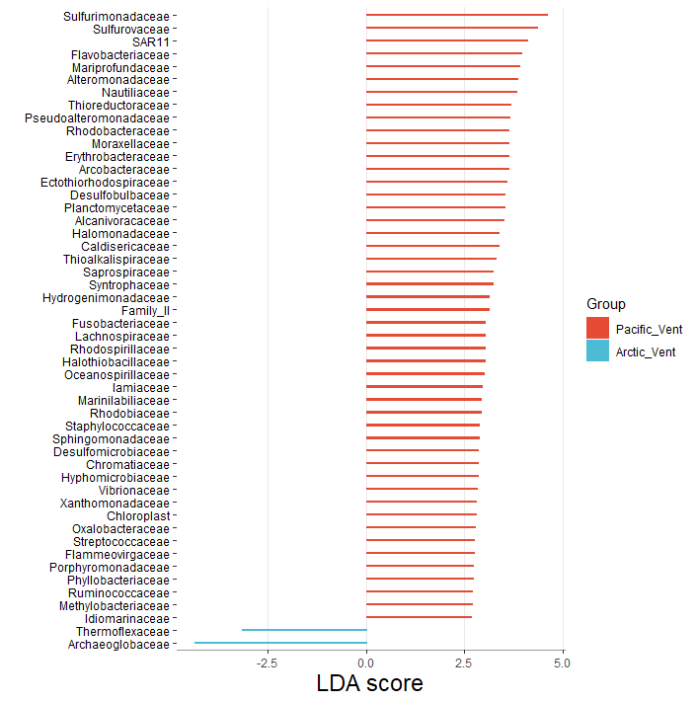

Fig. S8 Histogram of linear discriminant analysis (LDA) showing differential microbial abundance in the Pacific and Arctic Oceans.
The abundances of the taxa affiliated with the CAT phyla, including Sulfurimonadaceae, Sulfurovaceae, Nautiliaceae, and Hydrogenothermaceae, were all higher in the Pacific Ocean than those in the Arctic Ocean.
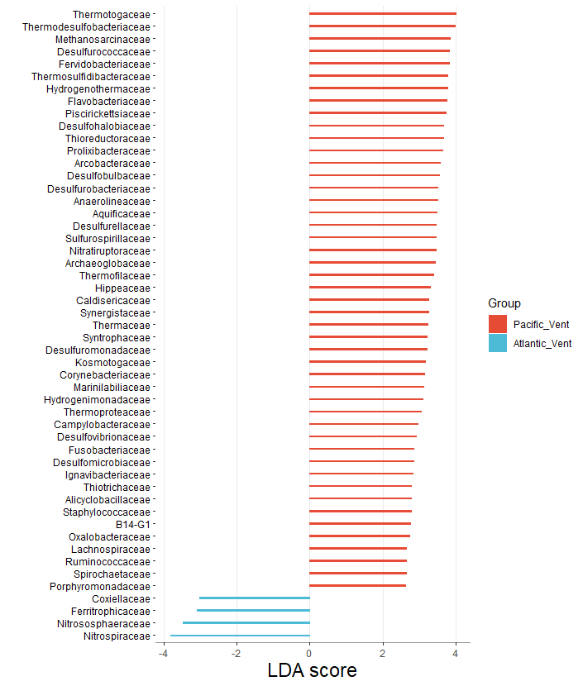

Fig. S9 Histogram of linear discriminant analysis (LDA) showing differential microbial abundance in the Pacific and Atlantic Oceans.
The abundances of the taxa affiliated with the CAT phyla, including Thermosulfidibacteraceae, Hydrogenothermaceae, Desulfurobacteriaceae, Aquificaceae, Desulfurellaceae, Nitratiruptoraceae, Hippeaceae, and B14-G1, were all higher in the Pacific Ocean than those in the Atlantic Ocean.
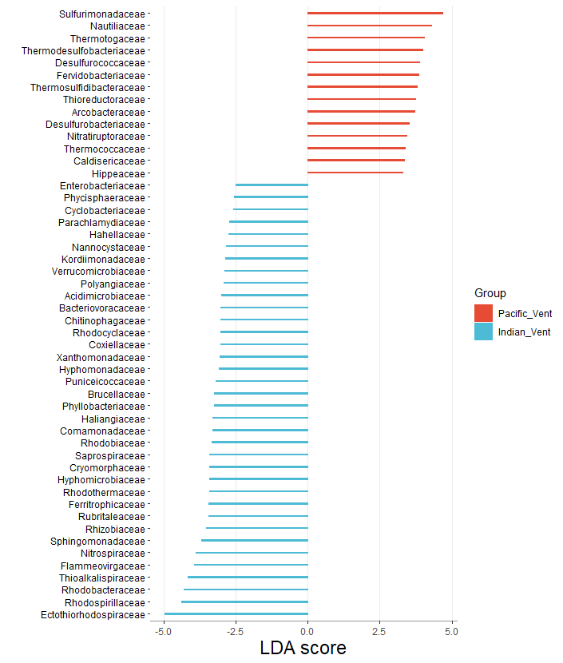

Fig. S10 Histogram of linear discriminant analysis (LDA) showing differential microbial abundance in the Pacific and Indian Oceans.
The abundances of the taxa affiliated with the CAT phyla, including Sulfurimonadaceae, Nautiliaceae, Thermosulfidibacteraceae, Desulfurobacteriaceae, Nitratiruptoraceae, and Hippeaceae, were all higher in the Pacific Ocean than those in the Indian Ocean.
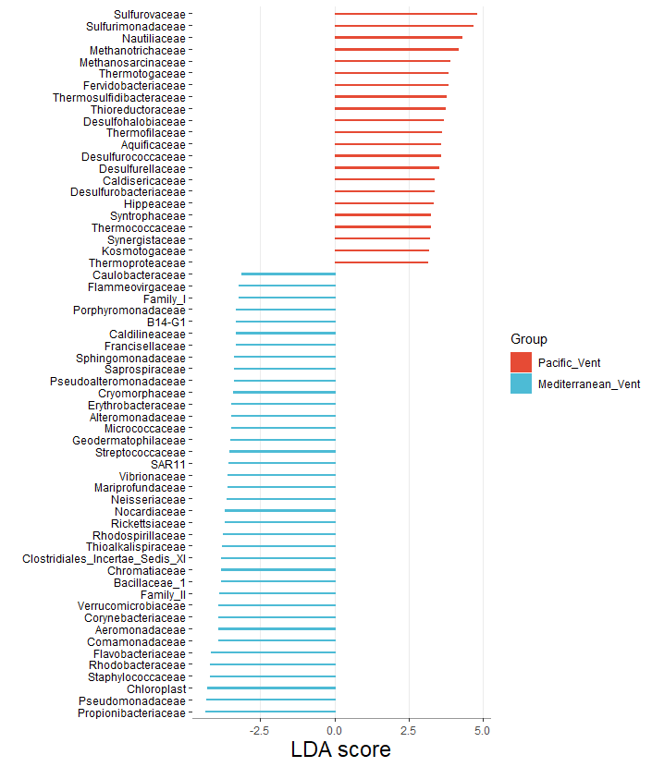

Fig. S11 Histogram of linear discriminant analysis (LDA) showing differential microbial abundance in the Pacific Ocean and Mediterranean Sea.
The abundances of the taxa affiliated with the CAT phyla, including Sulfurovaceae, Sulfurimonadaceae, Nautiliaceae, Thermosulfidibacteraceae, Aquificaceae, Desulfurellaceae, Desulfurobacteriaceae, and Hippeaceae, were all higher in the Pacific Ocean than those in the Mediterranean Sea.
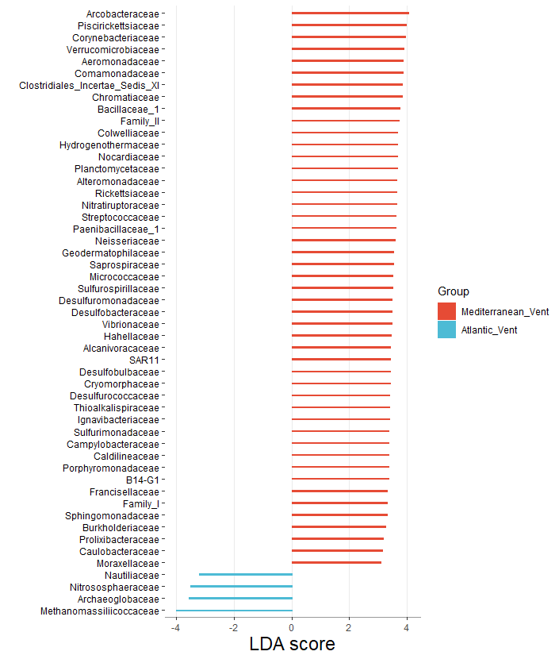

Fig. S12 Histogram of linear discriminant analysis (LDA) showing differential microbial abundance in the Mediterranean Sea and the Atlantic Ocean.
The abundances of the taxa affiliated with the CAT phyla, including Hydrogenothermaceae, Nitratiruptoraceae, Sulfurimonadaceae, and B14-G1, were higher in the Mediterranean Sea than those in the Atlantic Ocean. However, the abundance of Nautiliaceae was higher in the Atlantic Ocean.
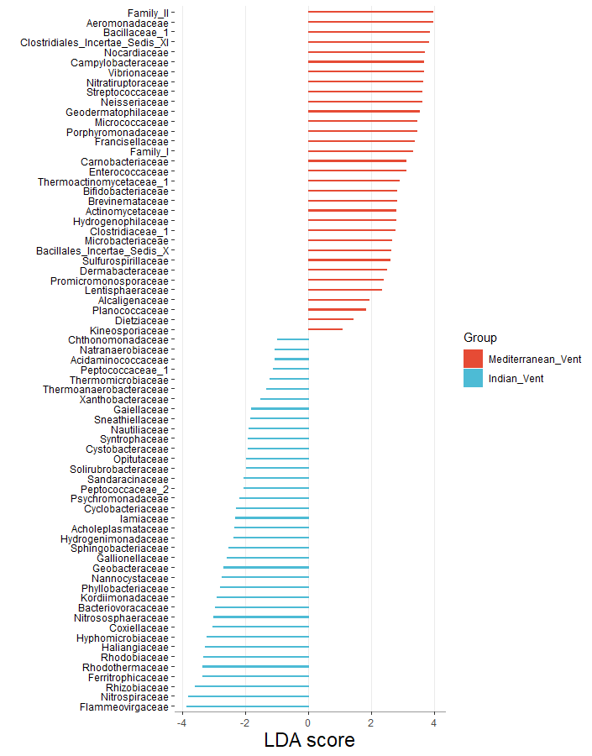

Fig. S13 Histogram of linear discriminant analysis (LDA) showing differential microbial abundance in the Mediterranean Sea and the Indian Ocean.
The abundance of the taxon affiliated with the CAT phyla, i.e., Nitratiruptoraceae, was higher in the Mediterranean Sea than in the Indian Ocean. However the abundances of Hydrogenimonadaceae and Nautiliaceae were higher in the Indian Ocean.
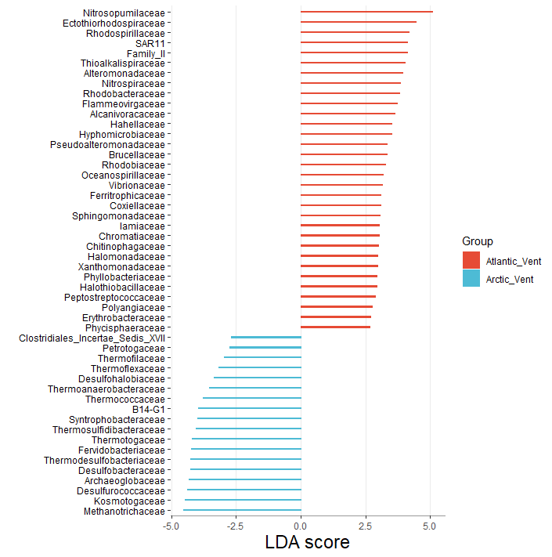

Fig. S14 Histogram of linear discriminant analysis (LDA) showing differential microbial abundance in the Atlantic Ocean and the Arctic Ocean.
The abundances of the taxa affiliated with the CAT phyla, including Desulfurobacteraceae, Thermosulfidibacteraceae, and B14-G1, were all higher in the Arctic Ocean than those in the Atlantic Ocean.
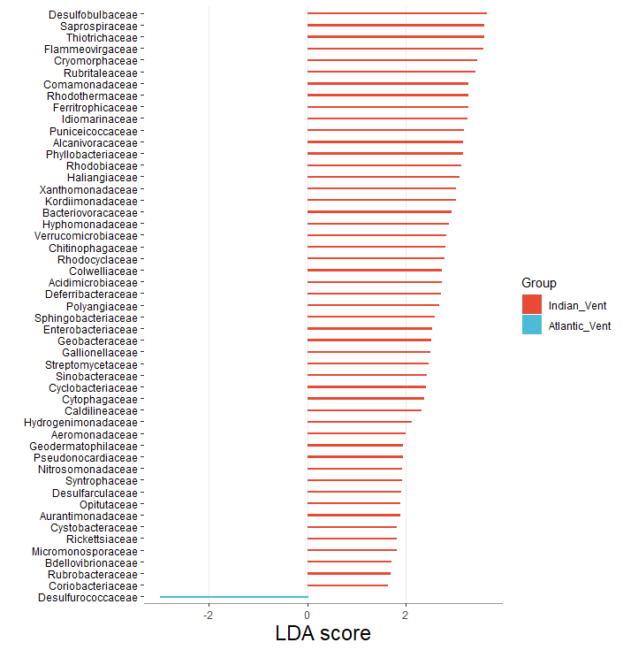

Fig. S15 Histogram of linear discriminant analysis (LDA) showing differential microbial abundance in the Atlantic Ocean and the Indian Ocean.
The abundance of the taxon affiliated with the CAT phyla, i.e., Hydrogenimonadaceae, was higher in the Indian Ocean than in the Atlantic Ocean.
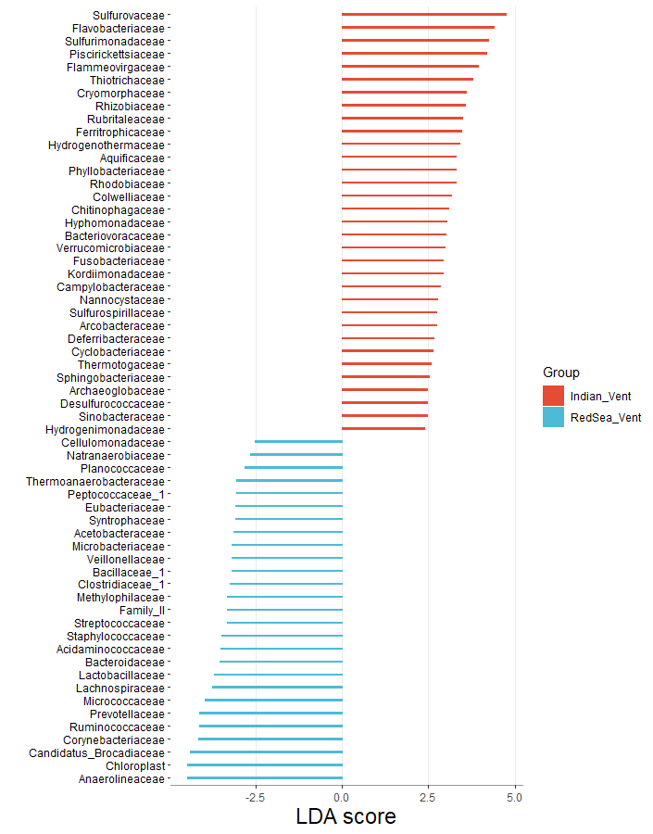

Fig. S16 Histogram of linear discriminant analysis (LDA) showing differential microbial abundance in the Indian Ocean and the Red Sea.
The abundances of the taxa affiliated with the CAT phyla, including Sufurovaceae, Sulfurimonadaceae, Hydrogenothermaceae, and Aquificaceae, were all higher in the Indian Ocean than those in the Red Sea.

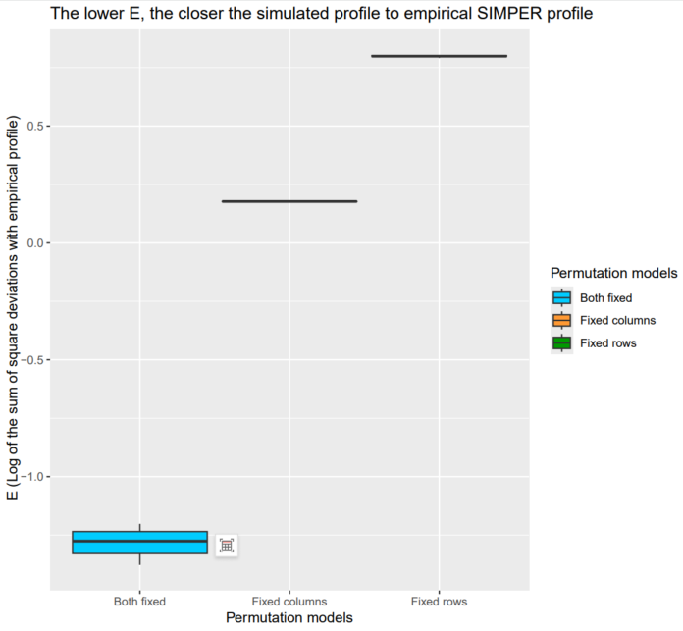

Fig. S17 Box plots of the E-index of the three null PER-SIMPER models (dispersal- and niche-controlled simulation model, dispersal-controlled simulation model, and niche-controlled simulation model) calculated for the microbial community pair-group between the early-originated oceans (the Pacific Ocean, Arctic Ocean, and Mediterranean Sea) and the late-formed oceans (the Atlantic Ocean, Indian Ocean, and the Red Sea)
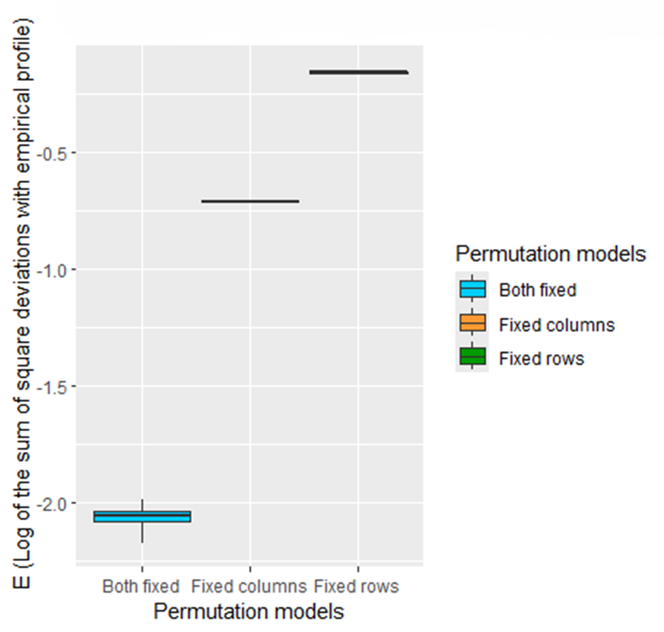

Fig. S18 Box plots of the E-index of the three null PER-SIMPER models (dispersal- and niche-controlled simulation model, dispersal-controlled simulation model, and niche-controlled simulation model) calculated for the microbial community pair-group between the Pacific Ocean and the Arctic Ocean
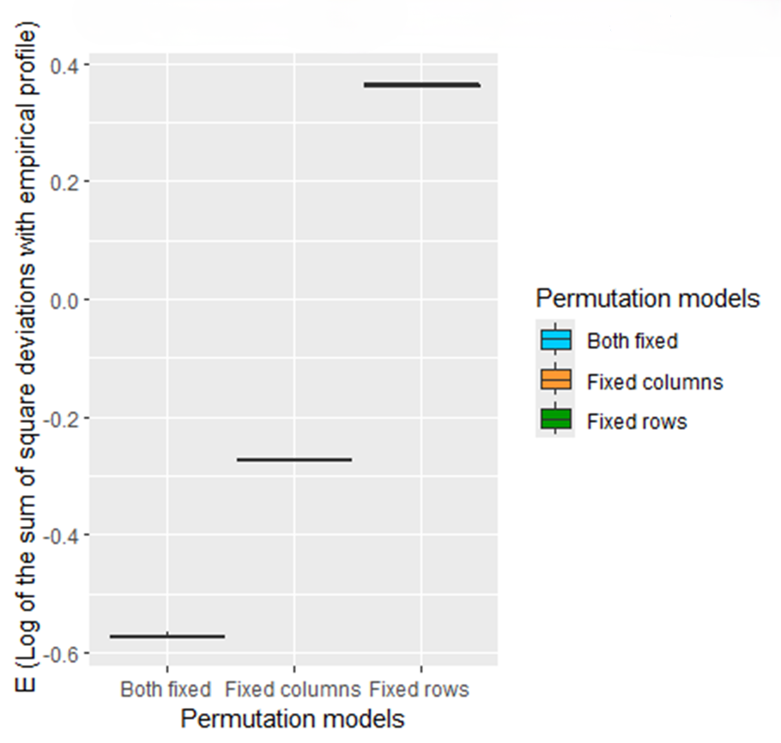

Fig. S19 Box plots of the E-index of the three null PER-SIMPER models (dispersal- and niche-controlled simulation model, dispersal-controlled simulation model, and niche-controlled simulation model) calculated for the microbial community pair-group between the Pacific Ocean and the Atlantic Ocean
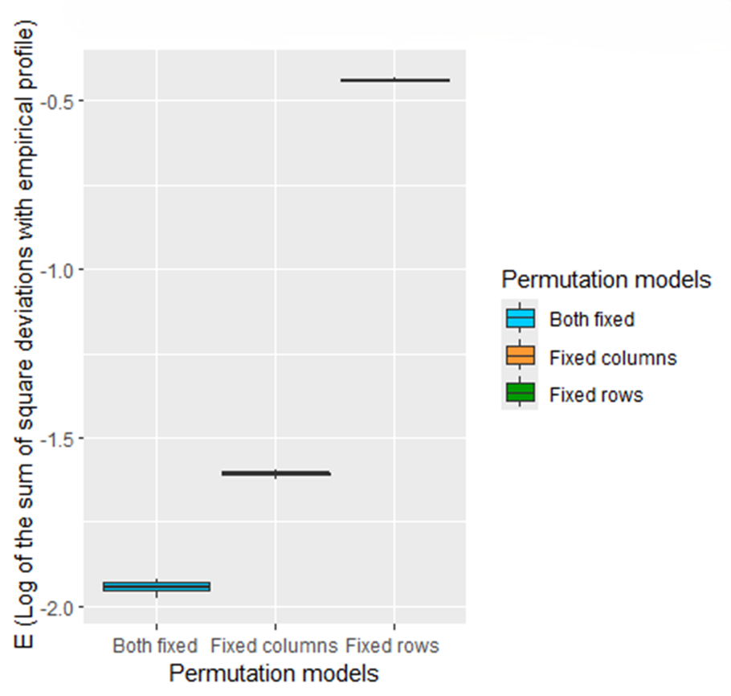

Fig. S20 Box plots of the E-index of the three null PER-SIMPER models (dispersal- and niche-controlled simulation model, dispersal-controlled simulation model, and niche-controlled simulation model) calculated for the microbial community pair-group between the Pacific Ocean and Indian Ocean
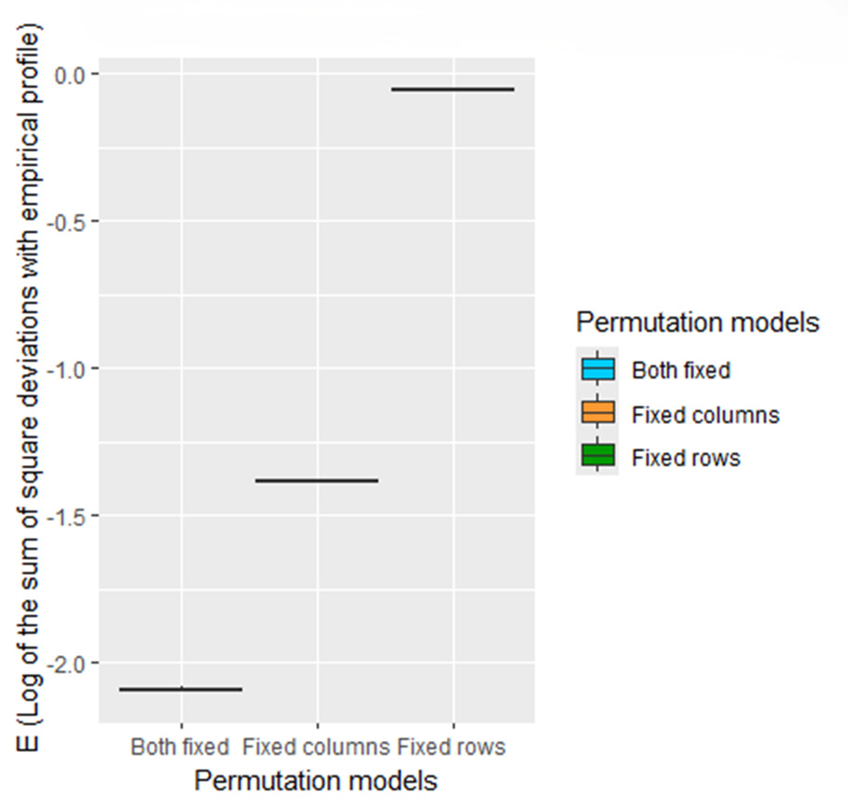

Fig. S21 Box plots of the E-index of the three null PER-SIMPER models (dispersal- and niche-controlled simulation model, dispersal-controlled simulation model, and niche-controlled simulation model) calculated for the microbial community pair-group between the Pacific Ocean, and the Mediterranean Sea
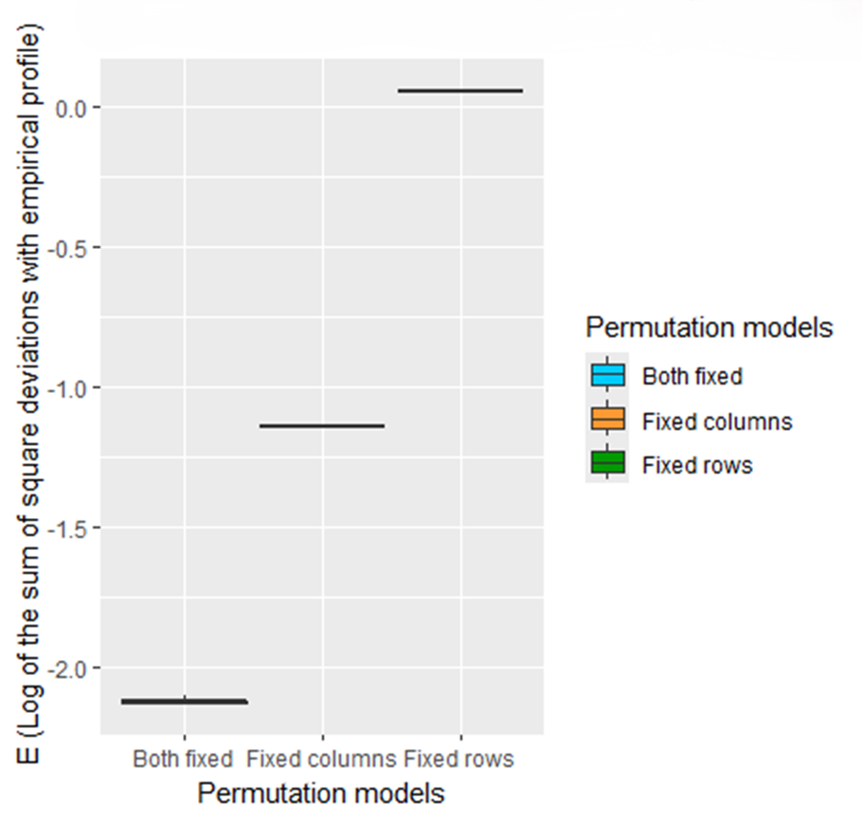

Fig. S22 Box plots of the E-index of the three null PER-SIMPER models (dispersal- and niche-controlled simulation model, dispersal-controlled simulation model, and niche-controlled simulation model) calculated for the microbial community pair-group between the Mediterranean Sea and the Atlantic Ocean
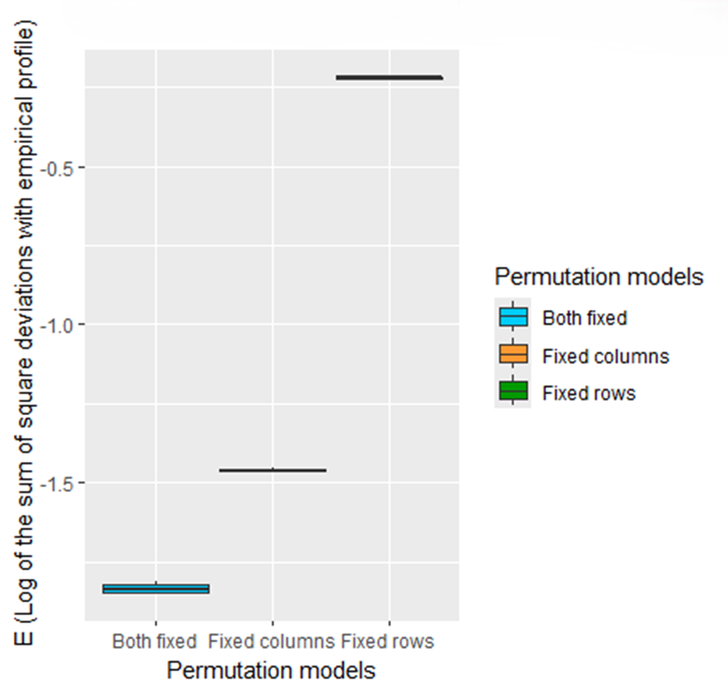

Fig. S23 Box plots of the E-index of the three null PER-SIMPER models (dispersal- and niche-controlled simulation model, dispersal-controlled simulation model, and niche-controlled simulation model) calculated for the microbial community pair-group between the Mediterranean Sea and the Indian Ocean
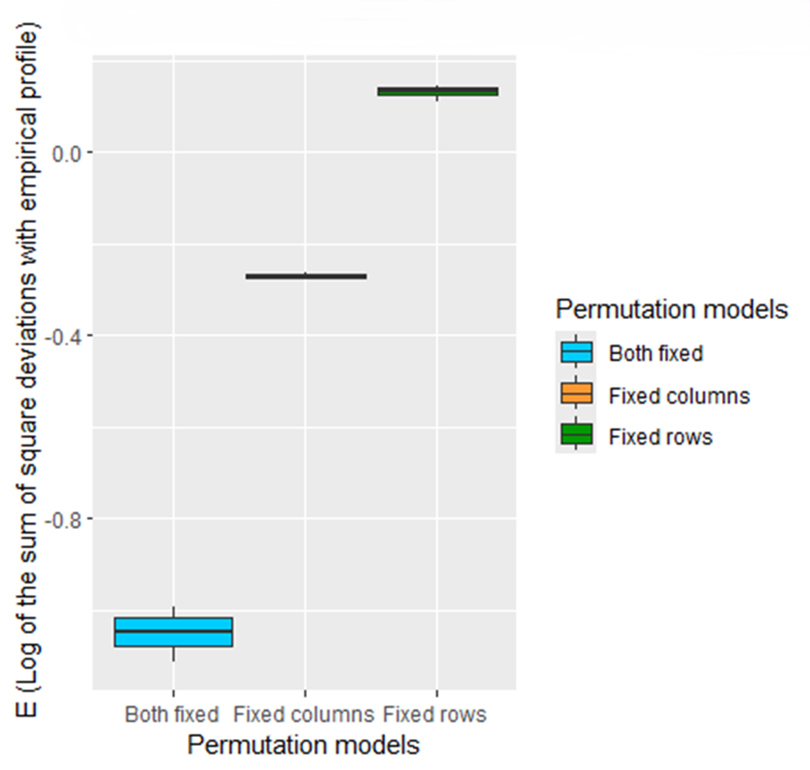

Fig. S24 Box plots of the E-index of the three null PER-SIMPER models (dispersal- and niche-controlled simulation model, dispersal-controlled simulation model, and niche-controlled simulation model) calculated for the microbial community pair-group between the Arctic Ocean and the Atlantic Ocean
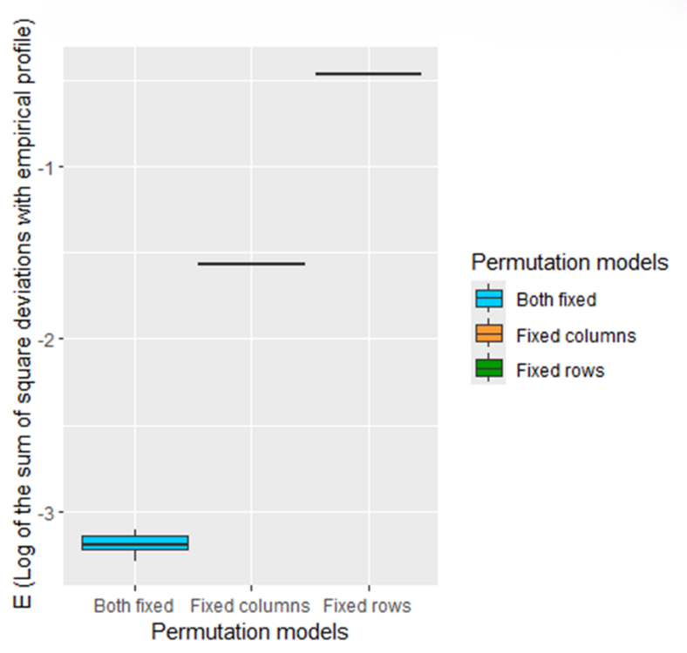

Fig. S25 Box plots of the E-index of the three null PER-SIMPER models (dispersal- and niche-controlled simulation model, dispersal-controlled simulation model, and niche-controlled simulation model) calculated for the microbial community pair-group between the Atlantic Ocean and the Indian Ocean
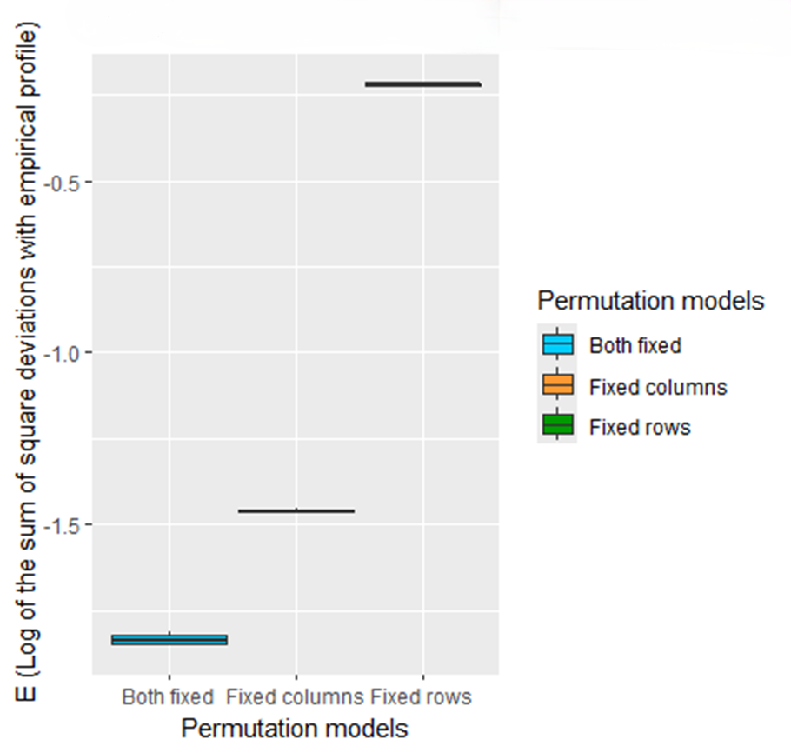

Fig. S26 Box plots of the E-index of the three null PER-SIMPER models (dispersal- and niche-controlled simulation model, dispersal-controlled simulation model, and niche-controlled simulation model) calculated for the microbial community pair-group between the Indian Ocean and the Red Sea

References
1. Nunoura, T., Oida, H., Miyazaki, M. & Suzuki, Y. Thermosulfidibacter takaii gen. nov., sp. nov., a thermophilic, hydrogen-oxidizing, sulfur-reducing chemolithoautotroph isolated from a deep-sea hydrothermal field in the Southern Okinawa Trough. Int. J. Syst. Evol. Microbiol. 58, 659-665 (2008).
2. Perez-Rodriguez, I. et al. Phorcysia thermohydrogeniphila gen. nov., sp. nov., a thermophilic, chemolithoautotrophic, nitrate-ammonifying bacterium from a deep-sea hydrothermal vent. Int. J. Syst. Evol. Microbiol. 62, 2388-2394 (2012).
3. L’Haridon, S. et al. Desulfurobacterium thermolithotrophum gen. nov., sp. nov., a novel autotrophic, sulphur-reducing bacterium isolated from a deep-sea hydrothermal vent. International Journal of Systematic and Evolutionary Microbiology 48, 701-711 (1998).
4. L'Haridon, S. et al. Desulfurobacterium atlanticum sp. nov., Desulfurobacterium pacificum sp. nov. and Thermovibrio guaymasensis sp. nov., three thermophilic members of the Desulfurobacteriaceae fam. nov., a deep branching lineage within the Bacteria. Int J Syst Evol Microbiol 56, 2843-2852 (2006).
5. Vetriani, C., Speck, M.D., Ellor, S.V., Lutz, R.A. & Starovoytov, V. Thermovibrio ammonificans sp. nov., a thermophilic, chemolithotrophic, nitrate-ammonifying bacterium from deep-sea hydrothermal vents. Int J Syst Evol Microbiol 54, 175-181 (2004).
6. Huber, H., Diller, S., Horn, C. & Rachel, R. Thermovibrio ruber gen. nov., sp. nov., an extremely thermophilic, chemolithoautotrophic, nitrate-reducing bacterium that forms a deep branch within the phylum Aquificae. International Journal of Systematic and Evolutionary Microbiology 52, 1859-1865 (2002).
7. Takai, K., Nakagawa, S., Sako, Y. & Horikoshi, K. Balnearium lithotrophicum gen. nov., sp. nov., a novel thermophilic, strictly anaerobic, hydrogen-oxidizing chemolithoautotroph isolated from a black smoker chimney in the Suiyo Seamount hydrothermal system. Int. J. Syst. Evol. Microbiol. 53, 1947-1954 (2003).
8. François, D.X. et al. Persephonella atlantica sp. nov.: How to adapt to physico-chemical gradients in high temperature hydrothermal habitats. Systematic and Applied Microbiology 44, 126176 (2021).
9. Gotz, D. et al. Persephonella marina gen. nov., sp. nov. and Persephonella guaymasensis sp. nov., two novel, thermophilic, hydrogen-oxidizing microaerophiles from deep-sea hydrothermal vents. International Journal of Systematic and Evolutionary Microbiology 52, 1349-1359 (2002).
10. Stohr, R., Waberski, A., Völker, H., Tindall, B.J. & Thomm, M. Hydrogenothermus marinus gen. nov., sp. nov., a novel thermophilic hydrogen-oxidizing bacterium, recognition of Calderobacterium hydrogenophilum as a member of the genus Hydrogenobacter and proposal of the reclassification of Hydrogenobacter acidophilus as Hydrogenobaculum acidophilum gen. nov., comb. nov., in the phylum'Hydrogenobacter/Aquifex'. International journal of systematic and evolutionary microbiology 51, 1853-1862 (2001).
11. Nunoura, T., Miyazaki, M., Suzuki, Y., Takai, K. & Horikoshi, K. Hydrogenivirga okinawensis sp. nov., a thermophilic sulfur-oxidizing chemolithoautotroph isolated from a deep-sea hydrothermal field, Southern Okinawa Trough. International Journal of Systematic and Evolutionary Microbiology 58, 676-681 (2008).
12. Nakagawa, S. et al. Hydrogenivirga caldilitoris gen. nov., sp. nov., a novel extremely thermophilic, hydrogen- and sulfur-oxidizing bacterium from a coastal hydrothermal field. International Journal of Systematic and Evolutionary Microbiology 54, 2079-2084 (2004).
13. Huber, R. et al. Aquifex pyrophilus gen. nov. sp. nov., Represents a Novel Group of Marine Hyperthermophilic Hydrogen-Oxidizing Bacteria. Systematic and Applied Microbiology 15, 340-351 (1992).
14. Guiral, M. & Giudici-Orticoni, M.-T. Microbe Profile: Aquifex aeolicus: an extreme heat-loving bacterium that feeds on gases and inorganic chemicals. Microbiology 167(2021).
15. Miroshnichenko, M.L., Rainey, F.A., Rhode, M. & Bonch-Osmolovskaya, E.A. Hippea maritima gen. nov., sp. nov., a new genus of thermophilic, sulfur-reducing bacterium from submarine hot vents. Int J Syst Bacteriol 49 Pt 3, 1033-8 (1999).
16. Flores, G.E. et al. Hippea jasoniae sp. nov. and Hippea alviniae sp. nov., thermoacidophilic members of the class Deltaproteobacteria isolated from deep-sea hydrothermal vent deposits. International Journal of Systematic and Evolutionary Microbiology 62, 1252-1258 (2012).
17. Miroshnichenko, M.L., Gongadze, G.A., Lysenko, A.M. & Bonch-Osmolovskaya, E.A. Desulfurella multipotens sp. nov., a new sulfur-respiring thermophilic eubacterium from Raoul Island (Kermadec archipelago, New Zealand). Archives of Microbiology 161, 88-93 (1994).
18. Florentino, A.P., Brienza, C., Stams, A.J.M. & Sánchez-Andrea, I. Desulfurella amilsii sp. nov., a novel acidotolerant sulfur-respiring bacterium isolated from acidic river sediments. Int J Syst Evol Microbiol 66, 1249-1253 (2016).
19. Miroshnichenko, M.L. et al. Nautilia lithotrophica gen. nov., sp. nov., a thermophilic sulfur-reducing epsilon-proteobacterium isolated from a deep-sea hydrothermal vent. Int. J. Syst. Evol. Microbiol. 52, 1299-1304 (2002).
20. Smith, J.L., Campbell, B.J., Hanson, T.E., Zhang, C.L. & Cary, S.C. Nautilia profundicola sp. nov., a thermophilic, sulfur-reducing epsilonproteobacterium from deep-sea hydrothermal vents. Int. J. Syst. Evol. Microbiol. 58, 1598-1602 (2008).
21. Pérez-Rodríguez, I., Ricci, J., Voordeckers, J.W., Starovoytov, V. & Vetriani, C. Nautilia nitratireducens sp. nov., a thermophilic, anaerobic, chemosynthetic, nitrate-ammonifying bacterium isolated from a deep-sea hydrothermal vent. International Journal of Systematic and Evolutionary Microbiology 60, 1182-1186 (2010).
22. Alain, K. et al. Nautilia abyssi sp. nov., a thermophilic, chemolithoautotrophic, sulfur-reducing bacterium isolated from an East Pacific Rise hydrothermal vent. International Journal of Systematic and Evolutionary Microbiology 59, 1310-1315 (2009).
23. Nagata, R. et al. Lebetimonas natsushimae sp. nov., a novel strictly anaerobic, moderately thermophilic chemoautotroph isolated from a deep-sea hydrothermal vent polychaete nest in the Mid-Okinawa Trough. Systematic and Applied Microbiology 40, 352-356 (2017).
24. Takai, K. et al. Lebetimonas acidiphila gen. nov., sp. nov., a novel thermophilic, acidophilic, hydrogen-oxidizing chemolithoautotroph within the ‘Epsilonproteobacteria’, isolated from a deep-sea hydrothermal fumarole in the Mariana Arc. International Journal of Systematic and Evolutionary Microbiology 55, 183-189 (2005).
25. Alain, K. et al. Caminibacter hydrogeniphilus gen. nov., sp. nov., a novel thermophilic, hydrogen-oxidizing bacterium isolated from an East Pacific Rise hydrothermal vent. Int. J. Syst. Evol. Microbiol. 52, 1317-1323 (2002).
26. Miroshnichenko, M.L. et al. Caminibacter profundus sp. nov., a novel thermophile of Nautiliales ord. nov. within the class ‘Epsilonproteobacteria’, isolated from a deep-sea hydrothermal vent. Int. J. Syst. Evol. Microbiol. 54, 41-45 (2004).
27. Voordeckers, J.W., Starovoytov, V. & Vetriani, C. Caminibacter mediatlanticus sp. nov., a thermophilic, chemolithoautotrophic, nitrate-ammonifying bacterium isolated from a deep-sea hydrothermal vent on the Mid-Atlantic Ridge. Int. J. Syst. Evol. Microbiol. 55, 773-779 (2005).
28. Grosche, A., Sekaran, H., Pérez-Rodríguez, I., Starovoytov, V. & Vetriani, C. Cetia pacifica gen. nov., sp. nov., a chemolithoautotrophic, thermophilic, nitrate-ammonifying bacterium from a deep-sea hydrothermal vent. International Journal of Systematic and Evolutionary Microbiology 65, 1144-1150 (2015).
29. Nakagawa, S., Takai, K., Inagaki, F., Horikoshi, K. & Sako, Y. Nitratiruptor tergarcus gen. nov., sp. nov. and Nitratifractor salsuginis gen. nov., sp. nov., nitrate-reducing chemolithoautotrophs of the ε-Proteobacteria isolated from a deep-sea hydrothermal system in the Mid-Okinawa Trough. International Journal of Systematic and Evolutionary Microbiology 55, 925-933 (2005).
30. Fukushi, M. et al. Biogeochemical Implications of N2O-Reducing Thermophilic Campylobacteria in Deep-Sea Vent Fields, and the Description of Nitratiruptor labii sp. nov. Iscience 23(2020).
31. Shiotani, T. et al. Nitrosophilus alvini gen. nov., sp. nov., a hydrogen-oxidizing chemolithoautotroph isolated from a deep-sea hydrothermal vent in the East Pacific Rise, inferred by a genome-based taxonomy of the phylum “Campylobacterota”. PLoS One 15, e0241366 (2020).
32. Fukazawa, S. et al. Nitrosophilus kaiyonis sp. nov., a hydrogen-, sulfur- and thiosulfate-oxidizing chemolithoautotroph within “Campylobacteria” isolated from a deep-sea hydrothermal vent in the Mid-Okinawa Trough. Archives of Microbiology 205, 12 (2022).
33. Mino, S., Shiotani, T., Nakagawa, S., Takai, K. & Sawabe, T. Hydrogenimonas urashimensis sp. nov., a hydrogen-oxidizing chemolithoautotroph isolated from a deep-sea hydrothermal vent in the Southern Mariana Trough. Systematic and Applied Microbiology 44, 126170 (2021).
34. Takai, K., Nealson, K.H. & Horikoshi, K. Hydrogenimonas thermophila gen. nov., sp. nov., a novel thermophilic, hydrogen-oxidizing chemolithoautotroph within the epsilon-Proteobacteria, isolated from a black smoker in a Central Indian Ridge hydrothermal field. Int J Syst Evol Microbiol 54, 25-32 (2004).
35. Inagaki, F., Takai, K., Nealson, K.H. & Horikoshi, K. Sulfurovum lithotrophicum gen. nov., sp. nov., a novel sulfur-oxidizing chemolithoautotroph within the ε-Proteobacteria isolated from Okinawa Trough hydrothermal sediments. International Journal of Systematic and Evolutionary Microbiology 54, 1477-1482 (2004).
36. Xie, S. et al. Sulfurovum indicum sp. nov., a novel hydrogen- and sulfur-oxidizing chemolithoautotroph isolated from a deep-sea hydrothermal plume in the Northwestern Indian Ocean. Int. J. Syst. Evol. Microbiol. 71, 004748 (2021).
37. Mino, S. et al. Sulfurovum aggregans sp. nov., a hydrogen-oxidizing, thiosulfate-reducing chemolithoautotroph within the Epsilonproteobacteria isolated from a deep-sea hydrothermal vent chimney, and an emended description of the genus Sulfurovum. International Journal of Systematic and Evolutionary Microbiology 64, 3195-3201 (2014).
38. Mori, K., Yamaguchi, K. & Hanada, S. Sulfurovum denitrificans sp. nov., an obligately chemolithoautotrophic sulfur-oxidizing epsilonproteobacterium isolated from a hydrothermal field. International Journal of Systematic and Evolutionary Microbiology 68, 2183-2187 (2018).
39. Inagaki, F., Takai, K., Kobayashi, H., Nealson, K.H. & Horikoshi, K. Sulfurimonas autotrophica gen. nov., sp. nov., a novel sulfur-oxidizing ε-proteobacterium isolated from hydrothermal sediments in the Mid-Okinawa Trough. International Journal of Systematic and Evolutionary Microbiology 53, 1801-1805 (2003).
40. Hu, Q., Wang, S., Lai, Q., Shao, Z. & Jiang, L. Sulfurimonas indica sp. nov., a hydrogen- and sulfur-oxidizing chemolithoautotroph isolated from a hydrothermal sulfide chimney in the Northwest Indian Ocean. International Journal of Systematic and Evolutionary Microbiology 71(2020).
41. Wang, S. et al. Characterization of Sulfurimonas hydrogeniphila sp. nov., a Novel Bacterium Predominant in Deep-Sea Hydrothermal Vents and Comparative Genomic Analyses of the Genus Sulfurimonas. Frontiers in Microbiology 12(2021).
42. Wang, S. et al. Sulfurimonas sediminis sp. nov., a novel hydrogen- and sulfur-oxidizing chemolithoautotroph isolated from a hydrothermal vent at the Longqi system, southwestern Indian ocean. Antonie van Leeuwenhoek 114, 813-822 (2021).
43. Wang, S. et al. Elemental sulfur reduction by a deep-sea hydrothermal vent Campylobacterium Sulfurimonas sp. NW10. Environ Microbiol 23, 965-979 (2021).
44. Kumar, S., Stecher, G., Suleski, M. & Hedges, S.B. TimeTree: A Resource for Timelines, Timetrees, and Divergence Times. Mol. Biol. Evol. 34, 1812-1819 (2017).

