Supplementary materials

TIA-1 promotes FUNDC1-mediated mitophagy to protect against stress-induced cellular senescence
​Seongho Cha^{1, 2}, Myeongwoo Jung¹, Hyosun Tak³, Seungyeon Ryu^{1,2}, Sukyoung Han^{1,2}, Dongwoo Chae⁴, Jiyoon Kim^{2, 5, 6}, Seung Min Jeong^{1, 2, 6}, Wook Kim⁷, and Eun Kyung Lee^{1, 2, 6, *}

¹ Department of Biochemistry, College of Medicine, The Catholic University of Korea, Seoul 06591, South Korea
² Department of Medical Science, Graduate School, The Catholic University of Korea, Seoul 06591, South Korea
³ INSERM U1052, CNRS UMR-5286, Cancer Research Center of Lyon (CRCL), Lyon 69008, France
⁴ Department of Pharmacology, Yonsei University College of Medicine, Seoul 03722, South Korea
⁵ Department of Pharmacology, College of Medicine, The Catholic University of Korea, Seoul 06591, South Korea
⁶ Institute for Aging and Metabolic Diseases, College of Medicine, The Catholic University of Korea, Seoul 06591, South Korea
⁷ Department of Molecular Science & Technology, Ajou University, Suwon 16499, South Korea
* Correspondence should be addressed to Eun Kyung Lee; leeek@catholic.ac.kr

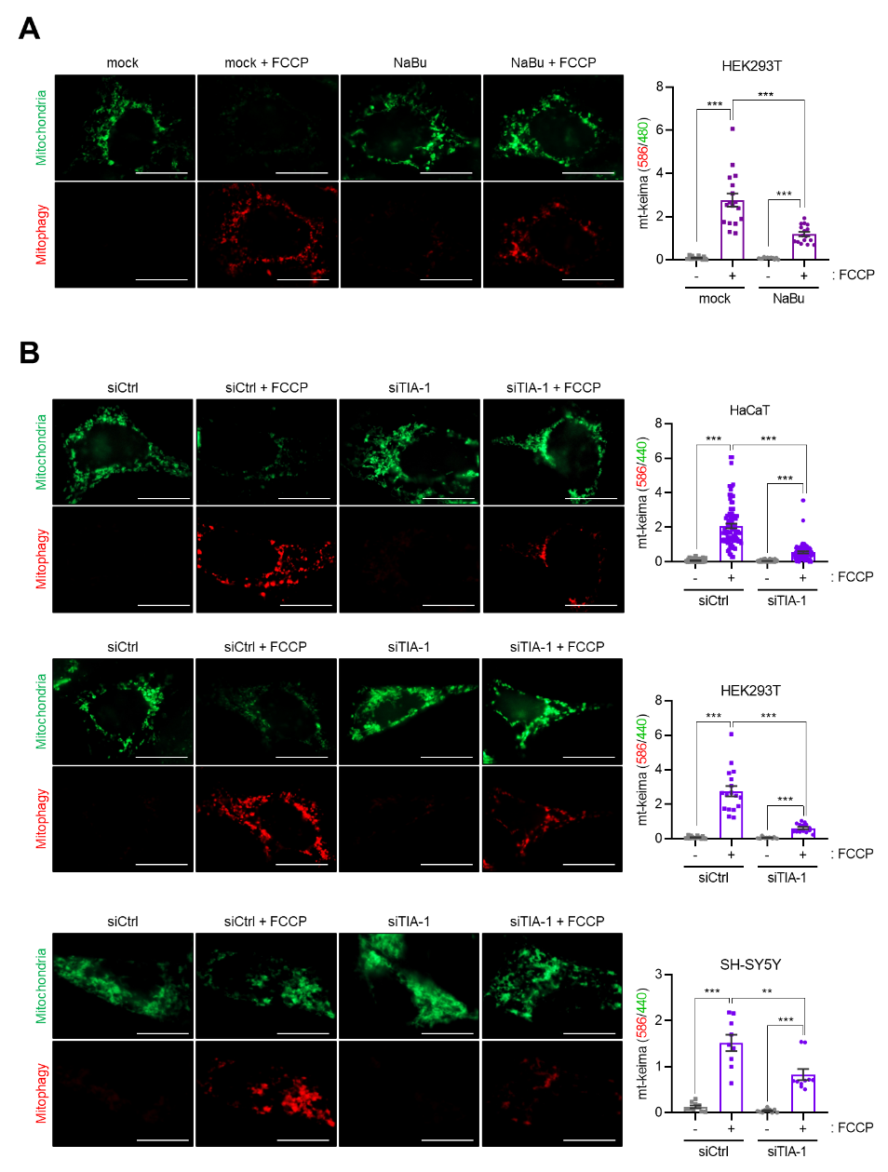
Supplementary Figure S1. Mitophagy activity assessed by hmt-Keima reporter assay
(A and B) HEK293T cells transfected with phmt-Keima were incubated with 1 mM sodium butyrate (NaBu) for 72 hours (A) or HaCaT, HEK293T, and SH-SY5Y cells were co-transfected with phmt-Keima and siRNAs (siCtrl or siTIA-1), followed by 48 hours of incubation (B). To induce mitophagy, cells were treated with FCCP (20 μM) and oligomycin (5 μM), and mitophagy activity was assessed by quantifying fluorescence signals (red/green) from the phmt-Keima reporter using ImageJ software. Representative images are shown and data are presented as mean ± SEM from three independent experiments. Scale bar, 20 μm. **p < 0.01; ***p < 0.001.
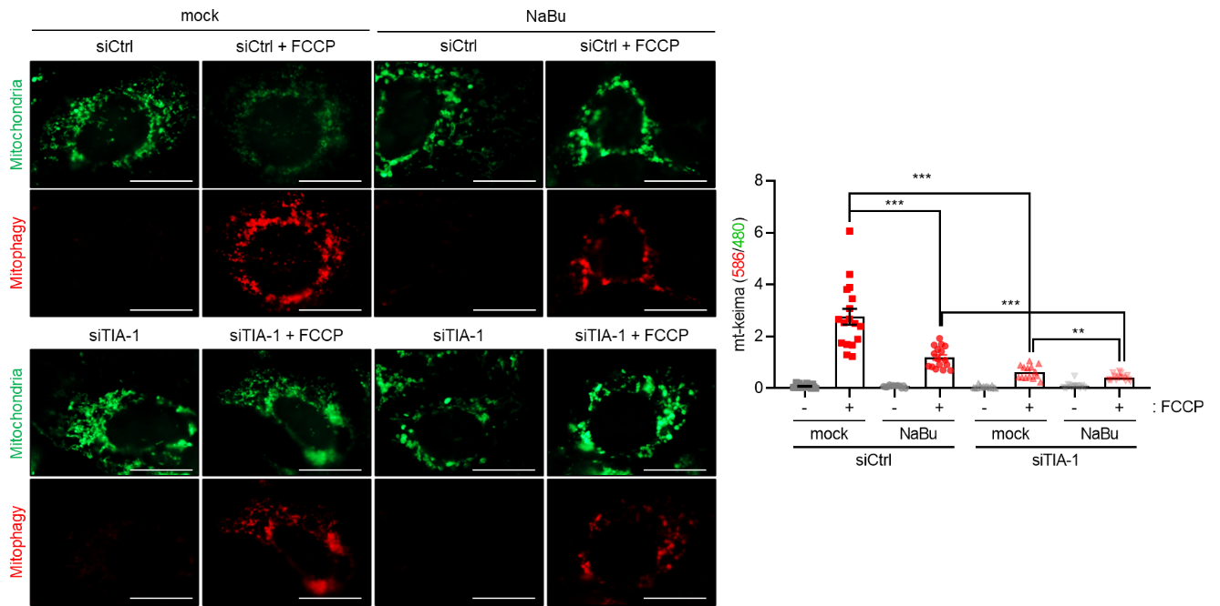
Supplementary Figure S2. Mitophagy activity assessed by hmt-Keima reporter assay in HEK293T cells
Following TIA-1 knockdown, HEK293T cells were treated with 1 mM NaBu for 48 hours. Mitophagy activity was assessed by monitoring the red fluorescence signals of the hmtKeima reporter following treatment with FCCP (20 μM), and the fluorescence ratio (red/green) was determined using ImageJ software. Representative images are shown and data represent mean ± SEM from three independent experiments. Scale bar, 20 μm. **, p < 0.01; ***, p < 0.001.
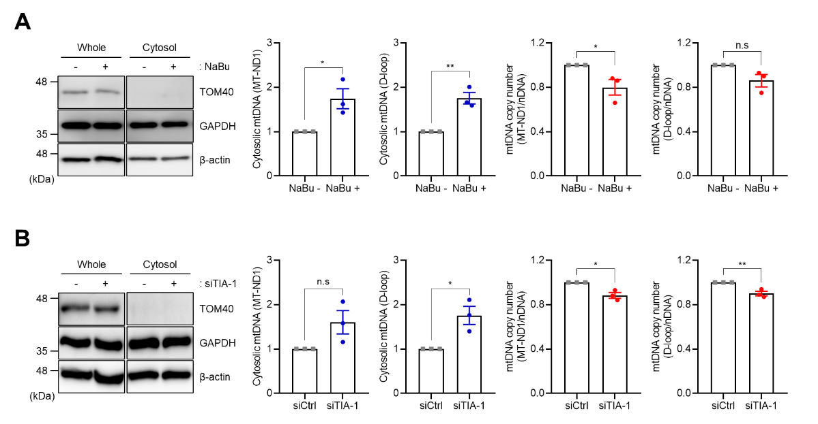
Supplementary Figure S3. Release of mitochondrial DNA after NaBu treatment or TIA-1 knockdown
(A and B) HaCaT cells were incubated with the media containing 1 mM sodium butyrate (NaBu) for 72 hours (A) or transfected with siRNAs (siCtrl or siTIA-1) for 48 hours (B). Fraction was confirmed by WB analysis. TOM40 and GAPDH served as markers for the mitochondrial and cytosolic fraction, respectively, and β-actin was used as a loading control. Cytosolic release of mitochondrial DNA (mtDNA) was analyzed by measuring the levels of mtDNA (ND1 and D-loop) in the cytosolic fraction using qPCR following normalization to the total mtDNA copy number in whole-cell lysate. Total mtDNA copy number was determined by qPCR using genomic DNA from whole-cell lysates, with normalization to KCNJ10 as the reference gene. Representative images are shown. Data are presented as mean ± SEM from three independent experiments. n.s., not significant (p > 0.05); *p < 0.05; **p < 0.01.

Supplementary Table S1. Oligonucleotide sequences used in this study
For RT-qPCR | Forward primers (5ʹ → 3ʹ) | Reverse primers (5ʹ → 3ʹ)
TIA-1 | CGAGATGCCCAAGACTCTATACG | CCTTACCCATTATCTTCCGTCCA
GAPDH | AGGTCGGTGTGAACGGATTTG | TGTAGACCATGTAGTTGAGGTCA
p62 | GACTACGACTTGTGTAGCGTC | AGTGTCCGTGTTTCACCTTCC
OPTN | AAAGAGCGTCTAATGGCCTTG | GTTCAGACACGATGCCCAACA
NBR1 | AGGAGCAAAACGACTAGCTGC | TCTGGGGTCTTCATGTCTGAT
CALCOCO2 | ATTTCATCCCTCGTCGAAAGGA | TAGAGGTGTAATACTCACGGGTT
TAX1BP1 | GCAGACCTGCATACTGCAC | GCCATCTGAAGACGGAGTTTC
NIX | TTGGATGCACAACATGAATCAGG | TCTTCTGACTGAGAGCTATGGTC
BNIP3 | CAGGGCTCCTGGGTAGAACT | CTACTCCGTCCAGACTCATGC
FUNDC1 | CCTCCCCAAGACTATGAAAGTGA | AAACACTCGATTCCACCACTG
BCL2L13 | TGGTTTTGCTACGACAAATGCT | TGCCGAATAGTCCTCCAGGT
PHB2 | GTGCGCGAATCTGTGTTCAC | GATAATGGGGTACTGGAACCAAG
MT-ND1 | GAACTAGTCTCAGGCTTCAACATCG | CTAGGAAGATTGTAGTGGTGAGGGTG
MT-D-loop | CATAAAGCCTAAATAGCCCACACG | CCGTGAGTGGTTAATAGGGTGATA
KCNJ10 | GCGCAAAAGCCTCCTCATT | CCTTCCTTGGTTTGGTGGG
IL6 | CAGGAGCCCAGCTATGAACT | GAAGGCAGCAGGCAACAC
IL8 | GAGTGGACCACACTGCGCCA | TCCACAACCCTCTGCACCCAGT
IL1β | AGCTACGAATCTCCGACCAC | CGTTATCCCATGTGTCGAAGAA
IFNγ | TCGGTAACTGACTTGAATGTCCA | TCGCTTCCCTGTTTTAGCTGC
For cloning | Forward primers (5ʹ → 3ʹ) | Reverse primers (5ʹ → 3ʹ)
pEGFP-FUNDC1 3U | AAAAAGATCTTAAGGACATGAATATTCTCCCATA | AAAAGAATTCTCATATTACATCAGCAGAGTC
pcDNA-mt-Keima | AAAAGCTAGCATGTCCGTCCTGACGCCG | AAAACTCGAGTTAGCCCAGCAGGGAGTG
For BPD | Sense sequences (5ʹ → 3ʹ) | Antisense sequences (5ʹ → 3ʹ)
FUNDC1 3U | CCAAGCTTCTAATACGACTCACTATAGGGAGAGGACATGAATATTCTCCCATA | TCATATTACATCAGCAGAGTC
siRNA | Sense sequences (5ʹ → 3ʹ) | Antisense sequences (5ʹ → 3ʹ)
Control siRNA (siCtrl) | AAUUCUCCGAACGUGUCACGUUU | ACGUGACACGUUCGGAGAAUUU
siTIA-1 | AACACAACAAAUUGGCCAGUAUU | UACUGGCCAAUUUGUUGUGUU

Supplementary Table S2. Antibodies information used in this study
Antibodies | Company | Catalog number
TIA-1 | Cell Signaling Technology, Inc.  (Danvers, MA, USA) | #86050
p21 | Cell Signaling Technology, Inc.  (Danvers, MA, USA) | #2947
GAPDH | Cell Signaling Technology, Inc.  (Danvers, MA, USA) | #2118
p-IRF3 | Cell Signaling Technology, Inc.  (Danvers, MA, USA) | #79945
ISG15 | Cell Signaling Technology, Inc.  (Danvers, MA, USA) | #2743
GFP | Santa Cruz Biotechnology, Inc.  (Dallas, TX, USA) | #sc-9996
Lamin B | Santa Cruz Biotechnology, Inc.  (Dallas, TX, USA) | #sc-6216
TOM40 | Santa Cruz Biotechnology, Inc.  (Dallas, TX, USA) | #sc-11414
p16 | Santa Cruz Biotechnology, Inc.  (Dallas, TX, USA) | #sc-1661
FUNDC1 | Abcam  (Plc., Cambridge, UK) | #ab224722
NDUFV2 | Proteintech  (Rosemont, IL, USA) | #15301-1-AP
β-actin | Genetex, Inc.  (Irvine, CA, USA) | #GTX629630
Anti-mouse HRP-conjugated secondary Ab | Sigma-Aldrich  (Burlington, MA, USA) | #AP124P
Anti-Rabbit HRP-conjugated secondary Ab | Sigma-Aldrich  (Burlington, MA, USA) | #AP132P
Anti-Goat HRP-conjugated secondary Ab | Sigma-Aldrich  (Burlington, MA, USA) | #AP186P
Normal Rabbit IgG | Sigma-Aldrich  (Burlington, MA, USA) | #12-370
Anti-Rabbit IgG H&L (Alexa Fluor® 488) | Abcam  (Plc., Cambridge, UK) | #ab150077

