Supporting Information

Photoacoustic Microscopy Reveals Deep Angiogenic Responses in 3D Bioprinted Tumor–vessel Models
Yongjae Jo^{1, #}, Seokgyu Han^{3, 4,} #, Hyunjun Kye¹, Jinhee Yoo¹, Junhyung Kim², Inki Kim¹, Sungsu Park^{1, 2, 3,} *, and Byullee Park^{1, 2,} *

#These authors contributed equally to this work
*Corresponding authors:
Byullee Park: byullee@skku.edu
Sungsu Park: nanopark@skku.edu

¹ Department of Biophysics, Institute of Quantum Biophysics, Sungkyunkwan University, Suwon 16419, Republic of Korea
² Departments of MetaBioHealth, Biopharmaceutical Convergence, Sungkyunkwan University, Suwon 16419, Republic of Korea
³ School of Mechanical Engineering, Sungkyunkwan University, Suwon 16419, Republic of Korea
⁴ Division of Engineering in Medicine, Department of Medicine, Brigham and Women's Hospital, Harvard Medical School, Cambridge, MA, 02139 USA

Keywords: photoacoustic imaging, cancer spheroids, bioprinting, vascularization, drug screening

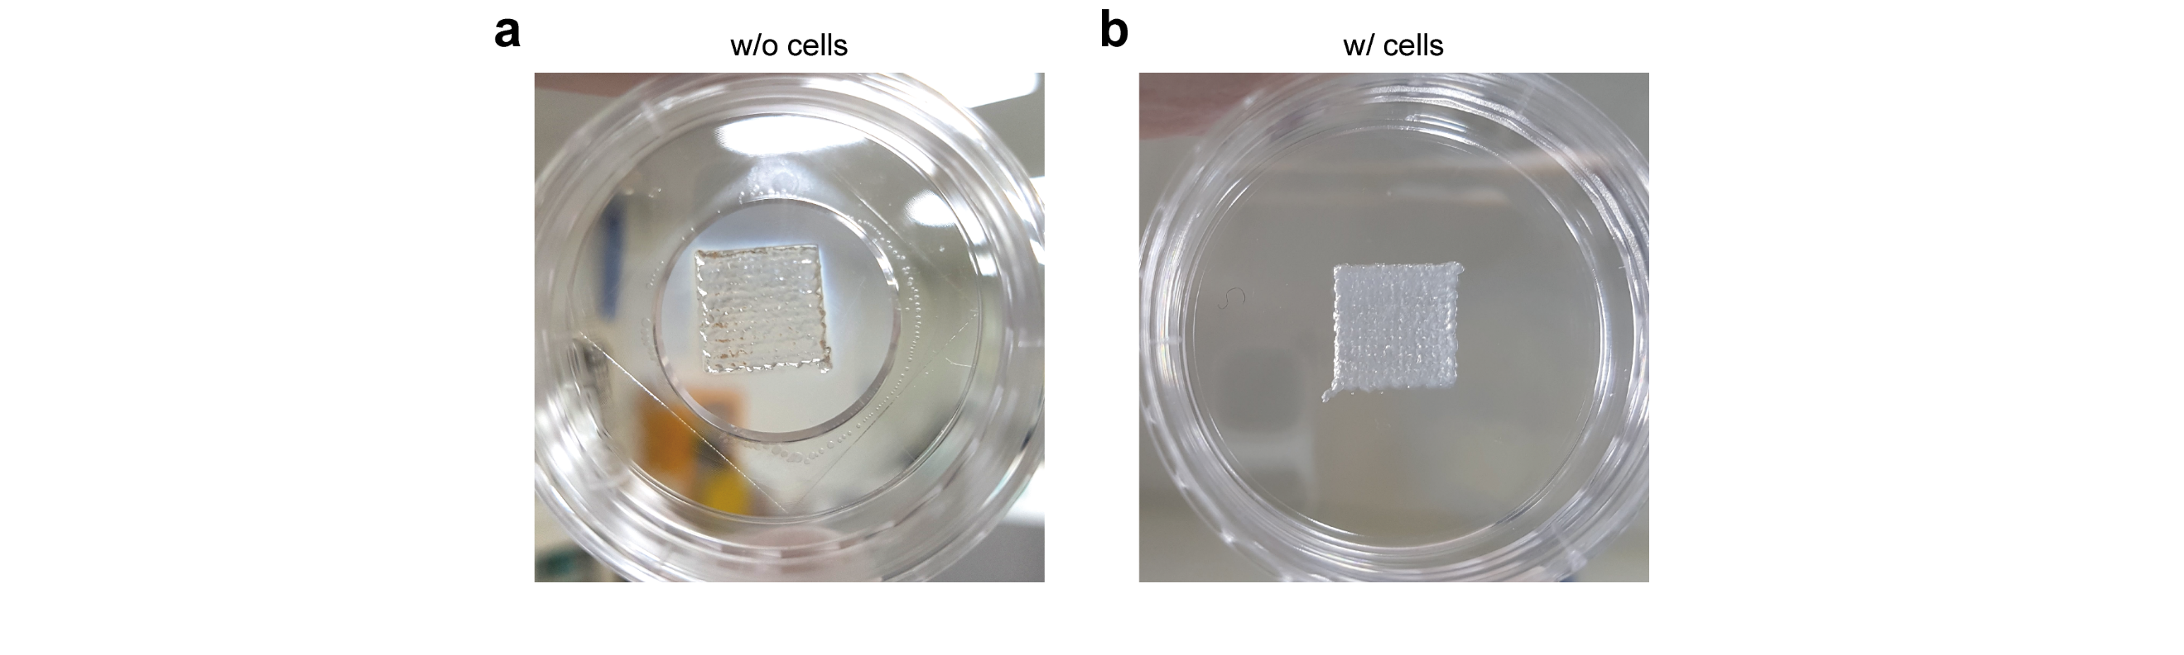

Figure S1. Comparison of optical properties of bioprinted hydrogels (a, b) Photographs of bioprinted hydrogels without (a) and with (b) embedded cells. Notably, the cell-embedded hydrogel appeared opaque, due to the refractive index mismatch between the hydrogel and the cells, whereas the hydrogel without embedded cells remained transparent.

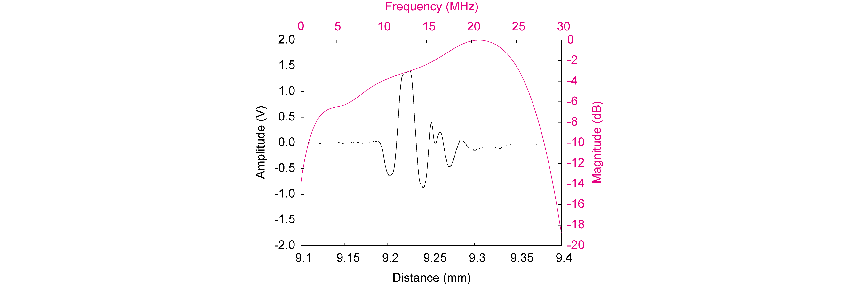

Figure S2. Pulse–echo response of the ultrasound transducer in the PAM system. Time–domain (black) and frequency–domain (magenta) representations of the pulse–echo response. The transducer exhibited a center frequency of ~19 MHz, and a bandwidth of ~69%.

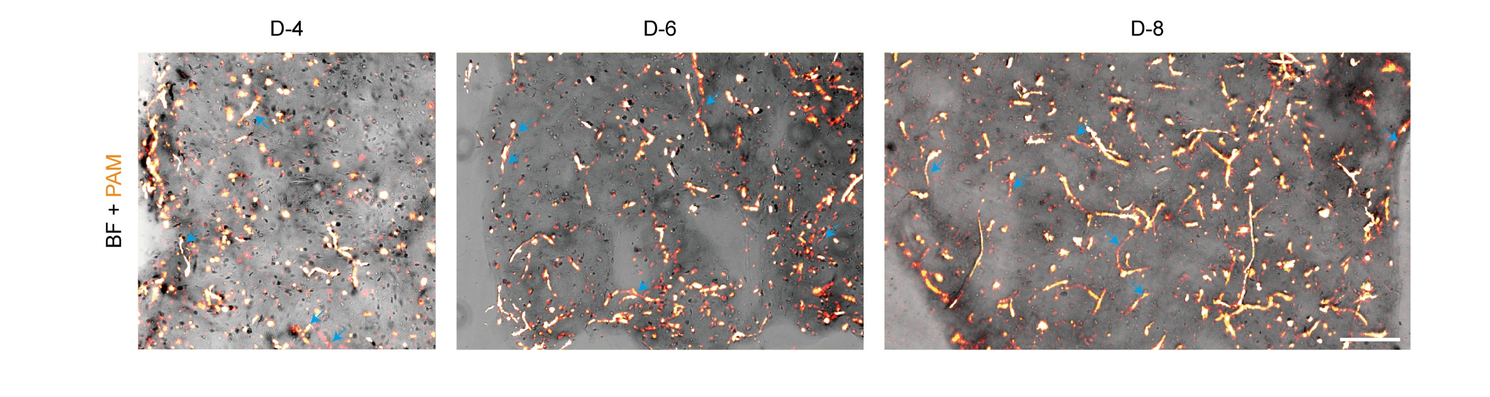

Figure S3. Merged BF and PAM images of vascular networks. Correlative images of BF (gray lookup table, LUT) and PAM (hot LUT) for hydrogels cultured for 4, 6, and 8 days, comparing the visibility of vascular structures between imaging modalities. Blue arrows indicate vascular structures that are clearly identified in PA images, but appear ambiguous in BF images. Scale bar: 400 µm.

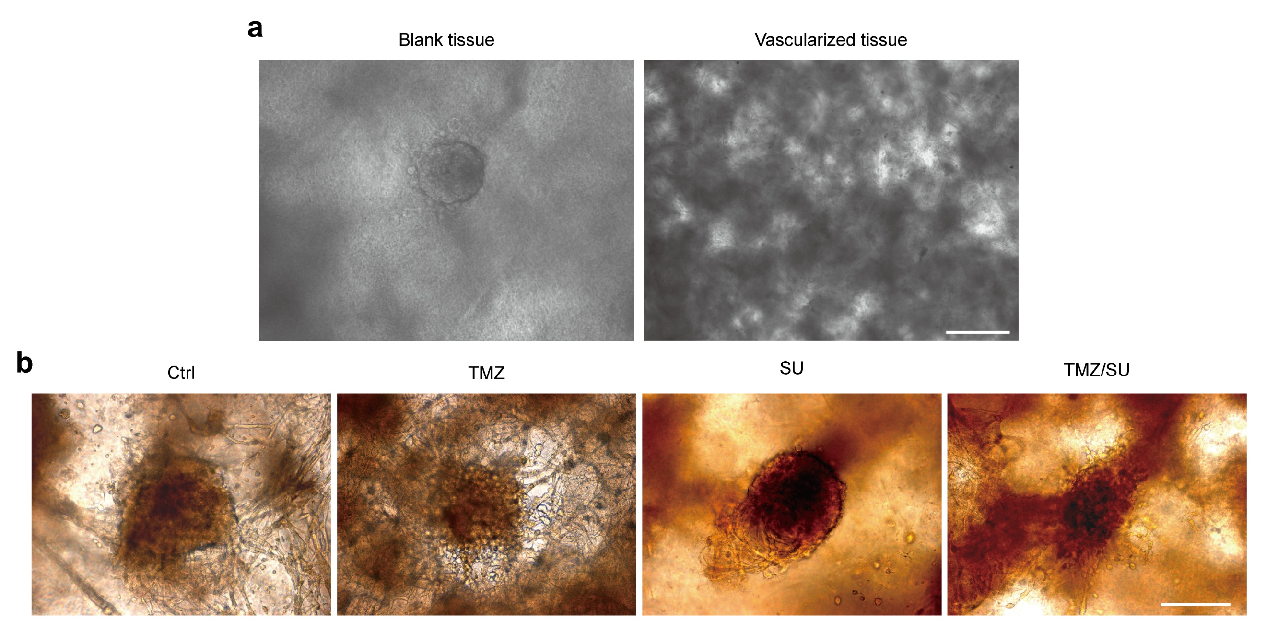

Figure S4. U87 spheroid seeded on vascularized tissue. (a) Bright-field images showing U87 spheroid seeded onto the blank (only gelatin, alginate, and fibrinogen) and vascuralized (HUVEC/LF in gelatin, alginate, and fibrinogen) tissues. (b) Representative images of U87 spheroids seeded onto vascularized tissues treated without, or with, TMZ, SU, and TMZ/SU combination on day 3 after seeding. Scale bars: 200 µm.

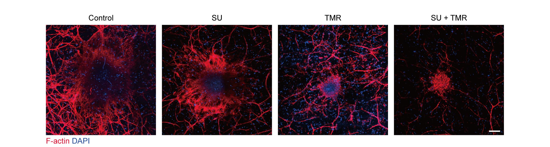

Figure S5. Fluorescence images of vascular networks in tumor-seeded hydrogels under various drug treatments. Vascular structures were stained with Phalloidin (F–actin) and DAPI (nuclei). Scale bar: 200 µm.

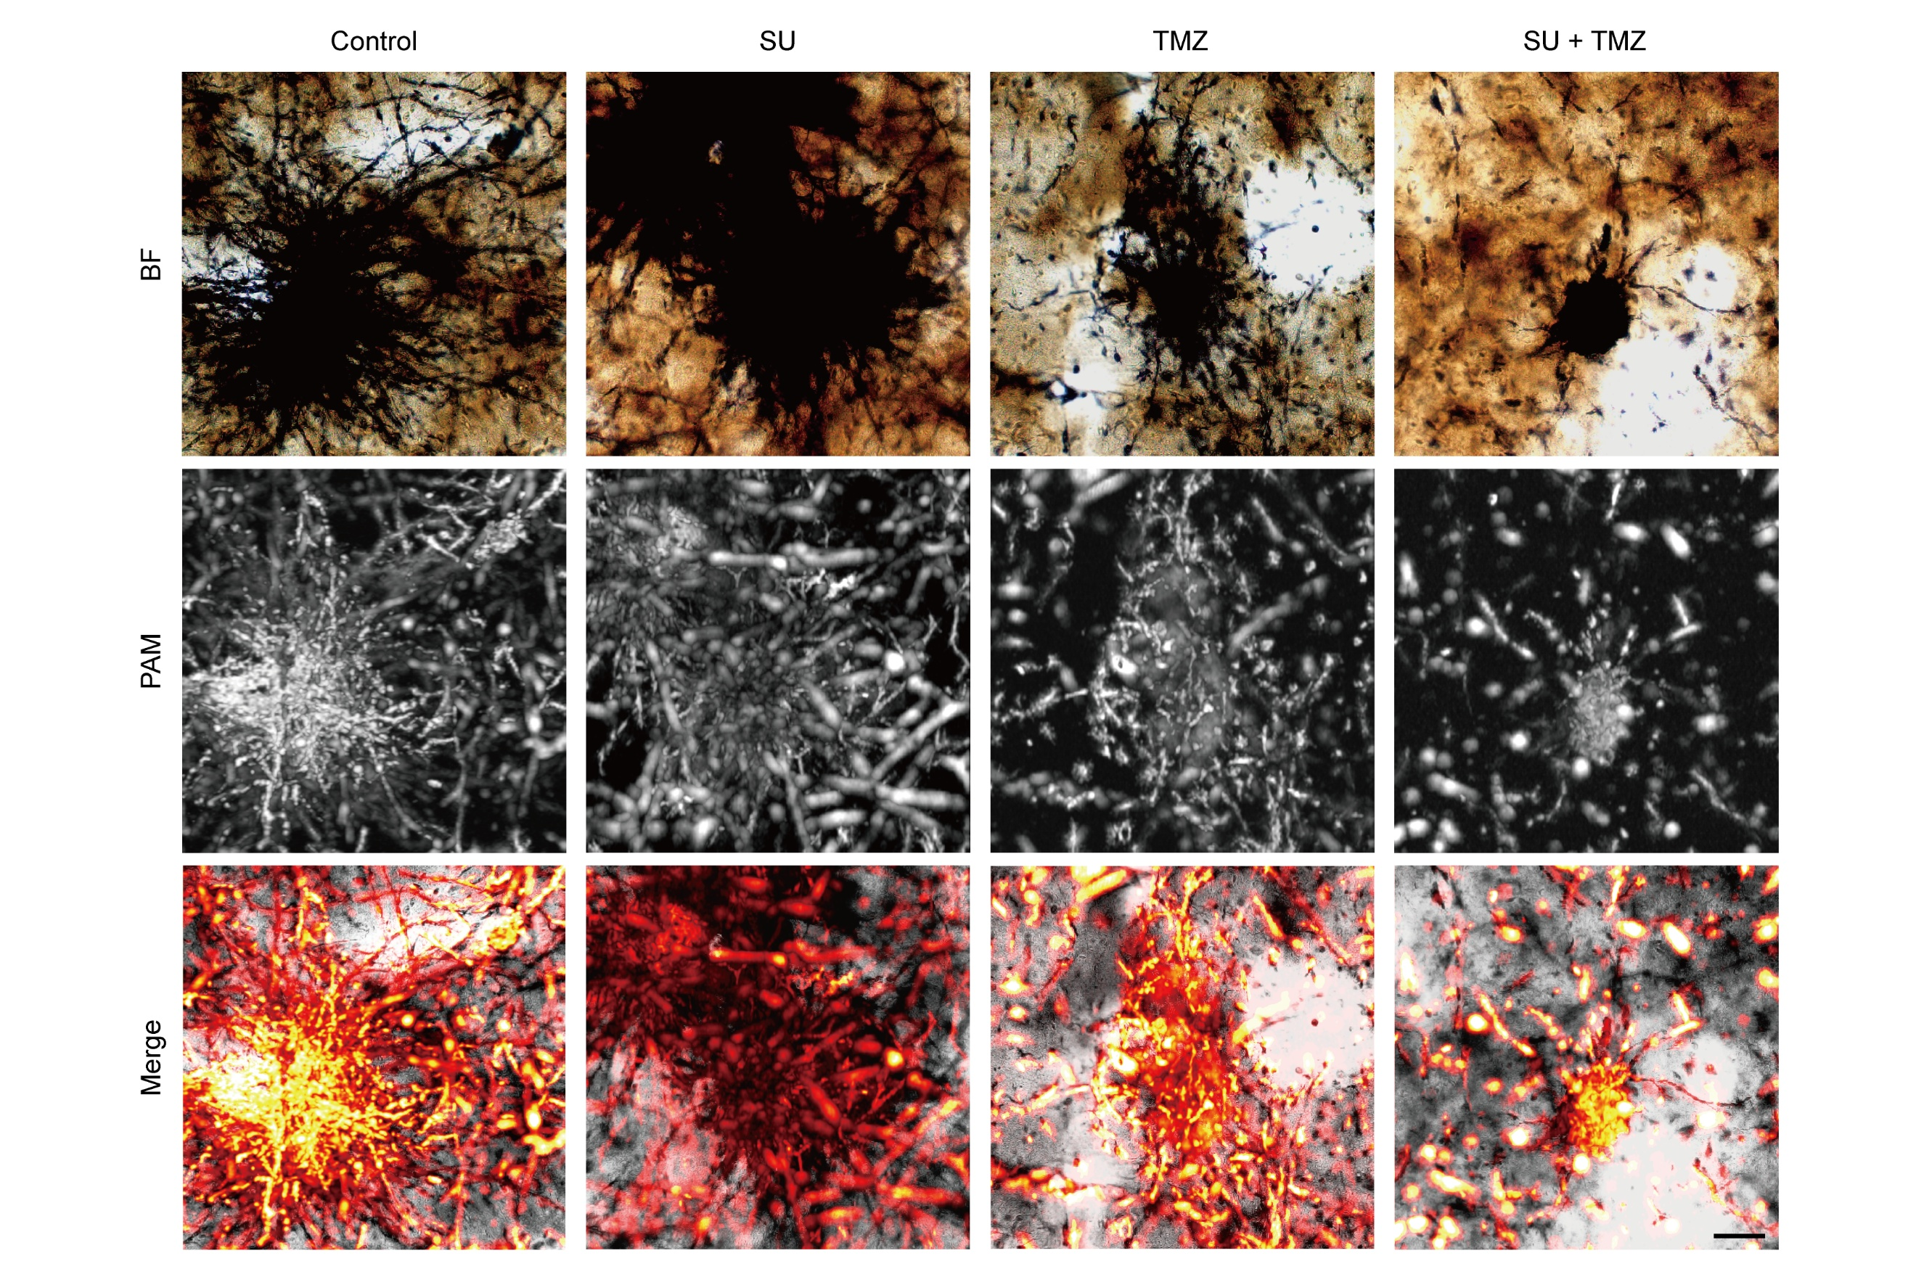

Figure S6. Merged BF and PAM images of vascular networks in tumor-seeded hydrogels under various drug treatments. BF, MAP of PAM images, and their merged views for the control group and drug-treated groups, including SU, TMZ, and their combination. Scale bar: 200 µm.

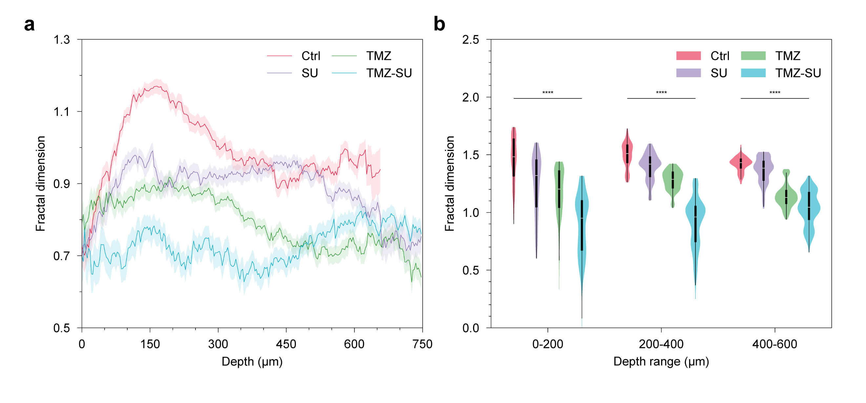

Figure S7. 3D quantification of vascular network complexity. (a, b) Depth profile (a) and statistical analysis (b) of fractal dimension-based vessel complexity under various drug treatment conditions. As normality was not satisfied in all groups, the Kruskal–Wallis non-parametric test was used, followed by Dunn’s post hoc test with Bonferroni correction for multiple comparisons. ****p < 0.0001; ***p < 0.001; **p < 0.01; *p < 0.05; ns, non-significance.

