Supplementary Materials

Table S1. Characteristics and sources of collected data
No. | Preference | Location / Region | soil texture(s) | Number of samples
1 | (Wang et al., 2014) | Shenmu (China) | Sandy loam | 5
2 | (Chen et al., 1996) | Loess Plateau (China) | Sandy loam | 43
3 | (Zamani & Mahmoodabadi, 2013) | Kerman (Iran) | Sandy clay loam - Clay loam | 9
4 | (Shahabinejad et al., 2019) | Kerman (Iran) | Sand | 60
5 | (Liu et al., 2007) | Loess Plateau (China) | Sand - Silt loam - Sandy loam | 45
6 | (Li et al., 2004) | Tengger Desert (China) | Sandy loam | 9
7 | (Négyesi et al., 2016) | Nyírség (Hungary) | Sand | 35
8 | (Sirjani et al., 2019) | Fars (Iran) | Silty clay loam - Loamy sand- Sandy loam - Clay loam - Silt loam - Silty clay - Sandy clay loam - Silty clay loam – Loam – Sand - Clay | 8
9 | (Liu et al., 2003) | Golmud, Zilingol, Shapotou (China) | Sand - Sandy loam - Loamy sand | 9
10 | (Han et al., 2009) | Guangdong (China) | Sand | 25
11 | (Mahmoodabadi & Rajabpour, 2017) | Kerman (Iran) | Sand - Loamy sand - Sandy loam | 18
12 | (Van Pelt et al., 2013) | Kansas, Colorado (USA) | Silt loam - Silt | 18
13 | (Liu et al., 2017) | Loess Plateau (China) | Loamy sand | 12
14 | (Fattahi et al., 2020a) | Desert Minqin (China) | Sand | 4
15 | (Avecilla et al., 2015) | Argentina | Sand – Loam - Sandy loam - Loamy sand | 6
16 | (Nan et al., 2018) | Yanchi (China) | Sandy loam - Loamy sand | 9
17 | (Tominaga & Okuyama, 2022) | Kagawa (Japan) | Sand - Loamy sand | 15
18 | (Zhang et al., 2004) | Guinan (China) | Silt loam | 5
19 | (Kohake et al., 2010) | Florida, California, Michigan (USA) | Loam | 24
20 | (de Oro et al., 2019) | Pampas Region (Argentina) | Loam - Sandy loam - Loamy sand | 66
21 | (Kheirabadi et al., 2018) | Kerman (Iran) | Sandy loam | 9

Table S2. Matlab code used for the DBSCAN algorithm
DBSCAN(DB, distFunc, eps, minPts) {
C := 0 /* Cluster counter */
for each point P in database DB {
if label(P) ≠ undefined then continue /* Previously processed in inner loop */
Neighbors N := RangeQuery(DB, distFunc, P, eps) /* Find neighbors */
if |N| < minPts then { /* Density check */
label(P) := Noise /* Label as Noise */
continue
}
C := C + 1 /* next cluster label */
label(P) := C /* Label initial point */
SeedSet S := N \ {P} /* Neighbors to expand */
for each point Q in S { /* Process every seed point Q */
if label(Q) = Noise then label(Q) := C /* Change Noise to border point */
if label(Q) ≠ undefined then continue /* Previously processed (e.g., border point) */
label(Q) := C /* Label neighbor */
Neighbors N := RangeQuery(DB, distFunc, Q, eps) /* Find neighbors */
if |N| ≥ minPts then { /* Density check (if Q is a core point) */
S := S ∪ N /* Add new neighbors to seed set */
}
}
}
}

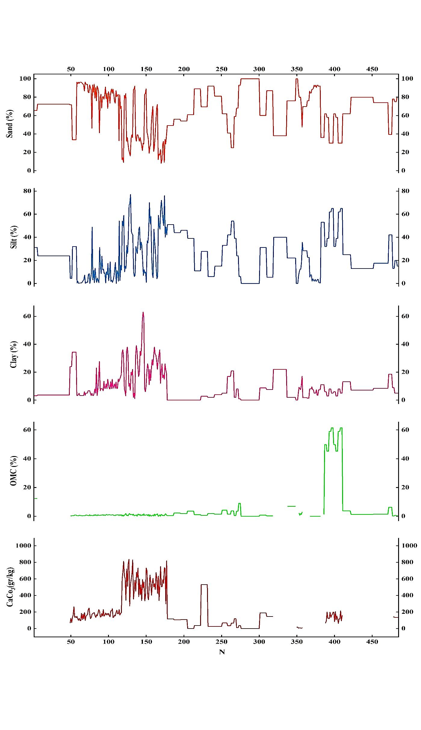
Fig. S1. Collected parameter values
Number of samples

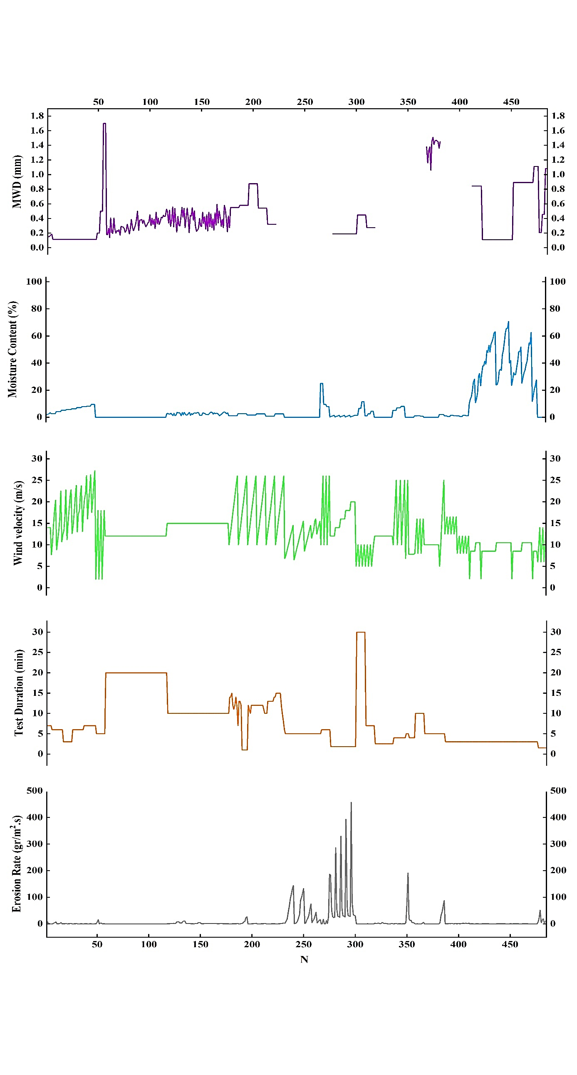
Fig. S2. Collected parameter values (cont.)
Number of samples
$$\left.Erosion Rate (g{r/{m^{2}}}/s\right)$$

References
Avecilla, F., Panebianco, J. E., & Buschiazzo, D. E. (2015). Variable effects of saltation and soil properties on wind erosion of different textured soils. Aeolian Research, 18, 145-153.
Chen, W., Zhibao, D., Zhenshan, L., & Zuotao, Y. (1996). Wind tunnel test of the influence of moisture on the erodibility of loessial sandy loam soils by wind. Journal of Arid Environments, 34(4), 391-402.
de Oro, L. A., Colazo, J. C., Avecilla, F., Buschiazzo, D. E., & Asensio, C. (2019). Relative soil water content as a factor for wind erodibility in soils with different texture and aggregation. Aeolian Research, 37, 25-31.
Han, Q., Qu, J., Zhang, K., Zu, R., Niu, Q., & Liao, K. (2009). Wind tunnel investigation of the influence of surface moisture content on the entrainment and erosion of beach sand by wind using sands from tropical humid coastal southern China. Geomorphology, 104(3-4), 230-237.
Kohake, D., Hagen, L., & Skidmore, E. (2010). Wind erodibility of organic soils. Soil Science Society of America Journal, 74(1), 250-257.
Liu, L.-Y., Li, X.-Y., Shi, P.-J., Gao, S.-Y., Wang, J.-H., Ta, W.-Q., Song, Y., Liu, M.-X., Wang, Z., & Xiao, B.-L. (2007). Wind erodibility of major soils in the farming-pastoral ecotone of China. Journal of Arid Environments, 68(4), 611-623.
Liu, L.-Y., Shi, P.-J., Zou, X.-Y., Gao, S.-Y., Erdon, H., Yan, P., Li, X.-Y., Dong, Z.-B., & Wang, J.-H. (2003). Short-term dynamics of wind erosion of three newly cultivated grassland soils in Northern China. Geoderma, 115(1-2), 55-64.
Liu, T., Xu, X., & Yang, J. (2017). Experimental study on the effect of freezing-thawing cycles on wind erosion of black soil in Northeast China. Cold Regions Science and Technology, 136, 1-8.
Mahmoodabadi, M., & Rajabpour, H. (2017). Study on the effect of initial soil moisture content on wind erosion rate using a laboratory wind tunnel. Journal of Water and Soil Conservation, 24(2), 167-183.
Négyesi, G., Lóki, J., Buró, B., & Szabó, S. (2016). Effect of soil parameters on the threshold wind velocity and maximum eroded mass in a dry environment. Arabian Journal of Geosciences, 9, 1-10.
Shahabinejad, N., Mahmoodabadi, M., Jalalian, A., & Chavoshi, E. (2019). The fractionation of soil aggregates associated with primary particles influencing wind erosion rates in arid to semiarid environments. Geoderma, 356, 113936.
Sirjani, E., Sameni, A., Moosavi, A. A., Mahmoodabadi, M., & Laurent, B. (2019). Portable wind tunnel experiments to study soil erosion by wind and its link to soil properties in the Fars province, Iran. Geoderma, 333, 69-80.
Tominaga, Y., & Okuyama, T. (2022). Investigating threshold wind velocity for movement of sparsely distributed gravels in a wind tunnel: Effect of surface coarseness. Aeolian Research, 54, 100775.
Van Pelt, R. S., Baddock, M. C., Zobeck, T. M., Schlegel, A. J., Vigil, M. F., & Acosta-Martinez, V. (2013). Field wind tunnel testing of two silt loam soils on the North American Central High Plains. Aeolian Research, 10, 53-59.
Wang, L., Shi, Z., Wu, G., & Fang, N. (2014). Freeze/thaw and soil moisture effects on wind erosion. Geomorphology, 207, 141-148.
Zamani, S., & Mahmoodabadi, M. (2013). Effect of particle-size distribution on wind erosion rate and soil erodibility. Archives of Agronomy and Soil Science, 59(12), 1743-1753.
Zhang, C.-L., Zou, X.-Y., Gong, J.-R., Liu, L.-Y., & Liu, Y.-Z. (2004). Aerodynamic roughness of cultivated soil and its influences on soil erosion by wind in a wind tunnel. Soil and Tillage Research, 75(1), 53-59.

