T-cell responses to ancestral SARS-CoV-2 and Omicron in unvaccinated hospitalised adults living with and without HIV in South Africa

William C. McMahon¹, Gaurav Kwatra^{1,2,3}, Alane Izu^{1,4}, Natali Serafin¹, Farzanah Laher¹, Sharon Shalekoff^{5,6}, Caroline T. Tiemessen^{5,6}, Shabir A. Madhi^{1,4,*}, Marta C. Nunes^{1,7,*}

SUPPLEMENTARY INFORMATION
Supplementary Fig. S1: Flow cytometry gating strategy and representative
staining profiles.

Supplementary Fig. S2: T-cell subset proportions and CD4⁺/CD8⁺ T-cell ratios.

Supplementary Fig. S3: Polyfunctionality of CD4⁺CD8⁺ T cells to ancestral SARS-
CoV-2 and Omicron variant.

Supplementary Fig. S4: Comparative polyfunctionality of CD4⁺ and CD8⁺ T cells in
response to ancestral SARS-CoV-2.

Supplementary Fig. S5: T-cell activation after stimulation with the full-length spike
and nucleocapsid proteins of ancestral SARS-CoV-2.

Fig. S1
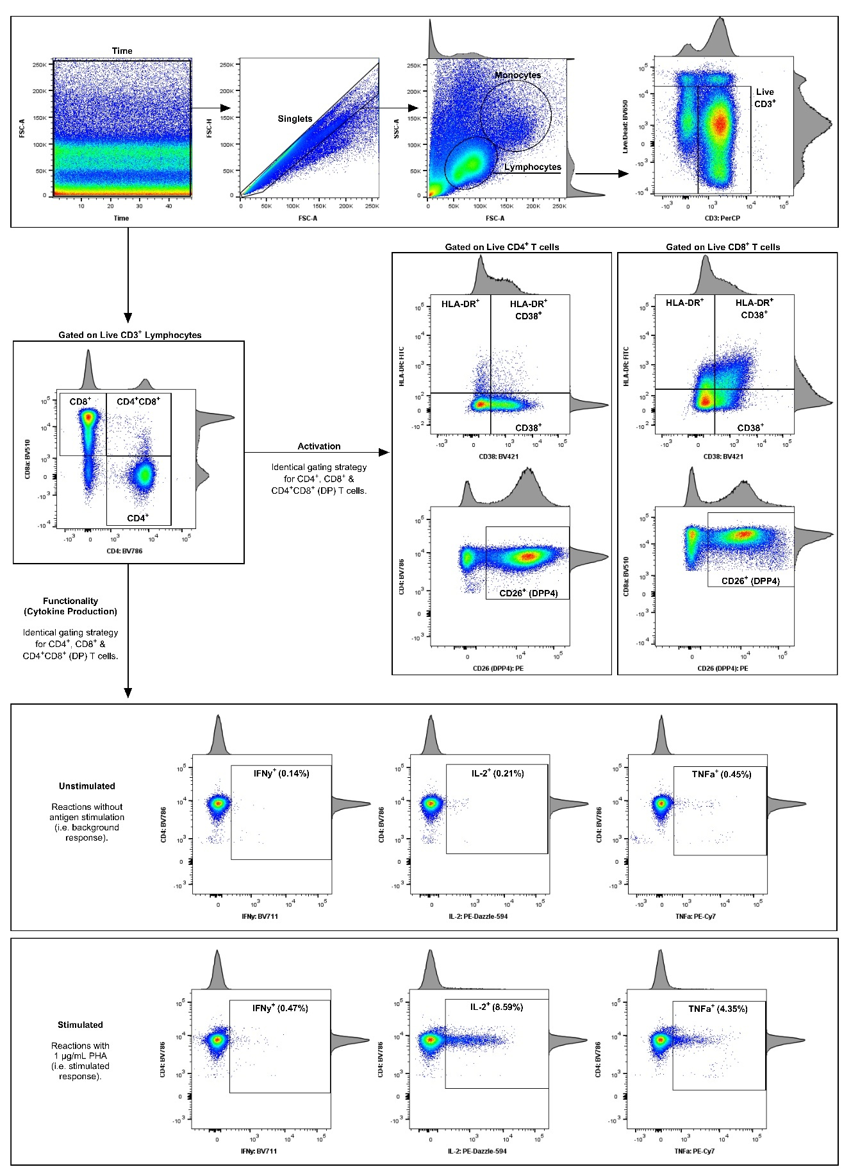
Fig. S1. Flow cytometry gating strategy and representative staining profiles.
The flow cytometry gating strategy is depicted using pseudocolour plots with accompanying histograms from a COVID-19-vaccinated donor (the plate control). (a) A time gate was applied to include only data acquired at a consistent flow rate. Doublets were excluded by gating on FSC-A vs. FSC-H, followed by the selection of lymphocytes based on FSC-A and SSC-A properties. Live CD3⁺ lymphocytes were selected as the final gating population to ensure the acquisition of approximately 100,000 events (cells) for each reaction. (b) CD4⁺, CD8⁺, and CD4⁺CD8⁺ (double positive, DP) T cells were individually gated and analysed for activation and functional responses. (c) T-cell activation was characterised by the extracellular expression of CD26 (DPP4), CD38, and HLA-DR. (d) Functional responses were assessed by the intracellular expression of IFN-γ, IL-2, and TNF-α. T-cell responses for an unstimulated control and a PHA-stimulated control are shown, with response frequencies indicated in each plot.

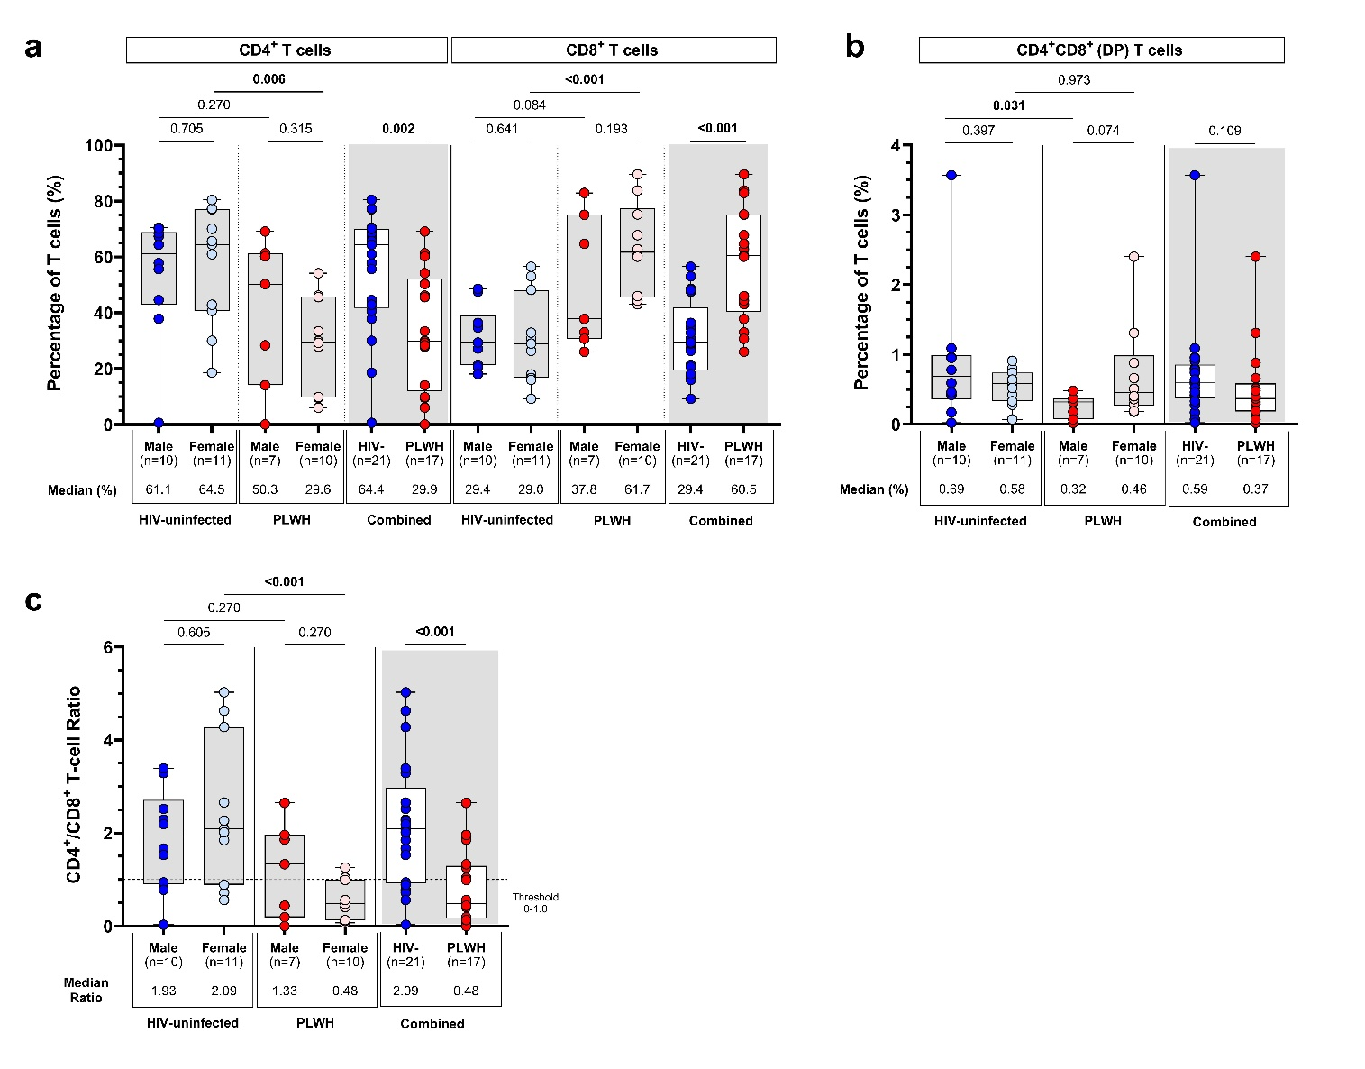
Fig. S2

Fig. S2. T-cell subset proportions and CD4⁺/CD8⁺ T-cell ratios.
(a, b) Proportion of live CD3⁺ T-lymphocytes expressing CD4 and CD8 among participants living with (n=17) and without HIV (n=21), with additional stratification by biological sex (male and female). (c) CD4⁺/CD8⁺ T-cell ratios. Each participant is represented by an individual point, with median proportions displayed below each axis. Box-and-whisker plots show medians (horizontal black lines), interquartile ranges (boxes), and minimum/maximum values (whiskers). Statistical comparisons between unpaired groups (HIV-uninfected vs. PLWH; male vs. female) were performed using the Mann–Whitney U-test. Denotations: Combined: participants living with and without HIV; PLWH: participants living with HIV.

Fig. S3
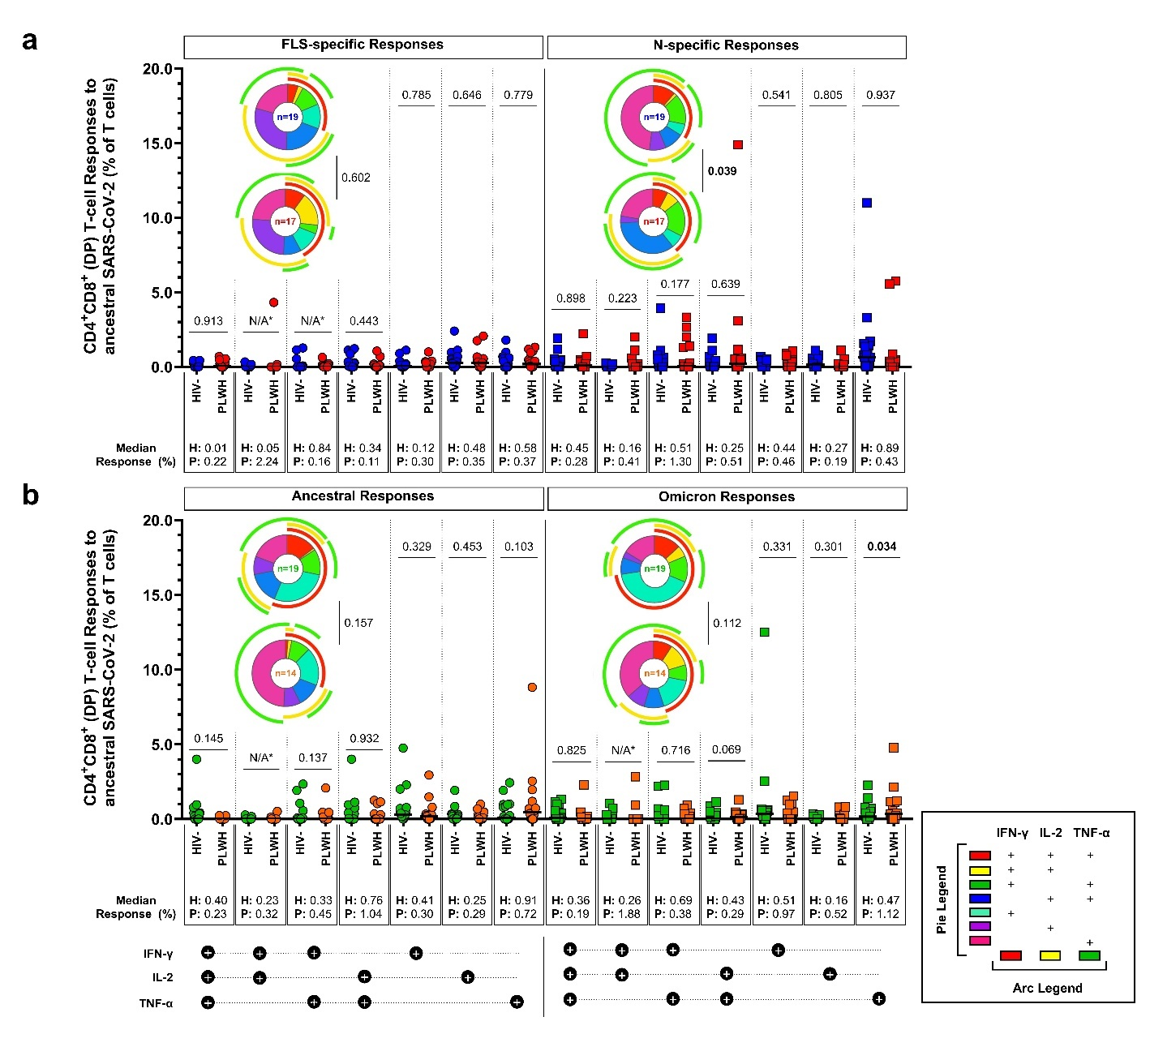

Fig. S3. Polyfunctionality of CD4⁺CD8⁺ T cells to ancestral SARS-CoV-2 and Omicron variant.
Polyfunctionality profiles of CD4⁺CD8⁺ (double positive, DP) T cells in response to (a) full-length spike (FLS) and nucleocapsid (N) proteins of ancestral SARS-CoV-2, as well as (b) partial ancestral SARS-CoV-2 and Omicron (BA.4/BA.5) spike proteins. Each participant is represented by an individual point, with median responses displayed below each axis. Polyfunctional response patterns are colour-coded and summarised in pie charts with overarching legend denoting cytokine production. Adjusted multivariate log-linear regression was used for unpaired comparisons between HIV-uninfected participants and PLWH. Differences in overall polyfunctional T-cell response profiles were assessed using a permutation test (10,000 iterations). Denotations: HIV-: HIV-uninfected participants; N/A*: not applicable – P-values could not be determined due to only two participants having polyfunctional response values >0.00%; PLWH: participants living with HIV.

Fig. S4
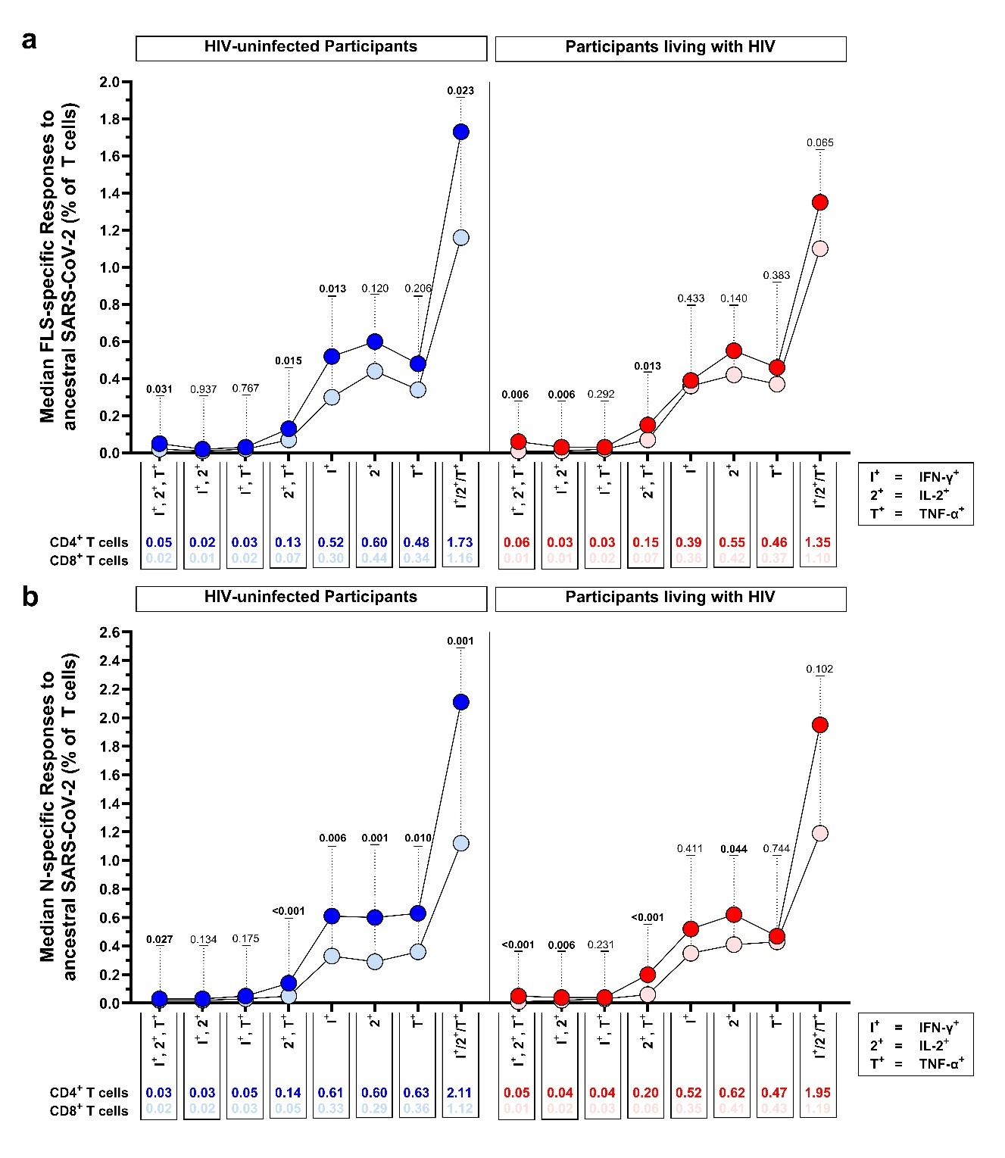Fig. S4. Comparative polyfunctionality of CD4⁺ and CD8⁺ T cells in response to ancestral SARS-CoV-2.
(a, b) Direct median comparisons of CD4⁺ and CD8⁺ T-cell polyfunctionality in response to the full-length spike (FLS) and nucleocapsid (N) proteins of ancestral SARS-CoV-2, stratified by HIV status. Each data point represents the median T-cell response (displayed below the axis) of positive responders for each cytokine combination. The Wilcoxon signed-rank test was used for paired comparisons (CD4⁺ vs. CD8⁺). Significant P-values are indicated in bold. Denotations: FLS: full-length spike glycoprotein; IFN-γ: interferon gamma; IL-2: interleukin 2; N: nucleocapsid protein; PLWH: participants living with HIV; TNF-α: tumor necrosis factor alpha.

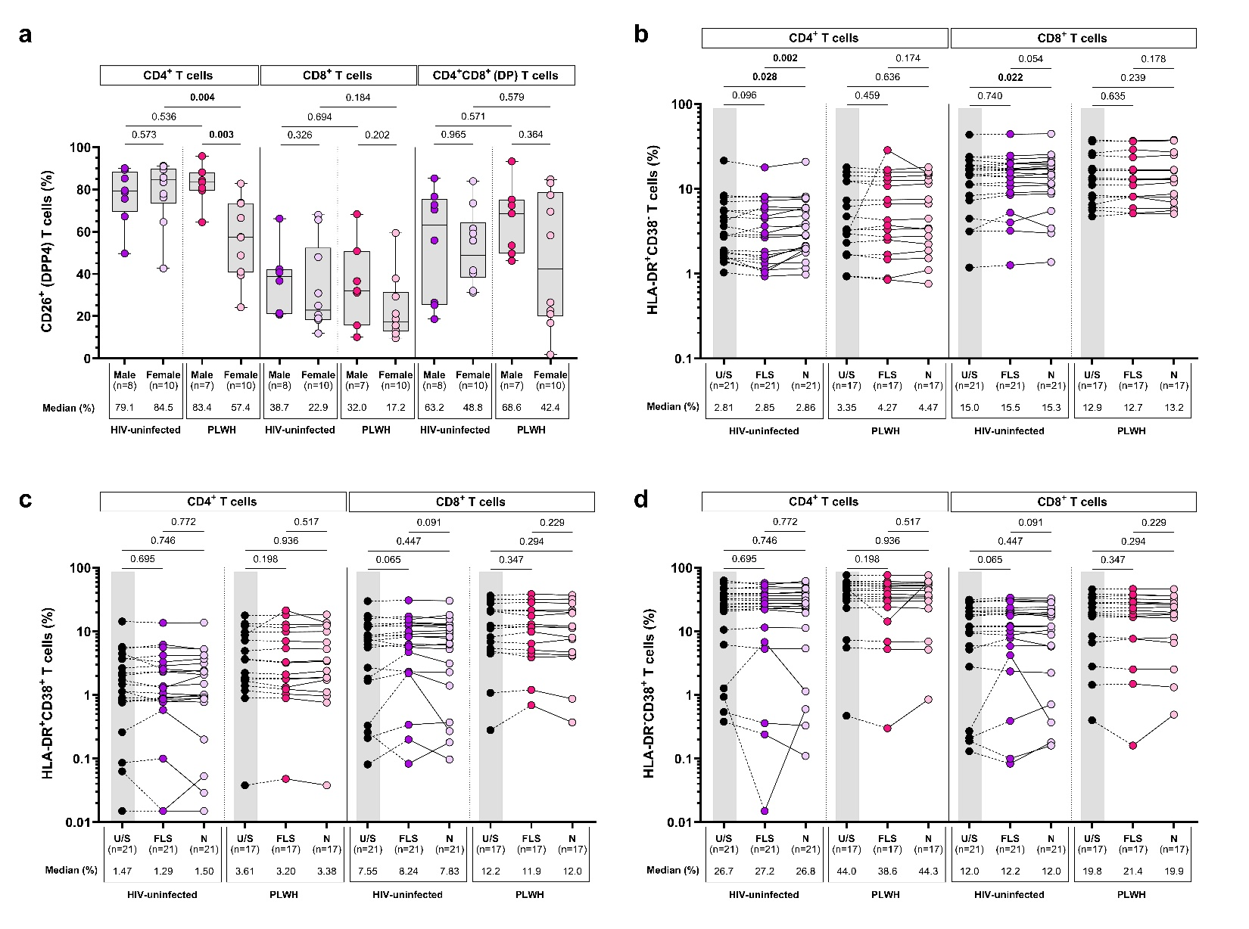
Fig. S5

Fig. S5. T-cell activation after stimulation with the full-length spike and nucleocapsid proteins of ancestral SARS-CoV-2.
(a) Proportion of CD4⁺, CD8⁺, and CD4⁺CD8⁺ (double positive, DP) T cells expressing CD26 (DPP4) among participants living with (n=17) and without HIV (n=18), further stratified by biological sex (male vs. female). Box-and-whisker plots show medians (horizontal black lines), interquartile ranges (boxes), and minimum/maximum values (whiskers). CD4⁺ and CD8⁺ T-cell activation following stimulation with the full-length spike (FLS) and nucleocapsid (N) proteins of ancestral SARS-CoV-2, as measured by the proportion of cells expressing (b) HLA-DR⁺CD38⁻, (c) HLA-DR⁺CD38⁺, or (d) HLA-DR⁻CD38⁺. Each participant is represented by an individual point, with median proportions displayed below each axis. Statistical comparisons between unpaired (HIV-uninfected vs. PLWH; male vs. female) and paired (U/S vs. FLS; U/S vs. N; FLS vs. N) groups were performed using adjusted multivariate log-linear regression and the Wilcoxon signed-rank test, respectively. Denotations: FLS: full-length spike glycoprotein; N: nucleocapsid protein; PLWH: participants living with HIV; U/S: unstimulated.

