Nanoplastic toxicity and uptake in kidney cells: differential effects of concentration, particle size, and polymer type
Authors:
Hayden Louis Gillings,* ^{a, b, c} Darling M Rojas-Canales,^{b, d} Soon Wei Wong,^{b,} ^{d} Iliana Delcheva,^{a, e} Jonathan M Gleadle,^{b, d} Melanie MacGregor * ^{a, c, e}
Affiliations:
ª College of Science and Engineering, Flinders University, Sturt Road, Bedford Park, South Australia, 5042, Australia
^{b} Flinders Health and Medical Research Institute, College of Medicine and Public Health, Flinders University, Sturt Road, Bedford Park, South Australia, 5042, Australia
^{c} Nano and Microplastics Research Consortium, Flinders University, Sturt Road, Bedford Park, South Australia, 5042, Australia
^{d} Department of Renal Medicine, Flinders Medical Centre, Flinders Drive, Bedford Park, South Australia, 5042, Australia
^{e} Flinders Institute for Nanoscale Science and Technology, Flinders University, Sturt Road, Bedford Park, South Australia, 5042, Australia
* Corresponding Authors
hayden.gillings@flinders.edu.au
melanie.macgregor@flinders.edu.au

Supplementary Information

Nanoplastic Particle Details and Calculations
Supplementary Table 1: Summary of NP treatment concentrations and particle numbers across NP exposure experiments. All NPs were diluted in PBS and cell culture media to a final ratio of 1:10 PBS to media. Particles/mL was calculated using Equation 1. Particles per cell was calculated using Equation 2. *Expected size and mean diameter as provided by manufacturer
Supplier | Polymer | Expected Size* (nm) | Mean Diameter* (nm) | Cat No. | Lot No. | Density (g/cm³) | Concentration (g/mL) | Concentration (µg/mL) | Particles/mL | Well Volume (µL) | Number of Cells | Particles per Cell
Thermo Fisher Scientific | PS | 20 | 28 | C37261 | 2418536 | 1.055 | 2×10⁻⁴ | 200 | 1.56×10¹³ | 500 | 0.1×10⁶ | 7.80×10⁰⁷
 |  |  |  |  |  |  | 2×10⁻⁵ | 20 | 1.56×10¹² | 500 | 0.1×10⁶ | 7.80×10⁰⁶
 |  |  |  |  |  |  | 2×10⁻⁶ | 2 | 1.56×10¹¹ | 500 | 0.1×10⁶ | 7.80×10⁰⁵
 |  |  |  |  |  |  | 2×10⁻⁷ | 0.2 | 1.56×10¹⁰ | 500 | 0.1×10⁶ | 7.80×10⁰⁴
Thermo Fisher Scientific | PS | 100 | 110 | C37485 | 2646517 | 1.055 | 2×10⁻⁴ | 200 | 2.71×10¹¹ | 500 | 0.1×10⁶ | 1.36×10⁰⁶
 |  |  |  |  |  |  | 2×10⁻⁵ | 20 | 2.71×10¹⁰ | 500 | 0.1×10⁶ | 1.36×10⁰⁵
 |  |  |  |  |  |  | 2×10⁻⁶ | 2 | 2.71×10⁰⁹ | 500 | 0.1×10⁶ | 1.36×10⁰⁴
 |  |  |  |  |  |  | 2×10⁻⁷ | 0.2 | 2.71×10⁰⁸ | 500 | 0.1×10⁶ | 1.36×10⁰³
Lab261 | PS | 15 | 12.5 | PST15C | 116437 | 1.05 | 2×10⁻⁴ | 200 | 1.86×10¹⁴ | 500 | 0.1×10⁶ | 9.32×10⁰⁸
 |  |  |  |  |  |  | 2×10⁻⁵ | 20 | 1.86×10¹³ | 500 | 0.1×10⁶ | 9.32×10⁰⁷
 |  |  |  |  |  |  | 2×10⁻⁶ | 2 | 1.86×10¹² | 500 | 0.1×10⁶ | 9.32×10⁰⁶
 |  |  |  |  |  |  | 2×10⁻⁷ | 0.2 | 1.86×10¹¹ | 500 | 0.1×10⁶ | 9.32×10⁰⁵
Lab261 | PS | 100 | 89 | PST100C | 113973 | 1.05 | 2×10⁻⁴ | 200 | 3.64×10¹¹ | 500 | 0.1×10⁶ | 1.82×10⁰⁶
 |  |  |  |  |  |  | 2×10⁻⁵ | 20 | 3.64×10¹⁰ | 500 | 0.1×10⁶ | 1.82×10⁰⁵
 |  |  |  |  |  |  | 2×10⁻⁶ | 2 | 3.64×10⁰⁹ | 500 | 0.1×10⁶ | 1.82×10⁰⁴
 |  |  |  |  |  |  | 2×10⁻⁷ | 0.2 | 3.64×10⁰⁸ | 500 | 0.1×10⁶ | 1.82×10⁰³
Lab261 | PMMA | 50 | 53 | PMMA50C | 215091 | 1.18 | 2×10⁻⁴ | 200 | 2.17×10¹² | 500 | 0.1×10⁶ | 1.09×10⁰⁷
 |  |  |  |  |  |  | 2×10⁻⁵ | 20 | 2.17×10¹¹ | 500 | 0.1×10⁶ | 1.09×10⁰⁶
 |  |  |  |  |  |  | 2×10⁻⁶ | 2 | 2.17×10¹⁰ | 500 | 0.1×10⁶ | 1.09×10⁰⁵
 |  |  |  |  |  |  | 2×10⁻⁷ | 0.2 | 2.17×10⁰⁹ | 500 | 0.1×10⁶ | 1.09×10⁰⁴
Lab261 | PE | 50 | 68.2 | PE50C | 938761 | <1 | 2×10⁻⁴ | 200 | 1.26×10¹² | 500 | 0.1×10⁶ | 6.28×10⁰⁶
 |  |  |  |  |  |  | 2×10⁻⁵ | 20 | 1.26×10¹¹ | 500 | 0.1×10⁶ | 6.28×10⁰⁵
 |  |  |  |  |  |  | 2×10⁻⁶ | 2 | 1.26×10¹⁰ | 500 | 0.1×10⁶ | 6.28×10⁰⁴
 |  |  |  |  |  |  | 2×10⁻⁷ | 0.2 | 1.26×10⁰⁹ | 500 | 0.1×10⁶ | 6.28×10⁰³
Phosphorex | PMMA | 50 | N/A | MMA50 | 44119 | 1.19 | 2×10⁻⁴ | 200 | 2.58×10¹² | 500 | 0.1×10⁶ | 1.29×10⁰⁷
 |  |  |  |  |  |  | 2×10⁻⁵ | 20 | 2.58×10¹¹ | 500 | 0.1×10⁶ | 1.29×10⁰⁶
 |  |  |  |  |  |  | 2×10⁻⁶ | 2 | 2.58×10¹⁰ | 500 | 0.1×10⁶ | 1.29×10⁰⁵
 |  |  |  |  |  |  | 2×10⁻⁷ | 0.2 | 2.58×10⁰⁹ | 500 | 0.1×10⁶ | 1.29×10⁰⁴
Phosphorex | PMMA | 100 | N/A | MMA100 | 11062D | 1.19 | 2×10⁻⁴ | 200 | 3.21×10¹¹ | 500 | 0.1×10⁶ | 1.60×10⁰⁶
 |  |  |  |  |  |  | 2×10⁻⁵ | 20 | 3.21×10¹⁰ | 500 | 0.1×10⁶ | 1.60×10⁰⁵
 |  |  |  |  |  |  | 2×10⁻⁶ | 2 | 3.21×10⁰⁹ | 500 | 0.1×10⁶ | 1.60×10⁰⁴
 |  |  |  |  |  |  | 2×10⁻⁷ | 0.2 | 3.21×10⁰⁸ | 500 | 0.1×10⁶ | 1.60×10⁰³

Supplementary Table 2: Summary of fluorescent NP treatment concentrations, volumes, and particle numbers for NP internalisation experiments. All NPs are diluted in PBS and cell culture media to a final ratio of 1:10 PBS to media. Particles/mL was calculated using Equation 1. Particles per cell was calculated using Equation 2. *Expected size and mean diameter as provided by manufacturer
Supplier | Polymer | Expected Size* (nm) | Mean Diameter* (nm) | Cat No. | Lot No. | Fluorescent Label | Excitation (nm) | Emission (nm) | Density (g/cm³) | Concentration (g/mL) | Concentration (µg/mL) | Particles/mL | Well Volume (µL) | Number of Cells | Particles per Cell
Magsphere | PS | 100 | 70-130 | CAFR100NM | CMFR4830 | Red | 505-545 | 560-630 | 1.05 | 7×10⁻⁵ | 70 | 1.36×10¹¹ | 100 | 0.1×10⁵ | 1.36×10⁰⁶
 |  |  |  |  |  |  |  |  |  | 7×10⁻⁶ | 7 | 1.36×10¹⁰ | 100 | 0.1×10⁵ | 1.36×10⁰⁵
 |  |  |  |  |  |  |  |  |  | 7×10⁻⁷ | 0.7 | 1.36×10⁰⁹ | 100 | 0.1×10⁵ | 1.36×10⁰⁴
 |  |  |  |  |  |  |  |  |  | 7×10⁻⁸ | 0.07 | 1.36×10⁰⁸ | 100 | 0.1×10⁵ | 1.36×10⁰³
Thermo Fisher Scientific | PS | 100 | 96-98 | 93470350011150 | 270531 | Europium (Internal) | 333 | 613 | 1.06 | 7×10⁻⁵ | 70 | 1.36×10¹¹ | 100 | 0.1×10⁵ | 1.36×10⁰⁶
 |  |  |  |  |  |  |  |  |  | 7×10⁻⁶ | 7 | 1.36×10¹⁰ | 100 | 0.1×10⁵ | 1.36×10⁰⁵
 |  |  |  |  |  |  |  |  |  | 7×10⁻⁷ | 0.7 | 1.36×10⁰⁹ | 100 | 0.1×10⁵ | 1.36×10⁰⁴
 |  |  |  |  |  |  |  |  |  | 7×10⁻⁸ | 0.07 | 1.36×10⁰⁸ | 100 | 0.1×10⁵ | 1.36×10⁰³
Lab261 | PS | 15 | 12.5 | FRP15C | 420359 | Red | 545 | 566 | 1.05 | 1×10⁻⁴ | 100 | 9.32×10¹³ | 100 | 0.1×10⁵ | 9.32×10⁰⁸
 |  |  |  |  |  |  |  |  |  | 1×10⁻⁵ | 10 | 9.32×10¹² | 100 | 0.1×10⁵ | 9.32×10⁰⁷
 |  |  |  |  |  |  |  |  |  | 1×10⁻⁶ | 1 | 9.32×10¹¹ | 100 | 0.1×10⁵ | 9.32×10⁰⁶
 |  |  |  |  |  |  |  |  |  | 1×10⁻⁷ | 0.1 | 9.32×10¹⁰ | 100 | 0.1×10⁵ | 9.32×10⁰⁵
Lab261 | PS | 100 | 89 | FRP100C | 425092 | Red | 545 | 566 | 1.05 | 1×10⁻⁴ | 100 | 1.82×10¹¹ | 100 | 0.1×10⁵ | 1.82×10⁰⁶
 |  |  |  |  |  |  |  |  |  | 1×10⁻⁵ | 10 | 1.82×10¹⁰ | 100 | 0.1×10⁵ | 1.82×10⁰⁵
 |  |  |  |  |  |  |  |  |  | 1×10⁻⁶ | 1 | 1.82×10⁰⁹ | 100 | 0.1×10⁵ | 1.82×10⁰⁴
 |  |  |  |  |  |  |  |  |  | 1×10⁻⁷ | 0.1 | 1.82×10⁰⁸ | 100 | 0.1×10⁵ | 1.82×10⁰³
Lab261 | PMMA | 50 | 53 | FRPMMA50C | 624505 | Red | 545 | 566 | 1.18 | 1×10⁻⁴ | 100 | 1.09×10¹² | 100 | 0.1×10⁵ | 1.09×10⁰⁷
 |  |  |  |  |  |  |  |  |  | 1×10⁻⁵ | 10 | 1.09×10¹¹ | 100 | 0.1×10⁵ | 1.09×10⁰⁶
 |  |  |  |  |  |  |  |  |  | 1×10⁻⁶ | 1 | 1.09×10¹⁰ | 100 | 0.1×10⁵ | 1.09×10⁰⁵
 |  |  |  |  |  |  |  |  |  | 1×10⁻⁷ | 0.1 | 1.09×10⁰⁹ | 100 | 0.1×10⁵ | 1.09×10⁰⁴
Lab261 | PE | 50 | 89 | FRPE50C | 923012 | Red | 545 | 566 | 1.05 | 1×10⁻⁴ | 100 | 1.82×10¹¹ | 100 | 0.1×10⁵ | 1.82×10⁰⁶
 |  |  |  |  |  |  |  |  |  | 1×10⁻⁵ | 10 | 1.82×10¹⁰ | 100 | 0.1×10⁵ | 1.82×10⁰⁵
 |  |  |  |  |  |  |  |  |  | 1×10⁻⁶ | 1 | 1.82×10⁰⁹ | 100 | 0.1×10⁵ | 1.82×10⁰⁴
 |  |  |  |  |  |  |  |  |  | 1×10⁻⁷ | 0.1 | 1.82×10⁰⁸ | 100 | 0.1×10⁵ | 1.82×10⁰³

Supplementary Figures
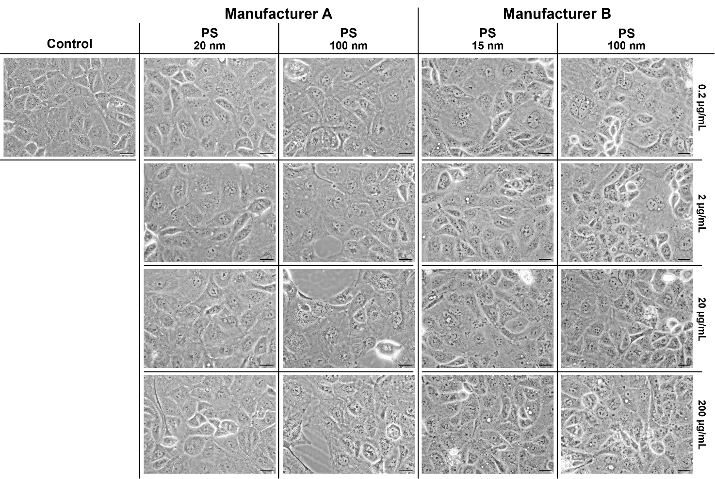
Supplementary Fig. 1 Micrographs of HK-2 cells following 24-hour exposure to PS NPs of various sizes from two different manufacturers. All cells were treated with either 15 nm, 20 nm or 100 nm PSNPs at increasing concentrations from 0.2 µg/mL to 200 µg/mL, top to bottom. 40x magnification. Scale bar = 25 µm. N=3. Data is representative of individual replicates tested
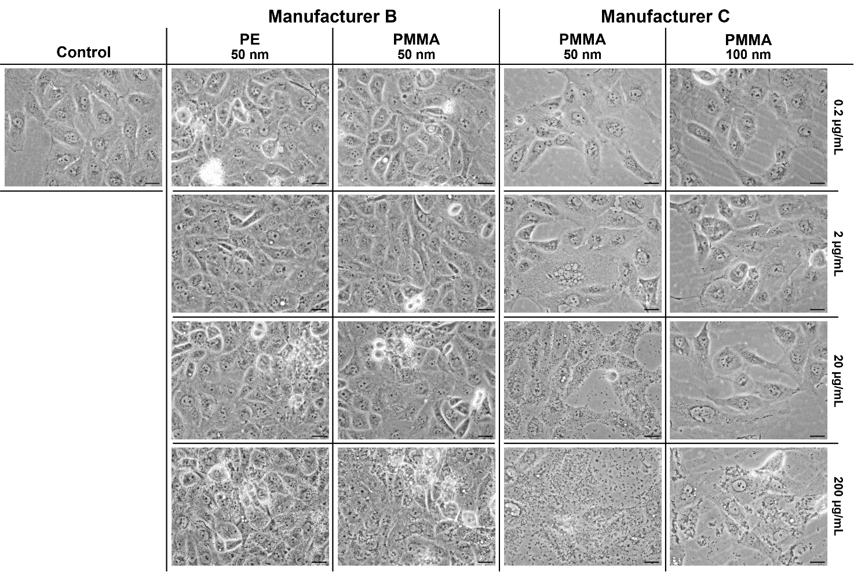
Supplementary Fig. 2 Micrograph images of HK-2 cells exposed for 24-hours to various concentrations of NPs from multiple manufacturers. Cells were exposed to 50 nm and 100 nm PE and PMMA NPs at increasing concentrations from 0.2 µg/mL to 200 µg/mL, top to bottom. 40x magnification. Scale bar = 25 µm. Data is representative of individual replicates tested. N=3

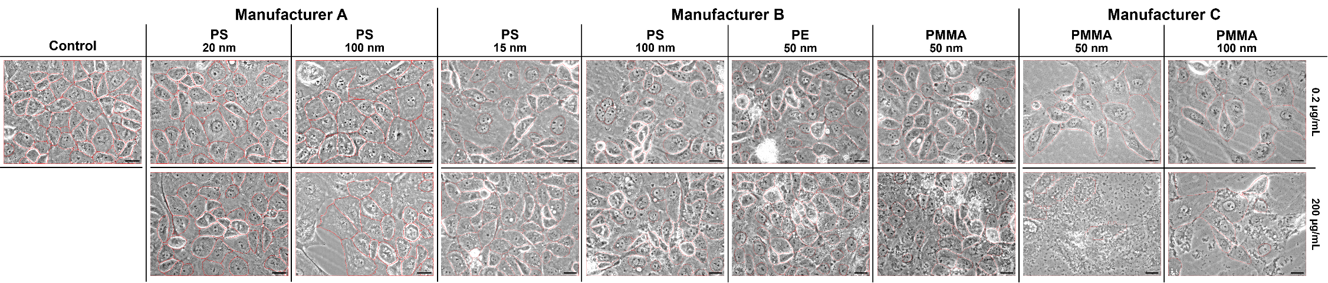
Supplementary Fig. 3 Cell segmentation of HK-2 cell micrographs following 24-hour exposure to NPs of various sizes and polymers from three different manufacturers. All cells were treated with either 15 nm, 20 nm or 100 nm PS NPs, 50 nm PE NPs, and 50 nm or 100 nm PMMA NPs at increasing concentrations from 0.2 µg/mL to 200 µg/mL. 40x magnification. Scale bar = 25 µm. Cell segmentation was performed using QuPath.
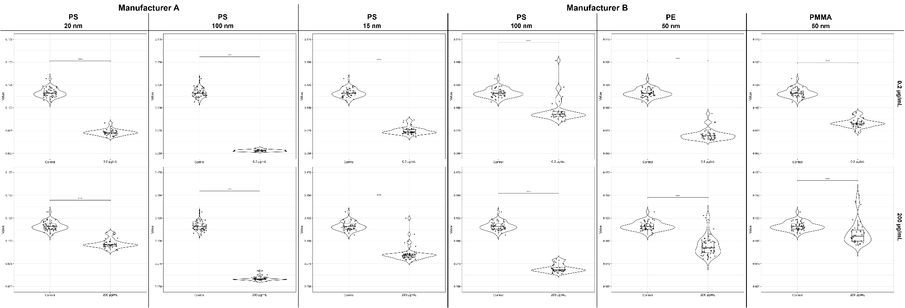
Supplementary Fig. 4 Assessment of mean cell intensity in HK-2 cells following 24-hours of NP exposure. Cell morphology was assessed via QuPath cell segmentation and analysis. Data is representative of individual replicates tested and normalised to the ROI area. Adjusted P-value = **** ≤0.0001

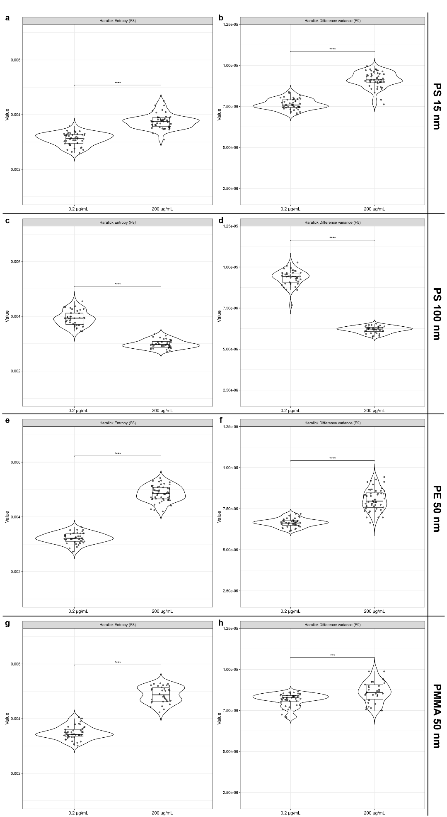
Supplementary Fig. 5 Assessment of cell morphology via Haralick Entropy and Difference in Variance in HK-2 cells following 24-hours of NP exposure. Cell morphology was assessed via QuPath cell segmentation and analysis comparing 0.2 µg/mL and 200 µg/mL NP concentrations. a) Entropy and b) Difference of Variance of 15 nm PS NPs. c) Entropy and d) Difference of Variance of 100 nm PS NPs. e) Entropy and f) Difference of Variance of 50 nm PE NPs. g) Entropy and h) Difference of Variance of 50 nm PMMA NPs. Data is representative of individual replicates tested and normalised to the ROI area. Adjusted P-value = **** ≤0.0001
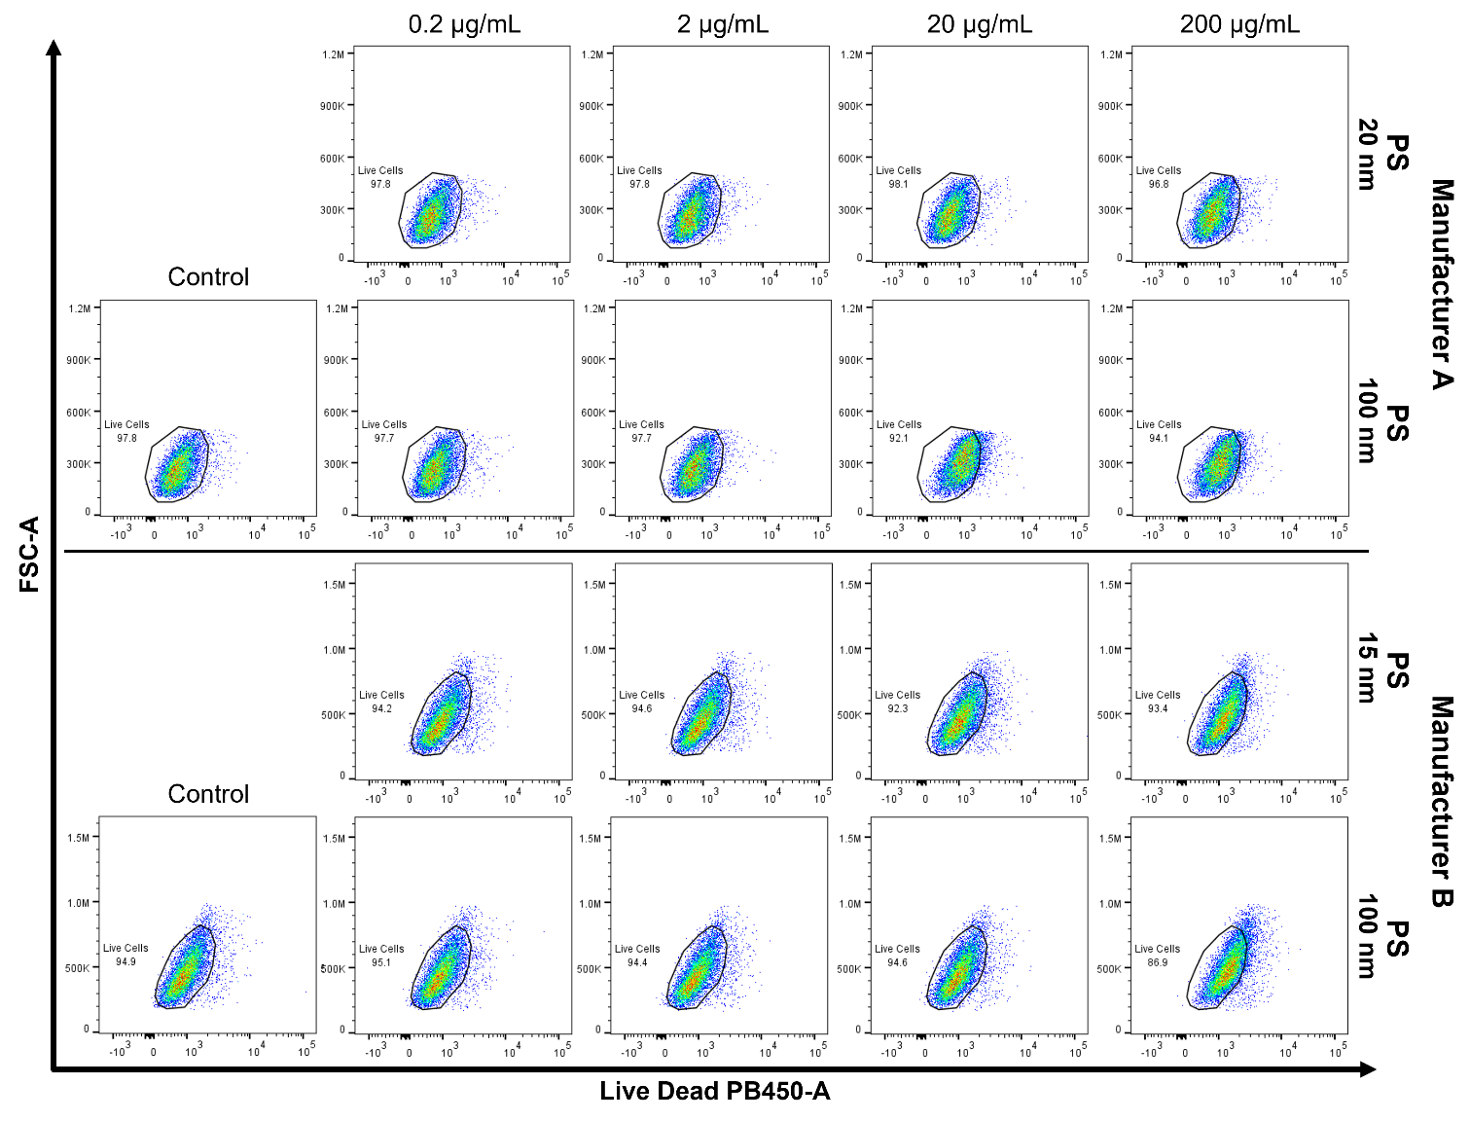
Supplementary Fig. 6 Flow cytometry assessment of the viability of HK-2 cells after 24-hour exposure with varying concentrations and sizes of PS NPs from different manufacturers. Cell viability was assessed using LIVE/DEAD™ Fixable Aqua Dead Cell Stain. Cells were exposed with increasing concentrations of PS NPs from 0.2 µg/mL to 200 µg/mL (Left to right). N=3. Data is representative of individual replicates tested
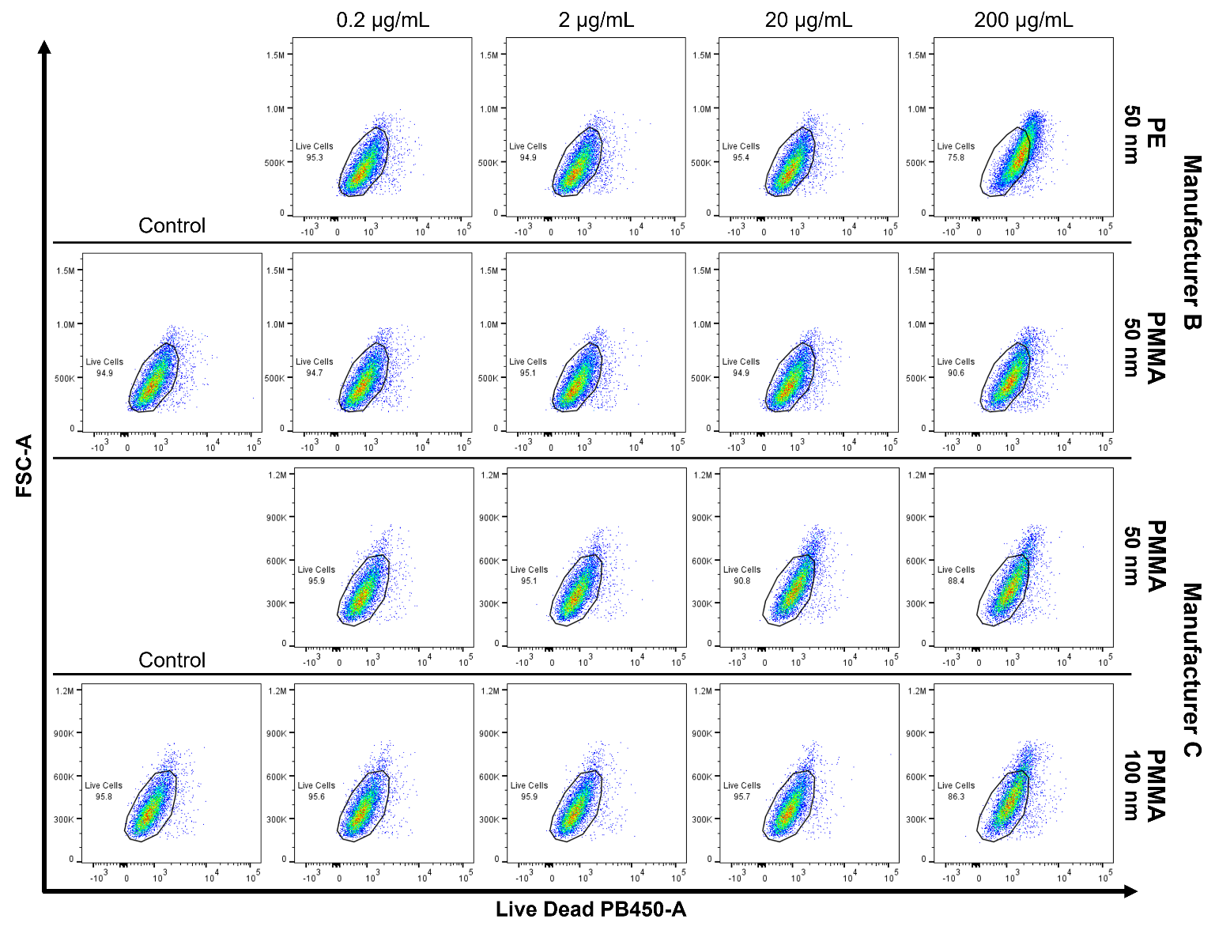
Supplementary Fig. 7 Assessment of cell viability of HK-2 cells via flow cytometry after staining with LIVE/DEAD™ Fixable Aqua Dead Cell Stain. Cells were exposed to 50 nm and 100 nm PE and PMMA NPs from two different manufacturers at concentrations of 0.2 µg/mL to 200 µg/mL (Left to right). N=3. Data is representative of individual replicates tested

Supplementary Fig. 8 Comparing the cell viability of HK-2 cells exposed to PS NPs spiked with NaN₃ and Tween-20 after 24-hours of exposure at NP concentrations from 0.2 µg/mL to 200 µg/mL. Viability was assessed via flow cytometry using Live/Dead Aqua to fluorescently label the cells. Cells were treated with 20 nm and 100 nm PS NPs from Manufacturer A both as they were supplied and spiked with NaN₃ and Tween-20 at equivalent concentrations to those supplied in NP suspensions from Manufacturer B. N=2. Data is representative of combined replicates and is expressed as mean with SEM. Significance was determined via two-way ANOVA with multiple comparisons Uncorrected Fisher’s least-significant difference test. P-value = *≤0.05, *** ≤0.001

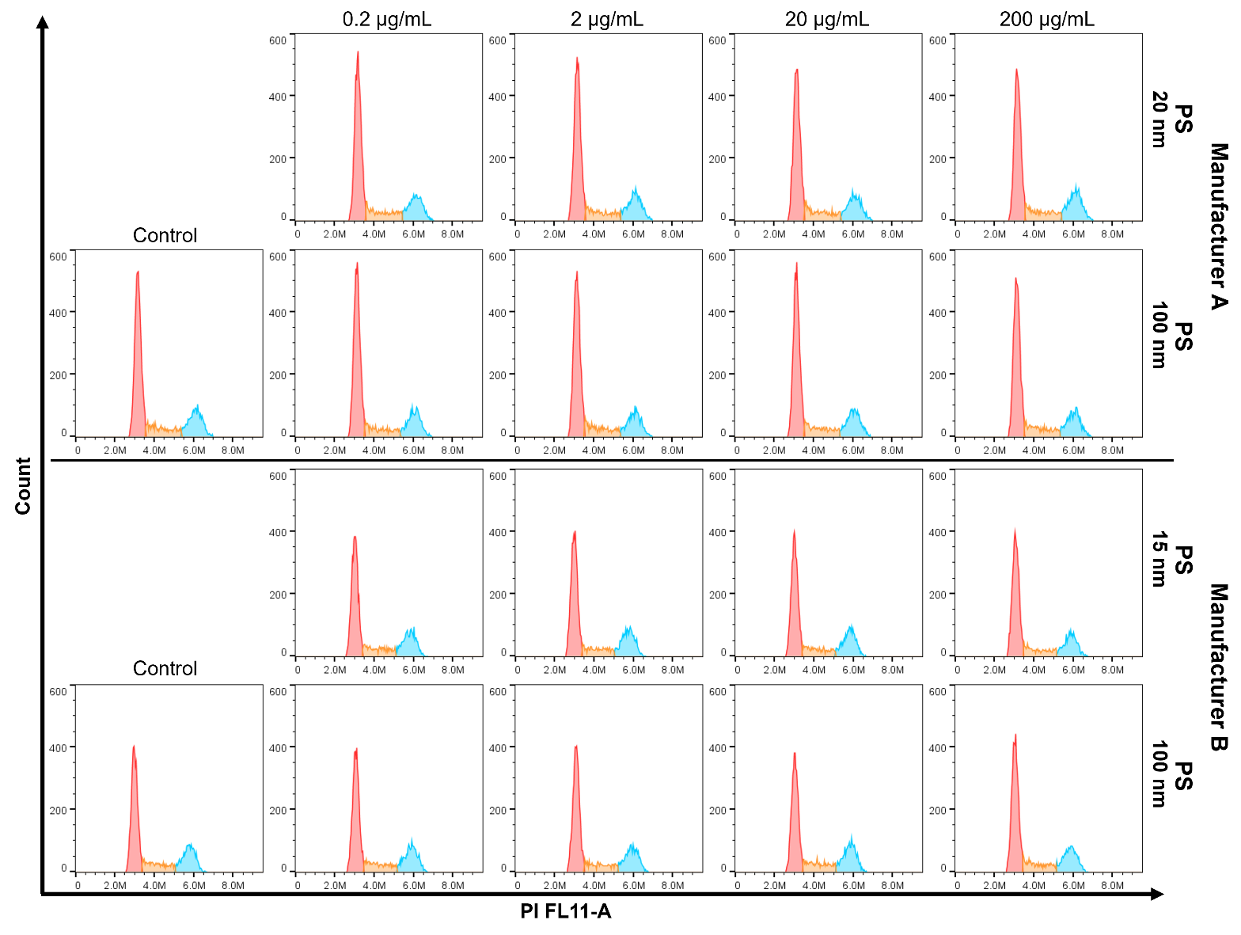
Supplementary Fig. 9 Changes to cell cycle in HK-2 cells exposed to increasing concentrations of PS NPs. Cells were treated with concentrations of PSNPs from 0.2 µg/mL to 200 µg/mL for 24-hours, stained with PI and analysed via flow cytometry. G0/G1 phase = red peak, S phase = orange peak, G2/M phase = blue peak. Data is representative of individual replicates tested. N=3. Cell cycle phase distribution was modelled using the Watson Pragmatic algorithm within FlowJo (BD Biosciences)

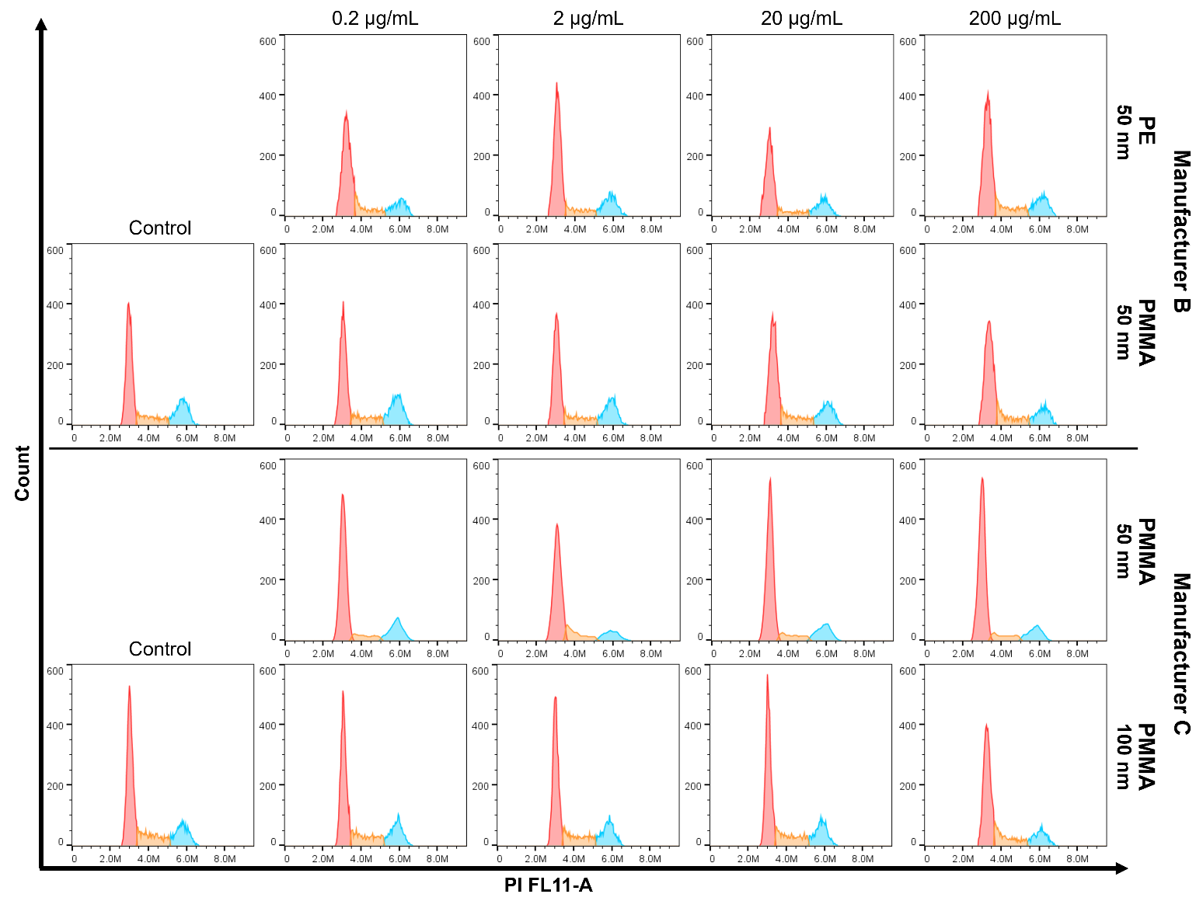
Supplementary Fig. 10 Cell cycle changes in HK-2 cells exposed to PE and PMMA NPs at increasing concentrations. Cells were treated with concentrations of NPs from 0.2 µg/mL to 200 µg/mL for 24-hours, stained with PI and analysed via flow cytometry. G0/G1 phase = red peak, S phase = orange peak, G2/M phase = blue peak. Data is representative of individual replicates tested. N=3. Cell cycle phase distribution was modelled using the Watson Pragmatic algorithm within FlowJo (BD Biosciences)
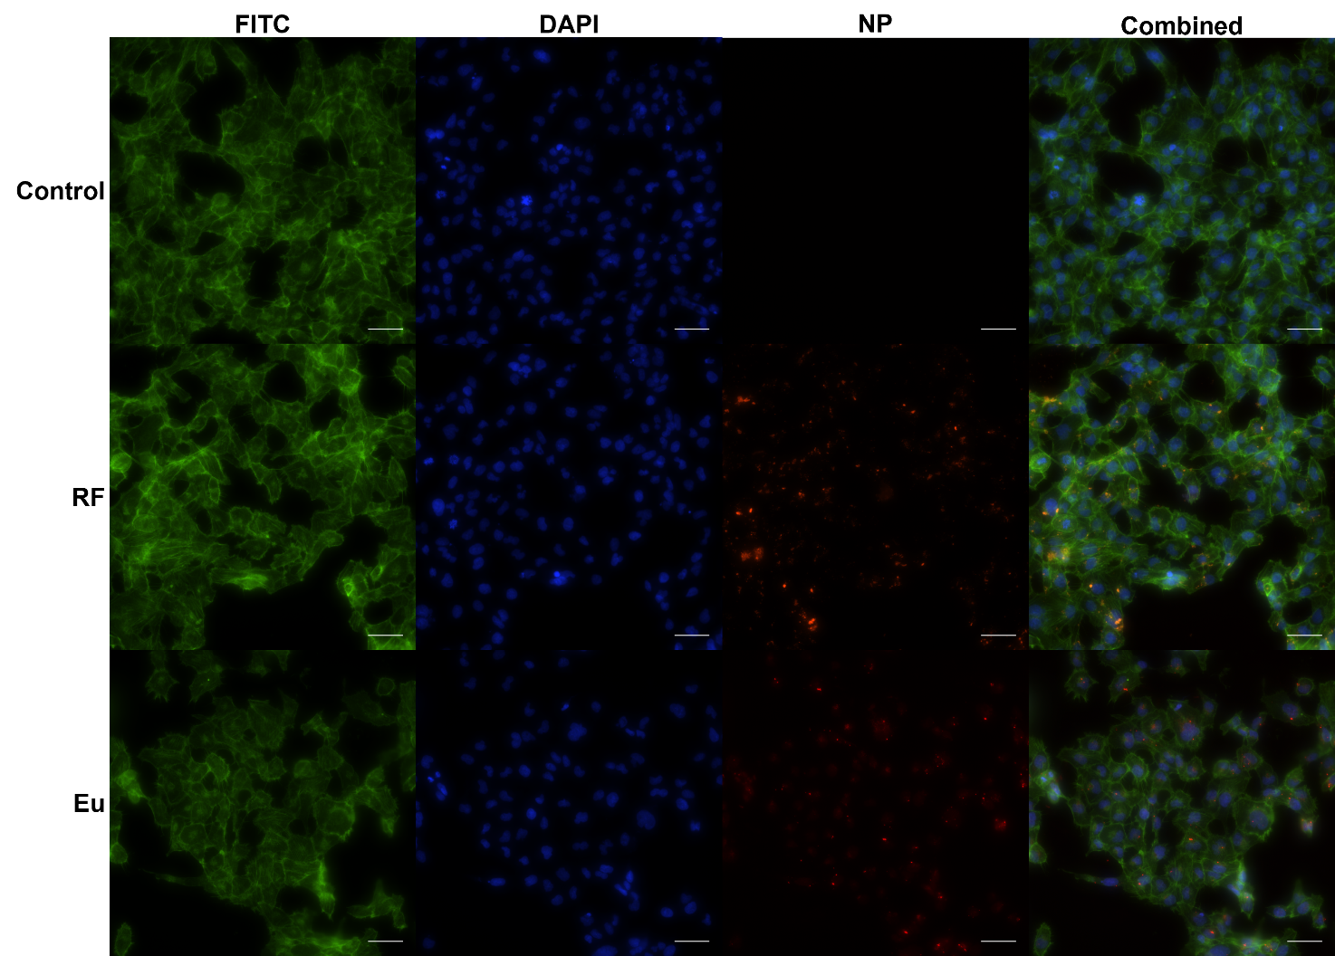
Supplementary Fig. 11 Internalisation of RF and Eu 100 nm PSNPs after 24-hours of exposure at 7 µg/mL. Cytoskeleton stained with Actin Green (Phalloidin), Nucleus stained with NucBlue (Hoescht 33342). Image taken at 400x (10x magnification with 40x objective) on Nikon Ti2 inverted microscope. Scale bar = 50 µm. Data is representative of individual replicates tested. N=3

