Inhibition of FTO attenuates Crohn’s Disease injury and inflammation by increasing BACH2 m6A modifications via YTHDF1-dependent mechanisms

Duo Ma^{2,#}, Xingxing Zhang^{1,#}, Yaling Hong^{1,#}, Famin Zhang¹, Cui Chang ¹, Junjie Zhao¹, Yumeng Wang¹, Wenhu Liu ¹, Qiao Mei³, Lu Zhou^{4,*}, Mingming Liu^{1,*}, Xinhua Liu^{1,*}

¹ School of Pharmacy, Inflammation and Immune Mediated Diseases Laboratory of Anhui Province, Anhui Medical University, Hefei, 230032, P. R. China
² Department of clinical pharmacology, the second affiliated hospital of Anhui Medical University, Hefei, 230601, P. R. China
³ Department of Gastroenterology, First Affiliated Hospital of Anhui Medical University, 230022, Hefei, China
⁴ School of Pharmacy, Fudan University, Shanghai 201203, China

Catalogue
Fig S1. 2
Fig S2. 3
Fig S3. 4
Fig S4. 4
Fig S5. 5
Fig S6: 5
Table S1 6
Table S2-1: Mouse primer sequences 7
Table S2-2: Human primer sequences 8
Table S3: The clinical features of the patients 9
Table S4: The primers of siRNA transfection 9
Table S5: The shRNAs targeting human FTO in Stable Cell Line 10
Table S6: Antibodies in Flow cytometry 10
¹H NMR of compound licochalcon B 12
Certificate of Analysis of compound licochalcon B 14
HPLC of compound licochalcon B 15

Fig S1. A: Representative Immunofluorescence staining pictures of FTO in TNBS-induced IBD. Full picture, Scale bars, 500 μm.
B: Immunofluorescence results were analyzed in mouse Colon of AAV9- packaged FTO knockdown. Full picture, Scale bars, 500 μm.
C. Real-time PCR analysis of FTO mRNA expression in mouse Colon of AAV9- packaged FTO knockdown.
D. predict the outcome of transcription factor binding sites in FTO promoter region using JASPAR database.

Fig S2. A: MeRIP-seq and RNA-seq analysis showing differentially expressed of eight genes in TNBS-induced IBD with controls.
B: The results of real-time PCR analysis of expressed of eight genes in TNBS-induced IBD with controls.
C: Agarose electrophoresis and real-time PCR analysis of RIP assays in HCT-116 cells showing the direct binding between the FTO protein and Bach2 mRNA. (n=3 biological replicates of mice, t test)
Data are means±SEM. *p<0.05, **p<0.01, ***p<0.001.

Fig S3. A: Real-time PCR analysis of FTO mRNA expression in Stable Cell Line (n=2 biological replicates of mice, t test).
B: Real-time PCR analysis of BACH2 mRNA expression in the YTHDF2 or YTHDF3 knockout in HCT-116 cells (n=5 biological replicates of mice, t test)
Data are means ± SEM. *p<0.05, **p<0.01, ***p<0.001.

Fig S4. A: CD4⁺ T cells were handled with nine compounds for a duration of 48 h, and the influence of the drug on cell viability was evaluated utilizing a CCK-8 kit to ascertain any alterations.
B: licochalcone B inhibited the relative enzymatic activity of ALKBH5(three independent replicates).

Fig S5. A: Disease activity index (DAI).
B: Representative H&E staining pictures of colon from licochalcon B and FTO knockdown treatment in TNBS-induced IBD. Scale bars, 500 μm.
C: Representative immunohistochemistry pictures of IL-17a in colon from licochalcon B and FTO knockdown treatment in TNBS-induced IBD. Scale bars, 500 μm.

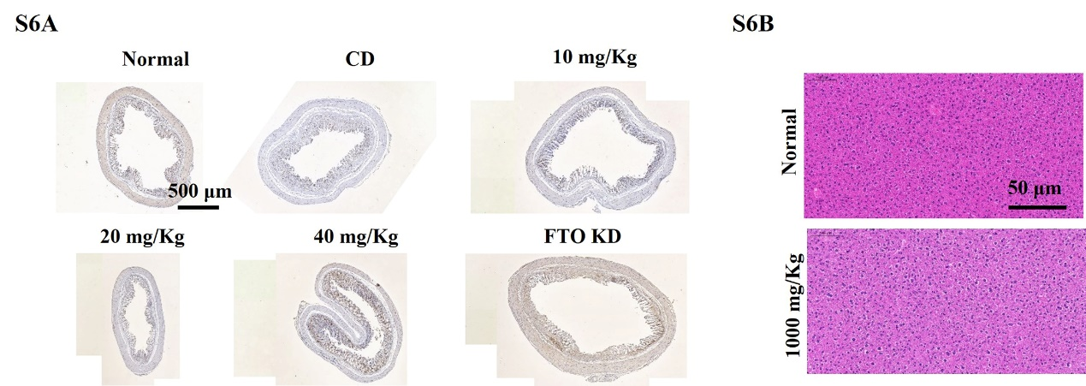
Fig S6: A: Representative H&E staining pictures of Liver injury. Scale bars, 500 μm.
B: Representative immunohistochemistry pictures of BACH2 in colon from licochalcon B and FTO knockdown treatment in TNBS-induced IBD. Scale bars, 500 μm.

Table S1
compound | structure
1
2
3
4
5
6
7
8
9 | ·Mg²⁺

Table S2-1: Mouse primer sequences
Primer name  (mouse) | Sequence (5'to 3')
Primer name  (mouse) | R | F
METTL3 | CCTCGATCTTGGAGCACTCA | GGAGCATCAGTTGCAGAAGG
METTL14 | CAATTCCATGGCCCTTCCTG | ACATGGAGCTACCGTATGGG
WTAP | GGTCAGACTTGGACTTGGGA | ACGCCTTCATCTCTTTGGGA
ALKBH5 | TTGAAGGTTAGCGGGATGGT | TGAGCGAGACCCTGATCTTC
FTO | CTCACCACGTCCCGAAACAA | GACACTTGGCTTCCTTACCTG
TNF-α | ACCTGACCACTCTCCCTTTG | CTCATGCACCACCATCAAGG
IL-1β | TGGATGCTCTCATCAGGACAG | GAAATGCCACCTTTTGACAGTG
IL-10 | ACACCTTGGTCTTGGAGCTT | AGAGAAGCATGGCCCAGAAA
GAPDH | AGACAACCTGGTCCTCAGTG | AATGTGTCCGTCGTGGATCT
BACH2 | CAAGTCATCTTTCGTCTGTCCA | GAGGAAGGAGTTCCGAGCC
IRF4 | CCTCACGATTGTAGTCCTGCTT | CCGACAGTGGTTGATCGACC
CLCA2 | GGCAGGTATGAAACCAGCAG | AGACTGCTCCGACTTCAACA
IFIH1 | CTCATTCCCGCTGTTTCCTG | GATCTGCCCTCTCCTTCCTC
GAL3ST2 | CTGTCTTGTGCGTCTTGAGG | TGGTTGGTTTCCTGCATGTG
ITLN1 | TCTTGTGCCTTTGTGTGCTC | AGTGCAGCTGAAGAGAACCT
CIT | TTGTCATCCTCCTGGGACAC | GCAGGAAATGACCCGGTTAC
SLC9A2 | TTGAAGGTTAGCGGGATGGT | TGAGCGAGACCCTGATCTTC
M6A PEAK-1 | GCAGGAGTCCTCCAGATTGT | CAGTTTGCCTACACTGCCAA
M6A PEAK-2 | ACGCGAGCTGGTACTTCTTA | GTACCCACAGACACCAAGGA
M6A PEAK-3 | CTCCTGGCCCCTGTCCTG | AGGTCACGGCCAGGGGCT
M6A-1 | AAGTCATCTTTCGTCTGTCCAAC | GGTTTGAACGGCATGTCTGTG
M6A-2 | GCAGGAGTCCTCCAGATTGT | CAGTTTGCCTACACTGCCAA
M6A-3 | CAGTTTCCGTATTTCACATTCCAAG | GTTAAACTTCCTTTTCCTGTCGATC
M6A-4 | ACGCGAGCTGGTACTTCTTA | GTACCCACAGACACCAAGGA
YTHDF1 | ATTGCTGCTAAGACTGCTGTAGTG | ACCTCTCTCATCTGGGTGTTCTTC
YTHDF2 | ACATTTGTCCCACCATTGCC | GCAGTTAAGACGGTGGGTTC
YTHDF3 | AGACGAATGTGTCGCAGTTG | TTTCAGTGTCAACGGCAGTG
IL-17a | ATGAGTTTTTCCCTTATGGGGAC | GCTGGAAGTTGGACACCTCAA

Table S2-2: Human primer sequences
Primer name  (human) | Sequence (5'to 3')
Primer name  (human) | R | F
FTO | TGTGCAGTGTGAGAAAGGCTT | ACTTGGCTCCCTTATCTGACC
BACH2 | CCTGAGTGATCCCCTTGTCAAAA | AAGGTCTCTGTTCAGCATAACG
YTHDF1 | TTGTTTCGACTCTGCCGTTC | CCAGGAGGTGCCCTTAGAAA
YTHDF2 | AGCAGCATCCAGTCTCTTGT | TGGAGAAGCTTCGGTCCATT
YTHDF3 | GAGCCTTTACCACTGACCCT | GCAGCACCTAAACCAACCTC
GAPDH | GGCTGTTGTCATACTTCTCATGG | GGAGCGAGATCCCTCCAAAAT

Table S3: The clinical features of the patients
age | sample | pathology
49 | normal | polyp of colon
50 | normal | polyp of colon
57 | normal | polyp of colon
37 | CD | Chronic mucositis; granulomas
31 | CD | Chronic mucositis; granulomas
18 | CD | Chronic mucositis; granulomas
67 | CD | Chronic mucositis; granulomas

Table S4: The primers of siRNA transfection
name | sequence（5’ to 3’) | Sequence (3’ to 5’)
YTHDF1（h）-si-1 | GCUCAACCGCAGUAUCAGATT | UCUGAUACUGCGGUUGAGCTT
YTHDF1（h）-si-2 | GUCCAUUGGAUUUCCUUATT | UAAGGAAAUCCAAUGGACGTT
YTHDF1（h）-si-3 | GGAGAAUAACGACAACAAATT | UUUGUUGUCGUUAUUCUCCTT
YTHDF2（h）-si-1 | GGUGAAGCUGCUUGGUCUATT | UAGACCAAGCAGCUUCACCTT
YTHDF2（h）-si-2 | AAGGACGUUCCCAAUAGCCAATT | UUGGCUAUUGGGAACGUCCUUTT
YTHDF2（h）-si-3 | UUCGGUCCAUUAAUAACUAUATT | UAUAGUUAUUAAUGGACCGAATT
YTHDF3（h）-si-1 | GCCUCAGCCAUUAAUUCAATT | UUGAAUUAAUGGCUGAGGCTT
YTHDF3（h）-si-2 | GGGCAAAUUUGAAGUUAAATT | UUUAACUUCAAAUUUGCCCTT
YTHDF3（h）-si-3 | UAAGUCAAAGAAGACGUAUUATT | UAAUACGUCUUCUUUGACUUATT

Table S5: The shRNAs targeting human FTO in Stable Cell Line
serial number | name | sequence（5’ to 3’)
FTOKD1 | LV3-FTO-homo-399 | GGAGCTCCATAAAGAGGTTCA
FTOKD2 | LV3-FTO-homo-610 | GCTGAAATAGCCGCTGCTTGT
FTOKD3 | LV3-FTO-homo-811 | GCAGCATACAACGTAACTTTG

Table S6: Antibodies in Flow cytometry
Antibody | Catalog no. | Company
anti-mouse  IL-17A | 506903 | Biolegend
Recombinant  Mouse IL-6 | 575702 | Biolegend
Purified anti-mouse  IFN-γ | 505834 | Biolegend
Purified anti-mouse  IL-4 | 504122 | Biolegend
Recombinant Murine  IL-1β | 211-11B-10UG | Biolegend
CD25 | 101910 | Biolegend
CD3 | 100204 | Biolegend
CD45.2 | 109830 | Biolegend
CD4 | 100540 | Biolegend
FOXP3 | 126404 | Biolegend
CD44 | 103012 | Biolegend
CD69 | 104507 | Biolegend

¹H NMR of compound licochalcon B
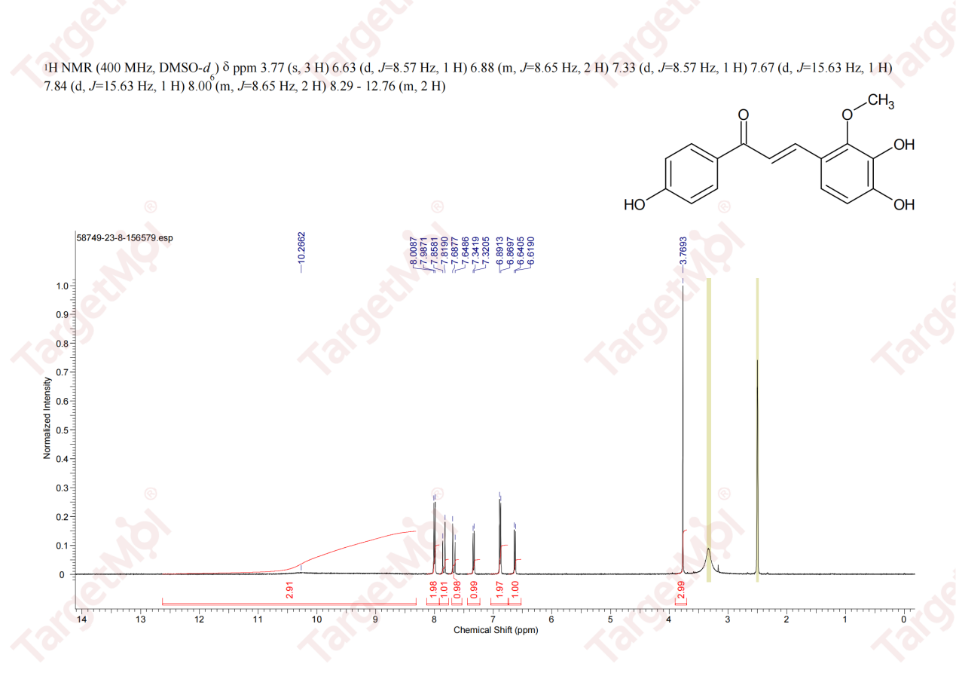

Certificate of Analysis of compound licochalcon B
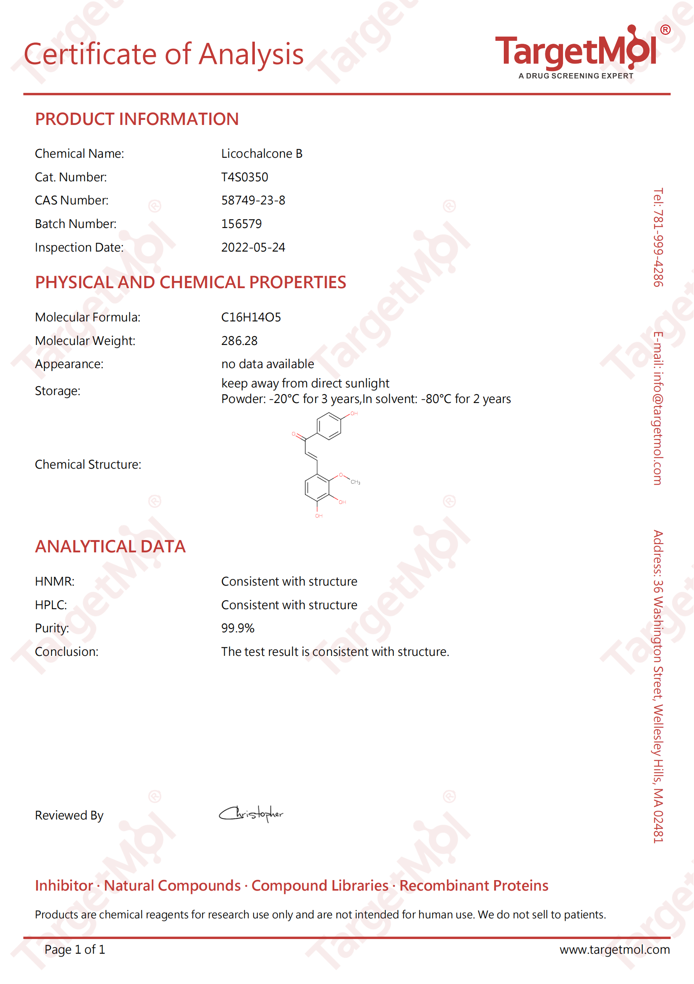

HPLC of compound licochalcon B
