Oligosaccharide oxidase for the enzymatic synthesis of glucosaminic acids
Olanrewaju Raji¹, Thu V. Vuong¹, Nadia Davoudvandi^{1,2}, and Emma R. Master^{1,3*}

¹ Department of Chemical Engineering and Applied Chemistry, University of Toronto, 200 College Street, Toronto, Ontario, M5S 3E5, Canada.
²Department of Biological and Biomedical Engineering, McGill University, 3775, rue University, Montréal, QC H3A 2B4, Canada
³Department of Bioproducts and Biosystems, Aalto University, Kemistintie 1, 02150 Espoo, Finland.

*Corresponding author
Emma R. Master
Email: emma.master@utoronto.ca
Phone number: +1416-946-7861

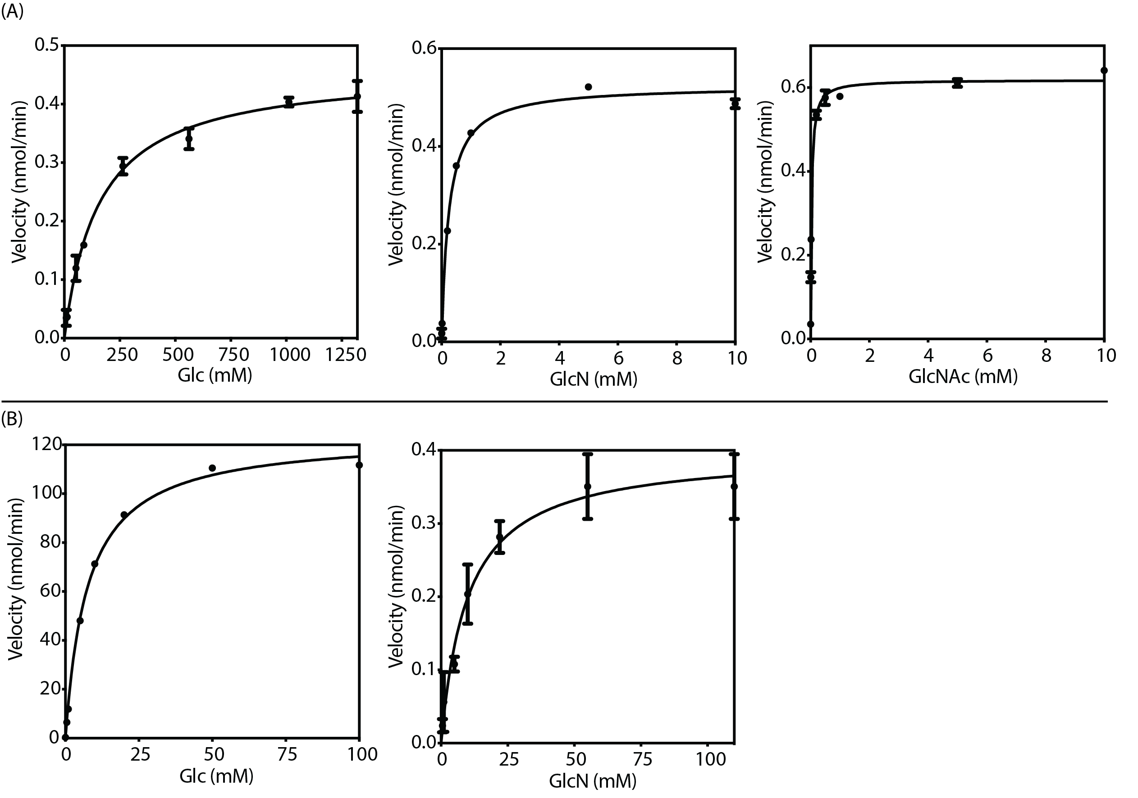
Figure S1. Michaelis-Menten fits for kinetics data of LbChi7A (A) and GOX (B). (The kinetics on Glc (1–1,320 mM), GlcN (0.01–110 mM), and GlcNAc (0.01–10 mM) were carried out in 50 mM sodium phosphate pH 8.0 at 30 °C.

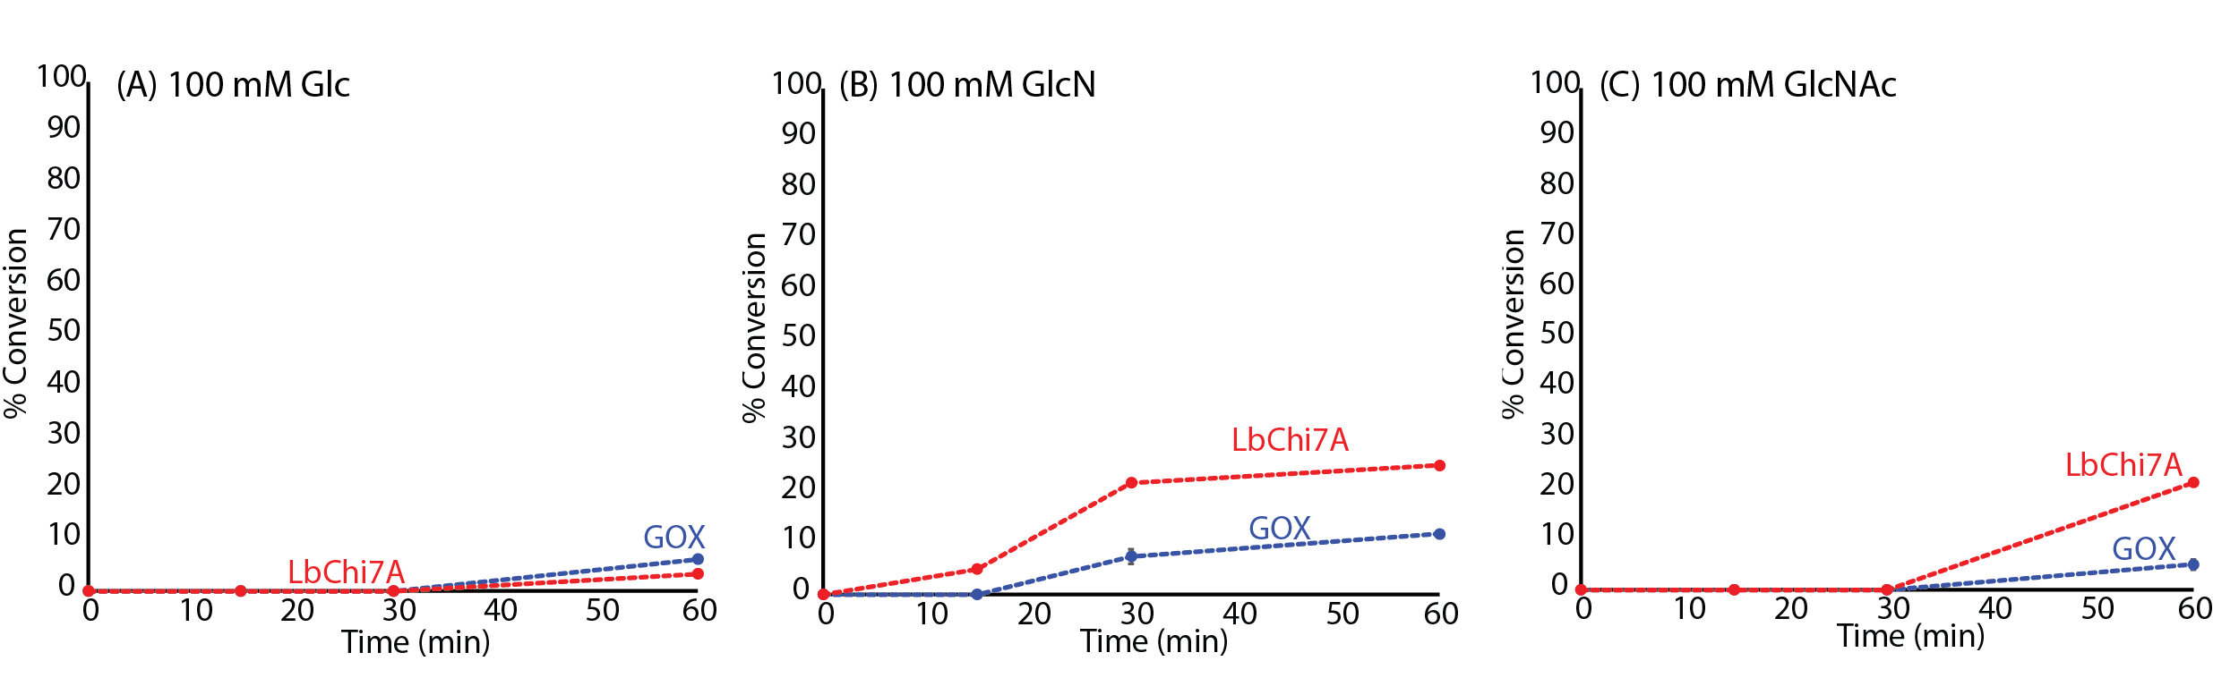
Figure S2. Time course conversion of LbChi7A and GOX at 0.05 µM of enzyme loading. GOX (blue) or LbChi7A (red) were incubated with 100 mM Glc (A), GlcN (B), and GlcNAc (C) at 30 °C. Samples were aliquoted at 15 min, 30 min, and 60 min. For each time point, residual substrate was quantified by HPAEC-PAD against a standard curve. Every point is the average of three independent assays measured individually, with error bars indicating the standard error of the mean.

