Pheromone and morphometric features of honey bee (Apis mellifera) queens from around the globe
Alison McAfee^{1,2‡}*, Brendan Daisley^{3‡}, Dylan Brettingham³, Elizabeth Mallory³, Christine Macpherson³, Armando Alcazar Magaña^{1,4}, Emma Allen-Vercoe³, David R Tarpy², and Leonard J Foster^{1,4}*
- Michael Smith Laboratories, Department of Biochemistry and Molecular Biology, University of British Columbia, Vancouver, BC, Canada
- Department of Applied Ecology, North Carolina State University, Raleigh, NC, USA
- Molecular and Cellular Biology, University of Guelph, Guelph, ON, Canada
- Life Sciences Institute, Department of Biochemistry and Molecular Biology, University of British Columbia, Vancouver, BC, Canada
‡ These authors contributed equally
*Corresponding authors: alison.n.mcafee@gmail.com (AM), foster@msl.ubc.ca (LJF)

Supplementary Figures
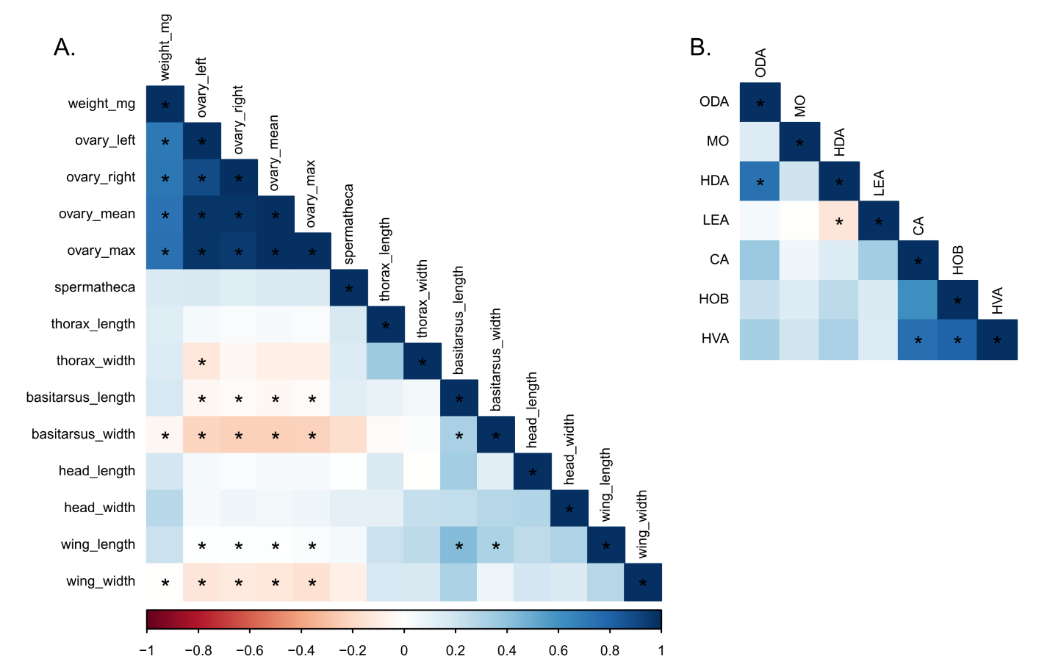
Figure S1. Pearson correlation matrices. Asterisks indicate significant p values (no multiple hypothesis testing correction). A) Morphometric measurements. B) Pheromone measurements. ODA = E-9-oxodec-2-enoic acid; HDA = 9(R/S)-hydroxydec-2(E)-enoic acid, MO = methyl oleate, LEA = linolenic acid, CA = coniferyl alcohol, HOB = methyl p-hydroxybenzoate, HVA = 4-hydroxy-3-methoxyphenylethanol.
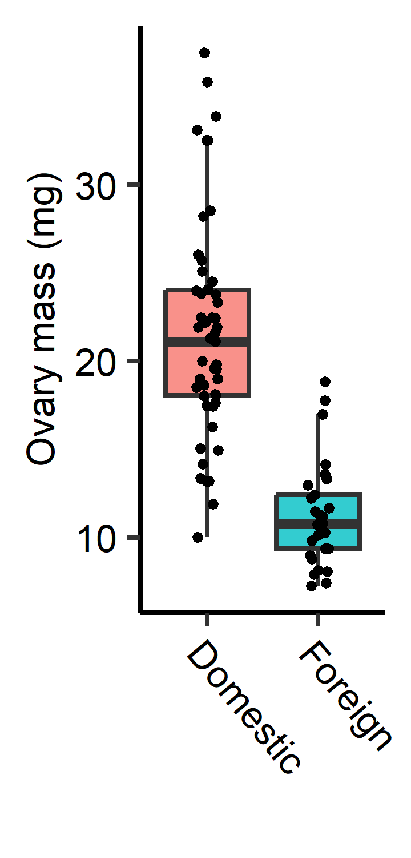
Figure S2. Ovary masses in domestic (Canadian) and international queens. Welch’s t test; t=8.4, df=78, p=1.5x10⁻¹².

