Supplementary Information

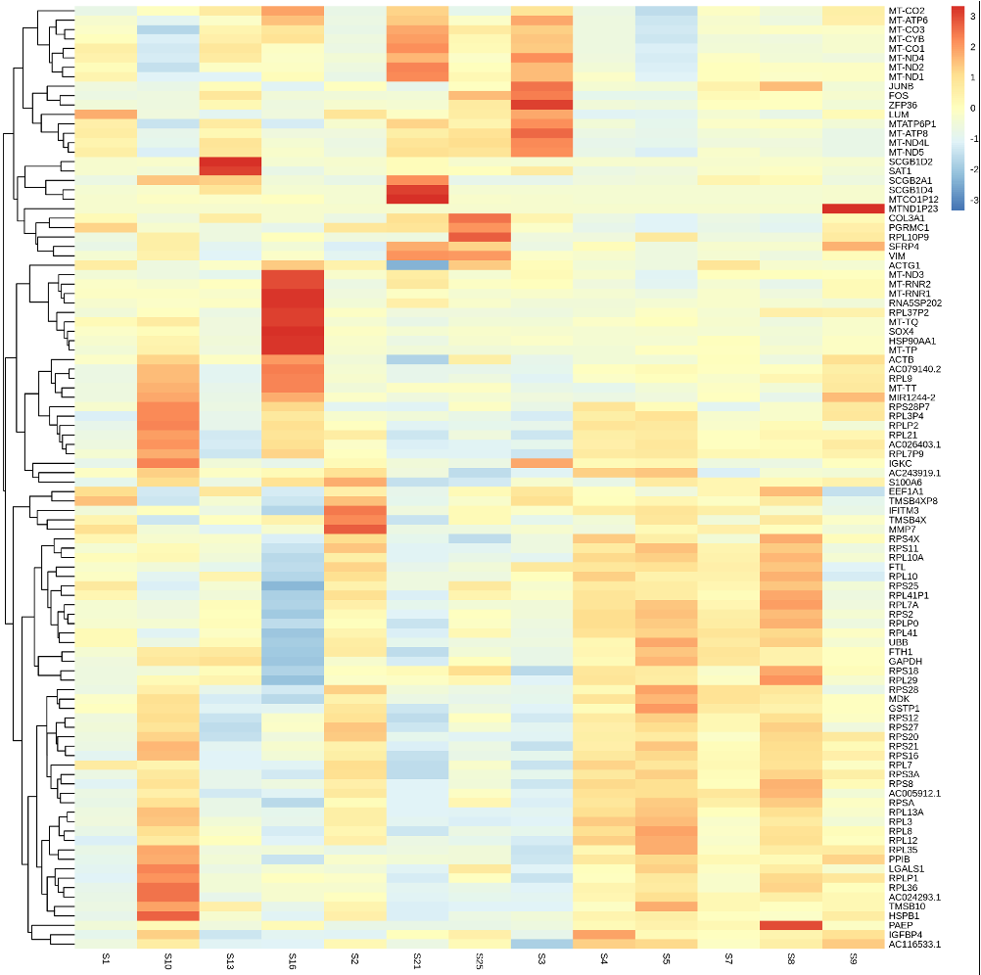
Fig. S1. Heatmap of Differential Gene Expression Across Endometrial Disease Groups. The heatmap illustrates gene expression patterns in different endometrial disease groups, including infertility, endometriosis, benign tumors, endometrial carcinoma, and controls. Key genes are highlighted, with clustering based on expression levels. Red indicates high expression, while blue shows low expression. This visualization provides insights into the transcriptional changes associated with various endometrial conditions.

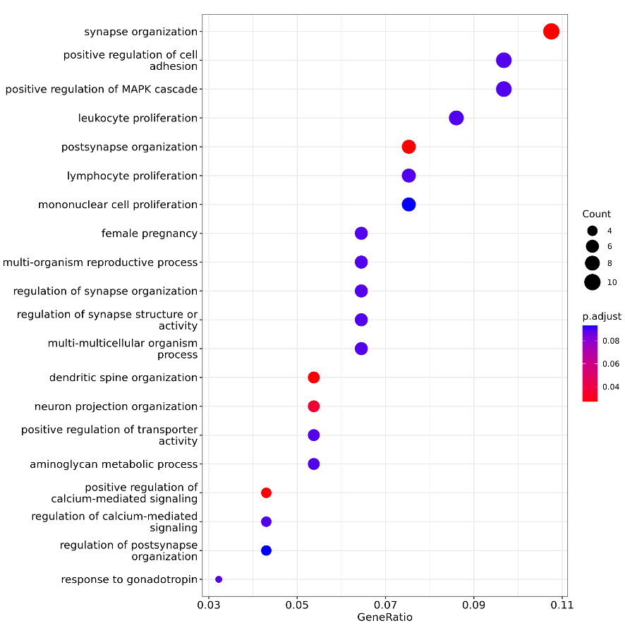

Fig. S2. Gene Ontology (GO) enrichment analysis for biological processes related to inflammation and cell proliferation. The plot highlights enriched GO terms, with GeneRatio on the x-axis representing the proportion of genes linked to each process. Dot sizes reflect the number of genes associated with each term, and colors indicate the adjusted p-value, with red indicating higher significance. Key processes like "leukocyte proliferation," "lymphocyte proliferation," and "mononuclear cell proliferation" are emphasized, reflecting inflammation observed in clinical samples.

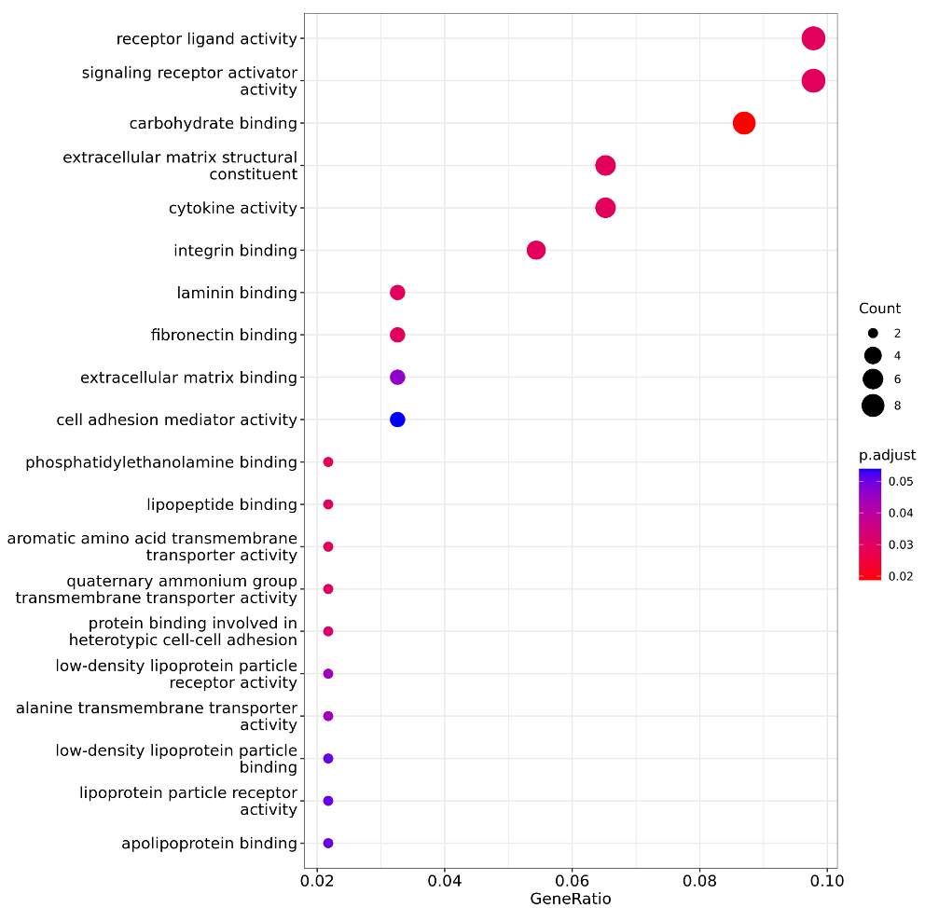

Fig. S3. Gene Ontology (GO) Enrichment Analysis for Molecular Functions. The plot highlights the enrichment of molecular functions based on differential gene expression. Key terms include receptor ligand activity and extracellular matrix binding, with color intensity representing p-adjust values. Larger circles indicate a higher number of associated genes for each function, showing the functional categories most impacted by the gene expression changes.

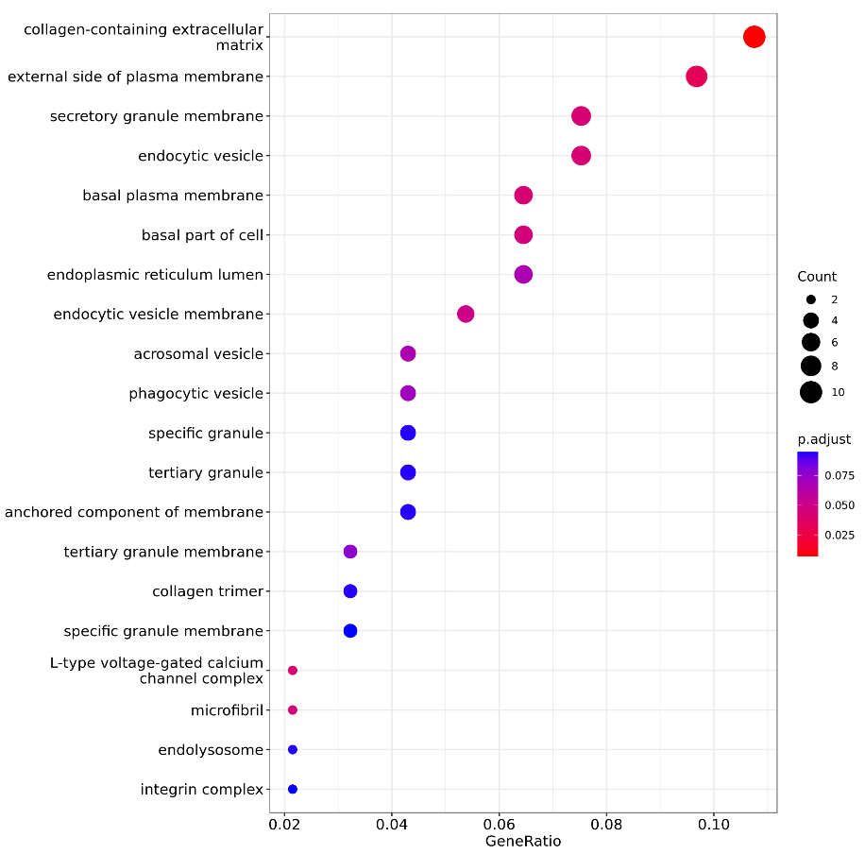

Fig. S4. Gene Ontology (GO) Enrichment Analysis for Cellular Components. The plot shows the enrichment of cellular component terms based on differential gene expression. Key terms include collagen-containing extracellular matrix and secretory granule membrane, with color intensity reflecting p-adjust values. Larger circles represent functional categories with more associated genes, highlighting the cellular structures most influenced by gene expression changes.

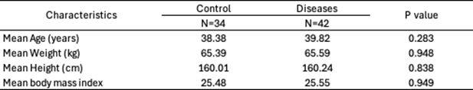
Table S1. Demographic Characteristics of Participants in the Control and Disease Groups.

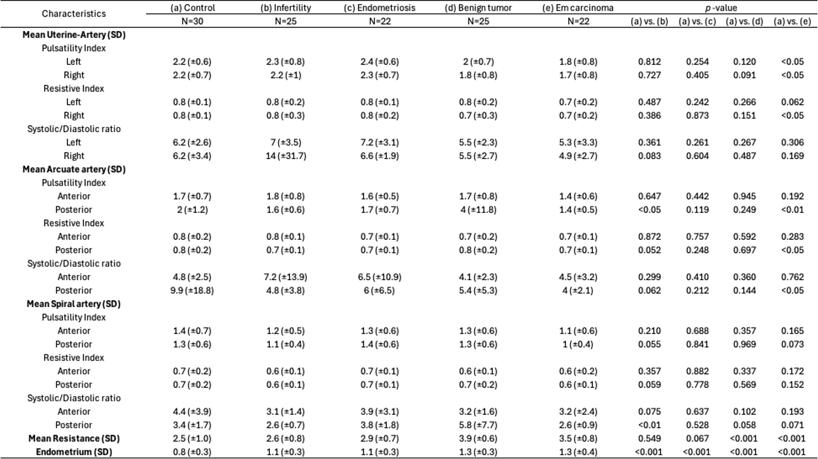
Table S2. Comparative Analysis of Uterine, Arcuate, and Spiral Artery Parameters Using Transvaginal Ultrasound Across Disease Groups with MED Gen Measurements.

Table S3. Demographic Characteristics of Participants Undergoing Biopsy in the Control and Benign Tumor Groups.
