Supplementary Materials
Optimization of Cr/SBA-15 Catalysts for CO₂-Assisted Oxidative Dehydrogenation of Propane to Propylene
Armin Moniri¹, Sandeep Badoga¹, Mohamed Ali¹, Jinwen Chen¹ and Mohsen Shakouri²
¹ Natural Resources Canada, CanmetENERGY Devon, 1 Oil Patch Drive, Devon, AB, T9G 1A8, Canada
² Canadian Light Source, Saskatoon, Saskatchewan, Canada, 44 Innovation Blvd, Saskatoon, SK S7N 2V3
Correspondence: armin.moniri@NRCan-RNCan.gc.ca

- Supplementary Tables
TABLE S1. Quadruplicate ODH data for each Taguchi condition (two runs × two GC injections) including the optimal run (Run 10), corresponding to data in Table 4.
No. | T (°C) | Cr (wt %) | W/F  (g min mL⁻¹) | Propane Conversion (%) | CO₂ Conversion (%) | Propylene Selectivity (%) | Ethylene Selectivity (%)
1 a | 550 | 5 | 0.010 | 22.1 | 11.1 | 70.2 | 3.0
1 b | 550 | 5 | 0.010 | 22.9 | 11.3 | 69.1 | 3.1
1 c | 550 | 5 | 0.010 | 21.7 | 10.6 | 71.4 | 2.9
1 d | 550 | 5 | 0.010 | 22.4 | 10.8 | 70.6 | 3.1
2 a | 550 | 7 | 0.015 | 18.4 | 3.2 | 88.5 | 5.0
2 b | 550 | 7 | 0.015 | 18.1 | 3.3 | 87.2 | 5.1
2 c | 550 | 7 | 0.015 | 19.1 | 3.1 | 89.6 | 4.7
2 d | 550 | 7 | 0.015 | 18.7 | 3.4 | 88.1 | 5.2
3 a | 550 | 10 | 0.020 | 28.9 | 12.8 | 75.7 | 3.3
3 b | 550 | 10 | 0.020 | 28.1 | 12.5 | 76.9 | 3.2
3 c | 550 | 10 | 0.020 | 29.4 | 13.0 | 74.5 | 3.4
3 d | 550 | 10 | 0.020 | 28.7 | 12.6 | 75.9 | 3.3
4 a | 600 | 5 | 0.015 | 33.1 | 8.7 | 84.1 | 5.8
4 b | 600 | 5 | 0.015 | 32.4 | 8.5 | 82.9 | 6.0
4 c | 600 | 5 | 0.015 | 34.3 | 8.9 | 83.6 | 5.6
4 d | 600 | 5 | 0.015 | 32.9 | 8.6 | 84.7 | 5.9
5 a | 600 | 7 | 0.020 | 32.9 | 8.2 | 84.1 | 6.4
5 b | 600 | 7 | 0.020 | 31.6 | 8.0 | 83.5 | 6.3
5 c | 600 | 7 | 0.020 | 33.4 | 8.4 | 84.9 | 6.2
5 d | 600 | 7 | 0.020 | 32.5 | 8.1 | 83.8 | 6.6
6 a | 600 | 10 | 0.010 | 25.6 | 7.9 | 83.7 | 6.8
6 b | 600 | 10 | 0.010 | 24.9 | 7.7 | 82.5 | 7.0
6 c | 600 | 10 | 0.010 | 25.8 | 8.1 | 84.3 | 6.6
6 d | 600 | 10 | 0.010 | 26.3 | 7.8 | 83.4 | 6.9
7 a | 650 | 5 | 0.020 | 45.7 | 13.4 | 74.5 | 17.0
7 b | 650 | 5 | 0.020 | 46.9 | 13.1 | 73.2 | 17.5
7 c | 650 | 5 | 0.020 | 44.2 | 13.7 | 75.4 | 16.8
7 d | 650 | 5 | 0.020 | 45.3 | 13.5 | 74.7 | 17.1
8 a | 650 | 7 | 0.010 | 37.7 | 11.9 | 71.7 | 15.8
8 b | 650 | 7 | 0.010 | 38.1 | 11.6 | 72.5 | 15.3
8 c | 650 | 7 | 0.010 | 36.4 | 12.0 | 70.9 | 16.1
8 d | 650 | 7 | 0.010 | 37.5 | 11.8 | 71.3 | 15.9
9 a | 650 | 10 | 0.015 | 40.8 | 13.9 | 72.6 | 14.8
9 b | 650 | 10 | 0.015 | 39.4 | 13.5 | 71.2 | 15.1
9 c | 650 | 10 | 0.015 | 41.2 | 14.1 | 73.4 | 14.4
9 d | 650 | 10 | 0.015 | 40.1 | 13.7 | 72.1 | 14.9
10 a | 600 | 7 | 0.015 | 36.7 | 14.0 | 83.6 | 5.1
10 b | 600 | 7 | 0.015 | 37.0 | 14.3 | 83.9 | 5.4
10 c | 600 | 7 | 0.015 | 37.2 | 14.5 | 84.1 | 5.6
10 d | 600 | 7 | 0.015 | 37.5 | 14.8 | 84.4 | 5.9

TABLE S2. Particle size statistics for Cr/SBA-15 catalysts based on three (50 nm, 100 nm, and 200 nm) TEM images per sample corresponding to Figure 8 and Figure S1.
Catalyst | n | Mean (nm) | Median (nm) | Geo mean ± GSD (nm)
5 % Cr/SBA-15 | 1200 | 3.24 | 3.17 | 3.14 ± 1.29
7 % Cr/SBA-15 | 1531 | 6.84 | 6.59 | 6.59 ± 1.32
10 % Cr/SBA-15 | 1952 | 8.61 | 8.04 | 8.10 ± 1.41

TABLE S3. H₂-TPR peak temperatures and integrated H₂ uptake values for Cr/SBA-15 catalysts with varying chromium loadings, corresponding to data in Figure 11.
Catalyst | Peak # | T_{max} (°C) | Quantity (mmol g⁻¹) | Total H₂ consumption (mmol g⁻¹)
5 % Cr/SBA-15 | 1 | 276 | 15.50 | 17.32
5 % Cr/SBA-15 | 2 | 460.9 | 1.82 | 17.32
7 % Cr/SBA-15 | 1 | 279.5 | 13.86 | 19.01
7 % Cr/SBA-15 | 2 | 426.3 | 5.15 | 19.01
10 % Cr/SBA-15 | 1 | 283.0 | 12.41 | 15.07
10 % Cr/SBA-15 | 2 | 444.5 | 2.66 | 15.07

TABLE S4. Catalytic performance (mean ± SD) for Taguchi runs, the optimal condition (Run 10) and carbon balance, corresponding to data in Table 4.
Run | T  (°C) | Cr  (wt %) | W/F  (g min mL⁻¹) | Propane Conv. (%) | CO₂ Conv. (%) | Propylene Sel. (%) | Ethylene Sel. (%) | C_{out}  (g min⁻¹) | Carbon Recovery (%)
1 | 550 | 5 | 0.010 | 22.3 ± 0.5 | 11.0 ± 0.3 | 70.3 ± 1.0 | 3.0 ± 0.1 | 0.0255 | 93.8
2 | 550 | 7 | 0.015 | 18.6 ± 0.4 | 3.2 ± 0.1 | 88.4 ± 1.0 | 5.0 ± 0.2 | 0.0258 | 95.2
3 | 550 | 10 | 0.020 | 28.8 ± 0.5 | 12.7 ± 0.2 | 75.8 ± 1.0 | 3.3 ± 0.1 | 0.0259 | 95.4
4 | 600 | 5 | 0.015 | 33.2 ± 0.8 | 8.7 ± 0.2 | 83.8 ± 0.8 | 5.8 ± 0.2 | 0.0261 | 96.2
5 | 600 | 7 | 0.020 | 32.6 ± 0.8 | 8.2 ± 0.2 | 84.1 ± 0.6 | 6.4 ± 0.2 | 0.0259 | 95.6
6 | 600 | 10 | 0.010 | 25.6 ± 0.6 | 7.9 ± 0.2 | 83.5 ± 0.7 | 6.8 ± 0.2 | 0.0258 | 95.1
7 | 650 | 5 | 0.020 | 45.5 ± 1.1 | 13.4 ± 0.3 | 74.4 ± 0.9 | 17.1 ± 0.3 | 0.0264 | 97.3
8 | 650 | 7 | 0.010 | 37.4 ± 0.7 | 11.8 ± 0.2 | 71.6 ± 0.7 | 15.8 ± 0.3 | 0.0260 | 96.0
9 | 650 | 10 | 0.015 | 40.4 ± 0.8 | 13.8 ± 0.3 | 72.3 ± 0.9 | 14.8 ± 0.3 | 0.0258 | 95.2
10 | 600 | 7 | 0.015 | 37.1 ± 0.4 | 14.4 ± 0.2 | 84.0 ± 0.5 | 5.5 ± 0.1 | 0.0260 | 95.8
- C_{in} is 0.0271 g min⁻¹ for all runs.

TABLE S5. Response Table for Signal-to-Noise Ratios (Larger is Better), corresponding to data in Table 4.
Level | T (°C) | Cr Loading (wt %) | W/F (g min mL⁻¹)
1 | 37.82 | 37.61 | 37.49
2 | 38.46 | 38.17 | 38.19
3 | 37.24 | 37.74 | 37.84
Delta | 1.23 | 0.56 | 0.70

TABLE S6. Response Table for Means, corresponding to data in Table 4.
Level | T (°C) | Cr Loading (wt %) | W/F (g min mL⁻¹)
1 | 78.17 | 76.17 | 75.13
2 | 83.80 | 81.37 | 81.50
3 | 72.77 | 77.20 | 78.10
Delta | 11.03 | 5.20 | 6.37
Rank | 1 | 3 | 2
- “Delta” = (maximum response − minimum response).
- “Rank” indicates the relative influence of each factor on mean propylene selectivity (1 = highest impact, 3 = lowest).

TABLE S7. Three-factor ANOVA for propylene selectivity (n = 36) for first 9 runs, corresponding to data in Table 4 (and Table S1).
Source | SS | df | MS | F-ratio | p-value
Temperature | 726.2 | 2 | 363.1 | 35.1 | 1.8 × 10⁻⁸
Cr loading | 178.8 | 2 | 89.4 | 8.65 | 1.1 × 10⁻³
W/F | 243.6 | 2 | 121.8 | 11.79 | 1.8 × 10⁻⁴
Residual (error) | 299.6 | 29 | 10.3 | — | —
Total | 1448.2 | 35 | — | — | —

- Supplementary Figures
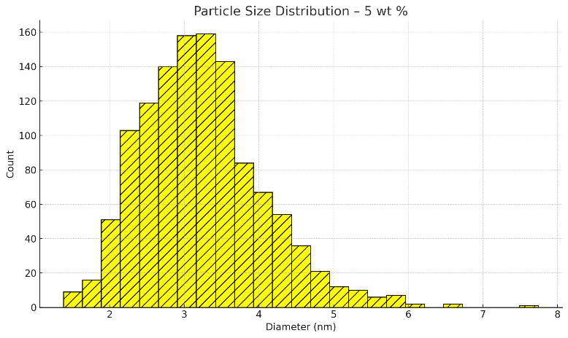
(a)
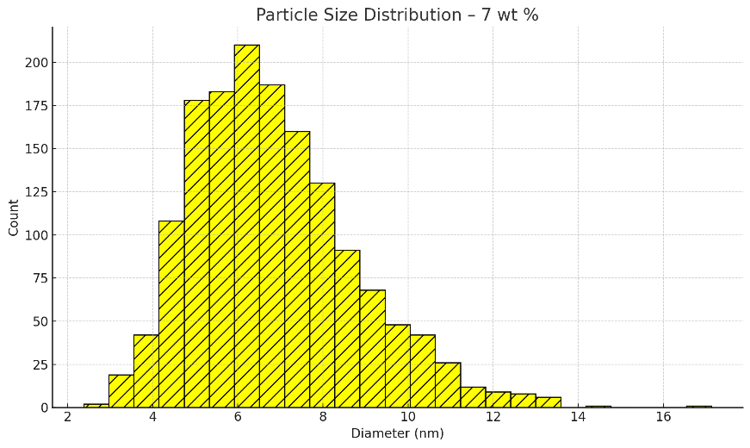
(b)
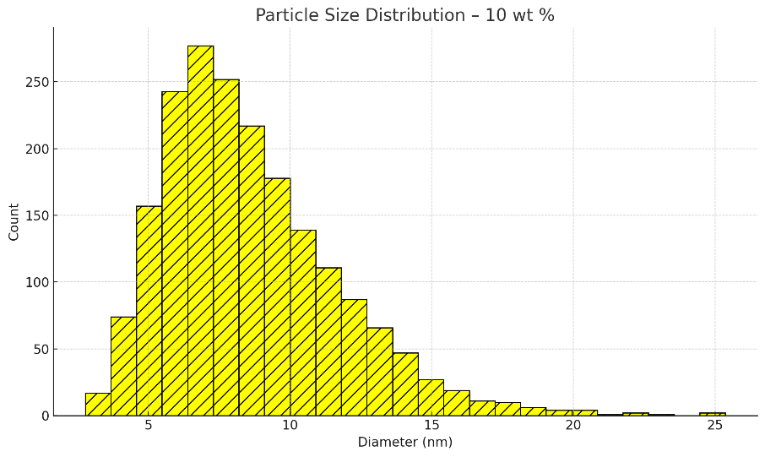
(c)
FIGURE S1. Particle size distribution for (a) 5 % Cr/SBA-15, (b) 7 % Cr/SBA-15 and (c) 10 % Cr/SBA-15 based on three (50 nm, 100 nm, and 200 nm) TEM images per sample.
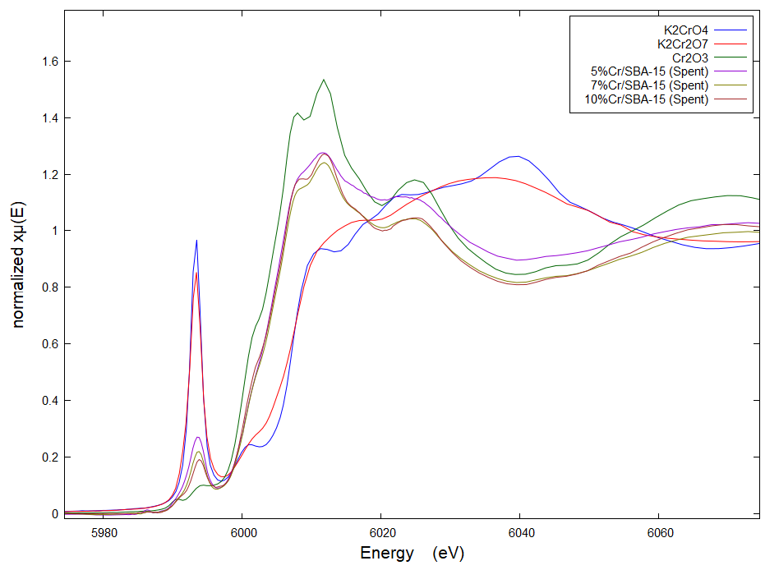
FIGURE S2. Normalized Cr K-edge XANES spectra of Cr/SBA-15 spent catalysts compared to Cr³⁺ and Cr⁶⁺ standards.

