Supplementary figures

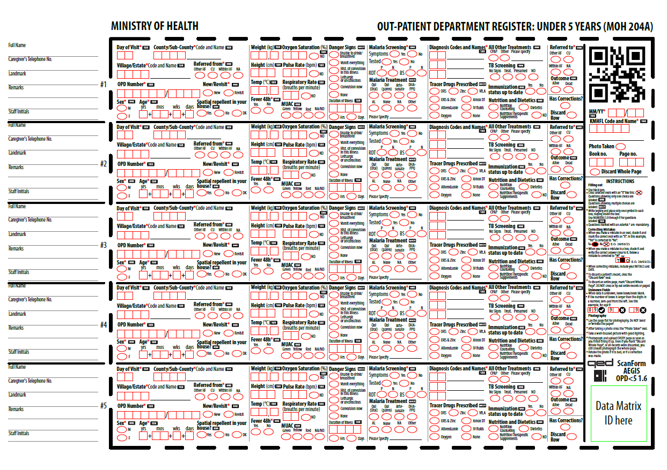Supplementary Figure 2: Scannable Quantitative Engineering Design (QED) outpatient registers for patients under 5 years. The doted region incorporates machine-readable markers and structured fields to enable digital data capture excluding patients unique identifiable.
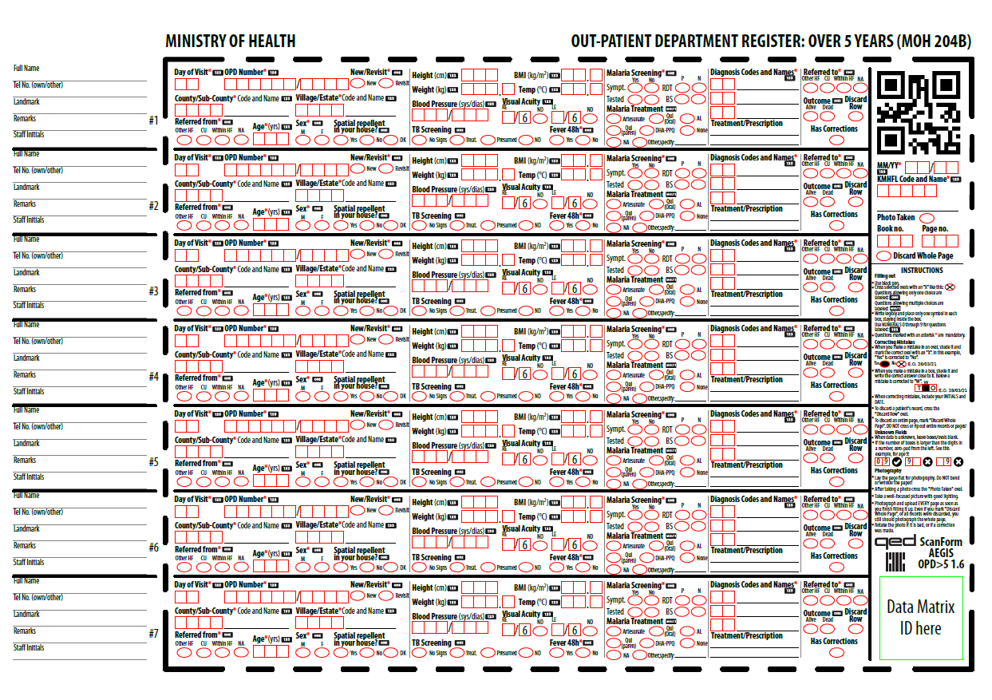
Supplementary Figure 3: Scannable QED outpatient registers for patients over 5 years. The doted region incorporates machine-readable markers and structured fields to enable digital data capture excluding unique identifiers of patients.

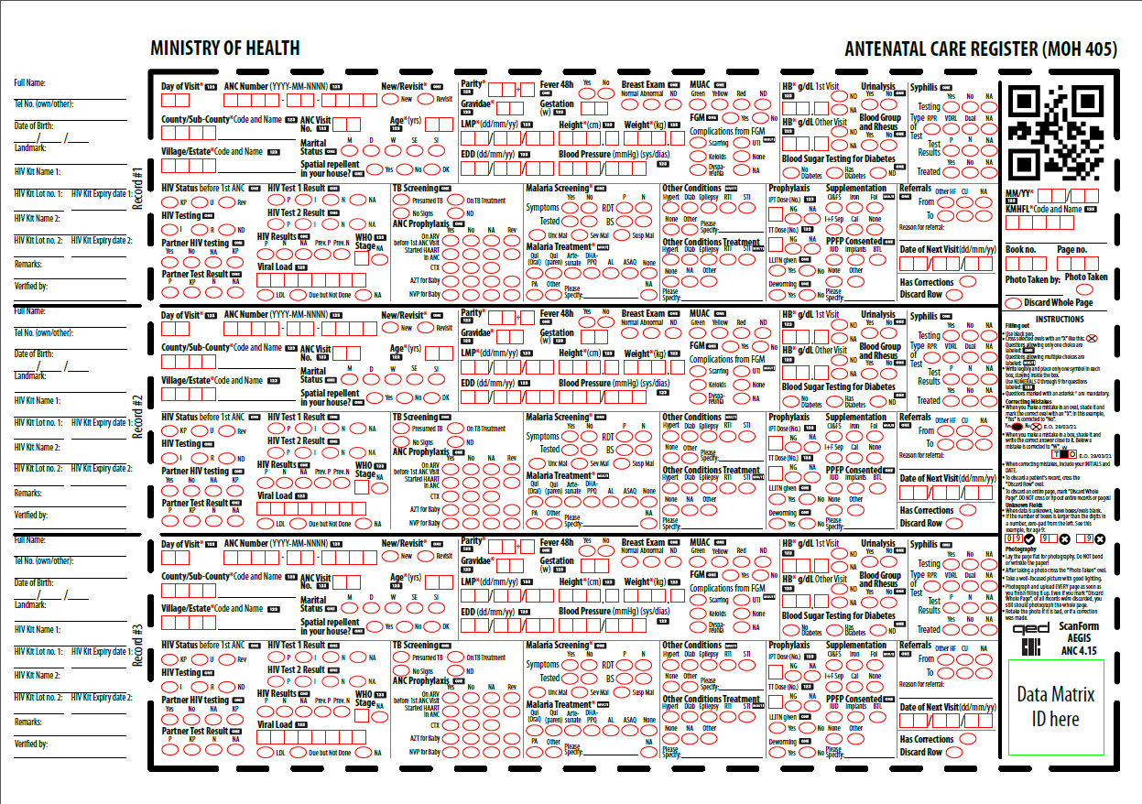
Supplementary Figure 4: Scannable QED antenatal clinic registers. The doted region incorporates machine-readable markers and structured fields to enable digital data capture excluding patients uniquely identifiable.

