Questionnaire FitForLife: Questions regarding study on lifestyle habits
Translated from Swedish

Living conditions/arrangements
Q42 Do you live together with another adult?
Answer: “no | “yes, permanently” | “yes, parent” | “yes, other”
Q43 Highest achieved education?
Answer: 1= ”General education” (Grundskola/enhetsskola), 2= ”High school”, practical (Fackskola, yrkesskola, gymnasieskola), 3= ”high school, theoretical” (Gymnasieskola teoretiska linjer), 4= ”higher education” (eftergymnasial utbilding, minst två år).

Tobacco
Q53 Have you used any tobacco products (Ex. Cigarettes, e-cigarettes, snus) during the past month?
Answer: no | yes

Alcohol
Q60 How often do you drink alcohol?
Answer: “never” (skip to the next question) | “1 time per month or less” | “2-4 times per month” | “2-3 times per week” | “4 times per week or more”

Q61 How many alcoholic units do you drink on a typical day when you drink alcohol?
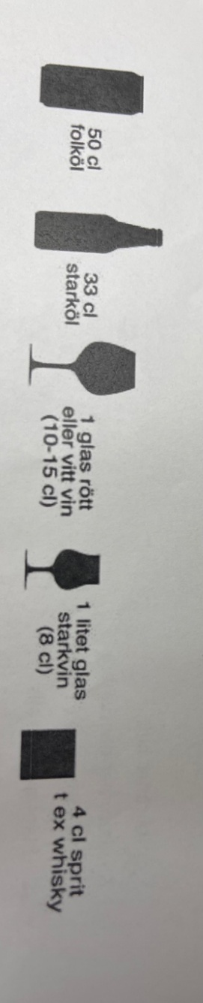
Answer: “1-2” | “3-4” | “5-6” | “7-9” | “10 or more”
Q62 How often do you drink six or more units during the same day?
Answer: 1= never, 2= less than 1 time per month, 3= every month, 4= every week, 5= Every day or almost every day
Q63 during the past year, how often have you not been able to stop drinking after you have started?
Answer: 1= never, 2= less than 1 time per month, 3= every month, 4= every week, 5= Every day or almost every day
Q65 during the past year, how often have you not done something you had to do because of your drinking?
Answer: 1= never, 2= less than 1 time per month, 3= every month, 4= every week, 5= Every day or almost every day
Q66 during the past year, how often have you need a drink the morning after drinking a lot the day before?
Answer: 1= never, 2= less than 1 time per month, 3= every month, 4= every week, 5= Every day or almost every day
Q67 during the past year, how often have you felt guilty about something you said or did when you were drinking?
Answer: 1= never, 2= less than 1 time per month, 3= every month, 4= every week, 5= Every day or almost every day
Q68 during the past year, how often have you not remembered what you said or did because of drinking?
Answer: 1= never, 2= less than 1 time per month, 3= every month, 4= every week, 5= Every day or almost every day
Q69 Have you or someone else ever been physically hurt because of your drinking?
Answer: “No” | “yes, but not during the past year” | “yes, recently”
Q70 Have a friend, family member, a doctor or someone else working within health care worried about your alcohol consumption and expressed that you should reduce your drinking?
Answer: “No” | “yes, but not during the past year” | “yes, recently”

Narcotics
Q71 Have you smoked /used cannabis during the past month?
Answer: “No” (skip to the next section) | “Yes”

Considering the past week, how many times did you eat/drink the following?:
Q83 Fruit
Answer: “1-2” | “3-4” | “5-6” | “6+”
Q84 Vegetables
Answer: “1-2” | “3-4” | “5-6” | “6+”
Q88 Meat
Answer: “1-2” | “3-4” | “5-6” | “6+”
Q91 Candy/ Soda
Answer: “1-2” | “3-4” | “5-6” | “6+”

