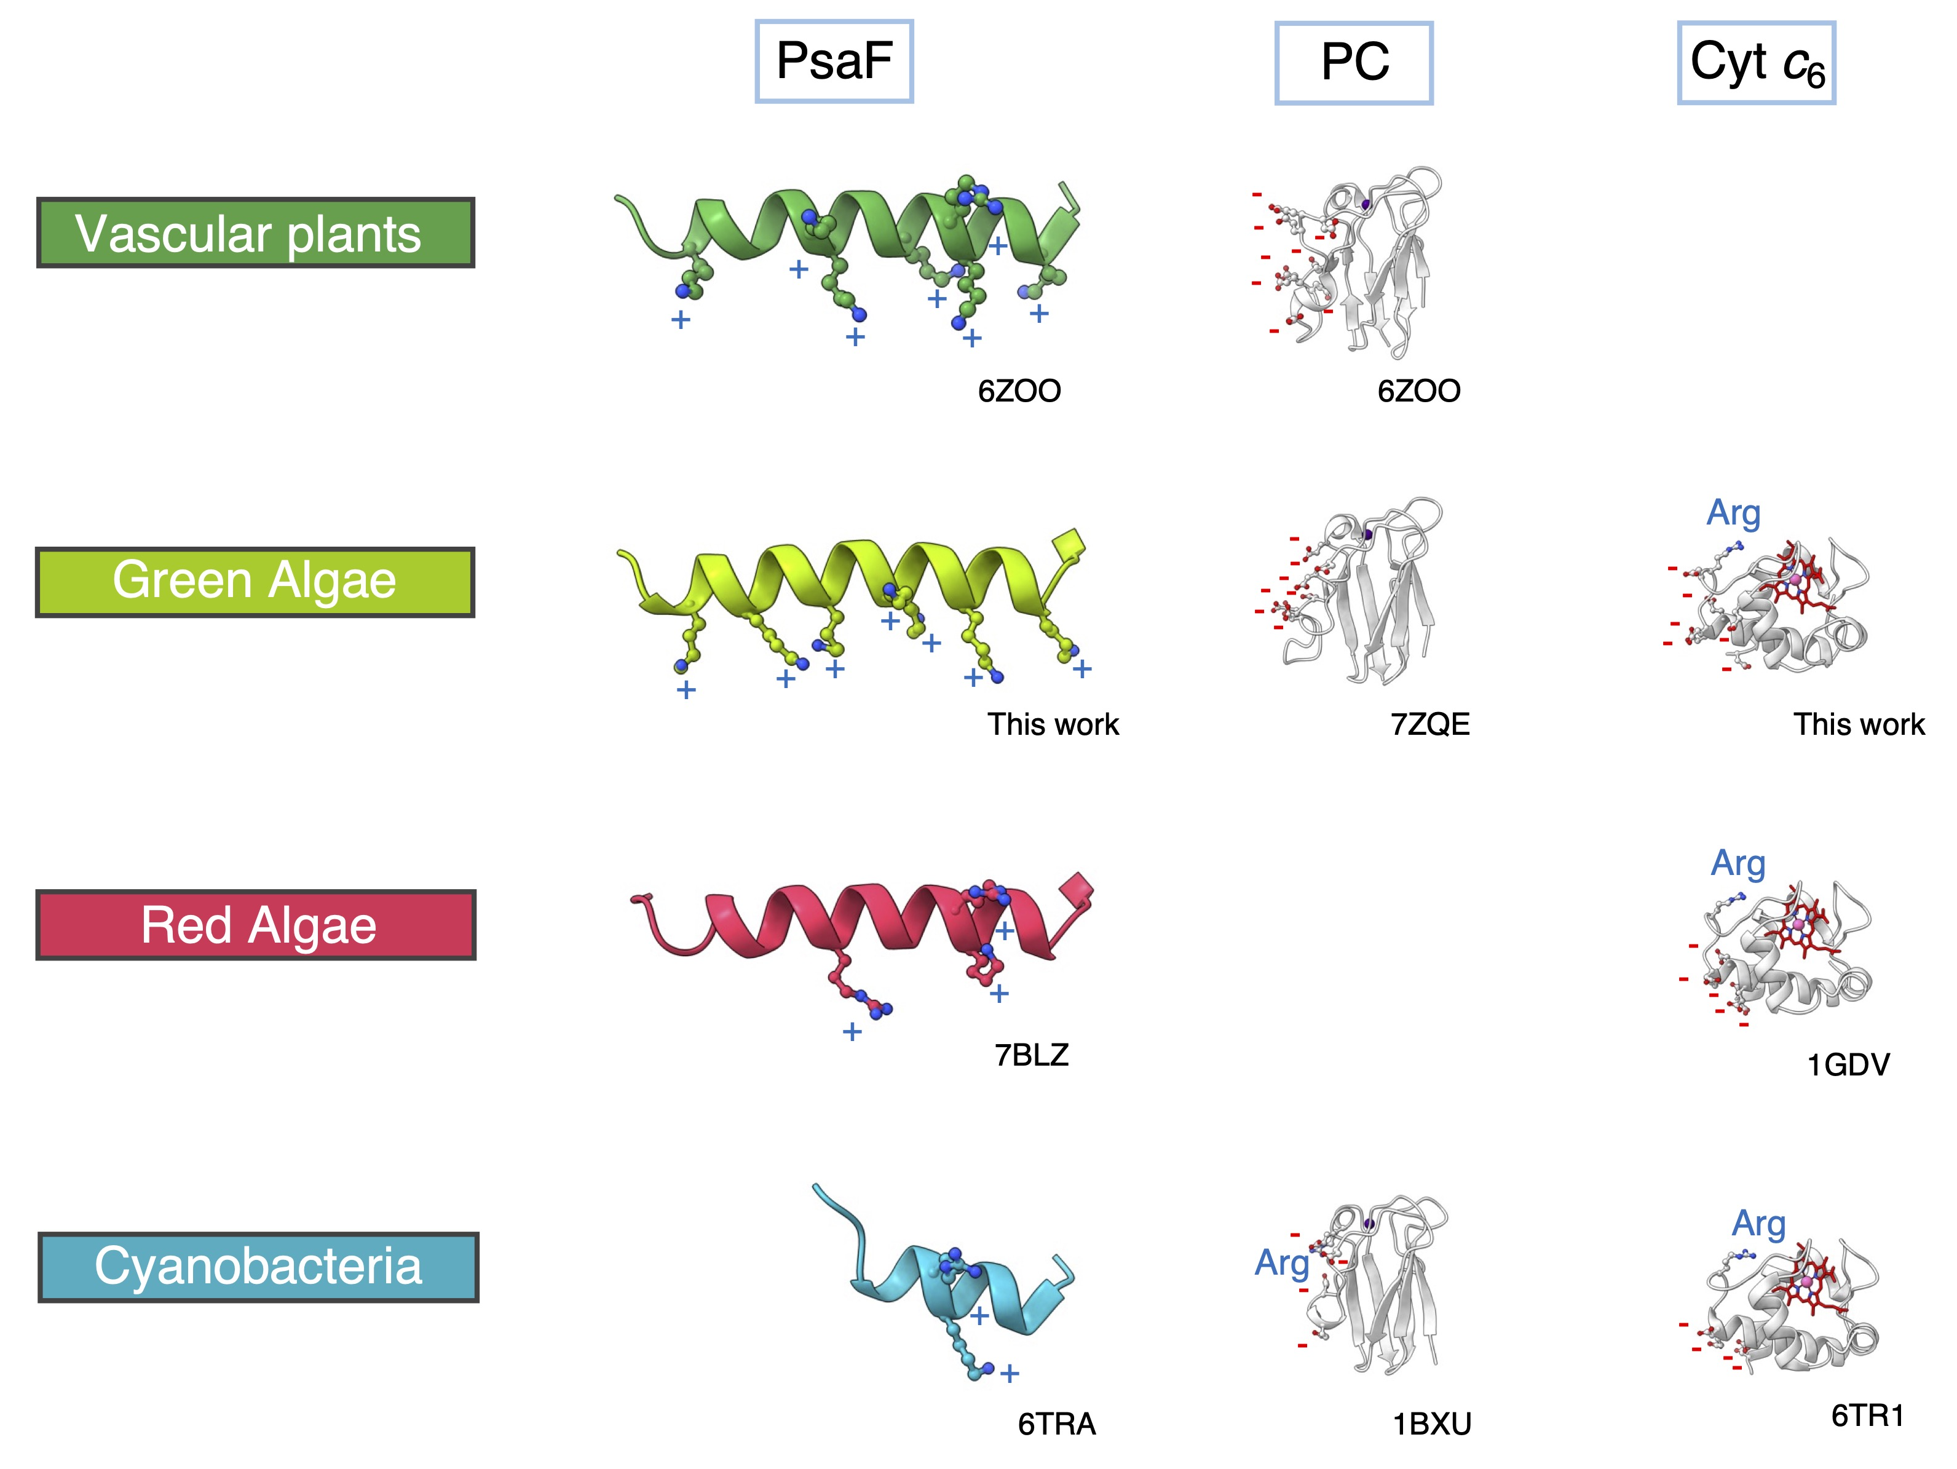

Extended Data Fig. 1| Comparison of the charged residues on interfaces of PsaF, PC and Cyt c₆ from vascular plants, green algae, red algae and cyanobacteria. Each PDB ID is provided.
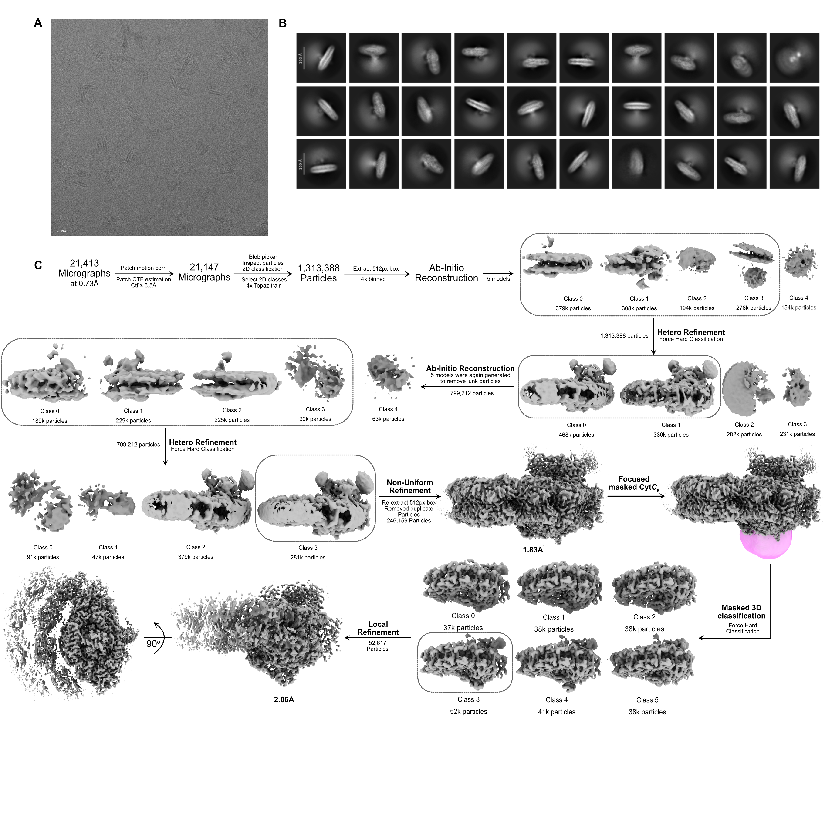

Extended Data Fig. 2| Cryo-EM data collection and processing workflow. a, A representative micrograph showing Cyt c₆:PSI particles. b, Reference-free 2D class averages revealing different views of the complex. c, Overview of the cryo-EM data processing pipeline performed in cryoSPARC.

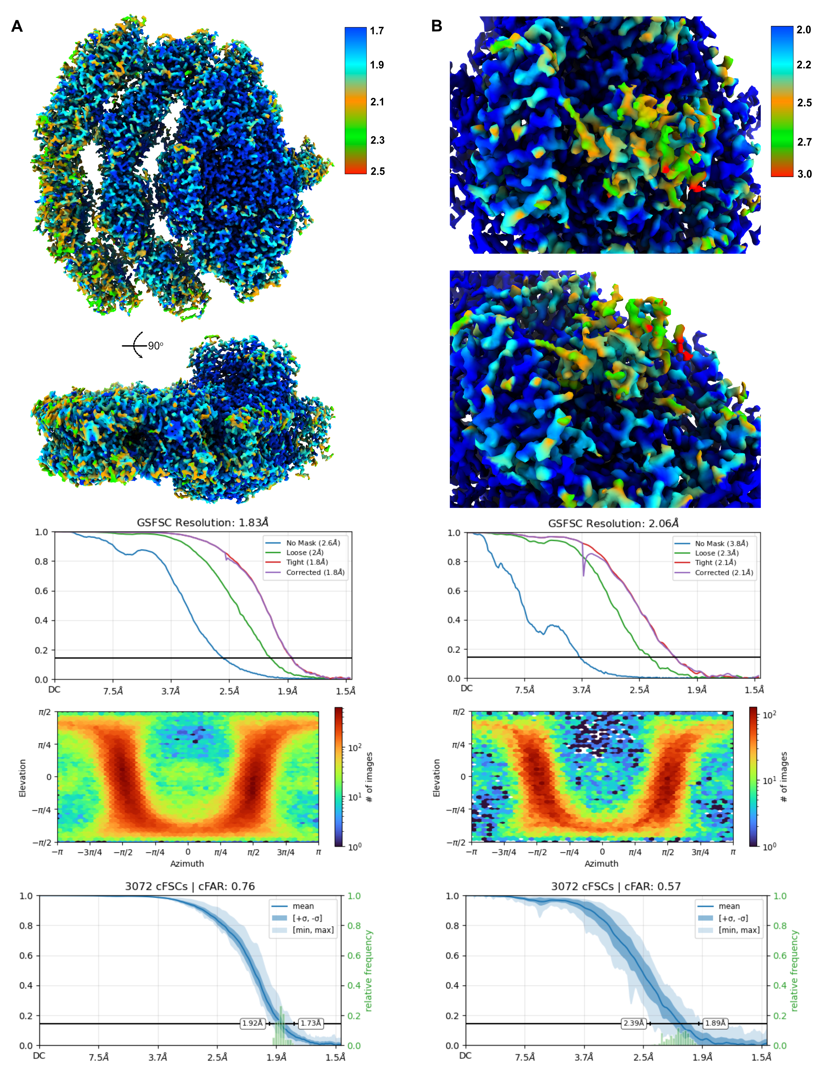

Extended Data Fig. 3| Cryo-EM maps resolution and quality. a, PSI cryoEM maps colored by their local resolution calculated by GSFSC plot. b, Cyt c₆-PSI cryoEM maps colored by their local resolution calculated by GSFSC plot.
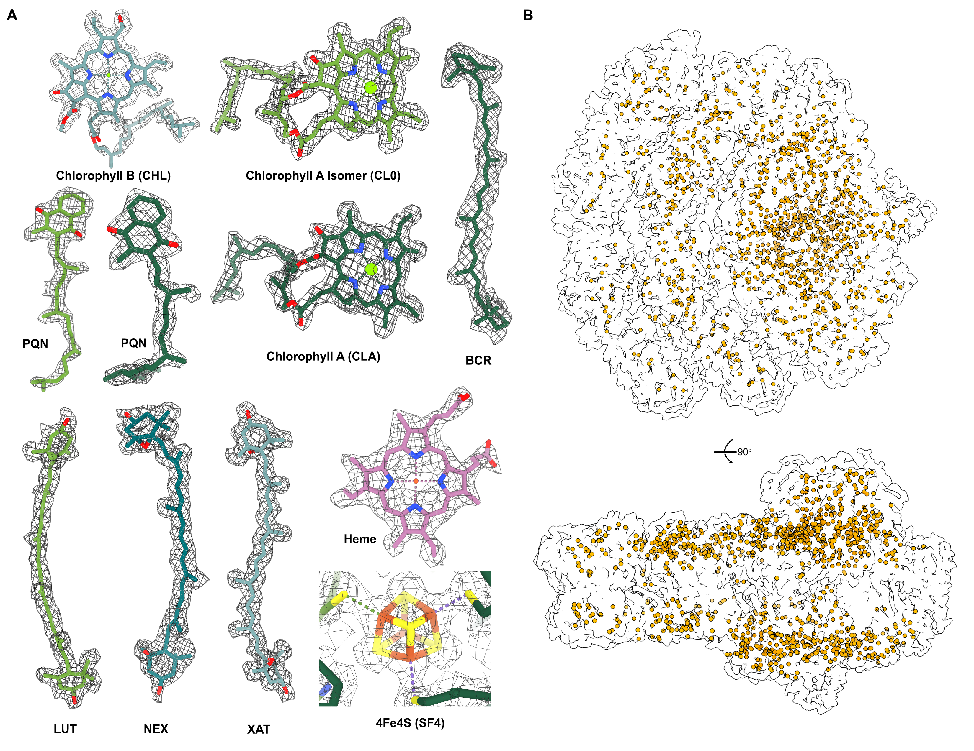

Extended Data Fig. 4| Electron-density maps of co-factors and water molecules distribution. a, Electron density maps of the co-factors: chlorophyll B (CHL), chlorophyll A isomer (CL0), chlorophyll A (CLA), Phylloquinone (PQN), Beta-Carotene (BCR), (3r,3'r,6s)-4,5-didehydro-5,6-dihydro-beta,beta-carotene-3,3'-diol (LUT), (1r,3r)-6-{(3e,5e,7e,9e,11e,13e,15e,17e)-18-[(1s,4r,6r)-4-hydroxy-2,2,6-trimethyl-7-oxabicyclo[4.1.0]hept-1-yl]-3,7,12,16 tetramethyloctadeca-1,3,5,7,9,11,13,15,17-nonaenylidene}-1,5,5-trimethylcyclohexane-1,3-diol (NEX), (3s,5r,6s,3's,5'r,6's)-5,6,5',6'-diepoxy-5,6,5',6'- tetrahydro-beta,beta-carotene-3,3'-diol (XAT), 4Fe4S iron/sulfur cluster (SF4). b, distribution of all the water molecules in orange.

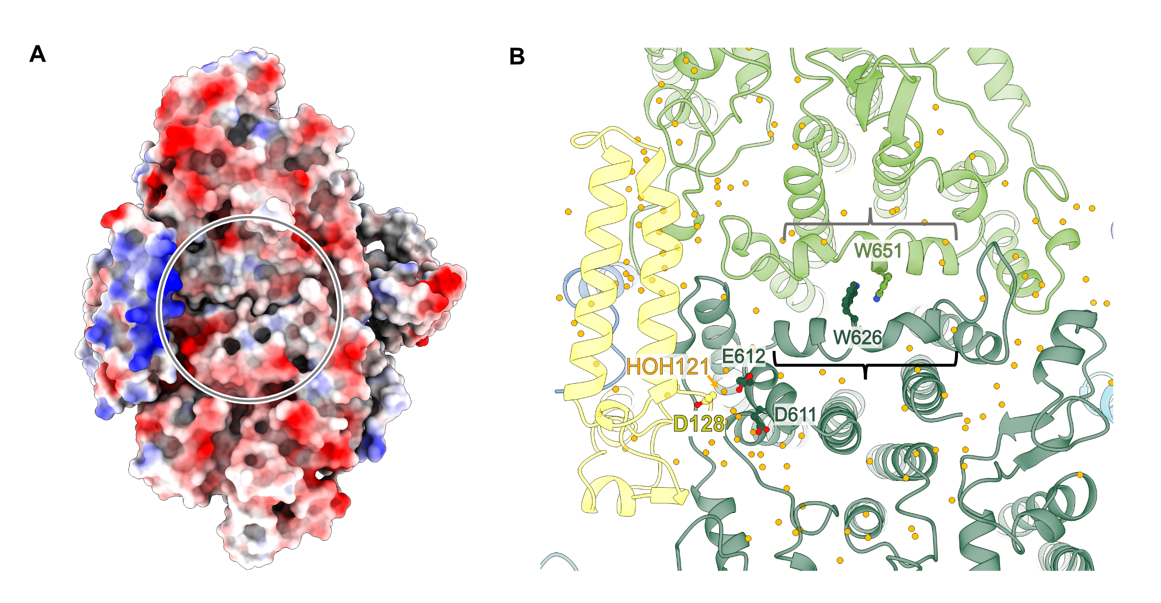

Extended Data Fig. 5| Luminal view of PSI core. a, Surface electrostatic potential distribution. Positively and negatively charged area are in blue and red, respectively. Gray circle represents the shallow pocket. b, Cartoon representation with water molecules (orange dots). The Trp dimer is shown. Gray and black brackets indicate PsaA-l loop and PsaB-l’ loop, respectively.
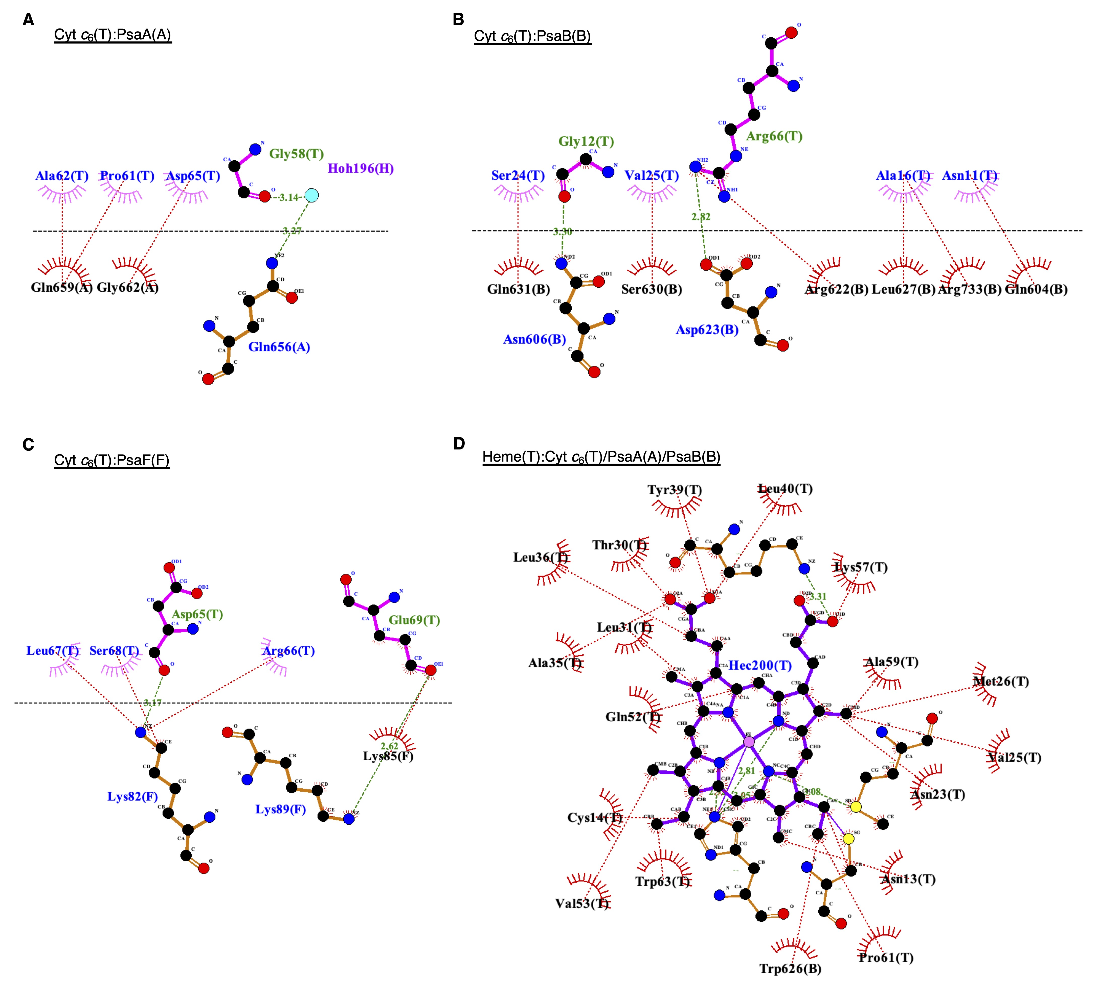

Extended Data Fig. 6| Protein(ligand)-protein interface diagrams of Cyt c₆: PsaA (a), Cyt c₆:PsaB (b) Cyt c₆:PsaF (c) and Heme: Cyt c₆/PsaA/PsaB (d) produced by LigPlot⁺. Green dashed lines with numbers indicate potential hydrogen bonds or electrostatic interactions shorter than 3.35Å, providing the atom-atom distances (Å). Red dashed lines represent other non-bonded contacts including hydrophobic interactions.

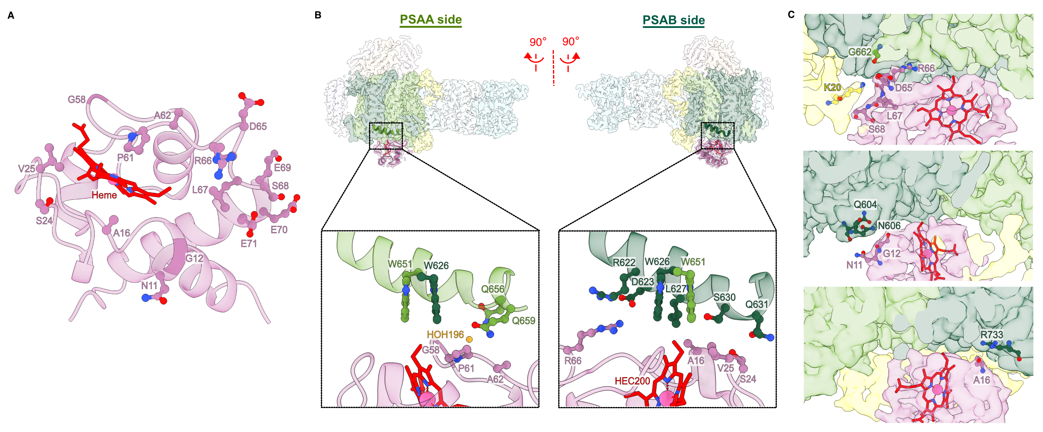

Extended Data Fig. 7| Additional figures for Cyt c₆:PSI binding. a, Stromal view of Cyt c₆:PSI interface (just Cyt c₆ side). Directly interacting amino acids are shown, in addition to E70 and E71. b, Interfaces between Cyt c₆ and PsaA-l loop (left)/PsaB-l’ loop (right). Directly interacting residues and water molecules (orange) are shown in bottom panels, in addition to PsaA-W651. The Trp dimer is shown in both bottom panels. c, Peripheral protein-protein interactions on the PsaA-PsaB shallow pocket.

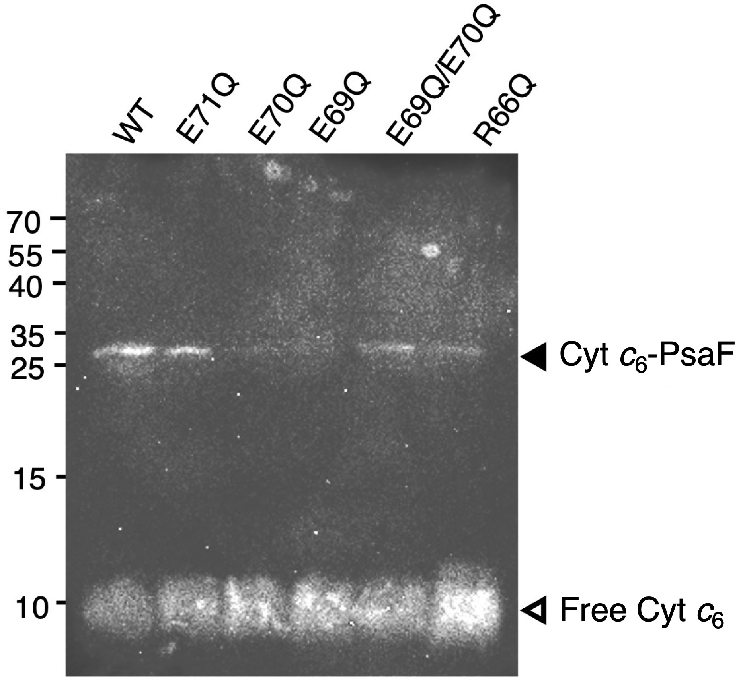

Extended Data Fig. 8| Cross-linking using Cyt c₆ variants with mutations at putatively interacting amino acid residues. The cross-linked samples were subjected to SDS-PAGE and Western blotting.

Primer names | Sequence 5’ to 3’
R66Q_fw | GGCGGATCAGCTGAGCGAAGAGGAGATCCAGG
R66Q_rv | CTCAGCTGATCCGCCCACGCCGGCATTGC
E69Q_fw | CCTGAGCCAGGAGGAGATCCAGGCGGTTGC
E69Q_rv | TCCTCCTGGCTCAGGCGATCCGCCCACG
E70Q_fw | GAGCGAACAGGAGATCCAGGCGGTTGCTGAATACG
E70Q_rv | ATCTCCTGTTCGCTCAGGCGATCCGC
E71Q_fw | CGAAGAGCAGATCCAGGCGGTTGCTGAATACG
E71Q_rv | TGGATCTGCTCTTCGCTCAGGCGATCCG
E69Q/E70Q_fw | TGAGCCAGCAGGAGATCCAGGCGGTTGCTGA
E69Q/E70Q_rv | TCTCCTGCTGGCTCAGGCGATCCGCCCA

Extended Data Table 1 Primers used in this study.

