Temperature and Emergency Department Visits: Present-Day Associations and Future Projections
Authors:
Chad Milando,^{1,2*} Ian Sue Wing,^{2,3} Gregory A. Wellenius^{1,2}
¹ Department of Environmental Health, Boston University School of Public Health, Boston, MA, USA
² Center for Climate and Health, Boston University, Boston, MA, USA
³ Department of Earth & Environment, Boston University, Boston, MA, USA
*corresponding author: cmilando@bu.edu

ABSTRACT
High ambient temperature (i.e., “heat”) is associated with increased rates of death. The association between heat and illnesses that result in emergency department (ED) visits is less well characterized: most studies have examined heat impacts in the summer months, for a subset of health outcomes, or at limited spatial scales. This work characterizes the relationship between temperature and all-cause ED visits across the entire year and at large spatial scale, and projects ED visits associated with future temperature change. We analyzed health data from 21,090,141 commercially insured individuals across 2,161 counties in the contiguous US from 2010 to 2021. We used distributed lag non-linear models (DLNM) to fit the exposure-response relationship in the historical period (2010-2021), then used projected mid-century (2040-2050) temperatures from global climate models across three Shared Socio-Economic Pathways to project future all-cause ED visits. Increasing daily maximum temperature were associated with increased ED visits throughout the year and across the US. ED visits increased 1.3% per year under the highest emission scenario and more than half of the counties in the study experienced 27 or more days per year of high healthcare utilization under future climate scenarios, an increase of 50% over present day conditions. These findings clarify the exposure-response relationship between daily maximum temperature and ED visits as distinct from the relationship between temperature and mortality. They also emphasize that future healthcare systems will need to accommodate more baseline ED visits throughout the year and a higher frequency of days with extremely high ED visit rates.

KEYWORDS
Temperature, Emergency Department Visits, Projected Future Impacts, Distributed Lag Non-linear Models, Case-crossover

INTRODUCTION
High ambient temperature (i.e., “heat”) is associated with excess death.^{1–7} In the United States (US) from 1997 to 2006, extreme heat was associated with approximately 10,000 deaths annually.⁸ The 2022 European heatwave was associated with approximately 61,000 excess deaths.⁹ The association between heat and illness that results in emergency department (ED) visits or hospitalizations is less well-known, but no less important; such events represent major life disruptions and utilize substantial healthcare resources.¹⁰ In studies of heat and illness limited to specific populations in summer-time and at the regional or sub-regional scale, heat has been associated with increased ED and hospitalization rates.^{11–16} However, a comprehensive analyses has yet to be performed that includes a population of all ages across a large spatial area, and for all-cause outcomes occurring across all months of many years.
Enhancing understanding of the associations between ambient temperature and health impacts is critical for healthcare management in a warming climate.^{17,18} The association between extreme temperature and mortality is “U-shaped”: days of extreme heat and cold are associated with excess deaths compared to days with moderate temperatures.^{19–22} In the US, climate models project fewer extremely cold days and more extremely hot days in the coming decades.^{23,24} Therefore, a reduction in the number of extremely cold days is estimated to be associated with a reduction in cold-related deaths, and an increase in heat-related deaths, thus attenuating the overall impact of warmer temperatures on mortality.^{19–22} The same pattern does not necessarily hold for illness. Results are mixed as to whether the association between year-round temperature and illness is “U-shaped” or monotonically increasing.^{21,25–30} In the latter case, warmer temperatures in any season could be associated with more frequent illnesses, resulting in greater healthcare utilization and costs.
To address this evidence gap, we assessed the relationship between daily maximum temperatures and ED visits among more than 21 million enrollees in commercial or Medicare Advantage health insurance plans across the contiguous US from 2010 to 2021. We then projected ED visits under three scenarios of warming at mid-century (2040-2050). Our findings clarify the exposure-response relationship between year-round temperature and ED visits across the entire contiguous US and provide important projections of the scale of increased ED visits due to the near-certain increase in temperatures in the future.

METHODS

Outcomes
We studied all-cause ED visits among people of all ages across the contiguous US enrolled in commercial and Medicare Advantage health insurance in the Optum Labs Data Warehouse (OLDW)® from 2010 to 2021, a total of 21,090,141 enrollees across 2,161 US counties (Figure 1). We limited our study domain to US counties with more than 500 enrollees per year and adjusted ED visit counts within each year by annual enrollee levels. We then aggregated counts by county and region of residence, with regions defined according to the 4th National Climate Assessment (NCA4): Southeast, Southwest, Northern Great Plains, Southern Great Plains, Midwest, Northeast, and Northwest.³¹ Analyses of the OLDW data were approved by the Boston University Medical Campus Institutional Review Board (IRB).

Exposures
Present-day daily maximum temperatures were estimated from the Copernicus Climate Change Service, a dataset known as ERA5³² that has been population-weighted to the US county scale³³ and utilized in studies temperature and health.³⁴
For projections of future daily maximum temperatures, we gathered results from 32 global climate models (GCMs) across 3 different Shared Socio-Economic Pathways (SSPs) for projected mid-century (2040-2050) future temperatures (Table S1).³⁵ The SSP scenarios are characterized by the relative level of global warming: SSP5 (highest warming), SSP3 (moderate to high warming), and SSP2 (moderate warming).

Exposure and outcome association
Estimating the exposure-response relationship and projecting future impacts used a sequence of modeling methods, outlined in Figure 2. We first fit distributed lag non-linear models (DLNM) to estimate the relationship between daily maximum temperature and ED visits (Fig2. Panel a). We used a single-stage distributed lag non-linear modeling framework with a quasi-Poisson model; this approach has been extensively used in environmental epidemiology related to temperature exposure.³⁶ For each county, we created a basis matrix for the temperature vector using natural cubic splines with internal knots at the 10th, 75th, and 90th percentile of daily county temperature in the present-day period. We extended the boundary knots to include the projected future temperature extremes. We then created a basis matrix for the lag structure, assuming again a natural cubic spline, with a maximum lag of 5 days (and sensitivity tests for 3 and 10 days), and three internal knots equally spaced on the time axis on the log scale. We then created a crossbasis for lagged temperature from these individual bases, using the dlnm package.³⁷ Novel to this work was adapting the method of how the future temperature basis was created. Instead of creating a new basis directly from the vector of future temperatures,³⁸ we instead rearranged rows of the present-day exposure matrix depending on the county-specific temperature percentile each day fell in (using bins of 1 °C). By doing so, we ensured that the regression model coefficients fit using present-day data could be applied to a future temperature time-series while maintaining the present-day exposure-response relationship. To derive the exposure-outcome relationship, we fit a quasi-Poisson model of county-specific all-cause ED visits using the present-day lagged exposure matrix, a dummy variable for day of week and a natural cubic spline to account of varying time trends (with 8 degrees of freedom per year). All analyses were performed in R version 4.2.1.³⁹

Projection of future outcomes
We then used the coefficients from the present-day model and the future temperature exposure matrix to create a future time-series of the expected value of daily ED visits with standard errors for each modeled point (Fig2. Panel b). To view the exposure-response relationships by NCA4 region, we reduced the model output along the lag dimension and calculated the relationship within regions using the mixmeta package.³⁶
Using the change in daily maximum temperature by GCM and SSP, we then created new multi-year time-series of the expected ED visits among the present-day population but with the projected mid-century temperatures (Fig2. Panel c.). Each of these future time-series also had a point estimate and standard error.
For each GCM within each SSP, we then calculated the difference in present day versus future ED visits using a bootstrap process. We used the present day and future expected ED visit counts and standard errors as parameters for two normal distributions and created 250 estimates of the difference between present day conditions and each GCM output (Fig2. Panel d.). We then calculated a combined difference and empirical confidence interval for each county and GCMs within each SSP by performing another bootstrapping process (Fig2. Panel e.). Thus, for each combination of county, GCM, and SSP, we had a multi-year time-series (and empirical confidence interval) for the daily change in ED visits that incorporated uncertainty from both the DLNM models and median daily estimates of GCMs. Resulting confidence intervals were narrow, reflecting the distribution around the median estimate, rather than the range across GCMs. In estimating uncertainties, we followed approaches similar to the temperature and mortality literature.²⁰
We created summary estimates of the sum of monthly changes in ED visits within NCA4 regions (Fig2. Panel f.). We sampled daily estimates of the difference between present and future ED visit within each combination of month, county, and SSP, then summed to the region and SSP level. Thus, for month, by season, or for a full year, we created estimates of the new ED visits that would occur under mid-century temperatures, all else being equal. To calculate the estimated change in ED visits, we compared averages of total ED visits per year.
Finally, we estimated how much more often surges in healthcare utilization would occur under future climate scenarios. Specifically, we estimated the number of additional days on which the number of ED visits exceeded the county and year-specific 95th percentile of the distribution of daily ED visit counts By definition, during the present-day period (2010 through 2021) there are 18 high healthcare utilization days that exceed the threshold defined by the 95th percentile of daily ED visits per county and year. These ‘high utilization’ days help estimate the increased burden on the healthcare system due to an increased frequency of extremely hot temperatures.

RESULTS
Across the US, increasing daily maximum temperatures was largely monotonically associated with increased relative risk of ED visits, i.e., not “U-shaped” (Figure 3). Only the Southern Great Plains and Southeast had exposure-response relationships which were elevated for high present-day temperatures but decreased slightly for projected future temperature extremes. We observed similar results at various exposure lag times typically used when examining changes in rates of ED visits due to extreme temperature (3 to 10 days, Figure S1, S2).
The highest warming scenario resulted in projected increases in median temperature from 1.6 to 3.3 °C in summer and from 1.2 to 2.0 °C in winter (Table S1). These increases resulted in a 1.3% increase in annual ED visits relative to the present day across the US (Table 1), a which figure translates to roughly 86,000 additional ED visits annually across the US among the commercially insured study population. The largest percentage increases were in regions that experience relatively cool climates today: the Northeast (+1.6%), Midwest (+1.4%), and Northwest (+1.5%). An analogous pattern of results was observed under lower-warming scenarios (Table S2). The severity of increases in ED visits varied by month and region (Figure S3). In the Midwest, Northwest, and Northeast, the largest projected impacts of warming temperatures on ED visits occurred in the summer months (June through August). Conversely, in the Northern and Southern Great Plains and the Southwest, the largest projected increases in total ED visits occurred in the spring (March through May) and fall (September through November). In the Southeast, the impact of projected warming was relatively constant throughout the year.
Under future projected scenarios, in each year there were many more days of high healthcare utilization that exceeded present-day thresholds (Figure 4). Under the highest warming scenario, 54% to 69% of all study counties exhibited a greater than 50% increase in high utilization days (more than 27 days), 23% to 38% saw the number of days over their current threshold double (more than 36 days), and 11% to 17% of counties experienced 45 or more high utilization days (a 150% increase). The Northeast region had the highest increase in high utilization days, while the Northern Great Plains had the smallest increase. This pattern of results was similar but of a lesser magnitude for the lower-warming scenarios (Table S3).

DISCUSSION
Among more than 21 million people with commercial health insurance across the lower 48 US states, we observed a positive and monotonic association between daily all-cause ED visit rates and daily temperatures, not “U-shaped” as for heat and mortality. We subsequently projected that increases in temperature in midcentury resulted in substantial increases in annual ED visits, 1.3% in the highest warming scenario. For context, this increase is similar in magnitude to the overall increase in the US ED visit rate from 1997 to 2007 (a 1.2% increase, from 352.8 to 390.5 visits per 1,000 persons per year).⁴⁰ Finally between half and two-thirds of counties were projected to experience at least a 50% increase in high ED utilization days by midcentury, with impacts concentrated in cooler northern regions.
The present paper adds to a small number of studies on the exposure-response relationship between heat and non-fatal health impacts. Most similar to ours is an investigation of current and future ED visits for hyperthermia in 136 US urban areas.⁴¹ That study found largely monotonic increases in May-September hyperthermia ED visit rates for adults 18 to 64 that translated to a projected increase in ED visit rates for hyperthermia. Hess et. al., (2014) used state-level ED records to show a linearly increasing relationship between average annual temperature anomaly and annual ED visits for heat-related illness.⁴² Finer geographic scale studies have also demonstrated monotonic or “J-shaped” associations between increased temperature (with lags of 3 to 7 days) and non-fatal health impacts: in Shanghai and Pudong New Area, China^{25,26} and in the US in California, Rhode Island, Massachusetts, and North Carolina^{27,28,43,44} Different from our result was a study across 12 cities in China that used a lag period of 32 days and showed a “U-shaped” exposure-response relationship between heat and ED visits.³⁰ The appropriate length of the lag time for calculating non-fatal health impacts of heat (as compared to fatal impacts) is an open question, especially given the potential for future heatwaves with multiple consecutive extreme heat days.^{45,46}
We can also situate our results in the context of heat-and-health research for mortality and for ED visit surges. Our findings with ED visits are similar to research on heat and mortality that show higher mortality impacts in high-latitude locations where infrastructure to adapt to extremely hot days may be lacking.² The impact on ED visit surges due to extreme heat (> 35 °C) was also quantified in Brisbane, Australia; by 2030, days of extreme heat were projected to increase ED visit usage by up 200% above present-day levels. ^{47,48}
To enable this work, we modified an existing method for projecting the future morbidity consequences of increased temperature.³⁸ The commonly-used approach estimates the increase in the fraction of observed cases that would have been attributed to temperature had temperatures been warmer.^{1–7} By contrast, our interest is estimating the additional ED visits that would occur under warmer temperatures, a value which encompasses not only the increased fraction of observed cases but also new cases that did not occur in the historical record. The key modification to the existing method was extending the boundary knots of the present-day temperature basis to include the range of future projected temperatures, and then constructing matrices of lagged temperature exposure for the present-day and future periods from this extended basis – an approach adapted from similar economic literature.²⁷
The benefits of our modified approach are two-fold. First, our exposure-response functions for future exposures now include both non-linearities and lagged effects. Although studies of temperature and mortality have shown that the strongest associations between heat and health occur on the day of exposure,⁴⁹ in warmer future climates where contemporaneous and lagged temperatures can exceed historical percentiles, lagged exposures could potentially exert larger adverse health impacts. Second, the method of calculating additional health impacts of future temperatures does not depend on the shape of the exposure response curve. Temperature-mortality studies have exploited the fact that the “U-shaped” exposure-response relationship’s nadir presents a natural point of comparison for the relative risks of colder versus hotter temperatures.^{1–7} However, the monotonicity of our estimated exposure-response curves render estimates of attributable number and attributable fraction using that approach highly sensitive to comparison point selection.^{38,43}
Our results are subject to several caveats, all of which constitute opportunities for further inquiry. We did not account for future population dynamics or adaptation.⁵⁰ Although such projections are available,⁵¹ their use is predicated on our currently limited understanding of how responses differ among demographic subgroups and intersect with susceptible individuals’ capacity to adapt. Our omission of these influences results in relatively narrow confidence intervals for estimated ED visits. A further uncertainty is the extent to which our estimated responses, which reflect the subset of currently-insured individuals, and therefore could underestimate the population incidence of heat-related illness,⁵² are representative of the true response in the broader US population—especially as the latter undergoes heterogeneous region-specific compositional shifts out to mid-century. Our modeling method assumes that the underlying causes of ED visits scale with temperature. Established practice treats the uncertainty associated with this assumption as being captured by our standard errors, which are small, and temperature differences across warming scenarios, which are larger.³⁸ We note however that there is an additional source of uncertainty, in the form of the dispersion of simulated temperatures and associated ED visits across GCMs within scenarios.⁵³ For the sake of concision, we leave characterization of that uncertainty to follow-on work. Our case-crossover model also did not incorporate specific adjustments for the COVID-19 pandemic. However, we note that any attendant biases would affect both present and future projections, and thus exert little influence on the changes we estimate here. Computational constraints also precluded meta-analysis of county-specific modeled coefficients that were not cross-reduced, limiting our ability to use best linear unbiased predictions of county-specific exposure response functions.³⁶
Our findings clarify the exposure-response relationship between year-round temperature and ED visits across the entire US and provide estimates for which regions may be at highest risk of increased ED visits due to increased temperatures in the future, absent other adaptation or population dynamics. Of paramount importance is uncovering the origins of monotonicity in the exposure response. It remains to be established whether this phenomenon reflects behavioral influences in the tails of the temperature distribution, or whether different diagnoses or risk factors might be more commonly associated with elevated risk of ED visits on hot days. With temperature increase all but certain,⁵⁴ these findings quantify the need for future healthcare systems to accommodate both more baseline ED visits due to increased heat as well as a higher frequency of days with extremely high rates of ED visits.

Acknowledgements
This work was funded by grant R01-ES029950 from the National Institute of Environmental Health Sciences (NIH/NIEHS), grant 216033-Z-19-Z from the Wellcome Trust, and US Department of Energy, Office of Science, Biological and Environmental Research Program, Earth and Environmental Systems Modeling, MultiSector Dynamics cooperative agreement DE-SC0022141. The content of this report is solely the responsibility of the authors and does not necessarily represent the official views of the sponsoring agencies.

Data availability
The health data used in this study are only available by contacting Optum Labs to obtain access to the insurance claims data. The code to recreate Figure 1 and demonstrate our approach are available on Github: www.github.com/cmilando/FuturePredMethods.

Disclosures
Dr. Wellenius serves as a consultant for the Health Effects Institute (Boston, MA) and Google, LLC (Mountain View, CA). Dr. Sue Wing serves as a consultant for the European Commission Joint Research Centre (Seville, Spain).

Author contributions
Conceptualization: CWM, ISW, GW. Data curation: CWM, ISW. Formal analysis: CWM. Funding acquisition and Resources: GW, ISW. Investigation and Methodology: CWM, ISW, GW. Validation and Visualization: CWM, ISW. Writing (original draft): CWM. Writing (review and edition): CWM, GW, ISW.

REFERENCES
1. Curriero FC, Heiner KS, Samet JM, Zeger SL, Strug L, Patz JA. Temperature and Mortality in 11 Cities of the Eastern United States. American Journal of Epidemiology. 2002 Jan 1;155(1):80–87.
2. Gasparrini A, Guo Y, Hashizume M, Lavigne E, Zanobetti A, Schwartz J, Tobias A, Tong S, Rocklöv J, Forsberg B, Leone M, Sario MD, Bell ML, Guo YLL, Wu C fu, Kan H, Yi SM, Coelho M de SZS, Saldiva PHN, Honda Y, Kim H, Armstrong B. Mortality risk attributable to high and low ambient temperature: a multicountry observational study. The Lancet. Elsevier; 2015 Jul 25;386(9991):369–375. PMID: 26003380
3. Ma W, Wang L, Lin H, Liu T, Zhang Y, Rutherford S, Luo Y, Zeng W, Zhang Y, Wang X, Gu X, Chu C, Xiao J, Zhou M. The temperature–mortality relationship in China: An analysis from 66 Chinese communities. Environmental Research. 2015 Feb 1;137:72–77.
4. Basu R, Feng WY, Ostro BD. Characterizing Temperature and Mortality in Nine California Counties. Epidemiology. 2008 Jan;19(1):138.
5. Cheng J, Xu Z, Bambrick H, Su H, Tong S, Hu W. Impacts of heat, cold, and temperature variability on mortality in Australia, 2000–2009. Science of The Total Environment. 2019 Feb 15;651:2558–2565.
6. Huynen MM, Martens P, Schram D, Weijenberg MP, Kunst AE. The impact of heat waves and cold spells on mortality rates in the Dutch population. Environ Health Perspect. 2001 May;109(5):463–470. PMCID: PMC1240305
7. Guo Y, Gasparrini A, Armstrong B, Li S, Tawatsupa B, Tobias A, Lavigne E, de Sousa Zanotti Stagliorio Coelho M, Leone M, Pan X, Tong S, Tian L, Kim H, Hashizume M, Honda Y, Guo YLL, Wu CF, Punnasiri K, Yi SM, Michelozzi P, Saldiva PHN, Williams G. Global Variation in the Effects of Ambient Temperature on Mortality: A Systematic Evaluation. Epidemiology. 2014 Nov;25(6):781.
8. Weinberger KR, Harris D, Spangler KR, Zanobetti A, Wellenius GA. Estimating the number of excess deaths attributable to heat in 297 United States counties. Environmental Epidemiology. 2020 Jun;4(3):e096.
9. Ballester J, Quijal-Zamorano M, Méndez Turrubiates RF, Pegenaute F, Herrmann FR, Robine JM, Basagaña X, Tonne C, Antó JM, Achebak H. Heat-related mortality in Europe during the summer of 2022. Nat Med. Nature Publishing Group; 2023 Jul;29(7):1857–1866.
10. Kegel F, Luo OD, Richer S. The Impact of Extreme Heat Events on Emergency Departments in Canadian Hospitals. Wilderness & Environmental Medicine. SAGE Publications; 2021 Dec 1;32(4):433–440.
11. Bobb JF, Obermeyer Z, Wang Y, Dominici F. Cause-Specific Risk of Hospital Admission Related to Extreme Heat in Older Adults. JAMA. 2014 Dec 24;312(24):2659–2667.
12. Anderson GB, Dominici F, Wang Y, McCormack MC, Bell ML, Peng RD. Heat-related Emergency Hospitalizations for Respiratory Diseases in the Medicare Population. Am J Respir Crit Care Med. American Thoracic Society - AJRCCM; 2013 May 15;187(10):1098–1103.
13. Bernstein AS, Sun S, Weinberger KR, Spangler KR, Sheffield PE, Wellenius GA. Warm Season and Emergency Department Visits to U.S. Children’s Hospitals. Environmental Health Perspectives. Environmental Health Perspectives; 2022;130(1):017001.
14. Green RS, Basu R, Malig B, Broadwin R, Kim JJ, Ostro B. The effect of temperature on hospital admissions in nine California counties. International Journal of Public Health. 2010 Apr;55(2):113–121.
15. Sun S, Weinberger KR, Nori-Sarma A, Spangler KR, Sun Y, Dominici F, Wellenius GA. Ambient heat and risks of emergency department visits among adults in the United States: time stratified case crossover study. BMJ. British Medical Journal Publishing Group; 2021 Nov 25;375:e065653. PMID: 34819309
16. Spangler KR, Adams QH, Hu JK, Braun D, Weinberger KR, Dominici F, Wellenius GA. Does choice of outdoor heat metric affect heat-related epidemiologic analyses in the US Medicare population? Environmental Epidemiology. 2023 Aug;7(4):e261.
17. Weilnhammer V, Schmid J, Mittermeier I, Schreiber F, Jiang L, Pastuhovic V, Herr C, Heinze S. Extreme weather events in europe and their health consequences – A systematic review. International Journal of Hygiene and Environmental Health. 2021 Apr 1;233:113688.
18. Patel L, Conlon KC, Sorensen C, McEachin S, Nadeau K, Kakkad K, Kizer KW. Climate Change and Extreme Heat Events: How Health Systems Should Prepare. NEJM Catalyst. Massachusetts Medical Society; 2022 Jun 15;3(7):CAT.21.0454.
19. Lee J, Dessler AE. Future Temperature-Related Deaths in the U.S.: The Impact of Climate Change, Demographics, and Adaptation. GeoHealth. 2023;7(8):e2023GH000799.
20. Gasparrini A, Guo Y, Sera F, Vicedo-Cabrera AM, Huber V, Tong S, Coelho M de SZS, Saldiva PHN, Lavigne E, Correa PM, Ortega NV, Kan H, Osorio S, Kyselý J, Urban A, Jaakkola JJK, Ryti NRI, Pascal M, Goodman PG, Zeka A, Michelozzi P, Scortichini M, Hashizume M, Honda Y, Hurtado-Diaz M, Cruz JC, Seposo X, Kim H, Tobias A, Iñiguez C, Forsberg B, Åström DO, Ragettli MS, Guo YL, Wu C fu, Zanobetti A, Schwartz J, Bell ML, Dang TN, Van DD, Heaviside C, Vardoulakis S, Hajat S, Haines A, Armstrong B. Projections of temperature-related excess mortality under climate change scenarios. The Lancet Planetary Health. Elsevier; 2017 Dec 1;1(9):e360–e367. PMID: 29276803
21. Weinberger KR, Haykin L, Eliot MN, Schwartz JD, Gasparrini A, Wellenius GA. Projected temperature-related deaths in ten large U.S. metropolitan areas under different climate change scenarios. Environment International. 2017 Oct 1;107:196–204.
22. Khatana SAM, Szeto JJ, Eberly LA, Nathan AS, Puvvula J, Chen A. Projections of Extreme Temperature–Related Deaths in the US. JAMA Network Open. 2024 Sep 20;7(9):e2434942.
23. O’Neill BC, Tebaldi C, van Vuuren DP, Eyring V, Friedlingstein P, Hurtt G, Knutti R, Kriegler E, Lamarque JF, Lowe J, Meehl GA, Moss R, Riahi K, Sanderson BM. The Scenario Model Intercomparison Project (ScenarioMIP) for CMIP6. Geoscientific Model Development. Copernicus GmbH; 2016 Sep 28;9(9):3461–3482.
24. Hansen J, Sato M, Ruedy R, Lo K, Lea DW, Medina-Elizade M. Global temperature change. Proceedings of the National Academy of Sciences. Proceedings of the National Academy of Sciences; 2006 Sep 26;103(39):14288–14293.
25. Zhang Y, Yan C, Kan H, Cao J, Peng L, Xu J, Wang W. Effect of ambient temperature on emergency department visits in Shanghai, China: a time series study. Environ Health. 2014 Nov 25;13(1):100.
26. Sun X, Sun Q, Yang M, Zhou X, Li X, Yu A, Geng F, Guo Y. Effects of temperature and heat waves on emergency department visits and emergency ambulance dispatches in Pudong New Area, China: a time series analysis. Environ Health. 2014 Oct 2;13(1):76.
27. Gould CF, Heft-Neal S, Heaney AK, Bendavid E, Callahan CW, Kiang M, Graff Zivin JS, Burke M. Temperature Extremes Impact Mortality and Morbidity Differently [Internet]. National Bureau of Economic Research; 2024 [cited 2024 Jul 29]. Available from: https://www.nber.org/papers/w32195
28. Kingsley SL, Eliot MN, Gold J, Vanderslice RR, Wellenius GA. Current and Projected Heat-Related Morbidity and Mortality in Rhode Island. Environmental Health Perspectives. Environmental Health Perspectives; 2016 Apr;124(4):460–467.
29. Kim J, Lim Y, Kim H. Outdoor temperature changes and emergency department visits for asthma in Seoul, Korea: A time-series study. Environmental Research. 2014 Nov 1;135:15–20.
30. Zhao Q, Zhang Y, Zhang W, Li S, Chen G, Wu Y, Qiu C, Ying K, Tang H, Huang J an, Williams G, Huxley R, Guo Y. Ambient temperature and emergency department visits: Time-series analysis in 12 Chinese cities. Environmental Pollution. 2017 May 1;224:310–316.
31. Wuebbles DJ, Fahey DW, Hibbard KA. The Climate Science Special Report (CSSR) of the Fourth National Climate Assessment (NCA4). 2016 Dec 1;2016:GC34D-04.
32. Hersbach H, Bell B, Berrisford P, Hirahara S, Horányi A, Muñoz-Sabater J, Nicolas J, Peubey C, Radu R, Schepers D, Simmons A, Soci C, Abdalla S, Abellan X, Balsamo G, Bechtold P, Biavati G, Bidlot J, Bonavita M, De Chiara G, Dahlgren P, Dee D, Diamantakis M, Dragani R, Flemming J, Forbes R, Fuentes M, Geer A, Haimberger L, Healy S, Hogan RJ, Hólm E, Janisková M, Keeley S, Laloyaux P, Lopez P, Lupu C, Radnoti G, de Rosnay P, Rozum I, Vamborg F, Villaume S, Thépaut JN. The ERA5 global reanalysis. Quarterly Journal of the Royal Meteorological Society. 2020;146(730):1999–2049.
33. Spangler KR, Weinberger KR, Wellenius GA. Suitability of gridded climate datasets for use in environmental epidemiology. J Expo Sci Environ Epidemiol. Nature Publishing Group; 2019 Nov;29(6):777–789.
34. Mistry MN, Schneider R, Masselot P, Royé D, Armstrong B, Kyselý J, Orru H, Sera F, Tong S, Lavigne É, Urban A, Madureira J, García-León D, Ibarreta D, Ciscar JC, Feyen L, de Schrijver E, de Sousa Zanotti Stagliorio Coelho M, Pascal M, Tobias A, Guo Y, Vicedo-Cabrera AM, Gasparrini A. Comparison of weather station and climate reanalysis data for modelling temperature-related mortality. Sci Rep. Nature Publishing Group; 2022 Mar 25;12(1):5178.
35. Thrasher B, Wang W, Michaelis A, Melton F, Lee T, Nemani R. NASA Global Daily Downscaled Projections, CMIP6. Sci Data. Nature Publishing Group; 2022 Jun 2;9(1):262.
36. Sera F, Gasparrini A. Extended two-stage designs for environmental research. Environmental Health. 2022 Apr 19;21(1):41.
37. Gasparrini A. Distributed Lag Linear and Non-Linear Models in R: The Package dlnm. J Stat Softw. 2011 Jul;43(8):1–20. PMCID: PMC3191524
38. Vicedo-Cabrera AM, Sera F, Gasparrini A. Hands-on Tutorial on a Modeling Framework for Projections of Climate Change Impacts on Health. Epidemiology. 2019 May;30(3):321.
39. R Core Team. R-4.1.3. 2022.
40. Tang N, Stein J, Hsia RY, Maselli JH, Gonzales R. Trends and Characteristics of US Emergency Department Visits, 1997-2007. JAMA. 2010 Aug 11;304(6):664–670.
41. Lay CR, Mills D, Belova A, Sarofim MC, Kinney PL, Vaidyanathan A, Jones R, Hall R, Saha S. Emergency Department Visits and Ambient Temperature: Evaluating the Connection and Projecting Future Outcomes. GeoHealth. 2018;2(6):182–194.
42. Hess JJ, Saha S, Luber G. Summertime Acute Heat Illness in U.S. Emergency Departments from 2006 through 2010: Analysis of a Nationally Representative Sample. Environmental Health Perspectives. 2014 Nov;122(11):1209–1215.
43. Weinberger KR, Kirwa K, Eliot MN, Gold J, Suh HH, Wellenius GA. Projected Changes in Temperature-related Morbidity and Mortality in Southern New England. Epidemiology. 2018 Jul;29(4):473.
44. Lippmann SJ, Fuhrmann CM, Waller AE, Richardson DB. Ambient temperature and emergency department visits for heat-related illness in North Carolina, 2007–2008. Environmental Research. 2013 Jul 1;124:35–42.
45. Cleland SE, Steinhardt W, Neas LM, Jason West J, Rappold AG. Urban heat island impacts on heat-related cardiovascular morbidity: A time series analysis of older adults in US metropolitan areas. Environment International. 2023 Aug 1;178:108005.
46. Cheng BJ, Li H, Meng K, Li TL, Meng XC, Wang J, Wang C, Jiang N, Sun MJ, Yang L, Zhu XY, Liu R. Short-term effects of heatwaves on clinical and subclinical cardiovascular indicators in Chinese adults: A distributed lag analysis. Environment International. 2024 Jan 1;183:108358.
47. Wettstein ZS, Hall J, Buck C, Mitchell SH, Hess JJ. Impacts of the 2021 heat dome on emergency department visits, hospitalizations, and health system operations in three hospitals in Seattle, Washington. J Am Coll Emerg Physicians Open. 2024 Feb;5(1):e13098. PMCID: PMC10799240
48. Toloo G (Sam), Hu W, FitzGerald G, Aitken P, Tong S. Projecting excess emergency department visits and associated costs in Brisbane, Australia, under population growth and climate change scenarios. Sci Rep. 2015 Aug 6;5:12860. PMCID: PMC4526860
49. Gasparrini A, Armstrong B. The impact of heat waves on mortality. Epidemiology. 2011 Jan;22(1):68–73. PMCID: PMC3324776
50. Wang Y, Nordio F, Nairn J, Zanobetti A, Schwartz JD. Accounting for adaptation and intensity in projecting heat wave-related mortality. Environmental Research. 2018 Feb 1;161:464–471.
51. Hauer ME. Population projections for U.S. counties by age, sex, and race controlled to shared socioeconomic pathway. Sci Data. Nature Publishing Group; 2019 Feb 5;6(1):190005.
52. Milando CW, Sun Y, Romitti Y, Nori-Sarma A, Gause EL, Spangler KR, Sue Wing I, Wellenius GA. Generalizability of heat-related health risk associations observed in a large healthcare claims database of patients with commercial health insurance. Epidemiology. 2024 Aug 1;10.1097/EDE.0000000000001781.
53. Burke M, Dykema J, Lobell DB, Miguel E, Satyanath S. Incorporating Climate Uncertainty into Estimates of Climate Change Impacts. The Review of Economics and Statistics. 2015 May 1;97(2):461–471.
54. Mahmoud H, Gadgil M, Hassan EM, Martin M, Castillo EG, Diem S, Krieger E. Hospital Capacity Data and Extreme Heat Event Vulnerability. JAMA Network Open. 2024 Sep 11;7(9):e2432578.

FIGURES
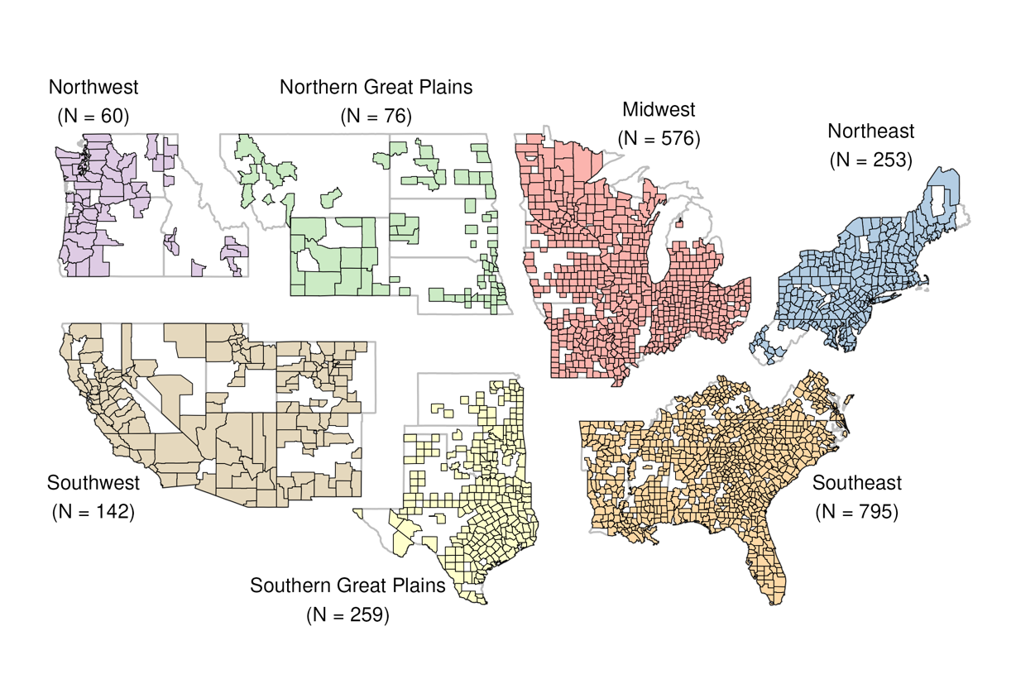
Fig 1. US counties with more than 500 annual average Optum Labs Data Warehouse (OLDW) enrollees. This study included 21,090,141 OLDW enrollees in 2161 US counties from 2010 to 2021. Regions defined according to the 4th National Climate Assessment (NCA4): Southeast, Southwest, Northern Great Plains, Southern Great Plains, Midwest, Northeast, and Northwest.

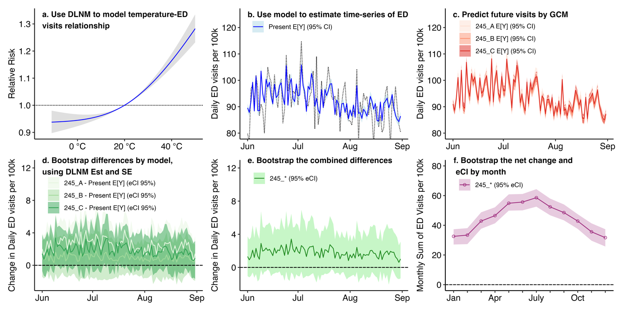
Fig 2. Graphical representation of the statistical methods used in this paper (using dummy data representing a single county). Panel (a) shows the exposure response curve resulting from a distributed lag non-linear model (DLNM). Panel (b) displays how this model is applied to the current dataset to create a multi-year timeseries of expected values of ED visit counts in the present day data (Present E[Y]). For panel (b) and panels (c), (d) and (e), only the summer months of a single year of the multi-year time-series is shown. Panel (c) shows how the temperature change from different global climate models (GCMs) within a Shared Socio-economic Pathway (SSP) is used to estimate the expected value of future ED visits resulting from a time-series of present-day temperatures shifted by the estimates of each GCM (e.g., 2-4.5_A, 2-4.5_B, and 2-4.5_C all represent different GCMs under SSP 2-4.5). Panel (d) shows the bootstrapped difference between present and future expected values and the empirical confidence intervals (eCI 95%). Panel (e) shows the daily bootstrapped difference across all GCMs within an SSP (i.e., the differences in 2-4.5_A, 2-4.5_B, and 2-4.5_C are combined into 2-4.5_*). Panel (f) shows the mean and empirical confidence interval (eCI) of the combined difference at the average monthly level across the entire timeseries, obtained by bootstrapping and summing values by region and month.

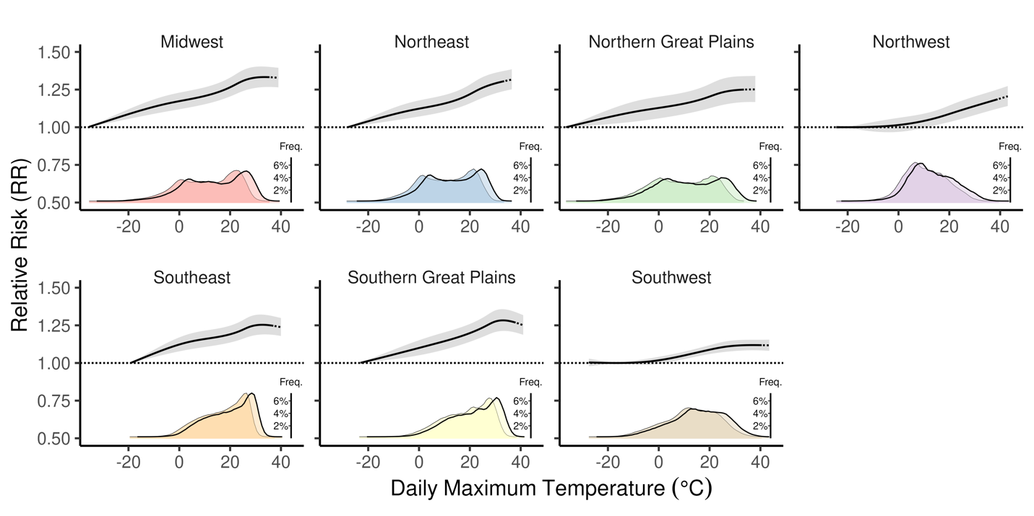
Fig 3. The exposure-response relationship and 95% confidence interval (CI) for daily maximum temperature and the relative risk of all-cause Emergency Department (ED) visits for OLDW enrollees in 2161 counties in the contiguous US from 2010 to 2021. The reference point for estimating the relative risk in each NCA4 region is represented by the temperature with the lowest relative risk of an ED visit. The dotted portion of each exposure-response curve shows the linear projection for temperatures above the range of temperatures in 2010 to 2021. The density plots beneath show the current (bordered in grey) and future (bordered in black) temperature distributions given the median of SSP5-8.5 scenarios.

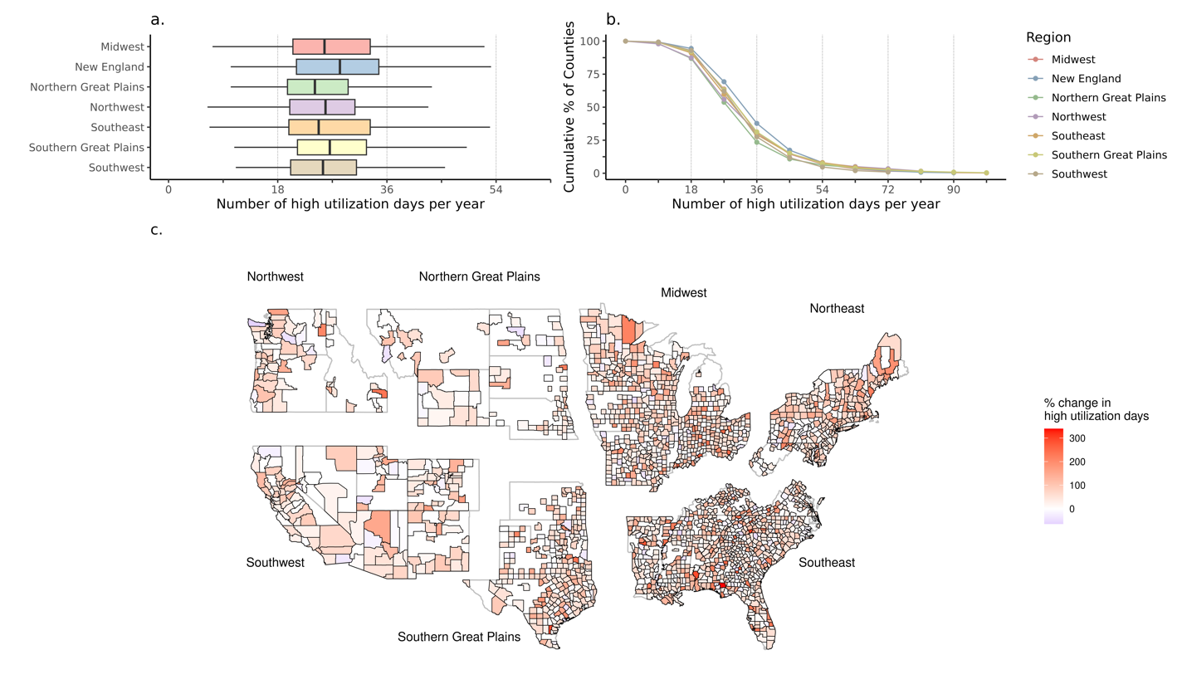
Fig 4. For the high emission scenario (SSP5-8.5), (a) boxplots showing the distribution of future high utilization days per year by NCA4 Region, (b) the cumulative proportion (%) of counties experiencing high utilization days using projected temperatures, and the (c) spatial distribution of county-specific changes (%) in the number of high utilization days. In each plot, a high utilization day is one with an emergency department (ED) visit count greater than the annual 95th percentile of daily ED visits.

TABLES
Table 1. Modeled median changes in annual Optum Labs Data Warehouse (OLDW) Emergency Department (ED) visits by NCA4 region due only to Mid-century (2040-2050) temperatures from Shared Socio-economic Pathway (SSP) model 5-8.5. Present-day and future modeled ED visits are estimated using distributed lag non-linear models (DLNMs) and using 2010-2021 ED visits among 21,090,141 OLDW enrollees in 2,161 US counties. The change in annual average ED visits was estimated using bootstrap methods.
NCA4 region | N counties | Annual Avg. OLDW Population  (2010-2021) | Annual avg. ED visits  (2010-2021) | Annual avg. ED  visits modeled  (2010-2021) | Change in  Annual avg. ED visits  modeled  (2040-2050) | Average modeled  % change in annual ED visits
Midwest | 576 | 5,163,809 | 1,718,395 | 1,718,392  (1,718,247, 1,718,549) | +24,772  (24,497, 25,055) | +1.4
Northeast | 253 | 3,483,720 | 1,055,423 | 1,055,422  (1,055,312, 1,055,526) | +16,712  (16,493, 16,914) | +1.6
Northern Great Plains | 76 | 286,049 | 83,857 | 83,855  (83,825, 83,887) | +1,022  (964, 1,083) | +1.2
Northwest | 60 | 501,741 | 130,086 | 130,084  (130,046, 130,126) | +2,005  (1,935, 2,083) | +1.5
Southeast | 795 | 5,778,368 | 2,186,146 | 2,186,152  (2,186,014, 2,186,320) | +23,732  (23283, 24168) | +1.1
Southern Great Plains | 259 | 2,937,845 | 907,101 | 907,092  (906,978, 907,228) | +10,873  (10,654, 11,118) | +1.2
Southwest | 142 | 2,938,609 | 691,344 | 691337  (691,245, 691,433) | 7,201  (7,009, 7,374) | +1.0
All | 2,161 | 21,090,141 | 6,772,351 | 6,772,338  (6,772,077, 6,772,616) | 86,298  (85,688, 87,007) | +1.3

SUPPLEMENTAL
Table S1. Projected change from baseline (2010-2021) and mid-century (2041-2050) daily maxmimum temperatures for each region for the 2,161 counties in OLDW.
NCAregion | season | Minimum change in daily maximum temperature | Median change in daily maximum temperature | Maximum change in daily maximum temperature | Minimum projected future daily maximum temperature | Median projected future daily maximum temperature | Maximum projected future daily maximum temperature
Midwest | Summer | 2.5 | 2.7 | 3.2 | 21.6 | 25.3 | 28.8
Northeast | Summer | 2.2 | 2.4 | 2.5 | 22.3 | 25.5 | 27.3
Northern Great Plains | Summer | 2.9 | 3.2 | 3.3 | 24.6 | 27.5 | 28.2
Northwest | Summer | 2.2 | 2.5 | 2.7 | 19.8 | 21.5 | 27.9
Southeast | Summer | 1.6 | 1.9 | 2.8 | 24.0 | 28.4 | 31.0
Southern Great Plains | Summer | 1.6 | 2.4 | 3.1 | 28.9 | 31.0 | 31.8
Southwest | Summer | 1.6 | 2.5 | 2.7 | 18.0 | 24.8 | 36.3
Midwest | Winter | 2.3 | 2.5 | 2.9 | -6.9 | 0.3 | 5.0
Northeast | Winter | 2.2 | 2.3 | 2.6 | -1.0 | 3.0 | 5.1
Northern Great Plains | Winter | 2.4 | 2.4 | 2.7 | -7.2 | -0.8 | 0.0
Northwest | Winter | 1.6 | 1.7 | 2.0 | 0.9 | 6.0 | 6.6
Southeast | Winter | 1.2 | 1.9 | 2.4 | 3.6 | 10.0 | 22.2
Southern Great Plains | Winter | 1.8 | 2.0 | 2.4 | 2.7 | 11.4 | 19.6
Southwest | Winter | 1.4 | 1.7 | 2.1 | -2.8 | 10.5 | 14.4

Table S2. Percent (%) changes by SSP 2-4.5, 3-7.0 and 5-8.5 versions of Table 1.
 | SSP 2-4.5 | SSP 3-7.0 | SSP 5-8.5
Midwest | 1.1 | 1.3 | 1.4
Northeast | 1.2 | 1.3 | 1.6
Northern Great Plains | 0.9 | 1.1 | 1.2
Northwest | 1.1 | 1.3 | 1.5
Southeast | 0.8 | 0.9 | 1.1
Southern Great Plains | 1.0 | 1.1 | 1.2
Southwest | 0.8 | 0.9 | 1.0
All | 1.0 | 1.1 | 1.3
Table S3. Quantiles of the average change in high utilization days, where a high utilization day is defined by having a higher ED visit rate than the 95th percentile of ED visit rates in a year. This table shows the change in the number of high utilization days under mid-century temperatures from during present day conditions. The present-day expected value of the 95th percentile is 18 days per year.
 |  | Quantiles of the change in high utilization days (N)
REGION | SSP | Minimum | 25th | 50th | 75th | Maximum
Midwest | 2-4.5 | -8.7 | 1.7 | 5.8 | 10.5 | 33.3
New England | 2-4.5 | -7.1 | 2.3 | 7.3 | 11.3 | 29.4
Northern Great Plains | 2-4.5 | -6.1 | 0.7 | 4.0 | 7.6 | 26.5
Northwest | 2-4.5 | -10.5 | 1.2 | 4.7 | 8.7 | 29.2
Southeast | 2-4.5 | -10.1 | 1.4 | 4.8 | 10.4 | 38.8
Southern Great Plains | 2-4.5 | -6.4 | 2.3 | 6.0 | 10.5 | 35.0
Southwest | 2-4.5 | -5.3 | 0.9 | 5.2 | 8.7 | 19.9
Midwest | 3-7.0 | -9.5 | 2.1 | 6.9 | 12.8 | 37.8
New England | 3-7.0 | -7.8 | 2.6 | 8.4 | 13.4 | 35.5
Northern Great Plains | 3-7.0 | -7.0 | 1.4 | 4.6 | 9.4 | 32.5
Northwest | 3-7.0 | -10.7 | 1.1 | 5.7 | 10.4 | 34.1
Southeast | 3-7.0 | -10.9 | 1.5 | 5.7 | 12.2 | 47.8
Southern Great Plains | 3-7.0 | -6.3 | 2.8 | 7.1 | 11.7 | 39.6
Southwest | 3-7.0 | -6.2 | 1.5 | 5.9 | 10.3 | 24.0
Midwest | 5-8.5 | -10.8 | 2.5 | 7.7 | 15.3 | 46.9
New England | 5-8.5 | -7.8 | 3.1 | 10.3 | 16.7 | 41.4
Northern Great Plains | 5-8.5 | -7.8 | 1.6 | 6.1 | 11.6 | 39.9
Northwest | 5-8.5 | -11.6 | 2.0 | 7.9 | 12.7 | 41.9
Southeast | 5-8.5 | -11.3 | 1.8 | 6.8 | 15.3 | 61.1
Southern Great Plains | 5-8.5 | -7.2 | 3.3 | 8.6 | 14.6 | 53.3
Southwest | 5-8.5 | -6.9 | 2.1 | 7.5 | 13.0 | 30.2

Table S4. Global climate models (GCMs) used for modeled mid-century (2040-2051) daily maximum temperatures under various Shared Socio-Economic Pathways (SSP). Not every GCM had outputs for every SSP.
# | GCM | SSP 2-4.5 | SSP 3-7.0 | SSP 5-8.5
1 | ACCESS-CM2 | x | x | x
2 | ACCESS-ESM1-5 | x | x | x
3 | BCC-CSM2-MR | x | x | x
4 | CanESM5 | x | x | x
5 | CMCC-CM2-SR5 | x |  | x
6 | CMCC-ESM2 | x | x | x
7 | CNRM-CM6-1 | x | x | x
8 | CNRM-ESM2-1 | x | x | x
9 | EC-Earth3 | x | x | x
10 | EC-Earth3-Veg-LR | x | x | x
11 | FGOALS-g3 | x | x | x
12 | GFDL-CM4ª | x |  | x
13 | GFDL-CM4^{b} | x |  | x
14 | GFDL-ESM4 | x | x | x
15 | GISS-E2-1-G | x | x | x
16 | HadGEM3-GC31-LL | x |  | x
17 | HadGEM3-GC31-MM |  |  | x
18 | INM-CM4-8 | x | x | x
19 | INM-CM5-0 | x | x | x
20 | IPSL-CM6A-LR | x | x | x
21 | KACE-1-0-G | x | x | x
22 | KIOST-ESM | x |  | x
23 | MIROC-ES2L | x | x | x
24 | MIROC6 | x | x | x
25 | MPI-ESM1-2-HR | x | x | x
26 | MPI-ESM1-2-LR | x | x | x
27 | MRI-ESM2-0 | x | x | x
28 | NESM3 | x |  | x
29 | NorESM2-LM | x | x | x
30 | NorESM2-MM | x | x | x
31 | TaiESM1 | x | x | x
32 | UKESM1-0-LL | x | x | x
^{a,b} represent different grid resolutions
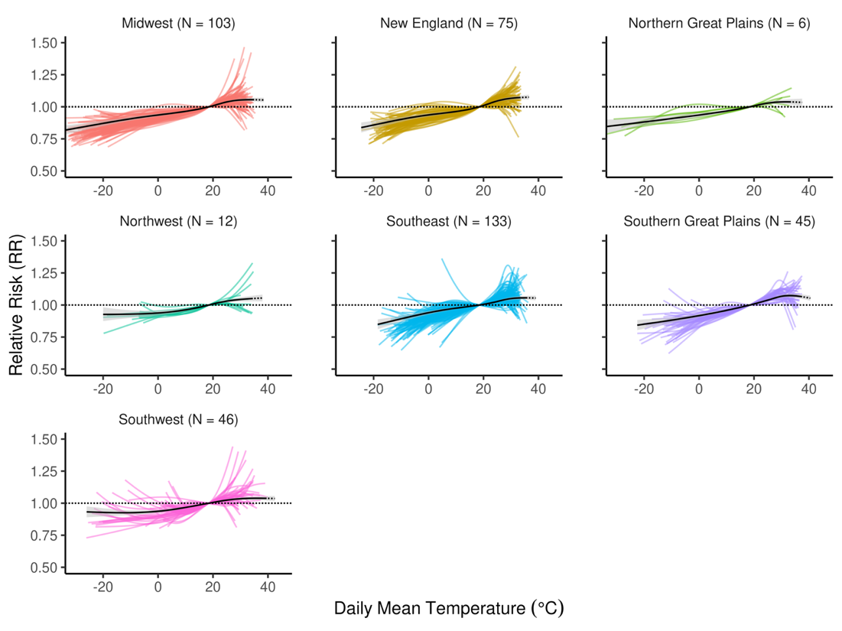
Figure S1. Same as Figure 3, but with a 3 day lag period and 1 lag knot. Re-run for the most-populated 2,161 counties (those with >10,000 annual average enrollees, 420 in total).
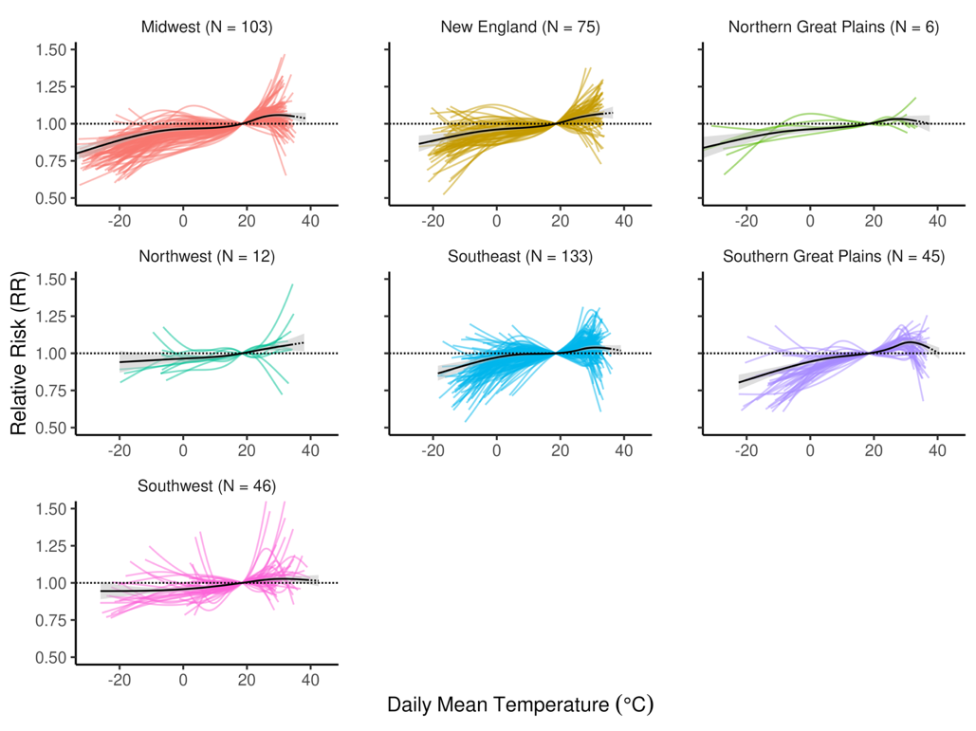
Fig S2. Same as Figure 3, but with a 10 day lag period and 4 lag knots. Re-run for the most-populated counties (those with >10,000 annual average enrollees, 420 in total).
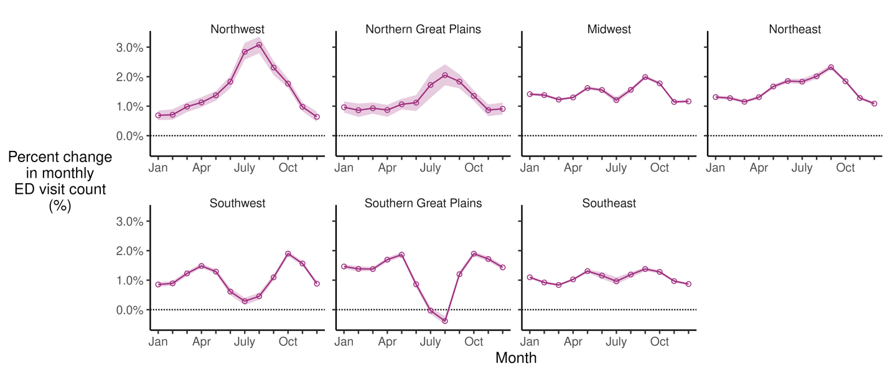
Fig S3. Percent change in monthly all-cause Emergency Department (ED) visit counts under projected midcentury temperatures of the high emission scenario (SSP5-8.5).

