Supporting Information

A hybrid additive manufacturing platform to create bulk and surface composition gradients on scaffolds for tissue regeneration

Ravi Sinha, Maria Cámara-Torres, Paolo Scopece, Emanuele Verga Falzacappa, Alessandro Patelli, Lorenzo Moroni, Carlos Mota*

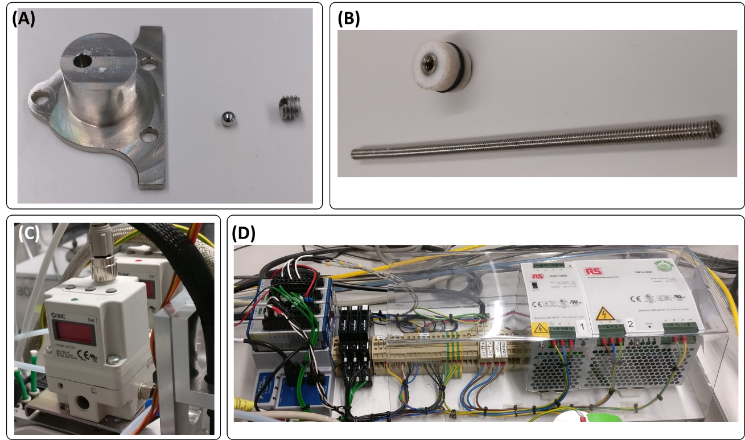
Supplementary Figure S1. Several key supporting technologies enable the proper functioning of the printhead. One-way valves (A) at the base of reservoirs prevent back-flows of materials into the other material’s reservoir. Extractable plungers (B) allow reduction of left-over material in the reservoirs and new material feeding after the reservoirs are emptied. Individual pressure regulators (C) and pressure and temperature controllers (D) are critical to the printhead operation.

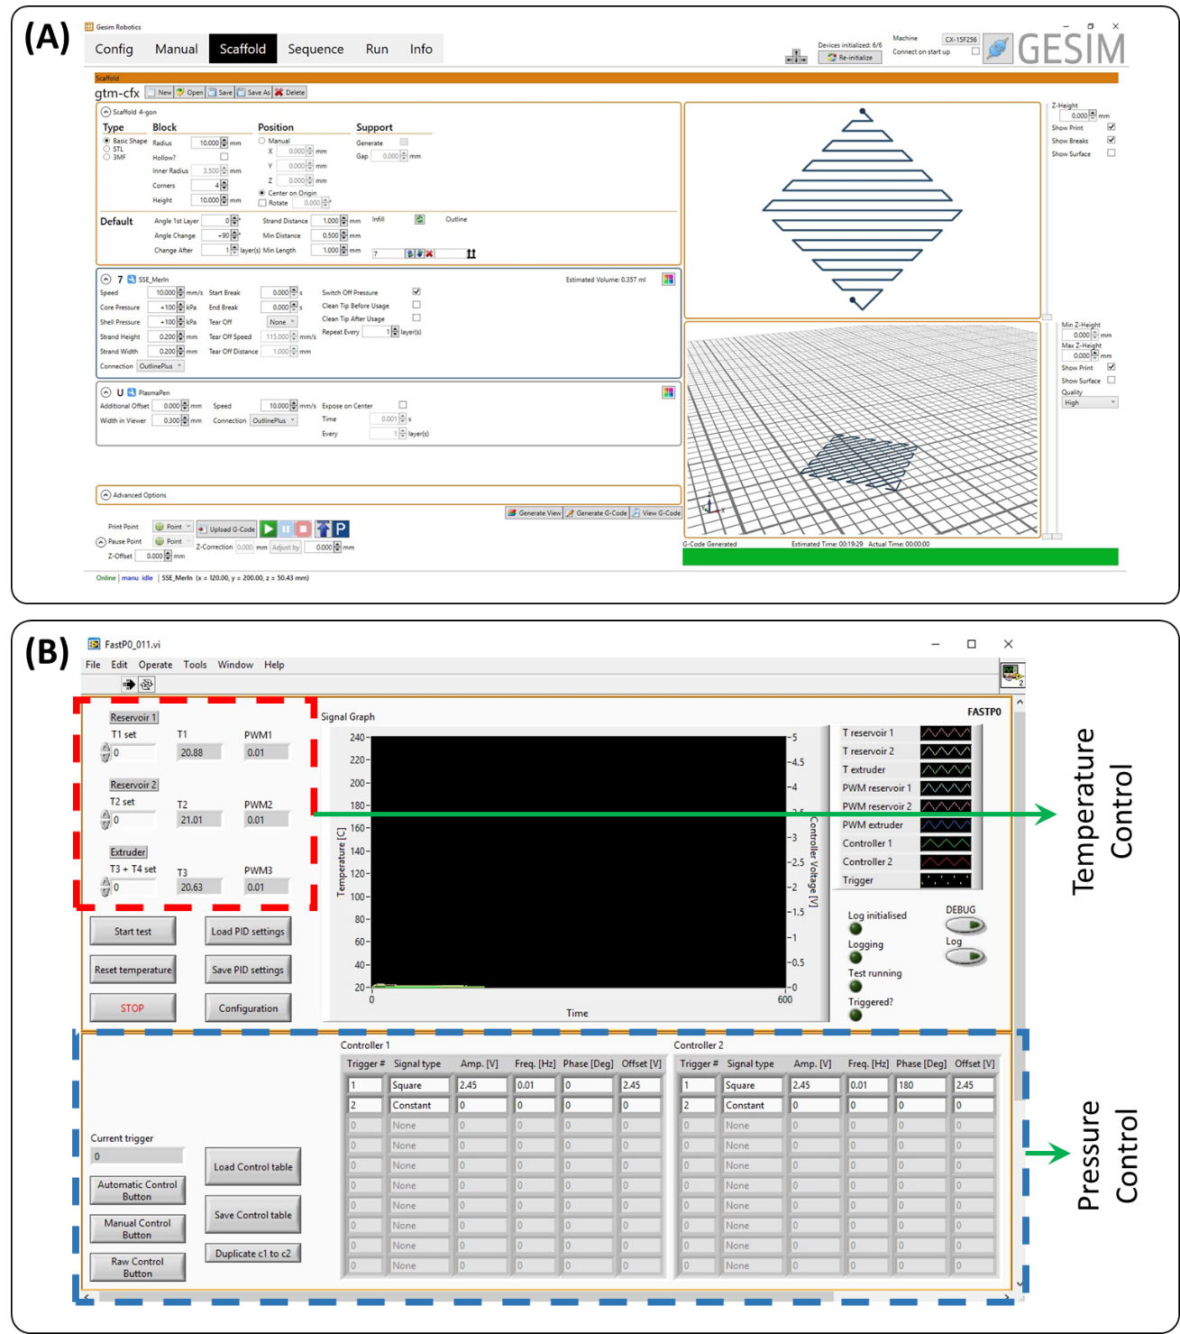
Supplementary Figure S2. Customized software enable the application of the desired print control via a user-friendly interface. The printer software interface (A) enables the desired print parameter entry and the automated generation of G-codes to appropriately move and trigger the printhead and the plasma jet. The temperature and pressure software interface (B) allows setting the printhead temperatures and the pressure profiles to be applied to each of the printhead reservoirs when triggered.

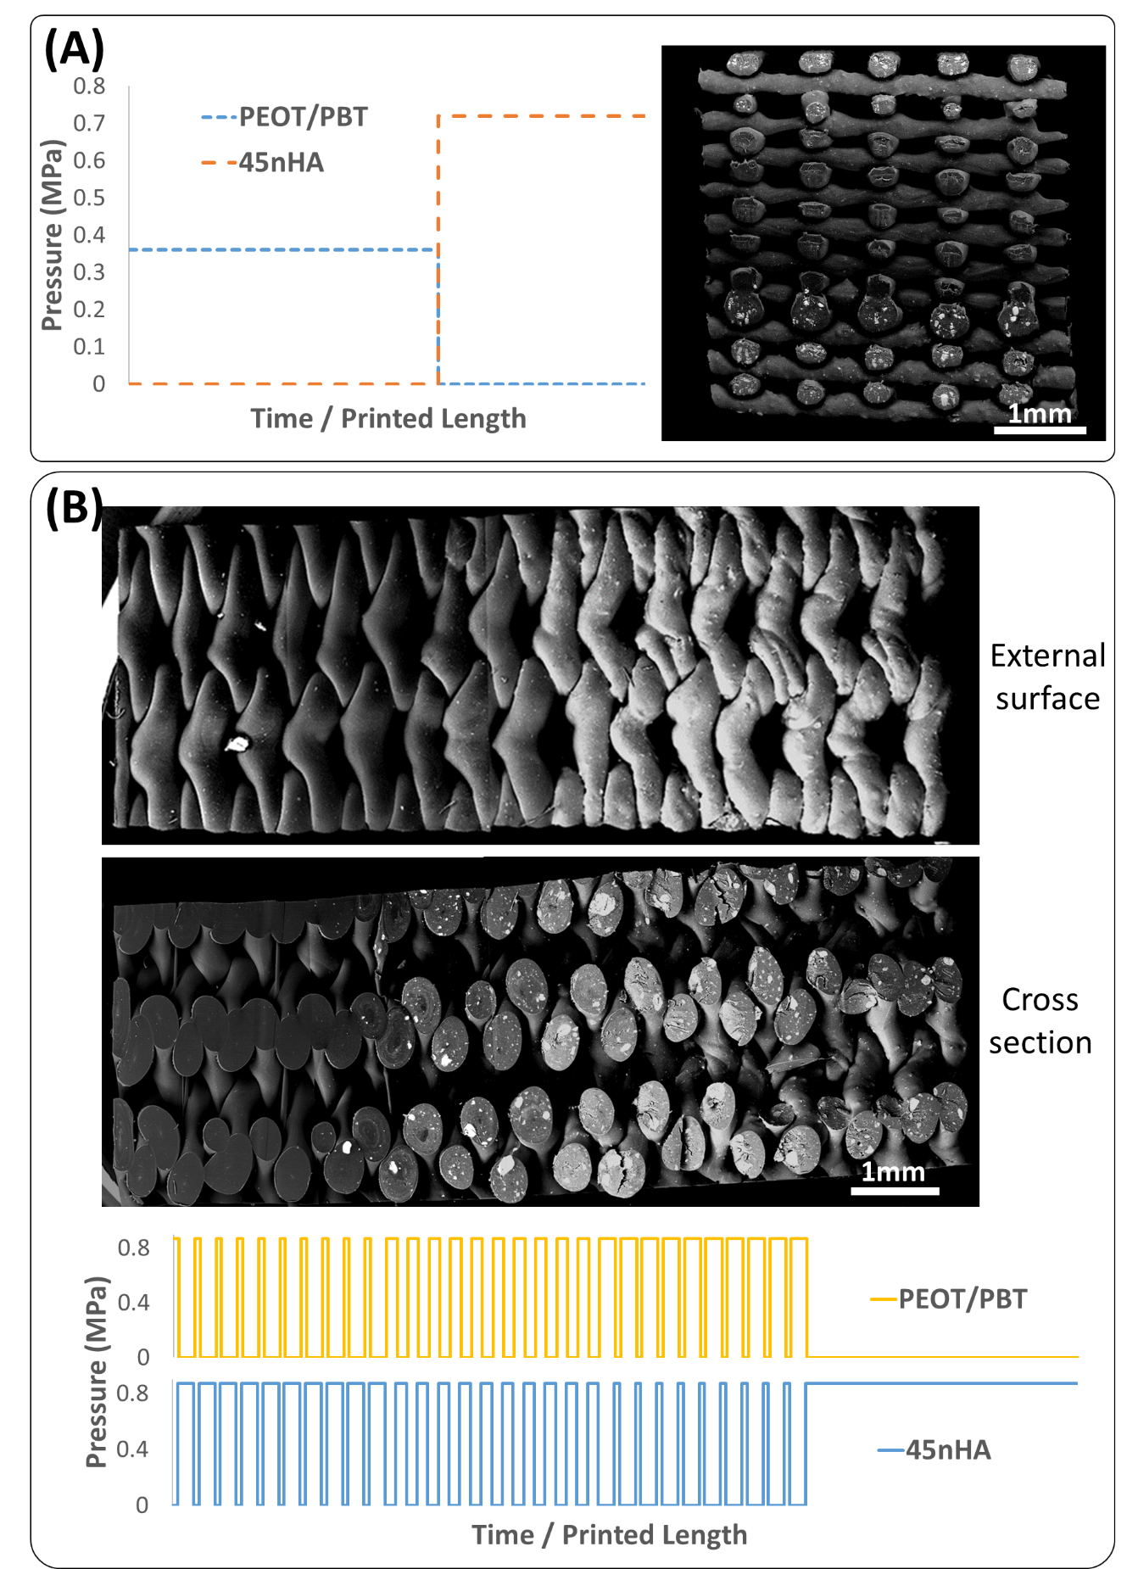
Supplementary Figure S3. Continuous complete composition switches as well as sustained intermediate composition printing were demonstrated. Back-scattered electron-mode scanning electron microscopy (BSE-SEM) images showing HA filler in contrast with the surrounding PEOT/PBT polymer demonstrated that continuous, smooth transitions between compositions could be made when pressures were alternatively applied to the two reservoirs for extended periods of time (A). Intermediate compositions could be sustained for a longer duration by alternatively injecting materials into the screw and controlling their ratio by controlling the ratio of times each pressure is on (B).

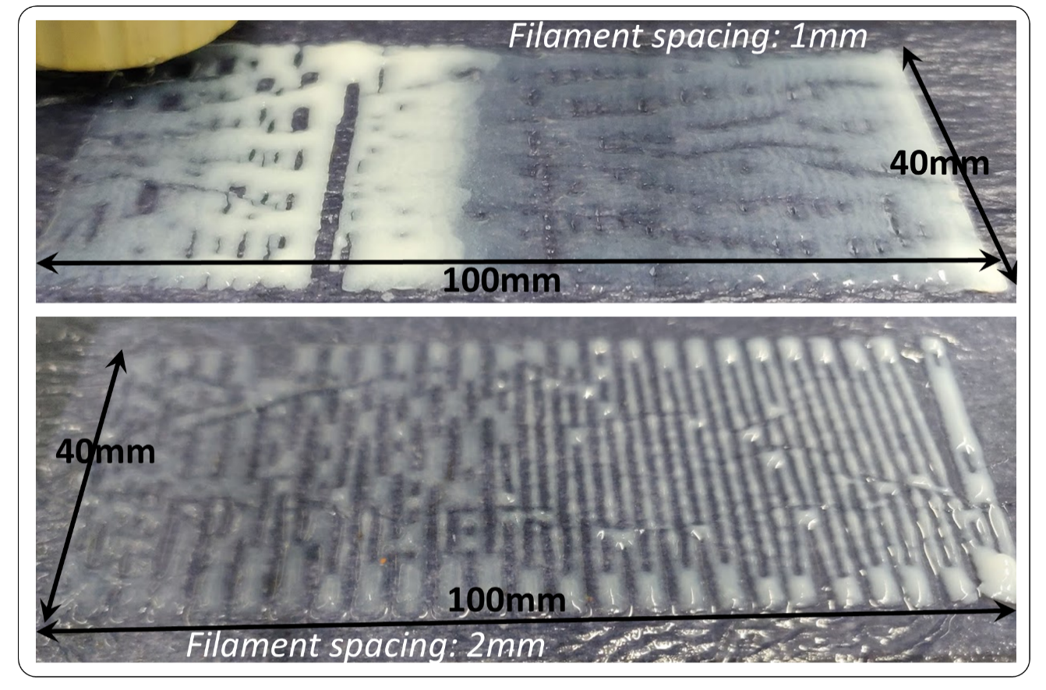
Supplementary Figure S4. Continuous composition gradients can be printed using hydrogels. Alginate gel loaded with hydroxyapatite (HA) was printed on calcium chloride–soaked tissue paper to gel the alginate. Gradients in HA composition could be produced using the printhead.

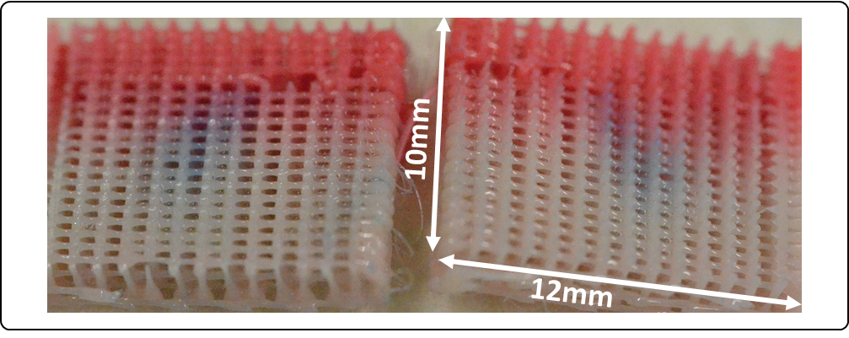
Supplementary Figure S5. Bulk composition gradients can be combined with plasma patterning to simultaneously test for the response of cells to various conditions. Dyed (pink) and non-dyed PEOT/PBT were used to generate the shown composition gradient scaffold, and the core of the scaffold was coated with plasma-polymerized VTMOS-MAA, which is visualized using methylene blue staining.

Supplementary Table S1. Screw geometrical parameters used for the tested designs in the computational modeling–assisted screw operational torque minimization. Column values, in mm, correspond to measurements shown in Figure 2A. Design no. 1 has the base dimensions and for the other designs, the parameter changed is highlighted in bold.

Design No. | t | D1 | D2 | p1 | p2
1 | 1.5 | 4.8 | 5.6 | 8 | 6
2 | 1 | 4.8 | 5.6 | 8 | 6
3 | 2 | 4.8 | 5.6 | 8 | 6
4 | 1.5 | 4.6 | 5.6 | 8 | 6
5 | 1.5 | 5 | 5.6 | 8 | 6
6 | 1.5 | 4.8 | 5.4 | 8 | 6
7 | 1.5 | 4.8 | 5.8 | 8 | 6
8 | 1.5 | 4.8 | 5.6 | 7 | 6
9 | 1.5 | 4.8 | 5.6 | 9 | 6
10 | 1.5 | 4.8 | 5.6 | 8 | 5
11 | 1.5 | 4.8 | 5.6 | 8 | 7

Supplementary Table S2. Printing parameters for various prints and scaffolds produced.
Scaffold type | PEOT/PBT temp. (°C) | PEOT/PBT + filler temp. (°C) | Mixing chamber temp. (°C) | PEOT/PBT pres. profile | PEOT/PBT + filler pres.  profile | Screw speed (rpm) | Translation speed (mm/s) | Starting Composition (w/ filler: w/o filler) | Extrusion needle inner diameter (μm) | Strand distance (μm) | Layer height (μm)
Empirical switching 45nHA | 195 | 210 | 220 | 0.88 MPa, 0.01 Hz sq. wave, phase 0 | 0.88 MPa, 0.01 Hz sq. wave, phase 180 | 30 | 6 | 50:50 | 400 | 1000 | 320
Empirical switching 10rGO | 195 | 220 | 220 | 0.45 MPa, 0.002 Hz sq. wave, phase 180 | 0.88 MPa, 0.002 Hz sq. wave, phase 0 | 60 | 3 | 50:50 | 250 | 1000 | 200
Empirical switching 20LDH-CFX | 195 | 185 | 195 | 0.88 MPa, 0.01 Hz sq. wave, phase 0 | 0.88 MPa, 0.01 Hz sq. wave, phase 180 | 60 | 10 | 50:50 | 400 | 1000 | 320
Empirical switching 20ZrP-GTM | 195 | 190 | 195 | 0.88 MPa, 0.005 Hz sq. wave, phase 0 | 0.88 MPa, 0.005 Hz sq. wave, phase 180 | 60 | 6 | 50:50 | 400 | 1000 | 320
Mech. Test – 45nHA | 195 | 210 | 220 | 0 | 0.72 | 60 | 22.5 | 100:0 | 250 | 750 | 200
Mech. Test – PEOT/PBT | 195 | 210 | 220 | 0.36 | 0 | 60 | 17.5 | 0:100 | 250 | 750 | 200
Mech. Test – HPH_C | 195 | 210 | 220 | 0.36 MPa for layers 1–13 | 0.72 MPa for layers 14–20 | 60 | 17.5 for first 15 layers, 22.5 for next 5 layers | 100:0 | 250 | 750 | 200
Mech. Test – HPH_D | 195 | 210 | 220 | 0.36 MPa for layers 1–5 and 16–20 | 0.72 MPa for layers 6–15 | 60 | 17.5 for first 5 and last 5 layers, 22.5 for middle 10 layers | 100:0 | 250 | 750 | 200
Mech. Test – PHP_C | 195 | 210 | 220 | 0.54 MPa for layers 1–3 and 14–32 | 0.72 MPa for layers 4–13 | 20, varied manually a few times | 7.5 for layers 15–20, 15 for rest of the layers | 0:100 | 340 | 850 | 250
Mech. Test – PHP_D | 195 | 210 | 220 | 0.54 MPa for layers 1–11 and 22–32 | 0.72 MPa for layers 12–21 | 20 | 15 | 0:100 | 340 | 850 | 250

Movie S1. Comparison of particle mixing between screws with a triangular and a square thread cut.

Movie S2. Segmental long bone defect scaffold printing with a cortical composition change.

Movie S3. Sustained printing of compositions intermediate between the compositions in the two reservoirs.

Movie S4. Mechanical testing of continuous and discrete gradient scaffolds with a PEOT/PBT region sandwiched between 45nHA regions.

Movie S5. Mechanical testing of continuous and discrete gradient scaffolds with a 45nHA region sandwiched between PEOT/PBT regions.

Movie S6. Scaffold production combining a continuous bulk composition gradient and plasma patterning.

