A theoretical investigation of decorated triazoles as DSSCs in PV devices
Louis-Charl Coetzeea, Adedapo Adeyinkaa, Nomampondo Magwab,
aChemical Sciences, University of Johannesburg, PO Box 524, Auckland Park, Johannesburg, 2006, Gauteng, South Africa.
Tel.: +27604699790
bDepartment of Chemistry, University of South Africa, Private Bag X6, Florida, Roodepoort, Johannesburg, 1710, Gauteng, South Africa.
Tel.: +27(011)6709302
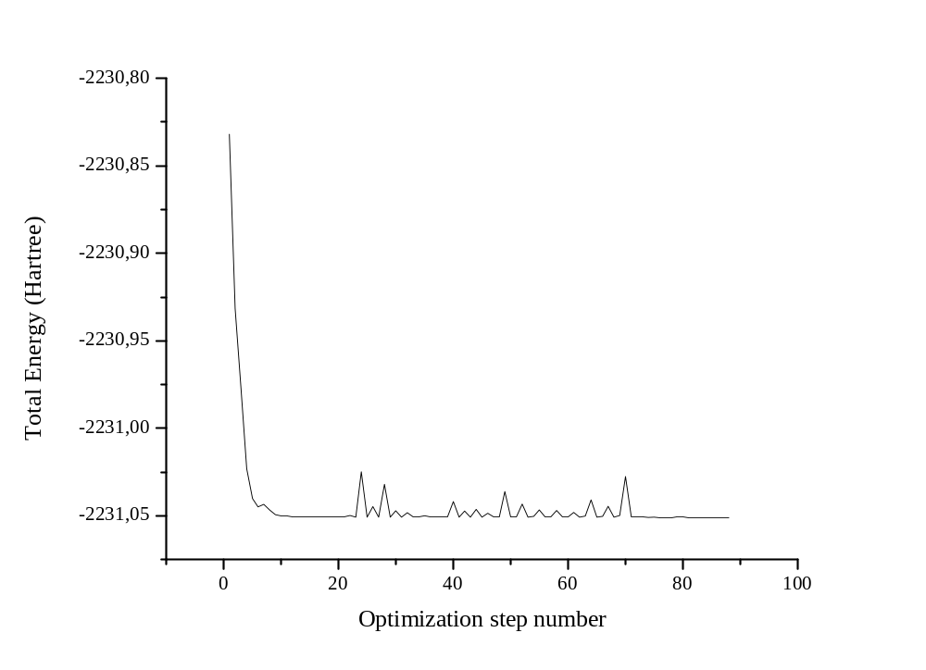
A1
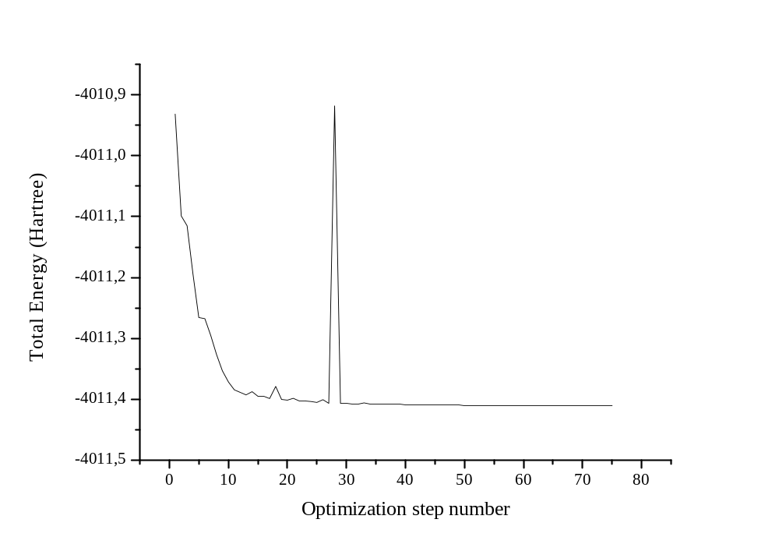
A2
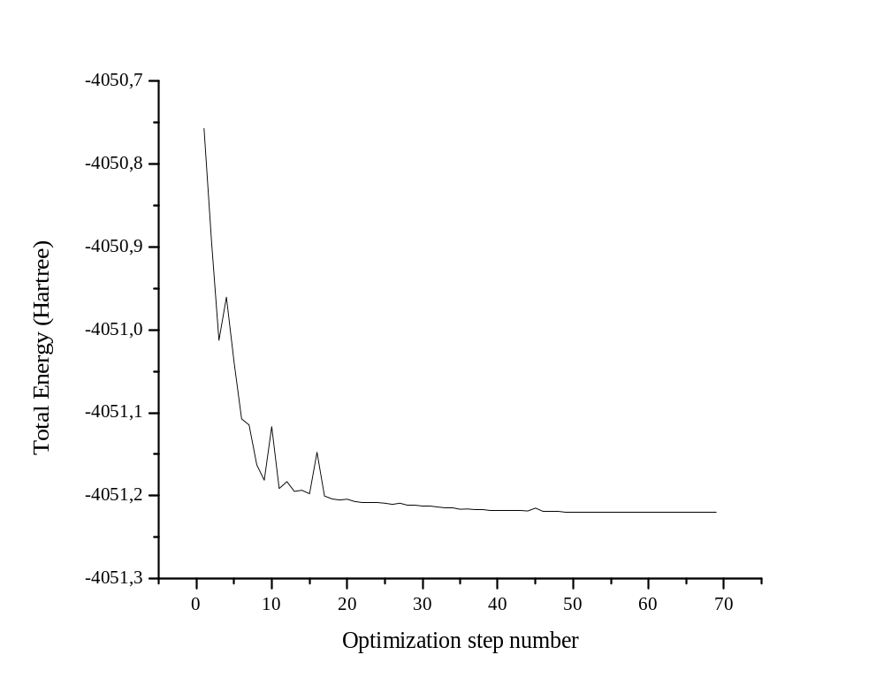
A3
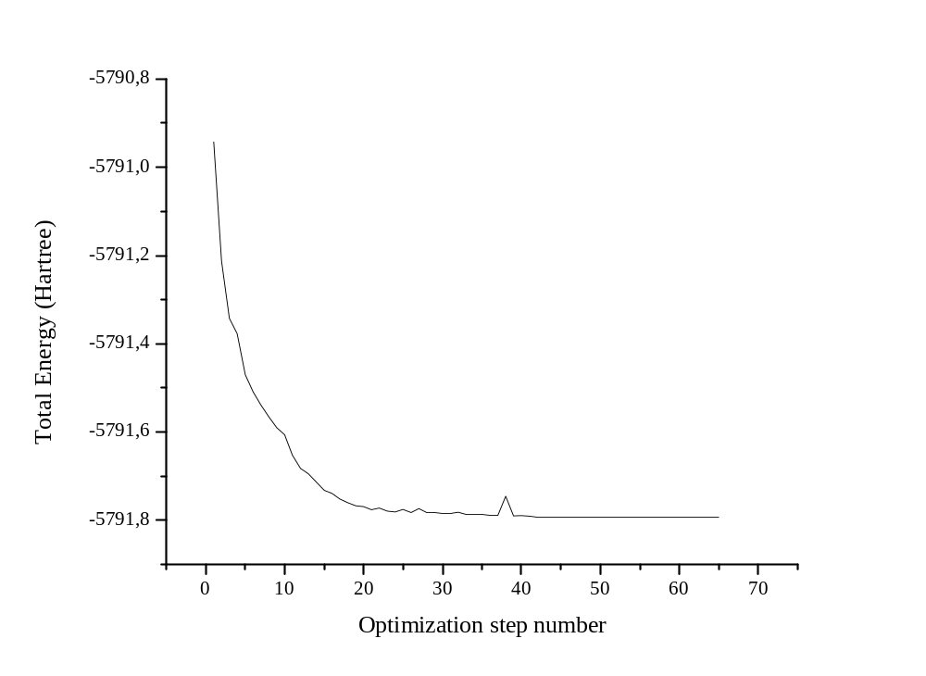
A4
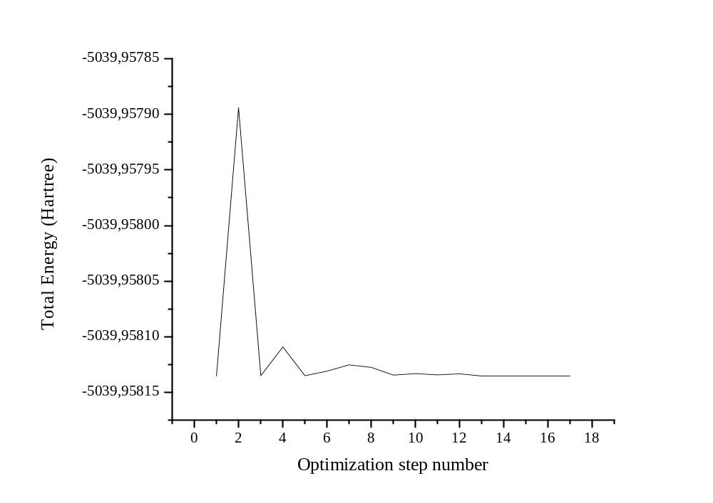
A5
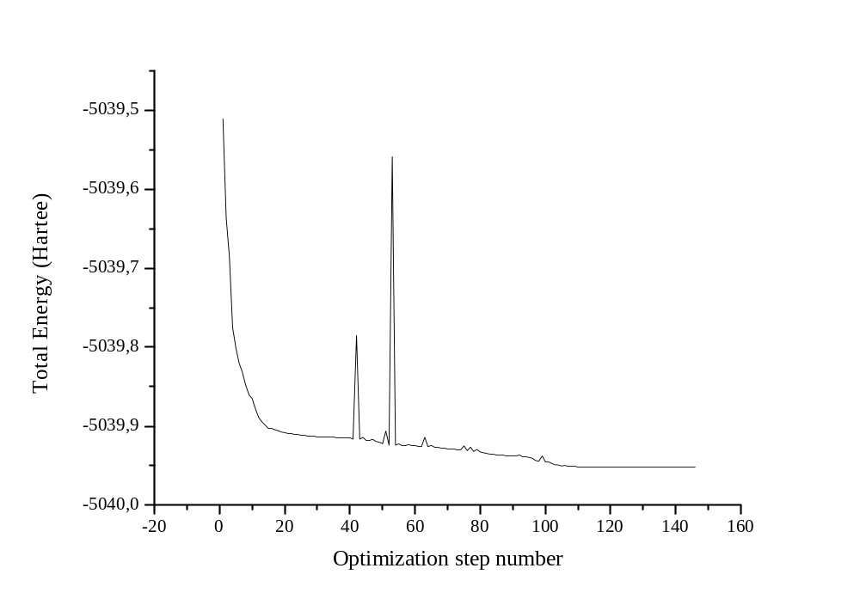
A6
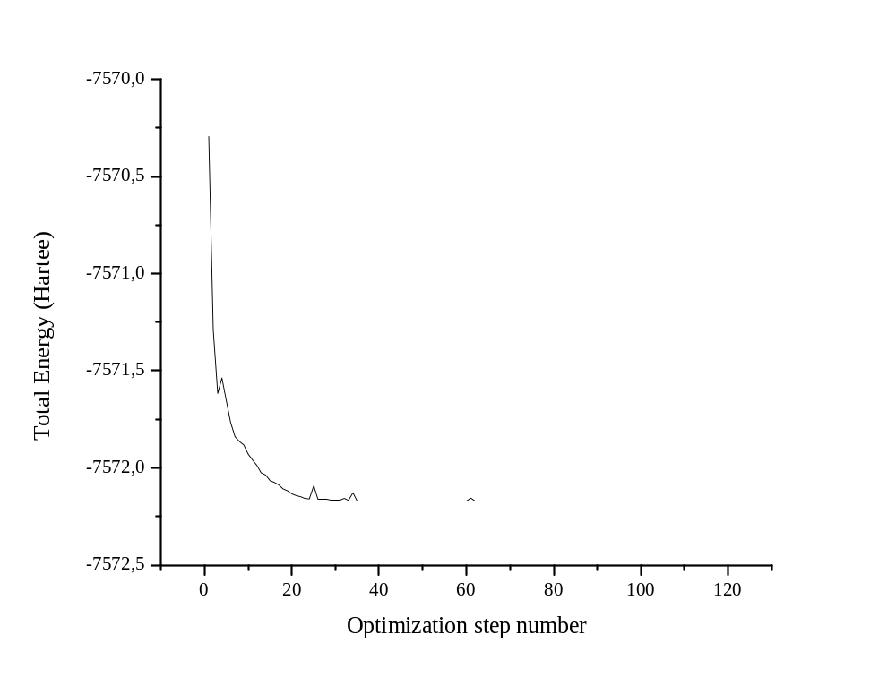
A7
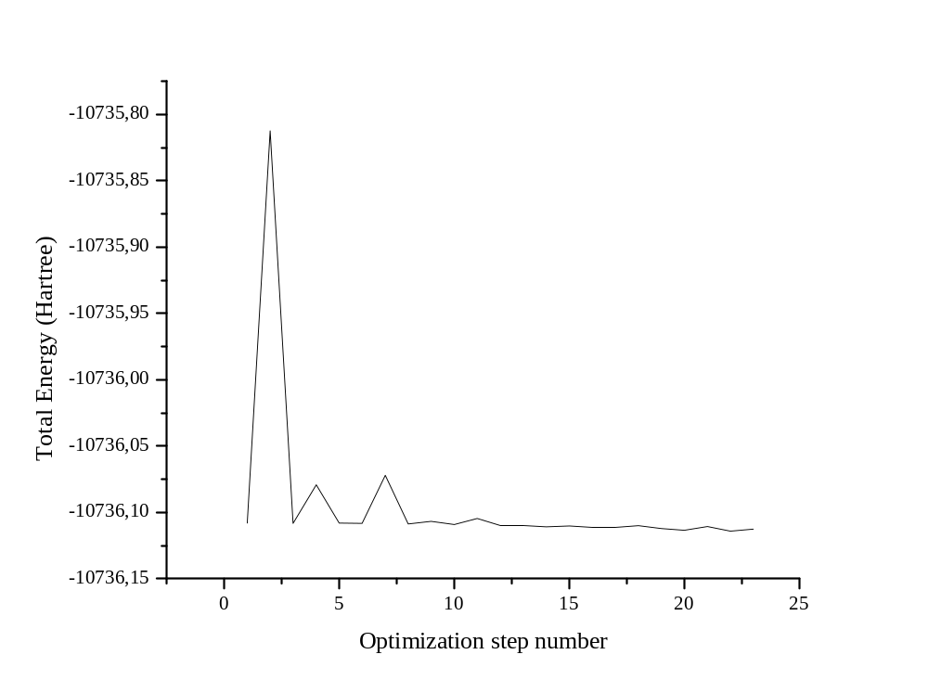
A8
Figure S1: Optimization energies for the molecules obtained through DFT calculations
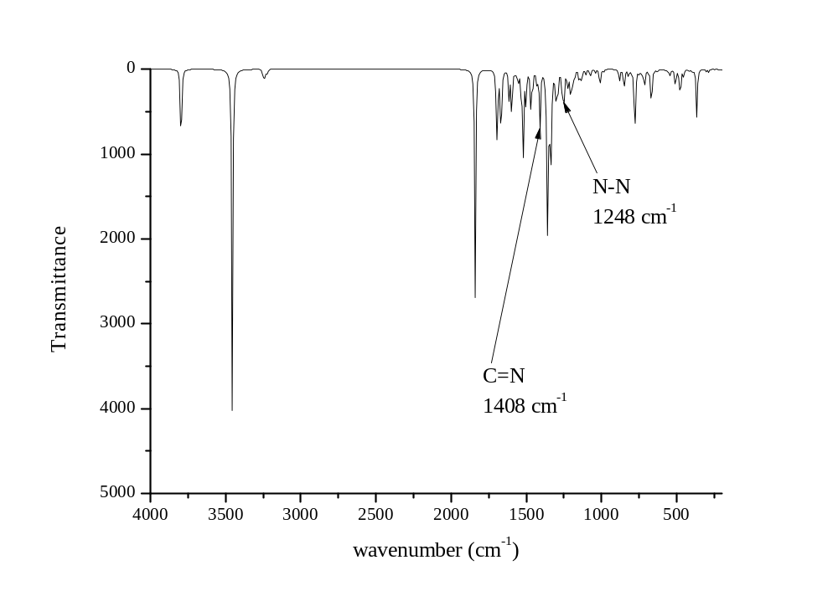
Parent compound
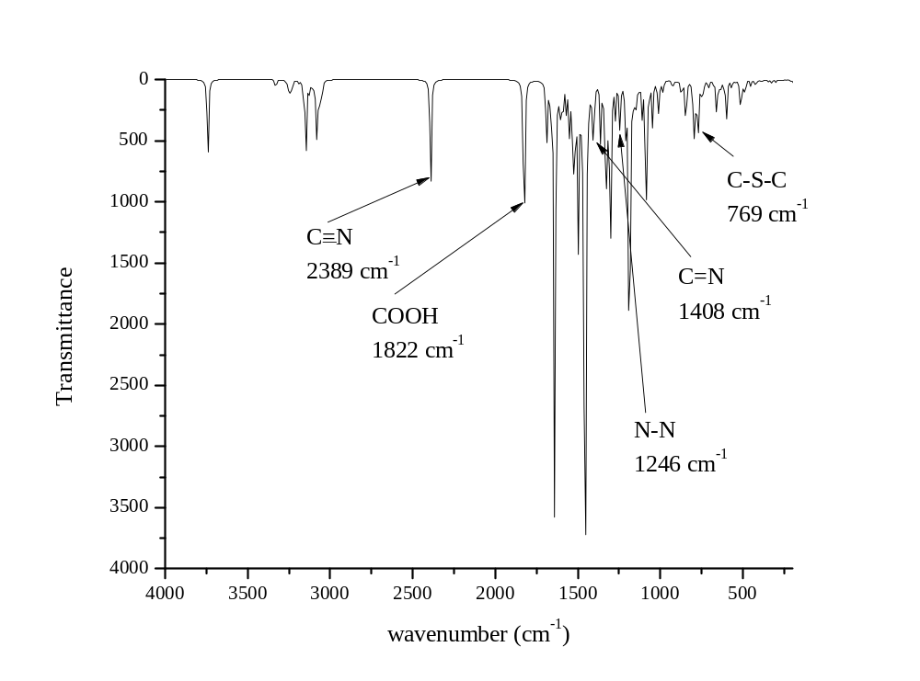
A1
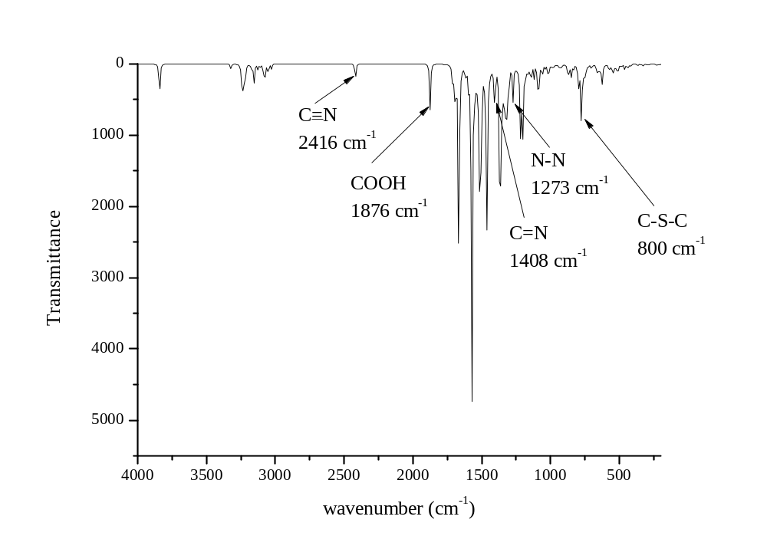
A2
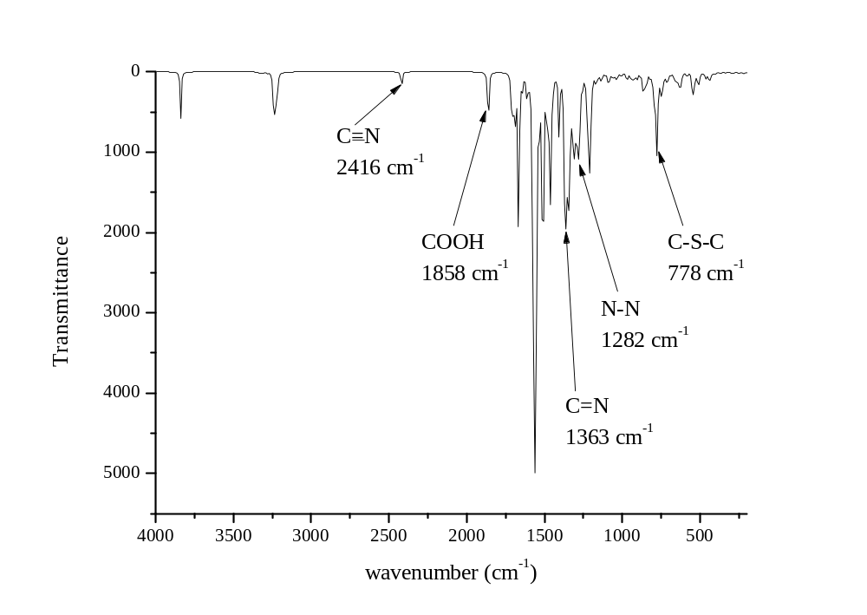
A3
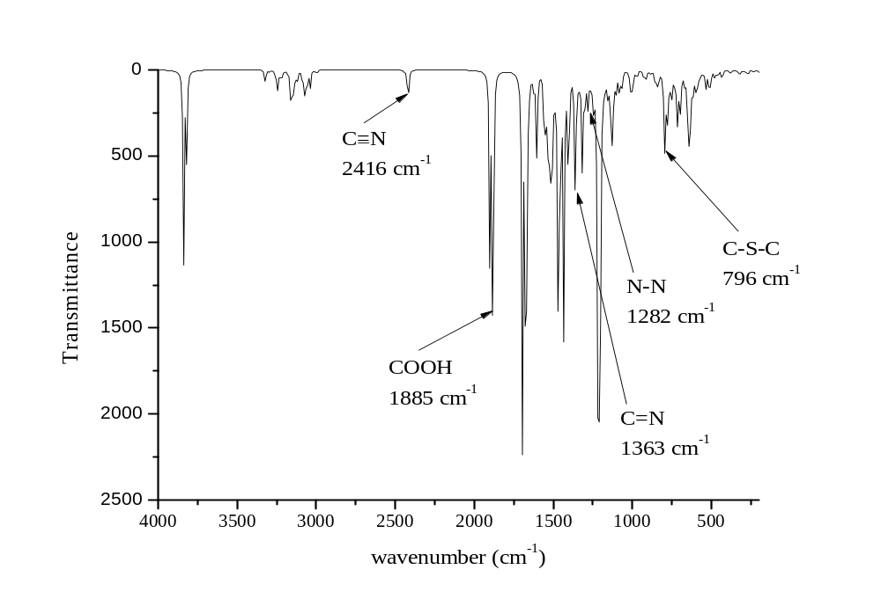

A4
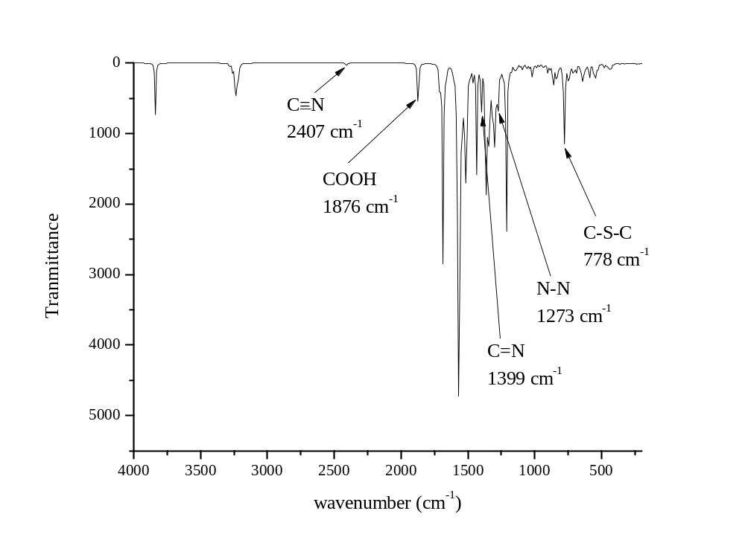
A5
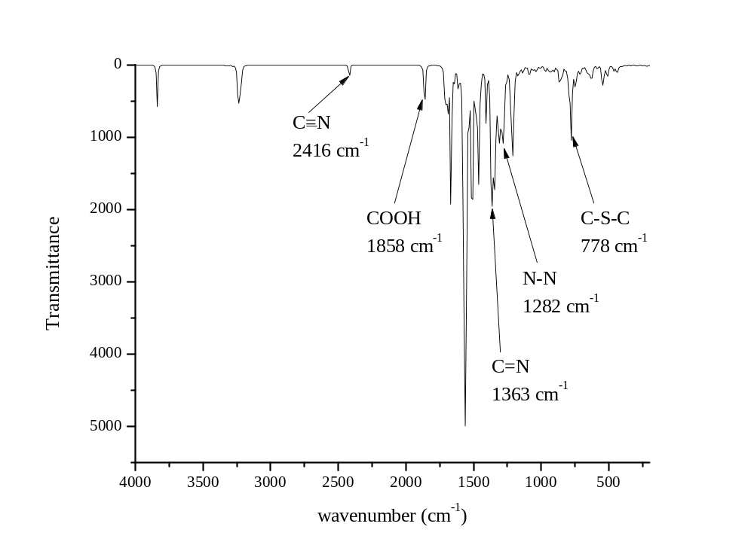
A6
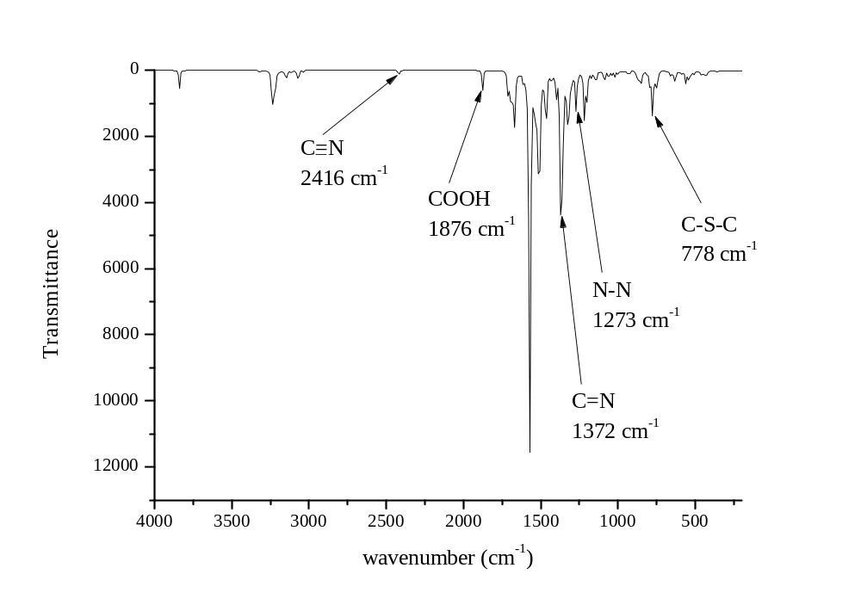
A7
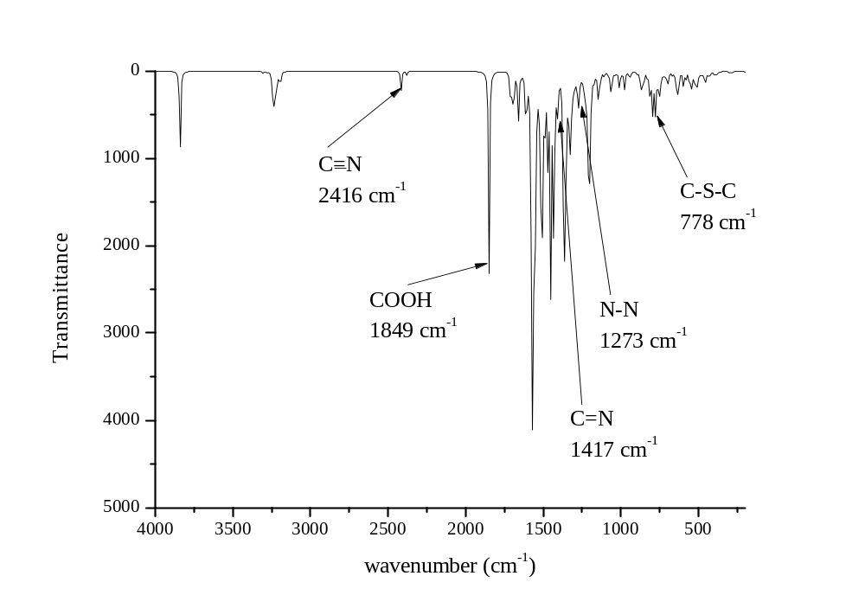
A8
Figure S2: Theoretical IR stretches of molecules
Table S1: Cartesian coordinates of A1
O 1.611700 1.852800 1.368700
O 3.747000 -2.644800 -0.297700
C 3.876300 -0.054400 -1.265200
C 2.778100 1.684700 -0.886000
N 3.843800 1.285500 -1.502800
C 2.427200 3.118500 -0.460400
C 2.748600 4.303700 -1.134800
C 1.785300 3.141200 0.758900
C 2.375700 5.535100 -0.555900
H 3.263200 4.278000 -2.071200
C 1.396400 4.349600 1.341500
C 1.691800 5.552300 0.681600
H 2.597900 6.456000 -1.057300
H 0.879000 4.361000 2.278500
H 1.417100 6.486900 1.124400
C 5.062900 -0.997800 -1.510300
C 4.947200 -2.301700 -1.017300
C 6.223300 -0.587600 -2.180600
C 5.980800 -3.223400 -1.227800
C 7.262500 -1.506600 -2.387200
H 6.315000 0.418900 -2.537400
C 7.143100 -2.822000 -1.910300
H 5.890200 -4.222400 -0.859600
H 8.150700 -1.204500 -2.900800
H 7.934500 -3.525100 -2.076700
N 1.989900 0.646200 -0.616400
N 2.754700 -0.491400 -0.768100
C 0.554000 0.717600 -0.224500
C -0.139600 -0.405300 0.262800
C -0.138200 1.936800 -0.374600
C -1.490400 -0.281700 0.634800
H 0.350800 -1.353600 0.344700
C -1.510000 2.032500 -0.065800
H 0.379200 2.796700 -0.737300
C -2.192000 0.922700 0.402700
H -1.990800 -1.115000 1.091400
H -2.022700 2.957300 -0.193400
C -3.719400 0.890600 0.643800
C -4.687100 1.738100 0.147400
S -4.434700 -0.390300 1.571600
C -5.946800 1.055100 0.081400
H -4.522500 2.746700 -0.179000
C -5.859000 -0.227900 0.597000
H -6.839800 1.480800 -0.317600
C -6.745700 -1.477800 0.378800
C -7.780700 -1.548000 -0.465800
C -8.294400 -0.362500 -1.246800
O -7.849700 0.793000 -1.040100
O -9.230100 -0.566900 -2.135400
H -9.551900 0.177500 -2.672300
C 3.948300 -3.716000 0.637000
H 4.188400 -4.609300 0.101600
H 4.748400 -3.473800 1.303700
C 2.651800 -3.930000 1.454700
H 2.433700 -3.042600 2.012200
H 1.842000 -4.143900 0.791000
C 2.832800 -5.109500 2.425700
H 1.933600 -5.246800 2.989400
H 3.044600 -5.998300 1.870400
H 3.642900 -4.903600 3.092000
C 2.925500 1.473100 1.853000
H 3.638500 1.603200 1.063800
H 3.188700 2.095700 2.681700
C 2.950300 -0.007600 2.289000
H 2.246300 -0.162200 3.075800
H 2.698400 -0.628300 1.454500
C 4.366700 -0.372300 2.785300
H 5.073700 -0.220400 1.996200
H 4.623100 0.248100 3.617000
H 4.385800 -1.398600 3.086500
H -6.499600 -2.344600 0.954300
C -8.452200 -2.909700 -0.693100
N -8.953400 -3.926100 -0.862700
Table S2: Cartesian coordinates of A2
O 4.613700 -2.433400 -2.207600
O 4.356300 -4.485800 2.627300
C 2.506100 -3.123800 1.082900
C 2.638800 -1.974900 -0.663500
N 1.760200 -2.508700 0.124200
C 2.440700 -1.502400 -2.106500
C 1.288300 -0.927400 -2.654900
C 3.545700 -1.759500 -2.887700
C 1.284300 -0.590700 -4.023600
C 3.568000 -1.420500 -4.242500
C 2.425600 -0.835000 -4.815100
H 0.415500 -0.143100 -4.464000
H 4.438000 -1.607500 -4.836500
H 2.420700 -0.582700 -5.855300
C 2.005400 -4.154200 2.104200
C 2.973400 -4.802400 2.875800
C 0.644400 -4.448100 2.268800
C 2.586900 -5.738300 3.843500
C 0.253800 -5.389800 3.233200
H -0.091500 -3.963200 1.660800
C 1.223300 -6.026800 4.026600
H 3.325100 -6.228300 4.442500
H -0.783300 -5.617500 3.370300
H 0.922300 -6.739500 4.766300
N 3.820900 -1.923400 -0.055400
N 3.756900 -2.760800 1.034900
C 4.984000 -1.095900 -0.481700
C 6.260300 -1.272600 0.084400
C 4.797500 -0.097100 -1.458300
C 7.327700 -0.480800 -0.354200
H 6.419800 -2.002900 0.848700
C 5.856200 0.740800 -1.842300
H 3.836700 0.032600 -1.902600
C 7.105000 0.562900 -1.263300
H 8.319400 -0.655900 0.019300
H 5.704900 1.514300 -2.568700
C 8.285000 1.499800 -1.511700
C 8.249900 2.796000 -2.051800
S 9.906700 1.052100 -1.049100
C 9.487800 3.575900 -1.550900
H 7.484100 3.214900 -2.665100
C 10.301400 2.725600 -0.774900
H 9.666300 4.605900 -1.759800
C 11.366900 3.071200 0.254500
C 11.630600 4.312300 0.694900
C 10.986200 5.558900 0.096500
O 10.226000 5.492000 -0.912200
O 11.307800 6.805400 0.705500
H 10.719300 7.481400 0.386100
C 5.242200 -5.556800 2.982300
H 5.202700 -5.711000 4.039300
H 4.949200 -6.455500 2.479500
C 6.683500 -5.183600 2.561200
H 6.721400 -5.059200 1.498000
H 6.969100 -4.270100 3.038000
C 7.658500 -6.299800 2.981800
H 8.652400 -6.035600 2.683400
H 7.625400 -6.418400 4.044600
H 7.377500 -7.217800 2.511100
C 4.167100 -3.802200 -2.045800
H 3.180000 -3.798700 -1.629200
H 4.152900 -4.283500 -3.000700
C 5.094900 -4.581700 -1.087800
H 6.086800 -4.599700 -1.482500
H 5.099600 -4.103900 -0.129300
C 4.573600 -6.029200 -0.932900
H 3.578800 -6.011900 -0.535400
H 4.566000 -6.510000 -1.888600
H 5.212700 -6.570500 -0.266300
H 11.933300 2.266900 0.662200
C 12.600700 4.481700 1.860700
N 13.331900 4.609500 2.739300
C 0.049500 -0.660000 -1.781700
C -1.097300 -0.090100 -2.354000
C 0.074600 -0.987600 -0.421900
C -2.228100 0.146400 -1.560500
H -1.110800 0.165900 -3.395900
C -1.050800 -0.738200 0.374000
H 0.952500 -1.430200 0.011200
C -2.199900 -0.178500 -0.202100
H -3.108300 0.583100 -1.992700
H -1.035200 -0.986300 1.420100
N -3.384400 0.047800 0.633700
C -3.660900 1.505800 0.686000
C -3.209700 2.295600 1.740700
C -4.393500 2.097200 -0.369200
C -3.496300 3.674700 1.761900
H -2.645300 1.850000 2.535200
C -4.671200 3.476100 -0.354600
H -4.740200 1.494000 -1.191100
C -4.234100 4.271900 0.712900
H -3.140100 4.278200 2.576600
H -5.219200 3.924100 -1.165900
C -4.538800 -0.645800 0.066700
C -4.882800 -0.476100 -1.270000
C -5.296000 -1.490900 0.896900
C -5.991200 -1.159200 -1.791400
H -4.301000 0.179300 -1.894000
C -6.397300 -2.183300 0.376200
H -5.022200 -1.615400 1.931600
C -6.760300 -2.023600 -0.963300
H -6.255000 -1.027600 -2.824900
H -6.963800 -2.843800 1.003700
C -5.048000 6.190700 2.072500
C -5.644000 6.115500 -0.202200
C -4.428400 6.127100 3.298400
C -6.327300 6.722900 1.964500
C -5.689500 5.952600 -1.568700
C -6.714300 6.671200 0.474100
C -5.139100 6.595900 4.433800
H -3.444500 5.720600 3.410400
C -7.038100 7.202900 3.018500
C -6.862300 6.357600 -2.250600
H -4.868400 5.526700 -2.112500
C -7.852600 7.091100 -0.137100
C -6.435900 7.136000 4.296800
H -4.689700 6.539600 5.407400
H -8.023100 7.618900 2.906500
C -7.937000 6.934100 -1.542700
H -6.931700 6.235600 -3.315600
H -8.666100 7.534000 0.404900
H -6.963400 7.492200 5.159700
H -8.821100 7.240200 -2.066000
N -4.503900 5.726100 0.723200
C -9.225900 -1.986300 -1.327200
C -8.214000 -4.051300 -0.822600
C -9.553300 -0.742600 -1.811100
C -10.128400 -2.704700 -0.561900
C -7.369100 -5.128600 -0.665900
C -9.463300 -4.053600 -0.223000
C -10.823200 -0.212900 -1.481400
H -8.871000 -0.176400 -2.415800
C -11.362300 -2.246100 -0.231600
C -7.830300 -6.237000 0.089600
H -6.390300 -5.145100 -1.101100
C -9.951600 -5.093300 0.503200
C -11.729500 -0.961400 -0.701000
H -11.106100 0.760100 -1.836100
H -12.050100 -2.821400 0.358600
C -9.118200 -6.225000 0.666700
H -7.198400 -7.095000 0.222700
H -10.930800 -5.075400 0.945600
H -12.692000 -0.555600 -0.459900
H -9.456800 -7.064300 1.241500
N -7.923600 -2.735900 -1.540800
Table S3: Cartesian coordinates of A3
C -2.382600 1.328100 -0.927100
C -1.417500 0.563100 0.780700
N -2.610900 0.901900 0.350800
C -1.050500 0.025500 2.101400
C -1.699700 -1.116800 2.587000
C -0.043000 0.616600 2.868400
C -1.353500 -1.642000 3.830300
C 0.301900 0.092000 4.108300
C -0.357400 -1.037800 4.589000
H -1.865700 -2.537200 4.169700
H 1.077200 0.566800 4.699100
H -0.090200 -1.453000 5.555500
C -3.434000 1.856400 -1.813800
C -3.273500 3.100900 -2.414800
C -4.595900 1.104500 -2.066900
C -4.260900 3.630300 -3.241200
C -5.595500 1.641700 -2.880700
C -5.420900 2.898100 -3.458600
H -4.129400 4.604600 -3.698000
H -6.507200 1.090500 -3.075000
H -6.208400 3.299900 -4.088400
N -0.501600 0.785600 -0.205800
N -1.118100 1.275100 -1.308200
C 0.860900 0.394800 -0.241500
C 1.859500 1.372500 -0.346400
C 1.174300 -0.974500 -0.177400
C 3.195000 0.964700 -0.335900
C 2.523000 -1.342800 -0.161600
C 3.537800 -0.386000 -0.229600
H 3.973000 1.721800 -0.356900
C 4.942300 -0.812200 -0.199200
C 5.467300 -1.932700 0.406900
S 6.178700 0.097900 -0.975200
C 6.863200 -2.058900 0.255500
H 4.860800 -2.629100 0.973400
C 7.422400 -1.025500 -0.475200
H 7.453900 -2.862200 0.667100
C 8.756100 -0.688700 -0.901600
C 9.977800 -1.273100 -0.755800
C 10.277700 -2.538500 -0.045000
O 9.474700 -3.237700 0.527700
O 11.582000 -2.839200 -0.104900
H 11.701200 -3.671300 0.377400
H 8.798400 0.239600 -1.469800
C 11.092700 -0.591100 -1.356900
N 11.965900 -0.014900 -1.852100
C 1.564200 2.812400 -0.451800
C 2.257600 3.708600 -1.233700
S 0.331200 3.593200 0.472800
C 1.789300 5.030000 -1.091600
H 3.053800 3.409200 -1.904100
C 0.750700 5.145500 -0.189000
H 2.186000 5.882800 -1.630200
H 2.775800 -2.397800 -0.159000
C 0.149800 -2.025100 -0.168100
C 0.199900 -3.198000 0.571200
S -1.246800 -1.994000 -1.194100
C -0.861100 -4.070800 0.334000
H 0.984500 -3.387900 1.295300
C -1.777900 -3.575700 -0.626300
H -0.985700 -5.014400 0.845100
C 0.113900 6.391700 0.129800
C -2.949100 -4.080800 -1.152700
H -3.500000 -3.475900 -1.865900
C -0.855200 6.666500 1.034100
H -2.360300 3.652700 -2.213000
H 0.457600 1.506000 2.495700
O -4.628200 -0.137100 -1.520600
O -2.614900 -1.766000 1.813600
C -5.783100 -0.943100 -1.699400
H -6.115800 -0.915500 -2.745900
H -5.456600 -1.965400 -1.491700
C -6.905900 -0.565000 -0.744200
H -7.271800 0.443100 -0.966600
H -6.482900 -0.527700 0.265400
C -3.988600 -1.444100 2.074500
H -4.216300 -0.478800 1.608500
H -4.136700 -1.369900 3.161700
C -4.823900 -2.570800 1.498600
H -5.883100 -2.338200 1.661800
H -4.662600 -2.597100 0.415000
C -4.464800 -3.916700 2.119900
H -5.080500 -4.733100 1.729100
H -3.413400 -4.152400 1.932500
H -4.611000 -3.896300 3.205600
C -8.041800 -1.582200 -0.812700
H -8.486400 -1.610800 -1.812700
H -7.670900 -2.587300 -0.587400
H -8.835200 -1.339200 -0.102400
C -3.573500 -5.432300 -0.938700
H -3.425800 -6.040500 -1.849000
C -3.039300 -6.246000 0.160500
N -2.615500 -6.909400 1.005300
C -5.103000 -5.308800 -0.833100
O -5.729200 -4.359000 -1.223000
O -5.657100 -6.411500 -0.325700
H -6.618400 -6.279300 -0.320500
C -1.320700 8.076500 1.139900
O -0.894700 8.983300 0.466200
O -2.269800 8.226900 2.072100
H -2.516200 9.164200 2.076300
C -1.428500 5.677800 1.895200
N -1.866700 4.859800 2.588600
H 0.467300 7.252500 -0.435900
Table S4: Cartesian coordinates of A4
C 0.590900 0.756000 0.693900
C -0.260900 -1.162800 0.861600
N -0.135900 -0.034300 1.534500
C -0.950300 -2.393400 1.284700
C -2.216300 -2.317900 1.884200
C -0.390800 -3.653300 1.048100
C -2.892600 -3.480400 2.246900
C -1.067800 -4.813200 1.406000
C -2.321500 -4.725300 2.006500
H -3.875200 -3.391500 2.700100
H -0.616400 -5.781200 1.218800
H -2.856200 -5.626900 2.287000
C 1.065600 2.125500 0.979600
C 2.435300 2.365100 1.017600
C 0.169900 3.200900 1.106400
C 2.937700 3.654000 1.175300
C 0.668900 4.498400 1.241600
C 2.046300 4.714700 1.275400
H 4.009800 3.817200 1.212300
H -0.003300 5.344800 1.308200
H 2.416400 5.730100 1.379100
N 0.374500 -1.046200 -0.337100
N 0.919300 0.182900 -0.451100
C 0.386500 -1.943400 -1.442300
C 1.618800 -2.392200 -1.939400
C -0.835400 -2.330000 -2.017200
C 1.608400 -3.298800 -2.998200
C -0.801600 -3.255300 -3.060300
C 0.408000 -3.757100 -3.550400
H 2.557800 -3.679200 -3.365500
C 0.399400 -4.736000 -4.644000
C -0.589800 -5.646200 -4.949800
S 1.711200 -4.869000 -5.749300
C -0.293600 -6.455300 -6.065100
H -1.494200 -5.744900 -4.361600
C 0.937300 -6.168100 -6.628600
H -0.938900 -7.229600 -6.448800
C 1.688700 -6.684600 -7.742200
C 1.467000 -7.654400 -8.673200
C 0.268800 -8.518300 -8.787700
O -0.695000 -8.496600 -8.057900
O 0.367200 -9.361000 -9.825300
H -0.445000 -9.889400 -9.835900
H 2.649900 -6.188700 -7.871800
C 2.505600 -7.860500 -9.646900
N 3.361900 -7.999300 -10.413300
H -1.735200 -3.536600 -3.537400
H 3.104200 1.514000 0.920700
H 0.583900 -3.724500 0.574200
O -1.148400 2.878800 1.039800
O -2.809400 -1.101000 2.055100
C -2.129300 3.900300 1.148000
H -1.902900 4.718900 0.450400
H -3.057900 3.426200 0.810000
C -2.317700 4.425300 2.567000
H -1.408000 4.922900 2.915400
H -2.482100 3.574300 3.234200
C -2.636200 -0.535200 3.363000
H -1.611300 -0.723600 3.699400
H -3.341000 -1.022200 4.054900
C -2.887400 0.953700 3.259700
H -2.768400 1.381300 4.262900
H -2.101800 1.369400 2.620900
C -4.264000 1.289200 2.693400
H -4.432300 2.371600 2.675300
H -4.352800 0.916500 1.668200
H -5.067200 0.836000 3.286400
C -3.503000 5.385900 2.628600
H -3.378200 6.211400 1.919200
H -4.437700 4.870700 2.380500
H -3.615700 5.814800 3.626400
C 2.905100 -1.877500 -1.400100
C 3.832300 -1.311900 -2.279400
C 3.195100 -1.874500 -0.032000
C 4.998200 -0.723800 -1.807600
H 3.618600 -1.301600 -3.344100
C 4.353000 -1.281600 0.449400
H 2.491000 -2.305900 0.674000
C 5.254300 -0.678300 -0.435400
H 5.701400 -0.263200 -2.494000
H 4.557500 -1.262700 1.515200
C -2.125400 -1.744800 -1.573100
C -3.239400 -2.556000 -1.342200
C -2.256300 -0.364500 -1.370400
C -4.448800 -2.013200 -0.926900
H -3.151300 -3.632500 -1.462500
C -3.452600 0.182700 -0.940300
H -1.406100 0.292200 -1.532500
C -4.568600 -0.634300 -0.716700
H -5.302700 -2.658400 -0.749900
H -3.521400 1.251300 -0.767400
N 6.399300 0.002800 0.051200
N -5.789800 -0.072700 -0.280900
C 6.645400 1.330800 -0.367200
C 5.592800 2.171500 -0.752300
C 7.954200 1.831000 -0.399500
C 5.843500 3.476200 -1.156100
H 4.573600 1.800200 -0.756400
C 8.197800 3.146000 -0.768600
H 8.778400 1.187300 -0.110600
C 7.144800 3.978700 -1.154800
H 5.021500 4.114200 -1.466700
H 9.210000 3.537800 -0.762000
C 7.124900 -0.562700 1.127000
C 7.421700 -1.930800 1.115300
C 7.538400 0.212600 2.216400
C 8.100200 -2.513700 2.175600
H 7.097800 -2.535500 0.274500
C 8.254500 -0.364000 3.256700
H 7.310300 1.273000 2.236300
C 8.531800 -1.732100 3.249400
H 8.305700 -3.579500 2.178100
H 8.598700 0.243000 4.088100
C -6.625500 -0.778400 0.620500
C -6.071600 -1.488300 1.691800
C -8.013600 -0.760900 0.453100
C -6.895900 -2.169700 2.576500
H -4.993800 -1.472600 1.830400
C -8.835500 -1.449400 1.336100
H -8.442700 -0.215100 -0.381000
C -8.281800 -2.159600 2.402500
H -6.474100 -2.694900 3.428700
H -9.911100 -1.460700 1.191300
C -6.141800 1.244700 -0.661600
C -5.967000 1.671400 -1.983200
C -6.665900 2.140000 0.278400
C -6.284600 2.971200 -2.350800
H -5.557200 0.981700 -2.713700
C -7.021100 3.428200 -0.099500
H -6.807900 1.811100 1.303200
C -6.823700 3.855900 -1.414100
H -6.122400 3.310000 -3.369000
H -7.452900 4.113800 0.622900
C 8.310300 5.732300 -2.500900
C 6.767700 6.442800 -1.008200
C 9.142000 4.965000 -3.318400
C 8.274600 7.140500 -2.592400
C 5.806800 6.528300 0.000900
C 7.286800 7.595800 -1.636200
C 9.955600 5.639900 -4.217900
H 9.144800 3.882100 -3.259200
C 9.104000 7.794500 -3.505700
C 5.361500 7.793700 0.357400
H 5.429100 5.638800 0.493100
C 6.819500 8.856700 -1.260300
C 9.944300 7.040100 -4.311300
H 10.612800 5.068700 -4.865600
H 9.085900 8.877200 -3.584700
C 5.855600 8.949100 -0.267000
H 4.617300 7.890300 1.141700
H 7.211000 9.750300 -1.736900
H 10.595600 7.533300 -5.024700
H 5.482700 9.921600 0.035800
C 8.914900 -2.213100 5.670300
C 10.385200 -3.108800 4.203100
C 7.838100 -1.557000 6.269000
C 9.857800 -2.938100 6.430600
C 11.099700 -3.464900 3.058000
C 10.799300 -3.511400 5.491100
C 7.736000 -1.623600 7.651800
H 7.104200 -1.022700 5.675700
C 9.731800 -2.988400 7.820300
C 12.229700 -4.253200 3.227300
H 10.788700 -3.130600 2.074300
C 11.939700 -4.304500 5.633000
C 8.672900 -2.326500 8.424400
H 6.909200 -1.121800 8.144100
H 10.451400 -3.542000 8.415900
C 12.647000 -4.675300 4.498700
H 12.804100 -4.545700 2.354200
H 12.267700 -4.621100 6.618500
H 8.562400 -2.354900 9.503000
H 13.534200 -5.292100 4.592500
C -6.764700 6.339800 -1.156600
C -8.004200 5.517000 -2.859500
C -5.906400 6.496400 -0.067200
C -7.339500 7.449000 -1.813400
C -8.677700 4.689400 -3.759500
C -8.132300 6.922000 -2.905000
C -5.657000 7.789200 0.372200
H -5.444800 5.639700 0.411300
C -7.068800 8.739400 -1.353500
C -9.467200 5.300500 -4.723900
H -8.594200 3.609700 -3.701900
C -8.932600 7.511000 -3.886100
C -6.233200 8.902700 -0.258200
H -5.002000 7.940400 1.224800
H -7.505700 9.600800 -1.849600
C -9.592800 6.696300 -4.794100
H -10.001300 4.681700 -5.437600
H -9.038000 8.590700 -3.931800
H -6.017800 9.898500 0.113500
H -10.216800 7.138600 -5.563000
C -10.206800 -2.333700 3.987600
C -8.979700 -4.204000 3.654100
C -10.706600 -1.030300 3.982200
C -10.779100 -3.344200 4.790100
C -8.057900 -5.148700 3.199300
C -9.993500 -4.542000 4.576500
C -11.808300 -0.763300 4.783200
H -10.246500 -0.254100 3.380700
C -11.887600 -3.048700 5.586300
C -8.158500 -6.437600 3.704500
H -7.298000 -4.886600 2.471100
C -10.071400 -5.846000 5.069900
C -12.399500 -1.759500 5.575200
H -12.218700 0.241200 4.797500
H -12.337100 -3.817900 6.206900
C -9.149800 -6.786900 4.634300
H -7.455100 -7.192700 3.368400
H -10.846100 -6.117400 5.780600
H -13.261100 -1.514800 6.186800
H -9.196600 -7.803400 5.009300
N -7.171800 5.172100 -1.796500
N -9.115800 -2.863400 3.302000
N 9.241900 -2.321600 4.320400
N 7.394000 5.317300 -1.537600
Table S5: Cartesian coordinates of A5
C 0.948500 -4.106100 0.518800
C -0.121800 -3.883900 2.327300
N 1.011100 -4.362500 1.859000
C -0.591600 -4.113000 3.716500
C -0.542600 -3.162600 4.743100
C -1.027700 -5.404300 4.031000
C -0.943000 -3.487400 6.034800
C -1.434000 -5.734100 5.318200
C -1.392700 -4.770500 6.322100
H -0.895100 -2.715100 6.794300
H -1.777500 -6.739200 5.535600
C 2.069400 -4.461400 -0.373000
C 2.120500 -4.162900 -1.745000
C 3.173600 -5.114600 0.194000
C 3.225700 -4.516800 -2.515100
C 4.279400 -5.463600 -0.570300
H 3.141500 -5.331000 1.255900
C 4.308700 -5.165100 -1.931100
H 3.224600 -4.248500 -3.567800
H 5.124800 -5.956300 -0.102300
H 5.177300 -5.413100 -2.534400
N -0.847300 -3.357700 1.300300
N -0.170100 -3.507200 0.142300
C -2.127500 -2.735000 1.297300
C -3.032900 -3.039600 0.280400
C -2.446300 -1.803800 2.281500
C -4.270900 -2.408200 0.256600
H -2.745800 -3.747000 -0.489200
C -3.688100 -1.185300 2.252800
H -1.720900 -1.543100 3.042600
C -4.612700 -1.469900 1.241800
H -4.968900 -2.611400 -0.551800
H -3.947000 -0.466300 3.023000
H -1.041800 -6.149300 3.242000
O -0.196400 -1.850200 4.511500
O 1.071800 -3.565600 -2.412600
C 0.898900 -2.210300 -2.328600
C 1.488100 -1.409400 -1.353700
C 0.045800 -1.644700 -3.274500
C 1.167200 -0.060000 -1.279500
H 2.153300 -1.839800 -0.618100
C -0.249500 -0.290900 -3.213000
H -0.380500 -2.283400 -4.039900
C 0.279100 0.505400 -2.193500
H 1.587500 0.546600 -0.482500
H -0.933900 0.155000 -3.928100
C 1.095600 -1.505900 4.171400
C 2.174400 -2.382200 4.232400
C 1.268600 -0.180300 3.779600
C 3.434300 -1.920500 3.862600
H 2.032800 -3.413600 4.535100
C 2.525600 0.263200 3.397900
H 0.405900 0.476900 3.759700
C 3.615200 -0.610500 3.421300
H 4.285900 -2.593400 3.870900
H 2.671200 1.285500 3.061400
N -0.210800 1.838000 -2.035500
N 4.879600 -0.202300 2.897800
C 5.360100 1.071200 3.327300
C 5.481200 2.149800 2.444600
C 5.655500 1.246800 4.679900
C 5.906900 3.387500 2.916300
H 5.233300 2.013300 1.396000
C 6.073700 2.488900 5.145800
H 5.549600 0.401200 5.352400
C 6.204700 3.560400 4.266400
H 5.976200 4.231900 2.235600
H 6.302900 2.616300 6.199100
H 6.524200 4.532800 4.626100
C 5.263700 -0.732600 1.651000
C 4.388600 -1.545700 0.915100
C 6.542900 -0.482800 1.125200
C 4.781100 -2.074600 -0.301600
H 3.403300 -1.786600 1.299100
C 6.913900 -0.985800 -0.116500
H 7.238100 0.131300 1.687000
C 6.029600 -1.784600 -0.840800
H 4.108800 -2.712400 -0.862400
H 7.890800 -0.753900 -0.530000
C -1.615600 1.942700 -1.856200
C -2.340500 3.008900 -2.400300
C -2.304300 0.920600 -1.192500
C -3.731500 3.016900 -2.346700
H -1.808900 3.805300 -2.912100
C -3.687000 0.932200 -1.138700
H -1.754800 0.096300 -0.748500
C -4.412300 1.959200 -1.740600
H -4.294300 3.813500 -2.823300
H -4.219700 0.129900 -0.645400
C 0.667500 2.858200 -1.632200
C 1.994400 2.846800 -2.092500
C 0.271400 3.874800 -0.753500
C 2.909200 3.781100 -1.636400
H 2.310000 2.072000 -2.783000
C 1.182200 4.837000 -0.333700
H -0.749700 3.906100 -0.390600
C 2.512200 4.782400 -0.746600
H 3.943900 3.736700 -1.962000
H 0.868000 5.628300 0.339800
C -6.738600 2.826500 -1.366200
C -6.528000 0.743800 -2.216600
C -6.504900 4.057800 -0.751700
C -8.048200 2.336800 -1.574700
C -6.044600 -0.477300 -2.696000
C -7.911500 1.007400 -2.130600
C -7.612800 4.792000 -0.346700
H -5.495200 4.416200 -0.580900
C -9.145800 3.093200 -1.156900
C -6.977900 -1.441500 -3.051700
H -4.980700 -0.666700 -2.787300
C -8.828500 0.027200 -2.520000
C -8.920300 4.318700 -0.542500
H -7.461700 5.751200 0.138100
H -10.157800 2.715300 -1.281200
C -8.358100 -1.200100 -2.961900
H -6.630300 -2.403500 -3.415000
H -9.895500 0.224500 -2.469600
H -9.761300 4.916100 -0.207700
H -9.059200 -1.980400 -3.235900
C 7.338600 -3.234900 -2.407700
C 5.506800 -2.205000 -3.226700
C 8.360600 -3.709700 -1.584600
C 7.160600 -3.712600 -3.726100
C 4.355900 -1.429700 -3.385200
C 5.977100 -3.058500 -4.247900
C 9.219400 -4.662100 -2.115700
H 8.470200 -3.350300 -0.567000
C 8.041800 -4.669300 -4.236000
C 3.665400 -1.542700 -4.583400
H 3.999400 -0.782200 -2.591000
C 5.268300 -3.147300 -5.449700
C 9.069100 -5.136200 -3.428500
H 10.024200 -5.050000 -1.499500
H 7.918800 -5.044400 -5.247700
C 4.113100 -2.393300 -5.608600
H 2.753400 -0.968700 -4.719400
H 5.614400 -3.802400 -6.243700
H 9.761400 -5.878500 -3.810800
H 3.548900 -2.459800 -6.532700
N 6.347300 -2.303300 -2.123200
N -5.824100 1.865100 -1.777900
C 3.734000 5.928400 1.100500
C 4.353900 6.454500 -1.007700
C 3.123600 5.378500 2.230300
C 4.815400 6.831800 1.207800
C 4.446800 6.570400 -2.395900
C 5.211700 7.169200 -0.143800
C 3.601100 5.770100 3.472800
H 2.314200 4.662800 2.138300
C 5.279100 7.206200 2.471700
C 5.430300 7.407600 -2.903700
H 3.769900 6.032200 -3.050300
C 6.192000 8.006200 -0.681400
C 4.663900 6.678500 3.598200
H 3.152500 5.350300 4.367300
H 6.107400 7.902000 2.567000
C 6.298600 8.117600 -2.059800
H 5.526300 7.516800 -3.979100
H 6.857200 8.562300 -0.027700
H 5.008100 6.964900 4.586500
H 7.056100 8.761800 -2.492800
N 3.458600 5.709400 -0.246000
H -1.706000 -5.017000 7.331000
C -5.869500 -0.708100 1.196600
C -6.002500 0.634200 1.486300
S -7.375100 -1.422200 0.749600
C -7.328500 1.086400 1.359800
H -5.158700 1.266700 1.736300
C -8.206100 0.091100 0.972300
H -7.647700 2.115200 1.495300
C -9.591400 0.349100 0.727100
H -9.904700 1.373300 0.925400
C -10.565300 -0.463300 0.248600
C -10.343900 -1.833600 -0.096900
N -10.141100 -2.939100 -0.378700
C -11.904400 0.133900 0.015600
O -12.168300 1.302700 0.180700
O -12.796300 -0.766700 -0.419000
H -13.631400 -0.293500 -0.553100
Table S6: Cartesian coordinates of A6
C 0.103900 -1.044000 -0.818000
C 1.696300 -2.439600 -0.547300
N 1.418900 -1.246000 -1.072900
C 3.004000 -3.206200 -0.817000
C 4.180400 -2.495900 -0.734300
C 2.998700 -4.567600 -1.189500
C 5.392500 -3.142400 -0.925200
C 4.214200 -5.205800 -1.421300
C 5.410100 -4.490100 -1.245000
H 6.316500 -2.623000 -0.814300
H 4.261100 -6.254000 -1.700800
C -0.654300 0.186300 -1.299100
C -1.952500 0.445900 -0.873700
C 0.017100 1.028400 -2.157300
C -2.603200 1.584300 -1.350200
C -0.618300 2.168700 -2.630100
H 1.018200 0.806800 -2.460100
C -1.933000 2.450800 -2.234600
H -3.609300 1.798200 -1.048300
H -0.105800 2.826600 -3.292000
H -2.417900 3.316900 -2.598500
N 0.662200 -2.830100 0.184800
N -0.440300 -2.033400 -0.103900
C 0.649100 -3.890100 1.200200
C -0.511400 -4.610900 1.370400
C 1.772100 -4.139300 2.008900
C -0.575800 -5.626000 2.318400
H -1.351500 -4.398400 0.752000
C 1.704600 -5.126800 2.997200
H 2.673300 -3.562800 1.894900
C 0.530300 -5.881100 3.140900
H -1.468500 -6.204700 2.418000
H 2.541800 -5.313400 3.638700
H 0.477300 -6.653100 3.872100
H 2.082700 -5.104700 -1.278900
O 4.149600 -1.120300 -0.358700
O -2.624200 -0.422300 0.049900
C -3.980500 0.011500 0.208600
C -4.268800 0.882000 1.262100
C -5.006800 -0.398900 -0.651100
C -5.572500 1.351300 1.469300
H -3.485700 1.192800 1.913900
C -6.315900 0.079900 -0.448800
H -4.806000 -1.071600 -1.464600
C -6.600100 0.952700 0.613400
H -5.774500 2.019000 2.282400
H -7.101300 -0.227600 -1.108300
C 5.462500 -0.579700 -0.367900
C 6.039600 -0.152200 -1.553600
C 6.173100 -0.486500 0.841800
C 7.331600 0.374700 -1.537900
H 5.501500 -0.229700 -2.476900
C 7.472500 0.029400 0.853600
H 5.726500 -0.807200 1.755700
C 8.044000 0.461000 -0.335000
H 7.782100 0.704200 -2.448700
H 8.019500 0.099800 1.774600
N -7.985100 1.427000 0.821200
N 9.395000 1.011300 -0.358200
C 10.293400 0.168100 0.455600
C 10.472300 0.443100 1.814800
C 10.949500 -0.917900 -0.128200
C 11.304600 -0.372600 2.592200
H 9.976100 1.275800 2.265800
C 11.780400 -1.734700 0.648300
H 10.818400 -1.128900 -1.165900
C 11.958500 -1.463000 2.009300
H 11.441000 -0.163000 3.635700
H 12.280600 -2.570000 0.200600
H 12.594100 -2.085700 2.601000
C 9.396100 2.382900 0.200000
C 8.913900 2.594900 1.495900
C 9.869000 3.459600 -0.550000
C 8.911000 3.887600 2.038300
H 8.562200 1.771400 2.080400
C 9.860600 4.759600 -0.013100
H 10.220200 3.303400 -1.543600
C 9.392300 4.975100 1.284700
H 8.550000 4.043800 3.039400
H 10.195800 5.587500 -0.601500
C -8.739100 0.421300 1.585400
C -9.444100 -0.573800 0.914700
C -8.754800 0.477900 2.979500
C -10.188800 -1.514300 1.640000
H -9.415700 -0.623900 -0.152600
C -9.493000 -0.462100 3.711100
H -8.202100 1.234100 3.489700
C -10.219800 -1.455800 3.042600
H -10.727900 -2.281200 1.122700
H -9.498900 -0.420000 4.782200
C -8.623500 1.650800 -0.486600
C -8.918400 0.568500 -1.310600
C -8.932800 2.950000 -0.894400
C -9.521900 0.792100 -2.555100
H -8.670000 -0.427000 -1.004000
C -9.575800 3.176800 -2.121300
H -8.689700 3.775200 -0.268000
C -9.871600 2.099100 -2.954500
H -9.723100 -0.040900 -3.202400
H -9.828900 4.171000 -2.422500
C -12.276800 -2.842900 3.133300
C -11.477700 -1.932200 5.135800
C -12.430800 -3.440400 1.923900
C -13.368200 -2.528000 3.899800
C -10.726200 -1.488400 6.174500
C -12.843900 -1.931000 5.209700
C -13.745600 -3.688300 1.441400
H -11.586700 -3.707300 1.319400
C -14.639200 -2.762400 3.520700
C -11.379600 -0.986400 7.331900
H -9.655100 -1.503800 6.135800
C -13.530300 -1.495400 6.283700
C -14.860100 -3.351900 2.255200
H -13.904200 -4.119300 0.482500
H -15.468200 -2.524200 4.148700
C -12.798700 -0.998600 7.387100
H -10.821400 -0.614000 8.156600
H -14.595400 -1.533400 6.326300
H -15.856400 -3.547400 1.903900
H -13.300400 -0.643400 8.268100
C 9.748600 7.388500 0.856500
C 10.405100 6.543500 2.938000
C 9.118500 7.709200 -0.304700
C 10.884500 8.064000 1.237500
C 10.490100 5.886300 4.120200
C 11.307100 7.507100 2.600800
C 9.683900 8.717600 -1.139400
H 8.223000 7.207500 -0.616700
C 11.452000 9.048500 0.513700
C 11.561400 6.187200 4.997900
H 9.768800 5.144800 4.397800
C 12.336700 7.864600 3.392000
C 10.857600 9.398100 -0.718700
H 9.241400 8.966400 -2.074000
H 12.323100 9.565900 0.850600
C 12.491800 7.195000 4.628900
H 11.667700 5.678400 5.924900
H 13.015500 8.640100 3.119600
H 11.282900 10.169000 -1.336700
H 13.292900 7.445700 5.297400
N 9.362300 6.317300 1.872100
N -10.971600 -2.454400 3.805700
C -10.512600 3.764800 -4.675000
C -11.994800 2.003700 -4.250100
C -9.438200 4.561800 -4.912400
C -11.787200 4.260100 -4.808000
C -12.573100 0.804500 -3.995400
C -12.753300 3.104200 -4.529600
C -9.655100 5.928500 -5.250100
H -8.435300 4.191700 -4.828600
C -12.064700 5.532000 -5.155700
C -13.988700 0.711700 -3.985800
H -11.983000 -0.067400 -3.796800
C -14.099700 3.087300 -4.563100
C -10.983800 6.413300 -5.380800
H -8.837300 6.590900 -5.403600
H -13.067600 5.879500 -5.270200
C -14.758900 1.868000 -4.280700
H -14.474400 -0.209400 -3.772400
H -14.669300 3.953800 -4.811400
H -11.156000 7.440400 -5.648200
H -15.830300 1.801300 -4.299100
N -10.513500 2.300400 -4.254900
C 6.719900 -5.222500 -1.502300
C 6.833300 -6.509600 -1.888900
S 8.293000 -4.454000 -1.292000
C 8.344300 -6.891000 -2.027800
H 6.004400 -7.157100 -2.039300
C 9.182000 -5.905500 -1.709100
H 8.667800 -7.898000 -2.338500
C 10.704400 -5.996000 -1.654100
H 11.273200 -5.461800 -0.903300
C 11.296400 -6.837600 -2.553100
C 12.798800 -7.176300 -2.422500
N 13.890900 -7.422500 -2.327500
C 10.478300 -7.346500 -3.766300
O 9.700800 -6.577700 -4.376500
O 10.476400 -8.766600 -4.100600
H 10.103800 -8.887100 -4.996300
Table S7: Cartesian coordinates of A7
O 2.229600 -0.751100 0.244900
O -3.277200 -1.035000 0.505500
C -1.215300 1.069100 0.038300
C 0.873200 1.342200 0.216600
N -0.172600 1.931700 -0.263000
C 2.356200 1.554500 -0.087800
C 2.998800 2.755600 -0.423700
C 3.027500 0.394000 -0.049400
C 4.374100 2.717900 -0.733500
C 4.394700 0.317800 -0.332800
C 5.076400 1.496000 -0.677600
H 4.888700 3.616300 -1.009000
H 6.122600 1.465600 -0.899700
C -2.636900 1.146800 -0.534600
C -3.588300 0.139000 -0.282100
C -2.974700 2.261200 -1.311100
C -4.862200 0.282300 -0.794400
C -4.270200 2.377500 -1.833200
H -2.230800 3.032500 -1.508100
C -5.210700 1.391100 -1.570500
H -4.517300 3.237600 -2.429100
H -6.193000 1.479800 -1.968200
N 0.487000 0.406200 1.046000
N -0.847600 0.154000 0.866300
C 1.335600 -0.255700 2.029200
C 0.846900 -1.356800 2.714800
C 2.629200 0.241000 2.301700
C 1.611700 -1.933600 3.715100
H -0.112600 -1.749000 2.472600
C 3.385200 -0.314400 3.349100
H 3.033000 1.050400 1.721100
C 2.842200 -1.377400 4.075800
H 1.248900 -2.802500 4.221800
H 4.355000 0.070100 3.588000
C 3.488900 -1.983900 5.314700
C 4.569700 -1.486900 6.072000
S 2.857500 -3.460300 6.018800
C 4.577400 -2.152800 7.488200
H 5.265200 -0.743200 5.739000
C 3.519200 -3.094100 7.595700
H 5.264900 -1.912700 8.267300
C 2.918500 -3.748800 8.846100
C 3.175600 -3.338100 10.111400
C 4.236800 -2.280300 10.428500
O 4.936500 -1.779100 9.511900
O 4.413900 -1.867600 11.787700
H 4.680900 -0.952700 11.810500
C 1.466200 -0.996400 -0.954600
H 0.998300 -0.082400 -1.259500
H 2.120400 -1.340400 -1.728200
C 0.366000 -2.045900 -0.701500
H 0.811100 -2.973100 -0.412300
H -0.281000 -1.701400 0.078600
C -0.457200 -2.243000 -1.994700
H -0.898800 -1.310000 -2.282300
H 0.183500 -2.589500 -2.777800
H -1.229900 -2.962900 -1.821000
H 2.226200 -4.555800 8.701300
C 2.326000 -3.979500 11.222000
N 1.694300 -4.456400 12.047800
C 2.245100 4.098400 -0.453400
C 2.902100 5.264400 -0.877400
C 0.908900 4.154600 -0.051800
C 2.206000 6.481600 -0.932900
H 3.933500 5.224800 -1.158200
C 0.228300 5.378600 -0.057100
H 0.406800 3.262000 0.261500
C 0.866000 6.540800 -0.522400
H 2.698300 7.364800 -1.281200
H -0.784900 5.425500 0.283500
N 0.106900 7.803400 -0.585900
C 0.638700 8.749800 0.422100
C 0.053600 8.911300 1.686800
C 1.776100 9.500000 0.082400
C 0.613700 9.828000 2.601700
H -0.811800 8.343900 1.957700
C 2.355300 10.381100 1.006700
H 2.209300 9.394700 -0.890500
C 1.785500 10.537700 2.273100
H 0.152600 9.977700 3.555700
H 3.233800 10.932800 0.743000
C 0.231900 8.407800 -1.916900
C 1.471800 8.532900 -2.552300
C -0.933000 8.876000 -2.543800
C 1.531600 9.131800 -3.813900
H 2.360900 8.184400 -2.074100
C -0.877100 9.437500 -3.823700
H -1.875900 8.799800 -2.043100
C 0.355600 9.563600 -4.457100
H 2.481100 9.250100 -4.302100
H -1.767200 9.755100 -4.319000
C 1.411900 12.282400 3.964400
C 3.329700 12.444800 2.663800
C 0.412700 11.905100 4.787700
C 1.612300 13.611500 3.654000
C 4.499800 12.207200 2.029200
C 2.862300 13.692400 2.814700
C -0.465800 12.904700 5.266600
H 0.281600 10.880100 5.061200
C 0.815400 14.607000 4.082100
C 5.195500 13.301100 1.474500
H 4.884200 11.213000 1.942800
C 3.467700 14.788300 2.309700
C -0.264500 14.261000 4.909600
H -1.286500 12.637400 5.898000
H 1.001700 15.625300 3.807600
C 4.672800 14.604900 1.613500
H 6.114200 13.144200 0.949100
H 3.048600 15.764600 2.442000
H -0.929300 15.018800 5.269800
H 5.190100 15.443900 1.195400
N 2.421300 11.417400 3.276300
C 0.539000 11.620800 -5.790700
C -0.750000 9.880600 -6.622800
C 1.504600 12.397300 -5.257900
C -0.536400 12.155900 -6.393800
C -1.231800 8.683000 -7.024700
C -1.365400 11.021400 -6.944800
C 1.339200 13.792000 -5.296100
H 2.381000 11.952700 -4.814600
C -0.756100 13.481000 -6.484100
C -2.425000 8.657400 -7.771000
H -0.727400 7.771800 -6.770000
C -2.498600 11.082500 -7.673500
C 0.197200 14.342000 -5.917100
H 2.081900 14.435800 -4.875200
H -1.627700 13.866400 -6.969900
C -3.060000 9.875000 -8.109500
H -2.861700 7.727700 -8.064800
H -2.952100 12.027200 -7.908900
H 0.062700 15.406000 -5.965000
H -3.974200 9.874300 -8.665000
N 0.480800 10.113900 -5.810200
C 5.135200 -1.045300 -0.282200
C 6.503900 -1.108200 -0.573000
C 4.442400 -2.224800 0.049700
C 7.178200 -2.339100 -0.539100
H 7.036200 -0.214700 -0.824100
C 5.118600 -3.462600 0.079300
H 3.397200 -2.181800 0.278400
C 6.490400 -3.522200 -0.224500
H 8.224100 -2.376600 -0.758300
H 4.586500 -4.355800 0.331400
N 7.232500 -4.807800 -0.231400
C 7.214900 -5.387800 -1.581800
C 6.292800 -6.400300 -1.871300
C 8.113500 -4.954400 -2.567700
C 6.286600 -7.005300 -3.132400
H 5.595600 -6.716500 -1.123500
C 8.092300 -5.546200 -3.842600
H 8.812600 -4.174100 -2.349800
C 7.175300 -6.572100 -4.124300
H 5.599500 -7.798500 -3.340000
H 8.772900 -5.213800 -4.598000
C 8.625500 -4.579600 0.180800
C 9.525000 -3.929100 -0.672700
C 9.054000 -5.030100 1.438600
C 10.853200 -3.730400 -0.267400
H 9.197600 -3.576800 -1.628500
C 10.384400 -4.842700 1.838700
H 8.365600 -5.526500 2.090300
C 11.279000 -4.173000 0.994800
H 11.539900 -3.229300 -0.916900
H 10.715700 -5.211500 2.786900
C 6.784600 -8.650300 -5.408600
C 8.466500 -7.203100 -6.112600
C 5.630000 -9.210200 -4.992300
C 7.824000 -9.427900 -5.874700
C 9.243100 -6.139800 -6.407100
C 8.908900 -8.490800 -6.341000
C 5.531800 -10.618500 -5.000100
H 4.814200 -8.604200 -4.659100
C 7.792400 -10.773200 -5.901500
C 10.509000 -6.377800 -6.984500
H 8.909000 -5.143600 -6.207200
C 10.102600 -8.780100 -6.890700
C 6.619100 -11.403800 -5.454100
H 4.635500 -11.093800 -4.661000
H 8.627500 -11.341300 -6.256200
C 10.938400 -7.703900 -7.232600
H 11.145400 -5.555500 -7.234800
H 10.403500 -9.793000 -7.062600
H 6.547700 -12.471600 -5.458500
H 11.894500 -7.886200 -7.677400
C 13.653100 -4.227200 0.355400
C 13.095100 -4.809800 2.537000
C 13.808900 -3.623800 -0.842400
C 14.463600 -5.287200 0.724300
C 12.612300 -4.843300 3.795300
C 14.102300 -5.659500 2.138700
C 14.778300 -4.147000 -1.730300
H 13.209900 -2.781900 -1.117000
C 15.405100 -5.821400 -0.073800
C 13.130100 -5.809800 4.682600
H 11.850500 -4.161300 4.108700
C 14.637500 -6.603000 2.937200
C 15.578200 -5.250600 -1.344100
H 14.907100 -3.711100 -2.698500
H 16.004600 -6.647300 0.250700
C 14.147200 -6.695100 4.251800
H 12.752700 -5.874800 5.681300
H 15.411700 -7.254100 2.586900
H 16.312800 -5.646300 -2.014800
H 14.542500 -7.428400 4.923500
N 12.657600 -3.901900 1.432600
N 7.120600 -7.192400 -5.459100
C -5.875900 -0.801900 -0.488700
C -7.162000 -0.745400 -1.015800
C -5.484400 -1.840700 0.338400
C -8.059100 -1.766000 -0.720300
H -7.460800 0.087900 -1.638600
C -6.388500 -2.835400 0.652100
C -7.667200 -2.807500 0.122500
H -9.060200 -1.748800 -1.148500
H -6.096400 -3.646000 1.310600
N -8.609500 -3.891200 0.472700
C -9.276100 -4.377100 -0.740300
C -8.789700 -5.516400 -1.391000
C -10.382700 -3.692800 -1.245300
C -9.419100 -5.974000 -2.552700
H -7.934700 -6.036200 -1.003400
C -10.991900 -4.129400 -2.426200
H -10.757000 -2.830000 -0.733400
C -10.500900 -5.261200 -3.089200
H -9.070100 -6.862400 -3.039100
H -11.832100 -3.596300 -2.824200
C -9.630400 -3.387000 1.401900
C -10.349100 -2.224100 1.088400
C -9.881800 -4.065600 2.597600
C -11.361300 -1.773100 1.949100
H -10.130000 -1.685100 0.188600
C -10.839700 -3.572200 3.492700
H -9.334600 -4.955000 2.833300
C -11.585300 -2.429100 3.168900
H -11.956700 -0.925000 1.677300
H -11.006800 -4.069900 4.423400
C -12.998900 -2.921300 5.143000
C -13.894000 -1.634400 3.422700
C -12.213000 -3.456500 6.096300
C -14.322200 -3.272600 5.028300
C -14.133000 -0.761200 2.419400
C -14.910800 -2.427400 3.927500
C -12.772800 -4.418700 6.958900
H -11.189000 -3.159000 6.194000
C -14.914700 -4.190800 5.813400
C -15.443100 -0.700400 1.887000
H -13.348600 -0.156400 2.014600
C -16.175100 -2.400300 3.471900
C -14.130500 -4.791400 6.814800
H -12.171700 -4.867300 7.721100
H -15.945500 -4.450300 5.685100
C -16.468700 -1.518300 2.421000
H -15.662200 -0.034800 1.079000
H -16.930800 -3.030900 3.894600
H -14.558700 -5.524100 7.466900
H -17.463200 -1.465000 2.026500
C -12.513000 -5.232100 -4.507800
C -11.250400 -7.184000 -4.425600
C -12.944100 -3.960900 -4.632900
C -13.398600 -6.286900 -4.506000
C -10.273900 -8.114900 -4.452700
C -12.582700 -7.553000 -4.452200
C -14.334900 -3.733200 -4.704500
H -12.251100 -3.145800 -4.667200
C -14.733700 -6.135700 -4.573600
C -10.652900 -9.477300 -4.447400
H -9.242200 -7.831800 -4.465100
C -13.003100 -8.829700 -4.458500
C -15.234200 -4.826100 -4.673900
H -14.709900 -2.734500 -4.780000
H -15.390300 -6.981200 -4.560200
C -12.023400 -9.835100 -4.452100
H -9.904100 -10.240600 -4.438700
H -14.046400 -9.070800 -4.475500
H -16.289900 -4.656300 -4.729600
H -12.312000 -10.866200 -4.453600
N -11.097800 -5.691700 -4.363700
N -12.588800 -1.918500 4.116500
C -2.137800 -0.769100 1.236500
H -1.267400 -1.103400 0.731200
H -2.170100 -1.250200 2.210700
C -2.109800 0.738900 1.345000
H -1.263300 1.065900 1.917000
H -2.064500 1.157500 0.366200
C -3.419700 1.153200 2.028600
H -3.444300 2.236500 2.088500
H -4.251400 0.795100 1.463300
H -3.434500 0.746300 3.026900
H -4.492700 -1.867600 0.728400
Table S8: Cartesian coordinates of A8
O -0.954000 0.679500 0.634300
O -0.133300 6.255300 -2.770900
C -1.898700 4.148500 -1.766300
C -1.995500 2.049400 -1.557500
N -2.774100 3.106700 -1.675700
C -2.447000 0.676400 -1.250900
C -3.477700 0.037900 -1.953000
C -1.912100 0.016600 -0.134700
C -3.897900 -1.231800 -1.542400
C -2.297100 -1.251500 0.244900
C -3.315500 -1.905500 -0.466800
H -4.719700 -1.695600 -2.080500
H -1.800400 -1.704800 1.094900
C -2.297400 5.571400 -1.860800
C -1.405100 6.570600 -2.299200
C -3.598300 6.002200 -1.521100
C -1.760000 7.903400 -2.411400
C -3.951600 7.346300 -1.650000
C -3.054400 8.320100 -2.089900
H -1.022100 8.595900 -2.802500
H -4.950600 7.642100 -1.343400
N -0.689100 2.440000 -1.606100
N -0.629800 3.772400 -1.733500
C 0.529000 1.704600 -1.553700
C 1.638000 2.316100 -0.972200
C 0.623500 0.419500 -2.079800
C 2.847000 1.638400 -0.919000
H 1.550700 3.327300 -0.592400
C 1.834600 -0.255700 -1.997600
H -0.231700 -0.050200 -2.552900
C 2.966600 0.336600 -1.423100
H 3.711300 2.142200 -0.493500
H 1.897300 -1.269400 -2.379900
C 4.250400 -0.399300 -1.354700
C 4.631000 -1.282300 -2.372500
C 5.118200 -0.241600 -0.267100
C 5.824700 -1.985500 -2.308600
H 3.998300 -1.395200 -3.247600
C 6.309800 -0.948500 -0.187500
H 4.836400 0.415600 0.550000
C 6.675900 -1.831700 -1.209300
H 6.110400 -2.654600 -3.113600
H 6.958200 -0.834000 0.674900
N 7.881300 -2.569600 -1.132700
C 9.066100 -1.958500 -0.667400
C 9.352500 -0.625100 -0.986000
C 9.979200 -2.681200 0.111400
C 10.530200 -0.034400 -0.548400
H 8.655100 -0.061500 -1.596500
C 11.152800 -2.087400 0.552700
H 9.757500 -3.709600 0.375400
C 11.438900 -0.762500 0.220500
H 10.765900 0.988600 -0.824500
H 11.848300 -2.642100 1.174700
C 7.898600 -3.924900 -1.543200
C 6.840200 -4.778100 -1.210300
C 8.970800 -4.429600 -2.287600
C 6.848300 -6.102000 -1.625200
H 6.004300 -4.390300 -0.637800
C 8.997400 -5.764800 -2.665800
H 9.792700 -3.772200 -2.551300
C 7.932800 -6.608900 -2.344400
H 6.015900 -6.757000 -1.388600
H 9.842800 -6.163000 -3.217900
C 12.760000 1.029200 1.357600
C 13.925100 -0.669300 0.435500
C 11.755300 1.876300 1.829200
C 14.125500 1.300300 1.593100
C 14.316000 -1.821400 -0.250000
C 14.872600 0.210500 1.002200
C 12.143400 3.016900 2.513300
H 10.707800 1.654600 1.657900
C 14.496400 2.439500 2.307900
C 15.673000 -2.081900 -0.349700
H 13.586000 -2.478600 -0.709100
C 16.234000 -0.082500 0.916100
C 13.500900 3.299600 2.755200
H 11.398800 3.718400 2.875000
H 15.537300 2.658900 2.525600
C 16.627100 -1.229300 0.236800
H 16.023400 -2.952500 -0.894800
H 16.982400 0.561400 1.368100
C 7.760800 -9.060000 -1.900200
C 8.169900 -8.432700 -4.035300
C 7.547300 -9.089200 -0.521100
C 7.853800 -10.244700 -2.661500
C 8.374800 -7.711800 -5.212600
C 8.115100 -9.842900 -4.028600
C 7.405700 -10.332800 0.079300
H 7.502800 -8.175600 0.061400
C 7.707600 -11.482800 -2.032700
C 8.546100 -8.435200 -6.385100
H 8.390600 -6.627400 -5.212900
C 8.290900 -10.546200 -5.221900
C 7.479300 -11.520100 -0.664900
H 7.237900 -10.385400 1.150100
H 7.777300 -12.401000 -2.608000
C 8.510100 -9.837800 -6.394400
H 8.708100 -7.900700 -7.315500
H 8.252100 -11.631200 -5.229000
H 7.362600 -12.474000 -0.162200
H 8.650000 -10.369600 -7.329200
N 12.647500 -0.166200 0.656500
N 7.953300 -7.965000 -2.740800
C 0.857900 6.023600 -1.905200
C 2.072400 5.496600 -2.279300
S 0.744800 6.319500 -0.209900
C 2.914600 5.274400 -1.176700
H 2.299200 5.244300 -3.305800
C 2.353400 5.631500 0.041800
H 3.902200 4.843600 -1.243500
C -1.425300 1.675600 1.407500
C -0.761000 2.864200 1.633500
S -2.930500 1.524400 2.277200
C -1.462700 3.675700 2.528800
H 0.180100 3.109500 1.155600
C -2.672200 3.110800 2.987300
H -1.141900 4.657900 2.855900
C -3.566100 3.718100 3.876200
C 2.795900 5.588500 1.399200
C -3.246400 5.017500 4.362100
N -2.946700 6.081500 4.714400
C -4.793500 3.056100 4.343000
O -5.210500 2.009600 3.877200
O -5.390900 3.726100 5.326400
H -6.178300 3.226200 5.606300
H 2.126000 6.104000 2.087400
C 3.874500 5.032700 2.032000
C 3.981800 5.254600 3.448100
N 4.038100 5.450000 4.588000
C 4.910000 4.187500 1.410000
O 4.919300 3.796700 0.262100
O 5.876300 3.856400 2.280600
H 6.514100 3.315400 1.792600
C -4.168100 0.702800 -3.086300
C -5.555000 0.871100 -3.037800
C -3.480300 1.114900 -4.227800
C -6.247000 1.390100 -4.121500
H -6.096600 0.573600 -2.144300
C -4.162200 1.658900 -5.308400
H -2.398800 1.003600 -4.276400
C -5.556500 1.781400 -5.275300
H -7.326500 1.498800 -4.077500
H -3.622800 1.970600 -6.196600
C -3.783800 -3.255300 -0.078600
C -3.618000 -3.750100 1.223300
C -4.411100 -4.090900 -1.011100
C -4.028800 -5.027500 1.572800
H -3.164900 -3.129000 1.989300
C -4.848900 -5.359000 -0.663900
H -4.556200 -3.763300 -2.037600
C -4.659600 -5.854500 0.632100
H -3.869500 -5.385900 2.583700
H -5.338800 -5.969000 -1.412800
C -4.637400 5.083700 -0.985500
C -5.837100 4.923700 -1.672900
C -4.449800 4.412700 0.226800
C -6.833400 4.080500 -1.185400
H -5.988100 5.468900 -2.600500
C -5.439300 3.580800 0.721200
H -3.515400 4.533400 0.770700
C -6.634500 3.408500 0.014700
H -7.764900 3.948000 -1.727900
H -5.313800 3.062300 1.665900
C -3.453400 9.738000 -2.210500
C -4.742500 10.091800 -2.625700
C -2.554900 10.769800 -1.913800
C -5.119800 11.419800 -2.751500
H -5.449700 9.313800 -2.897700
C -2.927400 12.101100 -2.015200
H -1.559700 10.526700 -1.553100
C -4.217200 12.446600 -2.441600
H -6.115600 11.673400 -3.098300
H -2.224300 12.885400 -1.756200
N -5.068400 -7.159800 0.978000
N -6.264600 2.292300 -6.388300
N -7.662900 2.546200 0.526300
N -4.597500 13.797300 -2.557800
C -5.554400 -7.453900 2.276700
C -5.311800 -8.718000 2.827500
C -6.284900 -6.518900 3.016900
C -5.814400 -9.052200 4.076600
H -4.744200 -9.445200 2.255800
C -6.751700 -6.840600 4.284100
H -6.483100 -5.538500 2.597400
C -6.532500 -8.111400 4.818200
H -5.653100 -10.043400 4.487900
H -7.298700 -6.106900 4.868100
C -5.245900 -8.125900 -0.047500
C -6.426600 -8.870500 -0.136900
C -4.240000 -8.330000 -0.998500
C -6.622600 -9.757800 -1.187700
H -7.204400 -8.724100 0.604800
C -4.434200 -9.216500 -2.048000
H -3.310600 -7.776700 -0.912000
C -5.635300 -9.921500 -2.160300
H -7.555800 -10.305200 -1.278200
H -3.653400 -9.380600 -2.783600
C -7.364900 3.156400 -6.179300
C -7.348300 4.065200 -5.115400
C -8.479500 3.112800 -7.025000
C -8.432900 4.905800 -4.896900
H -6.480600 4.093500 -4.464800
C -9.549500 3.973600 -6.809800
H -8.496800 2.407800 -7.849200
C -9.537400 4.870900 -5.745100
H -8.406000 5.604900 -4.065600
H -10.406100 3.931300 -7.474900
H -10.379000 5.533300 -5.577700
C -5.842400 1.971600 -7.702800
C -5.426100 0.671300 -8.012300
C -5.835600 2.947600 -8.705300
C -5.002000 0.360700 -9.298600
H -5.437700 -0.086800 -7.236000
C -5.427200 2.621700 -9.993500
H -6.153500 3.957000 -8.465700
C -5.003700 1.330600 -10.298200
H -4.681000 -0.651400 -9.523600
H -5.427900 3.389000 -10.761000
H -4.679200 1.083000 -11.302900
C -5.930500 14.193900 -2.278100
C -6.572100 15.124800 -3.101800
C -6.612400 13.669000 -1.175100
C -7.872800 15.525600 -2.820000
H -6.041700 15.530200 -3.957300
C -7.919600 14.062500 -0.912700
H -6.110600 12.954400 -0.530600
C -8.556200 14.994600 -1.728900
H -8.358200 16.249500 -3.466700
H -8.437200 13.647500 -0.053900
H -9.573400 15.304800 -1.515700
C -3.652100 14.775900 -2.958900
C -2.749200 14.509500 -3.993600
C -3.621700 16.022700 -2.325500
C -1.823300 15.473600 -4.375300
H -2.779500 13.545100 -4.490300
C -2.704700 16.986500 -2.727500
H -4.322000 16.226400 -1.522100
C -1.797200 16.717400 -3.749400
H -1.127100 15.253800 -5.178300
H -2.691900 17.949600 -2.227700
H -1.077800 17.469200 -4.055100
C -8.053100 2.721600 1.868600
C -7.898700 3.968400 2.498900
C -8.627300 1.671100 2.602000
C -8.213800 4.127800 3.839400
H -7.498800 4.808400 1.944200
C -8.955700 1.842000 3.938600
H -8.802000 0.710900 2.132900
C -8.720100 3.056700 4.576900
H -8.040500 5.080700 4.330500
H -9.383200 1.020700 4.505400
C -7.593400 1.199200 0.032100
C -8.459000 0.787100 -0.977700
C -6.696600 0.290500 0.604900
C -8.456700 -0.541600 -1.401500
H -9.155900 1.505300 -1.395900
C -6.699100 -1.034800 0.191600
H -6.038000 0.625100 1.403800
C -7.587300 -1.451400 -0.803500
H -9.147300 -0.888400 -2.163600
H -6.032600 -1.765900 0.639600
C -6.301800 -8.982800 7.149500
C -8.357900 -8.286300 6.511700
C -4.939400 -9.279900 7.216100
C -7.157700 -9.175200 8.255200
C -9.461100 -7.818400 5.795800
C -8.474200 -8.729600 7.846600
C -4.454100 -9.796500 8.409700
H -4.283200 -9.105000 6.370700
C -6.643600 -9.696300 9.444100
C -10.683600 -7.782500 6.452800
H -9.367600 -7.502900 4.762000
C -9.715500 -8.682600 8.484100
C -5.293900 -10.008900 9.513600
H -3.399000 -10.037100 8.490000
H -7.292700 -9.848800 10.301100
C -10.813900 -8.204400 7.784400
H -11.558200 -7.422000 5.920800
H -9.817100 -9.019900 9.511100
H -4.879500 -10.415500 10.429600
H -11.784500 -8.159800 8.266400
C -6.268800 -12.104100 -3.208500
C -5.767100 -10.394600 -4.603300
C -6.471400 -12.917900 -2.092900
C -6.441300 -12.587900 -4.522900
C -5.436100 -9.153800 -5.150600
C -6.122800 -11.492400 -5.416300
C -6.870700 -14.227700 -2.320400
H -6.314700 -12.542600 -1.087300
C -6.842800 -13.910000 -4.723800
C -5.450500 -9.039100 -6.534200
H -5.181700 -8.308800 -4.520500
C -6.124200 -11.351100 -6.805300
C -7.059400 -14.722300 -3.620100
H -7.037000 -14.883500 -1.472000
H -6.979800 -14.294500 -5.729900
C -5.784700 -10.124600 -7.357900
H -5.195000 -8.086300 -6.986700
H -6.394700 -12.189000 -7.440700
H -7.373500 -15.750900 -3.759500
H -5.781800 -9.999300 -8.435100
C 18.594700 -2.745900 0.502400
C 18.988500 -0.713600 -0.405900
C 18.013400 -3.864500 1.101800
C 19.977100 -2.687900 0.221200
C 18.867700 0.569700 -0.941500
C 20.229500 -1.385400 -0.360200
C 18.843900 -4.936600 1.397900
H 16.954200 -3.889900 1.334000
C 20.789800 -3.780900 0.529100
C 20.022000 1.176700 -1.416500
H 17.906200 1.069100 -0.990700
C 21.375400 -0.751000 -0.844100
C 20.217700 -4.901900 1.112700
H 18.419500 -5.819900 1.864100
H 21.854200 -3.749000 0.317300
C 21.266200 0.529200 -1.366900
H 19.958300 2.174700 -1.837900
H 22.335900 -1.256500 -0.813000
H 20.835700 -5.759100 1.356500
H 22.147600 1.035700 -1.744900
C 14.717300 5.468400 3.009300
C 13.367800 4.846800 4.713900
C 15.414100 5.550300 1.802600
C 14.796700 6.487400 3.983100
C 12.499800 4.159700 5.564400
C 13.931400 6.089800 5.074500
C 16.209700 6.669100 1.597000
H 15.330400 4.771800 1.052100
C 15.605600 7.601800 3.751100
C 12.189700 4.754500 6.779900
H 12.091800 3.193300 5.288700
C 13.602700 6.665600 6.303400
C 16.311400 7.685000 2.559900
H 16.763500 6.759300 0.668100
H 15.676500 8.391300 4.493200
C 12.729300 5.996500 7.148300
H 11.516600 4.244000 7.460900
H 14.029000 7.621700 6.592000
H 16.945200 8.543400 2.366100
H 12.462500 6.431900 8.105000
C -8.255500 2.451100 6.939600
C -9.744200 4.117500 6.610500
C -7.303800 1.441000 6.768100
C -8.636400 2.912300 8.220100
C -10.604600 5.061600 6.049100
C -9.595200 3.978200 8.007700
C -6.742900 0.893300 7.916400
H -7.017400 1.093700 5.778300
C -8.062300 2.335200 9.353400
C -11.313500 5.875600 6.921100
H -10.713800 5.148100 4.973300
C -10.322400 4.810100 8.862000
C -7.119500 1.327600 9.195100
H -6.000100 0.108600 7.817400
H -8.344400 2.676300 10.344900
C -11.176100 5.755600 8.313300
H -11.990700 6.620700 6.516400
H -10.218900 4.716300 9.938800
H -6.664700 0.873200 10.068300
H -11.745500 6.410400 8.963900
C -7.329200 -3.379200 -2.391400
C -8.078600 -3.837700 -0.312700
C -6.836000 -2.754200 -3.538400
C -7.542200 -4.774700 -2.334200
C -8.518900 -3.745700 1.007800
C -8.036300 -5.066000 -1.004200
C -6.524100 -3.565200 -4.622400
H -6.696700 -1.678300 -3.580300
C -7.218800 -5.566500 -3.438700
C -8.919000 -4.921400 1.626800
H -8.556200 -2.790500 1.521500
C -8.423400 -6.239000 -0.351600
C -6.704300 -4.956900 -4.575800
H -6.132400 -3.107700 -5.525400
H -7.363700 -6.642600 -3.404400
C -8.866600 -6.157400 0.961600
H -9.275700 -4.885400 2.651900
H -8.384400 -7.193000 -0.869600
H -6.449400 -5.559100 -5.441100
H -9.184700 -7.052500 1.485900
N -7.037400 -8.442700 6.096000
N -8.938300 3.181100 5.972700
N -5.852900 -10.776200 -3.265200
N -7.636100 -2.826300 -1.154800
N 13.848100 4.478000 3.460000
N 18.003000 -1.546000 0.118300

